AI Strategy for Banking and Financial Services

Project Report

Submitted by

Aakash Lal Krishnani
Enrolment No.: 20261001
PGDM in Big Data Analytics

Course: Introduction to Artificial Intelligence
Course Faculty: Chintan Patel

Date: 18 October 2026

1. Summary and Problem Formulation

The banking and financial services industry in India is undergoing tremendous changes, with a huge volume of data created every second and customer expectations. However, large organizations are still facing three closely related problems: First, there are organized fraud networks, followed by slow manual credit underwriting and generic engagement, which results in customer churn. Rule-based expert systems are the right approach to address all three problems since they are dependent on rigid deductive rules.

This paper suggests an AI approach based on four pillars, as follows: (i) fraud detection via adversarial reasoning, anomaly detection and graph learning; (ii) intelligent credit underwriting via probabilistic reasoning, fuzzy logic and supervised learning; (iii) hyper-personalization through hybrid recommender systems and Agentic AI; and (iv) ethical governance through Explainable AI and bias control in compliance with Indian regulation. Every pillar is associated with a course concept, a KPI metric and a regulatory protection mechanism described in (Appendix A).

1.1 Problem formulation in formal terms

With reference to agent-based perspective on AI (Russell & Norvig, 2021), the AI system used by the bank can be viewed as a rational agent acting in an environment that is partially observable, stochastic, dynamic and multi-agent. The PEAS definition (Performance measure, Environment, Actuators, Sensors) of the same is explained in Appendix B (Table B1).

2. Data Readiness & Uncertainty Management

Three types of data are mainly processed by banks: unstructured data (in the form of (emails, call transcripts)), semi-structured data (in the form of (XML and JSON which comes from aggregators and payment gateways)) and structured data (as (transaction databases)). Data readiness then requires a uniform data ingestion layer with schema validation, deduplication, data lineage as well as consent management. In India, this requirement is met through the Account Aggregator framework for consensual and machine readable financial data.

The biggest challenge is that of uncertainty particularly where the borrower does not have a formal credit history. This is addressed by three techniques as follows:

2.1 Probabilistic inference (Bayes' Theorem)

The system has an initial assessment of the default status and revises it based on the evidence, hence the system adheres to the Bayesian Theorem as P(Default | E) = P(E | Default) · P(Default) / P(E). Example: if the default rate among the thin-file customers is 8%, the individual shows evidence E in the form of 12 months of regular UPI receipts (evidence E), which occurs in 30% of the defaulters but 70% of the non-defaulters. Thus, P(Default | E) = (0.30 × 0.08) / (0.30 × 0.08 + 0.70 × 0.92) ≈ 3.6%. And the posterior risk is less than half the prior, which keeps being revised in the light of new evidence.

2.2 Fuzzy logic

Financial stability is not an either-or state. In fuzzy logic (Zadeh, 1965), there are grades of memberships from 0 to 1. Suppose there is an independent freelancer or a seasonal shop keeper whose monthly salary varies greatly. While a crisp rule that "deny if the income in any month falls below ₹X" will deny him immediately, fuzzy rule base system calculates the total annual cash flow: In case income volatility is medium (0.7 membership) and annual inflow is adequate (0.8 membership), then the rule "medium volatility AND adequate inflow → moderate risk" would be used with confidence min(0.7, 0.8) = 0.7. The borrower will be classified as moderately stable and may receive a small or more flexible loan, instead of getting rejected right away.

2.3 Defaulting and non-monotonic reasoning

In case of missing information, default reasoning will be used, meaning that it will assume the average segment behavior (e.g. average salary-credit date). With non-monotonic reasoning, those conclusions would be undone in case of additional information becoming available; thus in case salary-credits stop, the previous default conclusion will be undone, and the risk will be recalculated.

3. Fraud Detection: Adversarial Reasoning, Anomaly Detection and Graphs

Fraud detection is an adversarial problem where the attacker tests the security system of the bank and the bank then upgrades it accordingly. It is a good way to approach this using game theory. The pure game theoretic version of Minimax with Alpha-Beta pruning applies to sequential, two-player, zero-sum games that have perfect information(pure form). Fraud detection being a repeated game with imperfect information, this paper uses Minimax in a design perspective such that the defense will be measured against the optimal attacker move (worst case) and attackers can be simulated to test and adversarially train the models. Alpha-Beta pruning comes in the form of ignoring low-risk cases so high-risk cases can be tested extensively in the allotted time.
Since fraud techniques always evolve, historical data labels are not enough.

The Pipeline consists of three main components (Figure D1, Appendix D):

Unsupervised Anomaly Detection: Isolation Forests algorithm uses random splitting of observations and anomalies get split fewer times leading to shorter path lengths and therefore high anomaly scores. It allows to find abnormal transaction and/or behavioral-biometric patterns without needing any labeled data of the most recent scam.

Graph Neural Networks (GNNs): Application, devices, IP addresses, and accounts are modeled as a graph using GNNs. For example, three loan applications created under different names, IDs, and addresses can be treated as separate, but graph approach reveals that it was the same device/IP address that created applications in less than five minutes and that creates a synthetic identity ring.

Semantic Technologies: The knowledge graph of entities (people, addresses, devices, merchants) makes possible semantic queries such as "accounts associated to a known mule device within 2 hops".

Tradeoff in the design: Fraud occurs at a very low rate (almost never more than 1% of transactions), which means that the accuracy is not deceptive. The solution has been tested through the use of the precision recall curve, with a cost for blocking the legitimate customers and alert review capability. The flagged transactions have been analyzed by human experts, and their decisions are fed back as labels.

4. Intelligent Credit Underwriting and Model Evaluation

In order to speed up the underwriting process from days to minutes, we employ automation with the help of supervised learning. The core of our underwriting engine is made of tree-based classifiers (Decision Trees, Random Forests (Breiman, 2001) and Gradient Boosting) trained on the repayment history. We prefer tree ensembles over deep networks due to two reasons.

Bias-Variance Trade-off. When a model is too complex, it will memorize the training data (high variance) and fail to work for new applicants; when a model is too simple, it cannot capture all real credit signals (high bias). The team manages this with cross-validation, tree depth constraints, ensembling, and out-of-time validation, which is crucial because borrower behavior changes with economic cycles.

Beyond accuracy. Since defaults are a minority class, approving everyone will make the model look ‘accurate’. We define default as a positive class and measure its performance with the confusion matrix:

False Negative: a defaulter is approved. The bank will incur a principal loss, a substantial one-time expense. This metric is called Recall for the default class.
False Positive: a good customer is rejected. The bank will lose the interest payments and customer lifetime value. This metric is called Precision.
Each of these errors carries distinct costs and the decision point depends on expected costs rather than default status. Example: Suppose the typical loan is of ₹5,00,000, loss given default of 60% (cost of a False Negative = ₹3,00,000) and lost margin of ₹40,000 from a False Positive (cost of rejecting a good customer). Approval implies cost p x ₹3,00,000 in expectation; rejection costs (1-p) x ₹40,000. Reject when p > ₹40,000/₹40,000 + ₹3,00,000) ≈ 11.8%. The thin-file client of Section 2.1 (p ≈ 3.6%) will thus be approved. This decision point is constantly tracked and updated based on changes in risk appetites of the bank and in its portfolio and models are watched for drift using the Population Stability Index.

5. Hyper-Personalisation through Recommender Systems and Agent AI

Contextual personalisation is employed to move from mass marketing to a recommender system that marries collaborative filtering (similar financial behaviour) and content-based filtering (product characteristics matched to individual client behaviour). This is accomplished by combining content-based and demographic-based design for customers without transactions so that the danger of cold start is mitigated. The customer receives relevant onboarding suggestions until his/her behaviour is stored.
Although Generative AI using LLMs can interact with humans and generate text for them, they are mostly reactive in nature. In this case, Agentic AI adds on to goals, memories, planning and tool usage; where when the customer gives it a high-level goal, the Agentic AI breaks down the goal into tasks, calls the tools necessary for carrying out the tasks, which include the cash flow engine and the rate APIs, and executes under the permission levels given by the customer (Figure E1, Appendix E).

User types "help me save for a car". Legacy chatbot gives information on recurring deposit Legacy chatbot gives information on recurring deposit. Agent informs user about monthly savings of ₹5000, gives information on the current fund rates and recommends that the user should transfer ₹1250 per week to an appropriate fund and keeps records of every transaction and action taken while transferring money once the customer gives his consent, only up to the level of his spending capacity. Protection of the agents (permission scopes), prevention of prompt injection, doing suitability checks on investment advice and prevention of prompt injection are as important as the capability itself is.
6. Ethical Governance, Explainability and Regulation

Governance is an inherent aspect of AI technology while making important decisions. Deep neural network models capture significant hidden features, however, they are considered black box models. In other words, this approach involves (a) using explainable models and/or tree-based models as a standard one for decision making; (b) applying deep learning models only when there are significant improvements in their performance and post hoc explanation of their results with the help of SHAP (Lundberg & Lee, 2017) and LIME (Ribeiro et al., 2016); and (c) providing reason codes for all adverse decisions, e.g., "high income variability; short account history".

Algorithmic bias. As far as historical loan data contains previous biases, deleting protected attributes does not guarantee that algorithmic bias will disappear as any other attribute can cause such an issue, e.g., PIN, device type, occupation etc. Testing fairness metrics, such as demographic parity difference, equal opportunity / equalised odds, on different income, geographical, and gender segments; applying re-weighting / threshold changes in the training pipeline, when needed; and privacy preserving methods (masking, pseudonymization, and possibly differential privacy).
Regulatory Alignment (India)

DPDP Act, 2023: Consent, Purpose limitation, data minimization, breach notification and grievance redressal for personal data.

RBI FREE-AI Committee Report: Proposes seven "sutras" including but not limited to fairness, accountability, and explainability and 26 recommendations spread across six pillars such as AI policies from the Board, governance, auditing, and incident reporting, etc.

RBI Guidelines on Digital Lending: Protection of borrowers and transparency in automated credit decision-making and digital lending partnerships.
These requirements are facilitated by explanations and audit trail for each decision. Large ticket declines, fraud freezes on customer accounts, and other significant decisions are still done by humans and an appeals process is available.
7. Implementation Roadmap and Performance Indicators

Implementation will take place in stages over 18 months in total (see Appendix C, Table C1). The first three months are dedicated to data auditing, consent and provenance controls, benchmarking and AI governance approval. The following six months will include pilot deployments in shadow mode (anomaly detection, a credit score model for one product) along with explainability and fairness testing. The last nine months are dedicated to deployment of the GNN-based ring detection, the recommendation engine and low-risk agentic functions with customer confirmation. After that the bank implements its capabilities across all products with drift monitoring and model reviews.

The KPI goals presented in Appendix A are illustrative and need to be set up against a measured baseline (Phase 0) and verified by A/B testing or shadow-mode comparison.

7.1 Key Risks and Limitations

Data quality and drift: models degrade as fraud tactics and economic conditions evolve; mitigated by drift monitoring and scheduling retrainings.
Attacks on the models itself: malicious parties might try to evade or manipulate the models; mitigated by adversarial training and rate limiting of the scoring interface.
Over-automation: errors in autonomous agents can directly move money; mitigated by permission scopes, limits and human confirmation.
Cost and skills: requires investment in data engineering, MLOps and model risk management.

8. Conclusion
Transforming a legacy institution towards an AI-first model requires several disciplines need to come together as a unit, The Methods necessary in this transformation includes probabilistic and fuzzy logic for handling uncertainty, adversarial and graph approaches to counter organised fraud, cost sensitive supervised learning for speedy and fair credit decisions, and agentic personalisation and customization to try and deepen user engagement. However, to produce positive outcome these features need to be accompanies by explainability, bias control, human oversight and compliance with the DPDP Act and RBI's FREE-AI framework. The proposed roadmap enables the bank to deliver measurable gains in stages while controlling risk and customer trust under control.

References

Breiman, L. (2001). Random forests: https://doi.org/10.1023/A:1010933404324

Kipf, T. N., & Welling, M. (2017). Semi-supervised classification with graph convolutional networks: https://arxiv.org/abs/1609.02907

Liu, F. T., Ting, K. M., & Zhou, Z.-H. (2008). Isolation forest: https://doi.org/10.1109/ICDM.2008.17

Lundberg, S. M., & Lee, S.-I. (2017). A unified approach to interpreting model predictions (SHAP): https://arxiv.org/abs/1705.07874

Ribeiro, M. T., Singh, S., & Guestrin, C. (2016). "Why should I trust you?": Explaining the predictions of any classifier (LIME): https://arxiv.org/abs/1602.04938

Russell, S., & Norvig, P. (2021). Artificial Intelligence: A Modern Approach: http://aima.cs.berkeley.edu/ (Official textbook website)

Zadeh, L. A. (1965). Fuzzy sets: https://doi.org/10.1016/S0019-9958(65)90241-X
Government & Regulatory Documents
Government of India (2023) - The Digital Personal Data Protection Act, 2023: https://www.meity.gov.in/content/digital-personal-data-protection-act-2023 (Ministry of Electronics and IT)

Reserve Bank of India (2022) - Guidelines on Digital Lending: https://www.rbi.org.in/Scripts/NotificationUser.aspx?Id=12382&Mode=0

Reserve Bank of India. (2025). Report of the Committee on a Framework for Responsible
and Ethical Enablement of Artificial Intelligence (FREE-AI) in the Financial Sector. RBI, 13 August 2025. - https://rbi.org.in/Scripts/PublicationReportDisplay.aspx

Patel, C. (2026). Introduction to AI: Problem-Solving, Search & Optimisation [Lecture notes].

Patel, C. (2026). Knowledge Representation, Reasoning & Data Intelligence [Lecture notes].

Patel, C. (2026). Handling Uncertainty & Data Types [Lecture notes].

Patel, C. (2026). Foundations of Machine Learning & Model Evaluation [Lecture notes].

Patel, C. (2026). Neural Networks, Deep Learning & Generative AI Ethics [Lecture notes].

Appendices

All tables and figures referred to in the report are collected in this section.

Appendix A: AI Strategy and KPI Mapping

Strategic pillar | Core AI technology | Course concepts applied | Illustrative KPI (baseline to be measured)
1. Fraud detection & network security | Isolation Forests; Graph Neural Networks; knowledge graph | Adversarial search, game theory, unsupervised learning, semantic technologies | Reduce fraud losses vs. baseline; detect zero-day patterns; scoring latency under 50 ms; hold false-decline rate below an agreed limit.
2. Intelligent credit underwriting | Random Forest / Gradient Boosting; fuzzy rule base | Supervised learning, bias-variance trade-off, confusion matrix, Bayes, fuzzy logic | Turnaround from days to minutes; improved recall on defaults at fixed approval rate; approval of qualified thin-file borrowers.
3. Customer engagement & personalisation | Hybrid recommender; Agentic AI | Cold-start problem, agents and tool use, LLMs / Transformers | Uplift in cross-sell conversion (via A/B test); higher mobile-app active users; lower attrition.
4. Ethical governance & compliance | SHAP / LIME dashboards; fairness testing; privacy-preserving training | Black-box problem, algorithmic bias, AI ethics, data privacy | Reason code for every adverse decision; fairness gaps within agreed limit; zero critical audit findings.
Table A1: Strategy-to-KPI mapping

Appendix B: PEAS Specification of the Banking AI Agent

PEAS element | Specification
Performance measure | Fraud losses prevented; approval turnaround time; default rate at a given approval rate; precision and recall on the default class; customer retention; audit compliance.
Environment | Payment and lending channels; applicants (including thin-file borrowers); adversarial fraudsters; regulators (RBI, Data Protection Board). Partially observable, stochastic, dynamic and multi-agent.
Actuators | Approve / decline / step-up verification; block or hold a transaction; set credit limit and price; send personalised offer; execute customer-authorised transfers.
Sensors | Transaction streams, device and IP metadata, bureau and Account Aggregator data, app behaviour, call and email text.
Table B1: PEAS specification

Appendix C: Phased Implementation Roadmap

Phase | Key activities | Exit criteria
0–3 months | Data audit; consent and lineage framework; baseline measurement of fraud loss, turnaround time and default rate; governance committee and AI policy. | Baselines documented; policy approved by the board.
3–9 months | Pilot Isolation Forest + rules in shadow mode; build the credit model on one product (e.g., personal loans); explainability and fairness testing. | Pilot beats baseline on precision-recall; fairness gaps within the agreed limit.
9–18 months | Add GNN fraud-ring detection; launch recommender; limited Agentic AI for low-risk tasks with confirmations. | KPI targets met in A/B tests; no critical audit findings.
18 months+ | Scale across products; continuous monitoring for drift; periodic model audits and red-teaming. | Stable performance; regulator-ready documentation.
Table C1: Phased roadmap

Appendix D: Adversarial Fraud Defence Architecture

Figure D1 shows the ingestion pipeline: heterogeneous data passes through unsupervised anomaly detection, flagged outliers are analysed by a Graph Neural Network, and metadata cross-referencing blocks coordinated synthetic-fraud rings before authorisation.

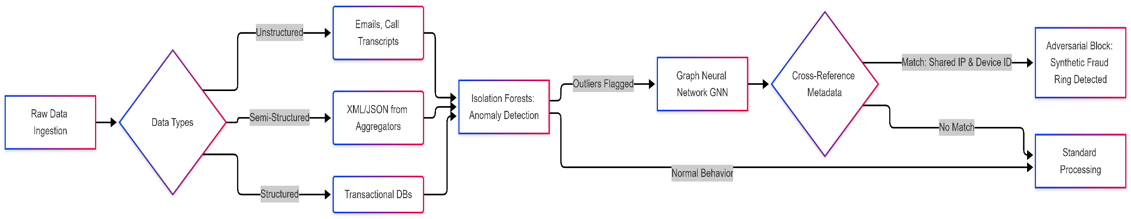
Figure D1: Fraud detection pipeline (Isolation Forest → GNN → metadata cross-reference)

Appendix E: Proactive Agentic AI Workflow

Figure E1 contrasts a reactive chatbot with an agent that analyses cash flow, retrieves external rates and executes a savings plan. In production, the transfer step would require customer confirmation (Section 5).

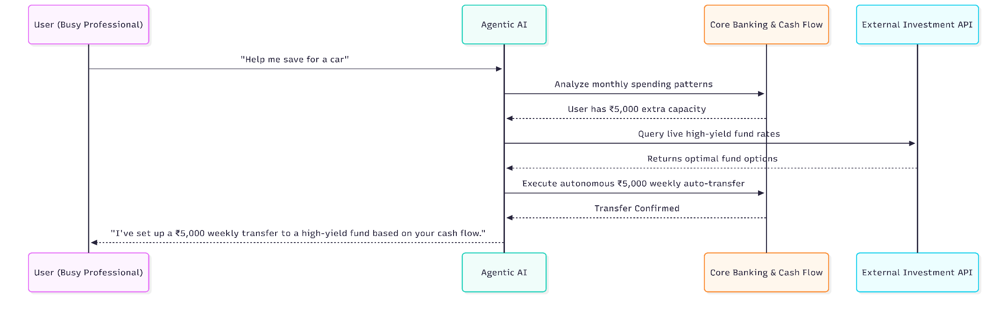
Figure E1: Agentic AI sequence for the "save for a car" goal

Appendix F: Underwriting and XAI Governance Loop

Figure F1 maps the decision pathway for a thin-file borrower: probabilistic reasoning and fuzzy logic handle missing data, a supervised model decides, and an Explainable AI module produces reason codes and an audit log for the customer and regulator.

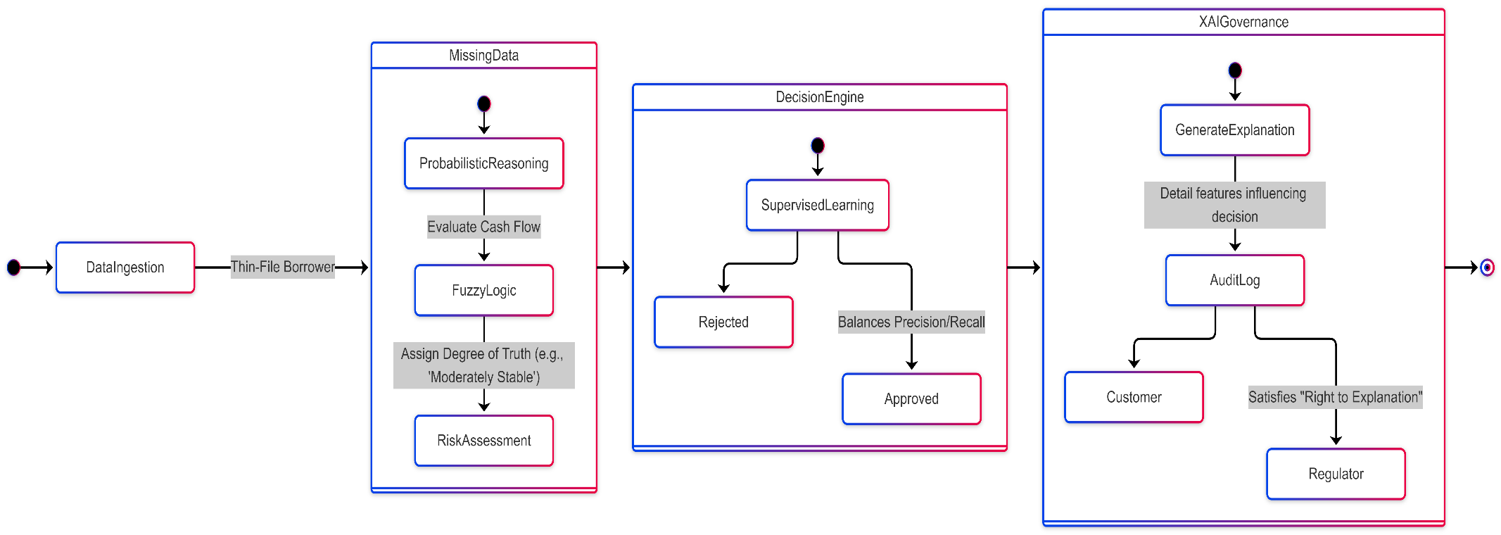
Figure F1: Credit decision and XAI governance state diagram

