
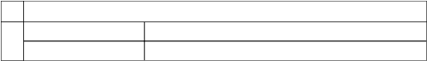
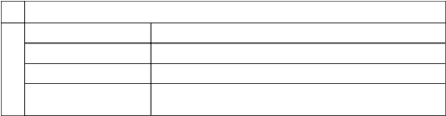
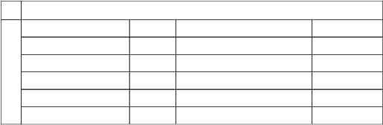
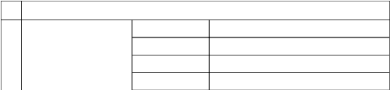
South
-
North
-
West
-
Adjoining Properties
East
-
Physical Details
4
Legal Documents
-
-
-
BU Permission
-
-
-
Construction Permission
-
-
-
Building Plan
-
-
-
Layout Plan
-
-
-
Yes/No
Name of Approving Authority
Approval No.
Document Details
3
property
Independent access to the
Yes
Nearby Landmark/Google Map
-
Legal Address
-
Address
-
Property details
2
Application No.
-
Name
-
Customer details
1
unit
Name of Customer (s)/ Borrowal
-
Name and Address of Branch
-
Property Front View
Insurable Value
-
DLC / Registration Value
-
Distress Sale Value
-
Realizable Sale Value
-
Fair Market Value
-
Location of the Property
AHMEDABAD
Name of Intended Purchaser
RAJ SHAH
Name of Proposed Owner
KRISHNAN ARUNBHAI PANDYA
Evaluation Warning : The document was created with Spire.PDF for Python.

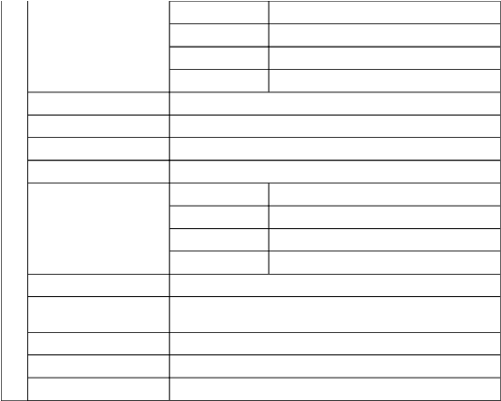

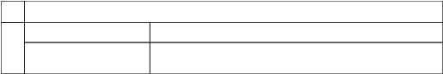
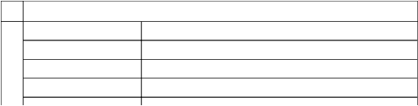
Saleable Area
- square feet / - square yard / - square meter
Carpet Area
- square feet / - square yard / - square meter
Plinth Area
- square feet / - square yard / - square meter
Site Area
- square feet / - square yard / - square meter
Area Details of the property
8
Nature and extent of violations
-
Violations if any observed
7
of completion
If under construction, extent
-
Stage of construction
-
Stage of Construction (for which valuation report is sought)
6
owner
Relationship of tenant or
-
No. of years of occupancy
-
Status of Tenure
-
Tenure / Occupancy Details
5
Type of structure
-
Residual age of the Property
-
Approx age of the Property
-
located
Floor on which the property is
-
Total No of Floors
-
Kitchen
-
Toilets
-
Bed rooms
-
No. of Rooms
Living/ Dining
-
Type of property
-
Approved land use
-
Plot demarcated
-
Matching of Boundaries
-
South East
-
South West
-
North West
-
North East
-
Evaluation Warning : The document was created with Spire.PDF for Python.

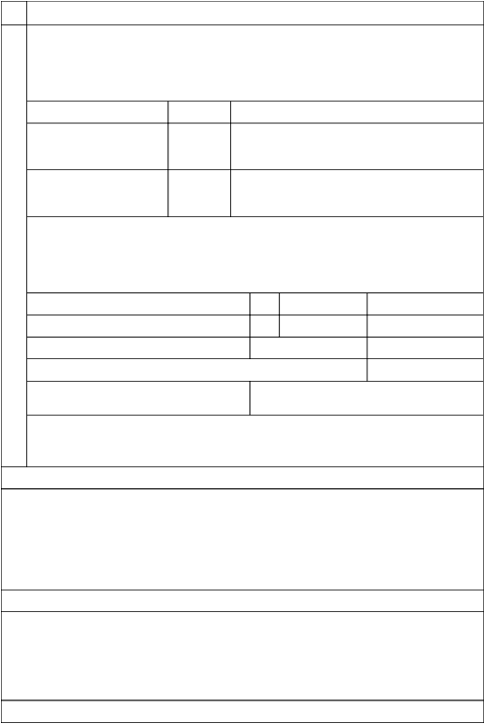
Forced Sale/ Distress Value
comprehensive understanding of the property's market value in relation to the costs involved.
with the specified attributes, stands at <>. This assessment considers the potential financial impact of the discount, ensuring a
In light of a <>% discount, we assert our view that the Realizable value of the aforementioned property, in its current condition and
assessment of the associated costs.
Realizable value pertains to the inherent worth of an asset that can be achieved through its successful sale, factoring in a prudent
Realizable Value
judgement, I propose considering the rounded-up value as the final figure, which I denote as <>.
Given the existing state of usability and the specific attributes of the property under consideration, and drawing on my professional
informed, prudent decisions devoid of any undue influence or pressure.
equitable. This transaction follows a comprehensive marketing process, and the parties involved are expected to make well-
the designated valuation date. This exchange would transpire between two willing participants in a transaction that is impartial and
The concept of Fair Market Value, as defined, centres around the estimated sum at which an asset could feasibly be exchanged on
Fair Market Value
deed ). And the distress sale value <>.
in the prevailing condition with aforesaid specifications is <>. The book value of the above property is <> <> ( As per sale
As a result of our appraisal and analysis, it is our considered opinion that the present fair market value of the above property
(Rounded off & in words)
Total Fair Value
Total Fair Value
Additional Value
Combined
Present value of the building (incl. car parking, if provided)
Description
Qty.
Rate per unit (in ₹)
Estimated fair value (in ₹)
determined the unit rate as follows, drawing from our comprehensive evaluation.
factors into careful consideration, including the unique characteristics and location of the subject property, we have
nearby vicinity is currently estimated to fall between Rs. 35,000.00 and Rs. 45,000.00 per square yard. Taking all these
and the specifics outlined in part 10 paragraph no. VI, the prevailing market / land rate for a comparable property in the
Incorporating the information presented earlier, encompassing a range of factors such as property location, size, condition,
₹ / s. feet
the surrounding area
3200.00
brokers and residents, among others.
Exploring the market conditions in
₹ 2700.00 - ₹
A local market inquiry was conducted, involving local real estate
₹ / s. feet
the surrounding area
3200.00
(Copy attached)
Exploring the market conditions in
₹ 2700.00 - ₹
Online portal
Particulars
Range
Source
the property's composite rate, ensuring accuracy and transparency in our valuation process.
comprehensive understanding of current market conditions. This information forms the basis for our informed estimation of
with property values and market trends. By analysing recent transactions and pricing dynamics, we've gained a
surrounding area. This included consultations with local real estate experts and engaging with community residents familiar
We conducted an extensive local market inquiry to determine the prevailing market or composite rate of the property in the
Valuation
9
Remarks
-
Evaluation Warning : The document was created with Spire.PDF for Python.


For the property's distress value, our perspective, as of the valuation date, is <>.
specified attributes, amounts to <>.
Following our thorough assessment, we assert that the Realizable value of the property, considering the existing condition and
as of <> is <>, which we consider to be equitable and rational.
After conducting a comprehensive appraisal and analysis, we hold the view that the current fair value of the property situated at <>
SUMMARY
reflect the True Market Value of any asset as upheld even by the court. So it is normal practice of doing valuation by local inquiries.
TaxAct Jantri rates are for stamp duty purpose only. These rates are considered as guideline rates only & they do not represent or
Generally the market rate of the property is higher than the government guideline rate ( Jantri ). As per Section, 50 C of the Income
Government guideline value Justification
The guideline value of the property as below is <>.
Total Fair Value (Rounded off & in words)
Total ( i-iii )
iii
ii
i
Sr. No
Description
Qty. (square meter)
Rate per unit (in ₹)
Estimated fair value (in ₹)
Revised Jantri rate as per Govt. notification
Jantri rate for residential flat premises - year 2011
from dated 15/04/2023. For residential flat premises, Jantri rate is considered 1.8 times of rate of Jantri - 2011 ( Copy attached ).
The Govt. of Gujarat has revised the Jantri rate vide Tharav No. STP-122023-20-H.1, Dated 13/04/2023 & implemented the same
stamp duty / registration purpose.
the local revenue practitioners / registration - jantri value derived by the State Government represents guideline value fixed for
Prevailing Govt. GuideLine/ Jantri rate derives to be <> per square meter for reasonably identical property, based on inquiry from
Government guideline value
encapsulates a careful synthesis of market realities, borrower behaviour, and the unique circumstances surrounding the sale.
Thus, based on our assessment, the estimated forced sale or distress value of the subject property amounts to <>. This value
value. In light of these considerations, an average discount of approximately 25% is prudent for the purpose of this valuation.
consideration, our perspective leads us to opine that the forced sale value could likely hover between 20% to 30% below the market
market influences, borrower's stance, property marketability, and prevailing conditions. As we delve into the specific property under
The determination of the appropriate discount for a particular property hinges on a multitude of variables, including but not limited to
contributing to the gap between perceived and realised values.
contrast essentially stems from factors such as market dynamics, borrower cooperation, and prevailing market conditions, all
market could command. This discrepancy between the market price and the realised sale price becomes more pronounced. This
context. It's widely acknowledged that sales orchestrated by enforcing authorities often yield a value significantly lower than what the
expectation is for an immediate, lump-sum payment. However, this alignment might not be viable within an imperfect property market
spread out across a duration and paid through instalments. Yet, when a lender seeks to sell a property under enforcement, the
the aforementioned market price might not be directly applicable. This is due to the conventional nature of property payments, often
shifts to circumstances where a financial institution seeks to recuperate its outstanding dues by initiating property sale proceedings,
The fair value delineated above finds its application in a theoretical realm of an ideal market scenario. However, when the scenario
Evaluation Warning : The document was created with Spire.PDF for Python.



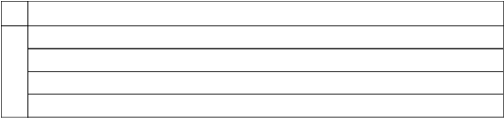
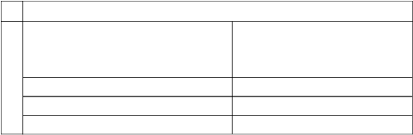
Enclosures
13
Wealth Tax Registration No.
CAT-1/788/2023-24
IBBI Reg. No.
IBBI/RV/02/2022/14608
Date of Valuation
-
Signature of the valuer
Name address & signature of valuer with Registration No.
12
iv) I have submitted a Valuation report directly to the Bank.
iii) The information furnished herein is true and correct to the best of our knowledge.
ii) The undersigned does not have any direct/indirect interest in the above property.
i) The property was inspected by the undersigned on 22.
Declaration
11
marketability of the property
relevance on the value or
Any other aspect which has
-
provided, if available.
in the locality/area to be
Details of last two transactions
-
mortgaged.
been mortgaged or to be
up / property is situated has
land on which the unit is set
Whether the entire piece of
-
etc.
hospital, school, old age home
social infrastructure like
Whether property belongs to
-
compliant
Property is SARFAESI
-
suggested, if any
Qualifications in TIR/Mitigation
-
Assumptions/Remarks
10
other than those explicitly mentioned in this report.
It's worth highlighting that values can vary based on purpose and date. It is advisable not to refer to this value for any purposes
associated society, coupled with our review of pertinent documents.
It's important to note that the information provided in this report is based on the data furnished by the property's owner and the
As for the insurable value, our judgement, as of the valuation date, is <>.
Regarding the guideline value, our assessment, as of the valuation date, is <>.
Evaluation Warning : The document was created with Spire.PDF for Python.



R. I have read the Handbook on Policy, Standards and procedure for Real Estate Valuation, 2011 of the IBA and this report is in
Q. I have not concealed or suppressed any material information, facts and records and I have made a complete and full disclosure.
P. I undertake to keep you informed of any events or happenings which would make me ineligible for empanelment as a valuer.
O. My Pan Card number/Service Tax number as applicable is CKHPP4738F / 24CKHPP4738F1Z1.
Gift Tax Act 1958 and My PAN card number/Service Tax number as applicable is CKHPP4738F.
N. I have not been convicted of an offence connected with any proceeding under the income Tax Act 1961, Wealth Tax Act 1957 or
confirmed by income-tax Appellate Tribunal, and five years have not elapsed after levy of such penalty.
Commissioner of income-tax (Appeals) or income tax Appellate Tribunal, as the case may be has expired, or such penalty has been
M. l have not been levied a penalty under section 271J of income-tax Act, 1961 (43 of 1961) and time limit for filing appeal before
L. I am not an undischarged insolvent.
K. I am not an undischarged bankrupt, or has not applied to be adjudicated as a bankrupt;
J. I have not been declared to be unsound mind.
I. I have not been found guilty of misconduct in professional capacity.
H. I have not been convicted of any offence and sentenced to a term of imprisonment.
G. I have not been removed/dismissed from service/employment earlier.
empanelment with you, I will inform you within 3 days of such depanelment.
F. I have not been depanelled/ delisted by any other bank and in case of any such depanelment by other banks during my
E. Valuation report is submitted in the format as prescribed by the Bank.
D. I have personally inspected the property on <>. The work is not subcontracted to any other valuer and carried out by myself.
made an impartial and true valuation of the property.
C. The information furnished in my valuation report dated <> is true and correct to the best of my knowledge and belief and I have
a period of three years prior to my appointment as valuer or three years after the valuation of assets was conducted by me.
B. I will not undertake valuation of any assets in which I have a direct or indirect interest or become so interested at any time during
A. I am a citizen of india.
l, Harsh Jayantilal Patel son of Jayantilal Shankarbhai Patel do hereby solemnly affirm, and state that
Format of undertaking to be submitted by individuals/ proprietor/ partners/ directors
DECLARATION CUM UNDERTAKING (Annexure-lII)
records
bank
i)
Any other relevant documents/ extracts
As per
(Distance from sea-coast / tidal level must be incorporated) if any
service purposes, road widening or applicability of CRZ provisions etc.
Applicable
h)
Special remarks, if any, like threat of acquisition of land for public
Not
viz Magickbricks.com, 99Acres.com, Makan.com etc
herewith
g)
Price trend of the Property in the locality/city from property search sites
Attached
ordinates of the property.
herewith
f)
Google Map location of the property, Longitude/Latitude and co-
Attached
from the concerned office
herewith
e)
Certified copy of the approved / sanctioned plan wherever applicable
Attached
"Selfie' of the Valuer at the site
owner (in case of housing loans, if borrower is available) including a
herewith
d)
Photograph of the property (including geo-stamping with date) and
Attached
herewith
c)
Floor Plan
Attached
herewith
b)
Building Plan
Attached
latitude and longitude
herewith
a)
Layout plan sketch of the area in which the property is located with
Attached
Evaluation Warning : The document was created with Spire.PDF for Python.



limitations faced by valuer,
explain or elucidate the
disclaimers to the extent they
Caveats, limitations and
Not Applicable
valuation
taken into account during the
Major factors that were not
As described in the report
valuation
into account during the
Major factors that were taken
As described in the report
report, if any
Restrictions on use of the
As described in the report
standards followed
out the valuation and valuation
Procedures adopted in carrying
As described in the report
information used or relied upon:
Nature and sources of the
As described in the report
undertaken
Inspections and/or investigation
As described in the report
date and date of report
Date of appointment, valuation
Verbal Mode
conflict, if any;
Disclosure of valuer interest or
No
valuation
other experts involved in the
Identity of the valuer and any
Harsh Patel (Edifice Valuation)
Appointing authority
<>
Purpose of valuation
As described in the report
assets being valued
background information of the
As described in the report
Signature:
Place: Ahmedabad
Date: <>
Z. Further, I hereby provide the following information.
Y. I will undertake the valuation work on receipt of Letter of Engagement generated from the system (i.e. LLMS/LOS) only.
X. I am the proprietor / partner I authorised officials of the firm / company, who is competent to sign this valuation report.
W. My ClBlL score and credit worthiness is as per Bank's guidelines.
V. I am valuer registered with insolvency & Bankruptcy Board of india (lBBl) (Strike off, if not applicable)
U. I am valuer registered under Section 34AB of the Wealth Tax Act,1957 (Strike off, if not applicable)
taken and kept along with this declaration).
T. I abide by the Model Code of Conduct for empanelment of valuer in the Bank. (Annexure V- A signed copy of the same to be
conformity to the "standards" as enshrined for valuation in the IVS in "General Standards" and "Asset Standards" as applicable.
S. I have read the international Valuation Standards (lVS) and the report submitted to the Bank for the respective asset class is in
conformity to the "standards" enshrined for valuation in the Part-B of the above handbook to the best of my ability.
Evaluation Warning : The document was created with Spire.PDF for Python.



registered valuers organisation with which he/it is registered, or any other statutory regulatory body.
21. A valuer shall provide all information and records as may be required by the authority, the Tribunal, Appellate Tribunal, the
authorised by the authority, the registered valuers organisation with which he/it is registered or any other statutory regulatory body.
20. A valuer shall appear, co-operate and be available for inspections and investigations carried out by the authority, any person
reasonable person to take a view on the appropriateness of his/its decisions and actions.
decision, and the information and evidence in support of such decision. This shall be maintained so as to sufficiently enable a
19. A valuer shall ensure that he/ she maintains written contemporaneous records for any decision taken, the reasons for taking the
Information Management
disclose.
which has come to his/its knowledge without proper and specific authority or unless there is a legal or professional right or duty to
18. A valuer shall not use or divulge to other clients or any other party any confidential information about the subject company,
Confidentiality
unconnected transaction, the valuer shall declare the association with the company during the last five years.
17. ln any fairness opinion or independent expert opinion submitted by a valuer, if there has been a prior engagement in an
16. As an independent valuer, the valuer shall not charge a success fee.
needs.
15. A valuer shall not indulge in "mandate snatching" or offering "convenience valuations" in order to cater to a company or client's
Trading) Regulations, 2015 or till the time the valuation report becomes public, whichever is earlier.
his/its association with the valuation, and in accordance with the Securities and Exchange Board of india (prohibition of insider
14. A valuer shall not deal in securities of any subject company after any time when he/it first becomes aware of the possibility of
unbiased services.
13. A valuer shall wherever necessary disclose to the clients, possible sources of conflicts of duties and interests, while providing
not.
of any bias, conflict of interest, coercion, or undue influence of any party, whether directly connected to the valuation assignment or
12. A valuer shall act with objectivity in his/its professional dealings by ensuring that his/its decisions are made without the presence
Independence and Disclosure of interest
be relying on other valuers or professionals or for which the client can have a separate arrangement with other valuers.
11. A valuer shall clearly state to his client the services that he would be competent to provide and the services for which he would
objectivity and independence.
10. A valuer shall not carry out any instruction of the client insofar as they are incompatible with the requirements of integrity,
information available in public domain and not generated by the valuer.
to the extent that the assumptions are based on statements of fact provided by the company or its auditors or consultants or
9. ln the preparation of a valuation report, the valuer shall not disclaim liability for his/its expertise or deny his/its duty of care, except
date developments in practice, prevailing regulations/guidelines and techniques.
8. A valuer shall continuously maintain professional knowledge and skill to provide competent professional service based on up-to-
specified from time to time.
7. A valuer shall carry out professional services in accordance with the relevant technical and professional standards that may be
professional judgement.
6. A valuer shall render at all times high standards of service, exercise due diligence, ensure proper care and exercise independent
Professional Competence and Due Care
5. A valuer shall keep public interest foremost while delivering his services.
4. A valuer shall refrain from being involved in any action that would bring disrepute to the profession.
situations.
3. A valuer shall endeavour to ensure that he/it provides true and adequate information and shall not misrepresent any facts or
2. A valuer shall maintain integrity by being honest, straightforward, and forthright in all Professional relationships.
clients and other valuers.
1. A valuer shall, in the conduct of his/its business, follow high standards of integrity and Fairness in all his/its dealings with his/its
Integrity and Fairness
MODEL CODE OF CONDUCT FOR VALUERS (Annexure-XIV-A)
report
responsibility for the valuation
purpose of limiting his
which shall not be for the
Evaluation Warning : The document was created with Spire.PDF for Python.


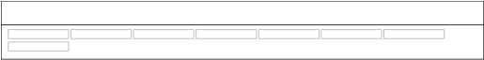

LATITUDE: - LONGITUDE: -
Photographs of the Property
30. A valuer shall follow this code as amended or revised from time to time.
the bank or housing finance institutions and with knowledge of the concerned valuer.
29. A valuer shall refrain from undertaking to review the work of another valuer of the same client except under written orders from
Miscellaneous
profession.
28. A valuer shall not conduct business which in the opinion of the authority or the registered valuer organisation discredits the
its assignments.
27. A valuer shall refrain from accepting too many assignments, if he/it is unlikely to be able to devote adequate time to each of his/
Occupation, employability and restrictions.
he would be rendering service.
26. A valuer shall not accept any fees or charges other than those which are disclosed in a written contract with the person to whom
necessarily and properly undertaken, and is not inconsistent with the applicable rules.
25. A valuer shall provide services for remuneration which is charged in a transparent manner, is a reasonable reflection of the work
Remuneration and Costs
view to obtain or retain work for himself/ herself, or to obtain or retain an advantage in the conduct of profession for himself/ herself.
24. A valuer shall not offer gifts or hospitality or a financial or any other advantage to a public servant or any other person with a
same Companies Act, 2013 (18 of 2013).
Explanation.- For the purposes of this code the term meaning as defined in Clause (77) of Section 2 of the 'relative' shall have the
23. A valuer or his/its relative shall not accept gifts or hospitality which undermines or affects his independence as a valuer,
Gifts and hospitality
Tribunal, the record shall be maintained till the disposal of the case.
for production before a regulatory authority or for a peer review. in the event of a pending case before the Tribunal or Appellate
maintain proper working papers for a period of three years or such longer period as required in its contract for a specific valuation,
22. A valuer while respecting the confidentiality of information acquired during the course of performing professional services, shall
Evaluation Warning : The document was created with Spire.PDF for Python.

