I developed 3 scoring functions

* Custom Score function using overlapping situations
* Custom Score 2 function using progressive improvement
* Custom Score 3 function using distance to Center

All of them were essentially modified versions of the “improved” score function

Custom Score

This Custom function looks at the overlap in the available moves of the two players, and if there is an overlap of 1, then the function gives a bonus if it’s the player’s turn, or a penalty if it’s the opponent’s turn.

The idea is that game player might prefer to steal the available spaces that the opponent can move to, thereby reducing their number of moves.

Custom Score2

This function enables progressive approach and inspired by the lectures, whereas the game progresses it puts a larger and larger multiplier on the “their moves” side of the “improved” score function. The later on in the game, the more this agent focuses on reducing the opponent’s moves relative to keeping its own moves.

Custom Score3

This function values board position by giving a bonus when the player’s piece is within the center of the board, and a further bonus when the opponent’s piece is outside of the center of the board.

Performance results review

After developing the above scoring functions by running tournament.py a few times, I ran two large batches by modifying tournament.py to increase the NUM_MATCHES to 100

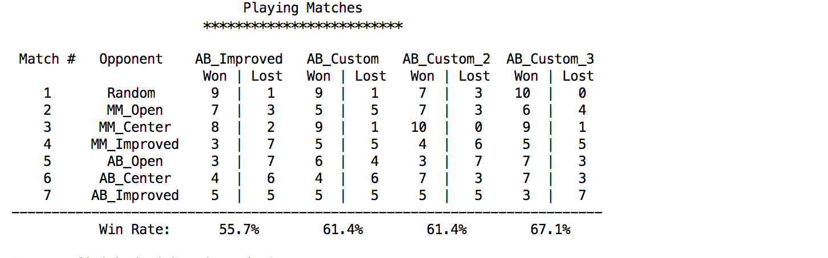

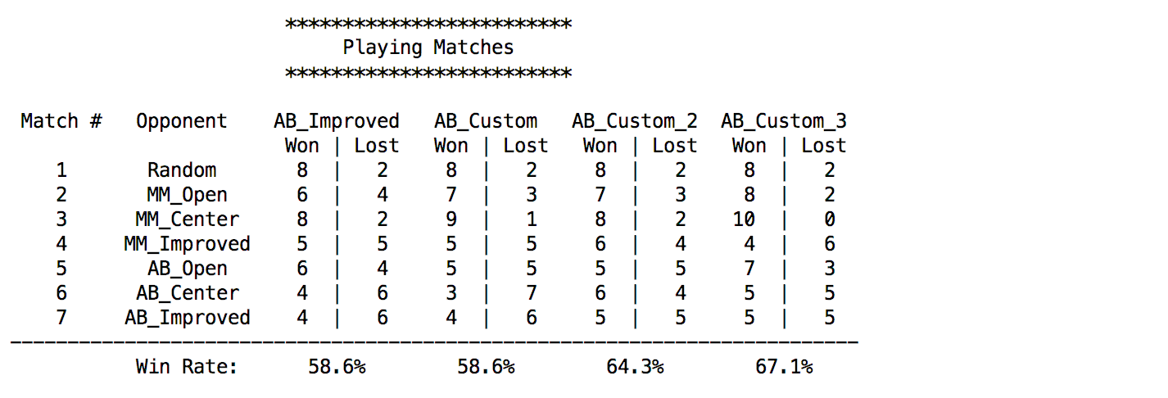

Custom score approach didn’t have the board partitioning aspect of the queen movement version, so positioning in a way to steal the opponent’s moves might be a good strategy.

Custom score 1 and Custom score 2 both seemed to outperform AB_Improved marginally, however given that AB_Improved wasn’t 50/50 with itself indicates a bit of a margin of error to me that they both fall within so we cannot confidently say any of my scoring functions reliably outplay AB_Improved.

I would guess some intelligent combination of the 3 of them might be able to though, since from a high level the idea of stealing opponent’s moves, positioning centrally, and being aggressive later in the game could work well together. I think the most promising idea is the one behind Custom score.

In summary, Custom score avoiding overlapping situations does everything that AB_Improved does, but with an extra little insight at almost no cost using the same available data.