TCGen
AI Test Case Generator
Complete User, Functional & Technical Documentation
AI4Dev + LLM@CIB | Dynamic Test Design | Excel + OCR + Reset All

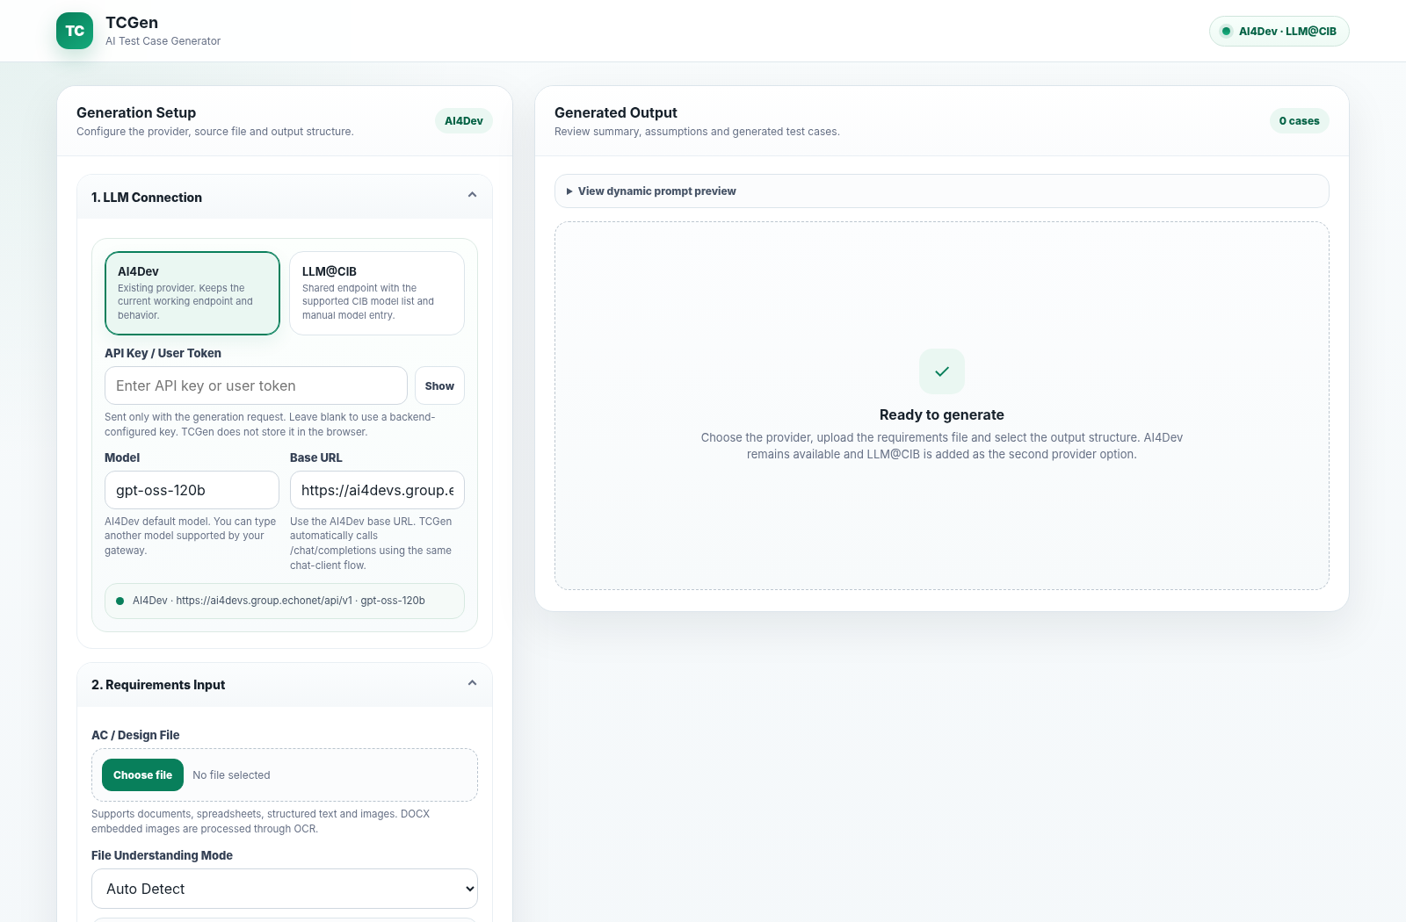
Figure 1. TCGen main workspace - professional green application theme.
Document scope: product overview, user guide, architecture, configuration, API reference, OCR/Excel behavior, security notes, reset semantics, troubleshooting, deployment and validation.

1. Executive Overview
TCGen converts requirement artefacts into structured test cases and exports them to Excel. It accepts documents, spreadsheets, structured text and images; understands embedded images in Word through OCR; dynamically builds output columns; and uses a selectable LLM connection to generate the final test set.
Current improvement: The non-functional “Refresh Prompt” action has been removed. “Reset All” now restores the complete working area to its initial state while preserving the active LLM provider, token, model and base URL.

Business value
- Accelerates test-design preparation from acceptance criteria and UI/design artefacts.
- Keeps output structure configurable for manual, API, BDD and regression test packs.
- Supports reusable Excel column schemas so teams can align with local templates and governance.
- Produces requirement summary, follow-up questions and assumptions alongside test cases.
- Reduces reconfiguration between runs because Reset All preserves the LLM connection.

Primary users
User | Typical usage
QA / Test Analyst | Generate and refine manual test scenarios from AC, requirements, screenshots or Word documents.
Automation Engineer / SDET | Generate automation-ready cases and identify automation candidates.
Test Lead / Architect | Enforce consistent columns, templates, coverage rules and review assumptions/questions.
API / Integration Tester | Use API template with method, endpoint, payload, status code and DB validation columns.

2. Functional Capability Map
Area | Capability | User outcome
LLM connection | AI4Dev and LLM@CIB; editable model/base URL; optional UI token | Use the gateway/model available to the team without changing code.
Input | TXT, PDF, DOC/DOCX, XLS/XLSX, CSV, JSON, XML, HTML, MD, PNG/JPG/BMP/TIFF/WEBP | Generate from common requirement and design artefacts.
Understanding mode | Auto, Document/Excel AC, Image AC Text, UI Design/Figma Screenshot, Word with Images | Guide extraction and prompt intent.
Test design | Manual, API, BDD and Regression templates; additional prompt | Control coverage and test style.
Columns | Default columns, select all/clear optional, custom columns, Excel schema detection | Match organisational output templates.
Generation | Structured JSON with summary, questions, assumptions and testCases | Review context and generated cases together.
Export | XLSX with Test Cases, Follow Up Questions and Assumptions sheets | Move output into execution/review workflows.
Reset All | Clean all working data while keeping LLM details | Start the next generation quickly and safely.

3. Solution Architecture
The application is a Java 17 Spring Boot web service with a static browser UI. The controller delegates file extraction, column resolution, prompt construction, LLM invocation, response parsing and Excel export to focused services.
Browser UI | → | Spring REST API | → | Generation Service
Files / Excel / Images | → | Tika + POI + OCR | → | Prompt Builder
Excel Download | ← | Excel Export | ← | JSON Parser + LLM Client

Runtime flow
- The user configures the LLM connection, uploads the requirement source and selects a file-understanding mode.
- TCGen resolves output columns from the optional column-template Excel, the requirement workbook schema, UI selections or defaults.
- FileTextExtractor reads source content; DOCX images and direct image uploads are OCR-processed when enabled.
- PromptBuilder creates a strict test-architect prompt containing only the selected columns and requested test-design rules.
- LlmClient calls the selected OpenAI-compatible /chat/completions endpoint using bearer authentication.
- JsonResponseParser converts the model response into the typed generation response; one strict same-model retry is used only when JSON parsing fails.
- The browser renders the summary, questions, assumptions and test cases. ExcelExportService produces the downloadable workbook.

Technology stack
Layer | Technology
Runtime | Java 17, Spring Boot 3.1.5
LLM integration | Java HttpClient / OpenAI-compatible chat contract; LangChain4j dependencies retained in project
Document parsing | Apache Tika
Excel / DOCX handling | Apache POI
OCR | Tess4J / Tesseract with bundled English trained data and path auto-detection
UI | Single static HTML/CSS/JavaScript workspace
Export | Apache POI XLSX generation

4. User Guide - LLM Connection
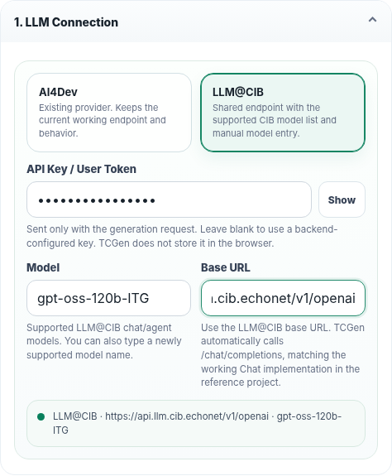
Figure 2. LLM provider and connection configuration.
- Choose AI4Dev or LLM@CIB.
- Enter an API key/user token when required. Leaving it blank allows the backend configuration to be used.
- Select or type the model. The field is intentionally editable for newly supported gateway models.
- Confirm or edit the base URL. TCGen appends /chat/completions when needed.
- Use Show/Hide only to inspect the token temporarily. TCGen does not persist the UI-entered token in browser storage.
Provider | Default base URL | Default model
AI4Dev | https://ai4devs.group.echonet/api/v1 | gpt-oss-120b
LLM@CIB | https://api.llm.cib.echonet/v1/openai | gpt-oss-120b-ITG

Security: Do not place real secrets in screenshots or documents. The UI token is sent with the generation request and is not written to localStorage/sessionStorage by the application.

5. User Guide - Requirement Input
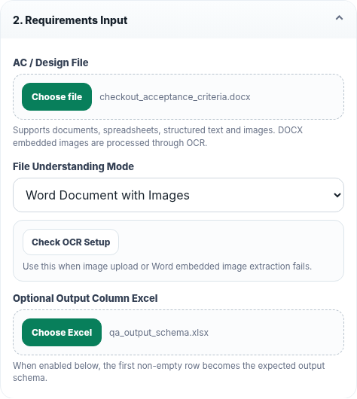
Figure 3. Requirement upload, understanding mode and optional output-column Excel.

Supported input categories
Category | Extensions / examples
Documents | TXT, PDF, DOC, DOCX, MD, HTML
Spreadsheets / structured | XLS, XLSX, CSV, JSON, XML
Images | PNG, JPG/JPEG, BMP, TIFF/TIF, WEBP
Word with embedded images | DOCX text/tables plus OCR of embedded pictures

File Understanding Mode
Mode | Use when
Auto Detect | General default; let TCGen infer normal document/image handling.
Document / Excel AC | Acceptance criteria, requirement docs or spreadsheets contain primary business text.
Image with AC Text | Screenshot/image contains readable acceptance-criteria text.
UI Design / Figma Screenshot | Screenshot represents UI labels, validations or screen design to be converted into test ideas.
Word Document with Images | DOCX combines written requirements and embedded screenshots/images.

6. User Guide - Test Design and Output Templates
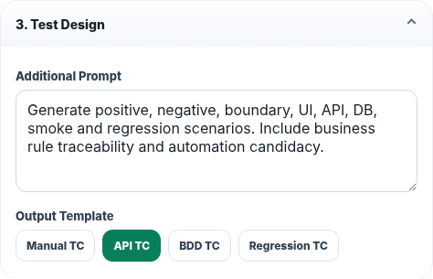
Figure 4. Additional prompt and output-template controls.
The Additional Prompt supplements the built-in senior test-architect rules. Keep it focused on domain-specific coverage, exclusions, data rules or naming conventions rather than repeating the entire system behavior.
Template | Typical columns / purpose
Manual TC | Test ID, module, requirement mapping, scenario, precondition, steps, data, expected result, priority, type and automation candidate.
API TC | Adds method, endpoint, payload, status code and DB validation for service/interface testing.
BDD TC | Feature, Scenario, Given, When, Then, Examples, Tags and automation metadata.
Regression TC | Regression scope, impact area, steps, expected result and remarks.

Prompt preview: The prompt preview updates automatically when the prompt, mode or columns change. A separate Refresh Prompt button is intentionally no longer required.

7. User Guide - Output Columns and Excel Schema
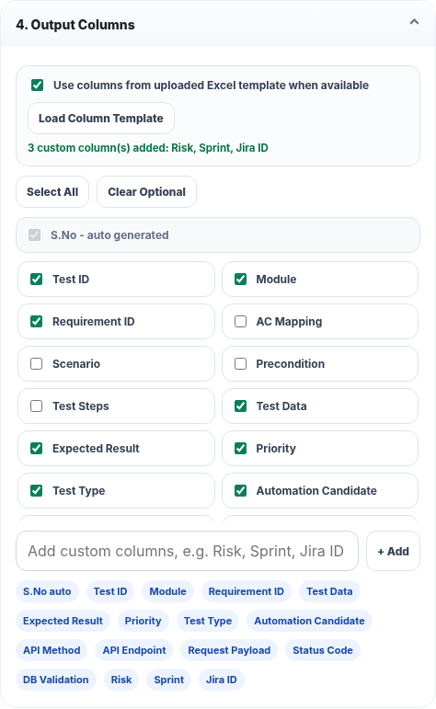
Figure 5. Dynamic output columns, Excel schema loading and custom columns.
- Keep “Use columns from uploaded Excel template” selected when the first non-empty row of a separate Excel should define the output schema.
- Click Load Column Template to detect and apply the Excel headers before generation.
- Use Select All or Clear Optional for quick UI selection.
- Add custom columns using comma, semicolon or newline separation, for example: Risk, Sprint, Jira ID.
- S.No is automatically generated in Excel and is therefore ignored when detected in template files.
Example first row:
Test ID | Module | Requirement ID | Scenario | Precondition | Test Steps | Test Data | Expected Result | Priority | Test Type | Automation Candidate | Risk | Sprint | Jira ID

8. Generate, Review and Export
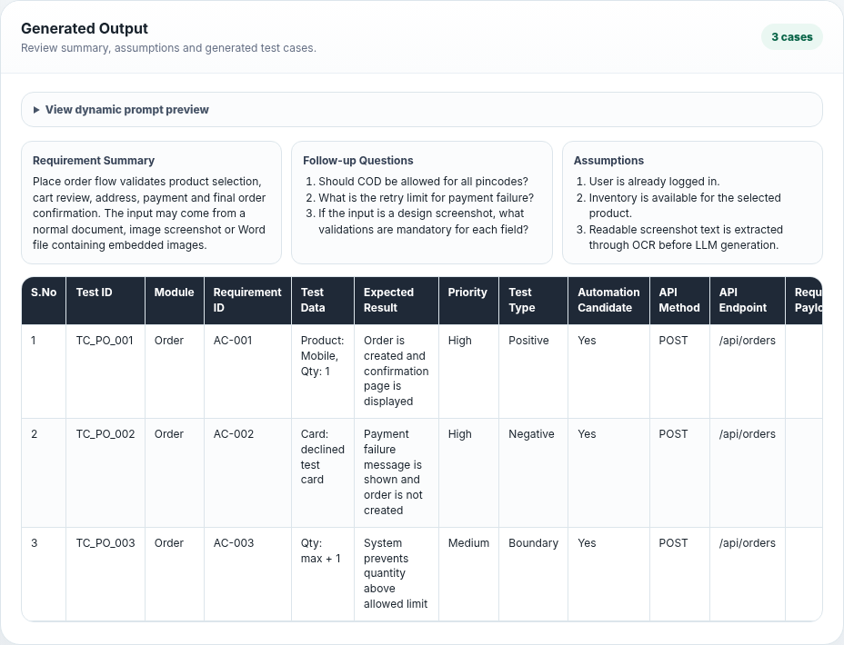
Figure 6. Generated summary, questions, assumptions and test-case table.
- Click Generate Test Cases after the source file, connection and output structure are ready.
- Review Requirement Summary to confirm the model understood the main flow.
- Review Follow-up Questions to identify missing or ambiguous requirement details.
- Review Assumptions before accepting test coverage, especially for business rules that were not explicitly specified.
- Review the generated test-case table against the selected columns.
- Click Download Excel to create the XLSX output.

Excel workbook contents
Sheet | Contents
Test Cases | Selected columns plus auto-generated S.No; wrapped cells; first row frozen.
Follow Up Questions | One generated question per row.
Assumptions | One generated assumption per row.

9. Reset All - Exact Behavior
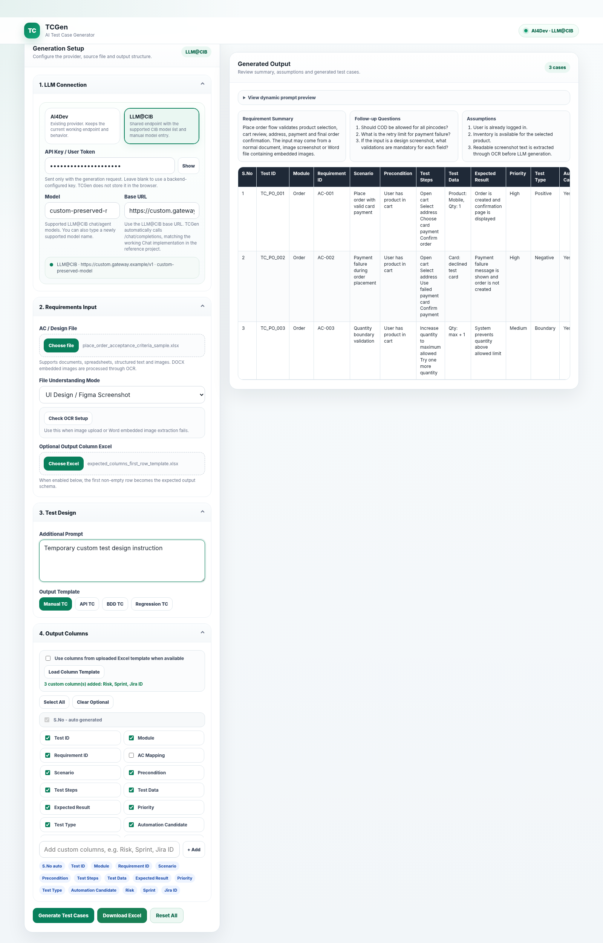 | 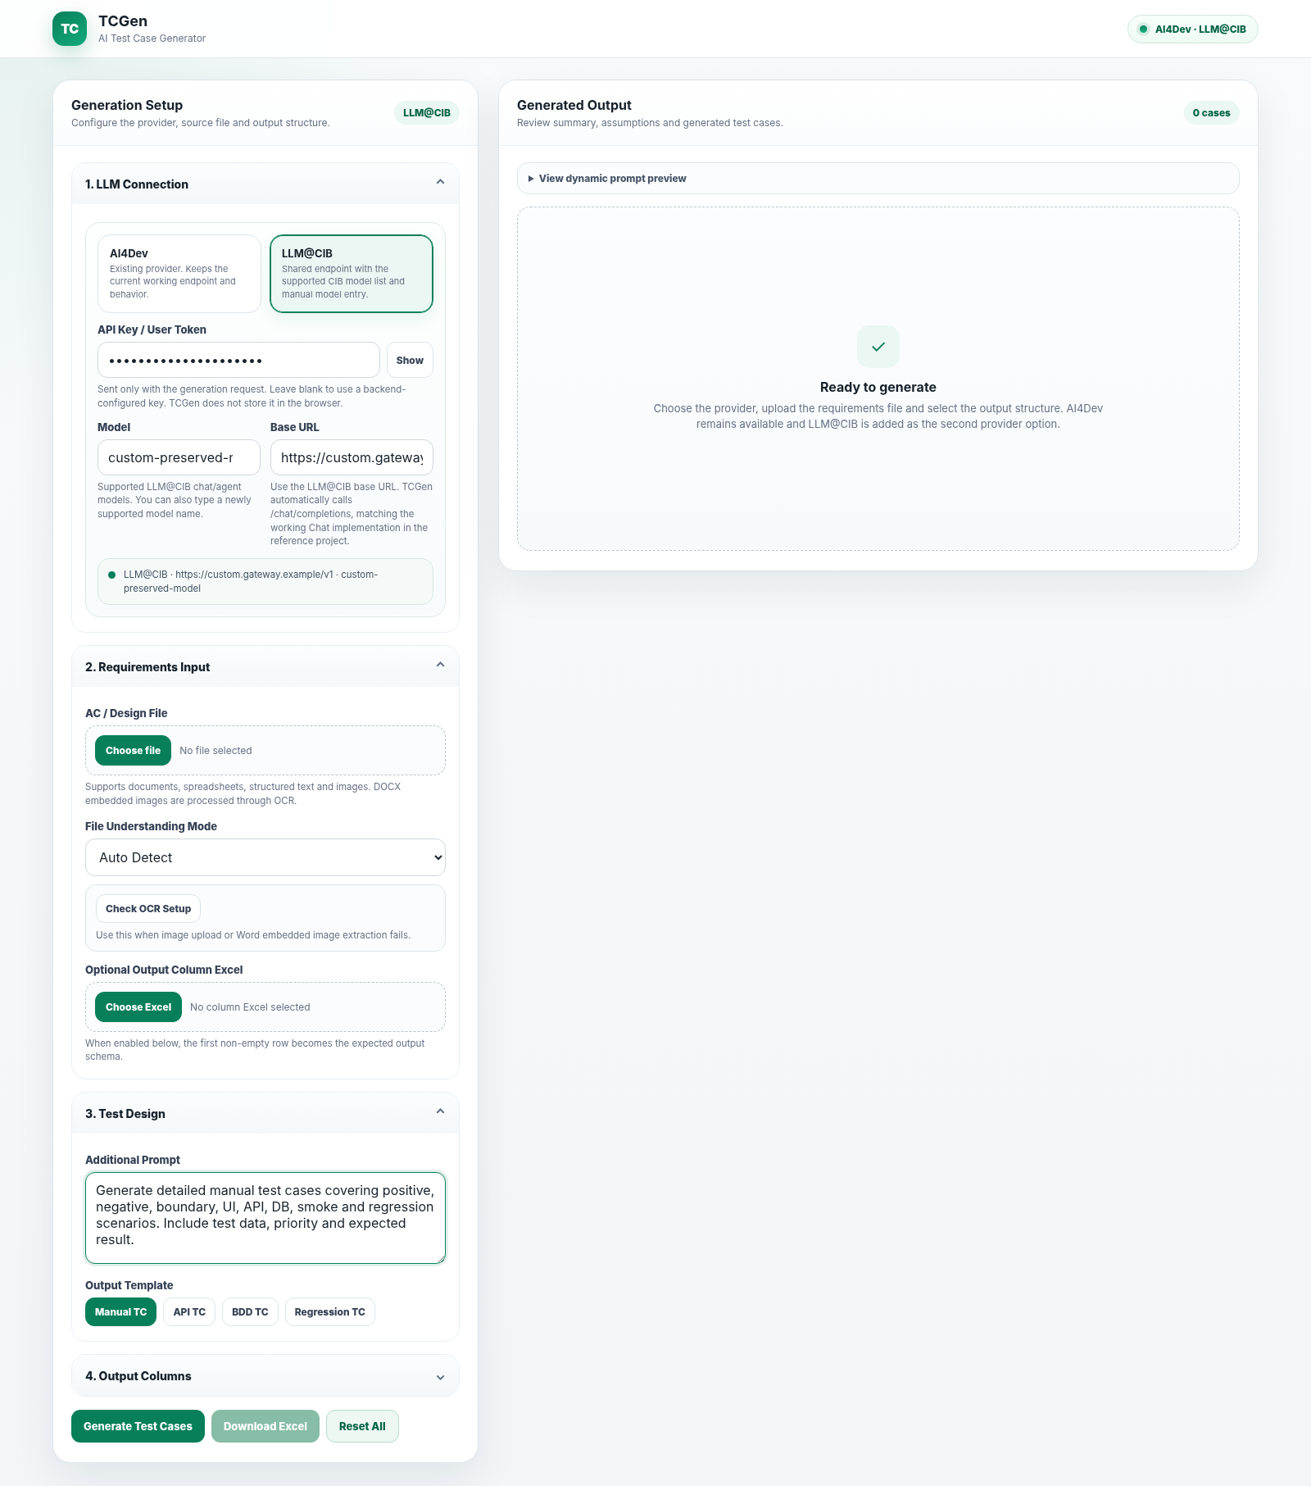
Before Reset All: files, custom prompt/columns and generated output are present. | After Reset All: working area returns to initial state; LLM provider/token/model/base URL remain.

Preserved | Reset
Selected provider | Main requirement file
API key / user token value | Optional column Excel file
Model name | File Understanding Mode → Auto Detect
Base URL | Additional Prompt → default
 | Template → Manual TC
 | Output columns → default Manual set; custom columns removed
 | OCR / Excel status messages
 | Generated output, count, export availability, errors and loading state

Long-running safety: Reset All aborts the active browser generation request. A reset epoch also prevents late OCR or Excel-column responses from modifying the freshly reset UI.

10. OCR and Word-with-Image Processing
TCGen uses OCR for direct images and for images embedded inside DOCX files. English OCR data is bundled by default; the application also supports Tesseract path auto-detection and an explicit TCGEN_OCR_TESSDATA_PATH override.
- Document text is extracted using Apache Tika.
- DOCX embedded images are enumerated using Apache POI.
- Images are normalized and sent through Tess4J/Tesseract when OCR is enabled.
- Extracted OCR text is merged with the normal document text before prompt construction.
- GET /api/testcases/ocr/status exposes the resolved language-data state for diagnosis.
Property | Default / purpose
tcgen.ocr.enabled | true
tcgen.ocr.language | eng
tcgen.ocr.tessdata-path | Blank; auto-detection/bundled data is used when possible
tcgen.ocr.minimum-width | 900
tcgen.ocr.minimum-height | 600
tcgen.ocr.docx-images.enabled | true
tcgen.ocr.docx-images.max-count | 20
tcgen.ocr.bundle-tessdata.enabled | true

Limitation: OCR extracts readable text. It is not a substitute for a vision model when the test objective depends on colour, spacing, visual hierarchy or non-textual layout interpretation.

11. LLM Request and Response Behavior
- Both providers use an OpenAI-compatible chat payload with model, system/user messages and stream=false.
- The client first requests response_format=json_object because TCGen requires structured JSON.
- If the gateway explicitly reports JSON mode as unsupported, the client retries once without response_format while staying on the same provider/model/endpoint.
- max_tokens is omitted by default when configured as 0, allowing the provider to manage the output budget.
- The HTTP request timeout is four minutes.
- If JSON parsing fails after a valid model response, TestCaseGeneratorService performs one focused strict-JSON retry using the same provider and model.
Expected top-level JSON:
{
"requirementSummary": "...",
"followUpQuestions": ["..."],
"assumptions": ["..."],
"selectedColumns": ["Test ID", "Scenario", "Expected Result"],
"testCases": [ { "Test ID": "TC_001", "Scenario": "...", "Expected Result": "..." } ]
}

12. REST API Reference
Method | Endpoint | Purpose
GET | /api/testcases/health | Service status and capability flags.
GET | /api/testcases/ocr/status | OCR/tessdata diagnostic information.
GET | /api/testcases/columns/defaults | Default UI/output columns.
POST | /api/testcases/columns/from-excel | Detect output columns from uploaded XLS/XLSX.
POST | /api/testcases/prompt-preview | Build a server-side prompt preview from selected columns/mode.
POST | /api/testcases/generate | Generate test cases from a multipart requirement source.
POST | /api/testcases/export | Export a generation response as XLSX.

Generate request - important multipart fields
Field | Required? | Description
requirementsFile | Yes (or legacy file) | Main requirement / AC / design artefact.
expectedColumnsFile | No | Optional Excel whose first non-empty row defines output columns.
provider | No | AI4DEV or LLM_CIB; backend defaults apply when omitted.
apiKey | No | Request-specific token; backend configured key can be used instead.
modelName | No | Request model override.
baseUrl | No | Request base URL override.
additionalPrompt | No | Extra test-design instructions.
selectedColumns | No | Comma-separated selected columns.
fileUnderstandingMode | No | UI mode value such as auto or ui-design.
useUploadedExcelColumns | No | true/false; when true, Excel-detected columns take priority.

curl -X POST http://localhost:8090/api/testcases/generate \
-F "requirementsFile=@requirements.docx" \
-F "provider=AI4DEV" \
-F "modelName=gpt-oss-120b" \
-F "fileUnderstandingMode=document-ac" \
-F "selectedColumns=Test ID,Scenario,Test Steps,Expected Result,Priority"

13. Configuration and Deployment

Build and run
mvn clean package
java -jar target/tcgen-service-0.0.7-SNAPSHOT.jar
Default port: 8090. Open http://localhost:8090 after startup.

Environment variables
Variable group | Examples
Legacy/default LLM | LLM_API_KEY, LLM_MODEL_NAME, LLM_BASE_URL
AI4Dev | AI4DEV_API_KEY, AI4DEV_MODEL_NAME, AI4DEV_BASE_URL
LLM@CIB | LLM_CIB_API_KEY, LLM_CIB_MODEL_NAME, LLM_CIB_BASE_URL
Generation limits | TCGEN_MAX_EXTRACTED_CHARACTERS (60000), TCGEN_MIN_SELECTED_COLUMNS (4)
OCR | TCGEN_OCR_ENABLED, TCGEN_OCR_LANGUAGE, TCGEN_OCR_TESSDATA_PATH and DOCX image limits

14. Security and Data Handling
- No API key is hardcoded in source code. Provider-specific environment variables can be used for backend configuration.
- The browser UI does not persist the entered token in localStorage or sessionStorage.
- Generation sends requirement content to the selected LLM endpoint; use only sources approved for that endpoint and environment.
- The API is currently annotated with CrossOrigin(origins="*"). For production deployment, restrict CORS to approved origins according to the hosting architecture.
- HTTP error messages distinguish common authentication, endpoint, rate-limit and provider-server failures.
- Only the selected output columns are requested from the LLM and written into the test case rows, reducing unnecessary response structure.
Deployment hardening: Use HTTPS at the ingress/reverse proxy, externalise secrets, restrict network egress to approved LLM endpoints, and apply organisation-standard authentication/authorisation if the service is exposed beyond a trusted internal network.

15. Error Handling and Troubleshooting
Symptom | Checks / resolution
401 / 403 from provider | Verify token, gateway entitlement, provider selection and model access.
404 chat endpoint | Check base URL. TCGen appends /chat/completions unless it is already present.
429 rate limit / quota | Retry after quota/rate window or use an approved alternative model/provider.
HTTP 200 but empty output | Validate model behavior and gateway compatibility.
JSON parsing failure | TCGen performs one strict same-model JSON retry; if it still fails, retry or select a more reliable chat model.
Image/DOCX OCR fails | Use Check OCR Setup and /ocr/status; verify traineddata resolution and image readability.
Excel template columns not detected | Ensure XLS/XLSX and place intended output headers in the first non-empty row or supported schema sheet.
Generate button validation error | Upload a main requirement file and select at least four output columns.
Need a clean next run | Use Reset All; LLM details remain configured.

16. Validation Checklist
Check | Expected result
UI JavaScript syntax | No syntax error.
Initial load | Manual template selected; prompt preview is populated; 0 cases.
Provider switch | Badge, model suggestions, model default, base URL and connection summary update.
Custom columns | Comma/semicolon/newline values are added individually and selected.
Reset All | All non-LLM workspace state is cleared; provider/token/model/base URL are preserved.
Reset during generation | Active browser request is aborted; late generation response cannot repopulate UI.
Excel export | Workbook contains Test Cases, Follow Up Questions and Assumptions.
OCR status | Endpoint returns language, resolved tessdata path and traineddata state.

Validation performed for this package: Reset All was browser-tested against a deliberately modified workspace. Provider, token, model and base URL were preserved; files, mode, prompt, template, custom columns, results and export state returned to initial values with no UI JavaScript errors. Maven compilation could not be executed in the packaging environment because Maven is not installed there; no Java source was changed for the Reset All enhancement.

17. Project Structure
src/main/java/com/llmart/llm
config/ChatConfig.java
controller/TestCaseController.java
dto/
exception/
service/ColumnSelectionService.java
service/ExcelExpectedColumnsService.java
service/ExcelExportService.java
service/FileTextExtractor.java
service/DocxImageOcrExtractor.java
service/OcrService.java
service/PromptBuilder.java
service/LlmClient.java
service/JsonResponseParser.java
service/TestCaseGeneratorService.java
src/main/resources/static/index.html
src/main/resources/application.properties
src/main/resources/tessdata/eng.traineddata
samples/
docs/

18. Quick Start - Recommended Working Pattern
- Configure the provider, token, model and base URL once.
- Upload the requirement source and optional output-schema Excel.
- Choose the file-understanding mode and test template.
- Adjust the prompt and columns only where the requirement needs extra guidance.
- Generate, review questions/assumptions and export the final Excel.
- Click Reset All before the next requirement. The LLM connection remains ready, while every working artefact and result is cleared.
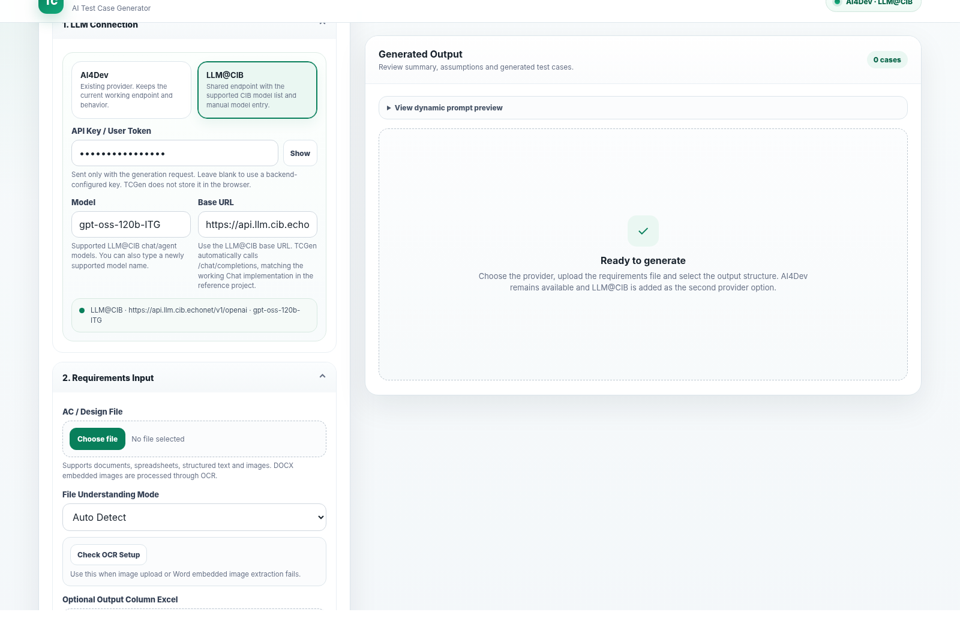
Figure 7. Clean ready state after Reset All with the LLM connection retained.

