ITPS VIBIUM
MCP Framework
Complete Functional, Technical, Operational and Demo Documentation
Java 17 • Spring Boot • Vibium MCP • WebDriver BiDi • LangGraph4j
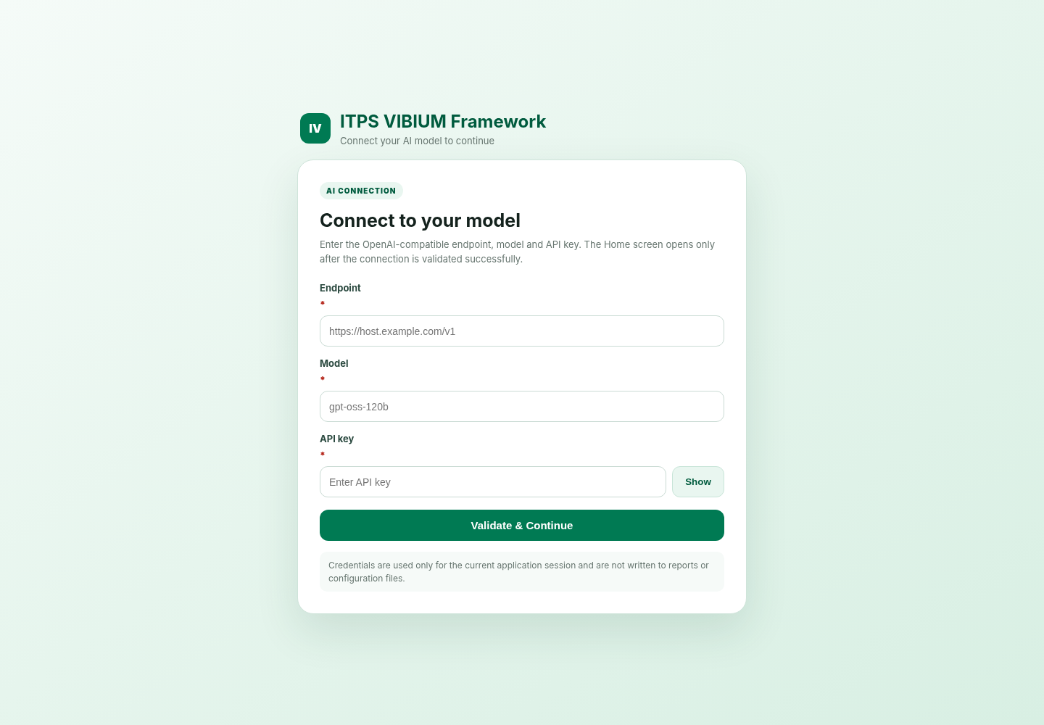
Scope: current source package including the AI connection gate, optional browser zoom fallback, parallel browser pool, recorder, self-healing and reporting.

Contents
1. Executive summary
2. What is Vibium?
3. Why Vibium for this framework?
4. Framework goals and design principles
5. Current feature inventory
6. Architecture
7. Startup AI connection gate
8. User interface and end-to-end workflow
9. Scenario files and test data
10. Browser and execution modes
11. Parallel browser pool
12. Agentic Step (LangGraph4j)
13. Deterministic execution and selector strategy
14. Self-healing and validation
15. Cookie/session handling
16. UI action recorder
17. Browser maximize, zoom and platform behavior
18. Reporting and diagnostics
19. REST API reference
20. Security model
21. Build, deployment and runtime
22. Demonstration guide
23. Automated tests and release validation
24. Troubleshooting
25. Current limitations / missed areas
26. Recommended roadmap
27. Appendices and references
Document basis This document is grounded in the current project source tree. External statements about Vibium itself use the official Vibium repository and documentation as the primary source.

1. Executive summary
The ITPS VIBIUM MCP Framework is a local Spring Boot web application for authoring/recording browser flows, executing Excel or JSON scenarios through Vibium MCP, validating observable browser state, attempting bounded LLM-assisted recovery, and generating auditable reports and diagnostics.
The framework deliberately separates responsibilities: Java owns test orchestration, data parsing, execution policy, retries, reporting and lifecycle management; LangGraph4j owns the per-step plan/execute/validate/heal state machine; Vibium owns structured browser control through MCP and WebDriver BiDi; the connected OpenAI-compatible model is used for planning and healing where reasoning is required.
Latest addition The application now starts with an AI connection gate. Endpoint, model and API key must validate successfully before the Home screen becomes available.

- Inputs: Excel (.xlsx/.xls) and JSON, including multiple worksheets and data placeholders.
- Execution: shared browser, separate browser per test, or fixed 2/3/4-browser parallel pool.
- Agentic behavior: LangGraph4j Plan → Execute → Validate → Heal/Re-plan.
- Resilience: deterministic-first executors, evidence validation, self-healing and full-scenario reruns.
- Operations: UI recorder, cookie workflows, certificate recovery, screenshots, live status and manual reruns.
- Artifacts: detailed HTML, Outlook body HTML, Excel, JSON, screenshot report/ZIP and MCP diagnostics.

2. What is Vibium?
Vibium is an open-source browser automation project that positions itself as a verification layer for coding agents. Its official repository exposes browser automation through a CLI, an MCP server and client libraries. The browser-control implementation is built on WebDriver BiDi, a standards-based bidirectional browser automation protocol.
Figure 1 — Overall framework context: ITPS orchestration uses Vibium MCP as the browser actuation layer.

2.1 Core Vibium concepts used here
Concept | How it is used in this framework
MCP server | Provides structured browser tools over JSON-RPC/stdio or through the local bridge.
Browser tools | Navigate, map/find, click, fill/type, select, press keys, screenshots, page/window/cookie functions when exposed by the active Vibium build.
WebDriver BiDi | Underlying standards-based browser-control path used by Vibium.
Visible browser by default | Supports observation and demo-friendly execution; the framework can also request headless mode.
Tool capability discovery | The framework records exposed tool schemas instead of blindly assuming every Vibium build has the same capabilities.

Important Vibium is not the entire testing platform. In this solution it is the browser execution substrate. Test management, orchestration, data handling, retries, reporting and security controls are implemented in the Java application.

3. Why Vibium for this framework?
- MCP-native structured tools are well suited to agent planning and recovery.
- Browser maps, DOM/text observations and screenshots provide evidence for validation and healing.
- The actuation layer remains separate from LLM reasoning, so deterministic Java logic can still take priority.
- Direct stdio MCP processes make it possible to create isolated parallel workers without depending on one shared bridge connection.
- Using WebDriver BiDi gives the solution a standards-based browser-control foundation.
Positioning This framework does not claim that Vibium universally replaces Selenium or Playwright. It uses Vibium specifically because MCP-based browser control fits the agentic execution and self-healing design.

4. Framework goals and design principles
Principle | Meaning
Deterministic first | Exact XPath/CSS, focused inputs, visible text and known dropdown mechanics are handled before asking the LLM to reason.
Closed-loop validation | A successful tool response does not automatically mean the test step passed; observable page evidence is checked.
Bounded agentic behavior | Healing and graph turns are limited. Recovery is not allowed to loop indefinitely.
Current-page evidence | Healing uses a fresh observation rather than repeating a plan based on stale DOM/page state.
Controlled concurrency | Parallelism uses a small fixed browser pool rather than one new browser for every scenario.
Auditable execution | Reports, screenshots, MCP tool manifests, transcripts and process logs are generated for investigation.
Graceful optional features | Cookie handling, custom zoom and insecure-certificate recovery are optional; unsupported zoom falls back to 100% rather than failing execution.
Runtime model configuration | AI endpoint/model/key are supplied and validated at application start instead of being hard-coded into the Home screen.

5. Current feature inventory
Area | Capability | Status
Scenario input | .xlsx, .xls and .json; JSON array or scenarios wrapper | Implemented
Excel worksheets | Discover/select one, several or all worksheets | Implemented
Row filtering | Run column accepts true, yes, y, 1, run, execute, enabled | Implemented
Data-driven execution | data.* fields, JSON test data, {{key}} and ${key} substitution | Implemented
AI connection gate | Endpoint + model + API key validation before Home | Implemented
Browser maximize | Headed browsers are automatically maximized through available framework/Vibium mechanisms | Implemented
Custom browser zoom | Optional 50%–200%; unsupported system falls back to 100% | Windows-native only
Shared browser | One browser for the full run, sequential execution | Implemented
Separate browser/test | Fresh MCP/browser per scenario in sequential mode | Implemented
Parallel pool | Fixed 2/3/4 browser workers reused across scenario queue | Implemented
Immediate scenario rerun | 0–5 complete-scenario reruns | Implemented
Agentic engine | LangGraph4j Plan → Execute → Validate → Heal/Re-plan | Implemented
Self-healing | Fresh observation + different recovery strategy + confidence threshold | Implemented
Strict evidence | URL/DOM/text/state/screenshot checks after actions | Implemented
Cookie replacement | Replace an existing session cookie using native MCP cookie tools | Optional
Additional cookies | Add up to 10 name/value pairs | Optional
Certificate recovery | Controlled Chrome privacy-interstitial bypass for approved internal sites | Optional
UI recorder | Capture actions and export Excel/JSON | Implemented
Screenshots | All steps / failures only / none | Implemented
Live run status | KPIs, progress bar, scenario lifecycle and attempt counts | Implemented
Manual rerun | Select failed/individual scenarios and rerun | Implemented
Reports | Detailed HTML, Outlook HTML, Excel, JSON, screenshot HTML and ZIP | Implemented
Diagnostics | MCP tool manifest, transcript, process/session logs | Implemented

6. Architecture
Figure 2 — High-level technical architecture.

6.1 Layer responsibilities
Layer | Primary responsibilities
Web UI | AI connection gate, recorder, scenario upload, browser/execution configuration, live status, rerun and artifact download.
Controllers | Expose REST endpoints for connection validation, browser discovery, recorder lifecycle and test runs/artifacts.
TestRunService / ItpsMcpRunner | Parse scenarios, create workers, manage browser lifecycle, run attempts, apply cookies and create reports.
AgenticActionGraph | Per-step LangGraph orchestration and state transitions.
Deterministic executors | Live XPath/CSS, focused-input and enterprise-dropdown handling before general LLM planning.
McpClient / ToolCatalog | JSON-RPC communication, tool discovery and capability-aware calls.
LlmClient | OpenAI-compatible connection validation, planning and healing requests.
Vibium MCP | Structured browser automation and browser session control.
ReportService / RunStore | Run status, artifacts, live progress and rerun snapshots.

6.2 Key source modules
The current source tree contains 38 main Java classes. Important classes include: ConnectionController, RunController, RecorderController, BrowserController, TestRunService, ItpsMcpRunner, AgenticActionGraph, LlmClient, McpClient, McpToolCatalog, CookieSessionManager, BrowserZoomSupport, NativeBrowserUiLock, InsecureCertificateRecovery, ScenarioFileParser, UiRecorderService and ReportService.

7. Startup AI connection gate
Figure 3 — Startup AI connection screen from the current UI.
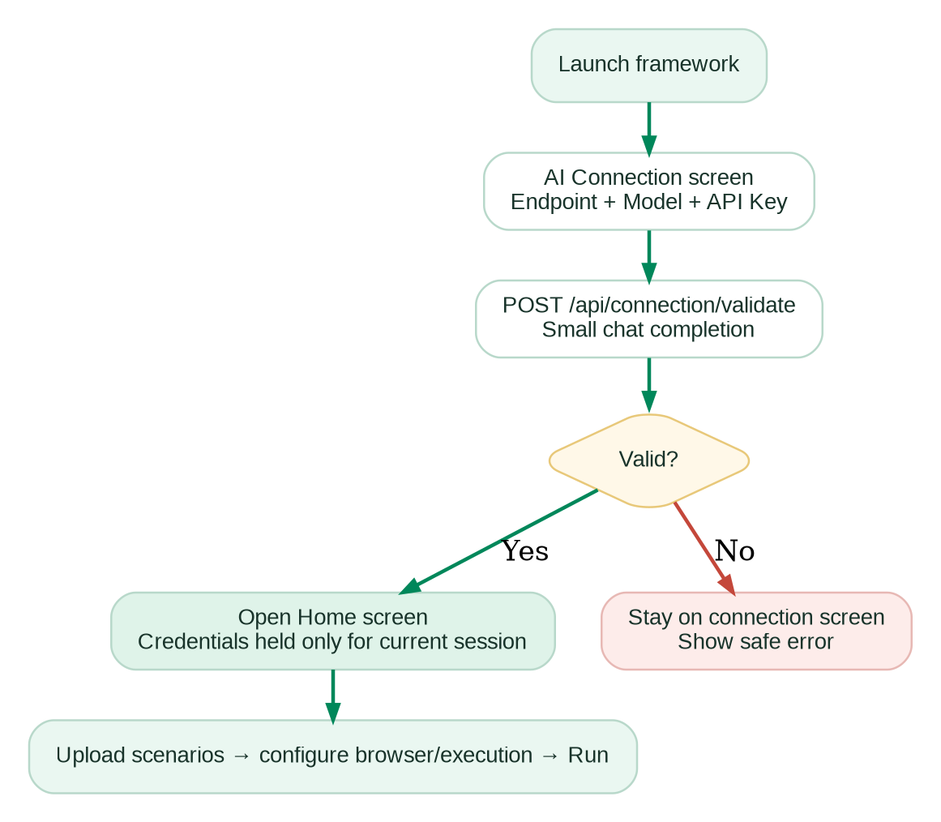
Figure 4 — AI connection validation flow.

7.1 Required inputs
- Endpoint — http:// or https:// OpenAI-compatible base URL.
- Model — model identifier to send in the chat-completions request.
- API key — sent as a Bearer token for validation and subsequent LLM calls.

7.2 Validation behavior
- The browser posts endpoint, model and API key to POST /api/connection/validate.
- LlmClient normalizes the base URL to /chat/completions when necessary.
- A minimal chat-completion request is sent with temperature 0 and max_tokens 8.
- Connect timeout is 10 seconds; read timeout is 30 seconds.
- Home opens only when the response contains an OpenAI-compatible choices[0].message.content value.
Condition | User-visible behavior
401 / 403 | API key was rejected by the endpoint.
404 | Endpoint or model route was not found.
400 | Endpoint rejected the model or request format.
Invalid URL | Endpoint must be a valid http:// or https:// URL.
Non-compatible payload | Endpoint responded but no compatible chat completion was returned.
Success | Home opens and shows only Connected / Endpoint / Model. The API key is hidden.

Secret scope The key is not written to application.properties, generated reports or status messages. It still exists in the current browser page state and in-memory RunConfig while the run is active; this is not a dedicated enterprise secret vault.

8. User interface and end-to-end workflow
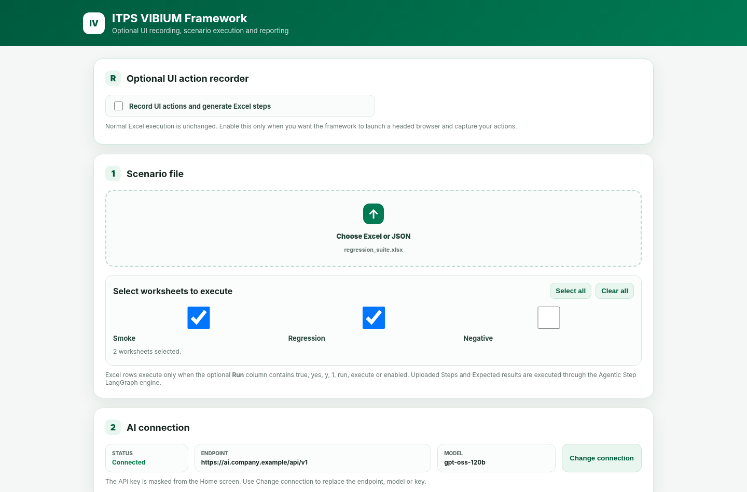
Figure 5 — Home screen: recorder, scenario file and connected-model summary.
- Launch the Spring Boot application.
- Validate the AI endpoint, model and API key.
- Optionally use the UI recorder or upload an Excel/JSON scenario file.
- For Excel, select one or more worksheets.
- Choose the browser and optional custom zoom.
- Configure execution mode, parallel pool, screenshots, timeout, healing attempts, reruns and cookie options.
- Click Run tests.
- Monitor live KPIs and scenario status.
- Rerun selected scenarios if required.
- Download reports, screenshots and MCP diagnostics.

8.1 Home-screen sections
Section | Purpose
Optional UI action recorder | Starts a headed recording session and converts interactions into reusable steps.
Scenario file | Upload Excel/JSON and select worksheets.
AI connection | Displays validated endpoint/model and offers Change connection.
Browser | Browser selection, automatic maximize, optional custom zoom.
Execution | Headless, isolation/parallelism, evidence, healing, screenshots, timeouts, reruns and cookies.
Results | Live progress, per-scenario status, manual rerun and artifact buttons.

9. Scenario files and test data

9.1 Supported formats
- Excel: .xlsx / .xls.
- JSON: array of scenarios or an object with a scenarios array.

9.2 Typical Excel fields
Field | Purpose
ID / Test ID | Scenario identifier.
Name / Scenario | Human-readable scenario name.
URL | Application or starting URL.
Steps | Instruction list or step columns.
Expected Result | Expected behavior used for validation/reporting.
Run | Optional row filter.
TestDataJson / TestData / Data | JSON object merged into the scenario data map.
data.someKey | Adds someKey to scenario data.

9.3 Data substitution
Before execution, placeholders are resolved from scenario data. Both {{key}} and ${key} styles are supported. This allows a single action definition to be reused with different accounts, users, amounts or environment-specific values.
Example steps:
Enter "{{username}}" in "User ID"
Enter "{{password}}" in "Password"
Click "Sign in"
Verify text "Welcome ${displayName}"

9.4 Direct MCP JSON
A step may also contain an explicit MCP call. This is useful when the author wants deterministic tool selection rather than natural-language planning.
{"tool":"browser_click","arguments":{"selector":"button[data-testid=submit]"}}

10. Browser and execution modes
Mode | Browser lifecycle | Parallel? | Best fit
Shared browser | One browser reused for all scenarios; sequential | No | Stateful/login-dependent suites where scenarios share session and cookies.
Separate browser per test | New direct Vibium stdio process + browser per scenario | No | Independent tests needing hard browser isolation.
Parallel browser pool | Fixed 2/3/4 direct MCP/browser workers reused across the queue | Yes | Independent scenarios where bounded concurrency is desired.

Shared-browser mode uses the localhost TCP bridge. Separate-browser and parallel modes bypass the bridge and launch direct Vibium stdio processes, which avoids the bridge client limit and ITPS_BRIDGE_BUSY-style contention during concurrency.
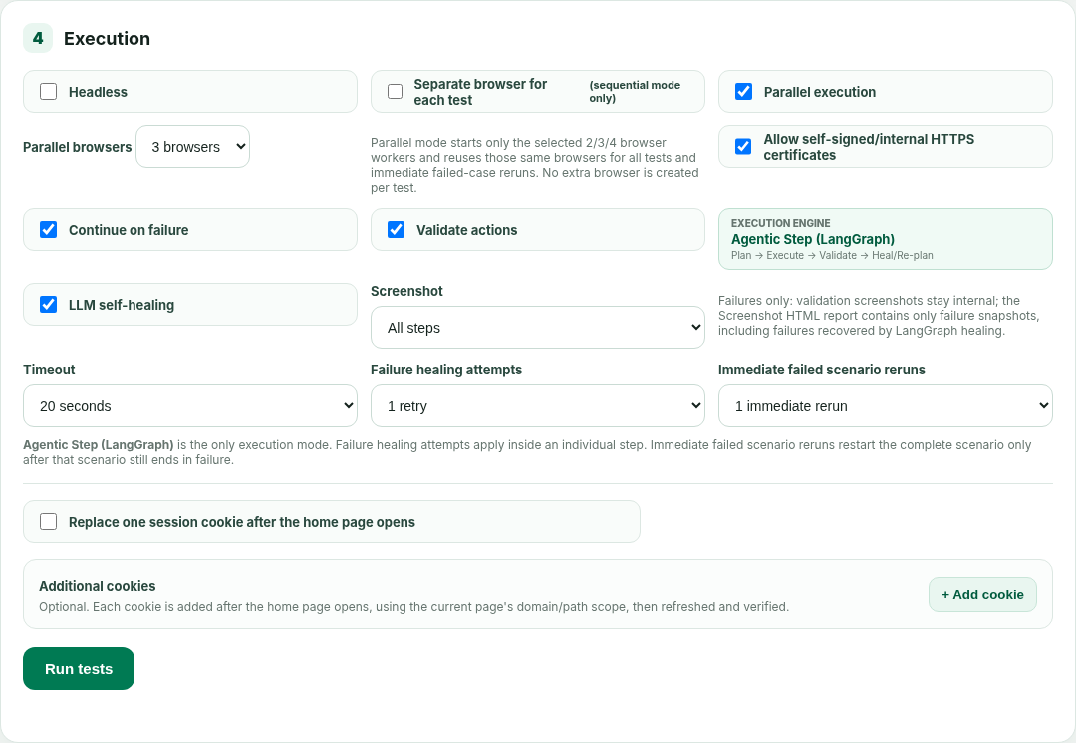
Figure 6 — Execution configuration in the current UI.

11. Parallel browser pool
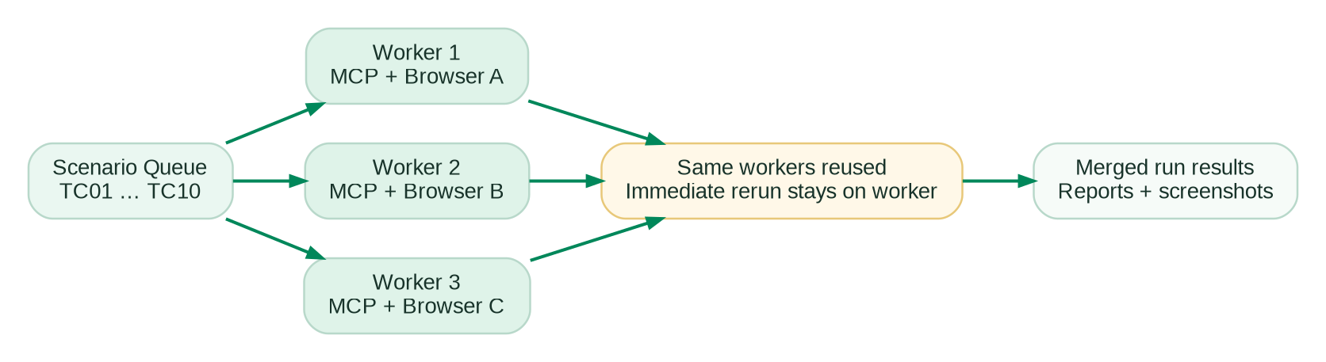
Figure 7 — Fixed worker pool and same-worker scenario rerun behavior.

11.1 Design
- Pool size is explicitly selected as 2, 3 or 4 browsers and is bounded by scenario count.
- Each worker owns an MCP process/client and browser for its lifetime.
- Workers pull scenarios from the queue and are reused until the queue is empty.
- An immediate failed-scenario rerun executes on the same worker/browser that ran the failed attempt.
- No extra browser is created for every scenario.
Why this was changed Earlier per-test browser creation increased startup cost and could make parallel tests appear slow or create unnecessary browser/process churn. The current pool design keeps concurrency bounded and predictable.

12. Agentic Step (LangGraph4j)
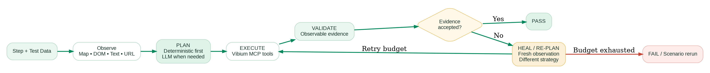
Figure 8 — Current per-step state machine.
All uploaded browser steps run through AgenticActionGraph. LangGraph4j owns orchestration, while the existing deterministic executors, LLM adapter and MCP implementation remain responsible for action resolution, reasoning and browser calls.

12.1 State flow
- Observe current browser/page evidence.
- Plan the step, preferring deterministic strategies.
- Execute the selected Vibium MCP call(s).
- Validate observable evidence.
- If validation fails, create a fresh observation and heal/re-plan.
- Stop when evidence passes or the configured budget is exhausted.

12.2 Retry levels
Control | Scope
Failure healing attempts / retryCount | Retries an individual failed step inside the LangGraph flow.
Immediate failed scenario reruns | Restarts the complete scenario after the scenario still ends in FAILED.
maxAgentTurns | Safety ceiling for total graph turns.

13. Deterministic execution and selector strategy
The framework does not send every action to the LLM. It intentionally preserves high-confidence deterministic behavior before using general agent planning.
Priority | Strategy | Examples
1 | Explicit XPath / CSS | Resolve exact locator against current DOM.
2 | Focused-input / visible-text executors | Fill the active input or click exact visible text.
3 | Enterprise dropdown executor | Open control once, re-read live DOM, select option and verify.
4 | Vibium page map / semantic references | Use current mapped refs and accessible names.
5 | LLM planning | Used when the instruction requires interpretation or deterministic methods do not apply.

Benefit Recorder-generated and hand-authored exact locators are not needlessly reinterpreted by the model, reducing latency and unnecessary token usage.

13.1 Known DOM boundaries
- Open shadow roots and same-origin frames may be inspected where supported.
- Closed shadow roots remain inaccessible to page JavaScript.
- Cross-origin frame internals are constrained by browser security boundaries.
- Canvas-only controls, CAPTCHA and native OS dialogs may require custom automation support.

14. Self-healing and validation

14.1 Healing behavior
- Failure triggers a fresh page observation rather than reusing stale state.
- Healing input includes DOM/page model, ranked candidates, clickable ancestors, visibility/hit-test details and the previous failed plan.
- The healing prompt explicitly requires a materially different safe strategy and forbids inventing elements not present in the observation.
- Healing plans include a confidence value; the framework applies the configured threshold.
- Self-healing never calls browser_start.

14.2 Evidence validation
A successful MCP method call is not sufficient proof of success. Depending on the step, validation may inspect the current URL, DOM, target value/state, visible content or screenshot evidence. A step can therefore fail validation even when the underlying click/fill/select command returned without an error.
Evidence type | Typical use
URL/navigation | Confirm route/page transition.
DOM / element state | Confirm target exists, enabled/checked/selected or changed.
Visible text | Confirm success message, label, status or expected content.
Input/select value | Confirm typed or selected value actually applied.
Screenshot evidence | Support visual/structural change checks and failure investigation.

15. Cookie and session handling

15.1 Replace one session cookie
- Navigate successfully to the resolved home URL.
- Read current URL and browser cookies using native MCP cookie/storage tools.
- Find the configured cookie name; if duplicates exist, choose the best domain/path match.
- Copy attributes supported by the active set-cookie tool schema.
- Remove cookies, restore the selected cookie with the replacement value, refresh/re-navigate and verify the new value.
- If setting fails after clearing, attempt rollback using the original value.

15.2 Additional cookies
Up to ten new name/value pairs may be added without clearing existing cookies. Existing names are rejected to avoid silent overwrite. Scope is copied from a suitable current-page cookie or derived from the current URL, then the page is refreshed once and all new cookies are verified.
Privacy Replacement and additional cookie values are intentionally redacted from framework reports and MCP transcripts.

Capability requirement The cookie workflow depends on native cookie-capable MCP tools. If they are absent, normal test execution still works when cookie setup is disabled.

16. UI action recorder
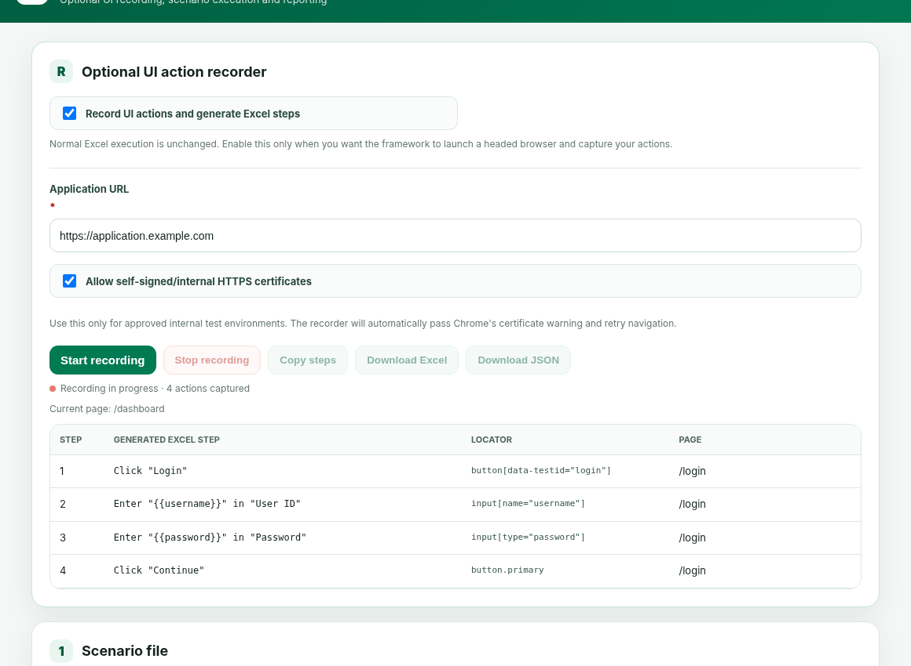
Figure 9 — Optional UI recorder in the current Home screen.

16.1 Recorder flow
- Enable Record UI actions and generate Excel steps.
- Enter the mandatory application URL.
- Optionally allow approved self-signed/internal certificates.
- Start recording in a headed browser.
- Interact with the application.
- Review generated step text, locator and page.
- Delete unwanted actions if required.
- Copy steps or export recorded Excel / JSON.

16.2 Recorded interaction types
- Click
- Typing/fill
- Select/dropdown
- Checkbox
- Keyboard actions
- Upload actions

17. Browser maximize, zoom and platform behavior
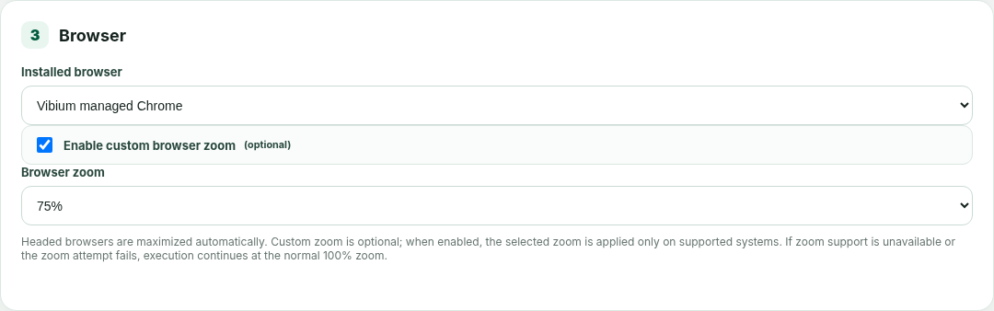
Figure 10 — Browser selection and optional custom zoom.

17.1 Automatic maximize
Headed browser sessions are maximized automatically through the available framework/Vibium window-control path. This is independent of the custom zoom option.

17.2 Optional zoom
- Custom zoom is OFF by default.
- 100% is the default and causes no native zoom processing.
- When enabled, users can choose 50, 67, 75, 80, 90, 100, 110, 125, 150, 175 or 200 percent.
- Unsupported or failed zoom does not fail the test run; execution continues at 100%.

17.3 Platform matrix
Platform | Browser discovery | Custom zoom | Fallback
Windows | Vibium-managed Chrome plus installed Chrome/Edge/Chromium discovery | Native attempt when PowerShell/pwsh and WScript are usable | 100% if unsupported/fails
macOS | Vibium-managed browser path expected; installed-browser discovery is not fully implemented | Not currently implemented | 100%
Linux | Vibium-managed browser path expected; installed-browser discovery is not fully implemented | Not currently implemented | 100%

Known gap BrowserDiscoveryService currently probes Windows filesystem locations. Cross-platform installed-browser discovery should be added before broad macOS/Linux rollout.

18. Reporting and diagnostics
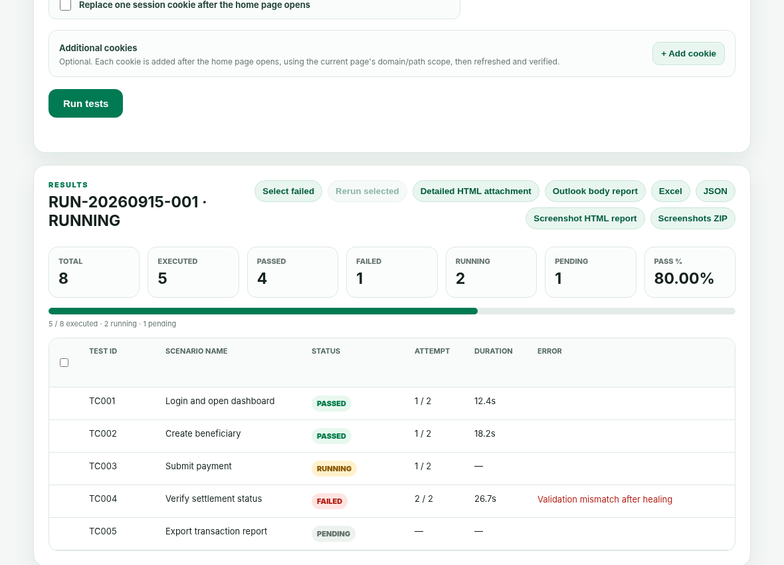
Figure 11 — Live execution results and artifact actions.

18.1 Generated run artifacts
Artifact | Purpose
report.html | Detailed standalone attachment report.
outlook-report.html | Compact Outlook-safe body report; summary + up to 25 scenarios.
report.xlsx | Excel execution/attempt report.
report.json | Machine-readable complete result.
screenshots-report.html | Standalone screenshot report with embedded images.
screenshots.zip | Screenshot archive.
mcp-tools.json | Manifest of exposed MCP tool schemas.
mcp-transcript.json | Redacted JSON-RPC request/response trace.
mcp-process.log | MCP/bridge process diagnostics.
mcp-sessions/ | Per-browser isolated-session diagnostics when applicable.

18.2 Live status
The UI displays Total, Executed, Passed, Failed, Running, Pending and Pass Percentage, plus a progress bar and per-scenario status. Scenario rows include attempt count, duration and error detail. Manual rerun can target failed or individually selected scenarios.

19. REST API reference
Method | Endpoint | Purpose
GET | /api/browsers | Discover browser options.
POST | /api/connection/validate | Validate endpoint/model/key.
POST | /api/runs/sheets | Discover worksheets in an uploaded Excel file.
POST | /api/runs | Start a run using multipart configuration + scenario file.
POST | /api/runs/{runId}/rerun | Rerun selected scenarios.
GET | /api/runs/{runId} | Get current run status.
GET | /api/runs/{runId}/report.html | Detailed HTML report.
GET | /api/runs/{runId}/outlook-report.html | Outlook body report.
GET | /api/runs/{runId}/report.xlsx | Excel report.
GET | /api/runs/{runId}/report.json | JSON report.
GET | /api/runs/{runId}/screenshots-report.html | Screenshot HTML report.
GET | /api/runs/{runId}/screenshots.zip | Screenshot ZIP.
GET | /api/runs/{runId}/mcp-tools.json | MCP tool manifest.
GET | /api/runs/{runId}/mcp-transcript.json | MCP transcript.
GET | /api/runs/{runId}/mcp-process.log | MCP process log.
POST | /api/recorder/start | Start recorder session.
GET | /api/recorder/{sessionId} | Get recorder status/actions.
POST | /api/recorder/{sessionId}/stop | Stop recorder.
GET | /api/recorder/{sessionId}/recorded-steps.xlsx | Download recorded Excel.
GET | /api/recorder/{sessionId}/recorded-actions.json | Download recorded JSON.

20. Security model
Area | Current behavior | Residual consideration
AI API key | Validated at startup; not written to properties/reports/status; hidden after connection. | Exists in browser page memory and in-memory run configuration while active.
Endpoint/model | User supplied at runtime and validated. | Only OpenAI-compatible chat-completion shape is supported.
Cookies | Sensitive values redacted from reports/transcript. | Still transmitted to the browser/MCP tool by design.
TLS | Optional self-signed certificate recovery for approved internal environments. | Must not be enabled blindly for untrusted sites.
Framework UI | Designed as a local tool. | No built-in RBAC/login or multi-user isolation.
Artifacts | Stored under target output directories. | Retention/access policy should be defined for shared environments.

20.1 Recommended enterprise hardening
- Add framework authentication/RBAC before shared-server deployment.
- Move AI keys/tokens to a vault, OS keychain or short-lived server-side session token.
- Define artifact retention and access controls.
- Redact additional environment-specific secrets from logs.
- Use HTTPS/reverse proxy if the framework is exposed beyond localhost.

21. Build, deployment and runtime

21.1 Prerequisites
- Java 17 or later.
- Maven for source build.
- Vibium installed globally, available through VIBIUM_MCP_COMMAND, or under tools/vibium-portable.
- Node.js for the local TCP bridge used by shared-browser mode and recorder.
- Network access to the application under test and configured LLM endpoint.

21.2 Build commands
Windows:
build-windows.cmd
macOS/Linux:
chmod +x build-mac.sh
./build-mac.sh
Direct Maven:
mvn clean package

21.3 Runtime configuration
server.port=8090
runner.output-dir=target/itps-vibium-runs
recorder.output-dir=target/itps-vibium-recordings
itps.vibium.mcp.mode=external-tcp
itps.vibium.mcp.host=127.0.0.1
itps.vibium.mcp.port=8765
itps.vibium.mcp.command=auto
itps.vibium.mcp.args=mcp

Shared-browser execution and the recorder use the local bridge. Separate-browser and parallel execution launch direct Vibium stdio processes and do not use port 8765.

22. Demonstration guide
Recommended duration 8–10 minutes for the full demo, or 4–5 minutes for a condensed stakeholder demo.

Time | Demo action | What to explain
00:00 | Launch application | Spring Boot local web application.
00:30 | AI connection | Enter endpoint/model/key; show failed validation once, then success.
01:30 | Upload scenarios | Choose Excel and select Smoke + Regression sheets.
02:30 | Browser/execution | Managed Chrome, optional zoom, 3-browser parallel pool, screenshots, healing and rerun count.
03:30 | Run tests | Show worker browsers and live progress.
05:00 | Healing example | Trigger one safe action/locator failure and show recovery attempt.
06:30 | Results | Show KPIs, scenario attempts and manual rerun.
07:30 | Reports | Open detailed report, screenshot report and MCP transcript.
09:00 | Recorder | Record a short flow and export Excel/JSON.

22.1 Suggested demo narrative
“The framework starts by validating the AI model connection. After that, the user loads Excel or JSON tests, chooses browser/session behavior and executes. The Java layer always prefers deterministic selectors where possible. LangGraph coordinates planning, execution, validation and bounded healing. Parallel mode uses a fixed browser pool. Every run produces live status, reports, screenshots and MCP diagnostics.”

23. Automated tests and release validation
Source inspection of the current package shows 13 test classes containing 45 @Test methods. This document records source coverage; it does not claim that all tests have been executed in every target environment.
Test area | Coverage examples
AgenticActionGraphTest | Graph planning/recovery behavior.
ItpsMcpRunnerParallelTest | Fixed browser-pool reuse and same-worker rerun behavior.
LlmClientConnectionValidationTest | Successful validation, rejected key without secret leakage, invalid URL.
BrowserZoomConfigTest | Optional zoom defaults/configuration.
CookieSessionManagerTest | Cookie replacement/addition/safety behavior.
EnterpriseDropdownExecutorTest | Custom dropdown flow.
FocusedInputExecutorTest | Focused-input actions.
LiveXPathActionExecutorTest | XPath resolution/action behavior.
InsecureCertificateRecoveryTest | Internal/self-signed interstitial recovery.
RecorderExportServiceTest / RecorderPromptFormatterTest | Recorder output and prompt formatting.
ReportServiceAttachmentTest | Standalone report / screenshot attachment rules.
McpToolCatalogTest | MCP capability/tool handling.

23.1 Recommended release gate
mvn clean test
# or
mvn clean package

- Fail the build on unit-test failure.
- Run at least one real headed smoke scenario with the target Vibium build.
- Run one shared-browser suite and one parallel-pool suite.
- Validate report generation and redaction before release.
- Test AI connection errors using invalid key/model/endpoint.

24. Troubleshooting
Symptom | Checks / action
Home does not open | AI endpoint/model/key validation failed. Check URL, authentication, model name and OpenAI-compatible response shape.
Parallel run is slow before tests start | Confirm custom zoom is disabled unless required and verify no unsupported native window operation is being attempted. Current code bypasses zoom work when disabled/100%.
Parallel test appears hung | Check MCP child processes, timeouts and worker shutdown. Unit test has a timeout guard for the historical native-zoom regression.
Browser not detected | Use Vibium Managed Chrome; installed-browser discovery is Windows-oriented and also depends on the active browser_start schema.
Zoom remains 100% | Custom zoom is optional. It is currently Windows-native only and requires usable PowerShell/pwsh + WScript. Unsupported systems intentionally stay at 100%.
Cookie setup fails | Inspect mcp-tools.json and confirm native cookie tools/schema are exposed. Disable cookie workflow if not required.
Self-healing repeats bad locator | Inspect transcript and observation. The current healing prompt forbids repeating the same strategy; confirm the deployed JAR matches the latest source.
No screenshots | Check screenshot mode and whether the active Vibium MCP exposes screenshot capability.
Shared-browser bridge busy | Separate/parallel modes should use direct stdio and bypass port 8765; for shared mode ensure the bridge is correctly started and not locked by a stale client.

25. Current limitations / missed areas
Gap | Current state | Impact
Cross-platform installed-browser discovery | BrowserDiscoveryService probes Windows locations. | macOS/Linux users should prefer Vibium-managed browser until discovery is extended.
Cross-platform custom zoom | Native custom zoom is Windows-only. | macOS/Linux remain at 100%; test execution still works.
Persistent run history | RunStore uses in-memory state. | Live run metadata disappears after restart, although generated artifact files remain.
Framework authentication | No application-level RBAC/login. | Local usage is appropriate; shared-server rollout needs hardening.
Secret vault | No Key Vault/Keychain integration. | API key is runtime-only but still present in browser/in-memory state.
Provider abstraction | OpenAI-compatible /chat/completions only. | Non-compatible providers require an adapter.
Distributed execution | No remote worker/grid scheduler. | Parallel capacity is limited to the local host.
Native/browser security boundaries | Closed shadow roots, CAPTCHA, OS dialogs, canvas-only UIs and cross-origin internals remain difficult. | May require custom integration.
Documentation drift | Some older README text still describes earlier parallel behavior. | Update README so the fixed browser pool is the single documented model.
Video artifact | Vibium supports additional recording features upstream, but this framework does not expose video recording. | Optional future enhancement.

26. Recommended roadmap

26.1 Priority 1 — stability and portability
- Update stale README sections to match the fixed 2/3/4-browser pool.
- Add macOS/Linux installed-browser discovery.
- Create a platform-neutral BrowserDisplayController abstraction for maximize/zoom, or keep custom zoom strictly optional with no native dependency.
- Add CI workflow that runs mvn clean test/package on every change.
- Add integration smoke tests against a known test site and current Vibium release.

26.2 Priority 2 — enterprise hardening
- Persist run history and metadata in SQLite/Postgres.
- Add authentication/RBAC and per-user run ownership.
- Integrate a secret vault or issue short-lived server-side AI connection tokens.
- Define artifact retention and audit policies.
- Add structured application logging/metrics.

26.3 Priority 3 — scale and intelligence
- Remote/distributed workers.
- Model routing: separate economical planner, validator and healer models.
- Token/cost/latency telemetry.
- Optional video artifact.
- Persistent app-map/locator intelligence where it provides measurable value.

27. Appendices and references

27.1 Example scenario
[
{
"id": "LOGIN-001",
"name": "Open dashboard",
"url": "https://application.example.com",
"data": {"username":"test.user"},
"steps": [
"Enter "{{username}}" in "User ID"",
"Click "Continue"",
"Verify text "Dashboard""
]
}
]

27.2 Important output locations
target/itps-vibium-runs/<RUN-ID>/
report.html
outlook-report.html
report.xlsx
report.json
screenshots-report.html
screenshots.zip
mcp-tools.json
mcp-transcript.json
mcp-process.log
mcp-sessions/
target/itps-vibium-recordings/

27.3 Primary references
[1] Vibium official repository — VibiumDev/vibium
[2] Vibium WebDriver BiDi explanation — docs/explanation/webdriver-bidi.md
[3] Current ITPS source package — Vibium08_ai_connection_gate_updated.zip (project source supplied in the working session).
Source note: Vibium product statements in Sections 2–3 are based on the official Vibium repository; implementation statements are based on the current ITPS source package inspected for this document.

