ITPS VIBIUM
Framework
User Guide & Technical Documentation
Browser automation powered by Vibium MCP, Agentic Step (LangGraph4j), deterministic action executors, self-healing, session controls, recording and auditable reporting.

Document scope This guide is based on the current uploaded source package. Where older markdown notes differ from the current implementation, the implementation behavior is documented here.

Application | ITPS VIBIUM Framework
Runtime | Java 17 / Spring Boot 3.2.6
Automation runtime | Vibium MCP
Agent orchestration | LangGraph4j 1.8.24

Contents
1. Executive overview
2. What the framework supports
3. Architecture and execution model
4. Prerequisites and installation
5. Starting the framework
6. User interface guide
7. Preparing test scenarios
8. Execution modes
9. Agentic Step and self-healing
10. Browser behavior and zoom
11. Cookie/session management
12. UI action recorder
13. Running, monitoring and rerunning tests
14. Reports and artifacts
15. Configuration and API reference
16. Troubleshooting
17. Security and operational guidance
18. Known limitations
19. Quick-start checklist
Appendix A. Example scenarios
Appendix B. Status definitions

1. Executive overview
ITPS VIBIUM Framework is a Spring Boot web application that allows teams to record browser actions, upload Excel or JSON test scenarios, execute those scenarios through Vibium MCP, validate each action using observable browser evidence, automatically heal eligible failures, and produce detailed execution reports.
The framework is designed for low-code and AI-assisted UI automation while preserving deterministic execution where a test already contains reliable XPath, CSS, exact-text, focused-input, dropdown or explicit MCP instructions. LangGraph4j coordinates each test step through a bounded plan–execute–validate–heal state machine; it does not replace the underlying Vibium browser actions.

Primary objectives
- Reduce the amount of handwritten browser-automation code required for functional UI tests.
- Allow business-readable test steps to coexist with deterministic locator-driven steps.
- Provide controlled LLM-assisted planning and self-healing instead of unrestricted browser actions.
- Support session-sharing, isolated browsers, and efficient parallel browser pools.
- Generate reports suitable for detailed analysis, email summaries, Excel/JSON consumption, and screenshot review.
- Keep MCP diagnostics and recovery history available for troubleshooting and auditability.

Typical end-to-end flow
- Prepare or record test scenarios in Excel/JSON.
- Start the Vibium runtime path required by the selected execution mode.
- Open the framework UI and configure LLM, browser and execution options.
- Upload scenarios and select Excel worksheets if applicable.
- Run tests; the UI shows live test status and counters.
- Allow Agentic Step to validate actions and perform bounded healing when enabled.
- Review the HTML/Excel/JSON/screenshot reports and rerun selected failed scenarios when required.

2. What the framework supports
Area | Capability | Status
Scenario input | Excel (.xlsx/.xls) and JSON; multi-sheet selection; optional Run filtering | Implemented
Data-driven execution | data.* columns, TestDataJson/TestData/Data JSON, {{key}} and ${key} substitution | Implemented
Browser execution | Vibium-managed Chrome plus compatible discovered browsers | Runtime-dependent
Shared session | One browser for the complete sequential run | Implemented
Separate browser | Fresh browser/MCP process per scenario in sequential mode | Implemented
Parallel pool | Fixed 2–4 browser/MCP workers reused across the scenario queue and immediate reruns | Implemented
Agentic Step | LangGraph4j plan → execute/validate → heal/re-plan | Only execution engine
Self-healing | Bounded re-planning using current browser evidence and confidence threshold | Optional
Recorder | Click, typing, selection, checkbox, keyboard and upload capture | Implemented
Cookies | Replace one existing session cookie; add up to 10 new cookies; verify after refresh | Optional / Vibium-tool dependent
HTTPS recovery | Controlled handling of standard Chrome privacy interstitials | Optional
Screenshots | All steps, failures only, or none; standalone screenshot report and ZIP | Implemented when screenshot tool exists
Reruns | Immediate full-scenario reruns plus manual selected-test reruns | Implemented
Reports | Detailed HTML, Outlook HTML, Excel, JSON, screenshot HTML/ZIP, MCP diagnostics | Implemented

3. Architecture and execution model
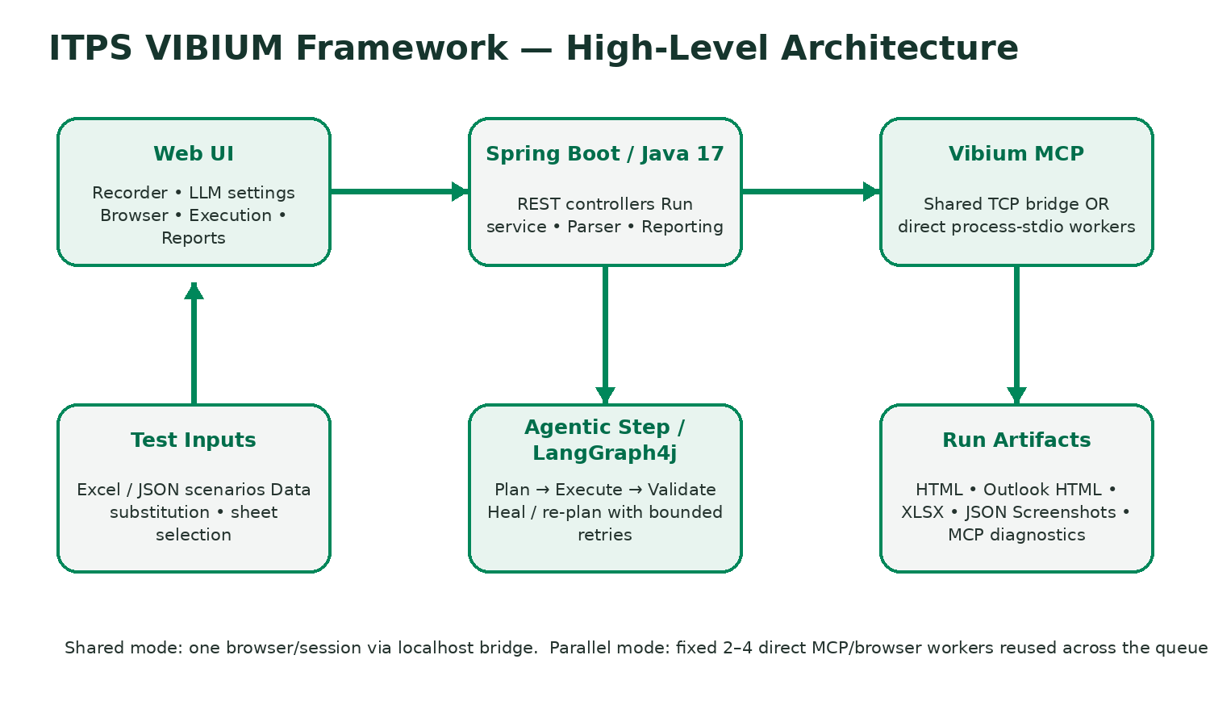

Core components
Component | Responsibility
Web UI | Static HTML/CSS/JavaScript user interface for scenario upload, configuration, recorder controls, live status, reruns and artifact access.
RunController / RecorderController | REST endpoints for starting runs, sheet discovery, status, rerun, report downloads, recorder lifecycle and exports.
ScenarioFileParser | Parses Excel/JSON, filters rows, merges data, normalizes steps, and makes duplicate IDs unique across selected sheets.
ItpsMcpRunner | Main browser-execution engine that manages sessions/workers, deterministic actions, Agentic Step integration, cookies, evidence and retries.
AgenticActionGraph | LangGraph4j state graph that owns per-step orchestration and bounded recovery.
LlmClient | OpenAI-compatible /chat/completions client used for natural-language planning and healing.
McpClient / MCP Tool Catalog | Discovers available Vibium tools and selects compatible browser, action, cookie, screenshot and evaluation operations.
ReportService | Generates detailed HTML, Outlook-safe HTML, Excel, JSON and screenshot artifacts.
UI Recorder Service | Captures browser interactions and exports generated Excel/JSON steps.

MCP transport by execution mode
Mode | MCP mode | Connection | Browser lifecycle
Shared browser | external-tcp | 127.0.0.1:8765 local MCP bridge | One shared browser/session
Separate browser per test | process-stdio | Direct vibium mcp child process | New browser for each sequential scenario
Parallel execution | process-stdio | Fixed direct worker processes | 2–4 browsers reused across the queue
Important Parallel execution does not use the localhost bridge and does not create a new browser for every scenario. It creates only the selected 2, 3, or 4 browser workers (bounded by scenario count), then reuses them for the entire queue and immediate failed-scenario reruns.

4. Prerequisites and installation

Required runtime
- Java 17 or later.
- Node.js (required to install/run Vibium and to operate the localhost bridge).
- Vibium installed either under tools/vibium-portable or available on PATH.
- Network access to the application under test.
- Network access to the configured LLM endpoint when natural-language planning/healing is required.
Maven is required to build the source package but is not required to run an already-built executable JAR.

Install Vibium in the portable project location
cd tools
mkdir vibium-portable
cd vibium-portable
npm init -y
npm install vibium@latest
Windows verification:
tools\vibium-portable\node_modules\.bin\vibium.cmd --help
macOS/Linux verification:
tools/vibium-portable/node_modules/.bin/vibium --help

Build the application
mvn clean package
The Spring Boot executable is generated under target/. The current project POM uses artifactId itps-vibium-mcp-framework and Java 17.

5. Starting the framework

Shared-browser mode or recorder
Start the local MCP bridge first and keep it running for the duration of the shared-browser run or recorder session.
Windows:
start-local-mcp-windows.cmd
macOS/Linux:
./start-local-mcp-mac.sh
The default bridge binds to 127.0.0.1:8765. Its maxClients setting does not control parallel-mode capacity because parallel mode bypasses the bridge.

Separate-browser or parallel mode
Do not start the bridge solely for these modes. The framework launches direct Vibium stdio child processes using itps.vibium.mcp.command=auto, which resolves the portable executable first and then PATH.

Start the Spring Boot JAR
java -jar target/itps-vibium-mcp-framework-1.0.0.jar --spring.config.additional-location=optional:file:./config/application-local.properties
Open the UI at: http://localhost:8090
Port change If port 8090 is unavailable, change server.port in config/application-local.properties and restart the JAR.

6. User interface guide
UI section | Purpose
Optional UI action recorder | Enable recorder, enter application URL, allow internal HTTPS if required, start/stop recording, copy steps, download Excel or JSON.
Scenario file | Upload .xlsx, .xls or .json. Excel uploads expose worksheet selection and Select all / Clear all controls.
LLM configuration | Base URL, model, and token for an OpenAI-compatible chat-completions endpoint.
Browser | Select the available browser. Headed execution is maximized. Custom zoom can be enabled from 50% to 200%.
Execution | Headless, separate-browser sequential mode, parallel mode, internal HTTPS, continue-on-failure, action validation, self-healing, screenshot mode, timeout, healing attempts and immediate scenario reruns.
Cookie setup | Optionally replace one existing session cookie and/or add up to 10 new cookies.
Run / results | Start execution; view total/executed/pass/fail/running/pending counters; select failed tests; rerun selected; open/download reports.

LLM configuration details
The LLM client appends /chat/completions to the configured Base URL unless that suffix is already present. The request uses the selected model, low temperature (0.05), and Bearer authentication when a token is supplied. If no model is provided, the current code falls back to gpt-oss-120b.
LLM requirement Deterministic XPath/CSS/explicit MCP actions can execute without requiring LLM planning where supported. Natural-language steps that cannot be resolved deterministically require a reachable LLM endpoint.

7. Preparing test scenarios

Excel format
Header | Meaning
Id | Test identifier. If blank, the parser generates a TC-style ID.
Name | Scenario display name. Defaults to Id when blank.
Url | Absolute URL or a path resolved against the configured application base URL.
Steps | One step per line or separated using |.
Expected | Optional expected result; included in Agentic Step verification flow.
Run | Optional execution filter. Accepted values: true, yes, y, 1, run, execute, enabled.
TestDataJson / TestData / Data | JSON object merged into scenario data.
data.someKey | Adds someKey directly into the scenario data map.
When multiple worksheets are selected, scenarios are combined. Duplicate test IDs are made unique using the source sheet name and, when necessary, an additional suffix.

Data substitution
Scenario data can be referenced inside steps using either {{key}} or ${key}. This allows the same step text to consume per-row data values.

Example Excel row
Id | Name | Url | Steps | Expected | Run | data.username
LOGIN-001 | Valid login | /login | Type "{{username}}" into username | Click "Sign in" | Dashboard | yes | test.user

JSON format
[
{
"id": "LOGIN-001",
"name": "Open the dashboard",
"url": "https://app.example.test/home",
"steps": [
"Click \"Sign in\"",
"Type \"{{username}}\" into the username field"
],
"expected": "Dashboard",
"data": { "username": "test.user" }
}
]
An object containing a top-level scenarios array is also accepted.

8. Execution modes

Mode 1 — One browser for all tests (default)
- Leave Separate browser for each test unchecked.
- Leave Parallel execution unchecked.
- Tests execute sequentially in one browser.
- Cookies, storage, tabs and login/session state can continue between scenarios.
- The localhost bridge is required.
- Use this mode when later tests intentionally depend on earlier session/application state.

Mode 2 — Separate browser for each test (sequential)
- Enable Separate browser for each test while Parallel execution remains off.
- Each scenario gets a new direct Vibium MCP process and a fresh browser.
- Scenarios still execute one at a time.
- Cookie replacement/additional-cookie setup is performed independently for each scenario browser.
- The localhost bridge is not used.

Mode 3 — Parallel execution with fixed browser pool
- Enable Parallel execution.
- The UI disables Separate browser for each test because parallel mode owns the browser lifecycle.
- Choose 2, 3 or 4 parallel browsers.
- The framework starts at most that many worker MCP/browser sessions, bounded by scenario count.
- Workers pull scenarios from a shared queue and are reused until the queue is complete.
- An immediate failed-scenario rerun is executed by the same worker/browser that ran the failed attempt; no extra browser is opened for that rerun.
- A worker startup failure is isolated; remaining workers continue to consume work where possible.

Which mode should I use?
Need | Recommended mode
Tests depend on the same login/session | Shared browser
Each test must start clean, but concurrency is unnecessary | Separate browser per test
Tests are independent and speed matters | Parallel 2–4 browser pool
Machine has limited CPU/RAM | Shared or separate sequential
Cookie injection must be isolated per test | Separate sequential or parallel pool

9. Agentic Step and self-healing
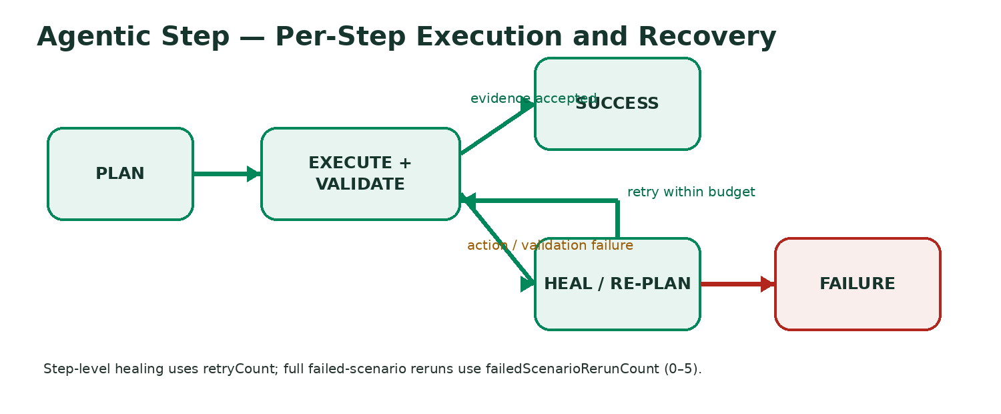
Agentic Step is always enabled by the backend in this implementation. LangGraph4j owns orchestration; Vibium MCP remains responsible for actual browser operations.

Deterministic priority
- Explicit JSON MCP calls.
- Explicit XPath or CSS resolved against the current DOM.
- Focused-input execution for active/target input interactions.
- Exact visible-text handling.
- Enterprise/custom dropdown transaction handling.
- Natural-language planning through the LLM when a deterministic path is not sufficient.

Validation model
A successful MCP response alone is not enough when Validate actions is enabled. The framework checks observable evidence such as URL changes, DOM state, target state, visible content, page map/text, or screenshots depending on the action and available tools.

Healing model
- Capture a fresh page/DOM observation after failure.
- Rank current candidates instead of trusting the failed locator.
- Ask the healing planner for a materially different safe strategy.
- Reject healing below the configured confidence threshold.
- Repeat only within the configured step-level healing budget.
- Never allow the healing planner to start a new browser.

Two retry levels
Setting | Scope
Failure healing attempts (retryCount) | Retries/re-plans the individual failed step. UI currently exposes 0, 1 or 2 attempts.
Immediate failed scenario reruns (failedScenarioRerunCount) | Reruns the complete failed scenario after step-level recovery is exhausted. UI supports 0–5 reruns.

10. Browser behavior and zoom

Maximize behavior
Headed browsers are automatically maximized. The framework prefers Vibium browser-window state when available, can pass start-maximized launch arguments when supported, and includes a Windows native fallback for older Vibium builds.

Custom browser zoom
Custom zoom is opt-in and disabled by default. Supported UI choices are 50%, 67%, 75%, 80%, 90%, 100%, 110%, 125%, 150%, 175% and 200%. When enabled, the framework resets to 100% and applies native Chrome zoom steps using browser key support where available.
- When custom zoom is disabled, no zoom capability probe is performed.
- If the platform cannot safely apply custom zoom, execution continues at normal 100% instead of failing the test.
- The enabled flag and selected zoom are preserved for reruns.
- Zoom is re-applied after navigation/state-changing actions as needed.
- The recorder uses the same optional zoom approach.

11. Cookie and session management

Replace one existing session cookie
Use this when an application creates a cookie after navigation but the test must replace its value while preserving the cookie identity/scope exposed by the installed MCP schema.
- Read current browser cookies before making changes (storage-state preferred; cookie-list fallback).
- Find the exact configured cookie name and select the best domain/path match when duplicates exist.
- Copy attributes supported by the active set-cookie schema.
- Clear cookies only after the target cookie has been found.
- Restore the matched cookie name with the new UI value.
- Refresh/reload the page.
- Read cookies again and verify the exact name/value pair.
Safety behavior If the named cookie does not exist, the framework fails before clearing cookies. If restoring the replacement fails after clearing, it attempts to restore the original selected cookie value. Cookie values are redacted from reports/diagnostics.

Add new cookies
- Use + Add cookie to define one or more new name/value pairs.
- Up to 10 additional cookie rows are supported.
- Existing names are rejected to prevent silent overwrites.
- Current domain/path scope is reused or derived from the current URL.
- Existing cookies are preserved; only the new cookies are added.
- The page refreshes once and every new pair is verified.
- The replacement-cookie name cannot also be used as an additional-cookie name.
When both features are enabled, replacement occurs first and additional-cookie injection occurs afterward.

12. UI action recorder
The optional recorder opens a headed browser and captures supported user interactions so they can be converted into reusable test steps.

Recorder workflow
- Enable Record UI actions and generate Excel steps.
- Enter the mandatory Application URL.
- Choose whether internal/self-signed HTTPS handling is allowed.
- Click Start recording.
- Perform the desired browser actions.
- Stop recording.
- Review/copy the generated steps or delete unwanted recorded actions.
- Download recorded-steps.xlsx or recorded-actions.json.

Captured action categories
The current recorder supports click, typing/input, selection, checkbox, keyboard and upload-style actions when the installed Vibium runtime exposes the required evaluation/action tools.
Recorder output is stored under target/itps-vibium-recordings/.

13. Running, monitoring and rerunning tests

Starting a run
- Upload the scenario file.
- For Excel, select one or more worksheets.
- Configure LLM, browser, execution, screenshot and cookie settings.
- Click Run tests.

Live run status
Every selected scenario is published immediately and the UI polls the run-status endpoint. Counters show total, executed, passed, failed, running, pending and pass percentage. The scenario grid also shows current status, attempt, duration and error information.

Manual rerun of selected tests
- After execution, click Select failed or manually select scenario checkboxes.
- Click Rerun selected.
- The framework reuses the run configuration snapshot held in memory.
- Review the updated artifacts and status.
Runtime note Rerun configuration snapshots are held in application memory. They do not survive a framework restart.

14. Reports and generated artifacts
Artifact | Purpose
report.html | Detailed standalone attachment report with scenarios, full attempts, steps, evidence, LangGraph/healing history and filtering. It intentionally contains no links to Outlook or screenshot artifacts.
outlook-report.html | Compact Outlook-safe body report with summary and up to 25 scenario rows.
report.xlsx | Spreadsheet-oriented execution results.
report.json | Machine-readable execution results.
screenshots-report.html | Standalone screenshot gallery with Base64-embedded images and filters for All, Failed, Passed, Healed, Rerun plus free-text search.
screenshots.zip | Downloadable screenshot archive.
mcp-tools.json | Tool manifest discovered from the MCP runtime.
mcp-transcript.json | Redacted MCP JSON-RPC transcript.
mcp-process.log | MCP process / bridge execution log.
mcp-sessions/ | Per-worker/per-browser diagnostics for direct-process execution.
report-generation.log | Report-generation diagnostics when produced.
Run artifacts are stored under:
target/itps-vibium-runs/<RUN-ID>/

Screenshot modes
Mode | Behavior
ALL | Passed and failed reportable step screenshots appear in the screenshot report.
FAILURE_ONLY | Only failure snapshots are exposed. A pre-healing failure image is retained even when the step later heals successfully.
NONE | No reportable screenshots are rendered in the screenshot HTML report.

15. Configuration and API reference

Key application properties
spring.application.name=ITPSVibiumFramework
server.port=8090
runner.output-dir=target/itps-vibium-runs
recorder.output-dir=target/itps-vibium-recordings
itps.vibium.mcp.mode=external-tcp
itps.vibium.mcp.host=127.0.0.1
itps.vibium.mcp.port=8765
itps.vibium.mcp.connect-timeout-seconds=10
itps.vibium.mcp.request-timeout-seconds=90
itps.vibium.mcp.command=auto
itps.vibium.mcp.args=mcp
itps.vibium.skip-browser-download=true
The framework also loads config/application-local.properties during the supplied startup script/command. VIBIUM_MCP_COMMAND can override the executable resolution for direct-process execution.

Main REST endpoints
Endpoint | Purpose
POST /api/runs/sheets | Discover worksheets from an uploaded Excel file.
POST /api/runs | Create and start a test run from multipart form data.
GET /api/runs/{runId} | Read the current run status.
POST /api/runs/{runId}/rerun | Rerun selected scenarios from an existing in-memory run snapshot.
GET /api/runs/{runId}/report.html | Detailed HTML report.
GET /api/runs/{runId}/outlook-report.html | Outlook-safe HTML report.
GET /api/runs/{runId}/report.xlsx | Excel report.
GET /api/runs/{runId}/report.json | JSON report.
GET /api/runs/{runId}/screenshots-report.html | Standalone screenshot report.
GET /api/runs/{runId}/screenshots.zip | Screenshot ZIP.
GET /api/runs/{runId}/mcp-tools.json | MCP tool manifest.
GET /api/runs/{runId}/mcp-transcript.json | MCP transcript.
POST /api/recorder/start | Start a recorder session.
GET /api/recorder/{sessionId} | Read recorder session status/actions.
POST /api/recorder/{sessionId}/stop | Stop recording.
DELETE /api/recorder/{sessionId}/actions/{sequence} | Remove a recorded action.
GET /api/recorder/{sessionId}/recorded-steps.xlsx | Download recorder Excel.
GET /api/recorder/{sessionId}/recorded-actions.json | Download recorder JSON.

16. Troubleshooting
Symptom | Checks / resolution
UI opens but tests do not start | Shared mode: confirm the bridge is running on 127.0.0.1:8765. Separate/parallel: confirm the Vibium executable is resolvable. Review mcp-process.log and mcp-transcript.json.
ITPS_BRIDGE_BUSY | Relevant only to shared-browser/recorder mode. If seen during direct-process modes, ensure an older JAR/UI is not still running.
Parallel workers fail to initialize | Verify portable Vibium with --help, reduce browser count, and inspect worker diagnostics under mcp-sessions/.
Vibium command not found | Check tools/vibium-portable/node_modules/.bin, PATH, VIBIUM_MCP_COMMAND, and bridge command paths.
Cookie setup fails | Verify exact cookie name, current page scope, and presence of native cookie tools in mcp-tools.json.
Selected installed browser rejected | The installed Vibium browser_start schema may not accept an executable/channel. Use Vibium Managed Chrome for Testing.
Internal HTTPS page blocked | Enable the option only for an approved test environment and only when the page is a standard Chrome privacy interstitial.
LLM API key rejected | Verify the endpoint is an OpenAI-compatible /chat/completions service, the token is valid for that endpoint, the model name is accepted, and the base URL is correct.
Port 8090 already used | Change server.port in config/application-local.properties and restart.

17. Security and operational guidance
- Use self-signed/internal HTTPS bypass only for systems you are authorized to test.
- Do not hard-code long-lived LLM tokens, production credentials or session-cookie values in scenario files.
- Cookie replacement/additional-cookie values are redacted by the framework, but generated artifacts and logs should still be treated as test-environment data.
- Use parallel execution only for scenarios that are safe to run concurrently and do not modify the same shared business record in conflicting ways.
- Use shared-browser mode deliberately because state, storage and authentication can carry from one scenario into the next.
- Review mcp-transcript.json and mcp-tools.json when diagnosing automation behavior; they provide a stronger audit trail than screenshots alone.
- Keep the framework and Vibium runtime updated together and regression-test key deterministic actions after runtime upgrades.

18. Known limitations
- The source archive does not itself embed a Vibium executable or browser runtime.
- Parallel capacity is intentionally limited to four browsers and is constrained by workstation CPU and memory.
- Shared-browser execution is deliberately sequential to prevent browser-state races.
- Native cookie APIs are required for safe cookie replacement; JavaScript cannot fully emulate secure cookie semantics.
- Installed-browser selection depends on what the active Vibium browser_start schema supports.
- Closed shadow roots, canvas-only controls, CAPTCHA, native OS dialogs and inaccessible cross-origin-frame internals may need custom handling outside normal Agentic Step automation.
- Application-specific anti-automation controls can block otherwise valid browser actions.
- Rerun snapshots are in memory and are lost when the framework restarts.
- Custom browser zoom is best-effort and intentionally non-fatal when platform support is unavailable.

19. Quick-start checklist
☐ Java 17+ installed and available from the terminal.
☐ Node.js installed.
☐ Vibium installed under tools/vibium-portable or available on PATH.
☐ Scenario Excel/JSON file prepared.
☐ If using shared mode or recorder: local MCP bridge started.
☐ Framework JAR started and UI opened on localhost:8090.
☐ Excel worksheets selected (when applicable).
☐ LLM base URL/model/token configured when natural-language planning is needed.
☐ Execution mode selected: shared, separate sequential, or parallel fixed pool.
☐ Cookie options configured only when required.
☐ Screenshot mode and retry settings reviewed.
☐ Run started and live status monitored.
☐ Artifacts reviewed after completion.
☐ Failed scenarios rerun only after checking whether the failure is environmental or functional.

Appendix A. Example scenarios

Natural-language example
Id: SEARCH-001
Name: Search customer
Url: /home
Steps:
Click the search icon
Type "{{customerId}}" into the search field
Click the matching customer result
Expected: Customer details page is displayed
Data: {"customerId":"C12345"}

Deterministic-style example
Click XPath //button[@data-testid='search']
Type "C12345" into CSS input[name='customerSearch']
Click exact visible text "C12345"
Verify text "Customer details" is visible
The exact deterministic syntax accepted by a runtime path depends on the runner’s step parser/executor logic and the available Vibium MCP tool schema. Recorder-generated steps are preferred when you want syntax aligned to the current implementation.

Appendix B. Status definitions
Status | Meaning
PENDING | Scenario has been accepted into the run but has not started.
RUNNING | Scenario is currently executing.
RERUNNING | A complete scenario rerun is currently executing.
PASSED | Scenario passed without needing a healed final classification.
PASSED_HEALED | Scenario completed successfully after step-level healing.
PASSED_AFTER_RERUN | Scenario failed an earlier full attempt but passed a later immediate rerun.
FAILED | Scenario remained failed after configured recovery/rerun behavior.

Document notes
This documentation describes the behavior observed in the current source package, including the fixed parallel browser-pool implementation. A local Maven test run could not be executed in the documentation environment because Maven was not installed there; this does not change the source-derived behavior described above.

