**DOCUMENTATION**

**USECASE-2**

*Age & Gender Prediction using Face Images*

Predicting the apparent age and gender from a picture is a very interesting problem from a technical point of view but can also be very useful when applied to better understand consumer segments or a user base for example. It can be used to infer the age or gender of a user and use this information to make personalized products and experiences for each user.

**Predicting apparent Age and Gender from face picture :** *Keras + Tensorflow*

In this Usecase, we will train a model to predict those attributes given a face picture.

### Data :

We use data from <https://www.openu.ac.il/home/hassner/Adience/data.html> which is a dataset of face photos in the wild that are labeled into 8 age groups (0–2, 4–6, 8–13, 15–20, 25–32, 38–43, 48–53, 60-) and into 2 gender classes.  
There are around 26,580 images (with missing labels in some cases) that are pre-split into 5 folds.

### Preprocessing :

Faces are cropped and aligned using this tool : <https://www.openu.ac.il/home/hassner/Adience/code.html#inplanealign>

### Data augmentation :

We use Random shift, Zoom, Horizontal Flip as a form of data augmentation to create synthetic examples used during training to improve the generalization of the model.

### Model :

We use a Res-Net architecture pre-trained on ImageNet :

Res-Net ( Deep Residual Networks ) are an architecture that reduces the under-fitting and optimization issues that occur in deep neural networks.

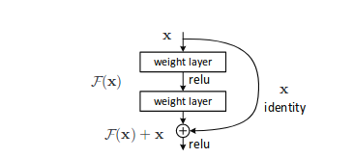

I have used Average Pooling instead of Max Pooling in this usecase because it gives better results here, since it was also written in many research papers that I have read.

I also used a pre-trained Weights .hdf5 file for the architecture of my model.

# Results :

We train the model 3 times for each fold and average the predictions and get the following results :  
 Gender : ‘M’ for Male and ‘F’ for Female  
 Age : As an integer value

**Prediction on my Face images :**

