* **What is Enterprise Service Bus? Discuss in details.(6 Marks)**

**Ans :**

An enterprise service bus moves data among multiple endpoints, both within and outside of an enterprise. It uses open standards to connect, transform, and route business documents (as Extensible Markup Language (XML) messages), among disparate applications. It enables monitoring and management of business data, with minimal impact on existing applications. An enterprise service bus is the underlying infrastructure for delivering a service-oriented architecture (SOA) and event-driven architecture (EDA).

"A style of integration architecture that allows communication via a common communication bus that consists of a variety of point-to-point connections between providers and users of services."

"An infrastructure that a company uses for integrating services in the application landscape."

"An architecture pattern that enables interoperability between heterogeneous environments, using service orientation." (Figure 1)

**1967697.jpg**

**Oracle Enterprise Service Bus Architecture**

As shown in [Figure 1-1](http://docs.oracle.com/cd/E11036_01/integrate.1013/b28212/intro_qs.htm#CHDBAJCG), Oracle Enterprise Service Bus consists of following components:

* **ESB Server**

The ESB Server is the server to which you register the ESB services that you have designed using JDeveloper ESB Designer and configured using the ESB Console. The ESB Server supports multiple protocol bindings including HTTP/SOAP, JMS, JCA, WSIF, and Java that ensure guaranteed, reliable message delivery using synchronous/asynchronous, request/reply or publish/subscribe models. However, ESB Server does not support Remote Method Invocation (RMI).

* **ESB Console**

The ESB Console provides a Web-based interface for managing, administering, and debugging services that you have registered with the ESB Server.

* **ESB Metadata Server**

The database that holds your ESB metadata such as schemas, transformations, and routing rules.

* **Oracle JDeveloper**

Oracle JDeveloper is a graphical and user-friendly way to model, edit, and design the services that comprise an Oracle Enterprise Service Bus system.

Figure 1-1 Oracle Enterprise Service Bus Architecture

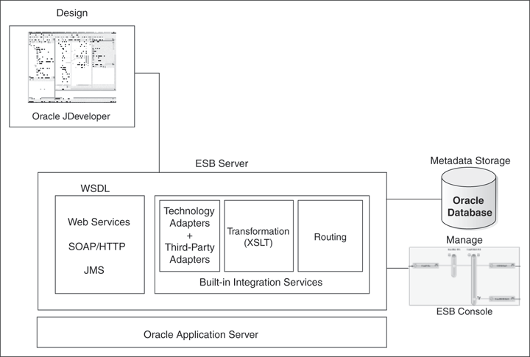

**Why use an ESB?**

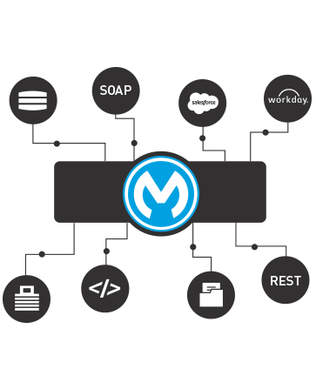

ESB Increasing organizational agility by reducing time to market for new initiatives is one of the most common reasons that companies implement an ESB as the backbone of their IT infrastructure. An ESB architecture facilitates this by providing a simple, well defined, "pluggable" system that scales really well. Additionally, an ESB provides a way to leverage your existing systems and expose them to new applications using its communication and transformation capabilities.

**Implementation**

The ESB architecture has some key principles that allow for business agility and scale. The key focus is to decouple systems from each other while allowing them to communicate in a consistent and manageable way.

* The "bus" concept decouples applications from each other. This is usually acheived using a messaging server like JMS or AMQP.
* The data that travels on the bus is a canonical format and is almost always XML.
* There is an "adapter" between the application and the bus that marshals data between the two parties.
* The adapter is responsible for talking to the backend application and transforming data from the application format to the bus format. The adapter can also perform a host of other activities such as message routing transaction management, security, monitoring, error handling, etc.
* ESBs are generally stateless; the state is embedded in the messages passing through the bus.
* The canonical message format is the contract between systems. The canonical format means that there is one consistent message format traveling on the bus and that every application on the bus can communicate with each other