* **What is Virtualization?**
* Virtualization allows multiple operating system instances to run concurrently on a single computer.
* It is a means of separating hardware from a single operating system.
* Each “guest” OS is managed by a Virtual Machine Monitor (VMM), also known as a hypervisor.
* The virtualization system sits between the guest and the hardware.
* It can control the guests’ use of CPU, memory, and storage, even allowing a guest OS to migrate from one machine to another.
* By using specially designed software, an administrator can convert one physical server into multiple virtual machines. Each virtual server acts like a unique physical device, capable of running its own operating system (OS).
* **Why use server Virtualization?**
* Consolidation
* Redundancy
* Segregation
* Legacy Hardware
* Migration

**CONSOLIDATION**

* It's common practice to dedicate each server to a single application.
* If several applications only use a small amount of processing power, the network administrator can combine several machines into one server running multiple virtual environments.
* For companies that have hundreds or thousands of servers, the need for physical space can decrease significantly.
* This saves on:
  + Cost : 10000$ maintenance cost per machine
  + Space: Less servers, less space needed
  + Energy: Savings by upto 80%
  + Environment: Reduced CO2 emissions due to decrease in number of servers

**REDUNDANCY**

* Server virtualization provides a way for companies to practice redundancy without purchasing additional hardware.
* Redundancy refers to running the same application on multiple servers. It's a safety measure -- if a server fails for any reason, another server running the same application can take its place.
* This minimizes any interruption in service.
* It wouldn't make sense to build two virtual servers performing the same application on the same physical server.
* If the physical server were to crash, both virtual servers would also fail.
* In most cases, network administrators will create redundant virtual servers on different physical machines.

**SEGREGATION**

* Virtual servers offer programmers isolated, independent systems in which they can test new applications or operating systems. Rather  
  than buying a dedicated physical machine, the network.
* Administrator can create a virtual server on an existing machine.
* Each virtual server is independent in relation to all the other servers, programmers can run software without worrying about affecting other applications.

**LEGACY HARDWARE**

* Server hardware will eventually become obsolete, and switching from one system to another can be difficult.
* In order to continue offering the services provided by these outdated systems – sometimes called legacy systems -- a network administrator could create a virtual version of the hardware on modern servers.
* From an application perspective, nothing has changed.
* The programs perform as if they were still running on the old hardware. This can give the company time to transition to new processes without worrying about hardware failures.
* Particularly if the company that produced the legacy hardware no longer exists and can't fix broken equipment.

**MIGRATION**

* An emerging trend in server virtualization is called migration.
* Migration refers to moving a server environment from one place to another.
* With the right hardware and software, it's possible to move a virtual server from one physical machine in a network to another.
* Originally, this was possible only if both physical machines ran on the same hardware, operating system and processor.
* It's possible now to migrate virtual servers from one physical machine to another even if both machines have different processors, but only if the processors come from the same manufacturer.
* **Types of Virtualization**
* Full Virtualization
* Para-Virtualization
* OS-level Virtualization

**Full Virtualization**

* Full virtualization uses a special kind of software called a hypervisor.
* The hypervisor interacts directly with the physical server's CPU and disk space. It serves as a platform for the virtual servers' operating systems.
* The hypervisor keeps each virtual server completely independent and unaware of the other virtual servers running on the physical machine.
* Each guest server runs on its own OS -- you can even have one guest running on Linux and another on Windows.

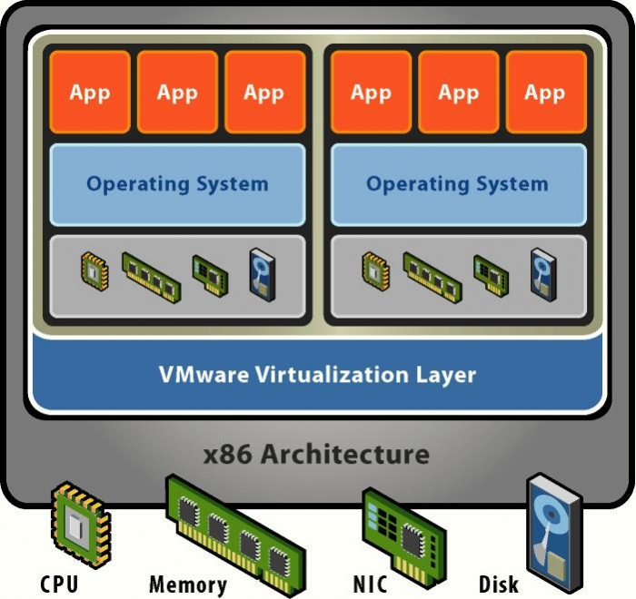

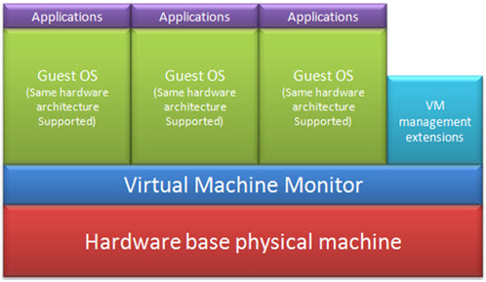

**Full Virtualization – Examples**

* Parallels Workstation , Parallel Desktop for Mac , VirtualBox , Virtual Iron , Oracle VM , Virtual PC , Virtual Server , Hyper-V , VMware Workstation , VMware Server , KVM , QEMU , Adeos , Mac-on-Linux , Egenera vBlade

**Para-Virtualization**

* The para-virtualization approach is a little different than the full virtualization technique.
* The guest servers in a para-virtualization system are aware of one another.
* A para-virtualization hypervisor doesn't need as much processing power to manage the guest operating systems.
* Each OS is already aware of the demands the other operating systems are placing on the physical server.
* The entire system works together as a cohesive unit.

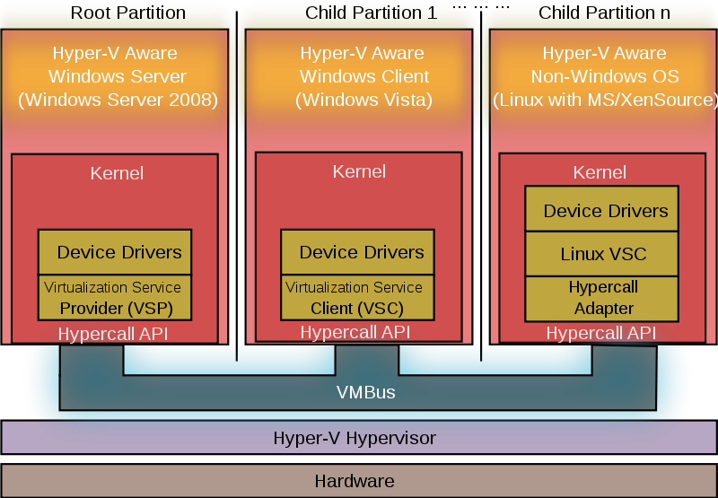

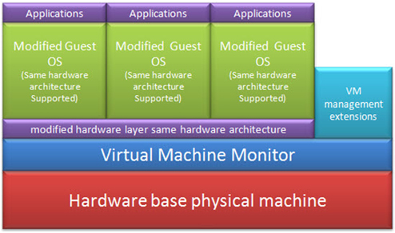

**Para-Virtualization – Examples**

* IBM's LPARs , Win4Lin 9x , Sun's Logical Domains , TRANGO , Xen

**OS-level Virtualization**

* An OS-level virtualization approach doesn't use a hypervisor at all.
* Instead, the virtualization capability is part of the host OS, which performs all the functions of a fully virtualized hypervisor.
* The biggest limitation of this approach is that all the guest servers must run the same OS.
* Each virtual server remains independent from all the others, but you can't mix and match operating systems among them. Because all the guest operating systems must be the same, this is called a homogeneous environment.

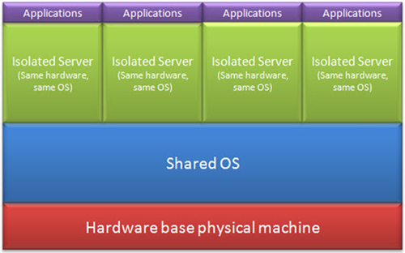

**OS-level Virtualization – Examples**

* Solaris Containers , OpenVZ , Linux-VServer , AIX Workload Partitions , Parallels Virtuozzo Containers , iCore Virtual Accounts

**Limitations of Virtualization**

* For servers dedicated to applications with high demands on processing power, virtualization isn't a good choice.
* It's also unwise to overload a server's CPU by creating too many virtual servers on one physical machine. The more virtual machines a physical server must support, the less processing power each server can receive.
* Another limitation is migration. Right now, it's only possible to migrate a virtual server from one physical machine to another if both physical machines use the same manufacturer's processor.
* **Cloud Computing and Virtualization** `
* Could Computing and Virtualization are related terms in resource optimization of IT infrastructure.
* Virtualization is a technology used in Cloud Computing concept.
* Virtualization is using the same hardware infrastructure to build several virtual servers as per the requirements and needs.
* Windows Server and Linux server for different purpose.
* **Virtualization with same H/W**

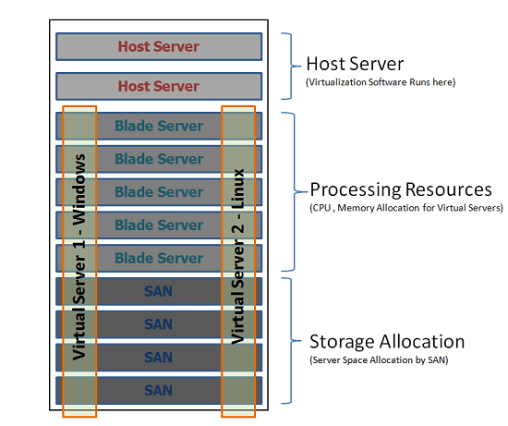

* Virtualization technique was introduced to achieve the optimized usage of hardware devices and reduce the maintenance burdens and related costs.
* **Virtualization techniques**
* **Soft Virtualization**
* Virtual sever with the same configuration as dedicated server, will give the exact performance what dedicated server can perform if required.
* **Hard Virtualization**
* Done by allocating dedicated resources when building the server.
* Branded servers only with the Pre OS.
* A physical partition of resources and will not achieve the maximum resource utilization.
* **Virtualization in Cloud Computing**
* CC concept is to deliver virtual servers with a specific configuration details with specific operating system, applications and services.
* The physical location of cores (Processors or computation power), software, data access and storage space is immaterial to the users.
* Cloud Computing uses the Virtualization technique in order to achieve its criteria.
* Cloud Computing is a collection of Virtualization Technique, SOA (Service Oriented Architecture), Autonomic and Utility Computing.
* **Difference Between Cloud Computing and Virtualization**
* Virtualization is a Technique but Cloud Computing is a Concept using Virtualization techniques.
* Virtualization could be done internally in on-site and the resource involvement except hardware still exists but whereas in Cloud Computing no internal resources will be required.