Page 1 of 19
Assignment – 4 (DBMS)

Krishna Pandey
(U20CS110)

1. Create a table Books library with fields.
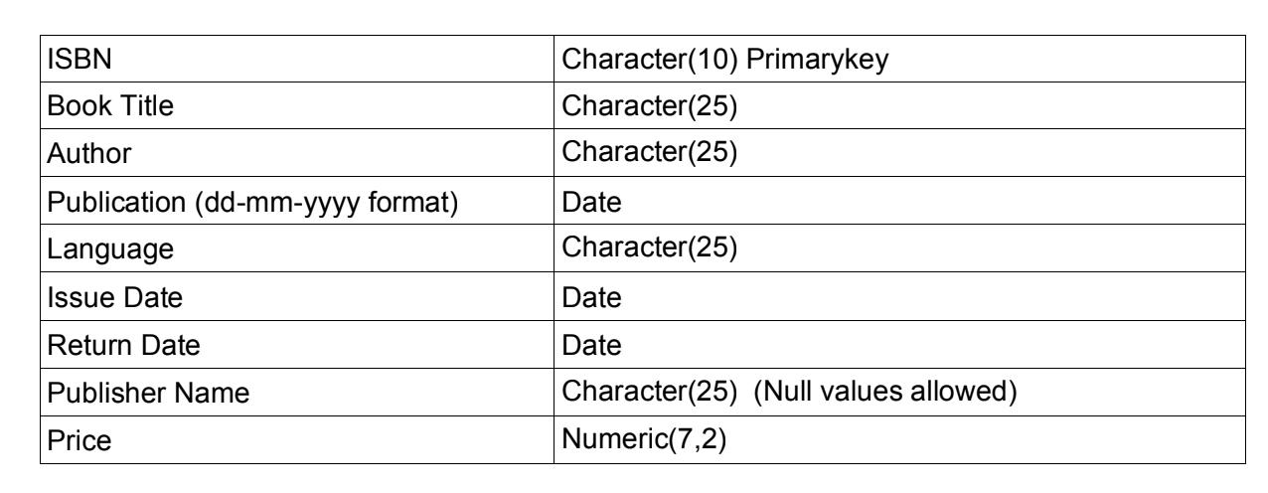

- Insert 10 Rows in the above created table for the books of subjects “DBMS” and “Computer Organization” written by single author. Consider your name and your father’s name in the author. Write SQL commands to display the following:

CODE :-

CREATE TABLE books


(
ISBN VARCHAR(10),

Book_Title VARCHAR(25),
Author VARCHAR(25),
Publication DATE,
Languaage VARCHAR(25),
Issue_Date DATE,

Return_Date DATE,
Publisher_Name VARCHAR(25) NULL,
Price DECIMAL(7,2),
PRIMARY KEY(ISBN)
);

Page 2 of 19

DESCRIBE books;


INSERT INTO books

VALUES('ISBN000001','F1_MERCEDES','DHAIRYA
OZA','2021-01-10','ENGLISH','2021-01-20','2021-01-27','TOTO',500);

INSERT INTO books

VALUES('ISBN000002','F1_REDBULL','DHAIRYA
OZA','2019-02-08','SPANISH','2019-02-20','2019-02-25','HORNER',575);

INSERT INTO books

VALUES('ISBN000003','F1_FERRARI','MV
OZA','2018-03-08','SPANISH','2019-03-20','2019-03-22','MATTIA',1000);

INSERT INTO books

VALUES('ISBN000004','F1_MCLAREN','MV
OZA','2017-04-08','SPANISH','2019-02-10','2017-04-15','BROWN',350);

INSERT INTO books

VALUES('ISBN000005','F1_ASTONMARTIN','DHAIRYA
OZA','2021-05-10','ENGLISH','2021-05-15','2021-05-25',NULL,450);

INSERT INTO books

VALUES('ISBN000006','F1_ALPINE','DHAIRYA
OZA','2021-06-05','ENGLISH','2021-06-15','2021-06-20',NULL,650);

INSERT INTO books

VALUES('ISBN000007','F1_TOROROSSO','DHAIRYA
OZA','2021-07-05','ENGLISH','2021-07-13','2021-07-17',NULL,950);

INSERT INTO books

VALUES('ISBN000008','F1_WILLIAMS','DHAIRYA
Page 3 of 19

OZA','2021-08-15','ENGLISH','2021-08-17','2021-08-19','CLAIRE',1500);

INSERT INTO books

VALUES('ISBN000009','F1_HAAS','MV
OZA','2021-09-07','ENGLISH','2021-09-10','2021-09-14','GUNTHER',1800);

INSERT INTO books

VALUES('ISBN000010','F1_ALFAROMEO','MV
OZA','2021-10-05','ENGLISH','2021-10-15','2021-10-19','VASSEUR',999);

(1).All columns and rows.

SELECT * FROM books;
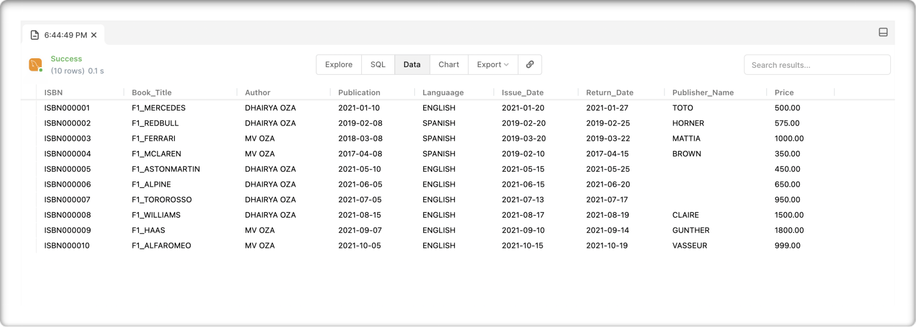
Page 4 of 19

(2).List of all rows in ascending order of price.

SELECT * FROM books

ORDER BY Price;
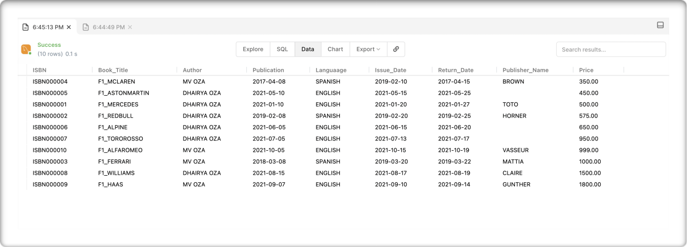

(3).Books details with columns ISBN and Book title only in descending order of Book title.


SELECT ISBN,Book_Title FROM books ORDER BY Book_Title DESC;
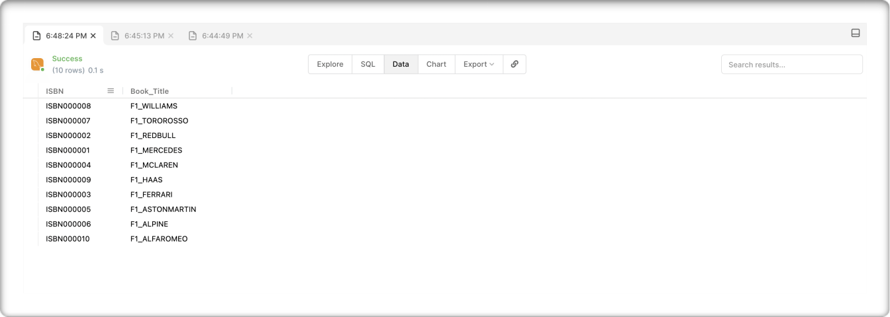
Page 5 of 19

(4).Display the maximum and minimum prices of books.

SELECT MAX(Price) as "Max Price",MIN(Price) as "Min Price" FROM books;
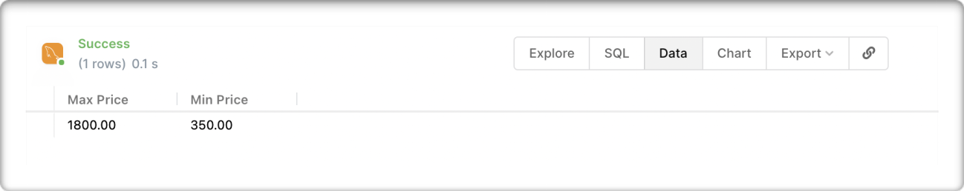

(5).Books details of all the books whose price is between 250 to700.

SELECT * FROM books WHERE Price BETWEEN 250 AND 700;
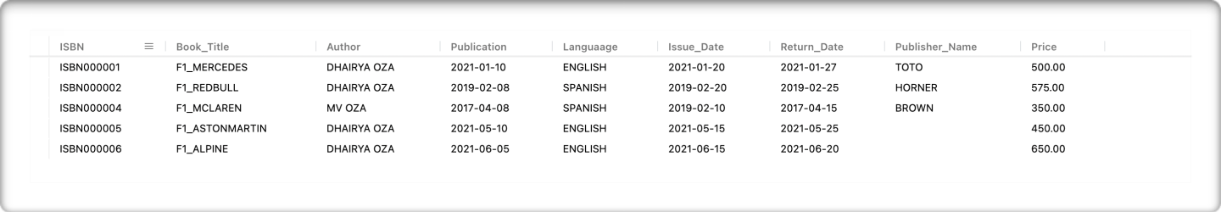

(6).Books details of all the books whose price is greater than 500.

SELECT * FROM books WHERE Price > 500;
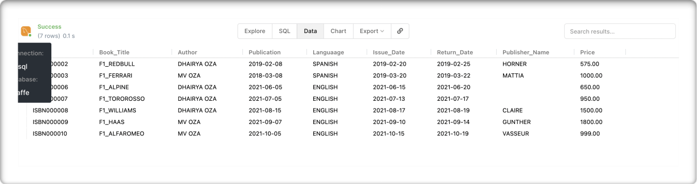
Page 6 of 19

(7).Count of books for the book title with “Computer” substring.

SELECT COUNT(*) AS "COUNT" FROM books WHERE Book_Title LIKE '%Computer%';
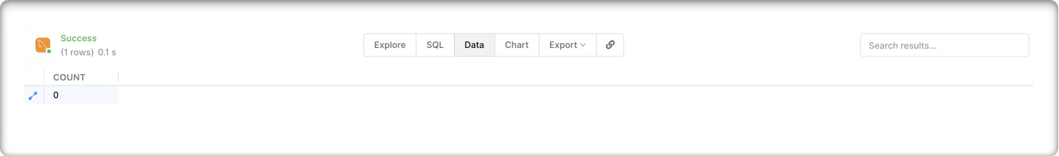

(8).Publication details of all the books whose Publication is after 1st jan2021.

SELECT * FROM books WHERE Publication > ‘2021-01-01';
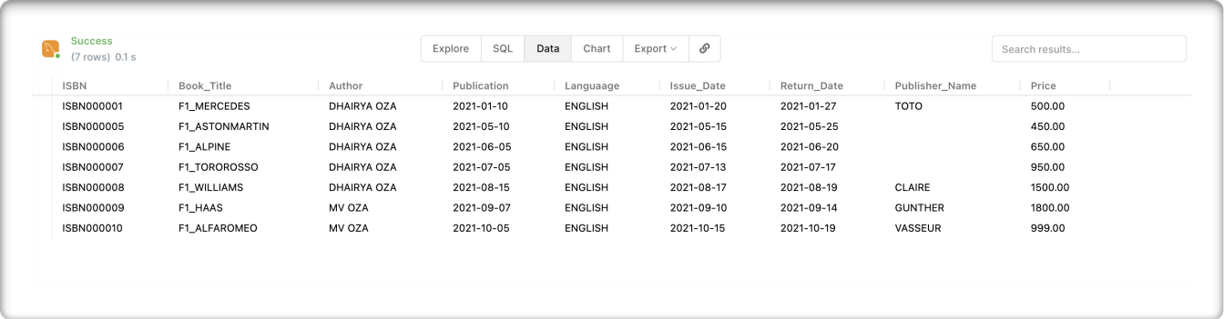

(9).Count of authors who have written books in other than the English language.

SELECT COUNT(*) AS "Count Non English" FROM books WHERE Languaage!='ENGLISH';
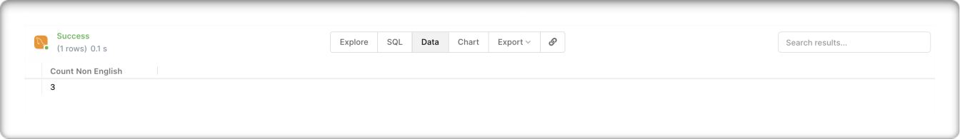
Page 7 of 19

(10).Details of books where publisher name is null.

SELECT * FROM books WHERE Publisher_Name IS NULL;
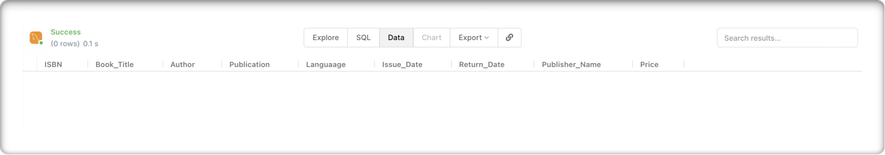

(11).Count of books whose publisher name is not null.

SELECT COUNT(*) AS "Name is not Null" FROM books WHERE Publisher_Name IS NOT NULL;
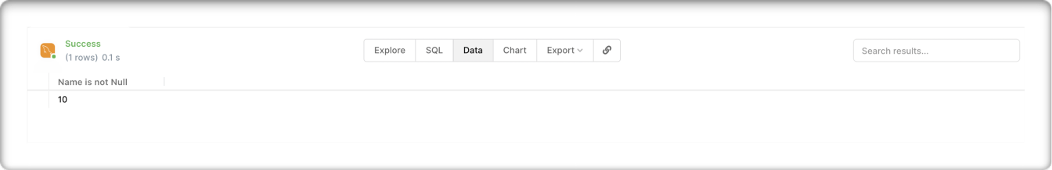

(12),Display the sum of price of all the books.

SELECT SUM(Price) AS "SUM OF ALL BOOKS" FROM books;
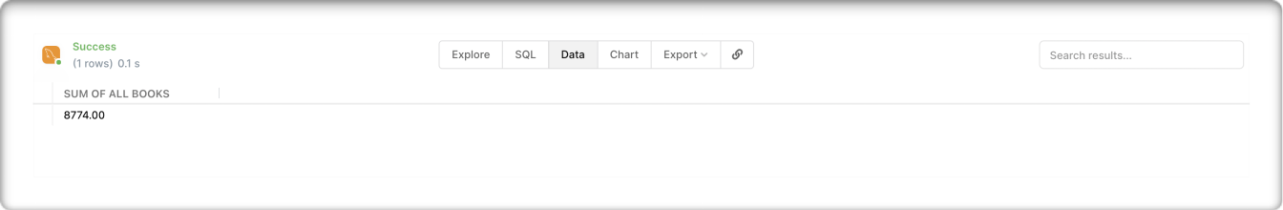
Page 8 of 19

(13).Count of books having price >250 and <1000.

SELECT COUNT(*) AS "Count Between 250 and 1000" FROM books WHERE Price BETWEEN 250 AND 1000;
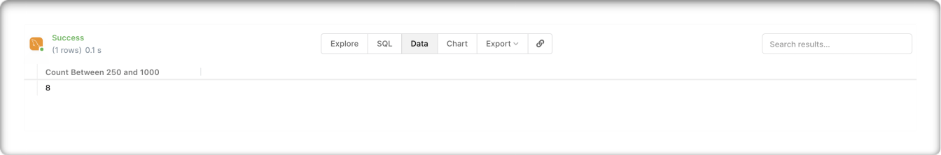

(14).Details of all the books whose author name is “Your name”.

SELECT * FROM books WHERE Author = "Dhairya Oza";
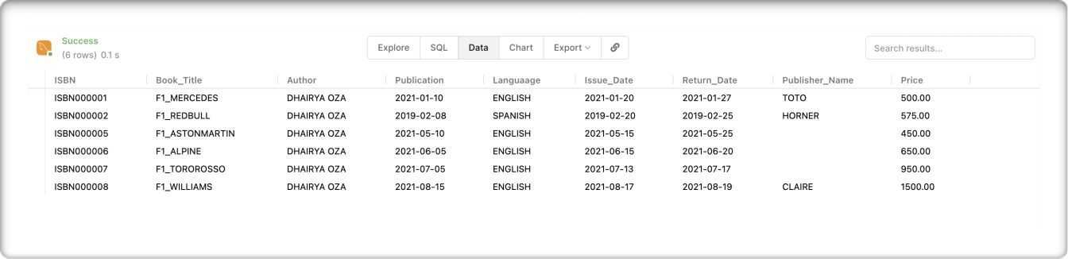

(15).Details of all the books whose author name is not “Your Father’s Name”.

SELECT * FROM books WHERE Author != "MV Oza";
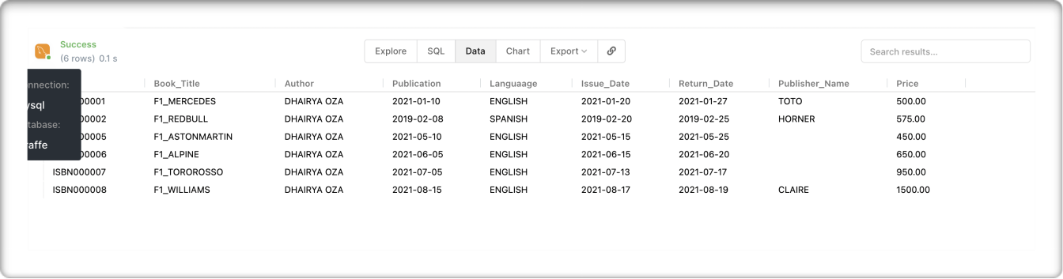
Page 9 of 19

2.Create a table Hospital Management with fields:
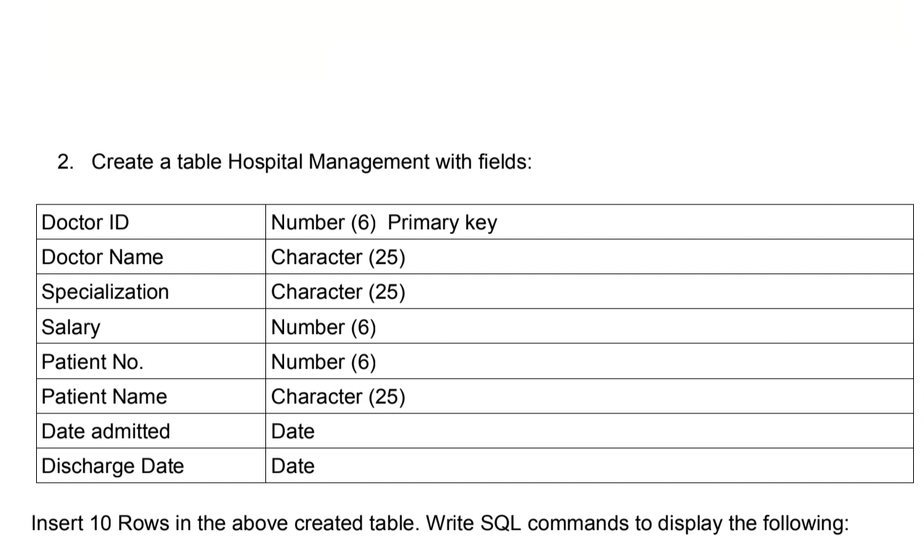

CODE :-


CREATE TABLE hospital


(
Doctor_Id NUMERIC(6) PRIMARY KEY NOT NULL, Doctor_Name VARCHAR(25), Specialization VARCHAR(25), Salary NUMERIC(6),


Patient_No NUMERIC(6),
Patient_Name VARCHAR(25),

Date_Admitted DATE,
Discharge_Date DATE

);
Page 10 of 19

DESCRIBE hospital;


INSERT INTO hospital VALUES

(1,'Dhairya','Covid-19',65000,1,'Krishna','2021-01 -06','2021-01-11');

INSERT INTO hospital VALUES

(2,'Payal','Covid-19',85000,2,'Aditya','2021-01-08 ','2021-01-13');


INSERT INTO hospital VALUES

(3,'Haimi','Omicron',200000,2,'Dairya','2020-11-11 ','2020-11-13');

INSERT INTO hospital VALUES

(4,'Jayshree','Delta',30000,2,'Harshvardhan','2021 -01-08','2021-01-14');

INSERT INTO hospital VALUES

(5,'Hiren','Gamma',50000,2,'Tanisha','2021-01-10', '2021-01-15');


INSERT INTO hospital VALUES

(6,'Gunjan','Omicron',100000,2,'Aarti','2021-01-11 ','2021-01-12');

INSERT INTO hospital VALUES (7,'Trisha','Blood Pressure',5000,2,'Suyog','2021-02-01','2021-02-11' );


INSERT INTO hospital VALUES

(8,'Delisha','Diabetes',45000,2,'Shivarth','2021-0 2-03','2021-02-12');
Page 11 of 19

INSERT INTO hospital VALUES

(9,'Ramesh','Cancer',150000,2,'Sanaskar','2021-03-08','2021-03-13');

INSERT INTO hospital VALUES

(10,'Suresh','Omicron',70000,2,'Laila','2021-03-08 ','2021-04-13');

(1).Hospital management table with all columns and rows.

SELECT * FROM hospital;
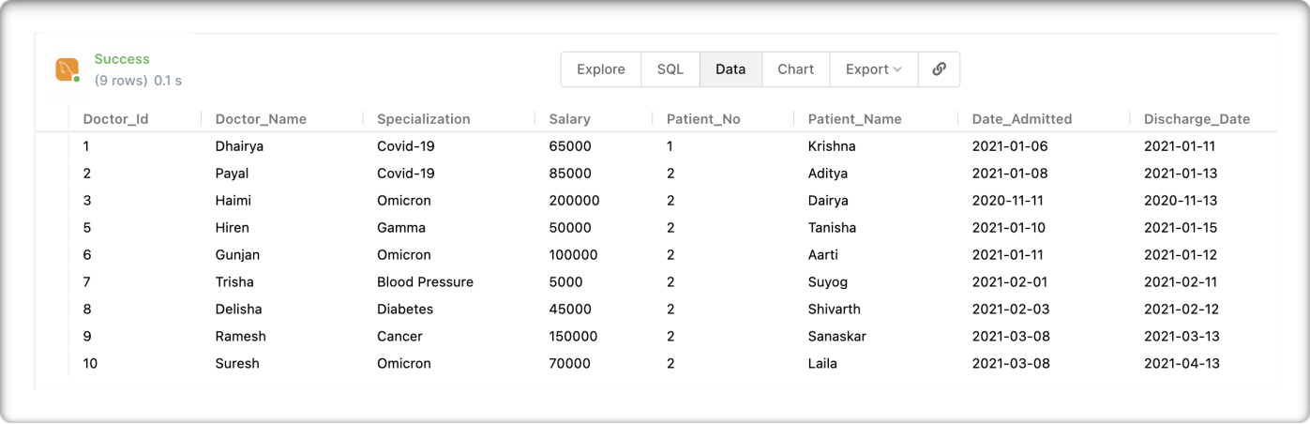

(2).Doctor details with columns ID and Name only.

SELECT Doctor_Id,Doctor_Name FROM hospital;
Page 12 of 19
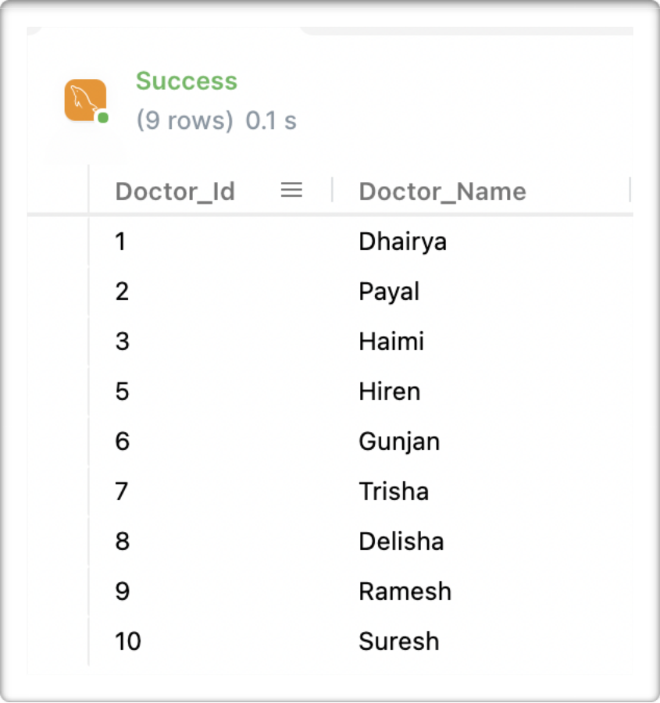

(3).Details of all the doctors who are specialized in cancer.

SELECT * FROM hospital WHERE Specialization = 'Cancer';
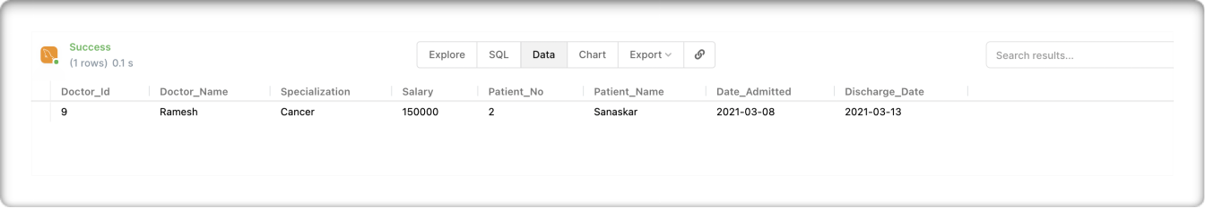
Page 13 of 19

(4).Count of the doctors’ specialization wise.

SELECT COUNT(*) as "Count",Specialization FROM hospital GROUP BY Specialization;
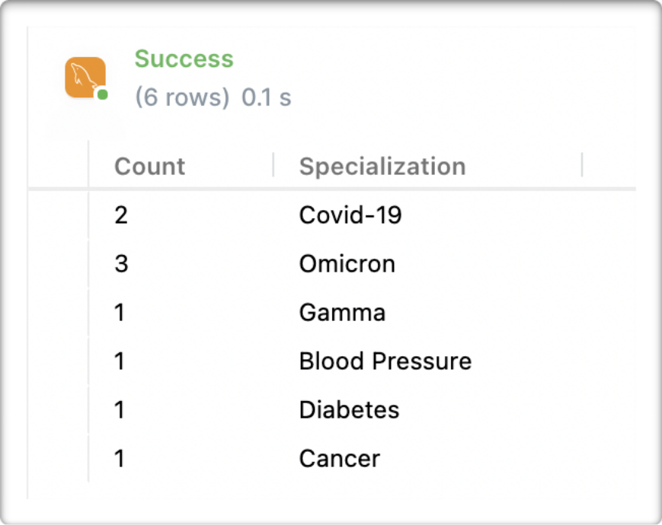

(5).Details of all the Doctors whose salary is between 50000 to 100000.

SELECT * FROM hospital WHERE Salary BETWEEN 50000 AND 100000;
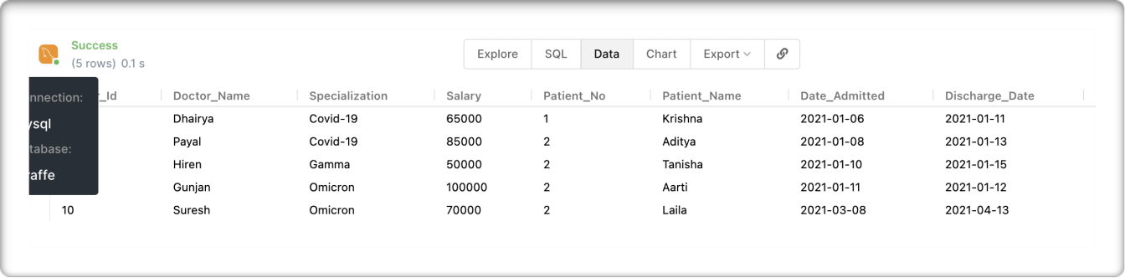
Page 14 of 19

(6).Display unique name of doctors.

SELECT DISTINCT(Doctor_Name) FROM hospital;
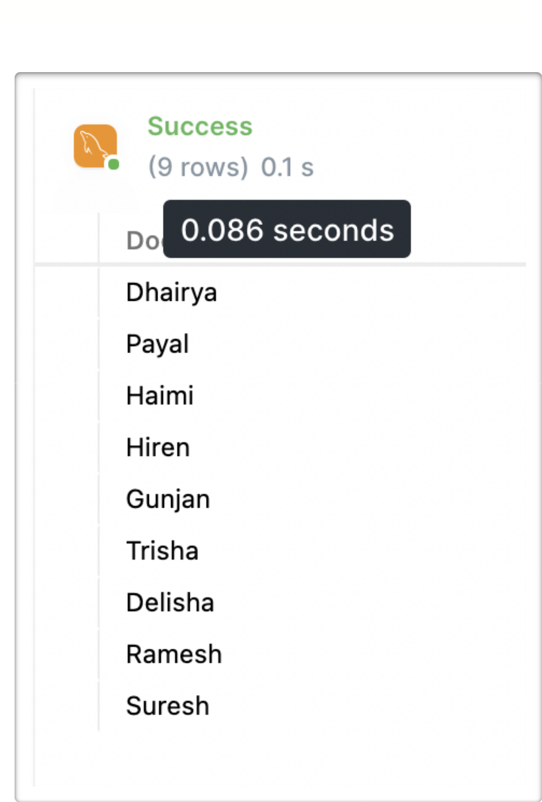
Page 15 of 19

(7).Display the list of patients who are treated by doctor “XYZ”.

SELECT Doctor_Name,Patient_Name FROM hospital WHERE Doctor_Name = 'Dhairya';
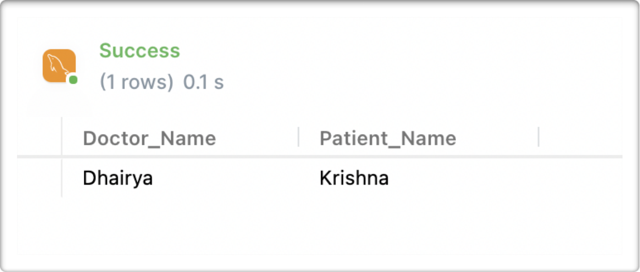
Page 16 of 19

(8).Count of the Patient admitted for the Covid.

SELECT COUNT(*) AS "Count for Covid" FROM hospital WHERE Specialization = 'Covid-19';
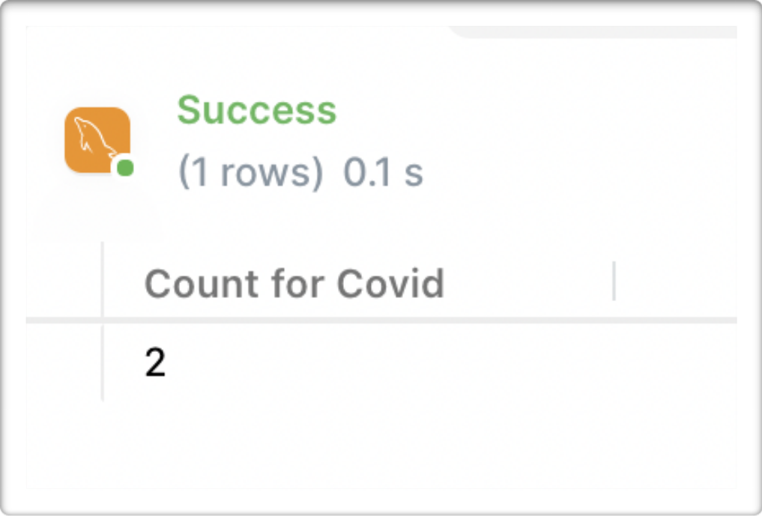

(9).Details of all the Patients who are admitted after 1st jan 2021.

SELECT * FROM hospital WHERE Date_Admitted > ‘2021-01-01';
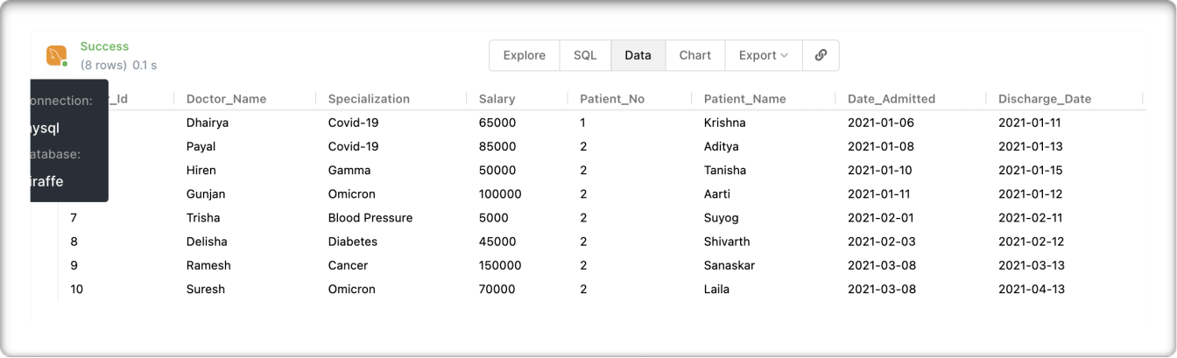
Page 17 of 19

(10).Details of all the patient who are admitted after 1st Jan 2021 and before 31st Jan

2021.

SELECT * FROM hospital WHERE Date_Admitted BETWEEN '2021-01-01' AND ‘2021-01-31';
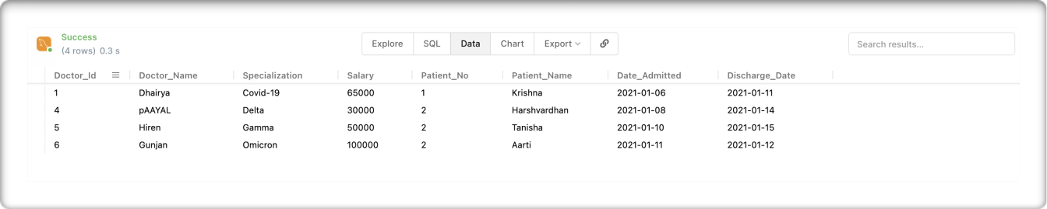

(11).Delete the patients who are under the doctor “ABC”.

DELETE FROM hospital WHERE Doctor_Name = 'Payal'; SELECT * FROM hospital;
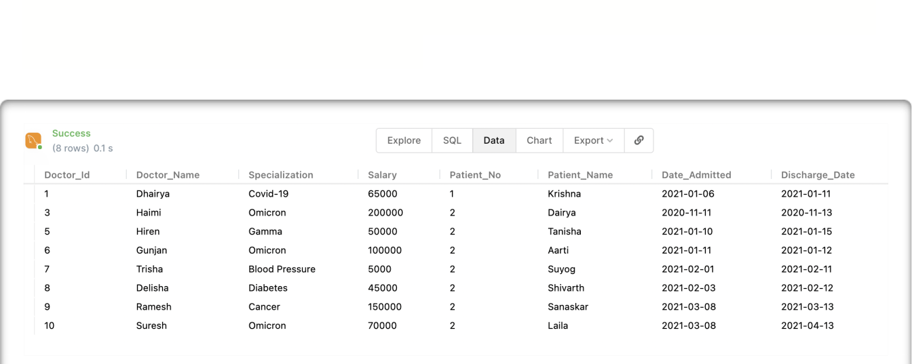
Page 18 of 19

(12).Update the doctor’s name from “XYZ” to “ABC”.

UPDATE hospital SET Doctor_Name = 'pAAYAL' WHERE Doctor_Name = 'Jayshree';

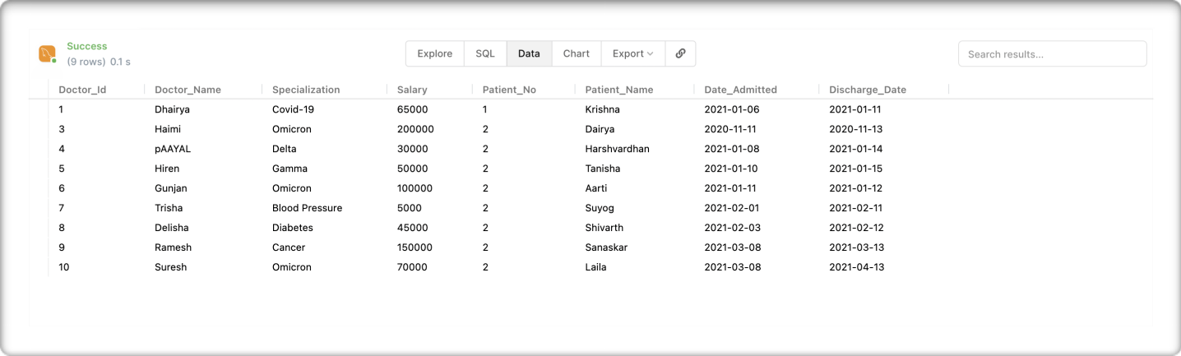
SELECT * FROM hospital

