ENERGY-EFFICIENT ACTIVE-RIS-ASSISTED
RSMA-ISAC UNDER IMPERFECT CSI
AND REALISTIC PROPAGATION
MILESTONE 2 — TECHNICAL SCRIBE

Group: g6_research_pass/ris
Ahmedabad University
Foundation paper implementation, mathematical model,
optimization workflow, preliminary simulation and validation status

Abstract
This scribe documents the Milestone 2 implementation effort for an active reconfigurable intelligent surface (RIS)-assisted rate-splitting multiple access (RSMA) integrated sensing and communication (ISAC) system under imperfect channel state information (CSI). The foundation model jointly considers communication precoding, an active RIS response, and a radar/sensing constraint. The supplied Python archive contains channel-generation, system-model, radar-model, optimization, experiment, and test modules. Its paper-based optimization attempt uses a base-station semidefinite-relaxation/convex–concave-procedure (SDR/CCCP) block, a RIS successive-convex-approximation (SCA) block, and an outer alternating-optimization (AO) loop.
The archived test cache lists 15 tests, and the development session reported 15 passing tests in 1.83 s. The latest saved limited run used one AO iteration, three CCCP iterations, and two RIS SCA iterations. It reports a sum rate of 3.2982 bit/s/Hz, radar SINR 246.5993, BS power 0.667207 W, and RIS power 0.00037305 W. The saved status is `max_iterations`; therefore this is a preliminary, constrained run, not evidence of AO convergence or exact reproduction. The supplied archive does not contain the foundation paper PDF itself, so paper-specific equation numbers and figure-by-figure verification remain provisional and must be checked against the original publication.
The near-term milestone outcome is a structured implementation and preliminary solver execution. Remaining work includes validating the mathematical equivalence of both optimization blocks, independently checking all constraints and units, running enough outer iterations to assess convergence, and comparing generated curves with the original paper. Energy-efficiency and realistic-propagation studies remain future extensions, not completed results.

Document status and evidence policy
Evidence sources used: the supplied Milestone 1 report, `Reproduction_Milestone_2.zip`, its README and reproduction notes, source files, saved JSON summary, and saved PNG plots. The original foundation-paper PDF was not included in the supplied files. Therefore this report explains the equations supported by the supplied model and standard background relationships, but does not claim that every formula has been verified against the paper's exact typesetting.
Evidence class | Meaning in this report
Repository evidence | Directly present in supplied source files, JSON output, or saved plots.
Session evidence | Reported during the working session (e.g., 15 tests passed); not independently rerun while preparing this document.
Standard model explanation | General wireless/optimization explanation included to clarify the implementation; not asserted to be a verbatim paper equation.
Unverified | Requires original paper PDF, full run, or independent mathematical/ numerical audit.

1. Introduction and objectives

1.1 Motivation
ISAC uses a shared wireless platform for data communication and sensing. The same transmitted waveform and propagation environment can support user data delivery and radar-like target observation, but the two functions compete for power, spatial degrees of freedom, and interference tolerance.
A reconfigurable intelligent surface modifies propagation by applying element-wise complex coefficients to an incident signal. A passive RIS mainly changes phase (and sometimes reflection amplitude under passive constraints); an active RIS can amplify signals, but its amplifiers consume power and add noise. Consequently, a communication-rate gain cannot be judged independently of active-RIS power consumption.
RSMA divides user information into a common stream and user-specific private streams. Users decode the common stream and then decode their private stream while treating other users' private streams as interference. This offers an additional interference-management degree of freedom compared with purely private-stream transmission.

1.2 Foundation and extension
The foundation paper named in the Milestone 1 report is A. S. Parihar, C. H. Chen, and C.-P. Li, “Beamforming Design for Enhanced Sum Rate in Active RIS-RSMA-Assisted ISAC Systems Under Imperfect CSIT/CSIR,” IEEE Transactions on Vehicular Technology, 2026, DOI 10.1109/TVT.2025.3648447. The foundation objective is communication sum-rate enhancement subject to power, active-RIS, and sensing constraints under imperfect CSIT/CSIR.
The Milestone 1 research direction retains active RIS + RSMA + ISAC + imperfect CSI and proposes two later extensions: (i) energy-efficiency analysis and (ii) realistic propagation conditions including distance, LOS/NLOS, fading, RIS placement and possible blockage. The active-versus-passive comparison is not positioned as the principal novelty because the foundation work already studies such comparisons.

1.3 Research questions carried forward
ID | Research question from Milestone 1 | Milestone 2 relation
RQ1 — Energy efficiency | How can energy efficiency be improved while maintaining acceptable communication and sensing performance? | Metric and future experimental design defined; extension not yet implemented/validated.
RQ2 — Realistic propagation | How do distance, LOS/NLOS and channel conditions affect system performance versus the controlled foundation environment? | Future extension; current configuration uses simplified assumed geometry.
RQ3 — Imperfect CSI | How does estimation error affect communication, sensing and energy efficiency under realistic propagation? | Imperfect CSI is included in the current foundation-model implementation attempt; full validation remains outstanding.

2. Foundation model and research positioning

2.1 Components
The modeled system includes a multi-antenna base station (BS), an active RIS with N elements, K single-antenna users, and a sensing/radar channel involving a target. The BS sends a common RSMA stream, K private streams, and a radar stream. The active RIS response is represented by a diagonal matrix whose entries contain amplitude and phase.
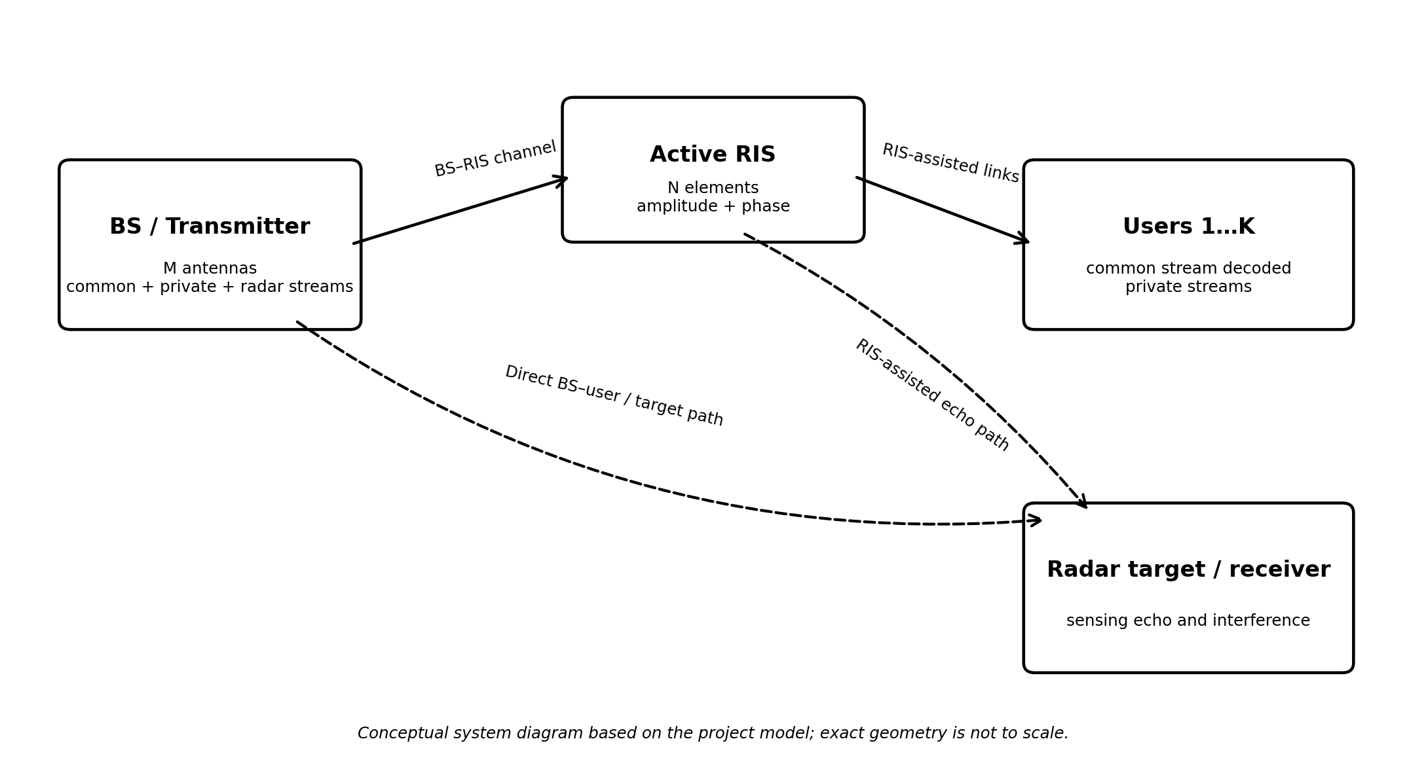
Figure 1. Conceptual system diagram created for this scribe. It illustrates the modeled links, not the exact geometry or a measured deployment.

2.2 Optimization goal
The repository describes a paper-based AO reproduction attempt. At a high level, it seeks to maximize communication sum rate while satisfying BS transmit-power, active-RIS output-power, per-element amplitude, and radar SINR constraints. Because the objective and constraints couple BS precoders and RIS coefficients nonlinearly, the joint problem is non-convex.

2.3 Channel assumptions
The README and reproduction notes describe Rayleigh direct BS–user channels and Rician BS–RIS/RIS–user channels, with Rician factor κ = 3. The path-loss laws recorded in the repository are 35.6 + 22 log10(d) dB for indirect paths and 32.6 + 36.7 log10(d) dB for direct paths. The source labels these as paper equations (102)–(103); the original paper must be consulted before asserting exact transcription.
PL_{indirect}(d) = 35.6 + 22 log₁₀(d) dB
Repository-recorded indirect-path loss law. The distance unit and normalization should be checked against the original paper before using this expression outside the configured implementation.
PL__{direct}(d) = 32.6 + 36.7 log₁₀(d) dB
Repository-recorded direct-path loss law. It models a different distance-dependent attenuation trend from the indirect path.

3. System and signal model

3.1 Active RIS response
Φ = diag(v₁e^{jθ₁}, …, v_Ne^{jθ_N})
Φ is the N×N diagonal RIS response; vₙ is the nonnegative amplification magnitude and θₙ is the phase shift of element n. The implementation stores the complex element coefficient directly as φₙ and imposes |φₙ| ≤ v_max.
|φₙ| ≤ v_{max}, n = 1,…,N
The amplitude constraint limits each RIS element. In the saved run, the maximum reported amplitude is approximately 6, almost exactly the configured limit.

3.2 Transmitted streams
x = p_{c} s_{c} + Σ_{k=1}^{K} p_{k} s_{k} + p_{r} s_{r}
p_c, p_k and p_r are M-dimensional precoding vectors for the common, private, and radar streams. The source notes state that all three stream types are retained. Stream powers and independence assumptions must match the paper's signal model.
The common stream carries portions of user messages that are decoded by all users; private stream k carries the remaining information intended for user k; the radar stream contributes to sensing. This joint waveform creates a coupling: allocating power to radar can improve sensing but reduce power available to communication.

3.3 Effective communication channel
h_{eff},k = h_{BU},k + h_{RU},k Φ H_{BR}
h_BU,k is the direct BS-to-user channel, H_BR is the BS-to-RIS channel, and h_RU,k is the RIS-to-user channel. With row-vector convention, h_BU,k is 1×M, h_RU,k is 1×N, Φ is N×N and H_BR is N×M, so both terms are 1×M. The first term is the direct path; the second is the RIS-assisted path.
The equation is a standard expression consistent with the repository's `effective_channels` function. It should be compared with the foundation paper's exact conjugation and channel-vector convention when the paper PDF is available.

3.4 Imperfect CSI
Ĥ = H + E
H is the actual channel, Ĥ the estimate, and E the estimation error. This is the convention used in the supplied Milestone 1 report. Some literature writes H = Ĥ + E; the sign convention does not by itself determine the error distribution.
C_{e},k = 𝔼[e_{k} e_{k}ᴴ]
C_e,k denotes the covariance of the effective channel error e_k. It determines the expected error-induced interference power for a given precoder. The implementation's `user_error_covariance` uses an independent-error expansion; the project notes explicitly warn that the paper's printed covariance notation is ambiguous and that the chosen interpretation is not independently verified against the original PDF.

3.5 Radar effective channel and sensing metric
H_{r}(Φ) = H_{m} + H_{n} Φ H_{BR}
The repository notes define H_m as the direct radar/target channel component and H_n as the RIS-side target component. Dimensions depend on the steering/channel conventions in `radar_model.py`; inspect the actual matrices before assigning dimensions in a final publication.
SINR_{r} = P_{desired} / (P_{interference} + P_{error} + P_{noise})
This is a generic SINR decomposition for explaining the sensing constraint, not a verified transcription of the paper's radar equation. The exact radar numerator, error terms, and normalization must be matched to the paper. The current model implements a paper-oriented radar SINR function and a separate proxy; these should not be conflated.

4. Mathematical formulation and equation explanations

4.1 Communication rate
R_{k} = R_{c},k + R_{p},k
The user-k rate combines its allocated part of the common rate and its private rate. The common rate is limited by the weakest user's ability to decode the common stream, so the common-rate allocation across users cannot exceed the common-stream bottleneck rate.
R_{c} = min_{k} R_{c},k
This bottleneck captures the fact that every user must decode the common stream. If any user has a poor common-stream SINR, it limits the common rate available to all users.
R_{sum} = Σ_{k=1}^{K} (C_{k} + R_{p},k), Σ_{k} C_{k} ≤ R_{c}
C_k is the portion of common-stream rate assigned to user k. The sum-rate objective includes allocated common-rate portions and private rates. This is the standard RSMA accounting form; exact GMI expressions used by the foundation paper are referenced by the repository as equations (34), (40), and (42) and require checking against the paper PDF.
R = log₂(1 + SINR)
This is a standard single-stream Shannon-style spectral-efficiency relationship in bit/s/Hz under Gaussian signaling assumptions. It is included as background only. The supplied implementation also has paper-oriented GMI rate equations; do not substitute this simple expression for those equations when reproducing the foundation results.

4.2 BS transmit-power constraint
Σ_{j∈streams} ||p_{j}||² ≤ P_{BS},max
Each precoder is an M-dimensional vector. The squared Euclidean norm is the power assigned to a stream; summing stream powers gives total BS transmit power under unit-power independent streams. The configured 35 dBm budget converts to 3.1623 W using P_W = 10^((P_dBm−30)/10).
P_{W} = 10^{((P_dBm − 30)/10)}
This conversion is implemented by `config.dbm_to_watt`. For reference, 35 dBm = 3.1623 W; 10 dBm = 0.01 W; −80 dBm = 10⁻¹¹ W; and −60 dBm = 10⁻⁹ W.

4.3 Active RIS power constraint
P_{RIS} = Σₙ |φₙ|² (Σ_{j} |[H_{BR} p_{j}]ₙ|² + σ_{d}²)
This is a representative active-RIS output-power accounting form: amplified incident signal power plus amplified RIS noise. The exact implementation in `active_ris_power` must be treated as authoritative for code behavior; its exact equivalence to the paper equation remains part of the audit.
P_{RIS} ≤ P_{RIS},max
The active-RIS output power must not exceed its budget. This constraint differs from the element amplitude limit: the amplitude limit bounds each coefficient, while the power constraint limits total output power including the modeled noise term.

4.4 Radar constraint and joint optimization
SINR_{r}( P, Φ ) ≥ Γ^{th}
P denotes the collection of BS precoders and Φ the RIS response. This constraint ensures the sensing metric reaches a configured threshold. In the current configuration Γ_th = 2; the threshold and reported radar SINR must use the same linear or dB convention.
maximize_{{P,Φ,C}} R_sum_{(P,Φ,C)}
Subject to the BS power budget, RIS power budget, RIS element amplitude bounds, radar threshold, nonnegative common-rate allocations, and any paper-specific constraints. This is a high-level statement of the objective; the exact optimization problem and all variable definitions must be verified against the original paper.
The problem is non-convex because the effective channel depends on the product of RIS coefficients and channel matrices, SINR expressions are ratios of coupled quadratic forms, the BS and RIS variables are jointly coupled, and the original beamforming vectors lead to non-convex constraints. The repository addresses the blocks with SDR/CCCP and SCA inside AO; this is an implementation strategy, not proof of exact equivalence.

4.5 Energy-efficiency extension
E_{E} = R_{sum} / P_{total}
EE is spectral efficiency per watt if R_sum is measured in bit/s/Hz and P_total in watts; units are then bit/s/Hz/W. If R_sum is a throughput in bit/s, the metric becomes bit/J. Keep the rate definition and units consistent.
P_{total} = P_{BS} + P_{RIS} + P_{circuit}
This total-power model appears in Milestone 1. Circuit power must be defined and sourced before numerical EE results are reported. This extension is planned, not included as a verified result in the current AO run.

5. Optimization methodology

5.1 Alternating optimization
AO alternates between optimizing the BS precoder while holding the RIS response fixed and optimizing the RIS response while holding the precoder fixed. It repeats these blocks until an outer stopping criterion is met or an iteration limit is reached.
P ^{(t+1)} ≈ arg max_P R_{sum}(P, Φ^{(t)}) subject to the BS-block constraints
This expresses the conceptual BS update. In the repository, `solve_bs_sdr_cccp` creates Hermitian positive-semidefinite covariance variables and uses CCCP-style linearizations. It then performs rank-one recovery to obtain candidate precoders. The recovered true sum rate can differ from the lifted surrogate objective.
Φ^{(t+1)} ≈ arg max_{Φ} R _{sum}(P^{(t+1)}, Φ) subject to RIS constraints
This expresses the conceptual RIS update. `solve_ris_sca` uses complex RIS variables, amplitude/power constraints, and auxiliary variables/tangent approximations. Its local nature means initialization and scaling may affect the result.

5.2 SDR, CCCP and SCA
Semidefinite relaxation lifts a vector quadratic term ppᴴ into a matrix W and relaxes the rank-one condition. This produces a convex semidefinite representation for selected quadratic constraints, but a solution W need not be rank one. A rank-one recovery step is therefore needed before the candidate can be interpreted as a physical beamformer.
W_{j} = p_{j} p_{j}ᴴ, W_{j} ⪰ 0, rank(W_{j})=1
W_j is Hermitian positive semidefinite. Dropping rank(W_j)=1 is the relaxation. Any recovered beamformer must be checked against the original constraints, not just the relaxed problem.
CCCP handles selected difference-of-convex expressions by linearizing one component at the current point. Tangent direction matters: for a concave logarithm, its first-order tangent is an upper bound, and inequality direction determines whether the resulting rate expression is a valid lower-bound surrogate. The exact tangent directions in the current code have not been independently certified in this report.
SCA similarly replaces a difficult non-convex term with a local convex approximation around an anchor. A valid SCA implementation should document approximation tightness at the anchor, feasible direction, and whether each step preserves feasibility. The saved RIS SCA actual-rate history rises slightly across its two iterations, but two points do not establish convergence.

5.3 Stopping criterion
|R_{sum}^{(t)} − R_{sum}^{(t−1)}| ≤ ε
This is a common outer convergence test, with ε = 10⁻³ recorded in the configuration. The limited run used an AO iteration cap of one, so the saved result status is `max_iterations`; the stopping tolerance was not demonstrated.
Conceptual workflow: initialize channels and feasible P, Φ → solve BS SDR/CCCP block → recover candidate precoders → solve RIS SCA block → recompute actual rate and constraints → test stopping tolerance → repeat or save diagnostics.
Figure 2. The system diagram is repeated here only as a reference to the physical variables; the optimization flow itself is described in the preceding paragraph.

6. Software architecture and reproducibility
File/module | Role evidenced by repository | Current validation status
config.py | SimulationConfig, dBm/W conversion, default parameters and explicit assumptions | Inspected from archive
channel_model.py | Rayleigh/Rician channels, steering vectors and path-loss laws | Tests listed for dimensions, finiteness and path-loss equations
model.py | Effective channels, active-RIS power, RSMA rates, CSI-error covariance, paper-oriented GMI rates and radar metrics | Tests listed for rates, shapes and finite values; exact paper equivalence not independently verified
radar_model.py | Radar echo/steering/channel model | Shape/finiteness tests listed
optimization/ao.py | BS SDR/CCCP, rank-one recovery, RIS SCA, outer AO | Latest limited run completed; full convergence not shown
reproduce_paper.py | CLI entry point for a paper-based AO scenario and saved summary/plot | Limited run output exists
baseline.py; main.py | Diagnostic random/normalized-precoder baseline and sweep | Not the optimized paper solution
experiments/run_power_sweep.py | BS power sweep experiment | Not confirmed completed in this archive
experiments/run_parameter_sweep.py | Parameter sweeps for users, RIS elements, radar threshold, BS–RIS distance, CSI error and antennas | Not confirmed completed in this archive
experiments/plot_beampattern.py | Beampattern proxy plot | Must validate target steering and normalization
tests/ | Unit and solver smoke tests | 15 test nodes in cache; session reported 15 passed
REPRODUCTION_NOTES.md | Equation mapping, assumptions, validation checklist | Inspected from archive
results/paper_reproduction/ao_summary.json | Saved limited-run metrics and status | Present; status max_iterations
results/paper_reproduction/ao_solution.npz | Saved solution arrays | Present; arrays not independently revalidated here
results/paper_reproduction/ao_convergence.png | Saved convergence plot | Present; based on one AO point in the saved JSON

6.1 Software and solver
The README specifies Python, NumPy, SciPy, CVXPY and MOSEK. MOSEK is a commercial optimization solver and requires a valid license. During development, a basic CVXPY/MOSEK smoke test returned `optimal`, x = 2.0, objective = 2.0. A later full-block attempt encountered a missing-license-file error when the license path was absent from the current PowerShell session; after restoring the path, the limited run completed.

6.2 Reproduction commands
From the project root in PowerShell, after selecting the correct Python environment and confirming the MOSEK license:
python -m pytest -q
python verify_environment.py
python optimization/smoke_mosek.py
python reproduce_paper.py --solver MOSEK
python reproduce_paper.py --solver MOSEK --ao-iterations 1 --cccp-iterations 3 --sca-iterations 2
The final command is the restricted run represented by the saved summary. The unrestricted run may take longer or fail if a block becomes infeasible. Record the full console output and preserve the resulting JSON, NPZ and plot.

7. Preliminary results and graph interpretation

7.1 Latest saved limited run
The supplied `ao_summary.json` reports `status: max_iterations`, `feasible: true`, solver requested MOSEK, seed 20261010, M=3, K=3 and N=36. The `feasible` field is the implementation's own recorded check; it is not independent proof that all equations and units are correct.
Metric | Saved value | Interpretation/caveat
Sum rate | 3.2982307237 bit/s/Hz | Preliminary model output; not compared against published curve.
Radar SINR | 246.5992541010 | Numerical value is reported; confirm threshold uses the same linear/dB convention.
BS power | 0.6672065984 W | Below configured 3.1623 W budget in saved output.
RIS power | 0.000373049953 W | Below configured 0.01 W budget in saved output.
Maximum RIS amplitude | 5.9999704340 | Near configured limit 6.
AO iterations | 1 | One iteration only; outer convergence not established.
BS CCCP iterations | 3 | Three iterations in restricted run; surrogate is not the same as recovered true sum rate.
RIS SCA iterations | 2 | Two iterations; insufficient to establish convergence.

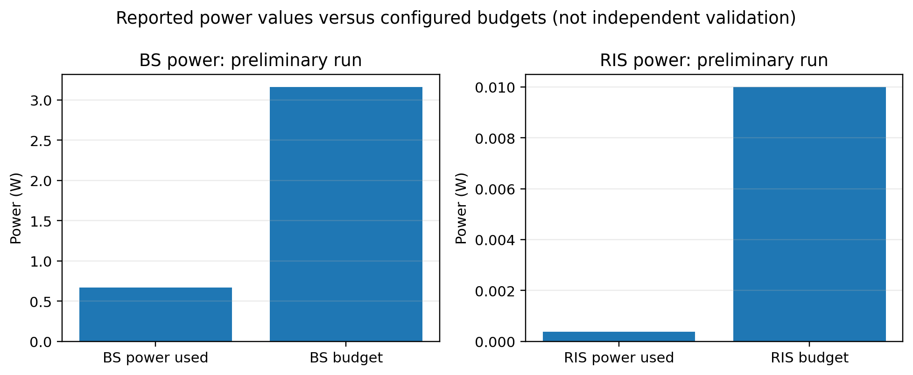
Figure 3. Reported power use versus configured budgets, generated from the saved JSON. This visualizes the stored numbers; it is not an independent recalculation of power.
The saved BS power is about 0.6672 W compared with the 3.1623 W budget. The saved RIS power is about 3.7305×10⁻⁴ W compared with the 0.01 W budget. The reported maximum element amplitude is 5.99997, close to the limit 6. These comparisons are consistent with the saved feasibility flag for these particular metrics, but radar constraint feasibility and the implementation's power definitions still require independent checks.

7.2 Diagnostic baseline plot
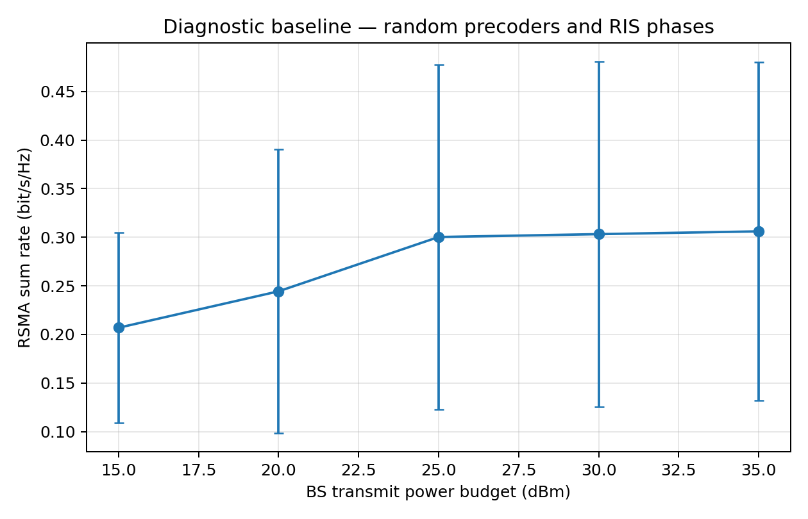
Figure 5. Diagnostic baseline sweep stored in the repository. This is a normalized/random-precoder diagnostic, not the optimized AO result and not a reproduction of a paper performance panel.
The README explicitly warns that the baseline is diagnostic only. Its curves should not be compared directly with the paper's optimized sum-rate results without matching channel assumptions, constraints, and averaging procedures.

7.3 Published figures not yet reproduced
The repository notes list planned implementations for power sweeps, parameter sweeps and a beampattern proxy, but this archive does not contain verified completed data for all paper figures. In particular, exact multi-scheme convergence and RIS-mode/access-scheme baselines remain incomplete. The paper's figures 2–10 must be compared against the original paper and the generated numerical data before they can be called reproduced.
Planned figure study | Repository support | Status for this scribe
Convergence | AO convergence PNG exists; JSON has one outer point | Preliminary only; no convergence claim
Sum rate vs BS power | Power-sweep script exists | Script available; completed validated sweep not evidenced
Sum rate vs users/RIS elements | Parameter-sweep script exists | Not verified completed
Perfect vs imperfect CSI | Model supports CSI error parameter | Full comparison not evidenced
Radar threshold / trade-off | Parameter-sweep script supports radar threshold | Exact metric/axes and data need verification
BS–RIS distance | Parameter-sweep script supports distance | Not verified completed
Radar beampattern | Beampattern proxy script exists | Target steering and normalization need reconciliation
Passive/no-RIS/other baselines | Notes say some comparisons incomplete | Not complete

8. Testing, validation and current status

8.1 Test evidence
The archive's pytest cache lists 15 test cases across core model checks, reproduction-model checks, and a solver smoke test. During development, the user observed `15 passed in 1.83s`. This is session evidence rather than a fresh test run performed while generating this report.
Validation item | Evidence | Status | What it establishes / does not establish
Unit tests | 15 passed in 1.83 s (session output); 15 cached test nodes | Completed for that run | Checks covered shapes, finite values, basic rates, path loss, power helpers and solver smoke test; does not prove paper-equation equivalence.
CVXPY/MOSEK smoke test | optimal; x=2.0; objective=2.0 | Completed for that environment/session | Confirms basic solver integration at that time; license path must be available per terminal session.
Limited AO run | JSON saved; status max_iterations; one outer iteration | Partially completed | Both blocks returned outputs for the restricted run; outer convergence not established.
Recorded power/amplitude checks | JSON feasibility flag true; values below budgets, amplitude near cap | Preliminary | Must independently recompute from saved arrays and verify units/formulas.
Radar constraint | Reported SINR 246.599; threshold configured 2 | Not independently verified | Ensure both are in the same linear or dB convention and use the intended radar equation.
Mathematical audit | REPRODUCTION_NOTES maps paper equation ranges to functions | Partially completed | Equation mapping exists; exact equivalence and tangent inequality directions need independent verification.
Published-figure validation | No verified full figure-by-figure comparison in archive | Not yet verified | Cannot claim exact reproduction.
Energy efficiency / realistic propagation | Planned in Milestone 1 | Not yet implemented/verified | Belongs to later milestones.

8.2 Development/debugging record
During development, the RIS SCA block repeatedly triggered CVXPY/MOSEK `SolverError` during solution retrieval despite MOSEK reporting an optimal status. A later run failed because the MOSEK license file could not be located in that PowerShell session. Restoring the environment variable allowed a restricted run to complete. The current JSON records the run as `max_iterations`, so the debugging history should be described as resolving a license-access interruption and obtaining a limited run—not as proving the original mathematical/numerical issue is fully resolved.

9. Limitations and remaining work
- Obtain and inspect the original foundation-paper PDF before finalizing original equation numbers, figure captions, exact GMI/radar expressions, and the interpretation of ambiguous covariance notation.
- Independently audit all matrix dimensions, conjugation conventions, error covariance expansions, radar channel/error terms, active-RIS power accounting, and SINR units.
- Audit CCCP tangent directions and SCA surrogate constraints to ensure the approximation preserves the intended bounds and feasible directions.
- Recompute BS power, RIS output power, maximum RIS amplitude, radar SINR and sum rate from the saved solution arrays using independent evaluation functions.
- Run a longer AO iteration budget; report actual objective history and a stopping reason. Do not use a one-iteration run to claim convergence.
- Run controlled parameter sweeps with documented seeds and sufficient channel realizations; compare trends and values with the paper's original figures.
- Complete relevant baselines under comparable constraints before making performance-gain claims.
- Add total circuit power and define the energy-efficiency units before reporting EE.
- Introduce realistic geometry/LOS/NLOS and obstacle models only after the foundation baseline is stable, retaining imperfect CSI as planned.

10. Conclusion
Milestone 2 has advanced from a repository scaffold to a modular paper-oriented optimization implementation with a passing test run and a limited MOSEK execution. The current saved run returns preliminary sum-rate, radar-SINR, BS-power, RIS-power and amplitude metrics and records a feasibility flag. However, the run stopped at its outer iteration limit, and the foundation paper's exact mathematical correspondence and published-figure reproduction have not been independently verified. The appropriate conclusion is that implementation and preliminary solver execution have been demonstrated, while full reproduction remains in progress.
The next priority is not to add the energy-efficiency extension immediately. It is to verify the foundation equations, recompute the saved metrics independently, establish AO convergence, and compare the relevant curves with the paper. Only after this baseline is defensible should the project proceed to energy efficiency and realistic propagation, as planned in Milestone 1.

References
- A. S. Parihar, C. H. Chen, and C.-P. Li, “Beamforming Design for Enhanced Sum Rate in Active RIS-RSMA-Assisted ISAC Systems Under Imperfect CSIT/CSIR,” IEEE Transactions on Vehicular Technology, vol. 75, no. 6, 2026. doi: 10.1109/TVT.2025.3648447. (Bibliographic details transcribed from the supplied project notes; verify against publisher record.)
- H. Niu, Z. Lin, K. An, J. Wang, G. Zheng, N. Al-Dhahir, and K.-K. Wong, “Active RIS Assisted Rate-Splitting Multiple Access Network: Spectral and Energy Efficiency Tradeoff,” IEEE Journal on Selected Areas in Communications, vol. 41, no. 5, pp. 1452–1467, 2023. doi: 10.1109/JSAC.2023.3240718. (As cited in Milestone 1.)
- J. Ye, M. Rihan, P. Zhang, L. Huang, S. Buzzi, and Z. Chen, “Energy Efficiency Optimization in Active Reconfigurable Intelligent Surface-Aided Integrated Sensing and Communication Systems,” IEEE Transactions on Vehicular Technology, vol. 74, no. 1, pp. 1180–1195, 2025. doi: 10.1109/TVT.2024.3465897.
- T. P. Truong, T. M. T. Nguyen, T. V. Nguyen, N.-N. Dao, and S. Cho, “Energy Efficiency in RSMA-Enhanced Active RIS-Aided Quantized Downlink Systems,” IEEE Journal on Selected Areas in Communications, vol. 43, no. 3, pp. 834–850, 2025. doi: 10.1109/JSAC.2025.3531522.
- CVXPY Developers, CVXPY documentation. The implementation README specifies CVXPY as the modeling layer; consult the installed version documentation when reproducing.
- MOSEK ApS, MOSEK Optimization Suite documentation. A valid license is required for the configured solver.

Appendix A. Reproduction commands
Run these commands from the `Active_RIS_RSMA_ISAC_Python` directory in PowerShell, using the Python interpreter where the dependencies are installed and after confirming MOSEK license access.
python -m pytest -q
python verify_environment.py
python optimization/smoke_mosek.py
python reproduce_paper.py --solver MOSEK
python reproduce_paper.py --solver MOSEK --ao-iterations 1 --cccp-iterations 3 --sca-iterations 2
python experiments/run_power_sweep.py --solver MOSEK
python experiments/run_parameter_sweep.py --parameter users --values 2 3 4 --solver MOSEK

