Instructions:

* When you start a website you see the index page where all blogs are show with the title and short description.

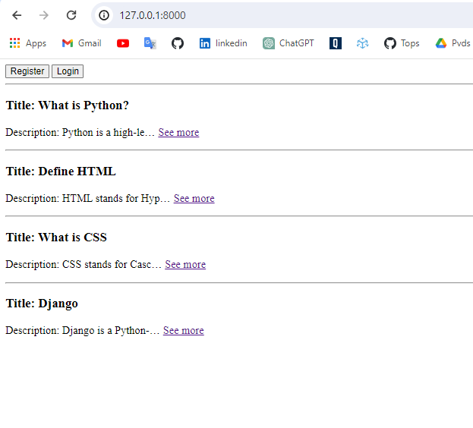Index.html View.py (index)

* When you click on the “See more” you can see all the description, blog title, author name, Author contact details and Post date.

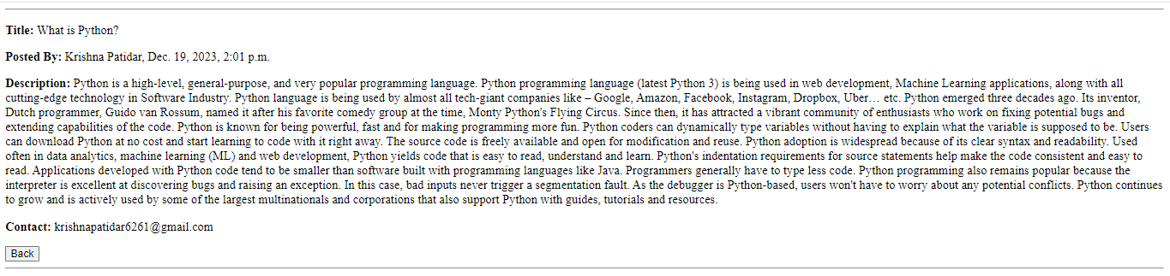

DetailView.html View.py (detailView)

* Register

You register your account for posting a blog.

* + using set of JavaScript functions designed for form validation. These functions are likely intended to be used in conjunction with an HTML form to ensure that user inputs meet certain criteria.
  + validation criteria for each field (e.g., first name, last name, email, password, confirm password).
  + Password Instruction Minium 1 Digit, Upper, Lower & Special(8,15)
  + Highlight the error messages that are displayed when validation fails for each field.
  + Provide any recommendations for improvement or additional validation checks if necessary.

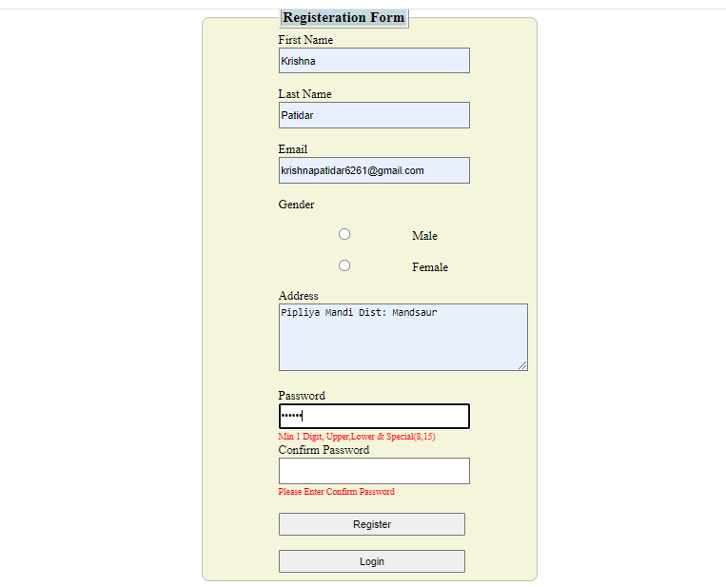

Register.html

* Login:

Using your crediantial you can login for posting a blog, deleting a blog

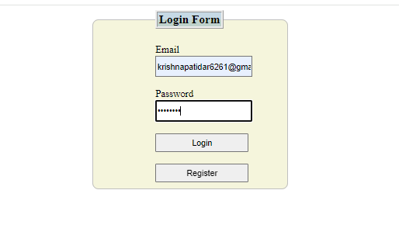Login.html

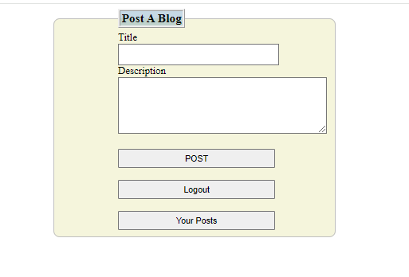blogerIndex.html

Here have a 3 button for user friendly website

1. Post: You can fill in the title of your blog, blog description and post the blog.
2. Logout: Logout button to log out your account when you click on logout it performs an action and goes to Index.html page
3. Your Posts: When you click on "Your Posts" button you see all your posts and perform actions like "Delete your post"

Your Post:

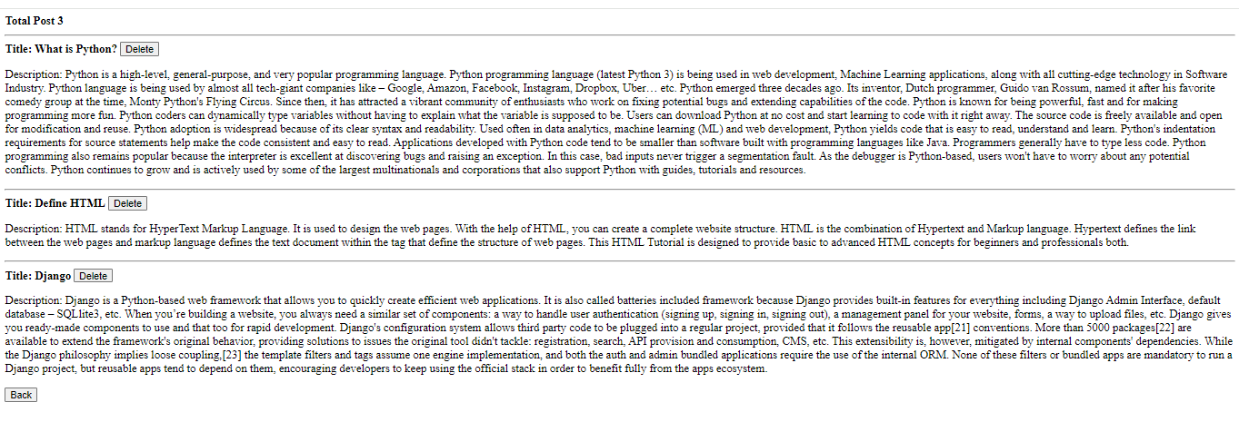

BlogerView.html view.py(BlogerView)

* Delete your post:

You can delete your post just one click on the delete button

View.py (blogerDeletePost)