GROUP B
2 HEART
- # import pandas library
import numpy as np
import pandas as pd
from sklearn.model_selection import train_test_split
import matplotlib.pyplot as plt
import seaborn as sns
from sklearn.preprocessing import LabelEncoder
from sklearn.metrics import accuracy_score,confusion_matrix
from sklearn.linear_model import LogisticRegression
import seaborn as sns
import matplotlib.pyplot as plt
- pwd
- # Reading csv file
df = pd.read_csv("Heart.csv")
df.head()
- df.shape
- #It removes repeated rows so that each row appears only once.
df = df.drop_duplicates()
- df
- df.shape
- # Count ,min,max ,etc of each column
df.describe()
- # Information about each column data
df.info()
- #Finding null values in each column
df.isna().sum()
- df.head()
- #unique() finds all different values in that column
df.fbs.unique()
- subSet1 = df[['age','cp','chol','thalachh']]
- subSet2 = df[['exng','slp','output']]
- #This command combines two DataFrames using a cross join.#subSet1#First DataFrame (left table)#subSet2#Second DataFrame (right table)#Every row of subSet1 is combined withevery row of subSet2
merged_df = subSet1.merge(right=subSet2,how='cross')
merged_df.head()
- df.columns
- #“If something goes wrong, error correcting identifies the problem and fixes it automatically or with guidance.# Error Correcting in Data Processing# 1.Removing duplicate data#2.Fixing missing values#3.Removing outliers#4.Correcting wrong formats#An outlier is a data value that is very different from the rest of the data.#It is unusually high or unusually low compared to other values.#Consider student marks: 45, 48, 50, 47, 49, 100 Most marks are around 45–50 ,100 is far away from others ,So, 100 is an outlier
def remove_outliers(column): Q1 = column.quantile(0.25) #Calculates the 1st quartile (25%) 25% of the data values are below this point
Q3 = column.quantile(0.75) #Calculates the 3rd quartile (75%) 75% of the data values are below this point
IQR = Q3 - Q1 #Computes the Interquartile Range Measures the spread of the middle 50% of the data
threshold = 1.5 * IQR #Sets the outlier limit The value 1.5 × IQR is a standard rule to detect
outlier_mask = (column < Q1 - threshold) | (column > Q3 + threshold) #Creates a True/False mask True → value is an outlier False → value is normal
return column[~outlier_mask] #Returns only the values that are not outliers
#The function finds very small or very large values compared to most data and removes them.
- 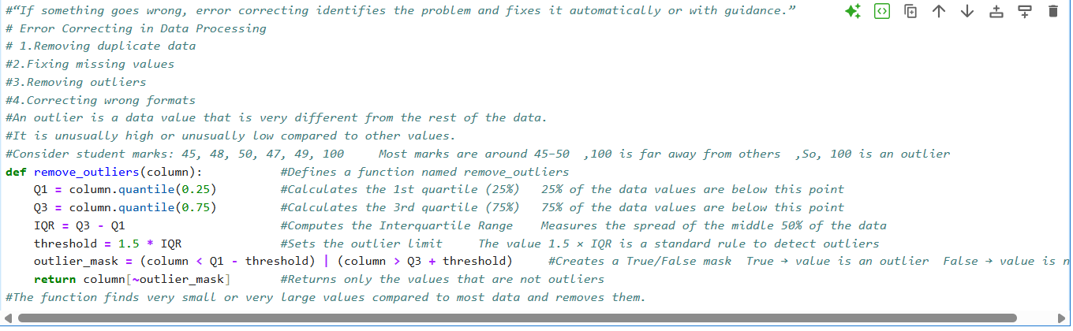
- # Remove outliers for each column using a loop
#This loop removes outliers from each specified column in the DataFrame.
col_name = ['cp','thalachh','exng','oldpeak','slp','caa']
for col in col_name:
df[col] = remove_outliers(df[col])
- plt.figure(figsize=(5, 6)) # Adjust the figure size if needed
for col in col_name:
sns.boxplot(data=df[col])
plt.title(col)
plt.show()
- #drops rows with NaN (missing values)
df = df.dropna()
- df.isna().sum()
- #It deletes the column named fbs from the DataFrame and saves the updated DataFrame back into df.#axis=1 → columns
df = df.drop('fbs',axis=1)
- # Compute correlations between features and target
#Computes the correlation matrix
correlations = df.corr()['output'].drop('output')
# Print correlations
print("Correlation with the Target:")
print(correlations)
print()
# Plot correlation heatmap
plt.figure(figsize=(8, 6))
sns.heatmap(df.corr(), annot=True, cmap='coolwarm')
#cmap='coolwarm' Red → strong positive correlation Blue → strong negative correlation
plt.title('Correlation Heatmap')
plt.show()
- # df.isna().sum()# splitting data using train test split
x = df[['cp','thalachh','exng','oldpeak','slp','caa']]
y = df.output
#y is the dependent variable (target) #The model will learn to predict output
- x_train,x_test,y_train,y_test=train_test_split(x,y,test_size=0.2,random_state=0)
# 20% data for testing, 80% for training
x_train.shape,x_test.shape,y_train.shape,y_test.shape
- from sklearn.preprocessing import StandardScaler
- scaler = StandardScaler()
- x_train_scaled = scaler.fit_transform(x_train)
x_test_scaled = scaler.transform(x_test)
- y_train= np.array(y_train).reshape(-1, 1)
y_test= np.array(y_test).reshape(-1, 1)
- y_train.shape
- model = LogisticRegression()
#Initializes a Logistic Regression classifier Logistic Regression is used for binary classification (0 or 1)
model.fit(x_train_scaled, y_train)
# Make predictions on the test set
y_pred = model.predict(x_test_scaled)
# Evaluate the model's accuracy
accuracy = accuracy_score(y_test, y_pred)
print("Accuracy:", accuracy)
- from sklearn.tree import DecisionTreeClassifier
tc=DecisionTreeClassifier(criterion='entropy')
tc.fit(x_train_scaled,y_train)
y_pred=tc.predict(x_test_scaled)
print("Training Accuracy Score :",accuracy_score(y_pred,y_test))
print("Training Confusion Matrix :",confusion_matrix(y_pred,y_test))

