

Mini Project Report
On

Accident Detection With GPS Tracking And Messaging System

Submitted by

Krishna Patil

Under the guidance of

Prof. Mrs. Renuka Suryawanshi

School of Computer Engineering and Technology
MIT World Peace University, Kothrud,
Pune 411 038, India



SCHOOL OF COMPUTER ENGINEERING AND TECHNOLOGY

CERTIFICATE

This is to certify that

Krishna Patil

of T. Y. B. Tech. successfully completed Mini Project Report in
Accident Detection With GPS Tracking And Messaging System

to my satisfaction and submitted the same during academic year 2019-20 Trimester VII as part of Embedded and Internet of Things Laboratory subject.

Prof. Mrs. Renuka Suryawanshi Dr. M. V. Bedekar
(Mini Project Guide) (Program Head)

Place: School of Computer Engineering and Technology, MIT-WPU, Pune

Date: _____________

Table of Contents
 | Topic |  | Page No.
1 | Introduction |  | 1
2 | Related Work |  | 2
 | 2.1 | Literature Survey /Analysis of existing methods | 3
3 | Proposed Work |  | 4
 | 3.1 | Problem Statement | 4
 | 3.2 | Social Relevance | 4
 | 3.3 | Architecture/Model | 5
 | 3.4 | Hardware and Software Requirement | 8
 | 3.5 | Results obtained | 9
4 | Conclusion |  | 11
5 | References |  | 11

ABSTRACT

This paper presents a review on an accident detection system which detects an accident and alerts the family members and emergency contacts. The number of accidents happening in our country are increasing rapidly everyday and existing systems for a person who meets with an accident are weak as per the ratio. Also the existing systems are focusing mostly on prevention of accident rather than taking immediate actions after an accident. Often the family members and emergency contacts are not informed in time. This results in delaying the help reached to the person suffered. Our project is designed to avoid such situations , detect such road accidents and locate the suffered using a real time vehicle tracking using GPS.
- Introduction

Transportation has great importance in our daily life and its development has made many of our chores much easy. But it can cause disaster to us and even can kill us through accidents. During 2008, Road Traffic Injuries ranked fourth among the leading causes of death in the world. Nearly 1.3 million people die every year on the world’s roads and 20 to 50 million people suffer non-fatal injuries, with many sustaining a disability as a result of their injury. Road traffic injuries are the leading cause of death among young people aged 15-29 years and cost countries 13% of the gross domestic product (GDP). If no action is taken, road traffic crashes are predicted to result in the deaths of around 1.9 million People annually by 2020.

When an individual riding his/her car, meets with an accident, there is a chance that the individual may suffer from a serious injury or expire instantaneously and there is no one around to help him. Well this system is a solution to the problem. The system acts as an accident identification system that gathers and sends this vehicle information that met with an accident, and conveys it to emergency contact which receives all information about the hospitals and police station nearby.

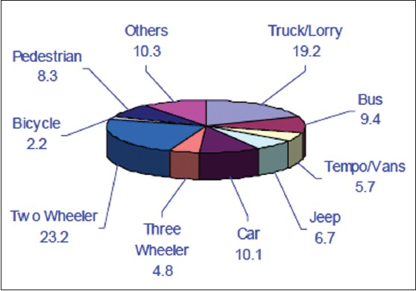
Fig. 1
- Related Work

2.1 Literature Survey

In highly populated Countries like India, everyday people lose their lives because of accidents and poor emergency facilities. These lives could have been saved if medical facilities are provided at the right time. Fig. 2 shows the death to injured ratio being almost half meaning only half of the injured are saved.This paper implies system which is a solution to this drawback.

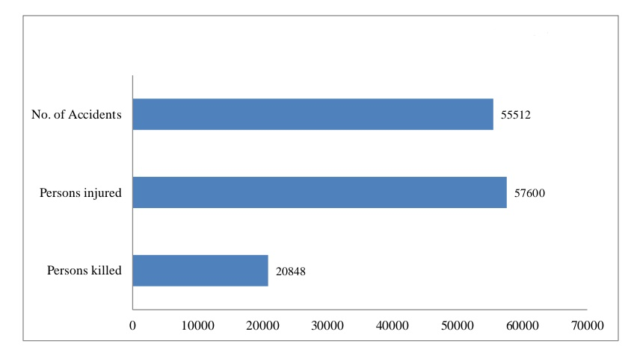
Fig. 2

Traditional traffic accident prediction uses long-term traffic data such as annual average daily traffic and hourly volume. In contrast to traditional traffic accident prediction, real-time traffic accident prediction relates accident occurrences to real-time traffic data obtained from various detectors such as induction loops, infrared detector, camera etc. Real-time traffic accident prediction focuses on the change of traffic conditions before an accident occurrence, while traffic incident detection studies are concerned with the change of traffic conditions after an incident occurrence. Manual incident detection methods detects the accident from the motorist report, transportation department or public crews report, aerial surveillance or close circuit camera surveillance.
2. 2 Analysis of existing methods
It detects the accident rather than predicting it. They are of three types.
• Manual detection system
• Driver initiated detection system
• Automatic detection system

- Manual Detection System

In this method, accident is detected from
-motorist report
-transportation department
-public crews report
-aerial surveillance
-close circuit camera surveillance.
The drawback of this type of detection system is that someone has to witness the incident. Driver initiated detection system. Moreover, there are delays and inaccuracies due to the expression problem of the witness.

b. Driver Initiated Detection System

Driver initiated incident detection system has more advantages which includes the quick reaction, more incident information etc. However, with the severity of the accident, driver may not be able to report at all.

c. Automatic Detection System

There are different types of automatic detection system. Conventional built-in automatic accident detection system utilizes impact car airbag senor to detect an accident. However, the system did not utilize the GPS to detect the accident unlike our system which shows live location as well.
• A smart phone based accident detection system is proposed. However, due to false alarm filter, it may not detect all accidents.
• An acoustic accident detection method is proposed. There are possibilities of false alarm in the system and also does not guarantee the occurrence of an
Accident.
- Proposed Work
3.1 Problem statement
This is a very serious and widespread problem as most deaths of the car accident may be alive now, if there was a faster respond from the emergency facilities. Many people die because they have an accident in a disused highway, so no one helps them. Another case if the person who has the accident cannot call the ambulance because he/she was injured, sometimes he/she is not awake and senseless, or the accident happened in an isolated road or far from the residential neighborhoods.
We consider that the time is very important factor to protect others life. We might lose many lives because of lateness. Therefore, the problem in this work concerns with mitigating the considerable number of deaths resulted from the car accidents and caused mainly due to the lack or latency of succoring responses to the injured person.

3.2 Social Relevance

In modern cities, the volume of vehicles has increased drastically in recent years. This increased traffic has resulted in an increase in the number of accidents. While there exist a number of accident detection systems being brought to market, still a significant number of fatalities arise. At least part of this problem is due to the lack of a timely response to serious accidents, caused by inadequate automatic accident detection, inefficient notification and routing of emergency response.

Also we can inform control centers about any major road accident immediately. We can perform simultaneous checks over the data collected through the sensors to predict the type of accident, transmit vehicle’s id which enables authorities to know probable number of victims, details of probable victims ,etc. It is important that every car has the accident detection system to decrease lots of loss. We understand the significant importance of such system as it helps the whole community and provides an additional safety for driving people.Our system will be connected as an integral part with vehicle’s computer unit and in a fixed protected place to avoid damages in case of accident. Many parties will benefit from this technology especially the medical side who will be very thankful due to the lots of time added to relieve the injured.

Here,we propose a system where we have better accident detection ratio and by using various sensors we put a better system in front of society.

3.3 Architecture Model

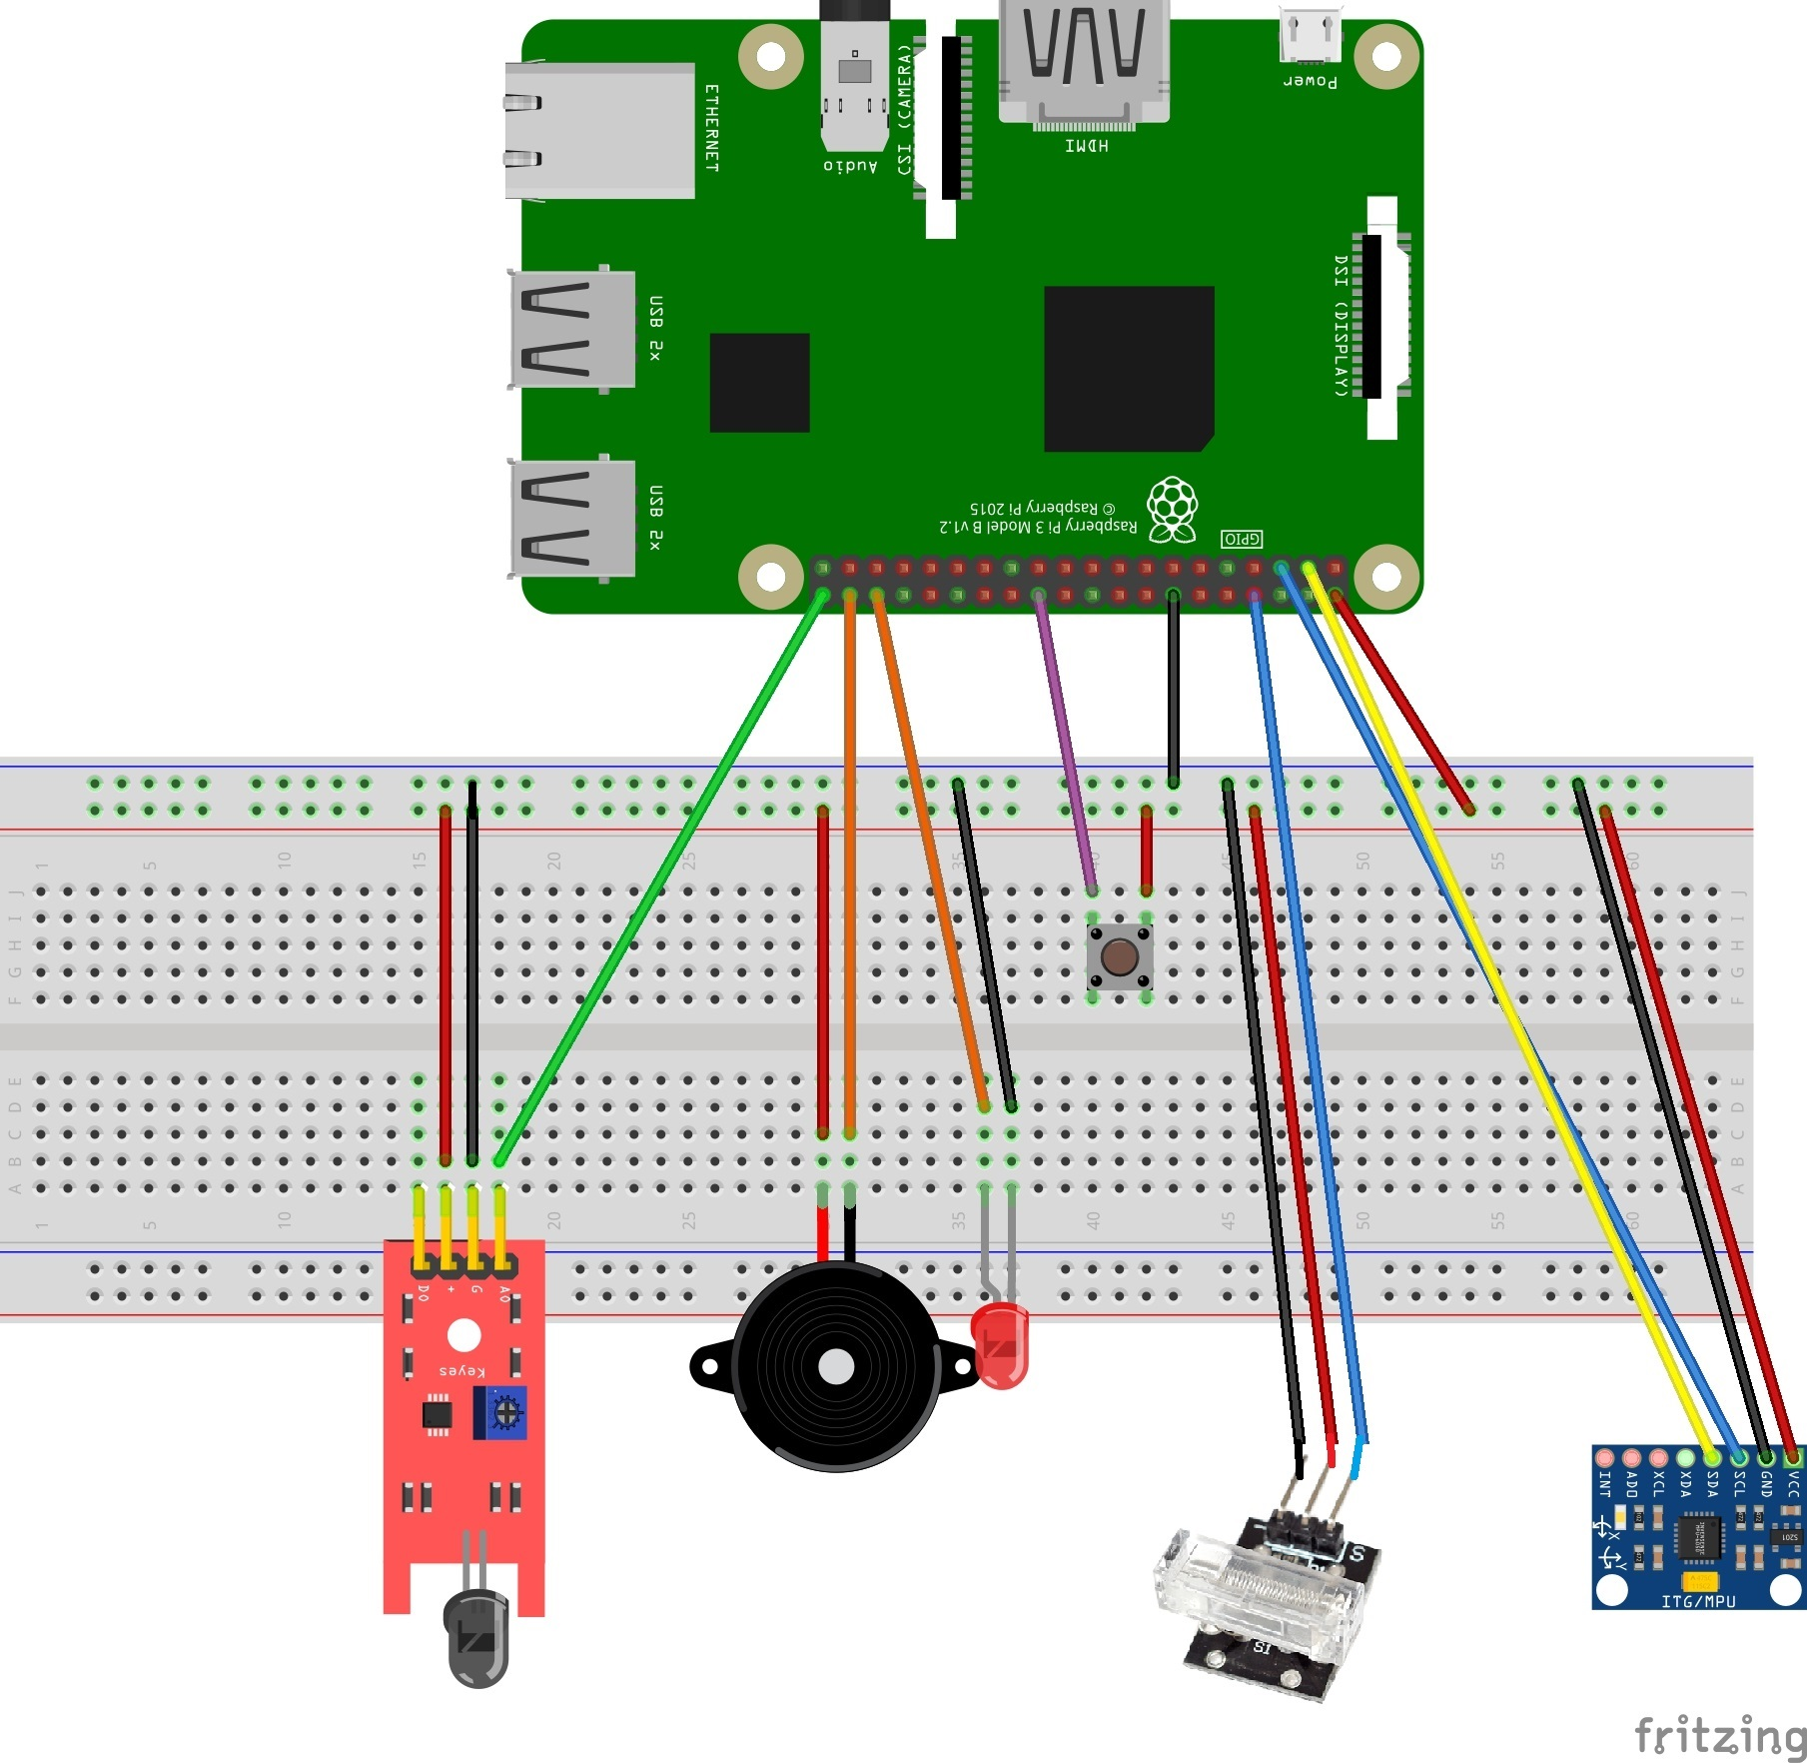
Fig. 3

The above figure (Fig. 3) shows the architectural interfacing of Raspberry pi with all the sensors used. Red jumper wires specify the the 5 volts vcc supply and black as ground. The given circuit can be mounted on the vehicle. The gyroscope should be mounted on the plane surface to provide a 0 degree angle of reference. Fire sensor should not be placed near the fuel tank or near the engine, so that no fake detection should occur due to increased temperature. Buzzer , led and push button should be placed near the driver for easy access.

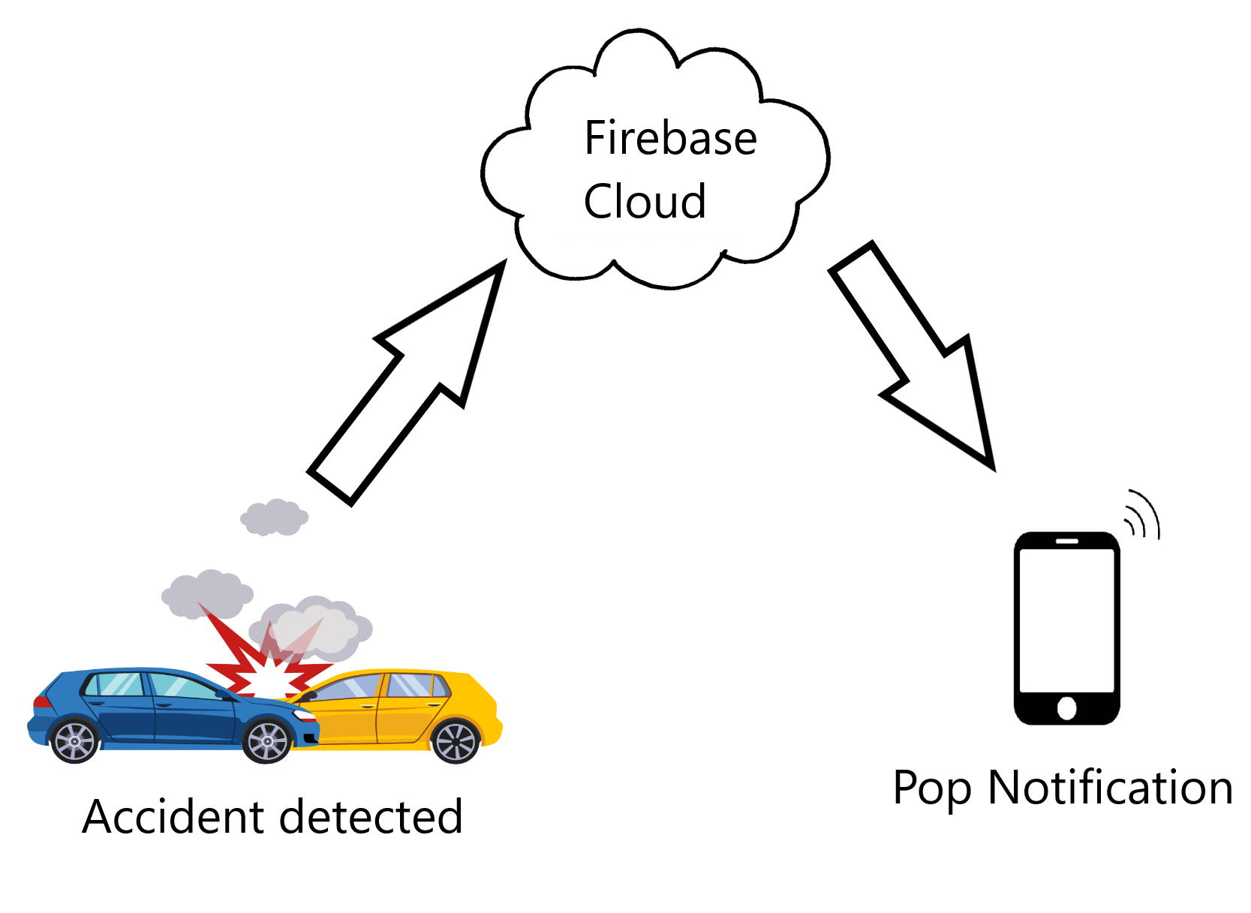
Fig. 4

The given figure (Fig. 4) shows the use of firebase cloud for collecting the real-time data. A simple binary variable flag is declared in the code, which will be set if any of the sensors detect an accident. The flag will in turn call a function which will update the firebase cloud. The cloud check the real time data if the flag is set or not. The cloud is interfaced with the emergency app and to pop a notification if any accident is detected.
No external GPS module is require to be installed. Using the riders phone as an GPS device reduces the cost and complexity of the whole system. Thus rider app gets the location form its own phone and send its coordinates to the emergency app in case of accident. Cloud in only used in case of accident detection. For location sharing, the app is developed in such a way that phone to phone transfer is done from rider’s app to the emergency app. The coordinates are then used by the emergency app. The emergency app has been interfaced with Google maps to show the riders current location. The app also has the facility to display all the hospitals and police station near the rider. This will result in quick response for taking further actions.

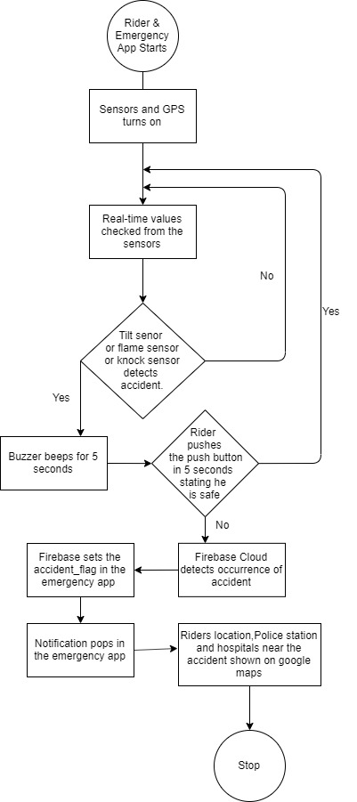
Fig. 5 show the flow chart of the accident detection system. After detecting any sort of accident by the senor the buzzer will beep. If the riders stops it by pressing a push button in 5 seconds, the system will detect that the rider is safe and no notification will be sent. If not then the system will detect accident and the emergency contact will be prompted with the pop notification. Further riders location, police stations and hospital near its location will be displayed.

This feature is provided in cases where the accident are not severe enough or in the case any sensor detects any accident by mistake. Thus enhancing the efficiency of the overall system.
Fig.5

Hardware Components | Prices(in Rupees)
- Raspberry Pi 3b | 3000
- Knock Sensor | 400
- MPU5060 Gyroscope | 150
- Flame Sensor | 120
- RGB Led | 110
- Bread Board | 90
- Push Button | 20
- Jumper wires | 20
- Buzzer | 50
10.Smart phone
3.4 Hardware and Software Requirement

Software used:-
1.Raspbian OS
2.Firebase Cloud
3.Android Studio

Senor used :-

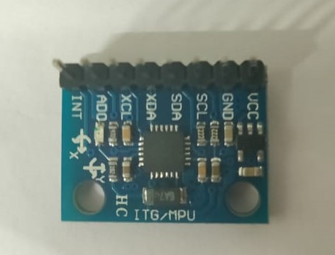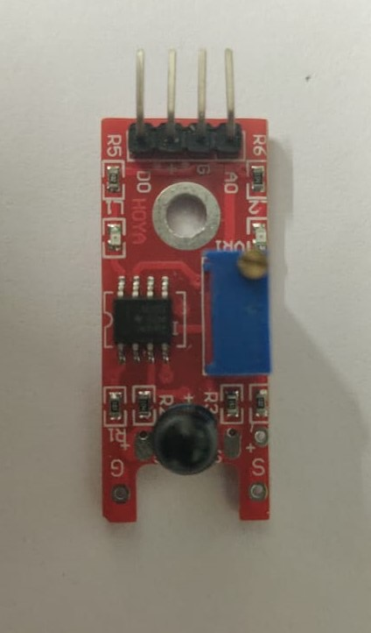
Fig. 5 - MPU5060 Gyroscope Fig. 6 - Flame Sensor

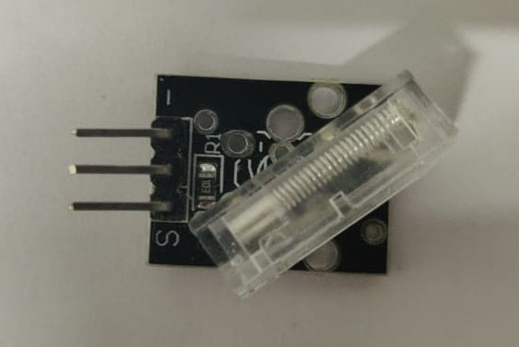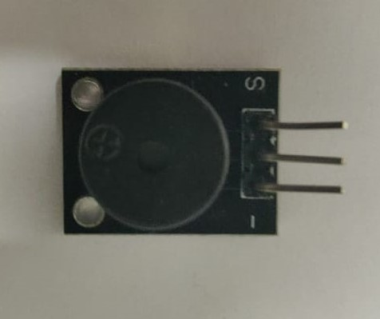
Fig. 7 - Knock Sensor Fig. 8 - Buzzer

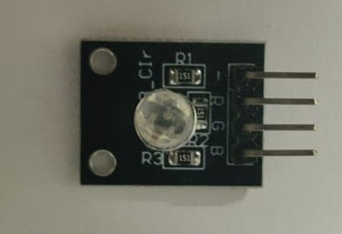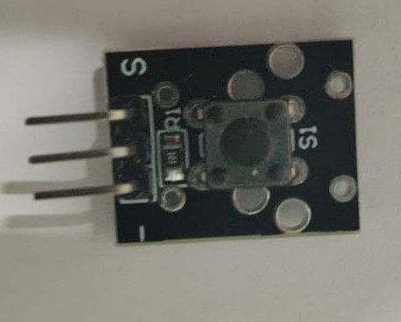

Fig. 9 - RGB led Fig. 10 - Push Button

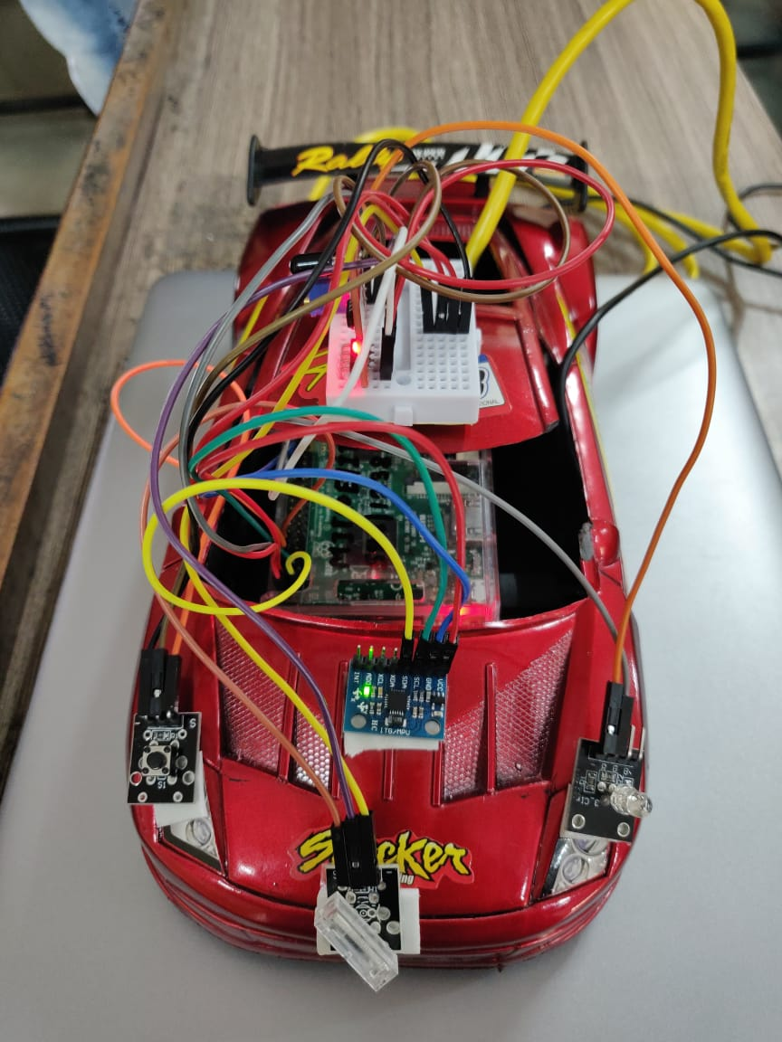
Fig. 11- Model with mounted sensors

3.4 Results obtained

The emergency application uses the location traced by the the riders application via his/her phones inbuilt GPS. Thus no external module is required in our system. The screenshots of the two applications(apks) is shown in the given figure. Fig.11 shows the Rider app interface and Fig.12 shows the Emergency app interface.

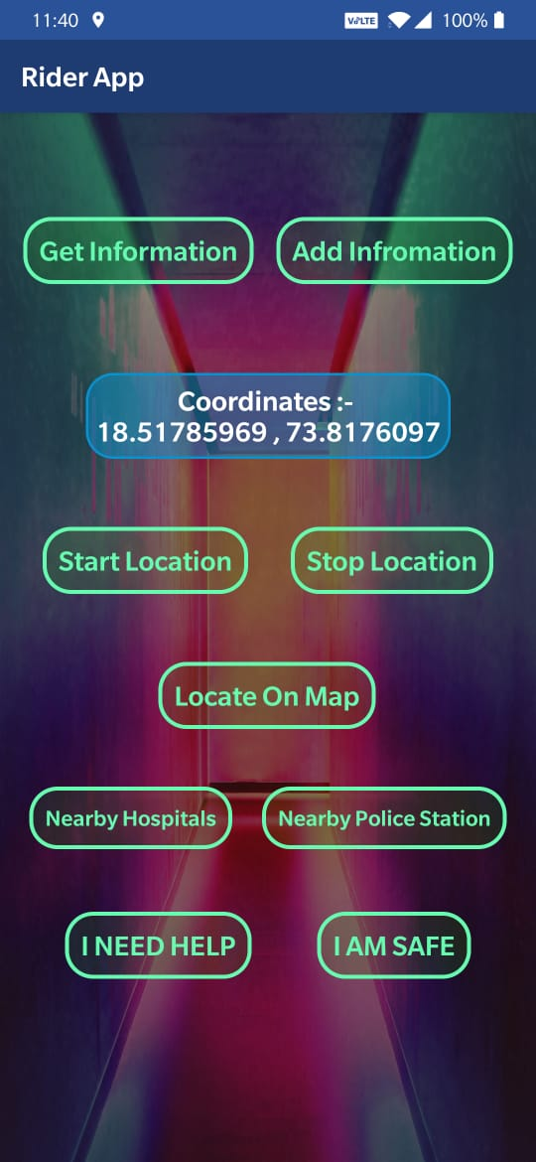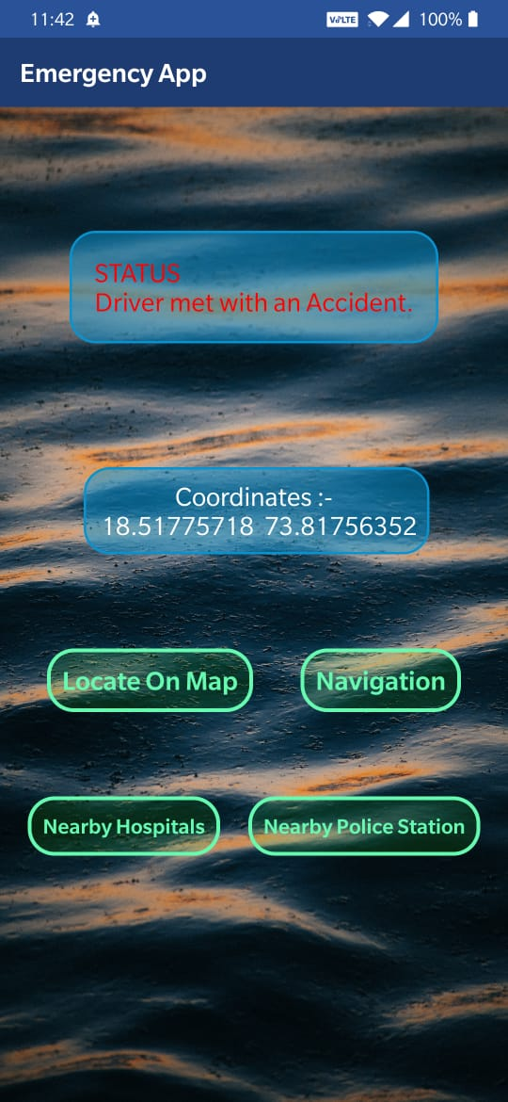
Fig. 11 - Emergency app Fig. 12 - Riders app

Whenever an accident is detected, the emergency app pops a notification stating that the driver has met with an accident. The emergency app also shows the location, hospitals nearby, police station nearby the riders location. Fig.13 show the pop notification, Fig. 14 shows the hospitals nearby and Fig. 15 shows the police station nearby.

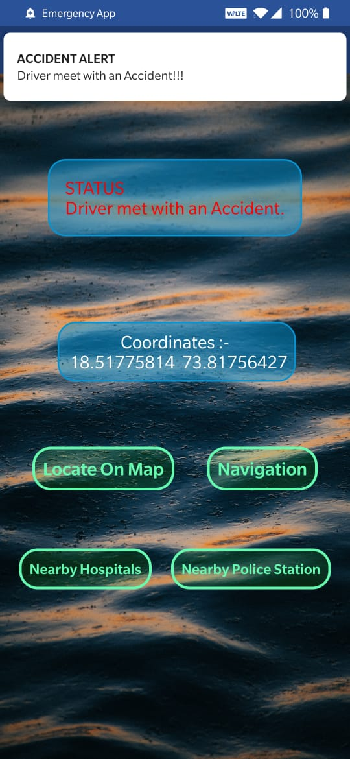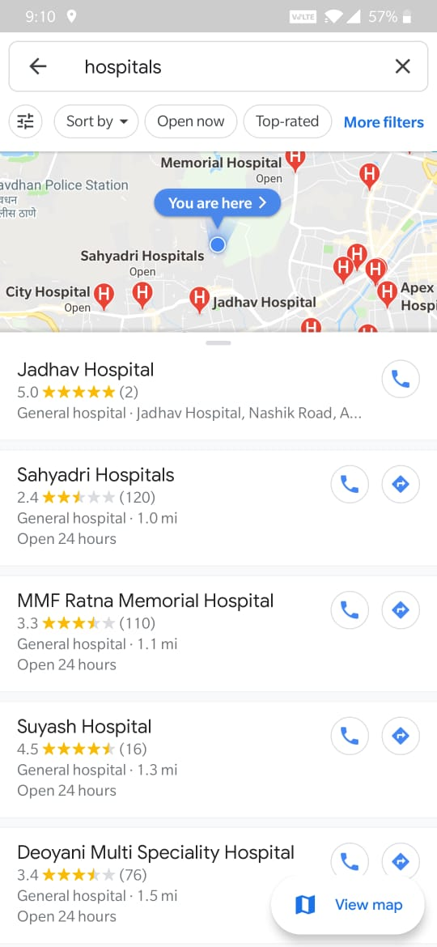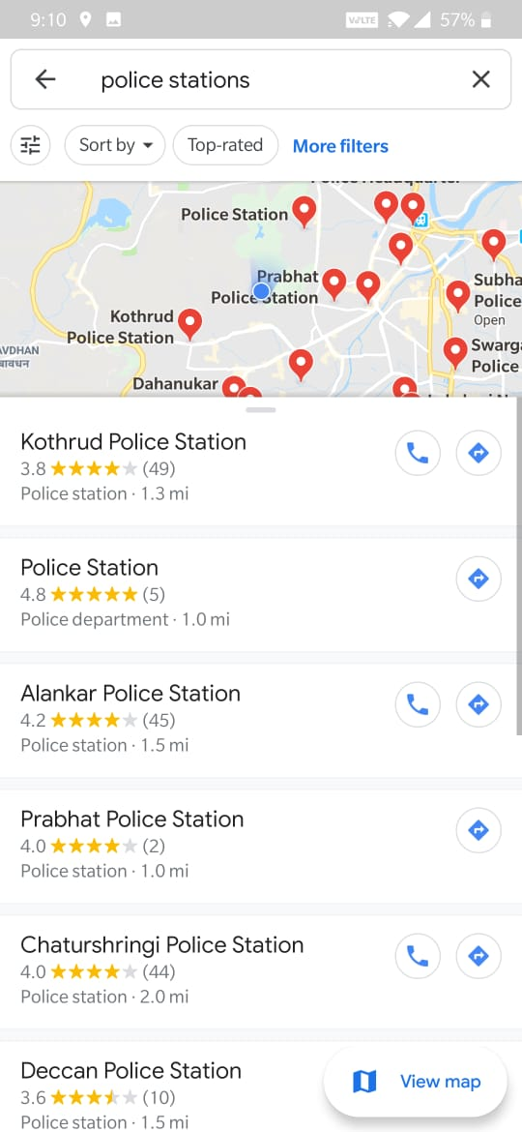
Fig. 13 Fig. 14 Fig. 15

4.Conclusion

In this project we have successfully designed a vehicle accident detection and tracking system by using raspberry pi, various sensors and an alert system with app notification to the user defined mobile numbers. The GPS tracking alert based algorithm is designed and implemented.Vehicle accident detection system can track geographical information automatically and sends an alert notification regarding accident with all hospitals and police stations nearby the mishap.

Experimental work has been carried out carefully. The result shows that higher sensitivity and accuracy is indeed achieved using this project. Thus the project is user friendly and reliable to be used in an vehicle..Our system will be connected as an integral part with vehicle’s computer unit and in a fixed protected place to avoid damages in case of accident.Also the proposed system can also be used for traffic estimation and accidents survey in a country by health department with slight modifications.

5.References

- A Public Health Perspective of Road Traffic Accidents by S. Gopalakrishnan - https://www.ncbi.nlm.nih.gov/pmc/articles/PMC3893966/

- Overview of Road Accidents in India , Available on https://www.prsindia.org/policy/vital-stats/overview-road-accidents-india

- “ Vehicle Accident Detection and Alerting System” by International Journal for Research in Applied Science & Engineering Technology (IJRASET) ISSN: 2321-9653; IC Value: 45.98; SJ Impact Factor:6.887 Volume 6 Issue I, January 2018- Available at www.ijraset.com

4. Accident detection system using GSM module and Bluetooth - by Vikram Singh Kushwaha,Deep Tadav,IJERGS May-June 2015

5. http://www.ijerd.com/paper/vol10-issue4/Version_4/B1042528.pdf

