Below is the Image for Next Screen C:\Users\kpemmaraju\eclipse-workspace\TestNGProjectUsingTestListner\test-output\Screenshots\For NewAddressBookHomePage_339122019131238.png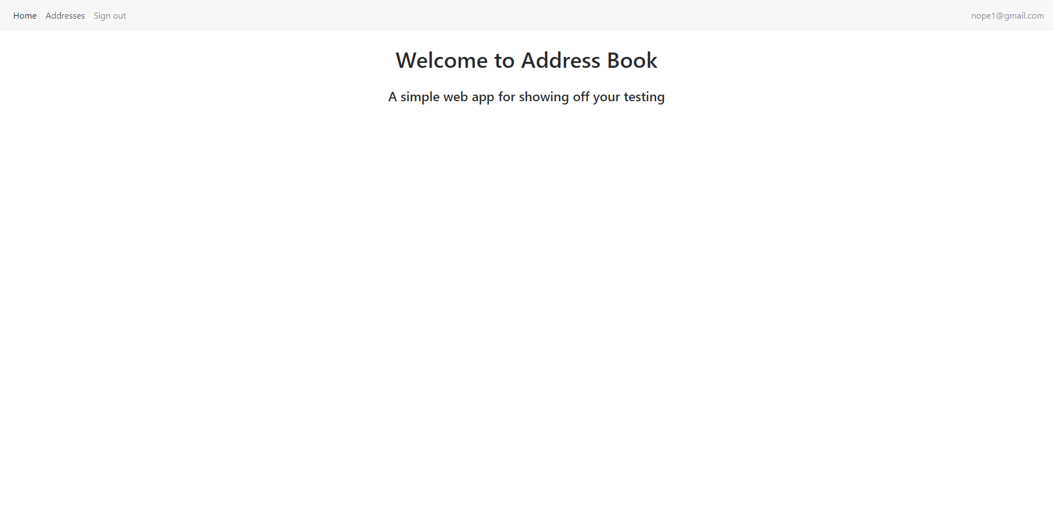

Below is the Image for Next Screen C:\Users\kpemmaraju\eclipse-workspace\TestNGProjectUsingTestListner\test-output\Screenshots\After_NewAddressFillingData_3391220191312316.png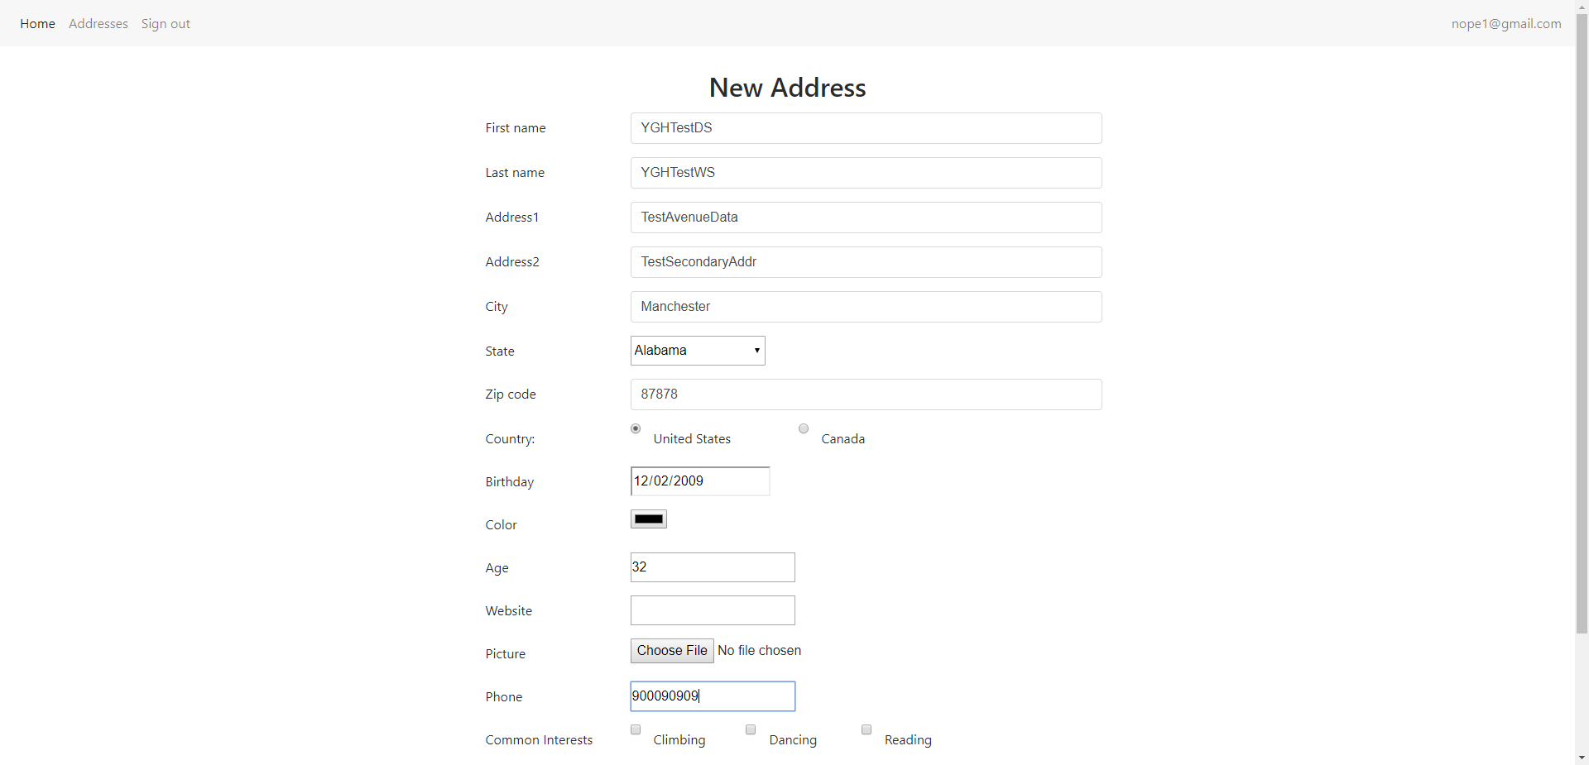

Below is the Image for Next Screen C:\Users\kpemmaraju\eclipse-workspace\TestNGProjectUsingTestListner\test-output\Screenshots\After_NewAddressSuccessMessage_3391220191312984.png