Screenshot 0  
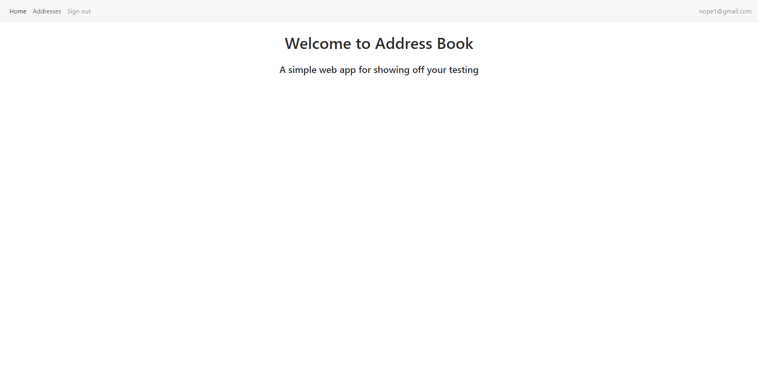  
  
Screenshot 1  
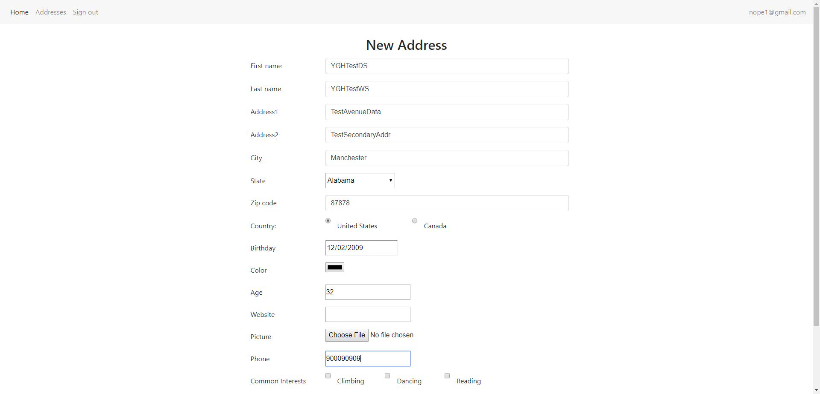  
  
Screenshot 2  
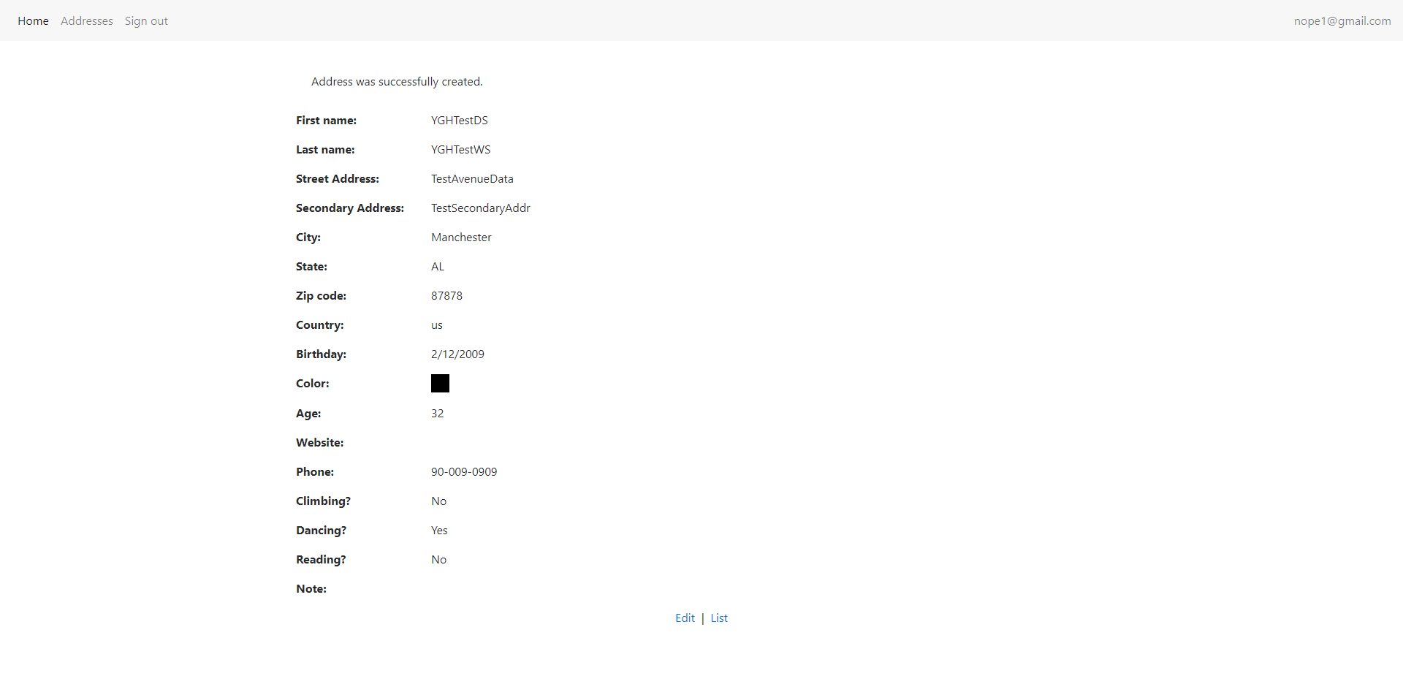  
FYI The Document is available under - C:\Users\kpemmaraju\eclipse-workspace\TestNGProjectUsingTestListner\test-output\NewAddressDataLink\NewAddressDataLink_05122019012039.docx