1.calculator

activity_main.xml

<?xml version="1.0" encoding="utf-8"?>

<LinearLayout xmlns:android="http://schemas.android.com/apk/res/android"

xmlns:app="http://schemas.android.com/apk/res-auto"

xmlns:tools="http://schemas.android.com/tools"

android:layout_width="match_parent"

android:layout_height="match_parent"

android:orientation="vertical"

tools:context=".MainActivity">

<LinearLayout

android:layout_width="match_parent"

android:layout_height="wrap_content"

android:orientation="horizontal">

<TextView

android:id="@+id/textview1"

android:layout_width="138dp"

android:layout_height="match_parent"

android:layout_weight="1"

android:text="First number"

android:textSize="20sp" />

<EditText

android:id="@+id/ed_text1"

android:layout_width="wrap_content"

android:layout_height="wrap_content"

android:layout_weight="1"

android:ems="10"

android:inputType="number" />

</LinearLayout>

<LinearLayout

android:layout_width="match_parent"

android:layout_height="wrap_content"

android:orientation="horizontal">

<TextView

android:id="@+id/textView2"

android:layout_width="wrap_content"

android:layout_height="50dp"

android:layout_weight="1"

android:text="Second number"

android:textSize="20sp" />

<EditText

android:id="@+id/ed_text2"

android:layout_width="wrap_content"

android:layout_height="wrap_content"

android:layout_weight="1"

android:ems="10"

android:inputType="number" />

</LinearLayout>

<LinearLayout

android:layout_width="wrap_content"

android:layout_height="wrap_content"

android:orientation="horizontal">

<Button

android:id="@+id/button1"

android:layout_width="wrap_content"

android:layout_height="match_parent"

android:text="+" />

<Button

android:id="@+id/button2"

android:layout_width="wrap_content"

android:layout_height="wrap_content"

android:text="-" />

<Button

android:id="@+id/button3"

android:layout_width="wrap_content"

android:layout_height="wrap_content"

android:text="*" />

<Button

android:id="@+id/button4"

android:layout_width="wrap_content"

android:layout_height="wrap_content"

android:text="/" />

</LinearLayout>

<LinearLayout

android:layout_width="match_parent"

android:layout_height="match_parent"

android:orientation="horizontal">

<TextView

android:id="@+id/textView3"

android:layout_width="112dp"

android:layout_height="wrap_content"

android:layout_weight="1"

android:text="Result:"

android:textSize="20sp" />

<TextView

android:id="@+id/textView4"

android:layout_width="wrap_content"

android:layout_height="wrap_content"

android:layout_weight="1"

android:text="0"

android:textSize="20sp" />

</LinearLayout>

</LinearLayout>

MainActivity.java

package com.example.calculator;

import androidx.appcompat.app.AppCompatActivity;

import android.os.Bundle;

import android.view.View;

import android.widget.Button;

import android.widget.EditText;

import android.widget.TextView;

import android.widget.Toast;

public class MainActivity extends AppCompatActivity {

EditText ed1;

EditText ed2;

Button b1;

Button b2;

Button b3;

Button b4;

Integer i1;

Integer i2;

Integer RES = 0;

TextView n4;

@Override

protected void onCreate(Bundle savedInstanceState) {

super.onCreate(savedInstanceState);

setContentView(R.layout.activity_main);

// Initialize EditTexts

ed1 = findViewById(R.id.ed_text1);

ed2 = findViewById(R.id.ed_text2);

// Initialize Buttons

b1 = findViewById(R.id.button1);

b2 = findViewById(R.id.button2);

b3 = findViewById(R.id.button3);

b4 = findViewById(R.id.button4);

// Initialize TextView

n4 = findViewById(R.id.textView4);

// Set onClickListeners for buttons

b1.setOnClickListener(new View.OnClickListener() {

@Override

public void onClick(View v) {

performOperation("+");

}

});

b2.setOnClickListener(new View.OnClickListener() {

@Override

public void onClick(View v) {

performOperation("-");

}

});

b3.setOnClickListener(new View.OnClickListener() {

@Override

public void onClick(View v) {

performOperation("*");

}

});

b4.setOnClickListener(new View.OnClickListener() {

@Override

public void onClick(View v) {

performOperation("/");

}

});

}

public void performOperation(String operation) {

// Error handling for empty input fields

if (ed1.getText().toString().isEmpty() || ed2.getText().toString().isEmpty()) {

n4.setText("Error: Please enter both numbers");

return;

}

// Parse the numbers

try {

i1 = Integer.parseInt(ed1.getText().toString());

i2 = Integer.parseInt(ed2.getText().toString());

} catch (NumberFormatException e) {

n4.setText("Error: Invalid number format");

return;

}

switch (operation) {

case "+":

RES = i1 + i2;

break;

case "-":

RES = i1 - i2;

break;

case "*":

RES = i1 * i2;

break;

case "/":

if (i2 == 0) {

n4.setText("Error: Divide by zero");

return;

}

RES = i1 / i2;

break;

default:

n4.setText("Error: Unknown operation");

return;

}

n4.setText("Result: " + RES);

}

}

OUTPUT

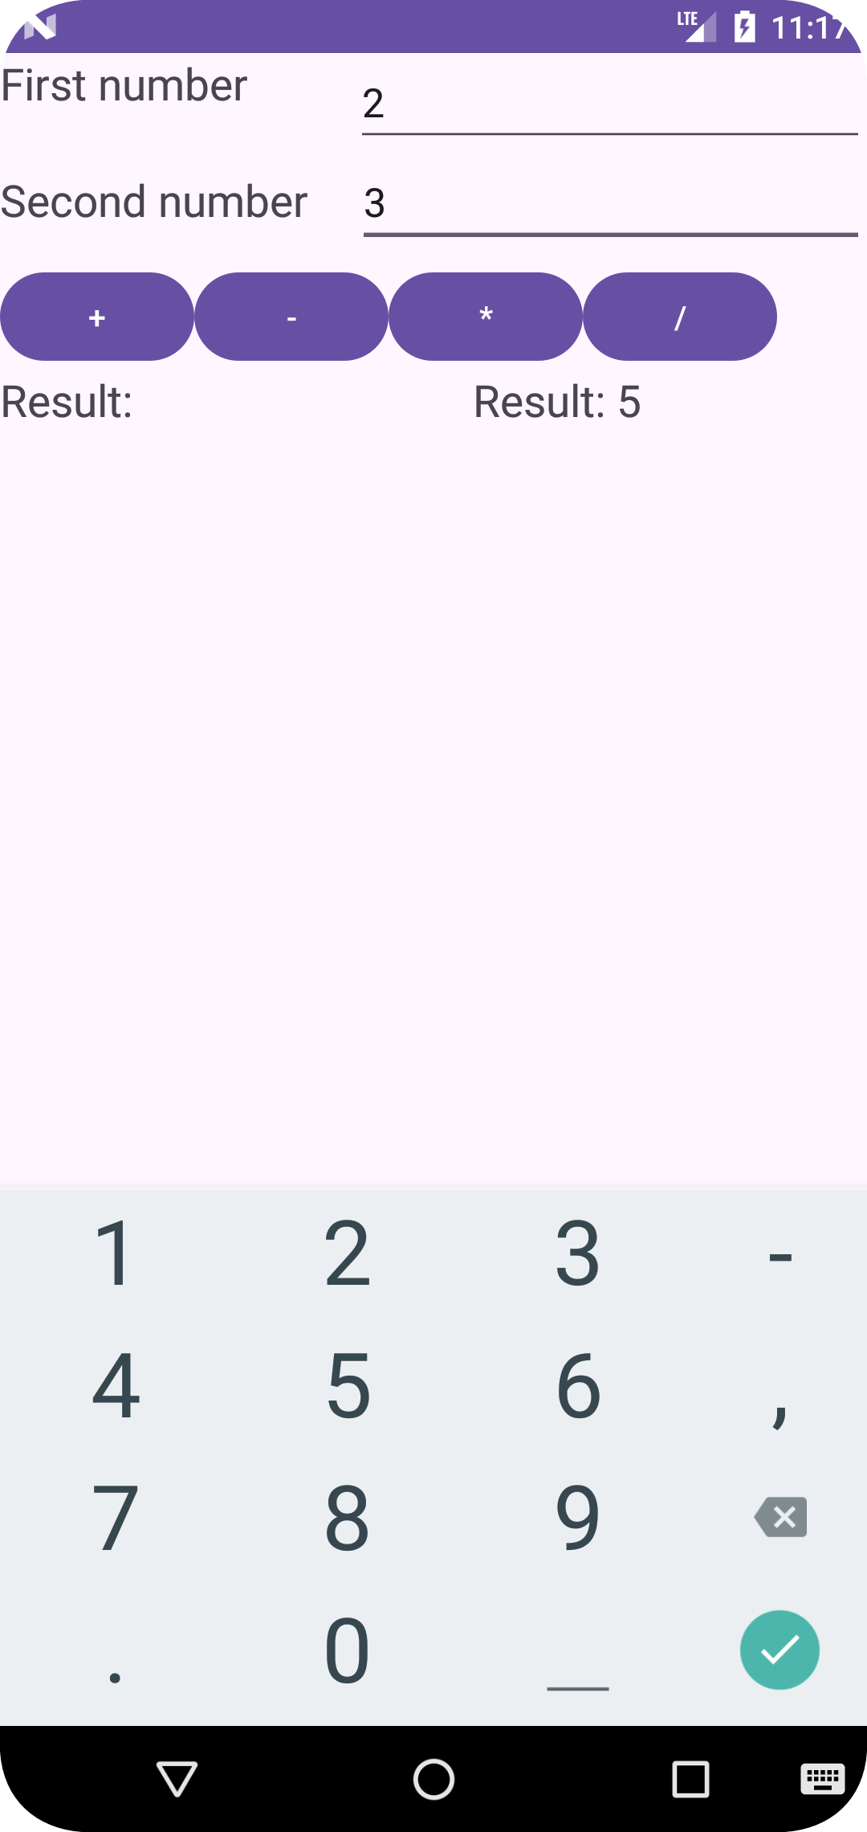

2.LOGIN FORM

activity-main.xml

<?xml version="1.0" encoding="utf-8"?>

<androidx.constraintlayout.widget.ConstraintLayout xmlns:android="http://schemas.android.com/apk/res/android"

xmlns:app="http://schemas.android.com/apk/res-auto"

xmlns:tools="http://schemas.android.com/tools"

android:id="@+id/text"

android:layout_width="match_parent"

android:layout_height="match_parent"

android:textAlignment="center"

tools:context=".MainActivity">

<LinearLayout

android:layout_width="match_parent"

android:layout_height="match_parent"

android:orientation="vertical">

<TextView

android:id="@+id/textView"

android:layout_width="match_parent"

android:layout_height="wrap_content"

android:text="LOGIN"

android:textAlignment="center"

android:textSize="20sp" />

<EditText

android:id="@+id/txt_uname"

android:layout_width="match_parent"

android:layout_height="wrap_content"

android:ems="10"

android:hint="Username"

android:inputType="text" />

<EditText

android:id="@+id/txt_pwd"

android:layout_width="match_parent"

android:layout_height="wrap_content"

android:ems="10"

android:hint="password"

android:inputType="textPassword" />

<Button

android:id="@+id/btn_login"

android:layout_width="match_parent"

android:layout_height="wrap_content"

android:text="Button" />

</LinearLayout>

</androidx.constraintlayout.widget.ConstraintLayout>

MainActivity.java

package com.example.myapplication1;

import androidx.appcompat.app.AppCompatActivity;

import android.os.Bundle;

import android.view.View;

import android.widget.Button;

import android.widget.EditText;

import android.widget.TextView;

import android.widget.Toast;

public class MainActivity extends AppCompatActivity {

TextView textView;

EditText txt_uname;

EditText txt_pwd;

Button btn_login;

@Override

protected void onCreate(Bundle savedInstanceState) {

super.onCreate(savedInstanceState);

setContentView(R.layout.activity_main);

textView = findViewById(R.id.textView);

txt_uname = findViewById(R.id.txt_uname);

txt_pwd = findViewById(R.id.txt_pwd);

btn_login = findViewById(R.id.btn_login);

btn_login.setOnClickListener(new View.OnClickListener() {

@Override

public void onClick(View v) {

String username = txt_uname.getText().toString();

String password = txt_pwd.getText().toString();

Toast.makeText(MainActivity.this, "Username: " + username + "\nPassword: " + password, Toast.LENGTH_LONG).show();

//Toast.makeText(MainActivity.this, "Login successfully", Toast.LENGTH_SHORT).show();

}

});

}

}

OUTPUT

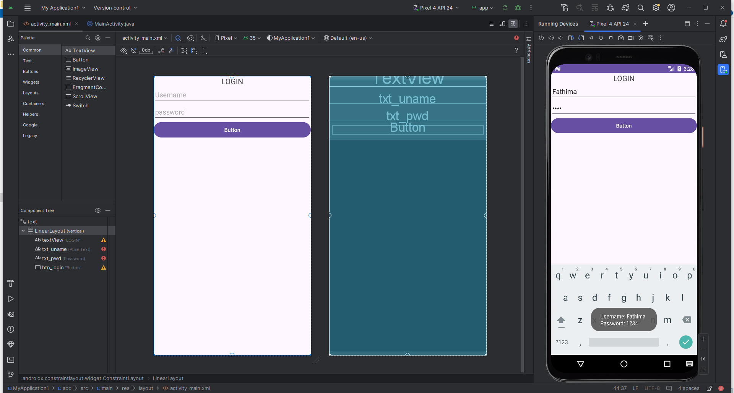

3.Android lifecycle

Activity_main.xml

<?xml version="1.0" encoding="utf-8"?>

<androidx.constraintlayout.widget.ConstraintLayout xmlns:android="http://schemas.android.com/apk/res/android"

xmlns:app="http://schemas.android.com/apk/res-auto"

xmlns:tools="http://schemas.android.com/tools"

android:layout_width="match_parent"

android:layout_height="match_parent"

tools:context=".MainActivity">

<TextView

android:layout_width="wrap_content"

android:layout_height="wrap_content"

android:text="Hello World!"

app:layout_constraintBottom_toBottomOf="parent"

app:layout_constraintEnd_toEndOf="parent"

app:layout_constraintStart_toStartOf="parent"

app:layout_constraintTop_toTopOf="parent" />

</androidx.constraintlayout.widget.ConstraintLayout>

MainActivity.java

import android.widget.Toast;

public class MainActivity extends AppCompatActivity {

@Override

protected void onCreate(Bundle savedInstanceState) {

super.onCreate(savedInstanceState);

setContentView(R.layout.activity_main);

Toast.makeText(this, "created", Toast.LENGTH_SHORT).show();

}

@Override

protected void onStart() {

super.onStart();

Toast.makeText(this, "START", Toast.LENGTH_SHORT).show();

}

@Override

protected void onPause() {

super.onPause();

Toast.makeText(this, "PAUSED", Toast.LENGTH_SHORT).show();

}

@Override

protected void onResume() {

super.onResume();

Toast.makeText(this, "Resume", Toast.LENGTH_SHORT).show();

}

@Override

protected void onStop() {

super.onStop();

Toast.makeText(this, "stopped", Toast.LENGTH_SHORT).show();

}

}

OUTPUT

