L2:

Steps:

1. Login to IAM console

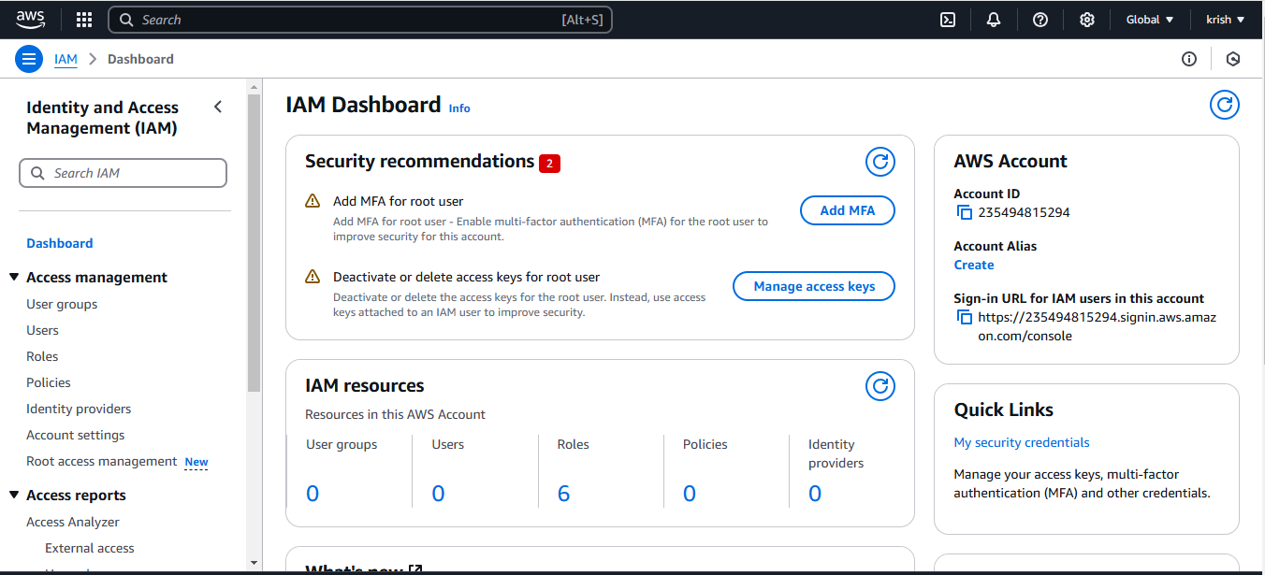

1. Go to Users and Create User

Create username and click on Next

Click on add user to group

Create group

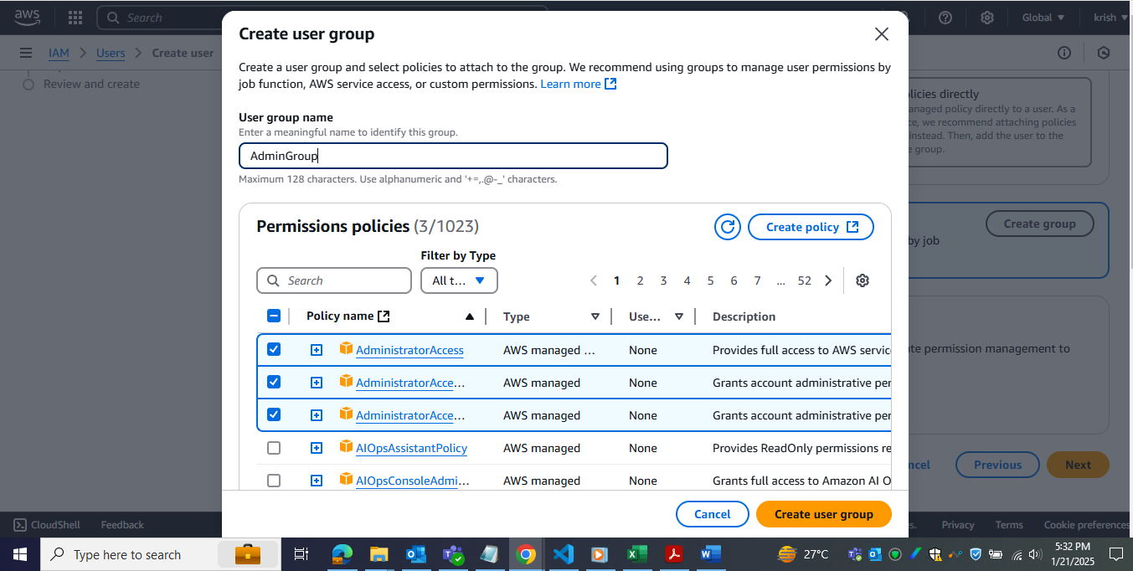

Click on review and create

