Name : Krishnapriya N
Emp ID:284273
Email ID:284273@ust.com

- Program
// Online Java Compiler
// Use this editor to write, compile and run your Java code online
import java.util.Scanner;

class IncreasingNumber {
private static boolean isIncreasingNumber(int input){
final String Method2_name ="Is Increasing numbers";
System.out.println("I am from Method :"+Method2_name);
int num=input%10;
input=input/10;
while(input>0){
if(num <= input%10){
return false;
}
num=input%10;
input=input/10;
}
System.out.println("End of Method :"+Method2_name);
return true;
}
public static int countOfIncreasingNumbers(int[] input){
System.out.println("I am from Method : Count if Increasing numbers");
int count=0;
if(input.length == 0 || input == null){
count=0;
}
else{
for(int i=0;i<input.length;i++){
if (input[i]>0){
if (isIncreasingNumber(input[i])){
count=count+1;
}
}
else{
return -1;
}

}
}

System.out.println("End of Method : Count if Increasing numbers");
return count;
}
public static void main(String[] args) {
System.out.println("I am from Main Method");
Scanner sc= new Scanner(System.in);
System.out.println("Enter the length of the Array");
int num=sc.nextInt();
int[] arr =new int[num];
System.out.println("Enter the numbers in the Array");
for (int i=0;i<num;i++){
arr[i]=sc.nextInt();
}

System.out.println("Count of Increasing Numbers : "+countOfIncreasingNumbers(arr));

}
}

OUTPUT and TEST cases

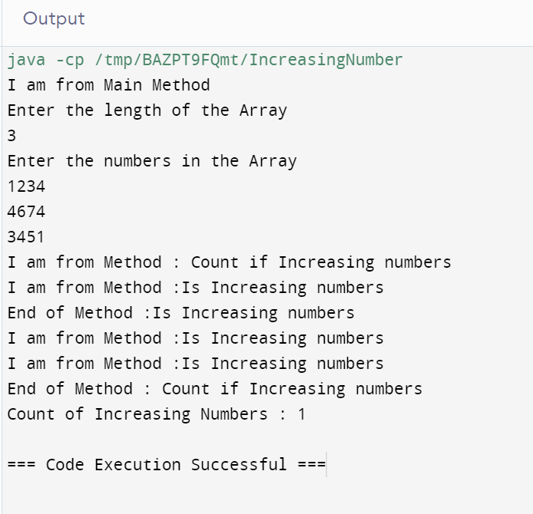

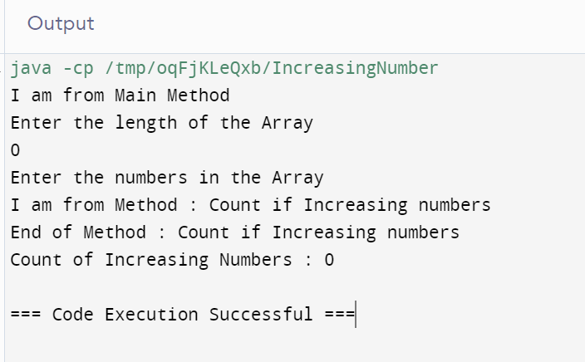

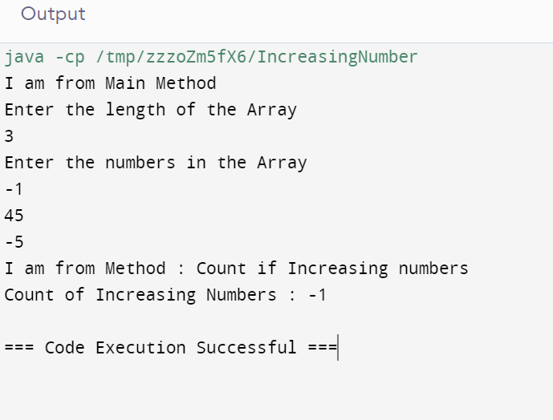

2. // Online Java Compiler
// Use this editor to write, compile and run your Java code online
import java.util.Scanner;

class SumofUnique {

public static int sumOfUniqueNumbers(int[] input){
System.out.println("I am from Method : Sum of Unique numbers");
int count=0,sum=0;
if(input.length == 0 || input == null){
sum=0;
}
else{
for(int i=0;i<input.length;i++){
if (input[i]>0){
int j=i+1;
for(;j<input.length;j++){
if(input[i] == input[j]){
break;

}

}
if(j==input.length){
sum=sum+input[i];
System.out.println(count+" "+sum);
}
count=0;

}
else{
return -1;
}

}
}

System.out.println("End of Method : Sum of Unique numbers");
return sum;
}
public static void main(String[] args) {
System.out.println("I am from Main Method");
Scanner sc= new Scanner(System.in);
System.out.println("Enter the length of the Array");
int num=sc.nextInt();
int[] arr =new int[num];
System.out.println("Enter the numbers in the Array");
for (int i=0;i<num;i++){
arr[i]=sc.nextInt();
}

System.out.println("Sum of Unique Numbers : "+sumOfUniqueNumbers(arr));

}
}

Output

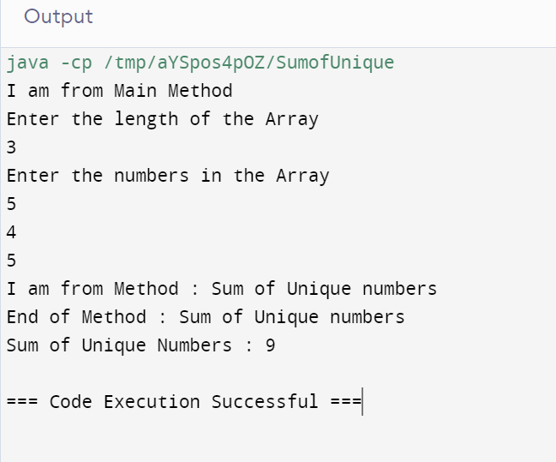

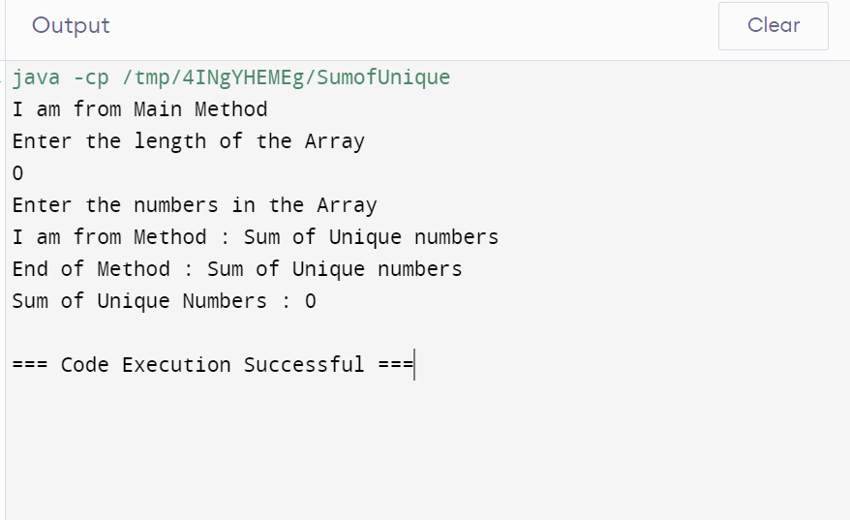

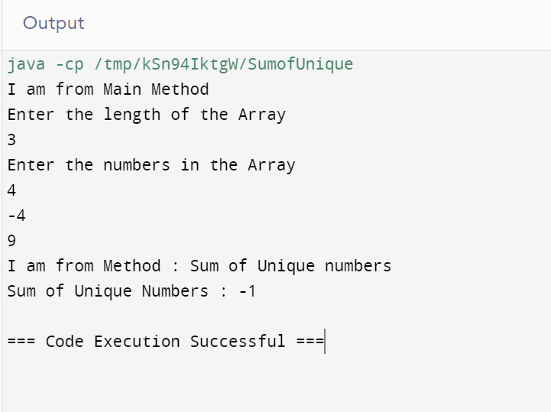
3. Java is Simple. Because it is syntax like C++. Java does not have any pointers. JIT is helping to achieve high performance without pointers.
4.In java main method is running and, in the background, there is a process garbage collector also running.
5. In Java there is no pointers.80 % of the complexity are solved by without pointer. It is platform independent, portable and secure. Java class files are saved by the extension .class. .class files are secure. It is not vulnerable.
6.Encapsulation: Wrapping up of data and methods into one. It is mainly using by the class. In the Class concept we can define the variables and functions in another file. By using packages, we can retrieve the functions and variables.
Abstraction: To abstract the details with a single name. We can hide the details of the class by writing into another file. We can call the class by its name without exposing the class details.

7. Rules of Identifier
1. Names can contain alpha numeric characters (a-z,A-Z,0-9),Special Character(_).
2.It does not contain ‘- ‘.
3.It does not start with numerical, special characters.
4.It does not contain keywords.

8. Bottom to top approach
Code reusability
9. User defined data types
Objects, Strings, Arrays
We can define the size of this data types at the time of creations.
Strings and Arrays are mutable.

10. Storage Areas
1.Temporary Storage Areas
2.Permanent Storage Areas

Temporary Storage Areas : Registers, Variables, It can be removed with the help of garbage collector when not in use.

Permanent Storage Areas, Files, Databases and Data warehouse

