LAB CYCLE-1
1.Write a program to count a vowels, consonants, digits, and special characters in a string given as input
2. Write a program to find the largest and second largest element in a list.
3. Write a program to count word frequency using a dictionary
4. Write a program to sort dictionary by keys and the by values
5. Write a program using list comprehension to generate prime numbers

1.write a program to count a vowels, consonants, digits and special characters in a string given as input

string = input("Enter a string: ")
vowels = 0
consonants = 0
digits = 0
special = 0
for ch in string:
if ch.isalpha():
if ch.lower() in "aeiou":
vowels += 1
else:
consonants += 1
elif ch.isdigit():
digits += 1
else:
special += 1
print("Vowels:", vowels)
print("Consonants:", consonants)
print("Digits:", digits)
print("Special characters:", special)

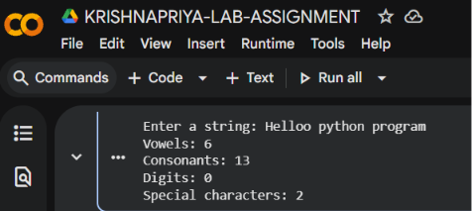

2.Write a program to find the largest and second largest elements in a list.

numbers = [10, 25, 8, 45, 32]
largest = second = float('-inf')
for num in numbers:
if num > largest:
second = largest
largest = num
elif num > second and num != largest:
second = num
print("Largest element:", largest)
print("Second largest element:", second)

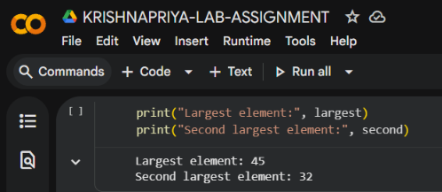

3.Write a program to count word frequency using a dictionary

text = input("Enter a sentence: ")
words = text.split()
frequency = {}
for word in words:
if word in frequency:
frequency[word] += 1
else:
frequency[word] = 1
print("Word Frequency:")
for word,count in frequency.items():
print(word, ":", count)

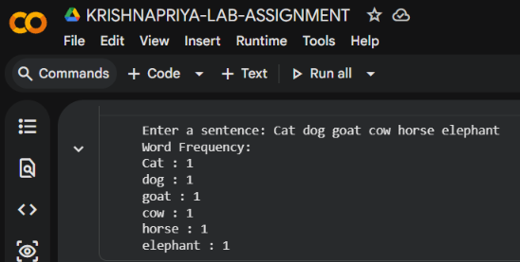

4.Write a program to sort dictionary by keys and the by values

d = {"banana": 3, "apple": 5, "orange": 2, "mango": 4}
# Sort by keys
print("Dictionary sorted by keys:")
for key in sorted(d):
print(key, ":", d[key])
# Sort by values
print("\nDictionary sorted by values:")
for key, value in sorted(d.items(), key=lambda x: x[1]):
print(key, ":", value)

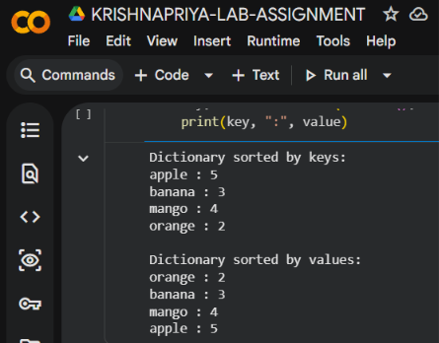

AIM:5-Write a program using list comprehension to generate prime numbers.

#USING LIST COMPREHENSION
def check_prime(num):
if(num<=1):
return False
for i in range(2,(num//2)+1):
if num%i==0:
return False
return True
#MAIN PROGRAM
l1=[]
limit=int(input("enter how many elements"))
for i in range(limit):
x=int(input("enter the element"))
l1.append(x)
prime_of_l1=[i for i in l1 if check_prime(i)]
print(f"The given list is",l1)
print(f"prime numbers of given list={prime_of_l1}")
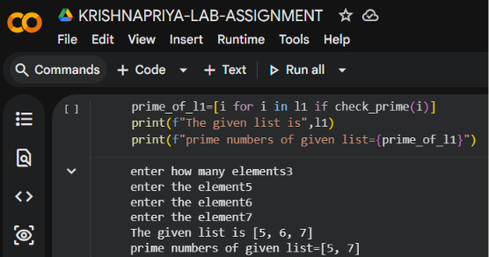
#WITHOUT USING LIST COMPREHENSION
def check_prime(num):
if(num<=1):
return False
for i in range(2,(num//2)+1):
if num%i==0:
return False
return True
#MAIN PROGRAM
l1=[]
limit=int(input("enter how many elements"))
for i in range(limit):
x=int(input("enter the element"))
l1.append(x)
print("The given list is",l1)
l2=[]
for i in l1:
if check_prime(i):
l2.append(i)
print("prime numbers=",l2)
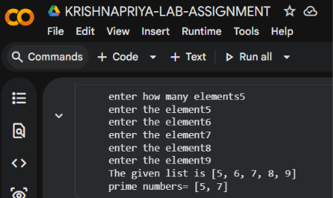
6. Write a program to generate Fibonacci series using loop

n = int(input("Enter the number of terms: "))
a = 0
b = 1
print("Fibonacci series:")
for i in range(n):
print(a, end=" ")
a, b = b, a + b

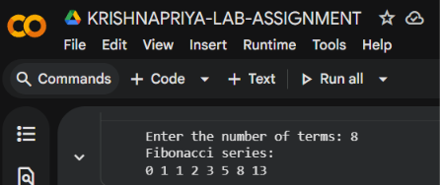

7. Sort strings by length using lambda function.

string=["apple","cat","banana","dog"]

sorted_strings=sorted(string,key=lambda x:len(x))

print("Strings sorted by length:")
print(sorted_strings)

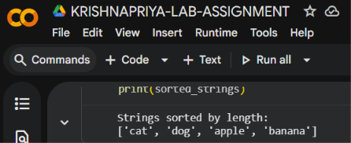

8. Sort dictionary using multiple values and lambda function.

students = {
"Asha": (85, 90),
"Binu": (75, 95),
"Cathy": (85, 80),
"Deepa": (75, 85)
}

sorted_students = dict(sorted(students.items(), key=lambda x: (x[1][0], x[1][1])))

print(sorted_students)

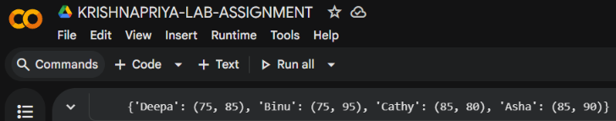

9.a)write a program to demonstrate polymorphism using function overloading andoperator overloading.
b)write a program to demonstrate Inheritance and polymorphism.

class ComplexNumber:
real=0
img=0
def __init__(self,rel,ig):
self.real=rel
self.img=ig
def display(self):
print(f"The complex number= {self.real}+{self.img}i")
def __add__(self,other):
real=self.real+other.real
img=self.img+other.img
c3=ComplexNumber(real,img)
return c3
#return complex number(real,img)
def __mul__(self,other):
real=self.real*other.real-self.img*other.img
img=self.real*other.img+self.img*other.real
return ComplexNumber(real,img)

#main program
print("sum of these=")
c1=ComplexNumber(5,3)
c2=ComplexNumber(2,3)
c1.display()
c2.display()

c3=c1+c2
c3.display()

print("product of these=")
c3=c1*c2
c3.display()

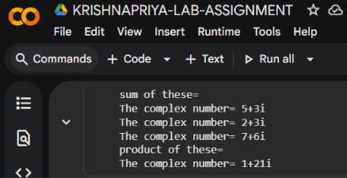

b)
class Person:
def __init__(self, name, department):
self.name = name
self.department = department

def display(self):
print("NAME:", self.name)
print("DEPARTMENT:", self.department)

class Student(Person):
def __init__(self, name, department, perc):
super().__init__(name, department)
self.perc = perc

def findgrade(self):
if self.perc >= 90:
print("Grade: A")
elif self.perc >= 80:
print("Grade: B")
elif self.perc >= 70:
print("Grade: C")
else:
print("Grade: D")
def display(self):
print("NAME:", self.name)
print("DEPARTMENT:", self.department)
print("PERCENTAGE:", self.perc)

class Teacher(Person):
def __init__(self, name, department, salary):
super().__init__(name, department)
self.salary = salary
def teach(self):
print(self.name, "has salary")
print(self.salary)

s1 = Student("KRISHNA", "BCA", 97)
s2 = Student("JESSU", "BBA", 87)

t1 = Teacher("MAAKKU", "BBA", 130000)
t2 = Teacher("KEETHU", "BCA", 100000)

s1.findgrade()
s1.display()

s2.findgrade()
s2.display()

print("-" * 20)

t1.display()
t1.teach()

t2.display()
t2.teach()

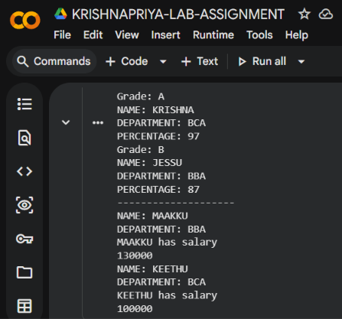

10. Write a program to read and write text files .Use exceptions

try:
# Writing to a file
file = open("students.txt", "w")
file.write("krish- BCA - 99\n")
file.write("jess - BCA - 90\n")
file.close()
# Reading from the file
file = open("students.txt", "r")
data = file.read()
print("File Content:")
print(data)
file.close()

except FileNotFoundError:
print("File not found.")

except Exception as e:
print("An error occurred:", e)

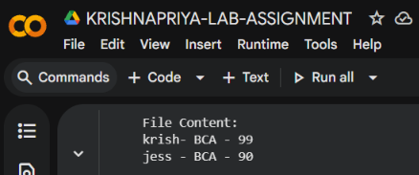

11. Write a Python program using Pandas
a. To create and analyze a student dataset containing student name,marks and grade.
b. Use the following data: data = { "Name": ["Aman", "Diya"," Rahul", "Sneha","Arjun"], "Marks": [78, 92, 85, 67, 74], "Grade": ["B", "A", "A","C", "B"]}
c. Perform the following operations:
i. Create a Pandas DataFrame using the given dataset.
ii. Display the complete dataset.
iii. Display the first 3 rows of the dataset.
iv. Check whether the dataset contains missing values.
v. Create a histogram showing mark distribution.
vi. Find median and standard deviation of marks.

import pandas as pd
import matplotlib.pyplot as plt

data = {"Name": ["Aman", "Diya", "Rahul", "Sneha", "Arjun"],
"Marks": [78, 92, 85, 67, 74],
"Grade": ["B", "A", "A", "C", "B"]}

student = pd.DataFrame(data)

print("COMPLETE DATASET:")
print(student)

print("FIRST 3 ROWS:")
print(student.head(3))

print("MISSING VALUES:")
print(student.isnull().sum())

plt.figure(figsize=(5, 3))
plt.hist(student["Marks"],
bins=7,
color="pink",
edgecolor="black")

plt.title("MARKS OF STUDENTS")
plt.xlabel("Marks")
plt.ylabel("No. of Students")
plt.show()

median = student["Marks"].median()
print("MEDIAN=", median)

std = student["Marks"].std()
print("STANDARD DEVIATION=", std)

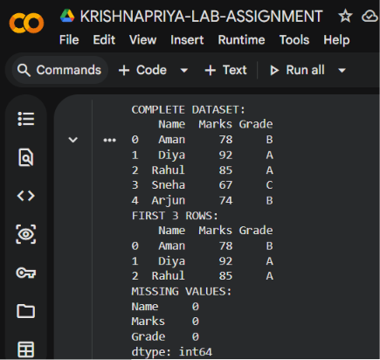
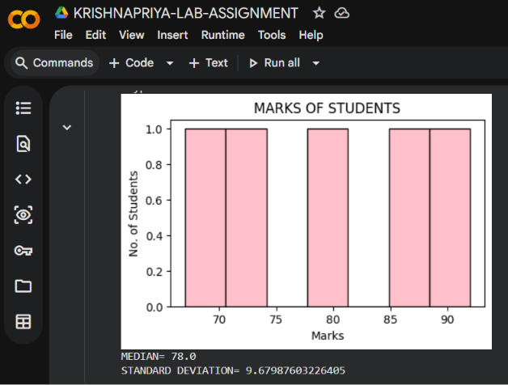

12. Create DataFrame from the given:
a.data = {"Name": ["Aman","Diya","Rahul","Sneha",Arjun"],"Department":["CS", "IT", "CS", "ECE", "IT"], "Marks": [78, 92, 85, 67, 74], "Attendance":[85, 90, 88, 75, 80], "Grade": ["B", "A", "A", "C", "B"]}.
b. Display Dataset Information
c. Display Statistical Summary
d. Display only student names and marks
e. Display students scoring more than 80 marks.
f. Sort students based on marks in descending order.
g. Add a new column named “Bonus” containing: 5 marks bonus for every student.

import pandas as pd
data = {
"Name": ["aman", "diya", "rahul", "sneha", "arjun"],
"Department": ["CS", "IT", "CS", "ECE", "IT"],
"Marks": [78, 92, 85, 67, 74],
"Attendance": [85, 90, 88, 75, 80],
"Grade": ["B", "A", "A", "C", "B"]
}
df = pd.DataFrame(data)
print("DataFrame Information:")
print(df.info())
print("\nStatistical Summary:")
print(df.describe())
print("\nStudent Name and Marks:")
print(df[["Name", "Marks"]])
print("\nStudents scoring more than 80:")
print(df[df["Marks"] > 80])
print("\nStudents sorted by Marks:")
print(df.sort_values(by="Marks", ascending=False))
df["Bonus"] = 5
print("\nDataFrame with Bonus:")
print(df)
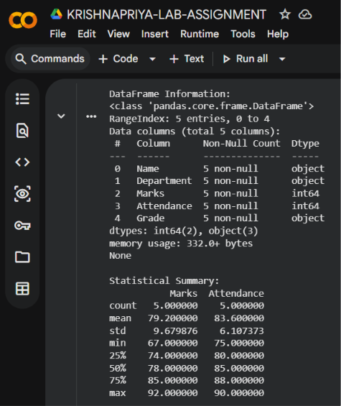
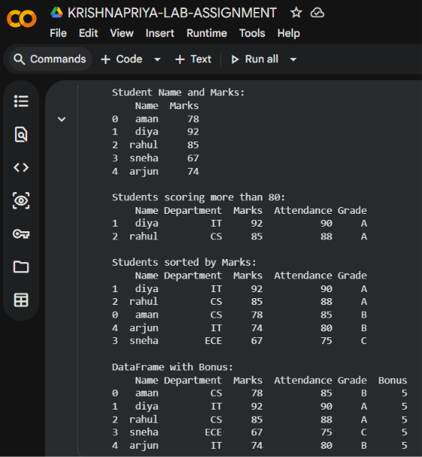

13. Using the above dataframe answer the following questions.
a. Create a new column named “Total” by adding marks and bonus.
b. Find average marks department-wise.
c. Count the number of students in each grade category.
d. Calculate: mean, median,standard deviation of student marks.
e. Display students having maximum attendance.
f. Increase marks of all students by 5.

df["Total"] = df["Marks"] + df["Bonus"]
print(df)

print(df.groupby("Department")["Marks"].mean())

print(df["Grade"].value_counts())

print("Mean:", df["Marks"].mean())

print("Median:", df["Marks"].median())

print("Standard Deviation:", df["Marks"].std())

print(df[df["Attendance"] == df["Attendance"].max()])

df["Marks"] = df["Marks"] + 5

print(df)
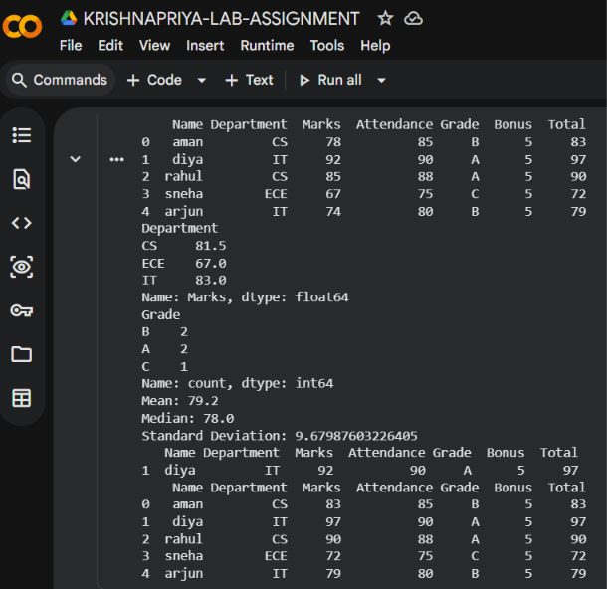

14. Write a Python program using Pandas to clean and preprocess the following student dataset. a. Perform the following operations:
i. Create a DataFrame containing student details.
ii. Identify missing values in the dataset.
iii. Replace missing values in the Marks column using the mean value.
iv. Remove duplicate rows from the dataset.
v. Convert student names into uppercase.
vi. Rename the column Marks to Score.
vii. Display the cleaned dataset.

import pandas as pd
data = {
"Name": ["Aman", "Diya", "Rahul", "Sneha", "Arjun", "Aman"],
"Marks": [78, 92, None, 67, 74, 78],
"Grade": ["B", "A", "A", "C", "B", "B"]
}
df=pd.DataFrame(data)
print("Original Dataset:")
print(df)
print("\nMissing Values:")
print(df.isnull().sum())
mean_marks=df["Marks"].mean()
df["Marks"]=df["Marks"].fillna(mean_marks)
df=df.drop_duplicates()
df["Name"]=df["Name"].str.upper()
df=df.rename(columns={"Marks":"Score"})
print("\nCleaned Dataset:")
print(df)

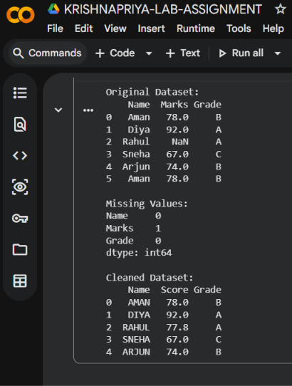

15. Plot simple mathematical functions.[y=3x^2+4x]

import matplotlib.pyplot as plt

x = range(-10, 11)
y = [3*i**2 + 4*i for i in x]

plt.plot(x, y)
plt.xlabel("x")
plt.ylabel("y")
plt.title("y = 3x^2 + 4x")
plt.show()
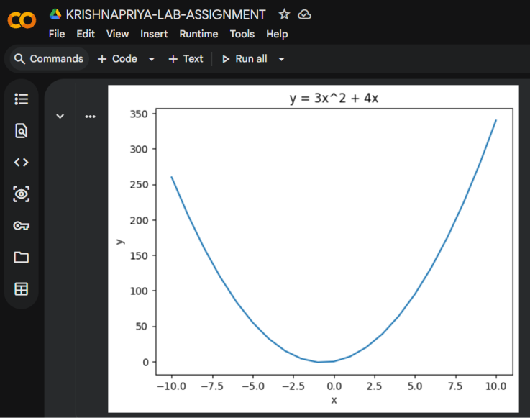
16. Create simple login form using streamlit

import streamlit as st

st.title("Login Form")

username = st.text_input("Username")
password = st.text_input("Password", type="password")

if st.button("Login"):
if username == "admin" and password == "1234":
st.success("Login Successful")
else:
st.error("Invalid Username or Password")

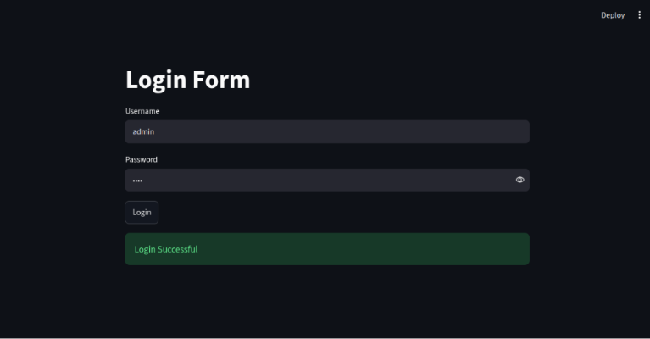
17. Create student registration form using streamlit

import streamlit as st

st.title("Student Registration Form")

name = st.text_input("Enter Name")
age = st.number_input("Enter Age", min_value=1,max_value=100)
course = st.selectbox("Select Course", ["BCA", "BBA", "BCom"])
gender = st.radio("Select Gender", ["Male", "Female", "Other"])
email = st.text_input("Enter Email")

if st.button("Register"):
st.success("Registration Successful")
st.write("Name:", name)
st.write("Age:", age)
st.write("Course:", course)
st.write("Gender:", gender)
st.write("Email:", email)
