CREATE TABLE BANK_50 (
bankcode VARCHAR(3) PRIMARY KEY,
bankname VARCHAR(50) NOT NULL,
headoffice VARCHAR(50),
branches INT CHECK (branches > 0)
);

INSERT INTO BANK_50 VALUES ('SBI', 'State Bank of India', 'Mumbai', 22000);
INSERT INTO BANK_50 VALUES ('HDF', 'HDFC Bank', 'Ernakulam', 6000);
INSERT INTO BANK_50 VALUES ('ICI', 'ICICI Bank', ‘Ernakulam', 5000);
INSERT INTO BANK_50 VALUES ('PNB', 'Punjab National Bank', 'New Delhi', 10000);
INSERT INTO BANK_50 VALUES ('CAN', 'Canara Bank', 'Bangalore', 9000);

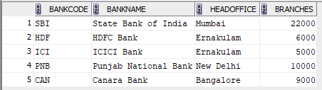

CREATE TABLE BRANCH (
branchid INT PRIMARY KEY,
branchname VARCHAR(50) DEFAULT 'New Delhi',
bankid VARCHAR(3),
FOREIGN KEY (bankid) REFERENCES BANK(bankcode)
);

INSERT INTO BRANCH VALUES (1, 'Kochi', 'SBI');
INSERT INTO BRANCH VALUES (2, 'Ernakulam', 'HDF');
INSERT INTO BRANCH VALUES (3, 'Chennai', 'ICI');
INSERT INTO BRANCH VALUES (4, 'Delhi', 'PNB');
INSERT INTO BRANCH VALUES (5, 'Bangalore', 'CAN');
INSERT INTO BRANCH (branchid, bankid) VALUES (6, 'SBI');
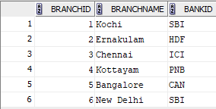

1.CREATE VIEW bank_head_office AS
SELECT *
FROM BANK_50
WHERE headoffice = 'Ernakulam';
SELECT * FROM bank_head_office;
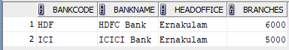

2. CREATE VIEW bank_branch AS
SELECT BR.* FROM BANK_50 B
JOIN BRANCH BR ON B.bankcode = BR.bankid
WHERE BR.branchname = 'Kottayam';
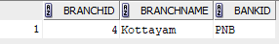

3. CREATE VIEW bank_more_than_50 AS SELECT * FROM BANK_50 WHERE branches>50;
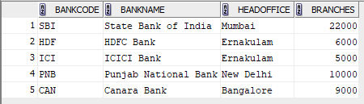

4. CREATE VIEW bank_branch_details AS
SELECT B.bankname, BR.branchname
FROM BANK_50 B
JOIN BRANCH BR ON B.bankcode = BR.bankid;
SELECT * FROM bank_branch_details;
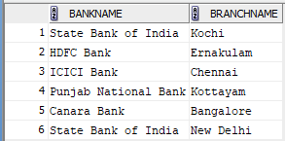

5. CREATE VIEW banks_outside_ernakulam AS
SELECT * FROM BANK_50
WHERE headoffice <> 'Ernakulam';
The condition <> 'Ernakulam' means not equal to Ernakulam
SELECT * FROM banks_outside_ernakulam;
