CREATE TABLE BANK (BANKCODE VARCHAR(3), BANKNAME VARCHAR(50) NOT NULL, HEADOFFICE VARCHAR(50), BRANCHES INT NOT NULL CHECK(BRANCHES>0), PRIMARY KEY (BANKCODE));

INSERT INTO BANK VALUES('SBT', 'SBI BANK', 'DELHI', 30);
INSERT INTO BANK VALUES('CNB', 'CANARA BANK' , 'ERNAKULAM' , 20);
INSERT INTO BANK VALUES('SIB' , 'SOUTH INDIAN BANK' ,'MADRAS' , 30);
INSERT INTO BANK VALUES('AXB','AXIS BANK', 'KOTTAYAM', 15);
INSERT INTO BANK VALUES('FDB', 'FEDERAL BANK', 'ERNAKULAM' , 25);

INSERT INTO BANK VALUES('IFB', 'INDIAN FEDERAL','ERNAKULAM', 25);
COMMIT;


SELECT * FROM BANK;

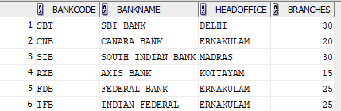

INSERT INTO BANK VALUES('ICL','ICL FINCORP','ERNAKULAM', 5);
SAVEPOINT A;



SELECT * FROM BANK;
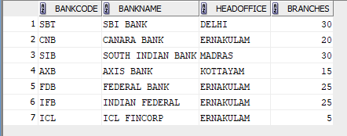

INSERT INTO BANK VALUES('GMB', 'GRAMEEN BANK', 'PUNE', 5);
SAVEPOINT B;



SELECT * FROM BANK;
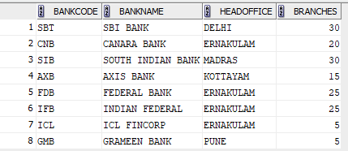

ROLLBACK TO B;

SELECT * FROM BANK;

