CREATE TABLE ITEMS_50( ITEMID INT PRIMARY KEY, ITEMNAME varchar(50),CATEGORY VARCHAR(50), PRICE INT ,INSTOCK INT CHECK(INSTOCK>=0));
CREATE TABLE CUSTOMERS_50(CUSTID INT PRIMARY KEY, CUSTNAME VARCHAR(50), ADDRESS VARCHAR(50), STATE VARCHAR(50));
CREATE TABLE ORDERS_50(ORDERID INT PRIMARY KEY, ITEMID INT, CUSTID INT, QUANTITY INT, ORDERDATE DATE, FOREIGN KEY (ITEMID)REFERENCES ITEMS_50(ITEMID), FOREIGN KEY (CUSTID)REFERENCES CUSTOMERS_50(CUSTID));
CREATE TABLE DELIVERY_50(DELIVERYID INT PRIMARY KEY, CUSTID INT, ORDERID INT, FOREIGN KEY (CUSTID) REFERENCES CUSTOMERS_50(CUSTID), FOREIGN KEY (ORDERID)REFERENCES ORDERS_50(ORDERID), STATUS VARCHAR(50));
SELECT * FROM DELIVERY_50;
DROP TABLE DELIVERY_50;

INSERT INTO ITEMS_50 VALUES (1, 'SAMSUNG GALAXY S4', 'Mobile', 6000, 10);
INSERT INTO ITEMS_50 VALUES (2, 'LAPTOP', 'Electronics', 45000, 5);
INSERT INTO ITEMS_50 VALUES (3, 'HEADPHONES', 'Accessories', 3000, 15);
INSERT INTO ITEMS_50 VALUES (4, 'SMART WATCH', 'Electronics', 8000, 7);
INSERT INTO ITEMS_50 VALUES (5, 'SHOES', 'footwear', 8000, 7);

INSERT INTO CUSTOMERS_50 VALUES(100,'MICKEY', 'STREET1','KARNATAKA');
INSERT INTO CUSTOMERS_50 VALUES(101,'JERRY', 'STREET2','GUJARAT');
INSERT INTO CUSTOMERS_50 VALUES(102,'AAMI', 'STREET3','KARNATAKA');
INSERT INTO CUSTOMERS_50 VALUES(103,'JACK', 'STREET4','KERALA');
INSERT INTO CUSTOMERS_50 VALUES(104,'CLARA', 'STREET5','GUJARAT');

INSERT INTO ORDERS_50 VALUES(10,1,100, 1,'12-2-2014');
INSERT INTO ORDERS_50 VALUES(11,2,101, 1,'22-7-2013');
INSERT INTO ORDERS_50 VALUES(12,3,102, 3,'8-12-2020');
INSERT INTO ORDERS_50 VALUES(13,4,103, 5,'12-12-2011');
INSERT INTO ORDERS_50 VALUES(14,5,104, 9,'10-1-2015');

INSERT INTO DELIVERY_50 VALUES (20,100,10,'DELIVERED');
INSERT INTO DELIVERY_50 VALUES(21,101,11,'NOT DELIVERED');
INSERT INTO DELIVERY_50 VALUES(22,102,12,'DELIVERED');
INSERT INTO DELIVERY_50 VALUES(23,103,13,'NOT DELIVERED');
INSERT INTO DELIVERY_50 VALUES(24,104,14,'DELIVERED');

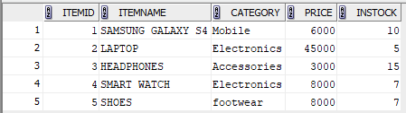

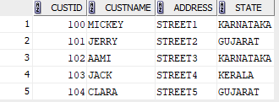

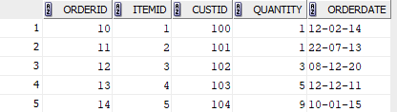

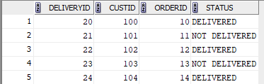

1.SELECT * FROM CUSTOMERS_50 WHERE CUSTID IN (
SELECT CUSTID FROM ORDERS_50 );

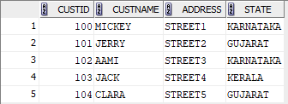

2. SELECT DISTINCT c.* FROM CUSTOMERS_50 cJOIN ORDERS_50 o ON c.CUSTID = o.CUSTID
JOIN DELIVERY_50 d ON o.ORDERID = d.ORDERID WHERE d.STATUS = 'DELIVERED';

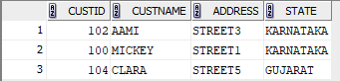

3. SELECT C.CUSTNAME, O.ORDERDATE FROM CUSTOMERS_50 C
JOIN ORDERS_50 O ON C.CUSTID = O.CUSTID WHERE C.CUSTNAME LIKE 'J%';

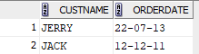

4. SELECT I.ITEMNAME, I.PRICE FROM CUSTOMERS_50 C JOIN ORDERS_50 O ON C.CUSTID = O.CUSTID JOIN ITEMS_50 I ON O.ITEMID = I.ITEMID WHERE C.CUSTNAME = 'MICKEY';

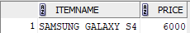

5. SELECT DISTINCT C.* FROM CUSTOMERS_50 C JOIN ORDERS_50 O ON C.CUSTID = O.CUSTID
LEFT JOIN DELIVERY_50 D ON O.ORDERID = D.ORDERID WHERE O.ORDERDATE > DATE '2013-01-31'
AND (D.STATUS <> 'DELIVERED' OR D.STATUS IS NULL);
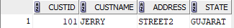

6. SELECT DISTINCT ITEMID FROM ORDERS_50 UNION SELECT DISTINCT O.ITEMID FROM ORDERS_50 O JOIN DELIVERY_50 D ON O.ORDERID = D.ORDERID WHERE D.STATUS <> 'DELIVERED';

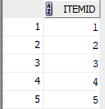

7. SELECT DISTINCT C.CUSTNAME FROM CUSTOMERS_50 C JOIN DELIVERY_50 D ON C.CUSTID = D.CUSTID WHERE D.STATUS = 'DELIVERED';

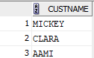

8. SELECT C.CUSTNAME FROM CUSTOMERS_50 C JOIN DELIVERY_50 D ON C.CUSTID = D.CUSTID WHERE D.STATUS = 'NOT DELIVERED';

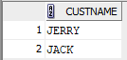

9.

