TABLE CREATION AND VALUE INSERTION

Answer 1
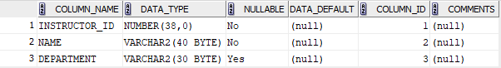

Answer 2
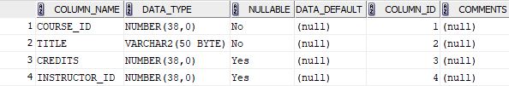

Answer 3
