CREATE TABLE STUDENTS ( sid INT PRIMARY KEY, sname VARCHAR(50), dept VARCHAR(50), marks INT);

SET SERVEROUTPUT ON;
SHOW SERVEROUT;

CREATE OR REPLACE TRIGGER trg_check1_marks
BEFORE INSERT ON STUDENTS
FOR EACH ROW
BEGIN
IF :NEW.marks < 0 THEN
RAISE_APPLICATION_ERROR(-20001, 'Marks cannot be negative');
END IF;
END;

INSERT INTO STUDENTS VALUES (1, 'Anu', 'CSE', 85);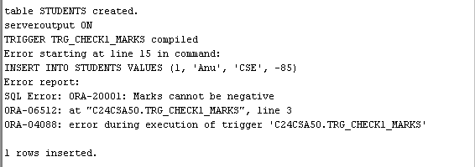

CREATE TABLE customer_details ( cust_id INT, cust_name VARCHAR(30),
address VARCHAR(30) );

CREATE TABLE emp_details ( empid INT, empname VARCHAR(30),salary INT);

CREATE TABLE cust_count ( count_row INT );

1.CREATE OR REPLACE TRIGGER tri
AFTER INSERT ON customer_details
FOR EACH ROW
BEGIN
DBMS_OUTPUT.PUT_LINE('A row is inserted');
END;

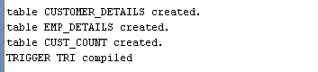

INSERT INTO customer_details (cust_id, cust_name, address) VALUES (1, 'Anu', 'Kochi');

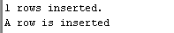

2. CREATE OR REPLACE TRIGGER trig
AFTER INSERT ON emp_details
FOR EACH ROW
WHEN (NEW.salary > 20000)
BEGIN
DBMS_OUTPUT.PUT_LINE('Salary is greater than 20000');
END;
/
INSERT INTO emp_details(empid, empname, salary) VALUES (2, 'Alen', 30000);
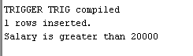

3. CREATE OR REPLACE TRIGGER trigg
BEFORE INSERT OR DELETE ON customer_details
FOR EACH ROW
BEGIN
IF DELETING THEN
UPDATE cust_count
SET count_row = count_row - 1;
ELSE
UPDATE cust_count
SET count_row = count_row + 1;
END IF;
IF SQL%ROWCOUNT = 0 THEN
INSERT INTO CUST_COUNT VALUES(1);
END IF;
END;

INSERT INTO customer_details VALUES (1, 'Anu', 'Kochi');
INSERT INTO customer_details VALUES (2, 'sara', 'Kottayam');
INSERT INTO customer_details VALUES (3, 'Elizabeth', 'Kozhikode');
INSERT INTO customer_details VALUES (4, 'Feba', 'Kochi');
DELETE FROM customer_details WHERE cust_id = 1;

SELECT * FROM cust_count;

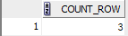

4. CREATE TABLE deleted (
empid INT,
empname VARCHAR(30),
salary INT
);

CREATE TABLE updated (
empid INT,
empname VARCHAR(30),
salary INT
);
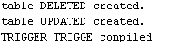
CREATE OR REPLACE TRIGGER trigge
BEFORE DELETE OR UPDATE ON emp_details
FOR EACH ROW
BEGIN
IF DELETING THEN
INSERT INTO deleted
VALUES (:OLD.empid, :OLD.empname, :OLD.salary);
ELSE
INSERT INTO updated
VALUES (:NEW.empid, :NEW.empname, :NEW.salary);
END IF;
END;

/
DELETE FROM emp_details WHERE empid = 2;
SELECT * FROM deleted;

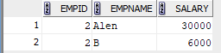

UPDATE emp_details
SET salary = 10000
WHERE empid = 1;
SELECT * FROM updated;

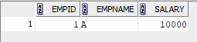

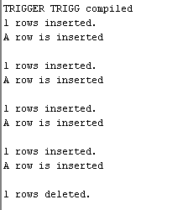
FUNCTION

1.set serveroutput on
show serveroutput
CREATE OR REPLACE FUNCTION factorial(n INT)
RETURN INT IS
fact INT := 1;
BEGIN
FOR i IN 1..n LOOP
fact := fact * i;
END LOOP;
RETURN fact;
END;
/
DECLARE
result INT;
BEGIN
result := factorial(5);
DBMS_OUTPUT.PUT_LINE ('Factorial is ' || result);
END;
/

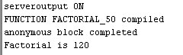

2. set serveroutput on
show serveroutput
CREATE OR REPLACE FUNCTION total_customers
RETURN NUMBER IS
total NUMBER := 0;
BEGIN
SELECT COUNT(*) INTO total FROM customers_seca_s2;
RETURN total;
END;
/
DECLARE
num NUMBER;
BEGIN
num := total_customers;
DBMS_OUTPUT.PUT_LINE('Total number of customers = ' || num);
END;
/
CREATE TABLE customers_seca_s2 (
cust_id NUMBER,
cust_name VARCHAR2(50)
);
INSERT INTO customers_seca_s2 VALUES (1, 'A');
INSERT INTO customers_seca_s2 VALUES (2, 'B');
COMMIT;

