**Data and Information for Each Page of the State Health Portal - DHS**

**Page 1**

* 1. What is New?

**1.1.1. Historical Triumph: 200 Government Health Centres get NQAS Recognition**

Two Hundred health institutions in the Kerala have received the National Quality Assurance Standards certification with three more institutions awarded the certification last week. All the tree centres qualified with a high score in all indictors. The State Government has prepared detailed road map to raise the quality of service delivery in its health centres in various category.

FHC Chinnakkanal (94.92 percent) in Idukki, FHC Vengappalli (89.65 percent) and Health and Wellness Centre, Muthanga both in Wayanad district are the latest ones to quality. The the certification has a there year validity, on the expiry of which there will be recertification process. The Family Health Centres will receive Rs. 2 Lakh and Health and Wellness centres will receive Rs. 18000 as grant.

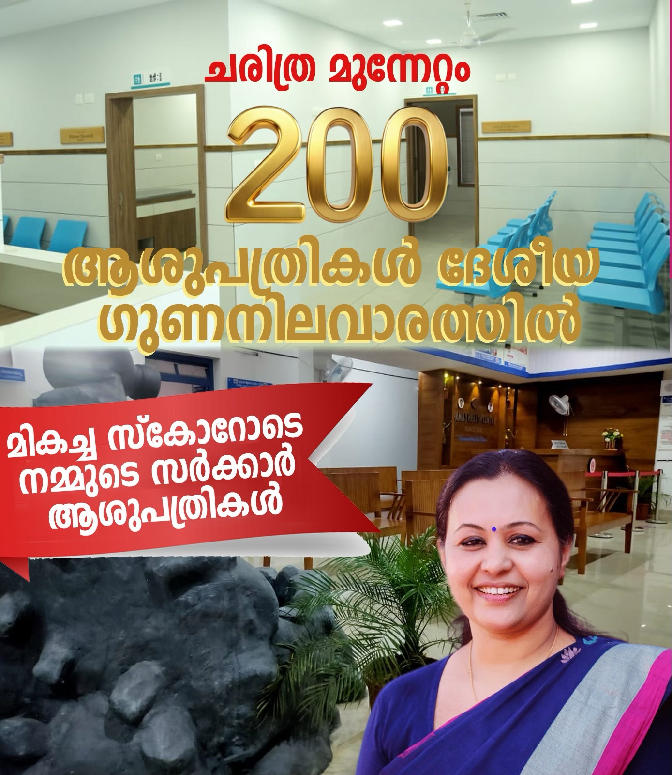

All the 200 NQAS accredited centres will provide services including dispensing of medicines and lab tests as per national standards.

**1.1.2. Health Minister Smt Veena George kick starts the LCDC Leprosy Case Detection Campaign (Aswamedham 6.0).**

Leprosy dates back to prehistory. It inflicted crores of humanity into a high level of dehumanization and death. The stamps of discrimination and stigma in social psyche continues to haunt humanity even today. But with the roll out of Muti Drug Therapy, complete cure is only a few months of compliance away. However Leprosy continues to be a problem eluding elimination for decades in India. But Kerala has been successful in bringing the cases down to 1 per lakh population (on the verge of elimination). The Sustainable Development Goals have put target 2030 for eradication of Mico Bacterium Leprae.

Leprosy Case Detection Campaign is an intensive 2 week campaign to detect the a sizable number of cases by screening all households in the State and bringing them to treatment. It starts on January 30 and ends on February 12, 2025. During the campaign phase, a trained female (ASHA) and a male volunteer visit the houses in their operational area and screen all the household members for symptoms of leprosy.

This is the 6th leg of the annual campaign that started in 2017. Aswamedham 6.0 is the name of the current leg of the campaign. The name Aswamedham has been taken from the name of a Malayalam movie that discussed the stigma and discrimination meted out to the leprosy patients in 1970s.

Even in Kerala case detection happens at a later stage after multiple patches and nerve involvement. And majority of the diagnosis is done at Medical Colleges (tertiary care setting) rather than in an FHC or HWC. Campaign should also alert the players in the system also to suspect cases more often.

‘Paadukal Nokkaam.. aroogyam kaakkam.. (Lets examine the patches, so as to protect our health) is the slogan for the campaign. The campaign places **Patches** at the centre stage of the campaign in order to remove the notion of **disfigurement** from the social psyche. It requires time to repair the social psyche, but once we are able to do it, the stigma removed, then public will be more amenable for screening and cases can be detected at an early stage.

The Health Department along with NHM has completed all preparation by training all the doctors, health workers and volunteers. All volunteers will carry a Flash Card that shows atypical symptoms, a referral slip to refer the suspected cases found in the screening and a tally sheet to record the findings.

Intensive IEC campaign by branding with a black horse in a deep blue background, poster, banner, promo videos by star celebrities, FAQ, social media clippings, messages for school assemblies, Volunteer badges, flash Card, demo house visit video, promo videos, curtain raiser reel etc. are part of State level campaign creatives. The Districts have also chipped in with equally good campaign tools like inten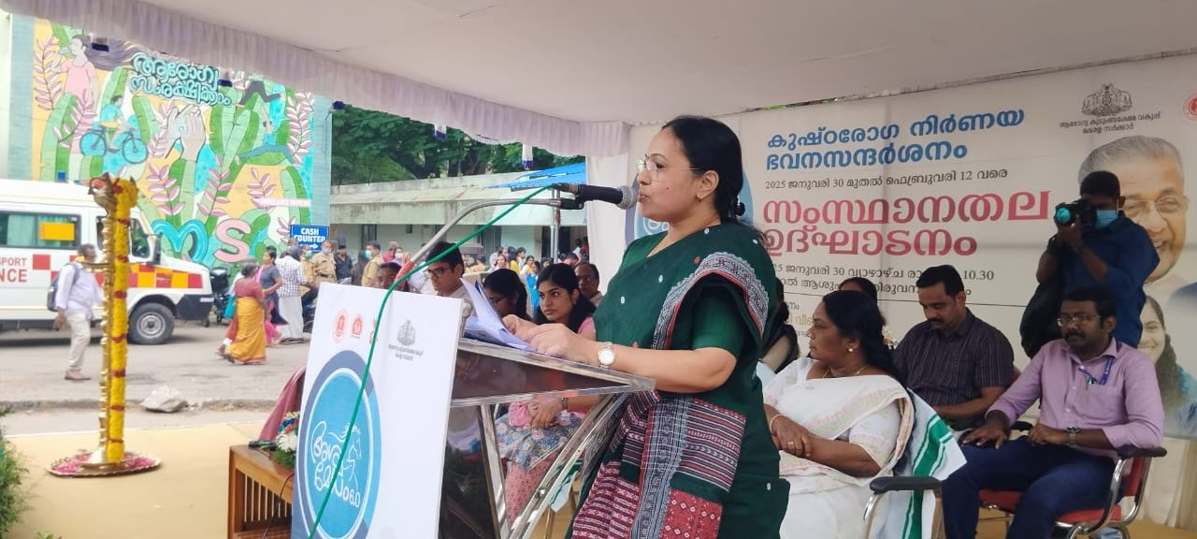se advocacy and social mobilisation with other departments, organisations, interactive radio programmes, TV scrolls, local celebrity bytes, cartoons etc are few to mention. All districts have been asked to streamline the Inter personal communication process that results in effective screening at houses.

**1.1.3. 100 days TB campaign in the State till March 17, 2025**

Tuberculosis (TB) is an infectious disease caused by a bacterium, *Mycobacterium tuberculosis* and usually spreads through respiratory droplets/droplet nuclei in the air. When these droplets are inhaled by a healthy person, she/he gets infected with tuberculosis. This infected person has a 10-15% lifetime risk of developing TB and a single patient (if not on treatment) can infect 10 or more people in a year.

The National TB Elimination Programme (NTEP) is a Centrally Sponsored Scheme, being implemented under the umbrella of National Health Mission (NHM) with vision of TB Free India, wherein free diagnostic and quality assured treatment are provided to all TB patients.

**NTEP Goal**

The goal of the NTEP is to achieve a rapid decline in the incidence and mortality of TB. The Government of India is aggressively pursuing the goal of advancing SDG targets to ending TB in India. Targets for achieving this ambitious goal are:

* 80% decline in annual TB incidence rate (from 2015 baseline)
* 90% decline in death due to TB (from 2015 baseline)
* Zero catastrophic expenditure due to TB

To achieve this ambitious goal, the programme is implementing a National Strategic Plan 2017-25. Key activities under the NTEP are

1. Early diagnosis of individuals with TB through high quality testing, and proactive community outreach to find missing cases in vulnerable population
2. Prompt treatment with quality assured drugs and treatment regimens including drug resistant TB
3. Engaging with the patients seeking care in the private sector.
4. Patient-centric treatment support and nutrition interventions through direct benefit transfer and Ni-kshay Mitra initiative
5. Contact tracing and TB preventive treatment among household contacts, children, PLHIV and in high risk /vulnerable populations.
6. Airborne infection control measures
7. Multi-sectoral response for addressing social determinants

India has made great strides in TB elimination efforts over the years. Since 2015, the annual TB incidence rate has declined by 18% and the mortality rate has declined 22% as of 2023. TB incidence rate has decreased from 237 cases per lakh population (in 2015) to 195 (in 2023). Similarly, TB death rate has decreased from 28 deaths per lakh population (in 2015) to 22 (in 2023).

## **Rationale of the campaign**

The progress made so far and to address the challenges in achieving SDG goals, there is a felt need for a renewed approach. The TB burden in India has wide variations in incidence ranging from 12 to 595 cases per lakh population across different geographies in the country. Also, the progress made on key performance indicators (KPIs) by the State/UTs also have wide variations. Hence, to accelerate efforts in finding missing cases, reducing TB deaths and prevention of new cases; a stratified approach has been designed to be implemented through this campaign. While routine programmatic activities will continue in all districts/blocks, the campaign specific focused interventions will be put in place in selected high focus districts for increased case detection, increased coverage of nutrition interventions (DBT + Nikshay Mitra + Jan Bhagidari) and increased awareness in the community towards importance of early detection and complete treatment of TB.

## **Goal & Importance of the campaign**

The Goals of the campaign are:

1. To increase case detection through intensified IEC campaign on community awareness and screening & testing of vulnerable populations
2. To reduce death among people with TB by implementing a differentiated TB care approach with nutritional support interventions
3. To prevent occurrence of new TB cases in the community by providing TB preventive treatment to household contacts, PLHIV & vulnerable populations

**1.1.4. Nirnaya Lab Network - A Hub and Spoke Model to become reality in three months.**

A Hub and Spoke model of Lab Network of all Government Hospitals is set to become a reality in the State in three months. Currently all the districts have functional network of primary, secondary and tertiary labs.

Once the Nirnaya system gets fully functional, the link containing the lab tests results will be sent to the registered mobile number of the patient. The software for this purpose is at a pilot stage.

This is part of the Ardram Mission of Nava Kerala Karma Padhathi of the State Government. IT will ensure that advanced lab tests are also included in the Government Hospital labs in optimum low/ subsidized costs.

All Health Centres at various levels such as Family, Health Centres, Block Family Health Centes, Thaluk Hospitals, District/ General Hospitals, Medical Colleges wil have a set of standardized number of lab tests across the State. Those tests that are not available at the respective facility will be transported to a higher facility where the test is available. And the results will be sent to the mobile number of the patient.

Internal Quality Control Committee and Lab Development Committees are in place at all levels to ensure the smooth sail of the initiative.

1.1.5 State releases Antibiogram for the year 2023

Kerala has released its antibiogram for the third consecutive year, reflecting the State’s commitment to strengthen the surveillance of antimicrobial resistance (AMR), which poses a significant threat to public health. The State’s antibiogram or the AMR surveillance report – the clinical data summarising the profile of various bacterial pathogens and its susceptibility to antibiotics – for the year 2023 was released by Health Minister Veena George .

The State established Kerala Antimicrobial Resistance Surveillance Network (KARS-Net) in 2019, to foster standardisation and to strengthen and expand AMR surveillance in Kerala so that emerging antibiotic resistance can be detected and monitored. The network of laboratories over the years has expanded from 21 labs in nine districts to 49 labs across 12 districts. KARS-Net collated and analysed the AMR data from 34 surveillance laboratories in 11 districts from January 1 to December 31, 2023, which forms the basis of the antibiogram or antimicrobial resistance profile of priority pathogens for 2023.

The antibiogram for 2023 has been generated from data submitted by laboratories in tertiary care centres and hence, this might not exactly reflect the community-level AMR profile.

In order to find the AMR profile at the community-level and to prepare the antibiogram from hospitals at the primary and secondary care levels, the State has already launched the hub and spoke model AMR surveillance system. From next year, the State intends to bring out district-level antibiograms every year.

* 1. Scrolling Banner

*Kerala: Top Performer in NITI Aayog’s Health Index*

Kerala has consistently secured the top position in NITI Aayog’s Health Index, ranking first among Larger States in all four rounds of the assessment. The Health Index is a composite measure based on three key domains: (a) Health Outcomes, (b) Governance and Information, and (c) Key Inputs and Processes.

Kerala ranked first in the following reference periods: 2015-16 (first round), 2017-18 (second round), 2018-19 (third round), and 2019-20 (fourth round). In Round IV, Kerala achieved an outstanding Health Outcomes Index score of 82.2, which is more than three times higher than that of the lowest-performing state (25.64).

**Page 2 Leadership**

Already included in the portal

**Page 3**

3.1 New Announcements

3.2 Dashboard

This page presents a dashboard highlighting Kerala’s major health indicators, showcasing the state’s remarkable achievements in areas such as Maternal Mortality, Infant Mortality, Life Expectancy at Birth, Sex Ratio at Birth etc.

*Kerala’s Health Milestones: Key Indicators of Success*

|  |  |  |
| --- | --- | --- |
| **Indicator** | **Current Level of achievement** | **Source** |
| **Total Fertility Rate** | 1.5 | SRS 2020 |
| **Infant Mortality Rate** | 6 | SRS 2020 |
| **Maternal Mortality Ratio** | 19 | MMR Bulletin 2018-20 |
| **Sex Ratio at Birth** | 974 | SRS 2020 |
| **Life Expectancy at Birth** | 75 Years | SRS Abridged Life table |

3.2.1 Declining Fertility Trends in Kerala:

The total fertility rate (TFR) indicates the average number of children expected to be born per woman during her entire span of reproductive period assuming that the age specific fertility rates, to which she is exposed to, continue to be the same and that there is no **mortality**. The TFR of Kerala has declined from **4.1 to 1.5 during 1971 to 2020**. This decline was rapid until the late 1980s, after which it remained consistently below the replacement level, stabilizing between 1.7 and 1.5. Kerala reached below the replacement level of fertility (2.1 TFR) in 1988, while the rest of India was experiencing higher or mid-level fertility. Kerala was the first state in India to achieve a TFR below the replacement level in 1988.

**Chart1: Total Fertility Rate trends in Kerala and India from 1971 to 2020.**

*Source: Registrar General of India. Reports of the sample registration system, 1981 to 2020*

3.2.2 Infant Mortality Rate: Kerala’s Success in Reducing Infant Deaths:

The Infant Mortality Rate (IMR), which is widely accepted as a crude indicator of the overall health scenario of a country or a region, is defined as the infant deaths (less than one year) per thousand live births in a given time period and for a given region. In the last ten years, IMR has witnessed a decline of about 55% in Kerala (from 13.3 in 2010 to 6 in2020). According to the latest Sample Registration System (SRS) Report (2020), Kerala has the lowest IMR in the country, being the only state with a single-digit IMR of 6 per 1,000 live births. Kerala successfully reduced its two-digit IMR from 10 in 2017 to a single digit in 2018 (7), and further lowered it to 6 in 2019, maintaining this impressive level in 2020. This achievement underscores Kerala’s ongoing commitment to improving child health and reducing infant mortality.

3.2.3 Maternal Mortality Ratio: Kerala’s Success in Protecting Maternal Health

Maternal Mortality Ratio is the number of maternal deaths during a given time period per 100,000 live births during the same period. According to this latest bulletin, Kerala’s MMR, which was the lowest in the country at 30 in 2017-19, dropped by another 11 points in 2018-20 to 19, significantly lower than the national average of 97

3.2.4 Sex Ratio at Birth: Kerala Leads with the Highest Ratio

The Sex ratio at birth is defined as the number of female births per 1000 male birth. Kerala stands out with the highest SRB in the country at 974, reflecting the state's commitment to gender equality and balanced sex ratios.

3.2.5 Life Expectancy at Birth: Leading the Way in Equal Life Expectancy for Urban and Rural Populations

The expectation of life at birth in India, according to the SRS Abridged Life Table 2016-20, is 70 years. Delhi has the highest life expectancy at 75.8 years, followed by Kerala at 75 years. Delhi records the highest life expectancy at birth for males (74.1 years), and Kerala holds the top spot for females (78.0 years). Kerala has recorded the highest life expectancy at birth for males and females in rural areas; whereas Jammu & Kashmir has recorded the highest for males in urban areas and Himachal Pradesh has recorded the highest life expectancy for females in urban areas. Generally, most states show a higher life expectancy in urban areas than rural ones, with Kerala being an exception. While the national difference in urban-rural life expectancy is about 4.6 years, Kerala’s difference is minimal—only 0.5 years (rural: 75.2, urban: 74.7).

**Page 4**

4.1 Awards and Recognition

*Kerala awarded Arogya Mandan Puraskar*

for treating the highest number of patients free of cost in the country. The State has been selected for tis purpose for three years in a row- 2021, 2022. and 2023.

Kerala bagged the award for the highest number of free medical treatments in the Arogya Manthan 2021, 2022, and 2023. "Kerala's Public health soars to new heights as it won the award at ArogyaManthan for three consecutive years for providing the highest number of free medical treatments. So far, through Karunya Arogya Suraksha Padhathi (KASP), Kerala has spent ₹1636.07 CR for the treatment of 43.4 lakh beneficiaries.

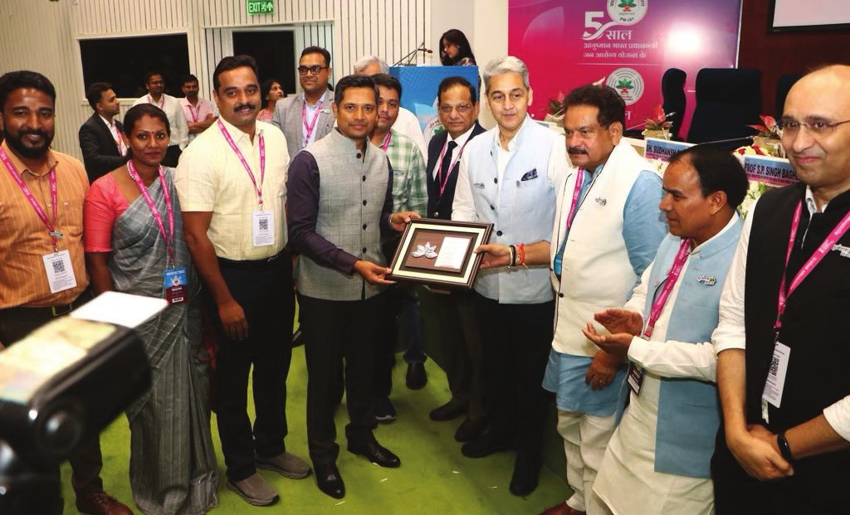

***Special Arogya Mandan Puraskar 2023 to Kerala***

For providing services to the visually challenged persons.

**Kerala Sree Puraskar 2023 for two health workers**

Kerala's prestigious Kerala Puraskar is the highest civilian honour from the Kerala government to recognize remarkable contributions across various fields. Two health workers received the Puraskar in the year 2023.

Renowned Cardio thoracic surgeon and superintendent of Kottayam Medical College,Dr.Jayakumar in Health category and Shaija Baby, Asha Worker from Wayanad district in Social service category. Shaija Baby received the award for her commitment and service during the landslide disaster where nine members from her family also lost their lives. The award reflects her commitment to helping families in their time of need even amidst profound grief. She has been an Asha Worker for 16 years. Aa a former ward member of Mundkai Panchayat and former vice president of Meppadi Panchayat,she was deeply connected to the local community.Having previously lived in Mundakkai, Shaija relocated to a rented home in Meppadi after the landslides in 2020 affected her original residence. The house that was under construction in Chooralmala also collapsed during the landslides.

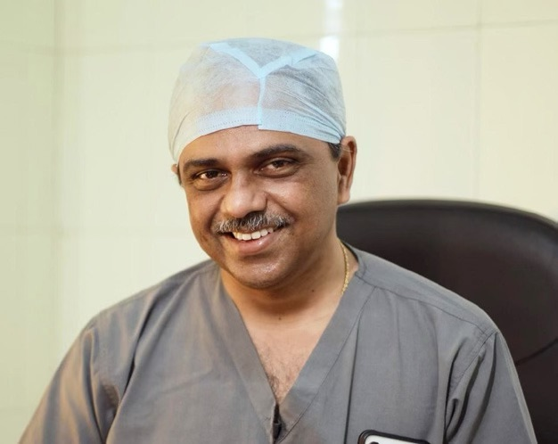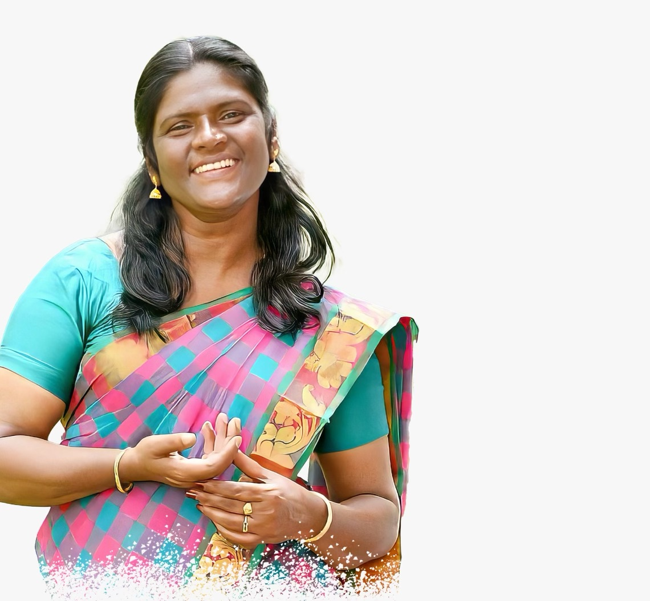

4.2 Sustainable Development Goals – Goal 3 Good Health and Well Being

|  |  |
| --- | --- |
| GOAL 3: Ensure healthy lives and promote well-being for all at all ages | |
| Target3.1 | By 2030, reduce the global maternal mortality ratio to less than 70 per 1,00,000 live births |
| Target3.2 | By 2030, end preventable deaths of newborns and children under 5 years of age, with all countries  aiming to reduce neonatal mortality to at least as low as 12 per 1,000 live births and under-5 mortality to at least  as low as 25 per 1,000 live births |
| Target3.3 | By 2030, end the epidemics of AIDS, tuberculosis, malaria and neglected tropical diseases and combat  hepatitis, water- borne diseases and other communicable diseases |
| Target3.4 | By 2030, reduce by one third premature mortality from non-communicable diseases through  prevention and treatment and promote mental health and well-being |
| Target3.5 | Strengthen the prevention and treatment of substance abuse, including narcotic drug abuse and  harmful use of alcoho |
| Target3.6 | By 2020, halve the number of global deaths and injuries from road traffic accident |
| Target3.7 | By 2030, ensure universal access to sexual and reproductive health-care services, including for family  planning, information and education, and the integration of reproductive health into national strategies and  programmes |
| Target3.8 | Achieve universal health coverage, including financial risk protection, access to quality essential  health-care services and access to safe, effective, quality and affordable essential medicines and vaccines for al |
| Target3.9 | By 2030, substantially reduce the number of deaths and illnesses from hazardous chemicals and air,  water and soil pollution and contamination |

4.3 Emergency Information

DISHA 1056

<https://disha1056.com/24-x-7-tele-helpline/>

Psychological Support <https://dhs.kerala.gov.in/wp-content/uploads/2020/06/IMG-20200612-WA0027.pdf>

**Page 5** Departments & Organizations

5.1 Overview of the Department

5.2 Dashboard

Infrastructure – DHS

|  |  |  |  |  |  |  |  |  |  |  |  |  |  |
| --- | --- | --- | --- | --- | --- | --- | --- | --- | --- | --- | --- | --- | --- |
| **Number of Modern Medicine Institutions under DHS** | | | | | | | | | | | | | |
| **Name of District** | **GH** | **DH** | **W&C** | **TH** | **THQH** | **CHC** | **PHC** | **DTBC** | **Speciality Hospitals** | **Others(mobile Unit, Dispensary & Health Clinic)** | **Total** | **Subcentres** | **Grand Total** |
| **TVM** | **2** | **2** | **1** | **5** | **3** | **22** | **70** | **1** | **4** | **8** | **118** | **487** | **605** |
| **KLM** |  | **1** | **1** | **4** | **5** | **16** | **58** | **1** | **1** | **1** | **88** | **421** | **509** |
| **PTA** | **2** | **1** |  |  | **4** | **12** | **43** | **1** | **0** | **1** | **64** | **261** | **325** |
| **ALP** | **1** | **2** | **1** | **2** | **4** | **16** | **61** | **1** | **2** | **0** | **90** | **366** | **456** |
| **KTM** | **4** |  | **1** |  | **3** | **20** | **55** | **1** | **1** | **0** | **85** | **333** | **418** |
| **IDK** |  | **2** |  | **1** | **3** | **13** | **41** | **1** | **0** | **2** | **63** | **309** | **372** |
| **EKM** | **2** | **1** | **1** | **6** | **5** | **23** | **75** | **1** | **0** | **1** | **115** | **411** | **526** |
| **TSR** | **2** | **1** |  | **3** | **3** | **24** | **79** | **1** | **2** | **3** | **118** | **471** | **589** |
| **PKD** |  | **1** | **1** | **1** | **6** | **19** | **76** | **1** | **0** | **9** | **114** | **504** | **618** |
| **MLP** | **1** | **3** | **1** | **3** | **4** | **21** | **84** | **1** | **1** | **7** | **126** | **589** | **715** |
| **KKD** | **1** | **1** | **1** | **6** | **1** | **16** | **64** | **1** | **2** | **0** | **93** | **401** | **494** |
| **WYD** | **1** | **1** |  |  | **2** | **8** | **23** | **1** | **1** | **8** | **45** | **200** | **245** |
| **KNR** | **1** | **1** | **1** | **8** | **1** | **10** | **80** | **1** | **2** | **6** | **111** | **416** | **527** |
| **KSD** | **1** | **1** | **1** | **1** | **4** | **6** | **40** | **1** | **1** | **3** | **59** | **247** | **306** |
| **Total** | **18** | **18** | **10** | **40** | **48** | **226** | **849** | **14** | **17** | **49** | **1289** | **5416** | **6705** |
| **(GH: General Hospital, DH: District Hospital, THQH: Taluk Head Quarters Hospital, TH: Taluk Hospital, CHC: Community Health Centre, PHC: Primary Health Centre, FHC: Family Health Centre, DTBC: District TB Centre, W&CH: Women & Children Hospital, MHC: Mental Health Centre, TB: TB Hospital, LEP: Leprocy Hospital)** | | | | | | | | | | | | | |