**PAEDIATRIC SPECIAL OP, GHMCH, THIRUVANANTHAPURAM**

**ACTIVITIES (F. Y: 2023-24)**

* **Treatment was provided to children suffering from various types of childhood systemic illnesses and NeuroDevelopmental Disorders –**

**(No. of beneficiaries - 15,611patients)**

* **Supportive therapies (Developmental therapy/ Speech therapy/ physiotherapy) and Counselling services (Parental counselling / Diet counselling) were given to children with Neurodevelopmental disorders- (No. of beneficiaries - 1,370 patients)**
* **Community Programmes: No. of beneficiaries - 720 people**
* **Screening medical camps in Anganwadis**
* **Health Awareness programmes for students**
* **Health Awareness programmes for parents**
* **Health Awareness programme for Anganwadi workers**
* **Voluntary activities:**

**Old age follow up medical camps at Sayahnam Old age Home.**

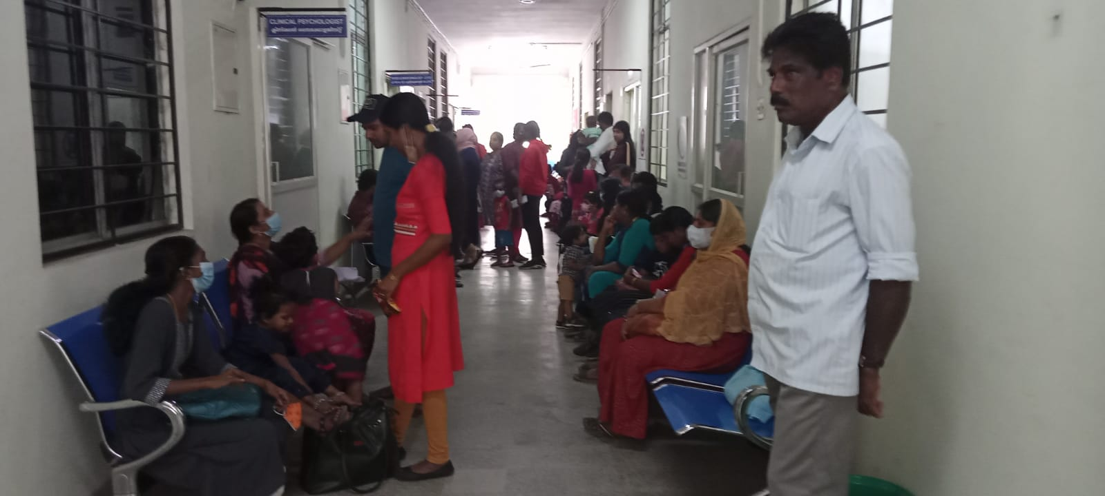**Paediatric Special Op**

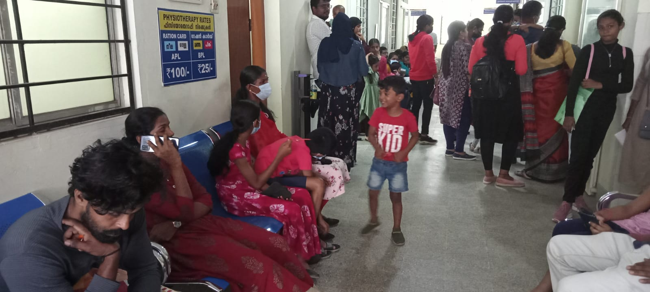

**Supportive therapies**

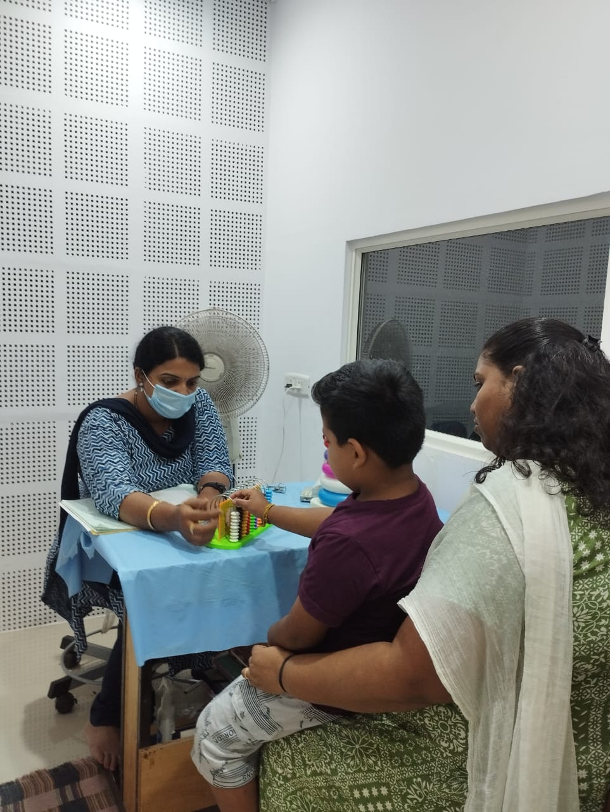

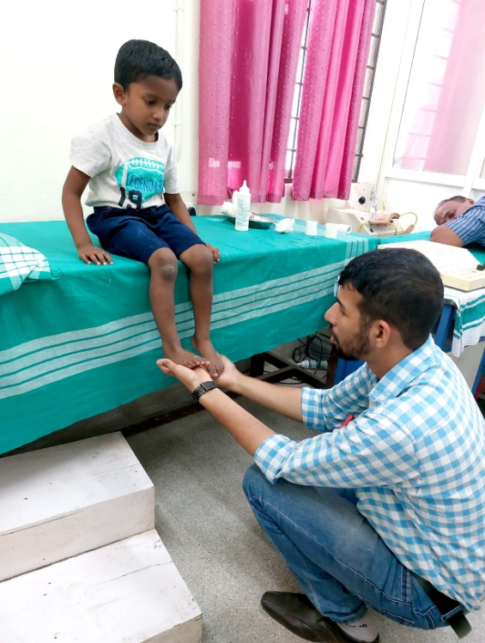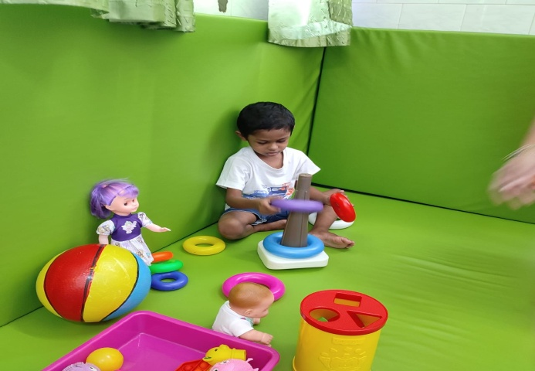

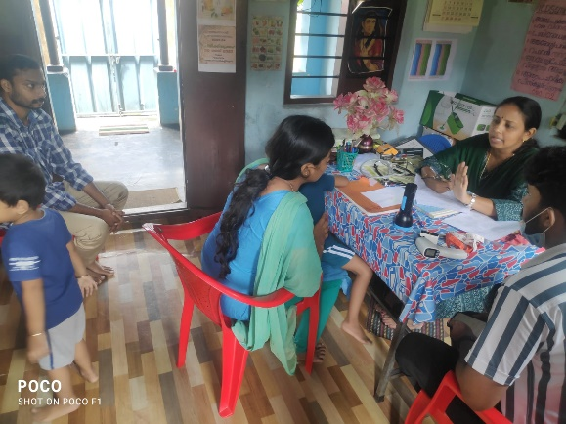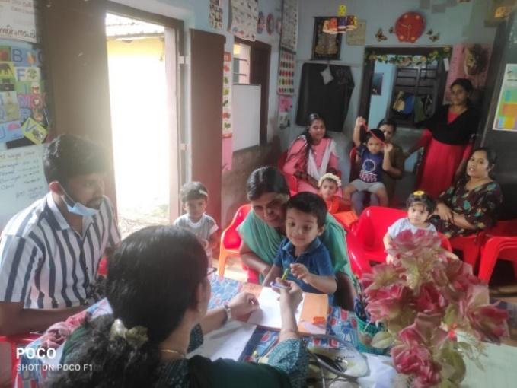**Screening medical camps in Anganwadis**

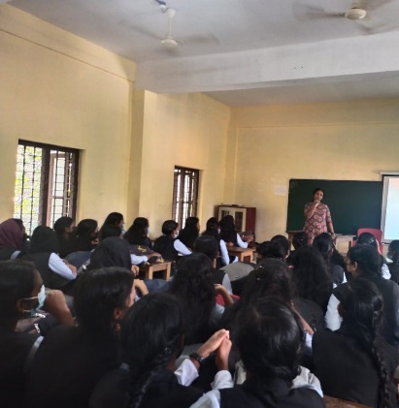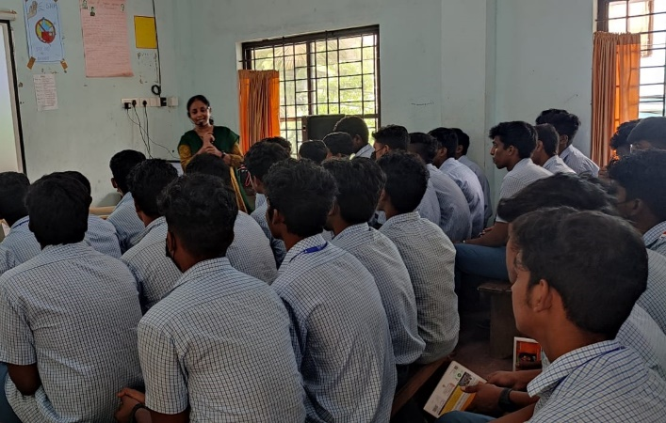**Health Awareness programmes for students**

**Health Awareness programmes for parents**

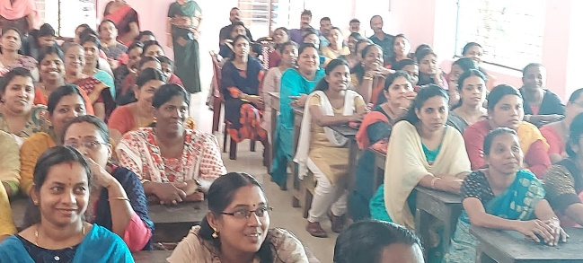

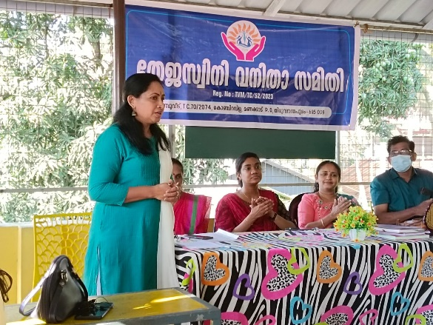

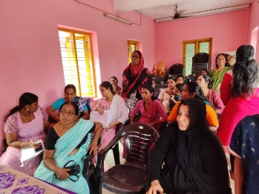 **Health Awareness programme for Anganwadi workers**

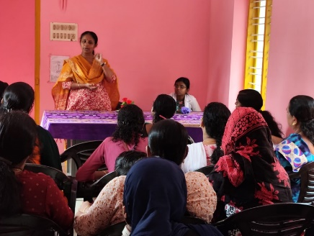  
 **Voluntary activities:** Old age follow up medical camps.

