S. H. I. E. L. D
Smart Hazard Identification & Emergency Live Dispatch

^{KRISHNA PRIYADARSHAN BEHARA1}
School of Computer Science and Engineering, Vellore Institute of Technology, Chennai, India¹
Abstract – The report discusses about SHIELD that is Smart Hazard Identification and Emergency Live Dispatch. It is an AI-assisted incident reporting system. It works on public safety enabling real-time reporting. Components include intelligent severity assessment and efficient alert dissemination. This system allows the users to submit incidents attested with geo-tagged information. There is an option to upload media evidence in the form of images or audio. These are then processed through machine learning models and contextual logic to estimate severity. The project's platform integrates Natural Language Processing (NLP) for incident classification. Image analysis for evidence validation and clustering techniques for hotspot detection. The platform provides live map visualization of incidents and generates alerts for high-risk situations. The system adopts modular service-oriented architecture. And as discussed it follows a Agile Scrum methodology. The final solution demonstrates a fully functional, deployable system capable of real-time data processing, visualization, and intelligent decision support.
Keywords – Incident Reporting, AI, NLP, Severity Score Prediction

I. INTRODUCTION
As with the increasing need for public safety systems has highlighted the limitations of traditional incident reporting systems. We need an efficient and real time incident reporting system. Now the problem with the traditional reporting systems that they are fragmented delayed and they lack any intelligent prioritization. This makes it difficult to respond effectively to critical situations.
The project aims to address those exact limitations by building a unified platform for reporting, analyzing, and visualizing public safety incidents. The project would enable an user to submit incident reports in real time with geo tagged information. The information is processed to estimate severity and call alerting systems.

II. BACKGROUND
Traditional public safety reporting systems like the call response centres have experienced many limitations as the number of incidents have been increasing. These systems often rely on fragmented broken pieces of half information. This make them delayed. It makes them impossible to implement any intelligent prioritization mechanisms. Traditional approaches rely heavily on manual reporting and human intervention. This results in inefficiencies in emergency response.
The increasing urbanization and the need for rapid response systems bring a strong requirement for real time intelligent and scalable platforms that does just that. These present systems typically lack real time severity assessment to prioritize the incidents. They do not integrate AI to claasify and validate the incidents.
S.H.I.E.L.D addresses these limitations by integrating AI-driven decision-making along with real-time reporting and visualizations.

III. PROPOSED SYSTEM
The proposed system introduces SHIELD that is the smart hazard identification and emergency live dispatch. It talks about a smart, modular and AI assisted incident management and reporting platform.
The key contributions that the project make are as follows – It provides real time incident reporting with GPS tagging for citizens reporting the accident. The system talks about having an AI assisted incident classification using NLP. There is an optional feature which lets user to upload images and analyse those for evidence. Following that it estimates severity score combining AI output and contextual rules. The platform allows live map visualisation with severity based markers. Maps display hotspots using clustering algorithms. Alert generation is fully based on severity thresholds.
Unlike traditional systems SHIELD provides AI as a core component not as an addon. The platform used multi modal inputs like text and images and audio. The system provides automated severity scoring reducing manual dependency. The platoform provides an additional feature of detecting emerging risk zones using clustering techniques. The entire development is designed as a real-time, deployable system.
Let us try and understand how the workflow works. First the user submits the incident report. NLP model classifies the incident and the image analyzer processes the viaual information. Severity engine computes urgency scores and the incident is then stored in the database. Map updates in real time. Alerts are triggered if the severity crosses a certain threshold.

IV. SYSTEM ARCHITECTURE

The project follows the following architecture:
We have the front-end layer as a part of the service oriented architecture. It handles user interation and visualization.
The API layer manages authentication and request handling. Processing Layer includes AI modules and severity engine. The Data Layer stores all the incident data and the user data.
Each module operates independently while ensuring scalability and maintainability.
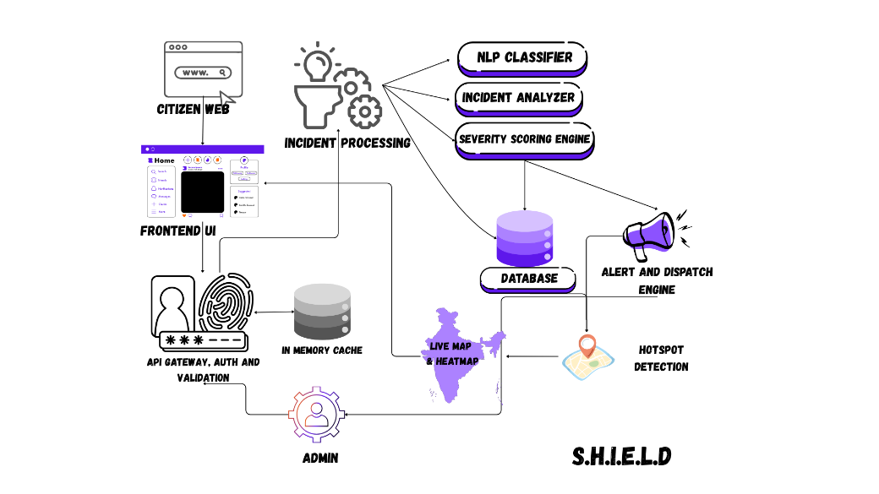

V. PROTOCOL STACK
The project follows this particular layered protocol stack:
We begin with the Application Layer. This consists of the user interface. React is used for the Web UI. The API layer for authentication and request routing. REST APIs are used along with Node.js for support.
We move on the processing layer:
- NLP classifier (text analysis)
- Image analyzer (visual evidence processing)
- Severity engine (decision logic)
- Hotspot detection (clustering)

The data layer consists of MongoDB database with geospatial support. It stores users, incidents and alerts. The infrastructure layer uses Vercel for hosting on cloud. This handles the deployment and the scalability.

VI. TESTBED/ EXPERIMENTAL SETUP
The experimental setup talks about the following:

- Development environment
OS - Windows
Backend – FastAPI, MongoDB, Node JS
FrontEnd – Next.js
- Tools and Libraries used
Leaflet was used for map visualizations. MongoDB for database. Pretrained LLMs from scikit learn for NLP. CNN for image processing (MobileNet)
- Datasets and Inputs
Synthetic incident for testing
Sample image for classification
- Model Setup
NLP model is used for text classification. CNN for image analysis. Rule based combined with ML hybrid approach for severity scoring.

All test setup was done using standard laptop systems and no specialised GPU was required.

VII. 100% IMPLEMENTATION
Completed features
- User authentication
- Incident reporting system
- Geo-location capture
- Database integration
- Severity scoring engine
- NLP-based classification
- Image analysis integration
- Live map visualization
- Hotspot detection
- Alert generation system
- Admin dashboard

Screenshots

Login Interface
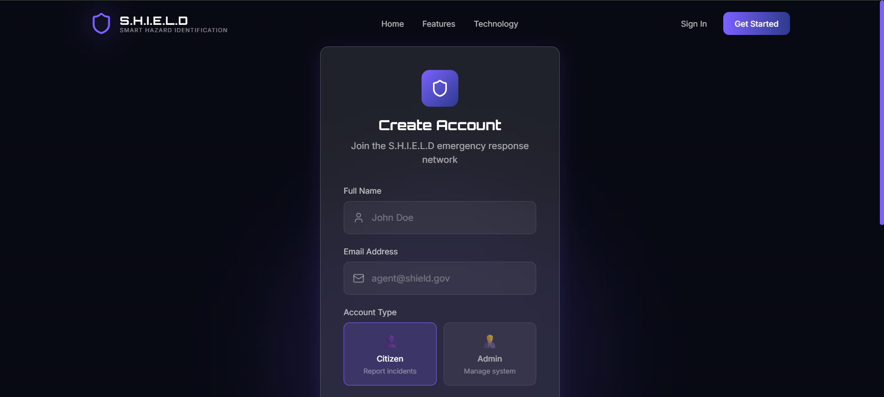
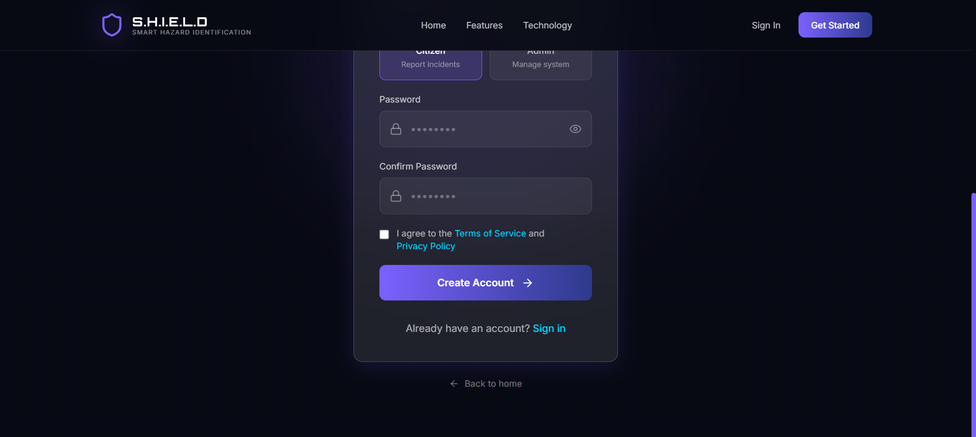
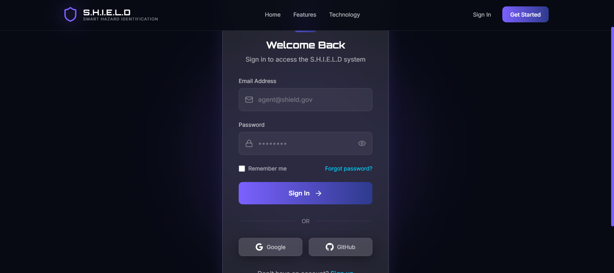

Incident Submission Page
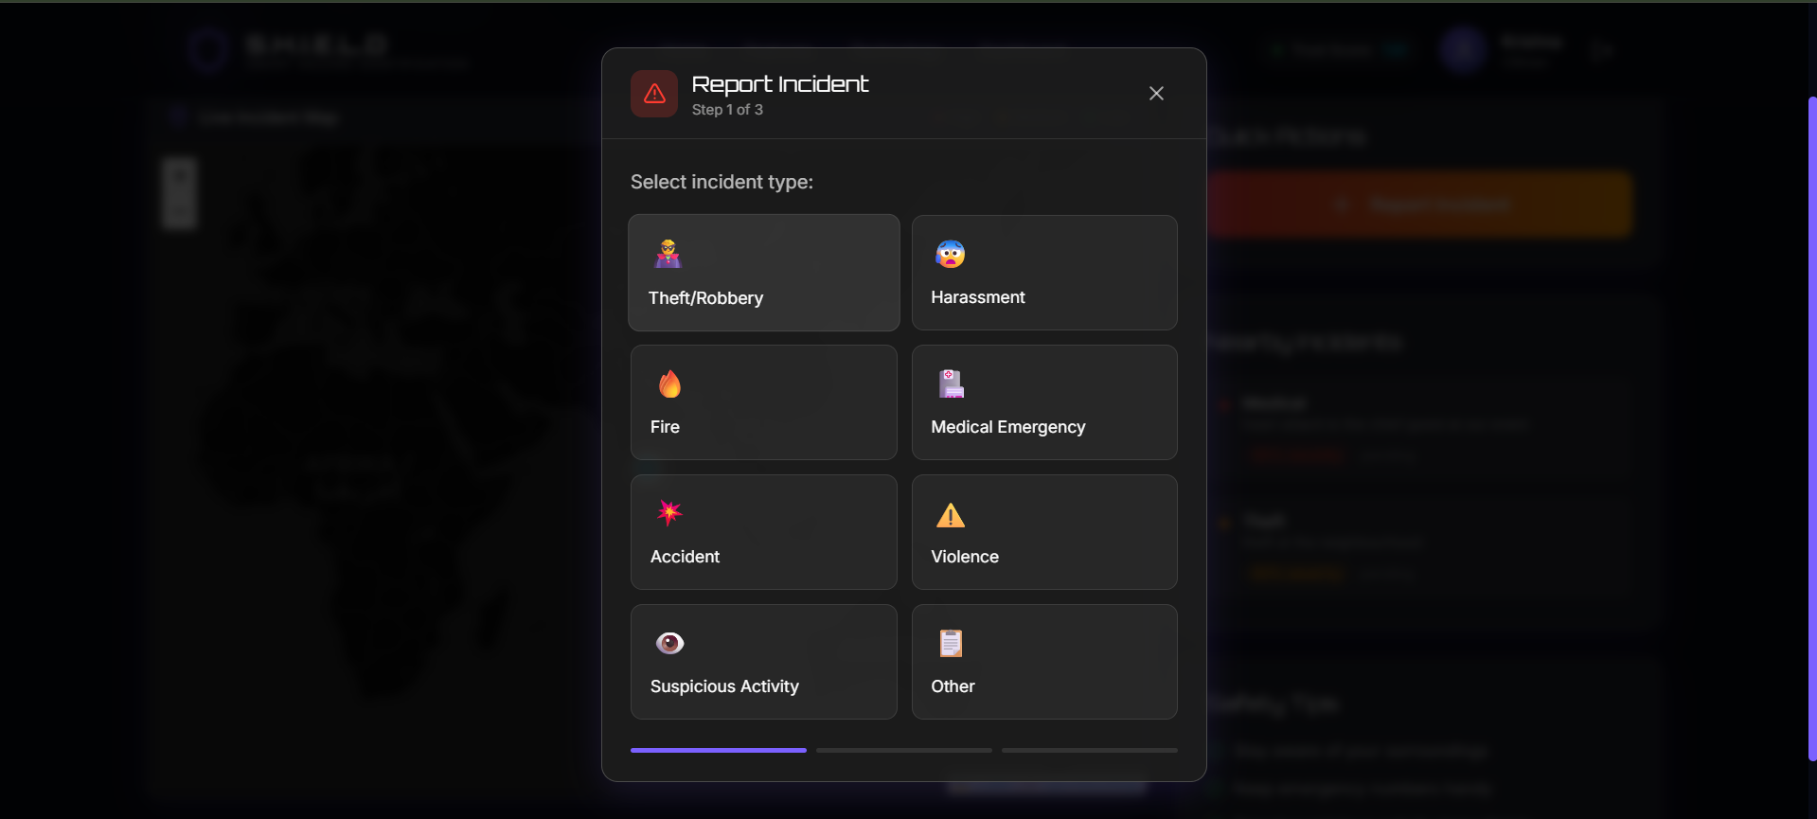
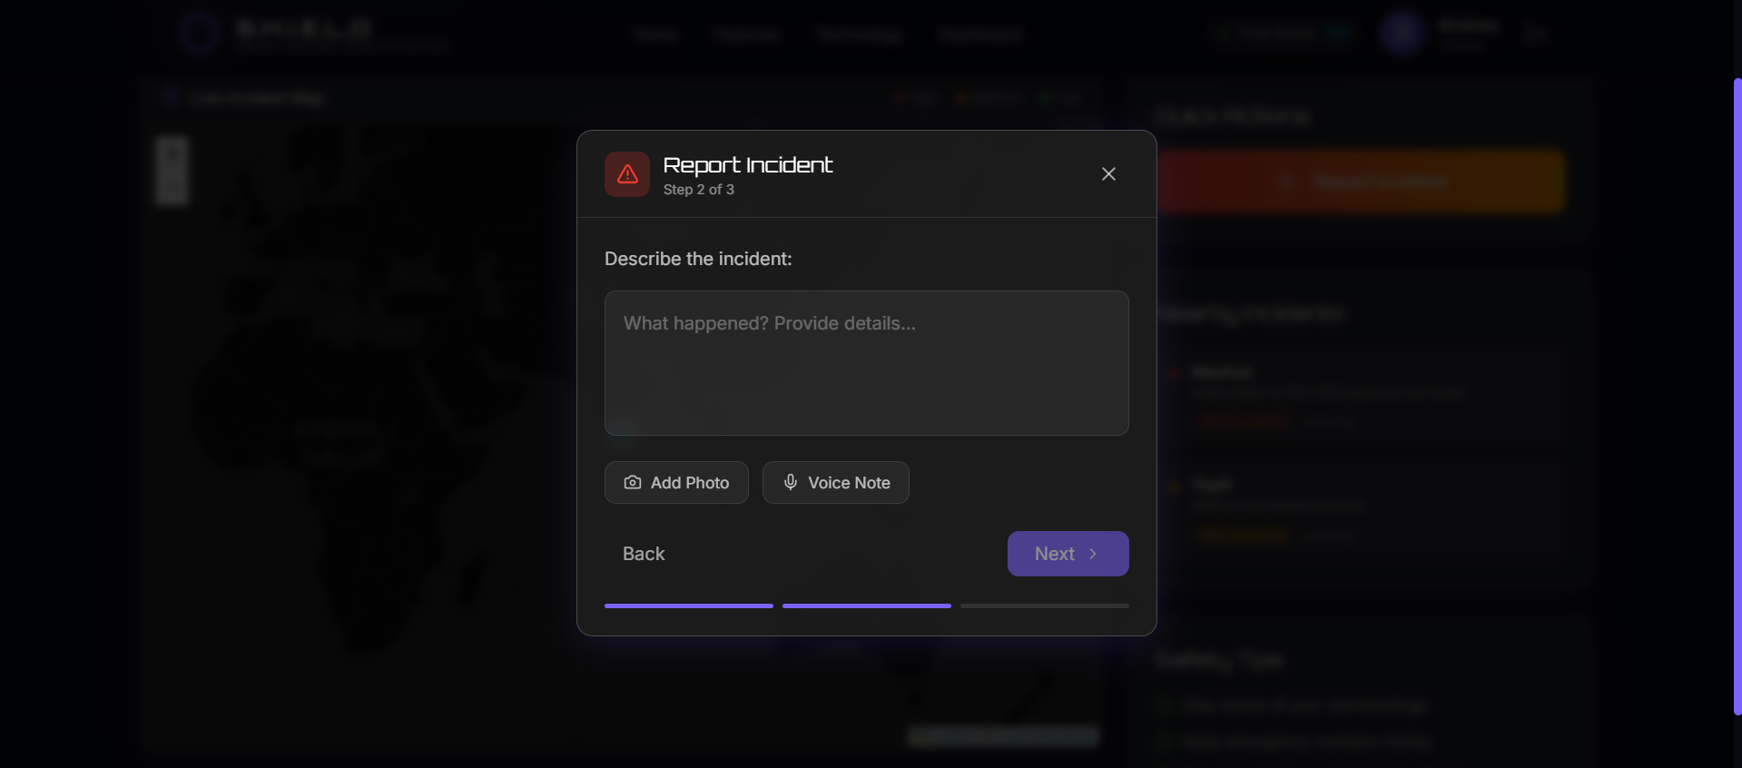
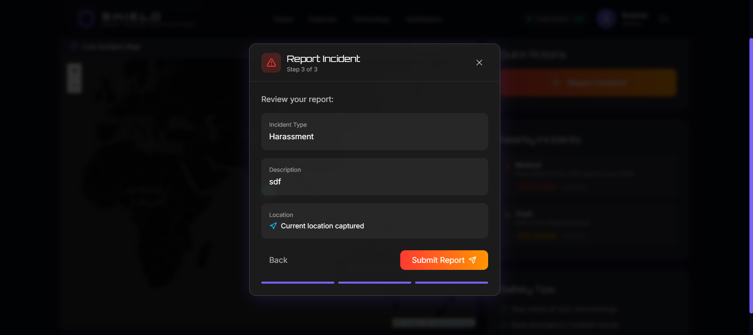

Map with Markers

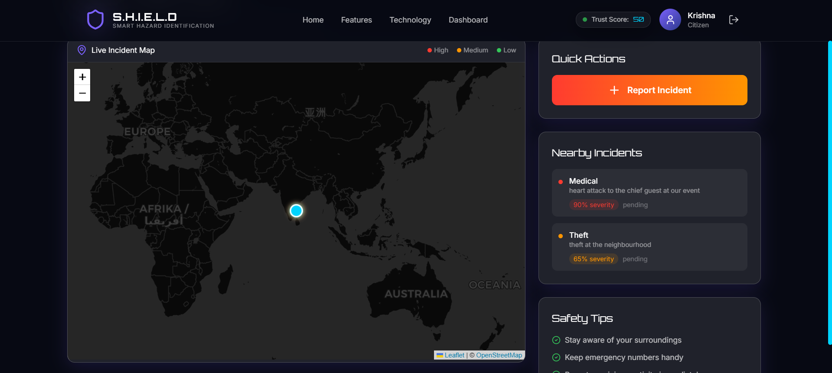

Severity Display
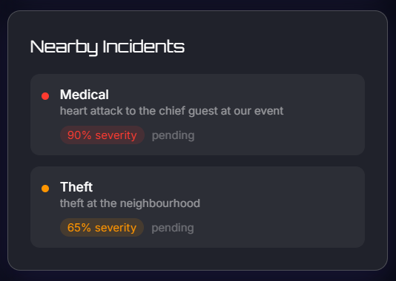
Alert Dashboard
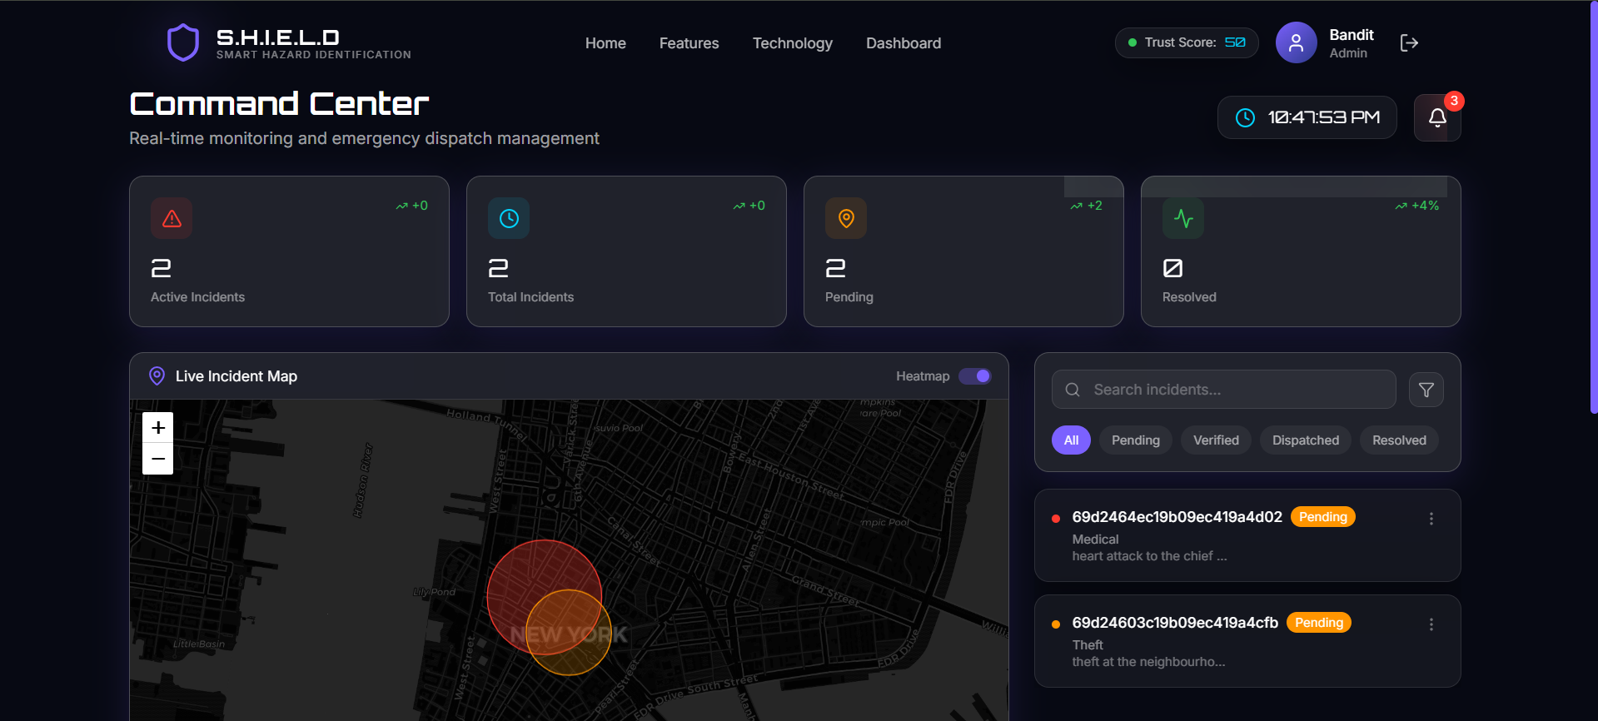
Hotspot Visualization
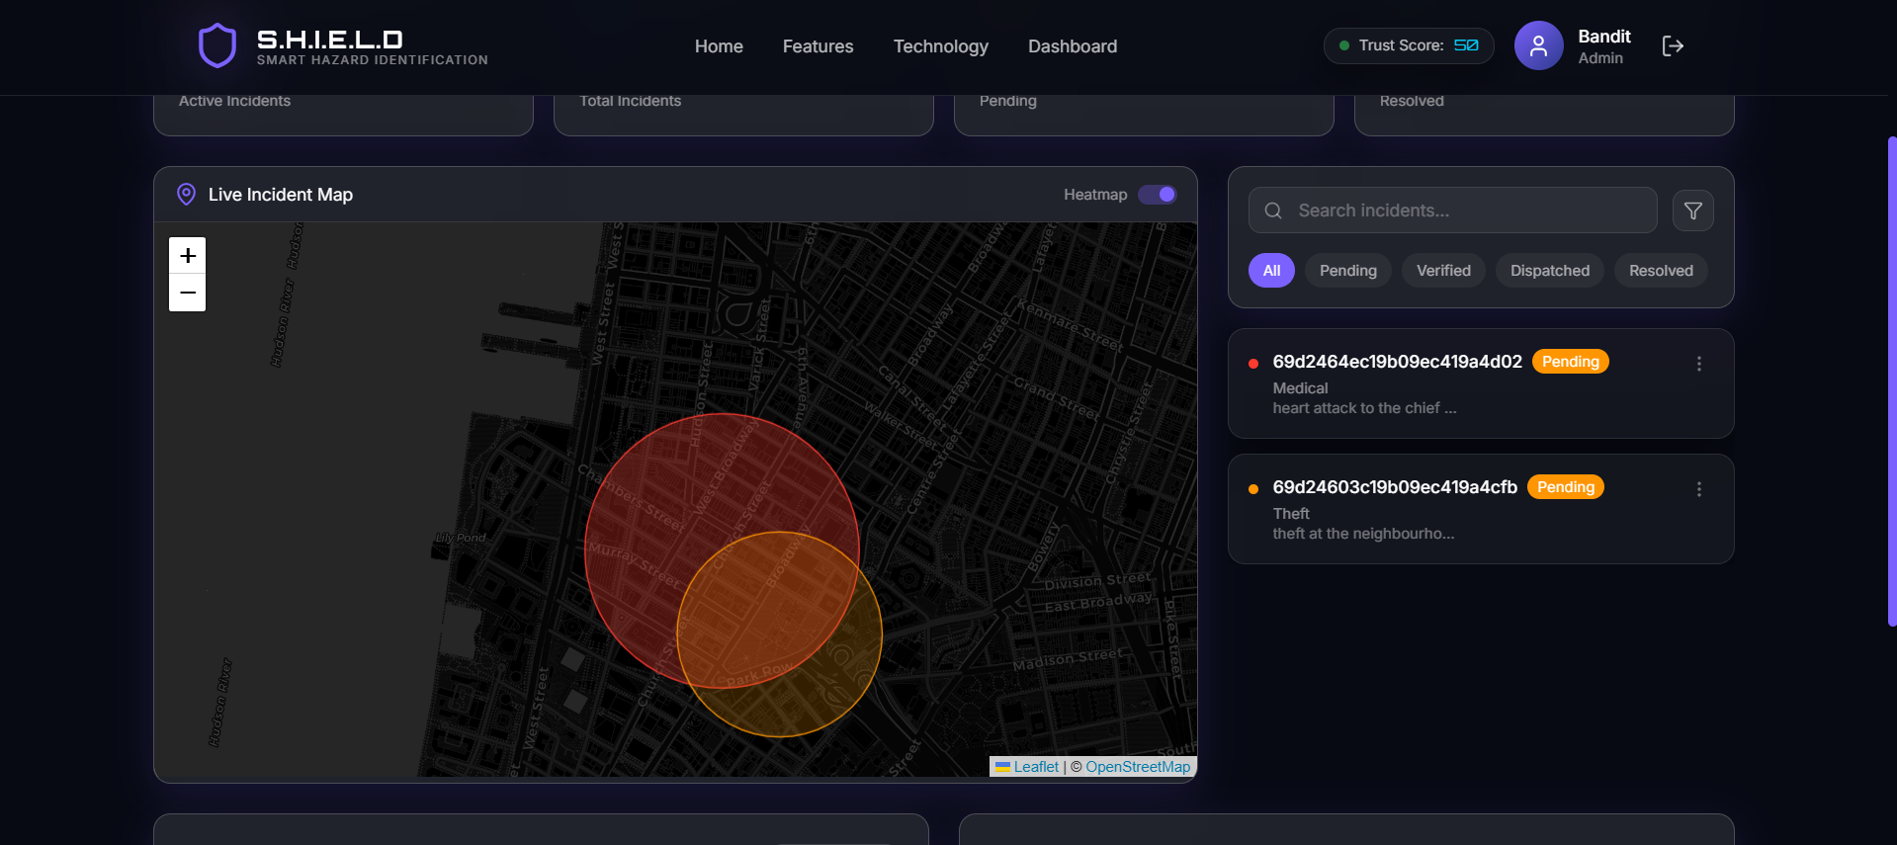

AI Output (classification results)
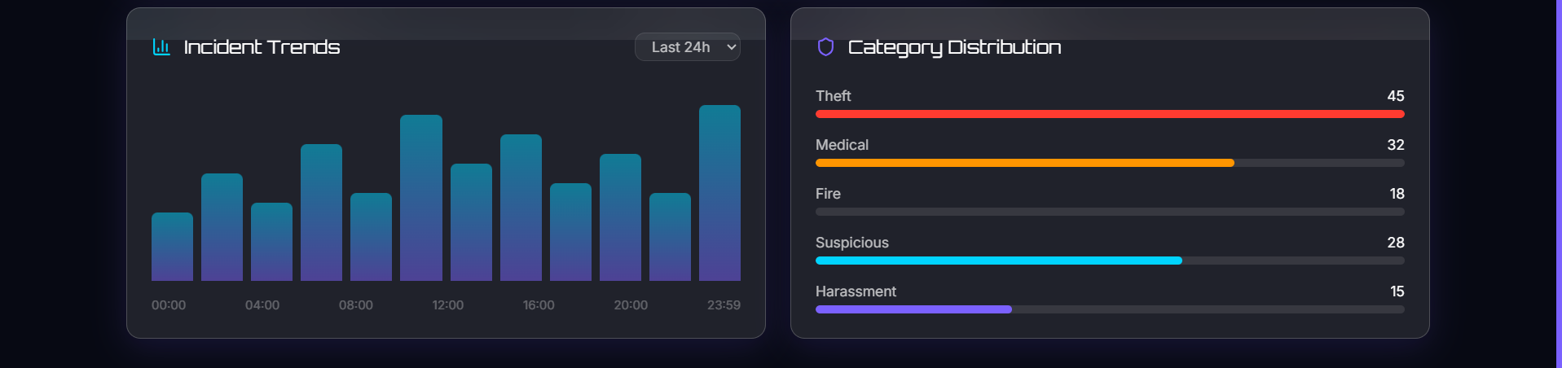

GitHub Repository

https://github.com/krishnapriyadarshan2023-dev/D2_23BCE5138_Krishna-Priyadarshan

