SQL PROJECT --- Ecommerce Analysis
Section-1: Joins
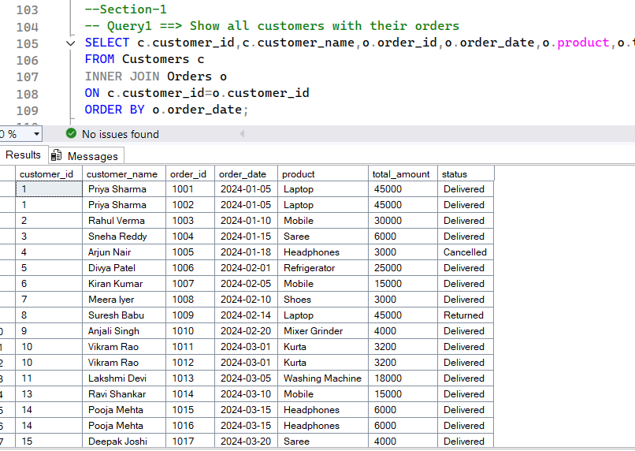___________________________________________________________________________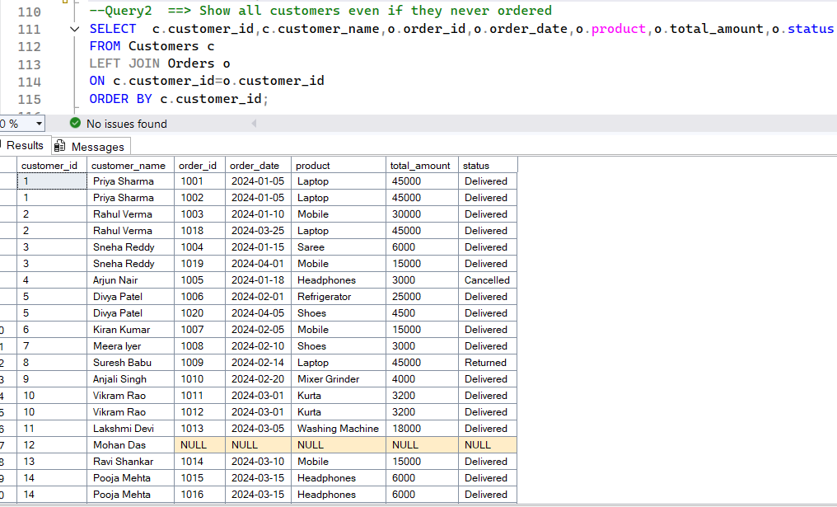
___________________________________________________________________________

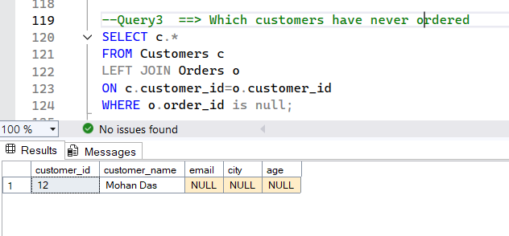___________________________________________________________________________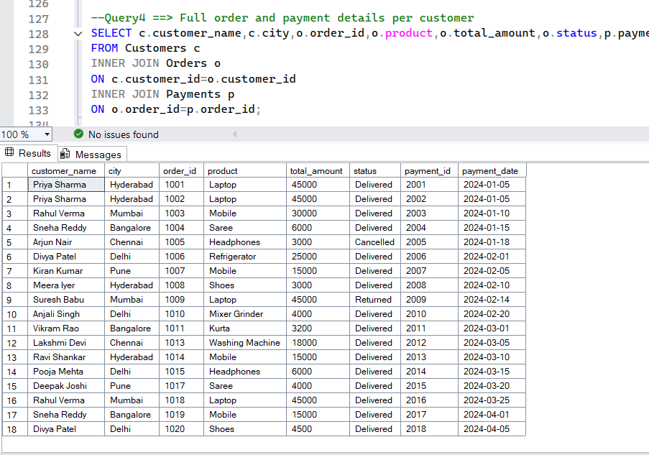___________________________________________________________________________
___________________________________________________________________________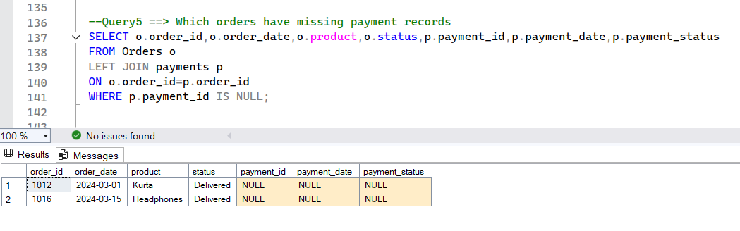___________________________________________________________________________
Section-2: Nulls
___________________________________________________________________________
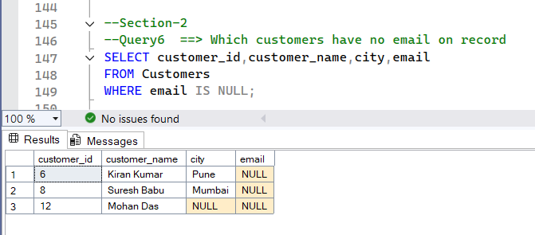___________________________________________________________________________
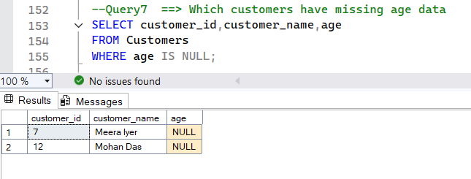___________________________________________________________________________

___________________________________________________________________________
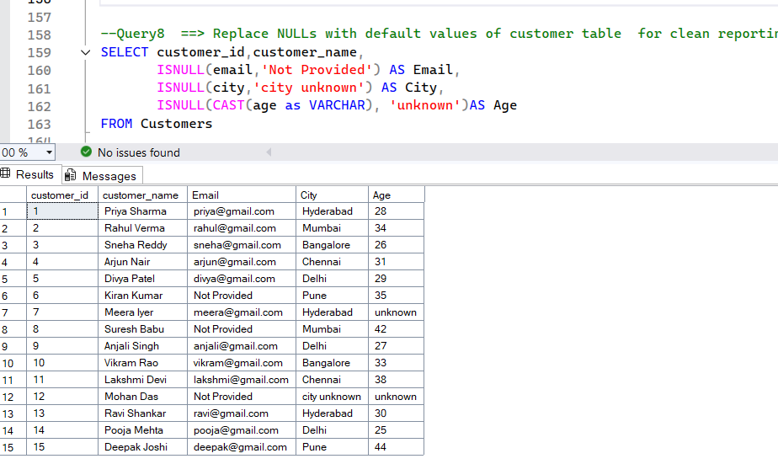___________________________________________________________________________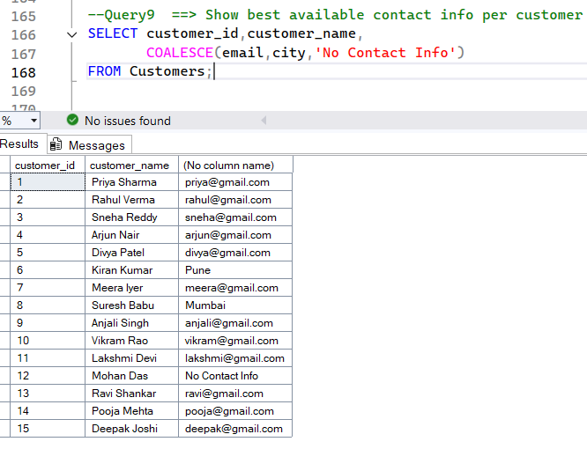__________________________________________________________________________
___________________________________________________________________________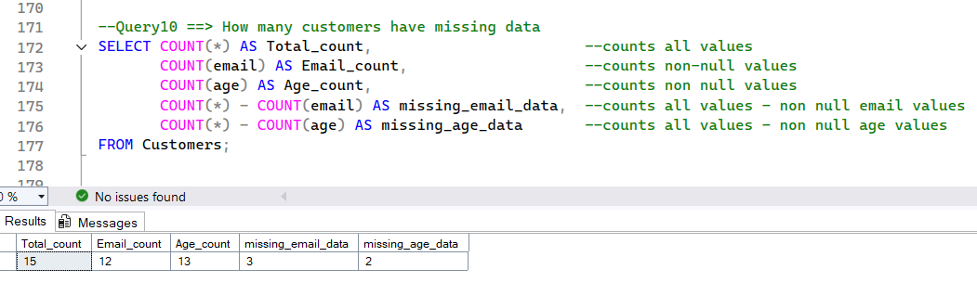___________________________________________________________________________
Section-3 : Duplicates


