SUPERMARKET SALES & PROFITABILITY OPTIMIZATION
Data Analytics Project Report
IBM SkillsBuild / Internship Project
Interactive Sales, Gross-Income, Risk, Opportunity & ML Assessment

1. Executive Summary
This project develops an interactive data analytics application for supermarket sales and gross-income performance. The application analyzes 1,000 cleaned transactions across branches, product lines, customer types, purchasing periods, payment methods, and transaction characteristics. The objective is to convert transaction-level data into measurable performance insights, identify observable drivers, highlight risks and opportunities, and translate findings into management actions.
The analysis reports total sales of 322,967.43, total gross income of 15,379.92, gross margin of 4.762065%, and 1,000 transactions. January recorded the highest monthly sales at 86,562.76, while April recorded the lowest at 7,957.65. Giza recorded the highest branch sales at 110,568.86. Food AandBeverages recorded the highest product-line sales at 56,144.96. Member customers generated 58.74% of total sales and had a higher AOV than Normal customers.
A leakage-controlled machine-learning assessment was also performed to classify Potential High-Value Transactions. The available contextual features did not demonstrate meaningful improvement over the 50% balanced baseline. This negative finding is retained rather than forcing a positive ML conclusion.

2. Business Problem
Supermarket management needs a data-driven approach to understand variations in sales and profitability across branches, product lines, customer segments, and purchasing periods, identify key performance drivers and areas requiring attention, and translate those findings into actionable business decisions.
Core decision chain: Performance → Trends → Drivers → Risks & Opportunities → Actions

3. Project Objectives
- Measure overall sales and gross-income performance.
- Compare performance across branches and product lines.
- Analyze Member vs Normal customer performance.
- Identify monthly, weekday, and time-period trends.
- Identify observable performance differences and drivers.
- Surface business risks and opportunities.
- Translate findings into practical management actions and monitoring KPIs.
- Assess whether contextual transaction features can predict high-value transactions.
- Provide an interactive decision-support interface.

4. Dataset & Data Preparation
The final cleaned dataset contains 1,000 rows and 17 original columns, covering January–December 2019. All original columns contain zero missing values. Invoice IDs are unique, with 1,000 unique IDs and no duplicate Invoice IDs.
Dataset source:
https://docs.google.com/spreadsheets/d/1IHsqV1qRNCvOk_IenUlxgmynPRVTTJv3tyfdJiStKTg/edit?usp=sharing
CSV export used by the notebook:
https://docs.google.com/spreadsheets/d/1IHsqV1qRNCvOk_IenUlxgmynPRVTTJv3tyfdJiStKTg/export?format=csv&gid=1992415326
- Quantity values were verified as whole-number transaction quantities.
- Tax values were cross-verified against the 5% calculation.
- Dates and times were standardized.
- COGS and Gross Income were cross-verified.
- Rating values were retained without modification.
- Date formatting was corrected.
- Calculation mismatches were checked.
- No records were removed during cleaning.
- Matching transaction attributes were not blindly removed because similar attributes can represent legitimate separate invoices.

5. Dataset Features
Invoice ID, Branch, City, Customer Type, Gender, Product Line, Unit Price, Quantity, Tax 5%, Sales, Date, Time, Payment, Cogs, Gross Margin %, Gross Income, Rating.

6. KPI Analysis
KPI | Result
Total Sales | 322,967.43
Total Gross Income | 15,379.92
Gross Margin % | 4.762065%
Total Transactions | 1,000
Average Order Value | 322.96743
Gross Income / Transaction | 15.37992
The project does not use Net Profit because the dataset does not contain operating expenses. Gross Income and Gross Margin are therefore used for profitability-related analysis.
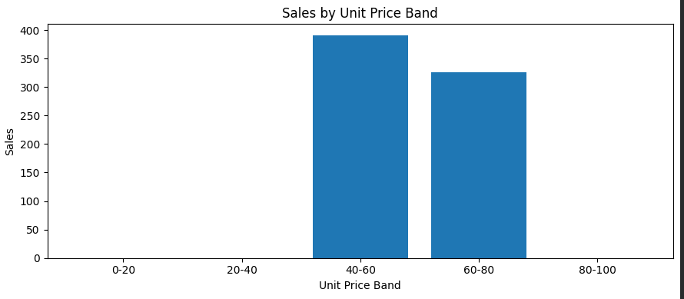
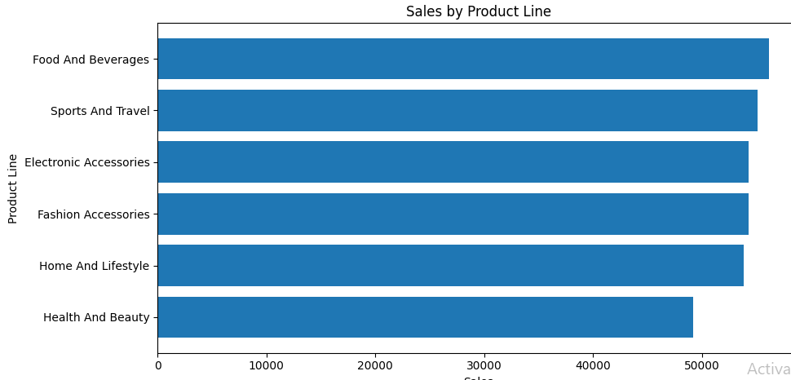

7. Analytical Methodology
The project follows: DATA → CLEANING → ANALYSIS → BUSINESS INSIGHT → DECISION → ACTION
- Performance: Sales, Gross Income, Gross Margin, Transactions, AOV.
- Trends: Monthly, weekday, and time-period performance.
- Drivers: Branch, Product Line, Customer Type, Quantity, Unit Price Band, and Payment.
- Decision areas: Risks, opportunities, actions, and monitoring KPIs.
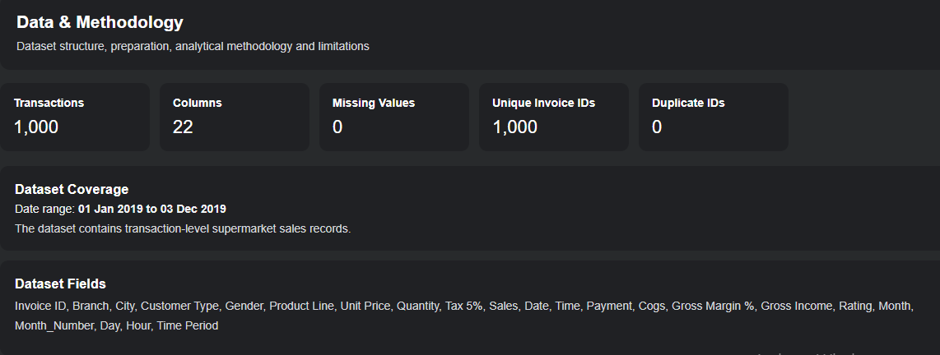

8. Key Findings

8.1 Monthly Performance
January recorded the highest monthly sales at 86,562.76. April recorded the lowest monthly sales at 7,957.65. Because transaction distribution across months is uneven, the analysis does not claim conventional seasonality from this dataset alone.

8.2 Branch Performance
Branch | Sales
Alex | 106,200.57
Cairo | 106,198.00
Giza | 110,568.86
Giza recorded the highest branch sales and an AOV of approximately 337.10.

8.3 Product Line
Food And Beverages recorded the highest sales at 56,144.96. Health And Beauty recorded the lowest sales at 49,193.84. Home And Lifestyle recorded the highest product-line AOV at approximately 336.64.

8.4 Customer Type
Customer Type | Sales | AOV
Member | 189,695.16 | 335.74
Normal | 133,272.27 | 306.37
Members represented approximately 58.74% of total sales.

8.5 Weekday & Time Period
Tuesday recorded the highest weekday sales. Monday recorded the lowest weekday sales at 35,048.96 and the lowest AOV at approximately 289.66. Afternoon represented approximately 45.83% of sales and 45.40% of transactions.

8.6 Quantity & Unit Price
Transactions with quantity 10 had the highest average sales, approximately 587.64. The 80–100 unit-price band recorded the highest sales at 122,737.25.

9. Risks & Opportunities

9.1 Risks
Area | Evidence | Management Review
April | Sales 7,957.65 | Review April transaction patterns, product mix, branch and customer activity.
Member concentration | 58.74% of sales | Monitor member purchasing patterns and engagement.
Monday | Lowest weekday sales: 35,048.96 | Review Monday volume, product mix and customer activity.
Health And Beauty | Lowest product sales: 49,193.84 | Review demand, transaction volume and product-level performance.

9.2 Opportunities
Area | Evidence | Action Area
Afternoon | 45.83% of sales | Align staffing and inventory readiness with afternoon activity.
Giza | Highest branch sales; AOV ~337.10 | Examine product/customer mix and observable practices.
Food And Beverages | Highest product sales: 56,144.96 | Review quantity, transactions and customer mix.
Members | AOV 335.74 vs 306.37 | Study member purchasing patterns and engagement.

10. Machine Learning Assessment
The project includes a High-Value Transaction Classification assessment. Potential_High_Value is defined as Sales greater than or equal to the median Sales value of 253.85, resulting in a balanced target of 500 lower-value and 500 high-value transactions.
Features used: Branch, Customer Type, Gender, Product Line, Payment, Day, Time Period, Rating.
Direct transaction-value fields were excluded to control leakage: Sales, Tax 5%, Cogs, Gross Income, Unit Price, Quantity, Invoice ID, raw Date, and raw Time.
Model | Accuracy | Precision | Recall | F1
Baseline | 50.0% | — | — | —
Logistic Regression | 50.0% | 50.0% | 53.0% | 51.46%
Decision Tree | 49.5% | 49.6% | 62.0% | 55.11%
Conclusion: the leakage-controlled contextual features did not demonstrate meaningful predictive improvement over the 50% baseline. The ML component is therefore treated as a model assessment and negative finding.
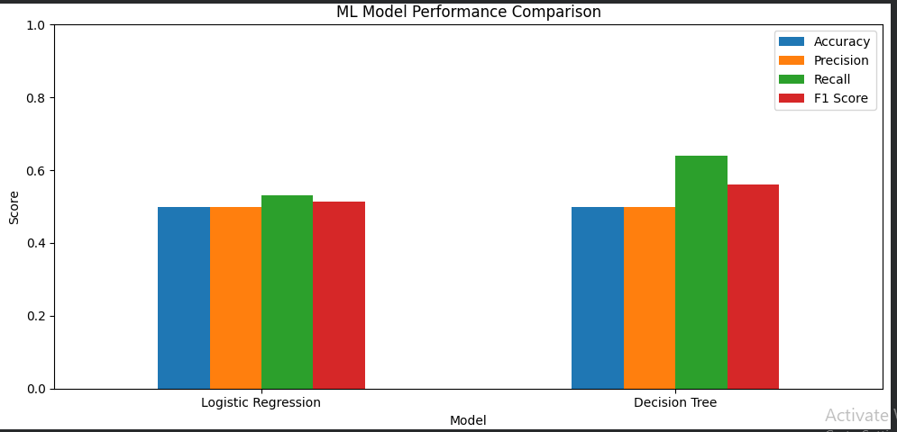
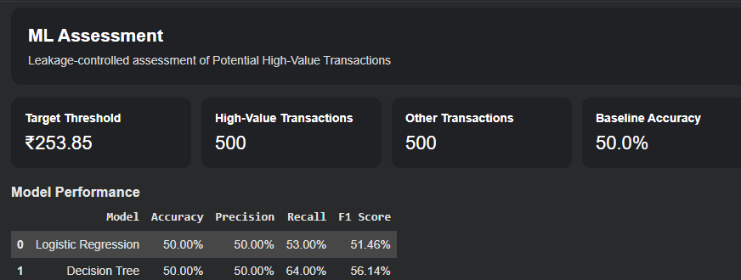

11. Application Design
The application contains six screens: Executive Overview; Sales & Trend Analysis; Driver Analysis; Risks & Opportunities; ML Assessment; and Data & Methodology.
Global filters include Branch, Product Line, Customer Type, Payment, Month, and Time Period. The application also includes reset functionality and user-facing error states.
Logical flow: USER → Dashboard/Filters → Frontend Interface → Python Application Logic → Data Processing → Analytics Engine → ML Assessment → Charts/Tables/Insights → USER
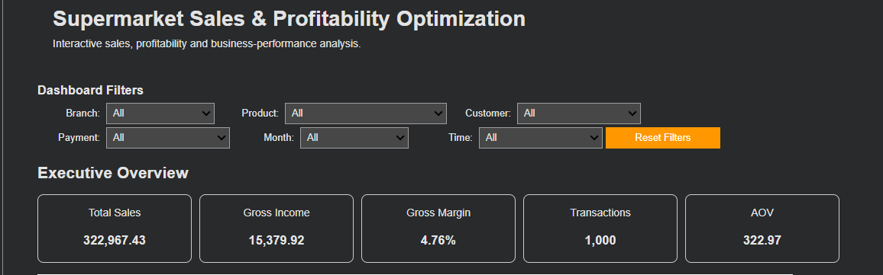

12. Error Handling
- Dataset Error: Unable to load or validate the dataset. Please verify the data source.
- Empty Filter Result: No transactions match the selected filters. Please adjust your filters.
- Zero Transactions: AOV is displayed as unavailable when transaction count is zero instead of causing a division-by-zero error.

13. Quality Assurance
QA Stage | Result
Data & KPI QA | 11/11 PASS
Analysis QA | 15/15 PASS
ML QA | 14/14 PASS
Application/UI QA | 10/10 PASS
Reproducibility & Error Handling QA | 10/10 PASS
QA confirmed row count, required base columns, missing-value status, unique Invoice IDs, KPI reproducibility, analytical outputs, ML target/split/leakage controls, navigation, filters, error handling, and reproducibility.

14. Limitations
- There is no persistent customer ID, so customer churn cannot be reliably modeled.
- Gross Margin % is constant at approximately 4.76%, limiting profitability-driver analysis.
- Operating expenses are unavailable, so Net Profit cannot be calculated.
- Uneven monthly transaction coverage limits conventional seasonality claims.
- Direct transaction-value fields are excluded from ML features because they would introduce leakage.
- Observed relationships are associations and should not be interpreted as causal effects without additional evidence.
- ML results do not demonstrate meaningful improvement over the balanced baseline.

15. Conclusion
The Supermarket Sales & Profitability Optimization project converts 1,000 supermarket transactions into an interactive analytical decision-support application. The analysis identifies measurable differences across branches, product lines, customer types, weekdays, time periods, quantities, and unit-price bands, and translates selected findings into risks, opportunities, management review areas, and monitoring KPIs.
The ML assessment found that the available leakage-controlled contextual features did not provide meaningful predictive improvement over the balanced baseline. This result is retained as a valid analytical finding.
Overall decision chain: DATA → CLEANING → ANALYSIS → BUSINESS INSIGHT → DECISION → ACTION

16. Recommended Screenshots to Add
Insert screenshots from the completed application in this section before final submission. Recommended captures:
- Executive Overview with KPI cards and charts.
- Sales & Trend Analysis screen.
- Driver Analysis screen.
- Risks & Opportunities screen.
- ML Assessment screen.
- Data & Methodology screen.

17. Final Deliverables
File | Purpose
IBM.ipynb | Single-code-file implementation and interactive application.
requirements.txt | Required Python libraries.
README.md | Repository documentation and project overview.
Project_Report.docx / .pdf | Formal project report with findings and screenshots.

