Create connection

Createdatabase using java



Tablecreation



Insert value



Select all from table

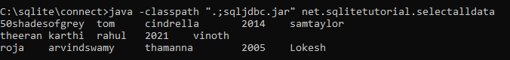

Select particular data

