1. Bar Chart

import matplotlib.pyplot as plt
import numpy as np

plt.figure(figsize=(8, 5))
courses = ['Python', 'Java', 'ML', 'Web Dev', 'Data Science']
students = [45, 30, 60, 25, 50]
colors = ['#1f77b4', '#ff7f0e', '#2ca02c', '#d62728', '#9467bd']

plt.bar(courses, students, color=colors)
plt.title('Number of Students Enrolled per Course')
plt.xlabel('Courses')
plt.ylabel('Number of Students')
plt.show()

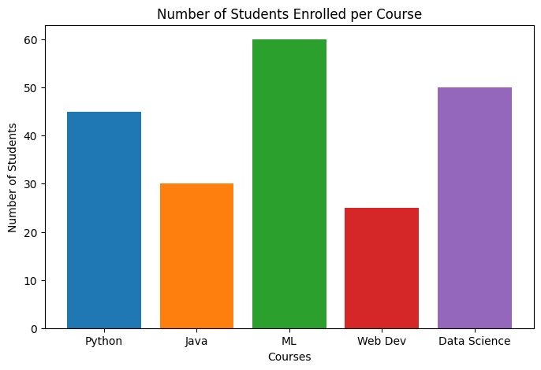

2. Line Chart

plt.figure(figsize=(8, 5))
months = ['Jan', 'Feb', 'Mar', 'Apr', 'May', 'Jun']
scores = [55, 62, 70, 68, 78, 85]

plt.plot(months, scores, marker='o', linestyle='--', color='b')
plt.title("Student's Monthly Test Scores")
plt.xlabel('Month')
plt.ylabel('Score')
plt.grid(True, linestyle=':', alpha=0.7)
plt.show()

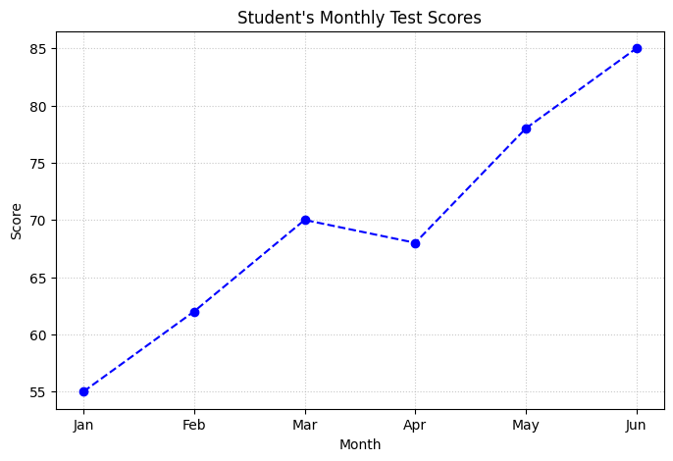

3. Pie Chart

plt.figure(figsize=(7, 7))
brands = ['Samsung', 'Apple', 'OnePlus', 'Xiaomi', 'Others']
market_share = [35, 28, 15, 12, 10]

explode = (0.1, 0, 0, 0, 0)

plt.pie(market_share, labels=brands, explode=explode, autopct='%1.1f%%', startangle=140)
plt.title('Mobile Store Sales Ratio')
plt.show()

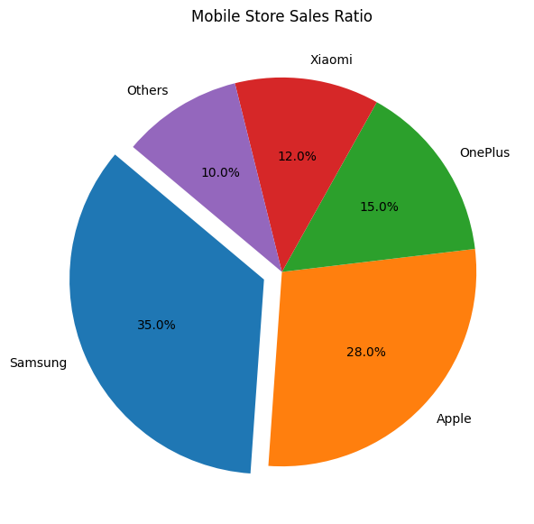

4. Histogram

import matplotlib.pyplot as plt
import numpy as np

np.random.seed(42)
exam_scores = np.random.normal(65, 10, 200)

fig, ax = plt.subplots(figsize=(8, 5))

ax.hist(exam_scores, bins=15, color='#ff9999', edgecolor='black', alpha=0.8)

ax.axvline(exam_scores.mean(), color='navy', linestyle='--', linewidth=2, label=f'Mean: {exam_scores.mean():.1f}')
ax.set_title('Distribution of Exam Scores')
ax.set_xlabel('Scores')
ax.set_ylabel('Frequency')
ax.legend()

plt.show()

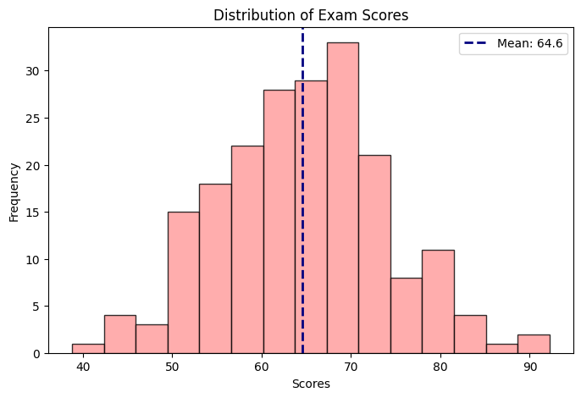

5. Scatter Plot

plt.figure(figsize=(8, 5))

hours_studied = np.array([1.5, 2.0, 2.5, 3.0, 4.0, 4.5, 5.0, 5.5, 6.0, 7.0])
marks_obtained = np.array([25, 30, 38, 42, 50, 55, 60, 65, 80, 85])

passed_hours = hours_studied[marks_obtained >= 40]
passed_marks = marks_obtained[marks_obtained >= 40]
failed_hours = hours_studied[marks_obtained < 40]
failed_marks = marks_obtained[marks_obtained < 40]

plt.scatter(passed_hours, passed_marks, color='green', label='Passed (â‰¥ 40)', s=80)
plt.scatter(failed_hours, failed_marks, color='red', label='Failed (< 40)', s=80)
plt.title('Hours Studied vs Marks Obtained')
plt.xlabel('Hours Studied')
plt.ylabel('Marks Obtained')
plt.legend()
plt.grid(True, linestyle=':', alpha=0.6)
plt.show()

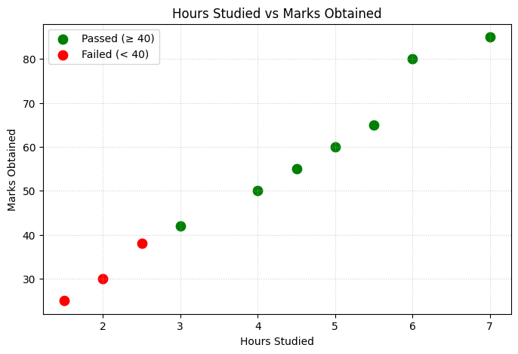

6. Horizontal Bar Chart

plt.figure(figsize=(8, 5))
countries = ['China', 'India', 'USA', 'Brazil', 'Indonesia']
users = [1050, 750, 310, 165, 155]

countries.reverse()
users.reverse()

plt.barh(countries, users, color='purple')
plt.title('Top 5 Countries by Internet Users (in Millions)')
plt.xlabel('Internet Users (Millions)')
plt.ylabel('Country')
plt.show()

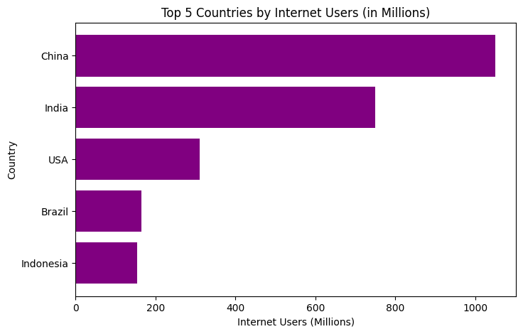

7. Stacked Bar Chart

plt.figure(figsize=(8, 5))
quarters = ['Q1', 'Q2', 'Q3', 'Q4']
hr_expenses = np.array([120, 130, 110, 140])
it_expenses = np.array([200, 210, 190, 220])
finance_expenses = np.array([150, 160, 140, 170])

plt.bar(quarters, hr_expenses, label='HR', color='#ff9999')
plt.bar(quarters, it_expenses, bottom=hr_expenses, label='IT', color='#66b3ff')
plt.bar(quarters, finance_expenses, bottom=hr_expenses + it_expenses, label='Finance', color='#99ff99')

plt.title('Quarterly Expenses by Department')
plt.xlabel('Quarter')
plt.ylabel('Expenses (in thousands)')
plt.legend()
plt.show()

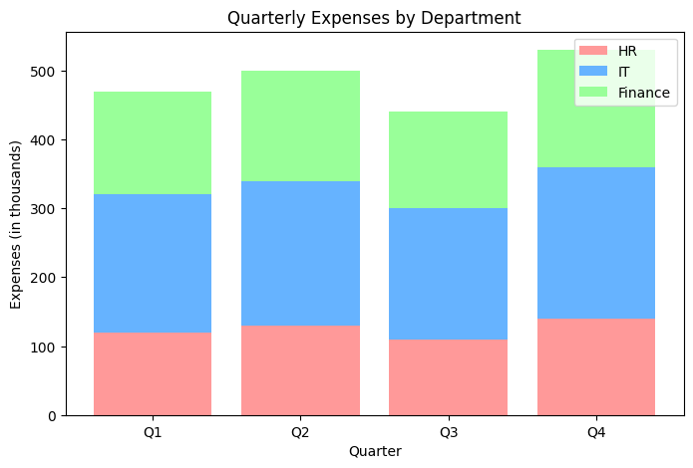

8. Box Plot

plt.figure(figsize=(8, 5))

class_a = np.random.normal(loc=65, scale=10, size=30)
class_b = np.random.normal(loc=75, scale=8, size=30)
class_c = np.random.normal(loc=55, scale=12, size=30)

data_to_plot = [class_a, class_b, class_c]
labels = ['Class A', 'Class B', 'Class C']

plt.boxplot(data_to_plot, labels=labels, patch_artist=True, boxprops=dict(facecolor='lightblue'))
plt.title('Test Score Distributions Across Classes')
plt.xlabel('Class')
plt.ylabel('Scores')
plt.show()

