CYBERHEAL AI
AI-Driven Autonomous Cyber Incident Investigation
and Verified Cloud Recovery
Provider-Independent Open-Source Cloud Edition
Final Year Project Concept & Implementation Document
Cloud Computing | Cybersecurity | AI/ML | DevSecOps
One-line description
Detect the attack, understand what happened, contain it, recover the cloud workload from a trusted state, and verify that the recovered environment is safe before returning it to service.

1. Executive Summary
CyberHeal AI is a provider-independent, open-source cloud cybersecurity and recovery framework. The system is designed to detect suspicious activity in a private cloud, investigate incidents using machine learning and a locally hosted LLM, execute policy-controlled containment, restore affected workloads from trusted snapshots, and perform explicit post-recovery security verification before returning a service to operation.
The project is intentionally designed without dependency on AWS-managed services. The reference cloud platform is OpenStack, while the application layer remains portable across virtual-machine environments. The implementation combines open-source cloud infrastructure, security monitoring, observability, AI/ML, policy enforcement, Infrastructure as Code, CI/CD, container tooling, storage, and automatic scaling.
Primary project contribution
The Recovery Confidence Score (RCS) combines identity, file-integrity, network, configuration, and service-health checks into a transparent post-recovery decision: SAFE, REVIEW, or UNSAFE.

2. Problem Statement
Cloud security systems commonly focus on detection and alerting. However, incident resolution requires more than identifying suspicious behaviour. A workload may be isolated but still need recovery; a backup may be restored but still contain compromised files or insecure configuration; and an automated response system may introduce additional risk if an AI model can directly perform unrestricted infrastructure actions.
- Attack detection alone does not guarantee safe recovery.
- Backups or snapshots can preserve compromised state if recovery points are not validated.
- Incident investigation is often manual and slow when logs are large or fragmented.
- Autonomous response must be constrained by explicit policy and least privilege.
- Post-recovery security verification is often treated as an operational afterthought.

3. Research Foundation and Proposed Extension
The primary IEEE base paper is: Machine Learning Based File Entropy Analysis for Ransomware Detection in Backup Systems
IEEE Access, Volume 7, 2019, pp. 110205-110215. DOI: 10.1109/ACCESS.2019.2931136.
The paper motivates the ransomware-detection portion of CyberHeal AI by showing how file entropy and machine learning can help identify ransomware-affected files in backup environments. CyberHeal AI extends that direction by integrating detection with AI-assisted investigation, policy-controlled containment, trusted recovery, and post-recovery verification in a single closed loop.
Existing Area | Typical Focus | CyberHeal AI Extension
Ransomware detection | Detect abnormal file/encryption behaviour | Link detection to trusted restore and verification
Log/SIEM analysis | Alerting and event correlation | LLM-assisted timeline and root-cause summary
Automated remediation | Scripted response | Policy-governed allow/deny actions
Cloud recovery | Restore workload/data | Verify identity, files, network, config and health
Cloud self-healing | Restore availability | Require security confidence before return to service

4. Project Objectives
- Build a three-node open-source private-cloud deployment for a three-member team.
- Detect ransomware-like file anomalies and suspicious credential/account behaviour.
- Use ML primarily for anomaly/threat detection and a local LLM for incident investigation.
- Separate AI reasoning from infrastructure authority using a deterministic policy engine.
- Recover affected workloads using open-source cloud storage and snapshot mechanisms.
- Verify recovery using a measurable Recovery Confidence Score.
- Demonstrate security controls, monitoring, alarms, automatic scaling, CI/CD and Infrastructure as Code.

5. Project Scope
In Scope | Out of Scope
OpenStack VM workloads | Real malware deployment
Ransomware-like file modification simulation | Use of stolen credentials
Controlled account/credential anomaly simulation | Unrestricted AI administration
ML anomaly detection | Replacement of a commercial SOC/SIEM
Local LLM incident analysis | Enterprise multi-region disaster recovery
Policy-controlled containment | Universal detection of all attacks
Cinder snapshot recovery and verification | Production-grade zero-trust implementation

6. High-Level Architecture
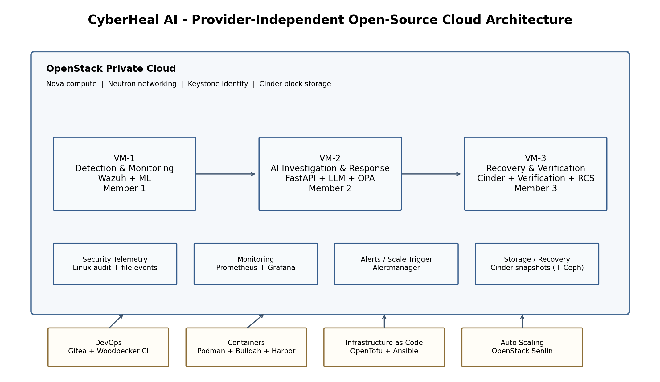
The three permanent virtual machines are placed inside one isolated OpenStack Neutron project network. Each node owns a distinct module boundary so individual contribution is visible, while Prometheus/Grafana, storage, CI/CD, and scaling services support the system as shared infrastructure.

7. Four Main Project Modules
Module | Core Flow | Primary Technologies | Owner
1. Detect | Telemetry -> features -> ML -> alert | Wazuh, Linux audit, Python, scikit-learn | Member 1
2. Investigate | Alert -> LLM -> timeline/root cause/risk | FastAPI, llama.cpp or vLLM, local model | Member 2
3. Respond | Risk -> policy -> approved action -> audit | OPA, OpenStack SDK, Neutron/Keystone | Member 2
4. Recover & Verify | Snapshot -> restore -> checks -> RCS | Cinder, optional Ceph, Python verification | Member 3

7.1 Module 1 - Detect
The detection module collects security telemetry from the test environment and creates machine-learning features. Wazuh provides centralized endpoint/security events and file-integrity monitoring, while the custom detector implements the project-specific ML logic.
- File entropy change
- File modification/rename frequency
- File hash/integrity changes
- Failed authentication patterns
- Privilege or account changes
- Abnormal administrative/API actions

7.2 Module 2 - Investigate
The investigation service accepts a structured threat alert and relevant sanitized evidence. A locally hosted LLM produces an incident summary, attack timeline, probable root cause, affected resources, and risk score. The LLM is advisory and has no unrestricted infrastructure privileges.

7.3 Module 3 - Respond and Contain
Open Policy Agent evaluates the proposed action against explicit rules. Only allow-listed actions are executed through Python/OpenStack SDK automation. Every decision is logged for auditability.
Example Condition | Example Allowed Action
Critical ransomware-like activity on test VM | Apply quarantine security group / isolate network
Compromised test account | Disable or restrict test credential/account
Medium-confidence anomaly | Alert and require human approval
Unknown/destructive action | Deny automatically

7.4 Module 4 - Recover and Verify
The recovery module selects a trusted Cinder snapshot or backup state, restores the affected workload/volume, and then runs security checks before service return. Recovery is not considered complete until the verification policy passes.

8. Recovery Confidence Score (RCS)
The Recovery Confidence Score is a project-defined experimental policy that combines multiple verification results into a single transparent decision. The initial weighting is:
Verification Factor | Weight | Example Evidence
Identity Security | 25% | Test account disabled, expected roles/permissions
File / Integrity Security | 25% | Hashes, entropy, file-integrity checks pass
Network Security | 20% | Expected Neutron security rules, no unwanted exposure
Configuration Security | 15% | Known-good service/configuration baseline restored
Application Health | 15% | API/service health and functional check

RCS = 0.25I + 0.25F + 0.20N + 0.15C + 0.15H
Score | Decision | Meaning
85-100 | SAFE | Eligible to return to service
70-84 | REVIEW | Human verification required
0-69 | UNSAFE | Reinvestigate or recover again

Important
These weights and thresholds are project-defined and must be presented as an experimental policy, not as an OpenStack, IEEE, or industry standard.

9. Cloud Storage and Recovery Design
Storage is a functional part of the security/recovery workflow rather than a checklist item. Each workload can use a persistent Cinder block volume. Clean states are captured as Cinder snapshots. In a larger lab, Ceph may be used as the underlying distributed storage backend; in a smaller installation, the Cinder backend may use another supported block-storage configuration.
Storage Component | Role in CyberHeal AI
Cinder Volume | Persistent workload and sample-file data
Cinder Snapshot | Point-in-time trusted recovery state
Ceph (optional backend) | Distributed resilient block/object/file storage
Wazuh Indexer | Security event/log storage
Prometheus TSDB | Operational and CyberHeal custom metrics
Harbor (recommended) | Versioned container image/artifact registry

Ransomware demonstration flow: clean volume -> snapshot -> benign ransomware-like file transformation -> anomaly detected -> isolate -> select trusted snapshot -> restore -> verify -> calculate RCS.

10. Automatic Scaling Design
Automatic scaling should be demonstrated on a stateless threat-processing or API worker tier rather than on the three permanent member-owned project nodes. The preferred open-source cloud mechanism is OpenStack Senlin. A Prometheus/Alertmanager rule can trigger a Senlin receiver or scaling action when load exceeds the project threshold.
Setting | Demonstration Value
Minimum workers | 1
Desired workers | 1
Maximum workers | 2
Metric | CPU utilization or request queue
Trigger example | Sustained load above project threshold
Scale-in | Return to 1 worker after load normalizes

Course requirement interpretation
The three team-member VMs remain the permanent nodes. Any extra worker created by Senlin is temporary scaling capacity used only to demonstrate elasticity.

11. Open-Source Technology Stack
Layer | Tool | Purpose
Cloud platform | OpenStack | Provider-independent private IaaS cloud
Compute | Nova | Creates and manages VM instances
Networking | Neutron | Isolated networks, ports and security groups
Identity | Keystone | OpenStack users, projects, roles and tokens
Block storage | Cinder | Volumes, snapshots and restore points
Storage backend | Ceph (optional) | Distributed storage when lab capacity allows
Security/SIEM | Wazuh | Security events, FIM and centralized monitoring
ML | Python + scikit-learn | Anomaly detection/classification
Backend | FastAPI | Incident and automation APIs
Local AI | llama.cpp / vLLM | Self-hosted LLM inference
Policy | Open Policy Agent | Deterministic allow/deny authorization
Monitoring | Prometheus | Metrics collection and alert rules
Dashboard | Grafana OSS | Operational/security visualization
Alerting | Alertmanager | Notification routing and alert handling
Auto scaling | OpenStack Senlin | Scale stateless worker cluster
Source control | Git + Gitea | Self-hosted repositories and collaboration
CI/CD | Woodpecker CI | Automated test/build/deploy pipelines
Containers | Podman + Buildah | Open-source runtime and image build
Registry | Harbor | Self-hosted artifact/container registry
IaC | OpenTofu | Declarative infrastructure provisioning
Configuration | Ansible | Repeatable VM/service configuration
Secrets | OpenBao (optional) | Central secret management
Runtime security | Falco (optional) | Near-real-time Linux/container event detection

12. DevOps / DevSecOps Architecture
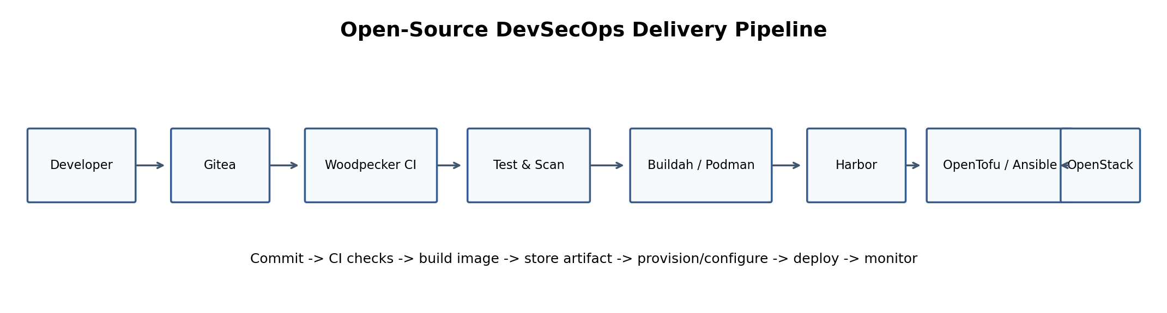
Tool | Why / Purpose | Goal | Scope / Method
Git + Gitea | Version control and collaboration | Auditable team contribution | Branches, PRs, code review
Woodpecker CI | Continuous integration/delivery | Automated validation and deployment | Lint, tests, scans, build, deploy
OpenTofu | Infrastructure as Code | Reproducible cloud environment | Provision OpenStack resources
Ansible | Configuration automation | Consistent VM/service setup | Idempotent playbooks
Podman + Buildah | Container runtime/build | Portable application packaging | Build and run OCI images
Harbor | Artifact registry | Controlled versioned images | Store and scan project images
Prometheus + Grafana | Observability | Measure health and project KPIs | Metrics, dashboards, alerts

13. Security Architecture
- Least-privilege OpenStack roles and project-scoped credentials.
- Neutron security groups permit only required communication paths.
- No unrestricted administrative role is given to the LLM.
- OPA acts as the policy boundary for automated remediation.
- Sensitive credentials are never hard-coded in source repositories.
- Administrative access uses controlled SSH keys and/or bastion/access policy.
- Wazuh collects security telemetry and file-integrity information.
- Every automated action is recorded with incident ID, resource, policy decision and result.
- Recovery points are treated as trusted only after policy and verification checks.

14. Monitoring, Alarms and Dashboard
Metric / Alert | Purpose
CPU, memory, disk | Resource health and scaling signal
VM/service health | Availability monitoring
CriticalThreatCount | Immediate security alert
InvestigationFailed | Detect failed AI investigation pipeline
RecoveryFailed | Detect unsuccessful restore attempt
RecoveryConfidenceScore < 85 | Prevent unsafe return to service
Detection latency | Measure incident detection performance
Containment/recovery duration | Operational evaluation

15. Three-Member Work Division
Member | Owned Node / Module | Primary Contributions | Individual Demonstration
Member 1 | VM-1: Detection & Monitoring | OpenStack test workload; Wazuh telemetry; file entropy features; ML detector; credential anomaly features; detection metrics | Generate controlled anomaly and produce a threat alert
Member 2 | VM-2: Investigation & Response | FastAPI; local LLM integration; timeline/root cause; risk score; OPA policies; OpenStack SDK containment; response audit trail | Investigate alert and execute an allowed containment action
Member 3 | VM-3: Recovery & Verification | Cinder snapshots; trusted recovery-point logic; restore automation; IAM/network/file/config/health checks; RCS | Restore a workload and produce SAFE/REVIEW/UNSAFE decision

Evidence of individual contribution should include Git/Gitea commits, pull requests, owned configuration/code paths, OpenStack resources, CI/CD history, test results, and module-specific live demonstrations.

16. Initial Attack Scenarios

16.1 Scenario A - Simulated Ransomware
1. Create a clean sample-data volume and trusted snapshot.
2. Run a harmless simulator that transforms/renames sample files.
3. Detect entropy/integrity/modification anomalies.
4. Generate incident and investigation summary.
5. OPA authorizes quarantine of the affected test workload.
6. Select and restore the trusted snapshot.
7. Run post-recovery checks and calculate RCS.

16.2 Scenario B - Compromised Test Credential
1. Use a dedicated test account or service credential.
2. Generate controlled abnormal login/privilege/administrative activity.
3. Detect anomaly using Wazuh events and custom features.
4. LLM summarizes the timeline and probable cause.
5. OPA authorizes restriction/disablement of the test credential.
6. Verify identity, network and service state after containment.

17. Evaluation Metrics
Category | Metrics
Detection | Accuracy, precision, recall, F1, false-positive rate
Response | Detection-to-containment time, policy decision success
Recovery | Recovery time, success rate, RPO, RTO
Verification | RCS, verification pass/fail accuracy
Automation | Percentage of permitted actions completed autonomously
Operations | Scaling response time, service availability, alert latency

No numerical accuracy or performance claims should be presented until measurements have been collected from the implemented system.

18. Review 1 - Initial Review Deliverables
- Problem statement, base paper, research gap and project objectives.
- Provider-independent OpenStack architecture with three project VMs.
- Four modules and data/control flow.
- DevOps-oriented architecture and explanation of each tool: why, purpose, goal, scope and method.
- Security model including least privilege, network isolation and OPA policy boundary.
- Storage/recovery design and proposed automatic-scaling design.
- Clear individual contribution plan for all three members.
- Implementation roadmap and planned evaluation metrics.

19. Review 2 - Final Demonstration Deliverables
- Three working VM instances in an isolated cloud network.
- Implemented security controls and centralized telemetry.
- Working alarms/dashboard and automatic scaling demonstration.
- End-to-end ransomware-like scenario.
- End-to-end compromised-test-credential scenario.
- Policy-controlled containment actions with audit evidence.
- Snapshot restore followed by security verification and RCS.
- CI/CD evidence and Infrastructure as Code/configuration automation.
- Individual technical demonstration by each member.

20. Implementation Roadmap
Phase | Target Work | Primary Output
1. Cloud foundation | OpenStack project/network, three VMs, Cinder volumes | Reachable isolated lab environment
2. DevOps foundation | Gitea, CI/CD, OpenTofu/Ansible, container workflow | Repeatable deployment pipeline
3. Detection | Wazuh agents/server, dataset/simulator, ML features/model | Threat alert API/output
4. Investigation | FastAPI + local LLM + structured incident schema | Timeline/root-cause/risk report
5. Response | OPA policies + OpenStack SDK actions | Audited quarantine/account restriction
6. Recovery | Cinder snapshots and restore automation | Trusted recovery workflow
7. Verification | Integrity/IAM/network/config/health checks + RCS | SAFE/REVIEW/UNSAFE decision
8. Observability & scaling | Prometheus/Grafana/Alertmanager + Senlin | Alarms and scale-out/scale-in demo
9. Evaluation | Run scenarios repeatedly and collect metrics | Results tables and final review evidence

21. Feasibility and Scope Control
The architecture contains many open-source technologies, but the team should not deploy every optional component before the core loop works. The minimum viable project should prioritize the following:
- OpenStack Nova/Neutron/Cinder/Keystone
- Wazuh
- Python + scikit-learn + FastAPI
- Local LLM using llama.cpp or vLLM
- OPA
- Prometheus + Grafana + Alertmanager
- OpenTofu + Ansible
- Gitea + Woodpecker CI
- Podman/Buildah
- Senlin if available in the lab
Optional enhancements after the core demonstration is stable: Ceph if not already provided by the lab, Harbor, OpenBao, Falco, advanced model fine-tuning, and additional attack scenarios.

22. Risks and Mitigations
Risk | Mitigation
OpenStack deployment complexity | Use an existing lab OpenStack environment where possible; freeze infrastructure scope early
LLM hardware requirement | Use a small quantized local model and structured prompts
Too many tools for three members | Implement core stack first; optional tools only after end-to-end flow works
Unsafe automation | OPA allowlist, least privilege and controlled test resources
False positives | Use labeled simulations, threshold tuning and report precision/recall
Recovery point is not clean | Track trusted snapshot timestamp and run full post-restore verification
Scaling service unavailable | Use Senlin if deployed; otherwise document a Heat/Aodh or scripted fallback approved by the instructor

23. Expected Outcome
The final system should demonstrate a complete open-source cloud-security loop: telemetry collection, ML detection, AI-assisted investigation, policy-controlled containment, trusted snapshot recovery, and explicit verification before return to service. It should also demonstrate a credible DevSecOps workflow, monitoring, alarms, storage, Infrastructure as Code, and automatic scaling without dependence on proprietary cloud-managed services.
Final principle
CyberHeal AI does not consider an incident resolved when a workload is merely restored. Recovery is complete only when the restored environment is verified as safe.

24. Key References and Project Documentation
- IEEE Access (2019). Machine Learning Based File Entropy Analysis for Ransomware Detection in Backup Systems. DOI: 10.1109/ACCESS.2019.2931136.
- OpenStack Documentation - https://docs.openstack.org/
- OpenStack Cinder Documentation - https://docs.openstack.org/cinder/latest/
- OpenStack Senlin Documentation - https://docs.openstack.org/senlin/latest/
- Wazuh Documentation - https://documentation.wazuh.com/
- Prometheus Documentation - https://prometheus.io/docs/
- Grafana Documentation - https://grafana.com/docs/
- Open Policy Agent Documentation - https://www.openpolicyagent.org/docs/
- OpenTofu Documentation - https://opentofu.org/docs/
- Gitea Documentation - https://docs.gitea.com/
- Woodpecker CI Documentation - https://woodpecker-ci.org/docs/
- Podman Documentation - https://docs.podman.io/
- Harbor Documentation - https://goharbor.io/docs/

