Virtual Lab Experiment-6
Jenkins with Build Tool (Maven)
Aim
To implement Continuous Integration using Jenkins and Maven where source code is automatically built and tested whenever changes are pushed to a Git repository.

Scenario (Real-Time Use Case)
A software company wants to automatically build and test a Java application whenever developers push code to GitHub.
The requirements are:
• Source code should be stored in Git
• Build process should be automated
• Build tool should compile the application
• Jenkins should trigger build automatically

Solution Stack
Requirement | Tool
Version Control | Git
CI/CD Tool | Jenkins
Build Tool | Maven
Programming Language | Java
Repository | GitHub
Operating System | Linux / Ubuntu

Architecture Overview
- Developer pushes code to GitHub
- Jenkins detects the code change
- Jenkins pulls the source code
- Maven compiles the application
- Jenkins shows build status

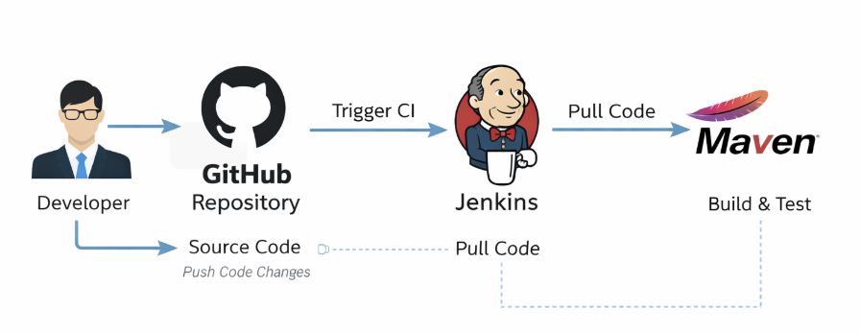

Tools & Technologies
• Git
• GitHub
• Jenkins
• Maven
• Java JDK
• Linux / Ubuntu

System Requirements
• OS: Ubuntu / Linux / Windows
• RAM: Minimum 4 GB
• Java JDK installed
• Git installed
• Maven installed
• Jenkins installed

Project Directory Structure
jenkins-lab/
│
│── src/
│ └── HelloWorld.java
│
│── pom.xml

Step-by-Step Implementation

PART A – Install Required Tools

Step 1: Install Java
sudo apt update
sudo apt install openjdk-11-jdk -y
Check version
java -version

Step 2: Install Maven
sudo apt install maven -y
Check version
mvn -version

Step 3: Install Jenkins
sudo apt install jenkins -y
Start Jenkins
sudo systemctl start jenkins
sudo systemctl enable jenkins
Check status
sudo systemctl status jenkins

Step 4: Access Jenkins
Open browser
http://localhost:8080
Unlock Jenkins
sudo cat /var/lib/jenkins/secrets/initialAdminPassword
Install Suggested Plugins

PART B – Create Sample Java Application

Step 5: Create Java Program
Create directory
mkdir jenkins-lab
cd jenkins-lab
mkdir src
Create file
nano src/HelloWorld.java
Example Code
public class HelloWorld {
public static void main(String[] args) {
System.out.println("Hello from Jenkins CI Pipeline!");
}
}

PART C – Create Maven Build File

Step 6: Create pom.xml
nano pom.xml
Example
<project xmlns="http://maven.apache.org/POM/4.0.0">
<modelVersion>4.0.0</modelVersion>

<groupId>com.devops</groupId>
<artifactId>jenkins-lab</artifactId>
<version>1.0</version>

<build>
<sourceDirectory>src</sourceDirectory>
<plugins>
<plugin>
<artifactId>maven-compiler-plugin</artifactId>
<version>3.8.1</version>
</plugin>
</plugins>
</build>
</project>

PART D – Push Code to GitHub
Initialize repository
git init
git add .
git commit -m "Initial Jenkins Maven Project"
Add GitHub repository
git remote add origin <repo-url>
git push origin main

PART E – Configure Jenkins Job

Step 7: Create Jenkins Job
- Open Jenkins Dashboard
- Click New Item
- Enter job name
- Select Freestyle Project
- Click OK

Step 8: Configure Source Code

In Source Code Management
Select Git
Enter repository URL
https://github.com/username/jenkins-lab.git
Branch
*/main

Step 9: Configure Build Tool
In Build Section
Select
Invoke top-level Maven targets
Goals
clean package

PART F – Build the Project
Click
Build Now
Jenkins will
• Pull source code
• Run Maven build
• Compile Java application
Check Console Output
Expected Output
BUILD SUCCESS

Observations
• Jenkins successfully integrated with GitHub
• Maven automatically compiled the Java project
• Jenkins dashboard shows build status

Result
The Continuous Integration pipeline was successfully implemented using Jenkins and Maven, where Jenkins automatically builds the application whenever source code is updated.

VIVA VOCE QUESTIONS
Basic
- What is Jenkins?
- What is Continuous Integration?
- What is Maven?
- What is a build tool?
- What is pom.xml?

Intermediate
- Difference between CI and CD
- What are Jenkins plugins?
- What is a Jenkins pipeline?
- What is a workspace in Jenkins?
- Difference between freestyle job and pipeline job

Advanced
- How does Jenkins trigger builds automatically?
- What is webhook in Jenkins?
- How does Maven manage dependencies?
- What is artifact generation in Maven?
- Explain Jenkins pipeline stages.

