VLE-7: Full DevOps Monitoring System (AWS + K8s + CI/CD + Alerts)

🎯 Objective
To design and deploy an end-to-end DevOps monitoring system using:
- Amazon Web Services
- Kubernetes
- Jenkins
- Prometheus
- Grafana
- Prometheus Alertmanager

🧠 System Architecture
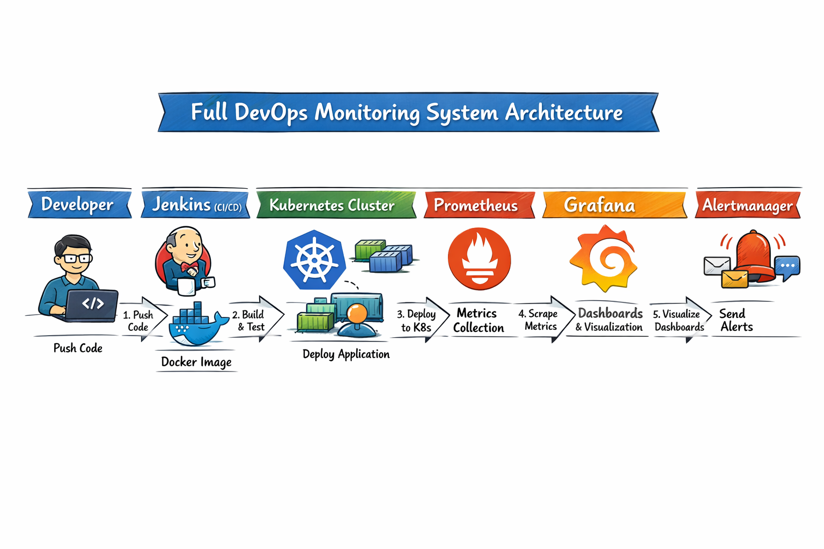
🧰 Prerequisites
- AWS account (Free tier or Educate)
- Ubuntu EC2 instance
- Basic knowledge of Docker & Kubernetes
- GitHub account

🪜 PHASE 1: Infrastructure Setup (AWS)
🔹 Step 1: Launch EC2 Instance
- Ubuntu 22.04
- t2.medium (recommended for K8s tools)
- Open ports:
  - 22 (SSH)
  - 3000 (Grafana)
  - 9090 (Prometheus)
  - 8080 (Jenkins)

🔹 Step 2: Install Required Tools
sudo apt update
sudo apt install docker.io git -y
sudo systemctl start docker
sudo usermod -aG docker ubuntu

🐳 PHASE 2: CI/CD using Jenkins

🔹 Step 3: Install Jenkins
sudo apt install openjdk-11-jdk -y
wget -q -O - https://pkg.jenkins.io/debian-stable/jenkins.io.key | sudo apt-key add -
sudo sh -c 'echo deb https://pkg.jenkins.io/debian-stable binary/ > /etc/apt/sources.list.d/jenkins.list'
sudo apt update
sudo apt install jenkins -y
Start:
sudo systemctl start jenkins
👉 Access:
http://<EC2-IP>:8080

🔹 Step 4: Configure Jenkins Pipeline
- Install plugins:
  - Docker Pipeline
  - Git
Sample Jenkinsfile:
pipeline {
agent any
stages {
stage('Build') {
steps {
sh 'docker build -t myapp .'
}
}
stage('Deploy') {
steps {
sh 'kubectl apply -f deployment.yaml'
}
}
}
}

☸️ PHASE 3: Kubernetes Setup

🔹 Step 5: Install Minikube (or use AWS EKS)
curl -LO https://storage.googleapis.com/minikube/releases/latest/minikube-linux-amd64
sudo install minikube-linux-amd64 /usr/local/bin/minikube
minikube start

🔹 Step 6: Deploy Sample Application
apiVersion: apps/v1
kind: Deployment
metadata:
name: myapp
spec:
replicas: 2
selector:
matchLabels:
app: myapp
template:
metadata:
labels:
app: myapp
spec:
containers:
- name: myapp
image: nginx
ports:
- containerPort: 80
Apply:
kubectl apply -f deployment.yaml

📊 PHASE 4: Monitoring using Prometheus & Grafana

🔹 Step 7: Install Helm
sudo snap install helm --classic

🔹 Step 8: Install Monitoring Stack
helm repo add prometheus-community https://prometheus-community.github.io/helm-charts
helm repo update

helm install monitoring prometheus-community/kube-prometheus-stack

🔹 Step 9: Access Grafana
kubectl port-forward svc/monitoring-grafana 3000:80
Login:
- admin / password (from secret)

📊 Dashboards Include
- Node metrics
- Pod usage
- Cluster health

🔔 PHASE 5: Alerting using Alertmanager

🔹 Step 10: Configure Alerts
Example rule:
groups:
- name: k8s-alerts
rules:
- alert: PodCrashLoop
expr: kube_pod_container_status_restarts_total > 3
for: 2m
labels:
severity: critical

🔹 Step 11: Configure Alertmanager
- Email / Slack integration
- Alert routing

📩 Expected Alerts
- Pod failures
- High CPU usage
- Node down

🔄 PHASE 6: CI/CD + Monitoring Integration

🔹 Step 12: Full Flow
- Developer pushes code → GitHub
- Jenkins builds Docker image
- Deploys to Kubernetes
- Prometheus monitors pods
- Grafana visualizes
- Alert manager sends alerts

📊 Expected Output
- Live dashboards in Grafana
- Auto-deployment via Jenkins
- Alerts triggered on failures
- Multi-layer monitoring system

🎓Sample Viva Questions
DevOps
- What is CI/CD pipeline?
- Difference between CI and CD?
Kubernetes
- What is a pod?
- What is deployment vs service?
Monitoring
- What is Prometheus scraping?
- Why Grafana is used?
Alerts
- What is Alertmanager?
- What are alert rules?

📝 Result
Successfully designed and deployed a Full DevOps Monitoring System integrating:
- Cloud (AWS)
- CI/CD (Jenkins)
- Containerization (Docker)
- Orchestration (Kubernetes)
- Monitoring (Prometheus + Grafana)
- Alerting (Alertmanager)

