Machine Learning Engineer Nanodegree

Capstone Project Proposal

Classifying Art Pieces Data Set

Gangapalli Venkata Krishna Reddy

December 26th, 2018

Proposal:

Classifying Art Pieces Data Set

**Domain Background:**

In this project, I am working on classifying art pieces.  Art has been a part of our life for as long as humanity has existed. For thousands of years people have been creating, looking at, criticizing, and enjoying art. Art is something that captures the eye. Whether the artist is trying to communicate an emotion, an idea or something else, the most important thing is how well the audience receives it. Art is something that inspires people, something that transports us into different realities and moves us into the subconscious places that we did not know existed.

There are many different types of art like animation, architecture, assemblage, calligraphy, ceramics, computer, Christian or religious, conceptual, artistic design, drawing, folk, graffiti, graphic, illuminated manuscript, illustration, mosaic, painting, performance, photography, sculpture, stained glass, tapestry, and video. Subclassifications include chalk, charcoal, pen and ink, watercolors, acrylics, miniature painting, engraving, lithography, screen printing, wood carving, dance, and acting.

Out of all, I have taken 5 different art forms to classify

1. Paintings - Painting is the practice of applying paint, pigment, color or other medium to a solid surface **(Wikipedia).**
2. Drawings - Drawing is a form of visual art in which a person uses various drawing instruments to mark paper or another two-dimensional medium **(Wikipedia).**
3. Sculpture - Sculpture is the branch of the visual arts that operates in three dimensions. The earliest example of sculpture dates back to the Upper Paleolithic period (40,000 to 10,000 years ago) **(Wikipedia).**
4. Engravings - Engraving is the practice of incising a design onto a hard, usually flat surface by cutting grooves into it with a burin **(Wikipedia).**
5. Iconography (old Russian art): Iconography, as a branch of art history, studies the identification, description, and the interpretation of the content of images **(Wikipedia).**

I am highly interested because I love to do image classification, fun fact, I didn’t these many types of arts are existed till I start this project, feels good to know about previous rich heritage.

**Problem Statement:**

To understand the difference between types of art forms. The aim of this project is to predict the type of art form it belongs to by visualizing image.

In the project, I am going to use various Machine Learning Algorithms to predict the types of images and compare their performance and finally declare my final model.

**Datasets and Inputs:**

The dataset that I am working is downloaded from <https://www.kaggle.com/pierrenicolaspiquin/classifying-art-pieces/data>. It contains over 9000 images of above mentioned 5 categories.

Citation:

Dataset for classifying different styles of art. Main categories have been taken http://rusmuseumvrm.ru/collections/index.php?lang=en.

The data is open – sourced and can be download for education purpose with no citation.

http://rusmuseumvrm.ru/collections/index.php?lang=en.

There are 5 categories of images and 9000 instances of data.



Data is separated on training and testing sets.

**Solution Statement:**

The classifier is a ​ Convolutional Neural Network​, which is the state-of-the-art algorithm for most image processing tasks, including classification. It needs a large amount of training data compared to other approaches; fortunately, the art pieces datasets are big enough. The algorithm outputs an assigned probability for each class; by using argmax probability the category for which probability is higher is used as final category of image. The following parameters can be tuned to optimize the classifier:

❖ Training parameters

➢ Training length (number of epochs)

➢ Batch size (how many images to look at once during a single training step)

❖ Neural network architecture

➢ Number of layers

➢ Layer types (​ convolutional​, ​ fully-connected​, or ​ pooling​)

Additionally, along with this I want to experiment with pretrained models like ResNet50, VGG16, VGG19 etc.,

**Benchmark Model:**

In this art pieces classification, I want to use random assignment to set the worst score benchmark. Any MLP (Multi-Layer Perceptron) that gives accuracy around 5% is my benchmark model.

**Evaluation Metrics:**

I want to use accuracy as evaluation metric for art pieces classification. Accuracy is a common metric for categorical classifiers

Accuracy = (images correctly classified) / (all images)

During development, a validation set was used to evaluate the model. I want to use a small set of training images as my validation images.

For validation I want to use “categorical_crossentropy” as loss metric for CNN, optimizer as “rmsprop” and also metrics as” accuracy”

**Project Design:**

The project is composed of different steps as follows:

First task is to read the dataset and perform visualizations on it to get some insights about the data.

After Data Exploration, I want to split the train data into training and validation sets and standardize the data to make it suitable for Machine Learning Algorithms.

First, I want to choose a Benchmark model which will at least gives accuracy around 5 %, and then I want to apply different Convolutional Neural Networks on the data and compare the performance of them against accuracy. I want to select the best model among them and then I want to apply different pretrained CNN models like CGG16, CGG19, ResNet50 etc., compare them against CNN model I have prepared and see which predicts best on Test set.

Finally, I will declare the model with highest accuracy on both training and testing data sets as my model.

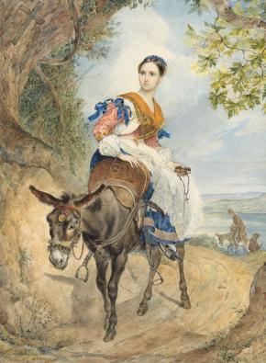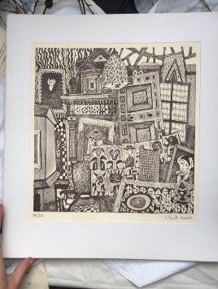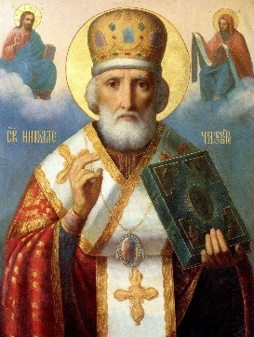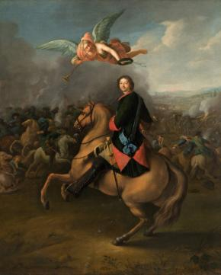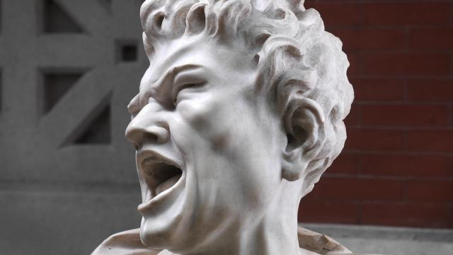

**Drawing engraving iconography painting sclupture**