CO- 2: AT – 2: Simulation Task
Name;C.ramakrishnareddy
Q1) 31. Simulation of propagation loss under 700 MHz, 3.5 GHz, 28 GHz, 38 GHz, and 60 GHz
Objective1
Matlab code;
clc;
clear;
close all;
% Frequencies (Hz)
freq = [700e6 3.5e9 28e9 38e9 60e9];
% Distance (m)
d = 1:1:1000;
figure;
hold on;
for i = 1:length(freq)
PL = 20*log10(d) + 20*log10(freq(i)) - 147.55; % FSPL
plot(d, PL, 'LineWidth',2);
end
grid on;
xlabel('Distance (m)');
ylabel('Path Loss (dB)');
title('Propagation Loss at Different Frequencies');
legend('700 MHz','3.5 GHz','28 GHz','38 GHz','60 GHz');
output;
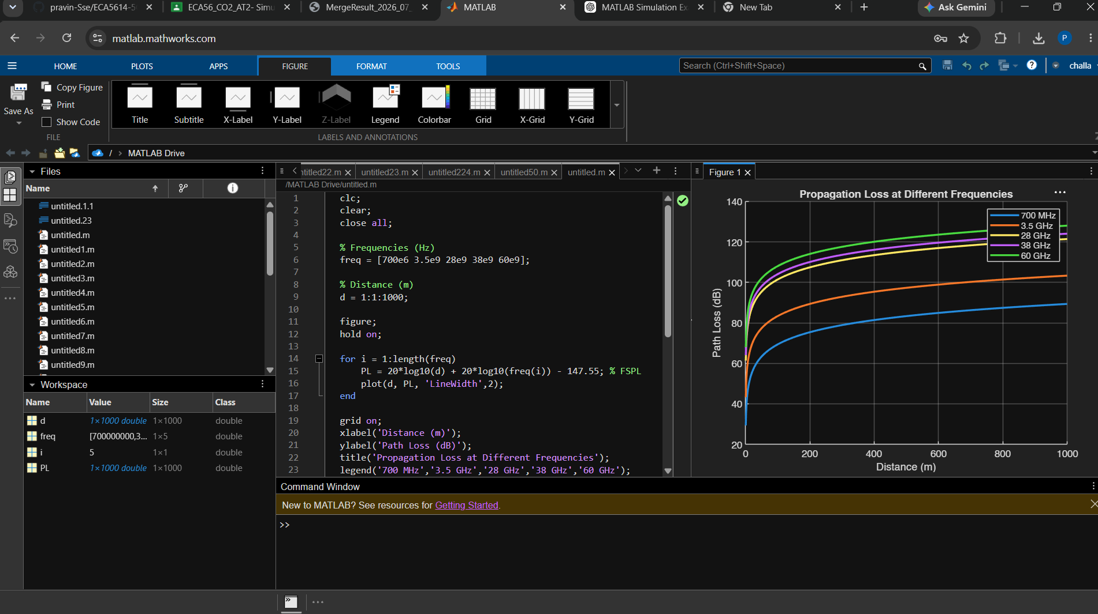
Q2) Simulation of mmWave path loss under distance, frequency, atmospheric absorption,
blockage, and antenna gain
Objective1
Matlab code
clc;
clear;
close all;

d = 1:1:500;
f = 28e9;

atm_loss = 0.015; % dB/m
blockage = 20; % dB
Gt = 20; % Transmitter gain
Gr = 20; % Receiver gain

FSPL = 20*log10(d)+20*log10(f)-147.55;

TotalLoss = FSPL + atm_loss*d + blockage - Gt - Gr;

plot(d,TotalLoss,'r','LineWidth',2);

grid on;
xlabel('Distance (m)');
ylabel('Path Loss (dB)');
title('mmWave Path Loss');
Output;
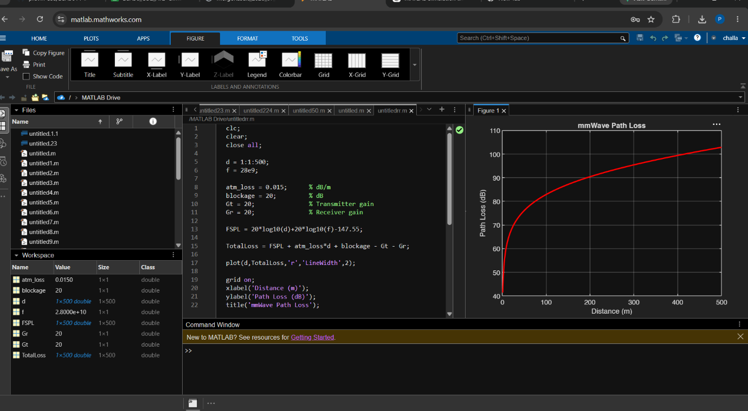
Q3) Simulation of channel modeling for mmWave MIMO under LOS, NLOS, fading, delay
spread, and SNR
Objective1;
Matylab code;
clc;
clear;
close all;

Nt = 4;
Nr = 4;
SNR = 0:2:30;

Capacity_LOS = zeros(size(SNR));
Capacity_NLOS = zeros(size(SNR));

for k=1:length(SNR)

% LOS Channel
H1 = ones(Nr,Nt);

% NLOS Channel
H2 = (randn(Nr,Nt)+1i*randn(Nr,Nt))/sqrt(2);

rho = 10^(SNR(k)/10);

Capacity_LOS(k)=log2(det(eye(Nr)+rho/Nt*(H1*H1')));
Capacity_NLOS(k)=real(log2(det(eye(Nr)+rho/Nt*(H2*H2'))));
end

plot(SNR,Capacity_LOS,'b-o','LineWidth',2);
hold on;
plot(SNR,Capacity_NLOS,'r-*','LineWidth',2);

grid on;
xlabel('SNR (dB)');
ylabel('Capacity (bits/s/Hz)');
title('mmWave MIMO Channel');
legend('LOS','NLOS');
Output;
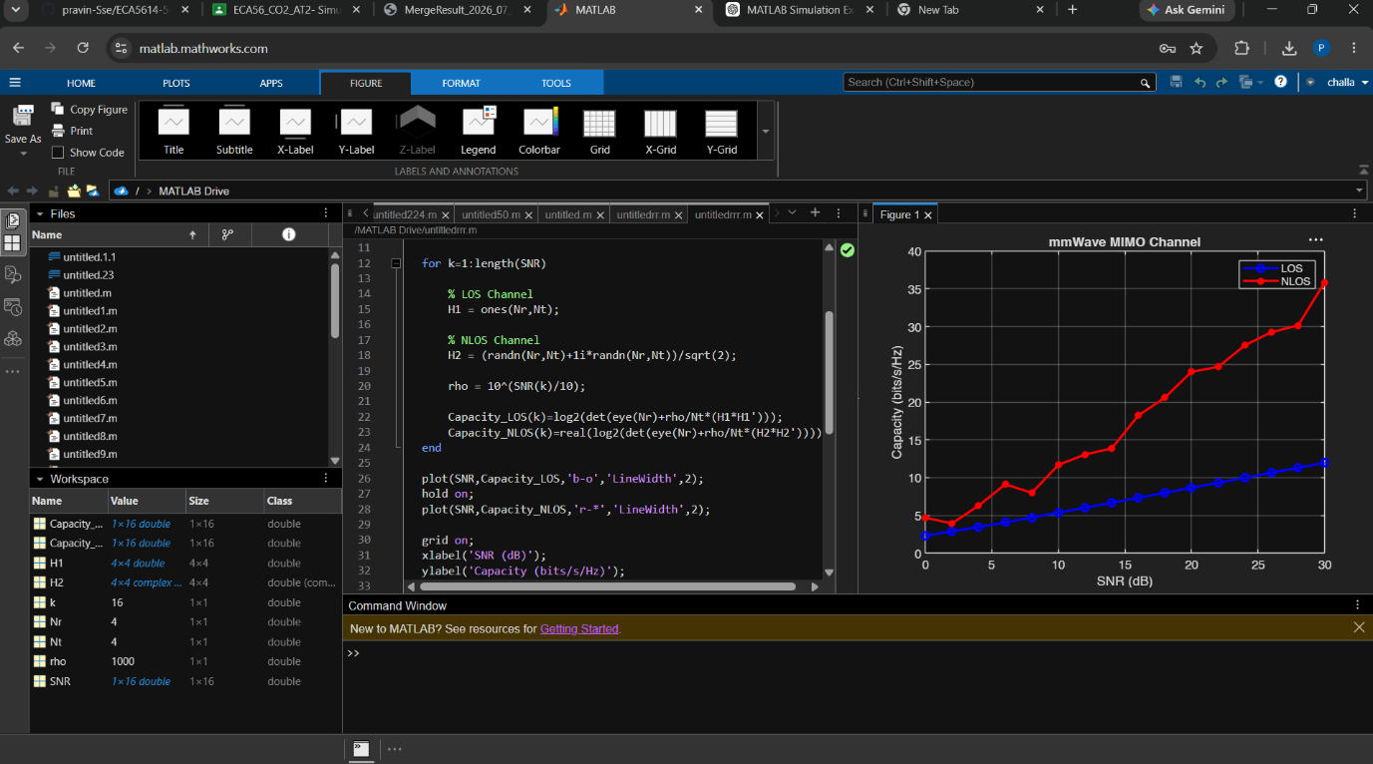
Q4) Simulation of Interference Management under User Density, Reuse Factor, SNR, SINR, and Throughput
Objective1;
Matlab code;
clc;
clear;
close all;

users = 10:10:200;
reuse = 3;
SNR = 20;

SINR = zeros(size(users));
Throughput = zeros(size(users));

for i=1:length(users)

interference = users(i)/reuse;

SINR(i)=SNR/(1+interference);

Throughput(i)=log2(1+SINR(i));
end

subplot(2,1,1)
plot(users,SINR,'LineWidth',2)
grid on
xlabel('Number of Users')
ylabel('SINR')

subplot(2,1,2)
plot(users,Throughput,'r','LineWidth',2)
grid on
xlabel('Number of Users')
ylabel('Throughput (bps/Hz)')
output;
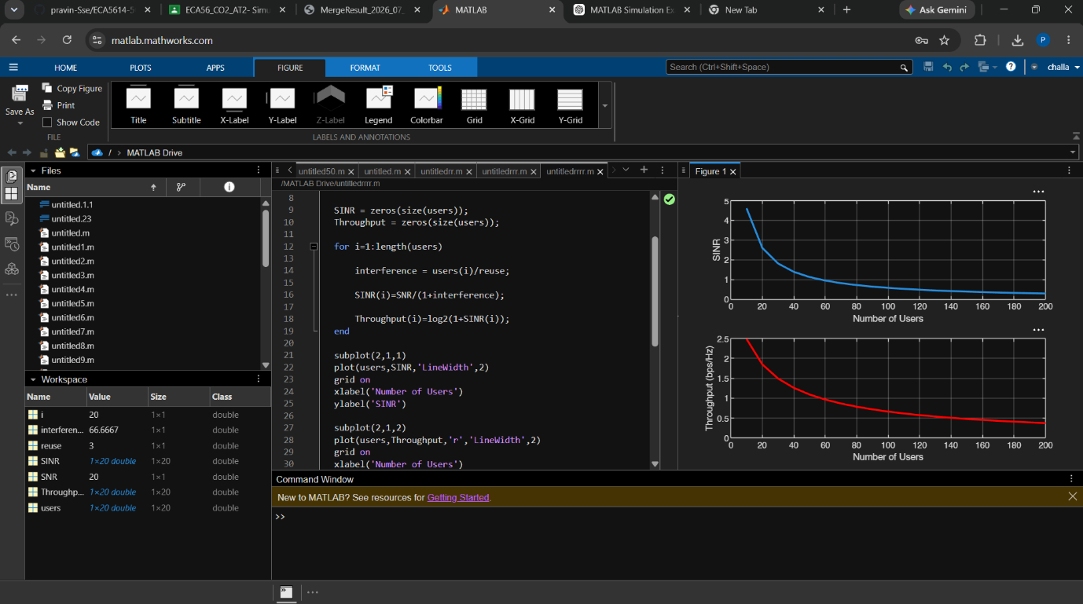
Q5) Simulation of Fading Channel Effects under Rayleigh, Rician, Nakagami, BER, and Outage Probability
Objective;
Matlab code;
clc;
clear;
close all;

SNRdB = 0:2:30;
snr = 10.^(SNRdB/10);

%% Rayleigh BER
BER_Rayleigh = 0.5*(1-sqrt(snr./(1+snr)));

%% Rician BER (Approximation)
K = 5;
BER_Rician = BER_Rayleigh./(K+1);

%% Nakagami BER (m=2 Approximation)
m = 2;
BER_Nakagami = (0.5*(1-sqrt(snr./(m+snr))));

%% Outage Probability
threshold = 5;

Outage = 1-exp(-threshold./snr);

subplot(2,1,1)
semilogy(SNRdB,BER_Rayleigh,'b','LineWidth',2)
hold on
semilogy(SNRdB,BER_Rician,'r','LineWidth',2)
semilogy(SNRdB,BER_Nakagami,'k','LineWidth',2)
grid on
xlabel('SNR (dB)')
ylabel('BER')
legend('Rayleigh','Rician','Nakagami')

subplot(2,1,2)
plot(SNRdB,Outage,'m','LineWidth',2)
grid on
xlabel('SNR (dB)')
ylabel('Outage Probability')
title('Outage Probability')
output;
