Uncertainty-Aware and Explainable Anomaly Detection in Industrial Time-Series
Bhuvanesh Kantamuneni, Krishnarjun Lakshminarayanan
CSC 675 Capstone in Artificial Intelligence
bkantamu@depaul.edu, klakshmi@depaul.edu
Abstract-
An industrial sensor system should predict machine failure beforehand, but not to a degree where it generates too many false alarms that cause the operator to ignore the system completely. In this paper, we propose an uncertainty-aware and interpretable anomaly detection pipeline for the NASA C-MAPSS FD001 turbofan degradation dataset. Our system involves a 30-cycle sliding window, RUL regression with Bidirectional LSTM, a healthy subspace detection model using Principal Component Analysis-Mahalanobis distance, Bayesian calibration of the uncertainty using Num Pyro, SHAP based sensor level explanations and a Retrieval-Augmented Generation layer for operator explanations. We deliberately skew our final operating point towards precision. This yields a precision of 0.968, recall of 0.871, F1 of 0.917 and false positive rate of 0.006. The test performance with the validation threshold kept constant results in a precision of 0.926, recall of 0.678, F1 of 0.783 and a false positive rate of 0.002.

I. INTRODUCTION
Modern engines, production lines, pipelines and other industrial assets are equipped with many sensors that record pressure, temperature, flow rate, speed, vibration and other correlated variables over time. The goal of anomaly detection is to identify early signs of abnormal behavior before complete failure occurs. A simple detector may compute one anomaly score and raise an alarm when the score crosses a threshold, but this approach is brittle. A highly sensitive threshold can create unnecessary alarms, while a conservative threshold can miss early degradation. Existing research on time-series anomaly detection shows that evaluation protocol and threshold selection strongly affect reported performance [1].

Hence, the motivation behind the development of the project cannot be said to be just the optimization of one score. Rather, it involves the creation of an effective warning system that can provide predictive information regarding the degradation of the engines, give the level of confidence of the prediction [2] and provide an explanation regarding the reasoning behind each of the predictions made. For purposes of this project, the NASA C-MAPSS FD001 Turbofan Benchmark Run to Failure data set will be used.

II. PREVIOUS WORK
A. LSTM-Based Multi-Sensor Anomaly Detection
The approach taken by Malhotra et al., which involved building a LSTM encoder-decoder framework for detecting anomalies through multiple sensors, can be applied in the context of our problem statement since NASA C-MAPSS involves multiple sensors for the engines and degradation is gradual during operating cycles [11], [17]. But reconstruction error alone is insufficient to explain what makes a warning valid or how sure the model is of its prediction [10].
B. Bayesian RUL Prediction for Aircraft Engines
An explainable data-driven method coupled with Bayesian filtering was proposed by Maulana et al. for prediction of remaining useful life based on NASA C-MAPSS dataset [18]. The paper proves the relevance of features selection, health index modeling and prediction of uncertainty in monitoring aircraft engines. All these factors play significant roles in our research since it involves predicting the state of the engine depending on time, i.e., a process involving multiple stages and not one-off predictions.
C. SHAP-Based Explainability
SHAP was created by Lundberg & Leeandit is a model interpretation technique based on Shapley values [6]. SHAP quantifies the contribution of each input towards a prediction made by a machine learning model. This is crucial in the context of our study since in case of anomaly detection, we want to be informed about the contributions of different sensors that resulted in triggering a warning.
D. Connection to This Project
The findings from these works guided the development of our proposed framework. LSTM work inspired temporal modeling based on sensor readings. Bayesian C-MAPSS work encouraged uncertainty-aware engine monitoring. SHAP-inspired work offered an insight into explaining model predictions. This work integrates all three concepts through BiLSTM RUL prediction, PCA Mahalanobis healthy subspaces detection, Bayesian uncertainty calibration and SHAP sensor interpretation.
III. APPROACH AND METHODOLOGIES
Pipeline consists of five components they are sensor history-based preprocessing, BiLSTM RUL prediction, PCA-Mahalanobis healthy subspace estimation, Bayesian uncertainty calibration and SHAP/RAG explanations. Every one of these components is intended to respond to a concrete practical question: What does the sensor history predict? Is the present behavior distant from the healthy one? Are we certain about the alarm? What caused it?
A. Dataset and Preprocessing
C-MAPSS FD001 contains 20,631 operating cycles from 100 training engines, with three operating settings and 21 sensor readings per cycle [3]. Six nearly constant sensors, s1, s5, s10, s16, s18 and s19, were removed because they add little predictive information. The remaining 15 sensors were scaled with a RobustScaler fit only on training engines to avoid data leakage. The data was then converted into sliding windows of 30 cycles by 15 sensors. Each window was labeled using the RUL of its final cycle, with a capped piecewise-linear RUL target so that very early healthy operation did not dominate the regression target.

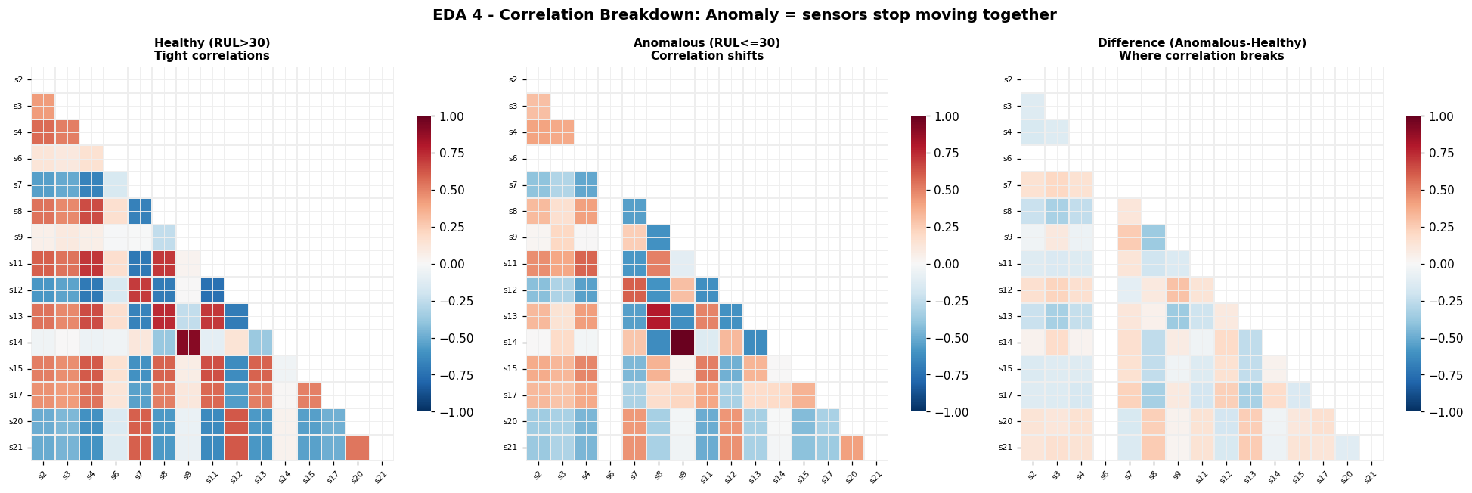
Fig. 1. Healthy and anomalous sensor-correlation patterns. Correlations are stronger during healthy operation and change near failure.
B. BiLSTM RUL Regressor
The main temporal model is a bidirectional LSTM with a regression head [4]. It receives a 30 * 15 window and predicts normalized RUL. A lower predicted RUL indicates higher degradation risk. The BiLSTM is trained with weighted mean squared error so that near-failure windows have more influence on training. This choice is practical because late-stage degradation is more important for maintenance action than small errors during early healthy life.
C. PCA-Mahalanobis Healthy-Subspace Detector
In parallel the project models healthy behavior using Principal Component Analysis. PCA is fit only on healthy training windows and keeps 64 components, explaining about 72.8% of the variance. Each new window is projected into this healthy subspace, standardized and scored using Mahalanobis distance. A high distance means the current sensor pattern is far from learned healthy behavior. This detector did not improve the best raw separation compared with the BiLSTM alone, but it provides useful geometric evidence for uncertainty estimation and explanation.
D. Fusion, Thresholding and Uncertainty
The BiLSTM score and Mahalanobis score were evaluated with a convex fusion sweep. Two operating points were considered. The first maximized F1, which balances precision and recall. The second used F-beta with beta = 0.5, which weights precision more heavily than recall. The final report uses the precision-focused threshold because the application values fewer false alarms. Bayesian uncertainty is estimated by fitting Normal priors to healthy-subspace means and Half-Normal priors to scale parameters, using NumPyro SVI [9], [16] with a diagonal guide. The posterior samples generate uncertainty estimates [8] and Platt scaling converts scores into calibrated probabilities.
E. SHAP and Retrieval-Augmented Reporting
SHAP explains which sensors contribute most strongly to the BiLSTM anomaly score [6], [13], [14]. Kernel SHAP is applied to selected windows and attributions are aggregated across time steps to produce sensor-level importance. The retrieval layer then builds a query from the alert, top SHAP sensors, drift direction and deviation magnitude. It searches a 25-document domain knowledge base indexed with FAISS and sentence-transformer embeddings. A language model or deterministic fallback turns the retrieved evidence into a graded diagnostic report for operators.
IV. RESULTS
The experiments evaluate detection performance, uncertainty calibration, explainability, RUL prediction and runtime efficiency. The final test values are reported using the validation frozen threshold.
A. Detection Results
On validation, the BiLSTM baseline achieved precision 0.9285, recall 0.9370, F1 0.9327and false-positive rate 0.0156. The precision-focused final operating point achieved precision 0.9676, recall 0.8709, F1 0.9167 and false-positive rate 0.0063. This reduced false positives from 47 to 19. On the held-out test set, the validation-frozen threshold achieved precision 0.9259, recall 0.6777, F1 0.7826 and false-positive rate 0.0018.
TABLE I
Detection performance summary.
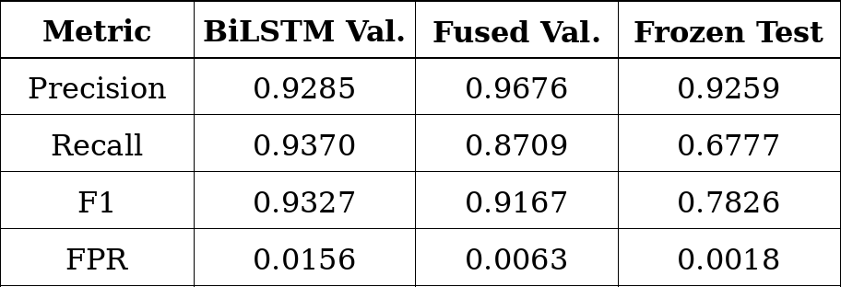
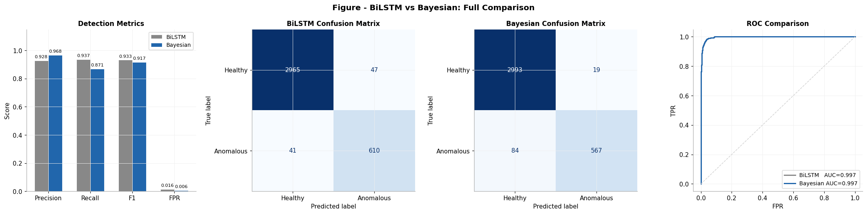
Fig. 2. Validation metrics, confusion matrices and ROC comparison for the baseline and final operating point.
B. Uncertainty Calibration
The calibrated probability output achieved Expected Calibration Error ECE = 0.0378, below the project target of 0.10. The Prediction Interval Coverage Probability was approximately 0.9918. This indicates that the reported confidence is reasonably aligned with observed outcomes. It also suggests that the SVI posterior and Platt scaling step produced useful calibration, even though the uncertainty model is applied to healthy subspace rather than the full BiLSTM weights.

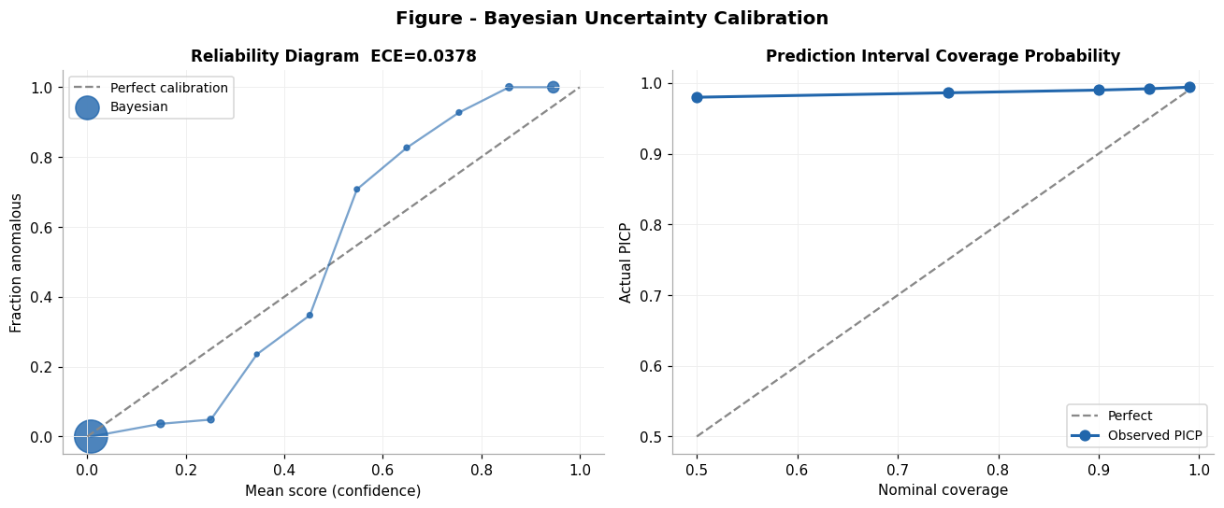
Fig. 3. Reliability and prediction-interval coverage plots for the uncertainty-calibrated detector.
C. Explainability and RUL Results
The global SHAP analysis identified s11, s20 and s12 as the strongest contributors to the BiLSTM anomaly score. An independent Cohen's d ranking identified s11, s4 and s12, giving two-of-three agreements and increasing confidence that the explanation is not only a visualization artifact. In a high-risk example, the local explanation highlighted s14, s7 and s4 and the RAG layer retrieved five supporting knowledge-base documents to generate an operator style diagnostic.

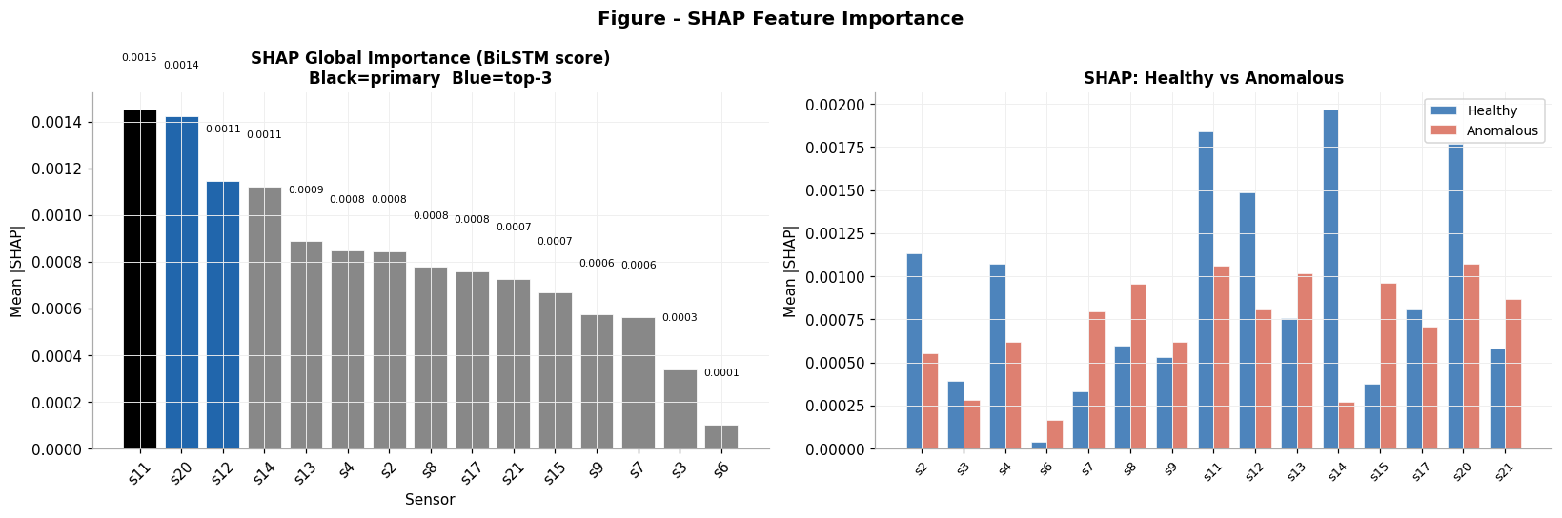
Fig. 4. Global SHAP importance and healthy-versus-anomalous attribution comparison.
The RUL model achieved RMSE = 15.13 cycles and MAE = 11.32 cycles on held-out test trajectories. About 61% of engines were within +/-10 cycles and 76% were within +/-20 cycles. The model also showed a conservative bias, which is safer than consistently overestimating engine life.

TABLE II
RUL prediction performance on held-out test engines.

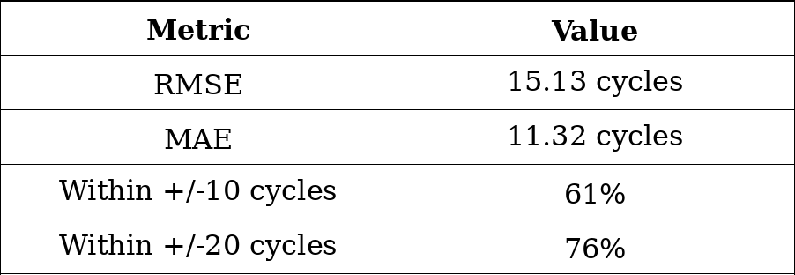
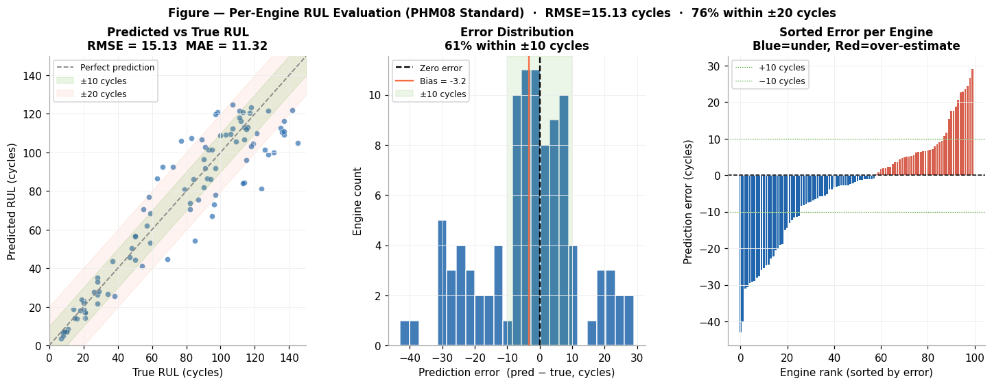
Fig. 5. Held-out per-engine RUL evaluation using the PHM-style protocol.
D. Efficiency
The deployed inference path is fast enough for near-real-time monitoring. The BiLSTM takes about 0.548 ms per sample and the Mahalanobis computation adds about 0.003 ms. The variational fitting step is performed offline, so online inference mainly uses the trained predictor, projection, distance computation, calibration and explanation logic.
V. DISCUSSION
The final model did not improve every metric, but it did improve the metric that matters most for the chosen operational goal.
A. Expected Improvement in F1 vs. Observed Trade-Off
The initial assumption was that incorporating Mahalanobis distance and uncertainty would increase the value of F1 relative to the baseline performance of BiLSTM. This assumption turned out to be partially true. Under the operating point of high precision, the F1 value of 0.9167 was obtained on validation set, which is slightly less than F1 score for BiLSTM equal to 0.9327. However, such low F1 value resulted from the operating point selection. Namely, the new model achieved lower false positive rate of 0.0063 compared to 0.0156 for BiLSTM, with false positives decreasing from 47 to 19.
B. Mahalanobis Contribution
The Mahalanobis component was anticipated to enhance separation between different classes. As per the results obtained during validation sweep, the BiLSTM was able to extract most of the separable signal from the degradations, hence no boost to the detection scores due to the use of the distance score. However, this finding is still very helpful. This is because the distance score gives us healthy-subspace geometry, posterior uncertainty evidence, and deviation magnitude which can help the explanation layer.
C. Validation-Test Difference
The value of F1 fell from 0.9167 to 0.7826. There is no point in obscuring this fact; the cause is the change in the base rate: the number of anomalous windows in test data is lower compared to validation data. With fewer positive examples, the recall and F1 will inevitably be more challenging to achieve. However, it is worth mentioning that the model still behaves adequately near the critical point when the system approaches failure. Recall falls especially fast in early weak degradation stages, which are less critical in terms of time.

D. Practical Meaning and Limitations
From a practical point of view, the final system can be considered an apprehensive maintenance assistant system, generating less alarms while adding confidence measures to them and identifying which sensors triggered the alarms. One of the main technical drawbacks is that the uncertainty is defined in the healthy PCA subspace instead of the full posterior distribution obtained from the BiLSTM. In addition, only FD001 was taken into account, as FD002-FD004 have several regimes that need normalization. Moreover, the RAG knowledge base is too small, hence needs to be expanded.
VI. CONCLUSIONS AND FUTURE WORK
An uncertainty-aware explainable anomaly detection framework has been designed and implemented for time series in an industrial context based on NASA C-MAPSS FD001. This framework comprises the following modules: the biLSTM RUL predictor, the PCA Mahalanobis distance, the NumPyro uncertainty calibrator, SHAP explanations and RAG diagnosis generator. While beating the baseline in every aspect is not the strongest outcome of the work, the strongest outcome is that the final operating point achieved low alarms without compromising high precision and offering explanations useful for maintenance.

Future work would involve extending this technique to FD002-FD004 datasets; normalizing with respect to the operating regime; performing an experiment where transformer encoders, temporal convolutional networks [12], LSTM autoencoders [5], Bayesian last layers, Monte Carlo Dropout [7] and deep ensembles [15] methods will be compared under the frozen threshold framework. Also, expanding the RAG knowledge base and measuring faithfulness in information retrieval will be essential and human factors testing with maintenance technicians will demonstrate how useful such explanations can be.
REFERENCES
[1] S. Schmidl, P. Wenig, and T. Papen Brock, "Anomaly detection in time series: a comprehensive evaluation," Proc. VLDB Endowment, vol. 15, no. 9, pp. 1779-1797, 2022.
[2] M. Abdar et al., "A review of uncertainty quantification in deep learning: techniques, applications and challenges," Information Fusion, vol. 76, pp. 243-297, 2021.
[3] A. Saxena, K. Goebel, D. Simon, and N. Eklund, "Damage propagation modeling for aircraft engine run-to-failure simulation," in Proc. Int. Conf. Prognostics and Health Management, 2008, pp. 1-9.
[4] S. Hochreiter and J. Schmid Huber, "Long short-term memory," Neural Computation, vol. 9, no. 8, pp. 1735-1780, 1997.
[5] D. P. Kingma and M. Welling, "Auto-encoding variational Bayes," in Proc. Int. Conf. Learning Representations, 2014.
[6] S. M. Lundberg and S.-I. Lee, "A unified approach to interpreting model predictions," in Proc. 31st Int. Conf. Neural Information Processing Systems, 2017, pp. 4768-4777.
[7] Y. Gal and Z. Ghahramani, "Dropout as a Bayesian approximation: representing model uncertainty in deep learning," in Proc. 33rd Int. Conf. Machine Learning, 2016, pp. 1050-1059.
[8] A. Kendall and Y. Gal, "What uncertainties do we need in Bayesian deep learning for computer vision?" in Proc. 31st Int. Conf. Neural Information Processing Systems, 2017, pp. 5574-5584.
[9] D. Phan, N. Pradhan, and M. Jankowiak, "Composable effects for flexible and accelerated probabilistic programming in NumPyro," arXiv:1912.11554, 2019.
[10] P. Wiessner, G. Bezirganyan, S. Sellami, R. Chbeir, and H.-J. Bungartz, "Uncertainty-aware time series anomaly detection," Future Internet, vol. 16, no. 11, art. 403, 2024.
[11] P. Malhotra, L. Vig, G. Shroff, and P. Agarwal, "Long short term memory networks for anomaly detection in time series," in Proc. European Symp. Artificial Neural Networks, 2015, pp. 89-94.
[12] M. Munir, S. A. Siddiqui, A. Dengel, and S. Ahmed, "DeepAnT: a deep learning approach for unsupervised anomaly detection in time series," IEEE Access, vol. 7, pp. 1991-2005, 2019.
[13] M. T. Ribeiro, S. Singh, and C. Guestrin, "Why should I trust you? Explaining the predictions of any classifier," in Proc. 22nd ACM SIGKDD Int. Conf. Knowledge Discovery and Data Mining, 2016, pp. 1135-1144.
[14] A. Shrikumar, P. Greenside, and A. Kundaje, "Learning important features through propagating activation differences," in Proc. 34th Int. Conf. Machine Learning, 2017, pp. 3145-3153.
[15] B. Lakshminarayanan, A. Pritzel, and C. Blundell, "Simple and scalable predictive uncertainty estimation using deep ensembles," in Proc. 31st Int. Conf. Neural Information Processing Systems, 2017, pp. 6402-6413.
[16] M. D. Hoffman, D. M. Blei, C. Wang, and J. Paisley, "Stochastic variational inference," Journal of Machine Learning Research, vol. 14, no. 1, pp. 1303-1347, 2013.
[17] P. Malhotra, A. Ramakrishnan, G. Anand, L. Vig, P. Agarwal, and G. Shroff, "LSTM-based Encoder-Decoder for Multi-sensor Anomaly Detection," ICML Anomaly Detection Workshop, 2016.
[18] F. Maulana, A. Starr, and A. P. Ompusunggu, "Explainable Data-Driven Method Combined with Bayesian Filtering for Remaining Useful Lifetime Prediction of Aircraft Engines Using NASA CMAPSS Datasets," Machines, vol. 11, no. 2, art. 163, 2023.

