Intelligent Search for the Wikipedia Computer-Science Domain: A Comparison of BM25 and TF-IDF with Rocchio Relevance Feedback
Krishnarjun Lakshminarayanan  klakshmi@depaul.edu | Sanjaiya Mohandas  smohanda@depaul.edu

Abstract—In a large corpus of technical documents, the simple criterion of keyword matching is not sufficient: it does not take into account the importance of the terms it matches and allows longer documents to overpower shorter ones. In this paper, we introduce an information-retrieval system for the Wikipedia Computer Science domain which ranks documents for two classical models, and fine-tunes documents according to user feedback. A recursive breadth-first crawler collects 2050 full-text articles in the Computer Science category tree that are then tokenized, stop-word filtered and Porter-stemmed and placed into a permanent inverted index. A Flask interface allows the user to make queries on the collection and switch between a probabilistic model (BM25) and a length-normalized vector-space model (TF-IDF cosine similarity) and a Rocchio relevance-feedback loop increases the query by adding documents that the user has marked relevant. Both rankers are tested against the standard CISI test collection with Mean Average Precision (MAP), Mean Reciprocal Rank (MRR) and Precision@10 used for all of the above. BM25 models are superior to the TF-IDF models for all three metrics and Rocchio feedback works well for short queries, albeit with some query drift.
Keywords—information retrieval; BM25; TF-IDF; vector space model; Rocchio relevance feedback; inverted index.
I. Introduction
Search engines are the main source of information, and the effectiveness of a search system depends on its ability to rank the results by relevance. In a specific field, like Wikipedia's Computer Science section, a user would normally expect to learn about the thing they wanted to know before he'd be shown a list of pages that contain the word he looked up. This isn't fulfilled by plain keyword matching: all terms are given equal weight and longer documents are made to appear in the list, even though they have less content. Wikipedia provides a natural test bed for this problem: The Computer Science section has a large number of articles, many of which link to one another in complex patterns and are of widely differing lengths, ranging from short stubs to long surveys. A retrieval system that treats these length differences equally will systematically bias the longest articles, no matter what the focus of the articles is—exactly what this work is trying to prevent.
This work fills that gap by developing a comprehensive retrieval system that employs mathematical models, which are principled, to rank the documents; and improves the output of the system based on user interaction. Using a recursive breadth-first traversal of the category tree, we crawl 2,050 full-text Computer Science articles, then preprocess and store them in an inverted index, and then implement two ranking models from scratch: the probabilistic BM25 model, and a length-normalized TF-IDF vector space model using cosine similarity scores. A Rocchio relevance-feedback mechanism is used to allow the user to indicate which results are relevant and then adjust the query to look for them. A light Flask web front-end provides access to the entire system.
The contributions to this paper are: (i) an over-coming shallow category limitation of Wikipedia that is implemented as a recursive breadth-first crawler that builds a clean corpus of computer science documents with 2050 documents, (ii) from-scratch implementations of BM25 and a correctly length-normalised TF-IDF cosine model, as well as a classical Rocchio-relevance feedback loop, which are exposed through an interactive Flask interface, and (iii) a controlled empirical comparison of the two rankers on the CISI benchmark using three standard metrics, with qualitative and quantitative analysis.
When evaluated in terms of MAP, MRR and P@10, BM25 performs better than TF-IDF in both cases (0.232 vs. 0.192 and 0.653 vs. 0.560 respectively), and Rocchio feedback works well with short queries, but sometimes causes query drift. In the rest of the paper the related work is discussed (Section II), the methodology and architecture is described (Section III), experiments and results are reported (Section IV), the findings are discussed (Section V) and the conclusion is drawn (Section VI).
II. Background
Classical information retrieval treats documents and queries as bags of weighted terms and ranks documents by either the vector space model or a probabilistic model like BM25; and relevance feedback improves query from judged results [4]. All of our work is based on three recent studies directly related to the three pillars of our system: ranking, feedback, and sparse-retrieval frontier. Now, a briefly overview of each and its relation to our work is summarized in Table I.
Kamphuis et al.[1] claim to have conducted a large-scale reproducibility study of eight widely used variants of BM25, using three TREC newswire collections with all the other factors, including tokenization, stemming and stop-words, kept constant. They don't reveal any statistically significant difference between the variants, including Lucene's much criticized approximation that uses the length of a document. This directly translates into our ranking core – since the variability of BM25 does not impact effectiveness, it is OK to simply use a standard BM25 variant with default values (without skewing the BM25 vs TF-IDF comparison).
BM25 is enhanced by Query2doc [2] which guides a very large language model to generate a pseudo-document for a short query and then attaches it to the original query, achieving a performance boost of 3–15% in ad-hoc retrieval. The authors clearly state the technique as a modern version of Rocchio and pseudo-relevance feedback. This confirms our feedback component - query expansion still gives significant improvements for BM25, and our Rocchio loop is the classical, light, fully interpretable component, given true user relevance judgements, not a generated document.
Formal et al. [3] present a learned sparse model called SPLADE, which learns a sparse model, a transformer that predicts the weight of the terms in the vocabulary, and a log-saturation activation that enforces sparsity, all of which are compatible with an inverted index, and jointly learn term weighting and expansion. It is competitive to dense retrievers, at about the cost of a bag-of-words model, on MS MARCO. It combines the two aspects of our system (weighting, expansion) into one model, and shows clearly the direction in which future work should go but the model needs to be trained with GPU and needs a large labeled corpus, which is not the case in this work.
These pieces all become a part of our design space when combined. Therefore, a baseline standard that is not tuned is a fair one, and a BM25 model is a good choice (Kamphuis et al.). Query expansion continues to be valuable (Wang et al.) and can be explained using a classical version of the Rocchio loop as a suitable alternative to generative expansion; the learned-sparse limit of the inverted index system is represented by Formal et al. Our contribution is firmly in the classical, low resource end of this spectrum and we emphasize transparency and reproducibility.

III. Methodology
The overall architecture is depicted in Fig. 1. The user's queries are sent to an online Flask server which scores them using both of the ranking models, and uses Rocchio feedback. The rest of this section provides a description of each component, the respective scoring equations and references to the libraries used.

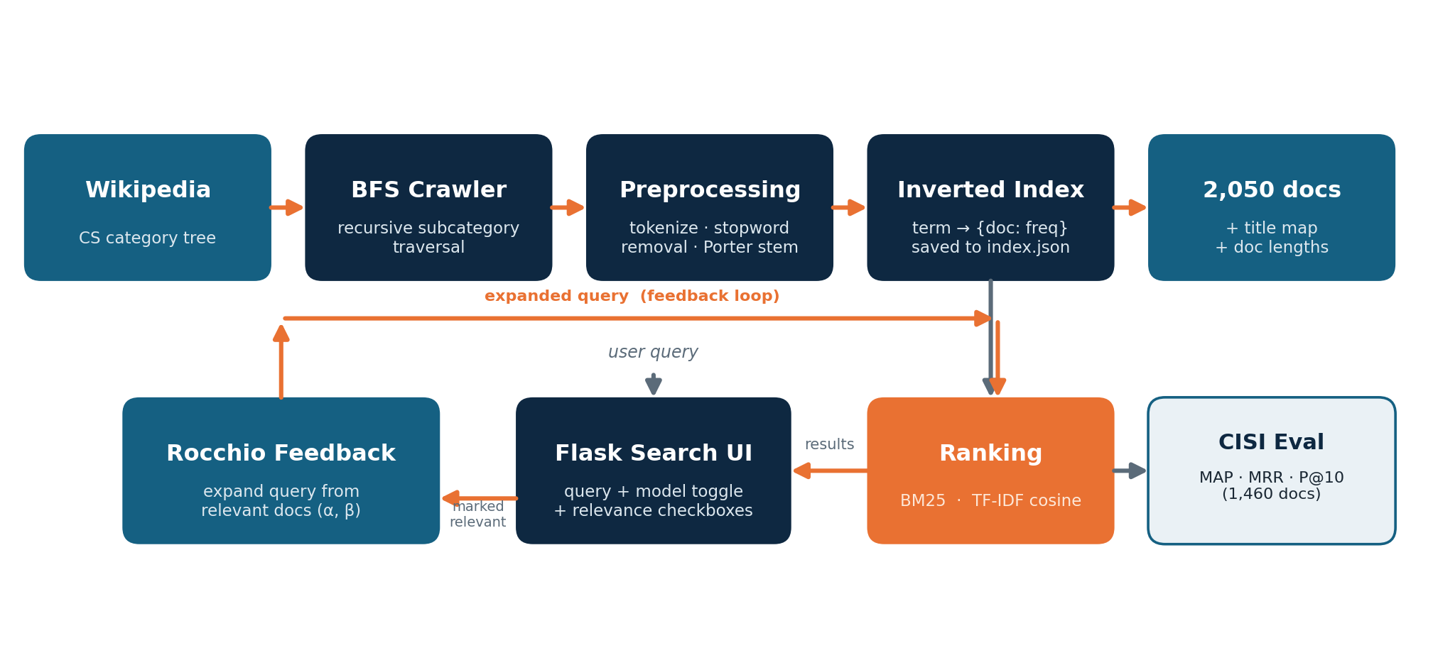
Fig. 1. System architecture: an offline crawl-and-index pipeline (top) feeds a persistent inverted index, which the online Flask server queries with BM25 or TF-IDF; a Rocchio loop expands the query from documents marked relevant. The two rankers are evaluated separately on CISI.

A. Corpus Acquisition
It uses a custom crawler and the wikipedia-api python library to access the official MediaWiki API with a proclaimed user agent, which is used to retrieve documents. If you just click on the top level Computer Science category, you get very few articles, as the top level contains mostly sub-categories, and not many pages. The crawler thus traverses in a breadth-first manner: it keeps a queue of the categories, and indexes all the articles it comes across while adding each new sub-category to the queue, until about 2,000 documents have been reached. Short pages (less than 100 characters, and resulting in zero tokens after preprocessing) are excluded from the calculation of administrative stubs and empty entries. In order to respect the MediaWiki access policy the crawler sends a series of requests under a descriptive user agent, not scraping the pages concurrently, but for politeness reasons: the full crawl is running offline; it is running only once.
B. Preprocessing and Indexing
The documents are all converted to lowercase, then tokenized with a regular expression, the common English stop-words are stripped away from the documents based on the NLTK stop-word list [6] and the roots of the remaining tokens are formed using the Porter stemmer [5]. At query time, the same transformation is applied to queries, and therefore, the vocabulary for queries and documents are shared. The terms are stored in an inverted index which associates each term with the set of documents containing the term and the frequency of the term in those documents, e.g., {doc-id: frequency} for the term “comput”. The system also documents the length of every document, the average document length and a mapping of the internal page identifiers to a human readable title. As all of the information is serialized to a JSON file (index.json), you get an offline index that is loaded at start time by the search server and won't be recomputed.
C. Ranking Models
Two ranking models are built from scratch as per their normal formulations [4] and [5]. The score of the probabilistic model is Okapi BM25 [5] which is calculated in (1), where the idf of term t is computed as follows (2):
s(q,d) = Σ(t∈q) IDF(t) · tf(t,d)(k₁+1) / [ tf(t,d) + k₁(1 − b + b·|d|/avgdl) ] (1)
IDF(t) = ln( 1 + (N − df(t) + 0.5) / (df(t) + 0.5) ) (2)
tf(t,d) denotes the term frequency, df(t) the document frequency, N the number of documents, |d| the length of a document and avgdl the average length of a document. The values of the parameters for the term-frequency saturation parameter k₁ = 1.5 and for the length-normalization parameter b = 0.75 are set.The values of term-frequency saturation parameter (k₁ = 1.5) and length-normalization parameter (b = 0.75) are set. In (2) the “+1” version of IDF maintains the non-negativity of the weights for very common terms.
The vector-space model considers the query and the document as vectors of weighted term vectors, where the weighting function is the logarithmic tf–idf weighting function (3), and scores each document using the cosine similarity function (4) which is always on the interval [0,1]:
w(t,d) = (1 + log₁₀ tf(t,d)) · log₁₀( N / df(t) ) (3)
cos(q,d) = Σ(t) w(t,q)·w(t,d) / ( ‖w_q‖ · ‖w_d‖ ) (4)
Vector norms ‖w_d‖ are precomputed when loading the index, and only require a sparse dot product over the terms in the query, plus a single normalization per query.
D. Relevance Feedback
Relevance feedback is used using Rocchio update [7]. The user specifies a set D_r of documents that are considered relevant to the query and the modified query q_m is calculated using (5):
q_m = α·q₀ + (β/|D_r|) · Σ(d∈D_r) d (5)
The values of α = 1.0 are used for keeping the original query and β = 0.75 is used to determine the weight of relevant documents. The 12 most important terms in the query q_m are used to build the query that will be re-submitted to ranker. The classical Rocchio formula does not include the non-relevant (negative) part of the formula as the corpus is unlabelled.
E. Implementation
The search server is a Flask application [9] that provides a search route and a feedback route, and serves HTML that the user will use to enter a query, choose the ranking model and check boxes for relevant items. It requires only wikipedia-api for crawling, NLTK [6] for stemming and stop-words, Flask [9] for the Web layer and the Python standard library (json, math, re, and collections.deque for the breadth-first queue). There is no external retrieval library (like Lucene or scikit-learn) and all the ranking and feedback logic is original, the classical formulations are based on [4] [5] [7].
The workflow at run time is easy to follow. The user enters a query and selects a model, the server tokenizes and stems the query, scores the collection according to the selected ranker and returns the top ten documents and their scores along with the titles. If the user "gives" one or more results that are relevant to him and asks for feedback, he instructs the server to form the Rocchio-expanded query and re-rank.
IV. Experiments and Results
A. Datasets
There are two data sets used. The development corpus consists of articles which we have crawled and its statistics are summarized in Table I. This corpus has no relevance judgements, so the quantitative accuracy evaluation is not possible. We, therefore, assess the retrieval quality using the CISI test collection [10] that contains 112 queries and a corpus of 1460 documents of which 76 are with relevance judgment. The same preprocessing and scoring algorithm is used on CISI as in the live system, but with objective ground truth to evaluate the same algorithms.
Table I. Dataset Statistics
Property | Value
Articles crawled (corpus) | 2,050
Unique stemmed terms | 42,445
Average tokens per document | 644
Empty / junk documents | 0
CISI documents (evaluation) | 1,460
CISI queries (judged) | 112 (76)

B. Evaluation Metrics
This course is based on three metrics studied. Precision@k (6) is the percentage of the top-k relevant results for a single page of results (k = 10). Average Precision (7) is the average of the precision at each relevant hit and Mean Average Precision (MAP) is the mean of the Average Prices over all queries. Reciprocal rank means 1/rank₁, where the first result that is relevant to the query is at position rank₁, and the mean value of the reciprocal rank for all of the queries is called Mean Reciprocal Rank (MRR), indicating that the user scans the results from top to bottom.
P@k = (1/k) · Σ(i=1..k) rel(i) (6)
AP = (1/R) · Σ(k=1..n) P@k · rel(k) (7)
In (6) and (7), the value of rel(i) is 1 if the document at rank i is relevant and 0 otherwise; R is the number of relevant documents to the query; and n is the number of documents in the ranked list. We run the ranker on the entire collection for each of the 76 CISI queries, and get the ranker score for the entire ranked list for each query and average each of the metrics over the 76 queries.
C. Quantitative Results
The effectiveness of the retrieval of the judged CISI queries is reported in Table II and in Fig. 2. On all three measures the BM25 model beats TFIDF cosine model. The benefits are not negligible: In terms of advantage, BM25 gets a higher score (MRR 0.653 vs. 0.560), and in terms of number of relevant documents on the first page, BM25 returns more relevant documents (P@10 0.370 vs. 0.292). The absolute MAP values are modest as is typical for bag-of-words models on CISI, a collection that is known to be difficult; the significant result is that the two models are consistently ranked.

Table II. Retrieval Effectiveness on CISI
Model | MAP | MRR | P@10
BM25 | 0.232 | 0.653 | 0.370
TF-IDF (cosine) | 0.192 | 0.560 | 0.292
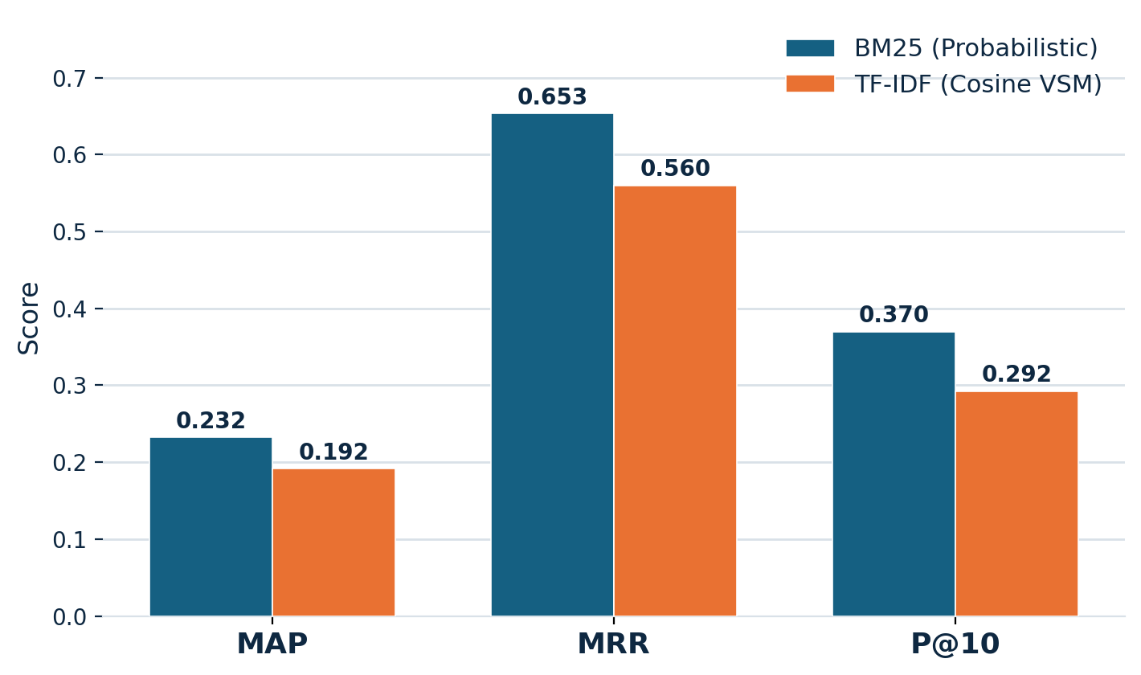
Fig. 2. BM25 vs. TF-IDF on CISI across MAP, MRR and P@10.
These numbers should be compared with the value of 0.1–0.2 that is typical for unsupervised bag-of-words retrieval over CISI, a collection of short, vocabulary sparse documents and broad information requests, and precisely because it is difficult for lexical models. Due to this four point MAP advantage and nine point MRR advantage, the MAP gap and MRR gap are meaningful in this regime and there is a general consensus that BM25 is a better first-stage ranker than unmodified TF-IDF.
D. Efficiency
The system is not only effective but also can be used with a laptop CPU. Timings have been measured and reported in Table III. The only "expensive" stage is the one-time crawl, after this, the start-up of the server and response to queries are effectively instantaneous, and a full benchmark of both models takes seconds. This is a confirmation that the classical approach works for thousands of documents, without special equipment.
Table III. Measured Runtime
Stage | Time
Crawl + index 2,050 docs (one-time) | ~30–60 min
Load index + precompute norms (start-up) | ~0.4 s
Single query (either model) | < 10 ms
Full CISI evaluation (76 queries) | < 10 s

E. Qualitative Examples
The single term “device” in BM25 is a success case in which the articles in the top ranks have a high relevance score and are tightly on-topic with the query – each article is displayed with its title and relevance score. With relevance feedback, the usefulness and danger of query expansion is demonstrated. Once this one result is considered relevant to the query, the user's query is extended to the set of terms below:
“a is comput devic peripher hardwar that to compon or”
It's also introduced some useful domain terms (“peripher,” “hardwar,” “compon”) that can be used to surface related articles but also some general, low information terms that are usually found at the front of the relevant doc (“a,” “is,” “to,” “or”). A clear example of the precision/precision-broadening dilemma: feedback wideens recall but may weaken precision if the selection of terms for expansion is based on their position, not on their importance.
V. Discussion
A. Why BM25 Outperforms TF-IDF
The benefit of BM25 is that it is able to deal with the length of documents and repeated terms. It is length normalized by b and its term-frequency saturation by k₁ helps avoid that a word which occurs a lot of times will dominate the score. This is in line with Kamphuis et al. [1] who demonstrated that the variant of BM25 is not important, but that the length normalization is key. In spite of the cosine normalization that corrects the TF-IDF model to lie within the range [0,1] the model over-compensates for very long encyclopedic pages, since normalizing by the document vector norm does not completely mitigate the effect of term coverage.
B. Effect of Hyper-parameters
The default values of k₁ = 1.5 and b = 0.75 yielded good performance results and are similar to the insensitivity reported in [1] to the variant choice. The expansion weight β in the feedback loop compromises between recall and precision: a bigger β will include more terms from the relevant documents, result in more coverage but will also create more drift. The number of expansion terms (twelve) acts the same, more terms increase recall but may dilute the topic.
C. What Worked and What Did Not
A few things went well: the breadth-first crawler retrieved 2,050 documents, while a shallow crawler would only have retrieved a few dozen; there was no need to re-crawl as the inverted index was kept up to date by the persistent crawler; and BM25 gave very good and well-ordered rankings for very little effort. There are limited other parts. The Rocchio routine is made up of expansion terms which are not based on term importance, and excludes the negative feedback component; the feedback route also uses BM25 regardless of which initial search model is selected.
D. Threats to Validity
There are three caveats to temper the results. The quantitative evaluation is based on 76 judged CISI queries, which is a small sample from a deliberately challenging collection; absolute values are therefore not necessarily a good measure of quality. Second, CISI is a general bibliographic collection, and not a Computer Science corpus, thus it is a good measure of the ranking algorithms, but not of the actual domain behaviour on the Wikipedia index itself. Thirdly both rankers employ a single, untuned parameter setting: the absolute numbers might change if they were per-collection tuned, although BM25 does not seem to be sensitive to variant choice as suggested by [1]. The qualitative examples are meant to illustrate, and should not be used as a replacement for systematic error analysis.
E. Opportunities for Improvement
Concrete improvements that are inspired by the analysis are: grid-searching k₁ and b on a validation split as in [1]; weighting Rocchio expansion terms by tf–idf and adding a negative component to prevent drift; making the feedback route honor the selected ranking model; and, longer-term, using generative query expansion, similar to Query2doc [2] or learned sparse retrieval, such as SPLADE [3], to combat vocabulary mismatch while still maintaining an inverted-index backend.
Lastly, CISI does not directly measure quality of the deployed Wikipedia index, but rather offers objective evidence about the ranking algorithms. It's very natural to proceed to an experiment of obtaining a small set of relevance judgments by combining the top-k results of both relevance models and evaluating them manually, and reporting the set of metrics on the target domain; this would fill the gap between the evaluation collection and the actual system.
VI. Conclusion
indexes 2,050 full-text articles, ranks them using BM25 and length normalized TF-IDF cosine model, and improves results by implementing Rocchio relevance feedback using a Flask interface. BM25 achieved the best performance over TF-IDF in all three metrics (MAP, MRR and P@10) on the CISI benchmark, and relevance feedback was shown to only introduce drift for short queries, but to improve them for other queries. The most interesting result is applied – the classical, fully interpretable retrieval scales easily to thousands of live documents without any neural model or GPU! The advantages of the system are that it is transparent and inexpensive; the disadvantages are the length sensitivity of the cosine model, and the simplicity of the feedback routine. Future work will involve tuning the BM25 parameters, adding weighted and negative terms to the feedback loop and exploring generative expansion and learned sparse retrieval as future steps on the road this pipeline takes. The whole pipeline (crawler, index, rankers, feedback loop) is a small, well contained codebase which runs end to end on commodity hardware, providing a clear and reproducible classical baseline to compare later more complex neural methods with.
Acknowledgment
The authors would like to thank the instructor of the course CSC 575 for his guidance during the development of this work, and the Wikimedia Foundation and the University of Glasgow Information Retrieval Group for the resources of data that are freely available. The authors implemented all the system code, including crawler, indexer, ranking models and feedback loop.
References
- C. Kamphuis, A. P. de Vries, L. Boytsov, and J. Lin, “Which BM25 do you mean? A large-scale reproducibility study of scoring variants,” in Advances in Information Retrieval (ECIR 2020), LNCS vol. 12036. Cham: Springer, 2020, pp. 28–34. doi: 10.1007/978-3-030-45442-5_4.
- L. Wang, N. Yang, and F. Wei, “Query2doc: Query expansion with large language models,” in Proc. 2023 Conf. on Empirical Methods in Natural Language Processing (EMNLP). Singapore: ACL, 2023, pp. 9414–9423. doi: 10.18653/v1/2023.emnlp-main.585.
- T. Formal, B. Piwowarski, and S. Clinchant, “SPLADE: Sparse lexical and expansion model for first stage ranking,” in Proc. 44th Int. ACM SIGIR Conf. on Research and Development in Information Retrieval (SIGIR ’21). New York: ACM, 2021, pp. 2288–2292. doi: 10.1145/3404835.3463098.
- C. D. Manning, P. Raghavan, and H. Schütze, Introduction to Information Retrieval. Cambridge, U.K.: Cambridge Univ. Press, 2008.
- S. Robertson and H. Zaragoza, “The probabilistic relevance framework: BM25 and beyond,” Foundations and Trends in Information Retrieval, vol. 3, no. 4, pp. 333–389, 2009. doi: 10.1561/1500000019.
- S. Bird, E. Klein, and E. Loper, Natural Language Processing with Python. Sebastopol, CA: O’Reilly Media, 2009.
- J. J. Rocchio, “Relevance feedback in information retrieval,” in The SMART Retrieval System: Experiments in Automatic Document Processing, G. Salton, Ed. Englewood Cliffs, NJ: Prentice-Hall, 1971, pp. 313–323.
- M. F. Porter, “An algorithm for suffix stripping,” Program, vol. 14, no. 3, pp. 130–137, 1980. doi: 10.1108/eb046814.
- Pallets Projects, “Flask documentation.” [Online]. Available: https://flask.palletsprojects.com/
- University of Glasgow IR Group, “The CISI test collection.” [Online]. Available: https://ir.dcs.gla.ac.uk/resources/test_collections/cisi/

