STEP1 : Invoking file(starting localserver)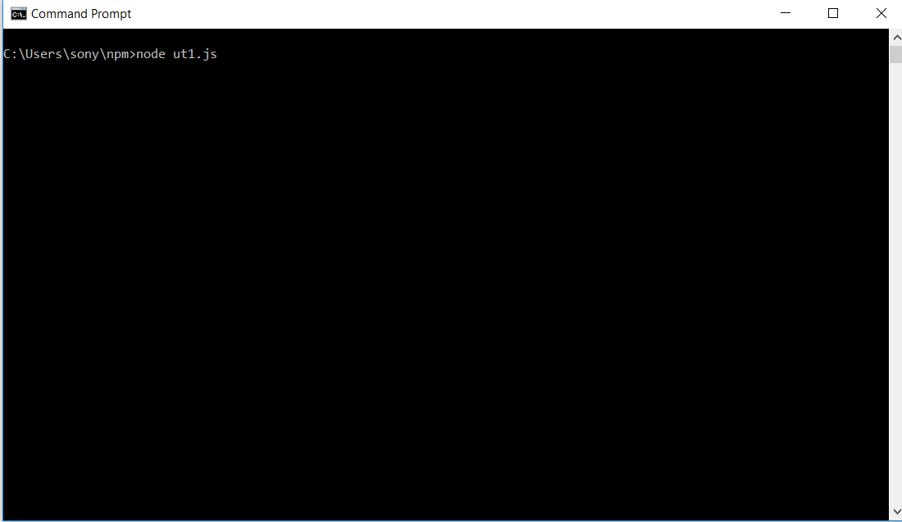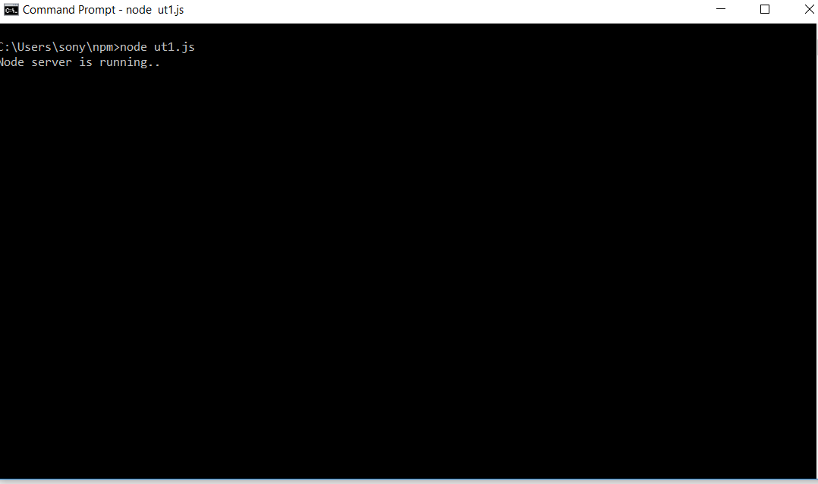
STEP 2: Accessing lcoalhost from browser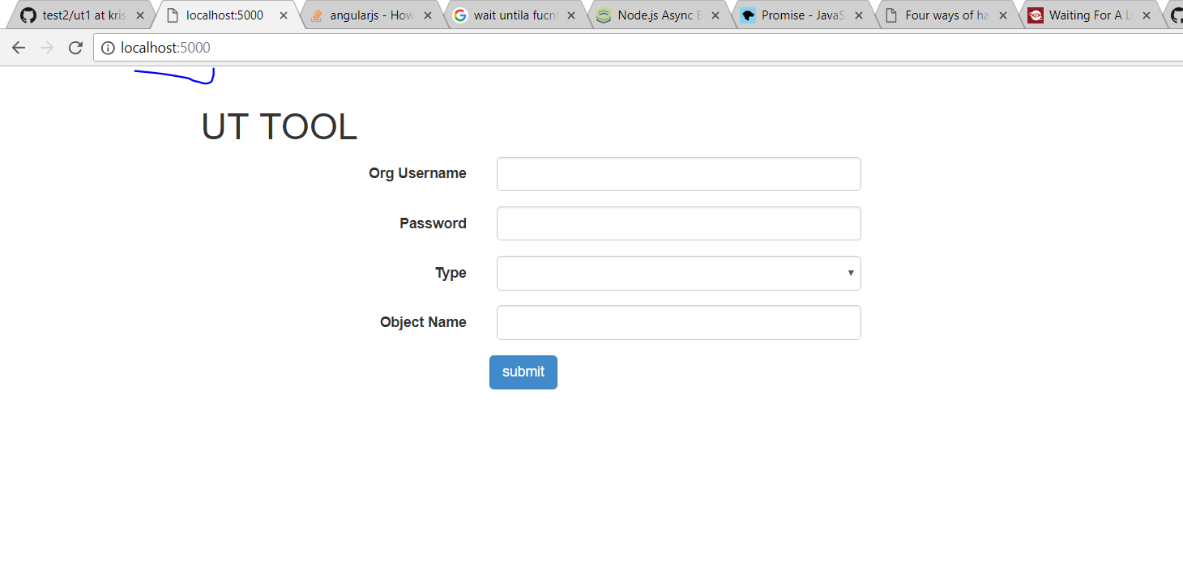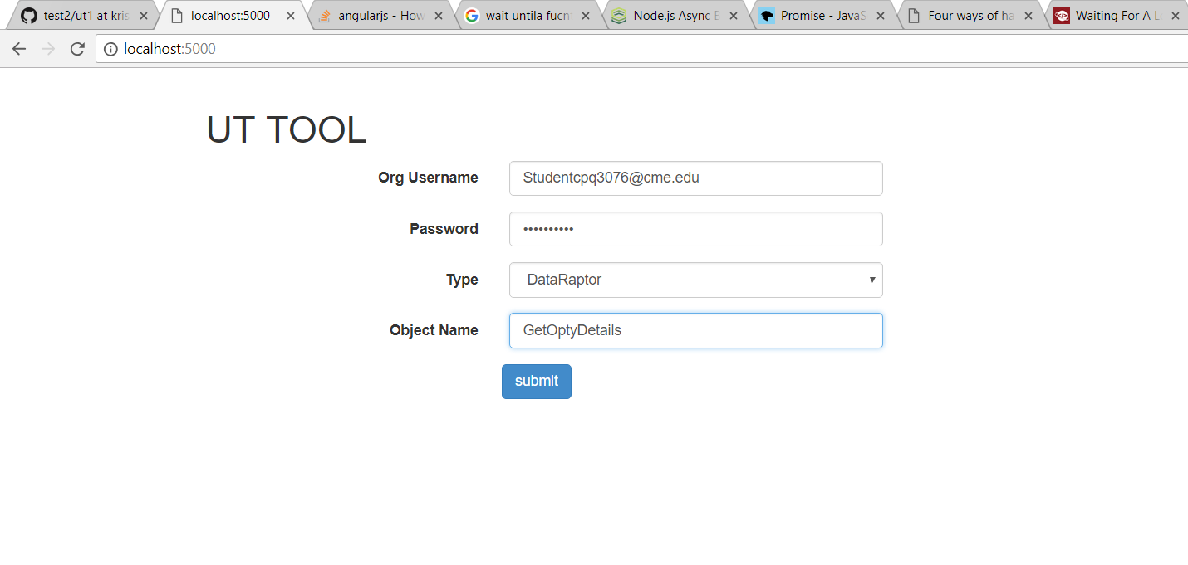

STEP 3 :
1. Connection to Salesforce org is established
2. Able to identify if DR is present
