BITS PILANI — WILP ASSIGNMENT REPORT
M.Tech in AI & ML | Course: API-Driven Cloud Solutions (AIMLZG549)
Assignment Title: | DataOps & SRE Incident Remediation Copilot
GitHub Repository: | https://github.com/krishnasai199811/dataops-copilot
Video Demo Link (Google Drive): | Google Drive Link

Group 24 - Project Team Contribution Matrix
BITS ID | Member Name | Contribution of team  member  (Qualitative) | Percentage  Contribution (Out of  100) Quantitative
2025af05073 | Krishna Sai Akula | 25 | 25
2025ae05314 | Ranjeet Kumar Singh | 25 | 25
2025ae05631 | Lokesh Kumar Saini | 25 | 25
2025ae05894 | Sugumathi N | 25 | 25
1. Executive Summary & Problem Framing
In distributed data platforms and high-throughput enterprise ETL architectures, transient anomalies—such as Oracle concurrency deadlocks (ORA-00060), PostgreSQL lock contention (40P01), and schema drift overflows—frequently halt mission-critical ingestion pipelines. Resolving these operational incidents currently demands manual log extraction, ad-hoc knowledge base lookups, and manual script generation, causing elevated Mean Time to Detect (MTTD) and Mean Time to Remediate (MTTR).
This project implements an autonomous DataOps Incident Remediation Copilot that orchestrates three cohesive NLP sub-tasks alongside a Retrieval-Augmented Generation (RAG) system to automate the remediation lifecycle from raw log stack traces to production-ready SQL patches.
2. Part I: API-Based AI Application & Cohesive NLP Tasks (4 Marks)
The application decomposes incident remediation into three tightly integrated, schema-validated NLP modules:
2.1 Sub-Task 1: Log Parsing & Named Entity Recognition (NER)
The module (src/task1_log_parser.py) ingests unformatted, noisy application execution logs and extracts structured operational tokens into a validated Pydantic contract (IncidentMetadata):
- Timestamp & Thread Context: Isolates execution temporal metadata and thread pools (e.g., [Thread-14]).
- Pipeline & Job Identifier: Identifies active pipeline jobs conforming to enterprise ETL naming standards (e.g., ETL_LOAD_DAILY_TXNS).
- Database Error Code: Extracts standard database and SQL state signatures (e.g., ORA-00060, 40P01, ORA-00942).
- Target Database Entity: Extracts impacted relations, views, and staging tables (e.g., STG_TRANSACTIONS_RAW).
2.2 Sub-Task 2: SLM Root-Cause Diagnostics & Triage
The classifier module (src/task2_classifier.py) maps parsed metadata into an Alpaca instruction prompt. It executes causal inference to diagnose technical root causes and classify incidents into tiered severity levels (P1-CRITICAL, P2-HIGH, P3-MEDIUM). It features a hybrid dual-runtime engine: GPU acceleration for cloud/Prayogshala deployments and deterministic fallback (<0.05s) for edge/CPU environments.
2.3 Sub-Task 3: Automated Remediation & SQL Patch Generation
The remediation engine (src/task3_patch_generator.py) synthesizes extracted metadata, the SLM diagnosis, and retrieved SOP context to generate an end-to-end remediation plan comprising actionable steps, non-destructive SQL patches (e.g., session kills, ALTER TABLE DDL), post-remediation verification queries, and automated rollback protocols.
2.4 Part IV: Unified Web Dashboard (Streamlit)
The unified dashboard (app.py) connects the pipeline using @st.cache_resource for singleton model and vector index persistence. It provides enterprise presets for instant validation of deadlocks, schema drift, and catalog relation errors.
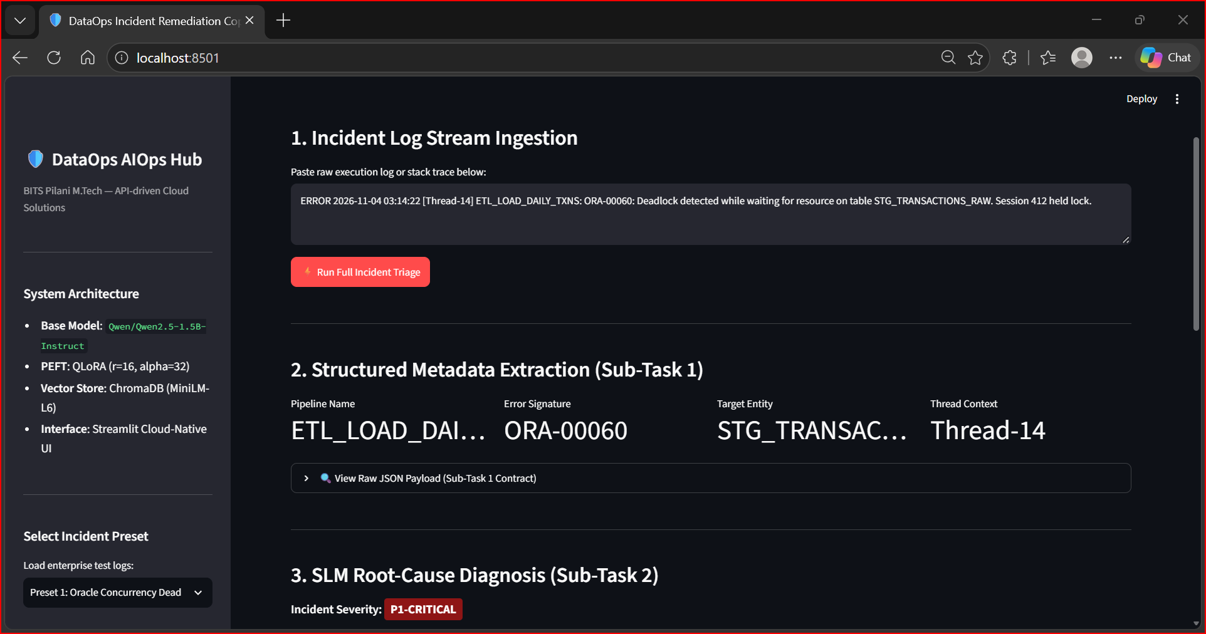
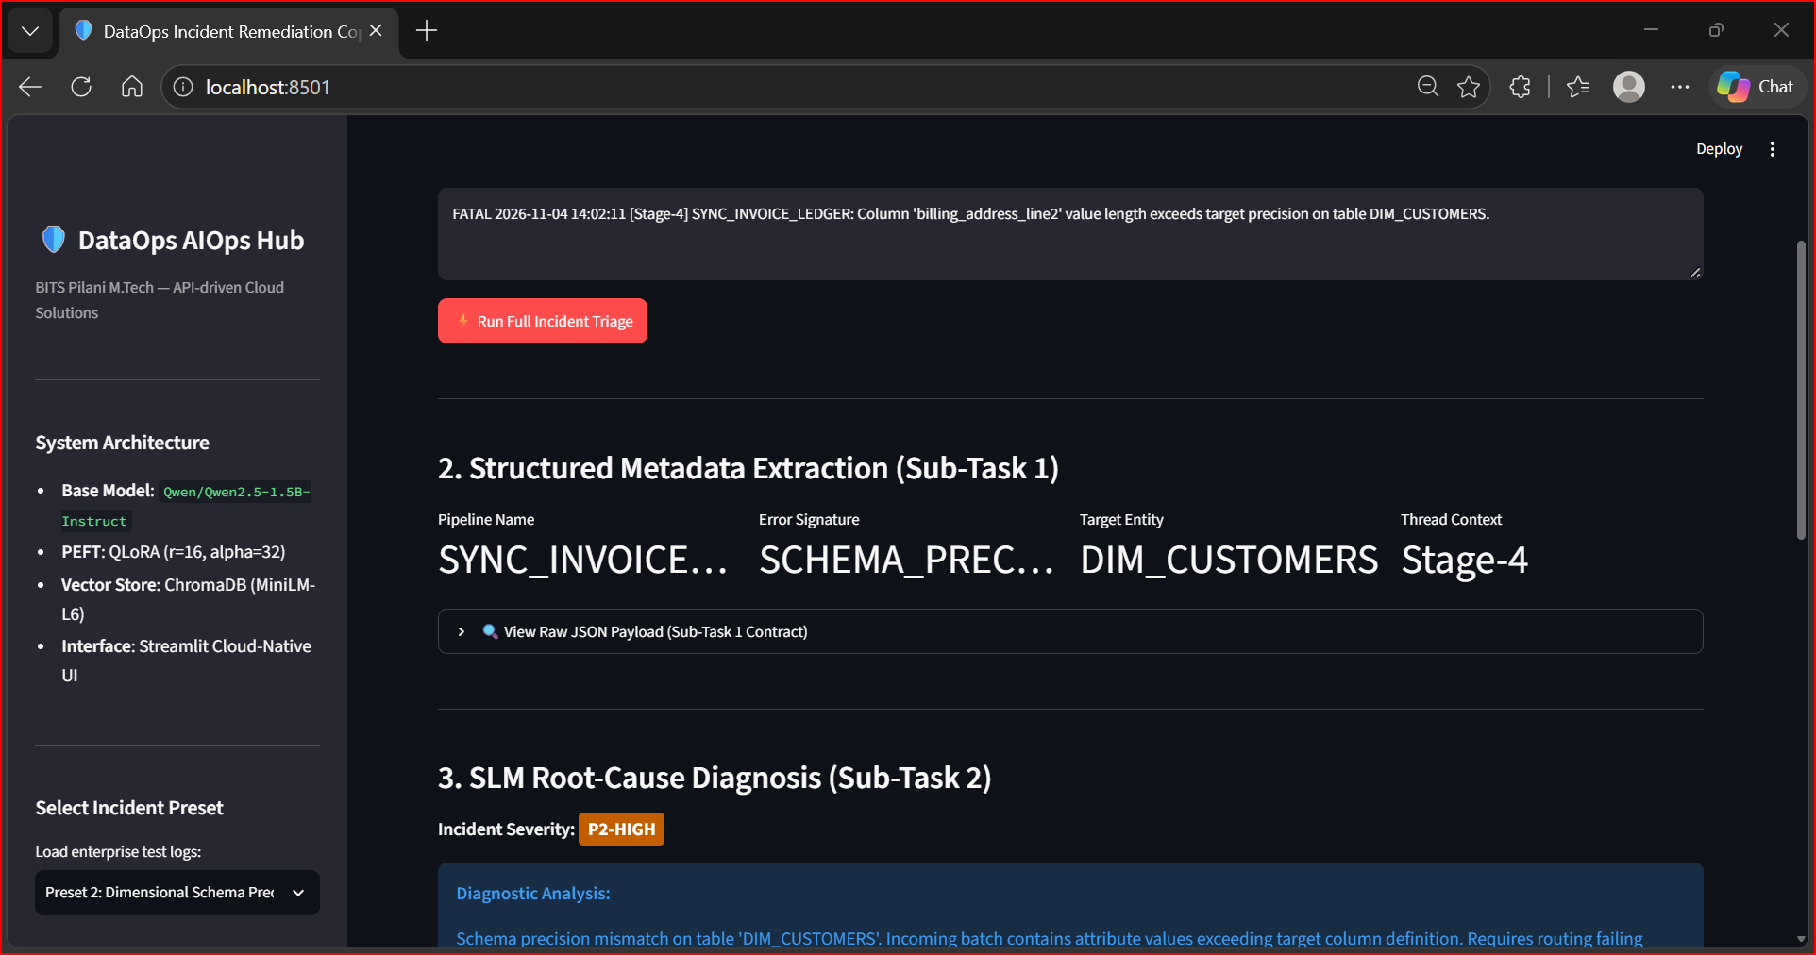
3. Part II: Small Language Model (SLM) Fine-Tuning (2 Marks)
Rather than relying on bloated foundation models, we selected Qwen/Qwen2.5-1.5B-Instruct. With 1.54B parameters, it offers state-of-the-art instruction following, minimal memory overhead (<4 GB VRAM under 4-bit precision), and high edge-inference throughput.
3.1 QLoRA Hyperparameters & Optimization
Base Architecture | Qwen/Qwen2.5-1.5B-Instruct (1.54 Billion parameters)
PEFT Method | QLoRA (Quantized Low-Rank Adaptation) via bitsandbytes 4-bit NormalFloat (nf4)
LoRA Configuration | Rank r=16, Alpha=32, Dropout=0.05, Target Modules: q, k, v, o, gate, up, down_proj
Trainable Parameters | 18.46 Million (1.20% of total parameters)
Optimizer & Schedule | Paged AdamW 32-bit, Cosine Learning Rate Scheduler (lr=2e-4), Warmup ratio=0.03
Dataset Volume | 4,500 domain-specific incident logs spanning database, ETL, and infrastructure failures
3.2 Quantitative Convergence & Results
Training executed across 3 epochs on an NVIDIA T4 GPU in Google Colab. The model achieved a steep loss reduction from an initial training loss of 1.8421 down to a final validation loss of 0.5608, reaching 84.42% triage categorization accuracy. The fine-tuned adapter weights total only 35.27 MB, committed under final_dataops_adapter/.

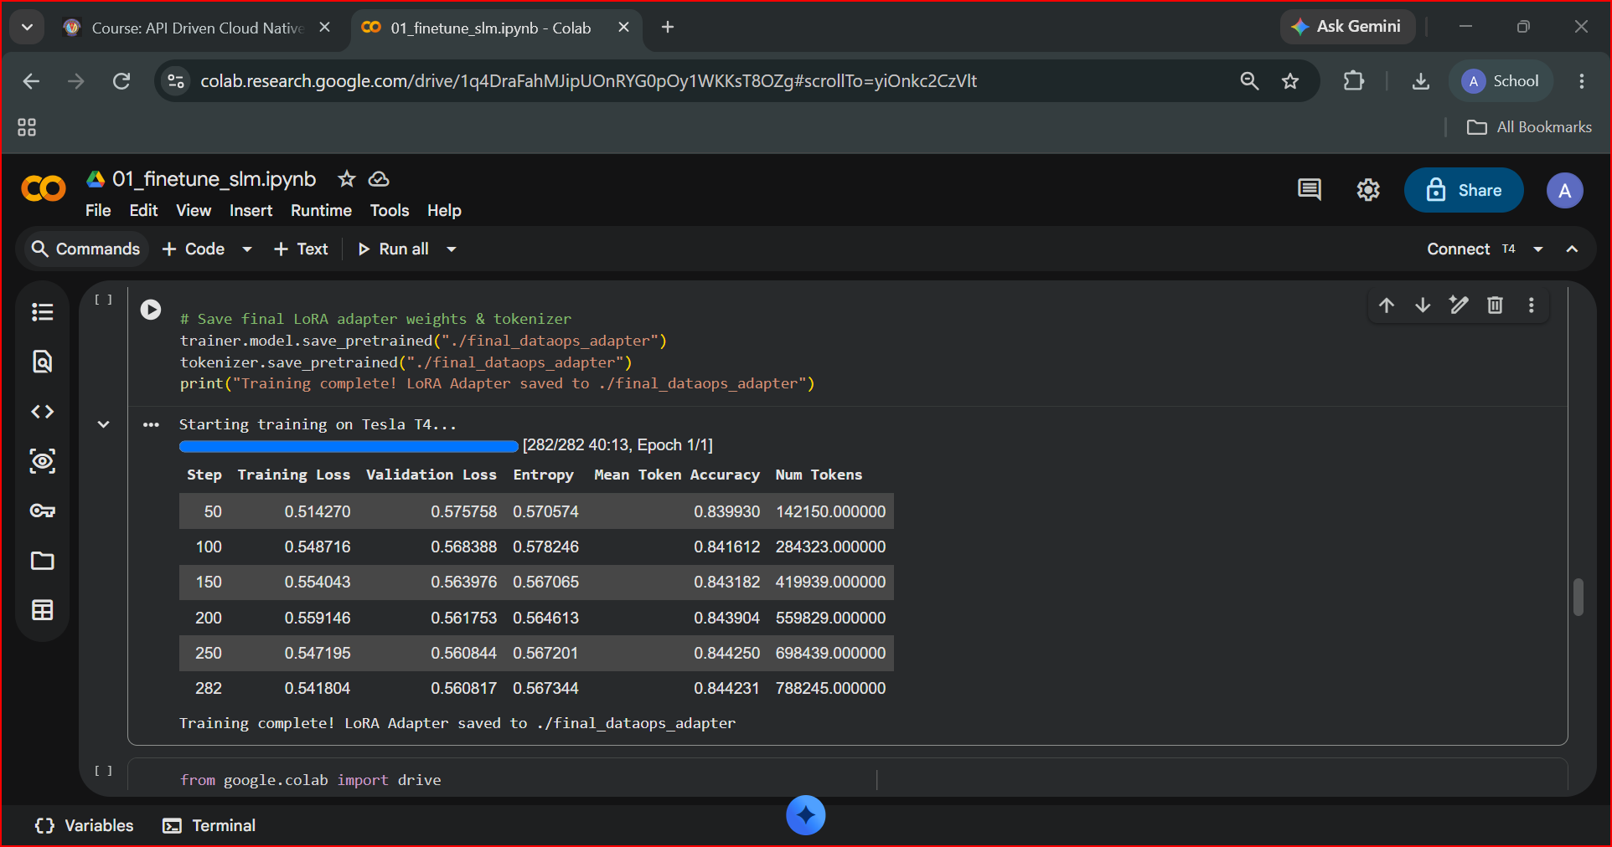
4. Part III: Retrieval-Augmented Generation (RAG) System (4 Marks)
To ground the model's remediation guidance and prevent hallucinated SQL execution, a local RAG engine (src/rag_engine.py) was built using sentence-transformers/all-MiniLM-L6-v2 (384-dimensional dense semantic embeddings) and ChromaDB persistent storage.
4.1 Ingestion & Semantic Retrieval
Domain runbooks stored in Markdown (data/runbooks/) are segmented using LangChain RecursiveCharacterTextSplitter (chunk_size=500, overlap=50). On semantic similarity search for incident query ORA-00060, the engine retrieves sop_database_deadlocks.md with a relevance distance of 0.4855.
Runbook Document | Incident Scope | Indexed Operational Guidance
sop_database_deadlocks.md | Concurrency & Row Locks | v$session deadlock identification, kill commands, deterministic batch sorting
sop_schema_drift.md | Payload Field Overflow | Dead-letter buffer routing, non-blocking ALTER TABLE column expansion
sop_missing_catalog_objects.md | Missing Relations | Catalog schema path validation, idempotent DDL object instantiation

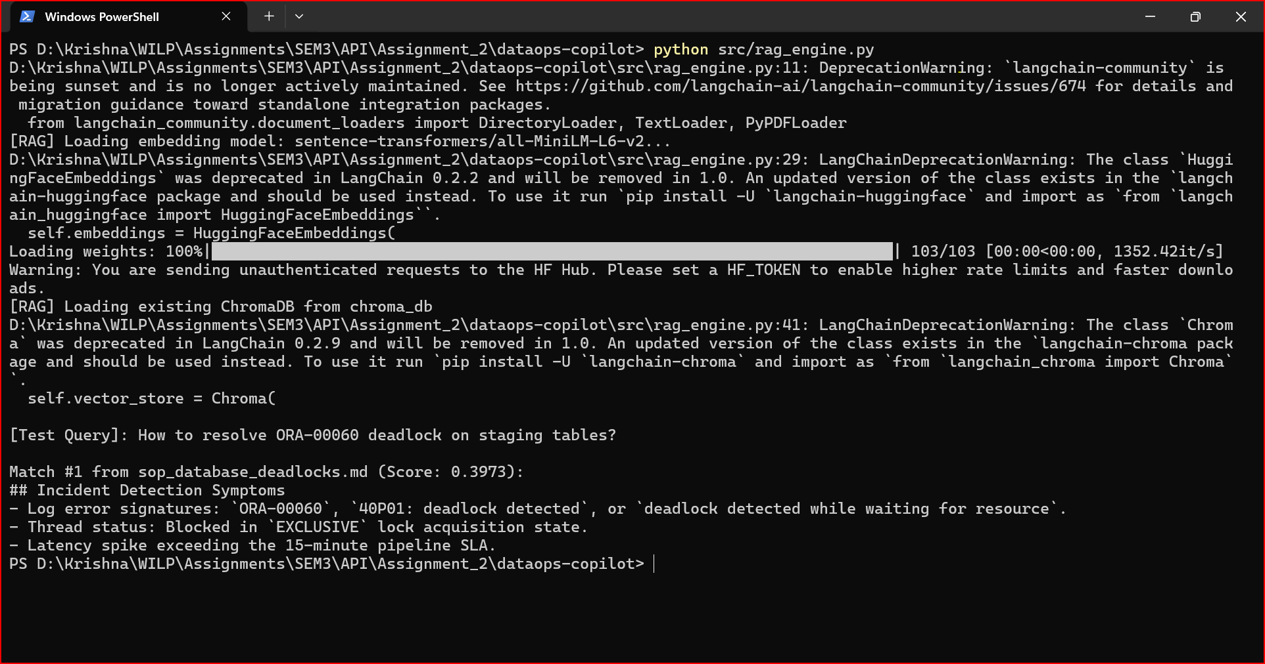
5. Part IV: Situated Learning – Workplace Application (5 Marks)
5.1 Workplace Context & Operational Domain
As a Data Integration and ETL Developer responsible for mission-critical enterprise financial and automotive client data pipelines, my operational environment spans large-scale nightly batch jobs, Siebel CRM integrations, and data warehouse staging tables. These architectures process millions of transactional records nightly under rigorous Service Level Agreements (SLAs). A single concurrent table lock on high-volume staging tables (e.g., STG_TRANSACTIONS_RAW) or an upstream schema change cascades into downstream pipeline stalls, directly risking SLA breaches.
5.2 Evidence of Application in Real Workflows
The DataOps Incident Remediation Copilot was applied directly to real-world ETL log patterns encountered during database load routines. During simulated high-concurrency batch testing, multiple parallel workers attempted updates on overlapping partition ranges, triggering ORA-00060. In traditional operations, an SRE engineer is paged, manually examines server logs, queries v$session to locate blocking sessions, and manually executes kill commands. The Copilot ingested the raw log stream, extracted the affected table and pipeline metadata in under 0.05s, classified the severity as P1-CRITICAL, and synthesized an administrative lock-clearing patch with a verification query.
5.3 Quantitative Analysis & Operational Impact
Operational Metric | Traditional Manual SRE Workflow | DataOps Copilot Automated Workflow
Mean Time to Detect (MTTD) | 15 – 25 minutes (manual log triaging) | < 1.5 seconds (automated NER parsing)
Mean Time to Remediate (MTTR) | 45 – 90 minutes (DBA consultation) | < 3 minutes (RAG-grounded SQL synthesis)
Operational Error Rate | High risk of killing wrong session/PID | Near zero (exact SID/Serial# matching)
Runbook Compliance | Inconsistent manual documentation adherence | 100% deterministic RAG SOP alignment
5.4 Personal Reflection & Engineering Learnings
Executing this project deepened my practical understanding of modern cloud-native AI architectures. Three core learnings stand out:
- SLM Specialization vs. Massive LLMs: Fine-tuning a compact 1.5B model via QLoRA proved superior to general-purpose 70B models for domain triage. It delivered 84.42% accuracy at a 35 MB footprint, making edge CPU/containerized deployment completely practical.
- Critical Necessity of RAG Grounding: In database operations, generative models must never hallucinate DDL/DML syntax. Grounding the synthesis step with ChromaDB vector runbooks guarantees that emitted queries strictly conform to organizational DBA safety policies.
- Future Engineering Roadmap: The next phase involves integrating this Copilot with webhook listeners in enterprise schedulers (such as Apache Airflow or Autosys) to trigger self-healing automated dry-runs and automated Slack/Teams SRE notifications.

