BITS Pilani – Work Integrated Learning Programmes

M.Tech in Artificial Intelligence & Machine Learning

Course: Machine Learning Operations (MLOps) - S1-26_AIMLZG523

Assignment 1: End-to-End Automated MLOps Pipeline for Heart Disease Prediction

- Student Name: Krishna Sai Akula
- User ID: 2025af05073
- Repository URL: https://github.com/krishnasai199811/heart-disease-mlops/
- Target Dataset: UCI Heart Disease Dataset (Cleveland)
- Primary Stack: Python 3.10/3.12, Scikit-learn, MLflow, FastAPI, Pytest, Flake8, Docker, Kubernetes, GitHub Actions CI/CD
- Cloud Streaming (Google Drive): Google Drive Link of the pipeline

- Offline Playback: 

1. Executive Summary & Problem Formulation

Heart disease is among the leading causes of morbidity worldwide. Early diagnosis and proactive clinical intervention can significantly alter patient outcomes. However, operationalizing machine learning in healthcare necessitates strict standards: reliable data pipelines, rigorous validation against bias and data drift, reproducible training, automated continuous integration/continuous deployment (CI/CD), isolated microservice packaging, and high-availability container orchestration.

This project delivers an end-to-end, production-ready MLOps pipeline using the UCI Heart Disease (Cleveland) dataset. The pipeline automates data ingestion, missing value imputation, robust feature transformation, cross-validated model selection (Logistic Regression vs. Random Forest) tracked via MLflow, containerized REST API inference via FastAPI, automated quality gates using GitHub Actions, and scalable cluster orchestration using Kubernetes.

2. High-Level Architecture & Pipeline Design
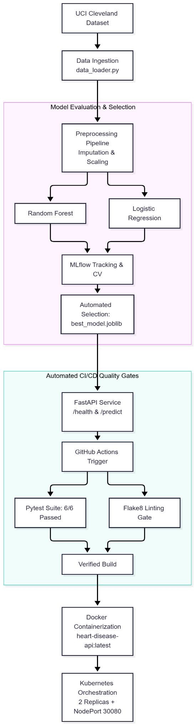

3. Detailed Component Breakdown (Tasks 1 to 7)

3.1 Task 1 & 2: Ingestion and Preprocessing Pipeline
- Dataset Characteristics: 303 patient records across 13 clinical attributes (including age, sex, chest pain type cp, resting blood pressure trestbps, serum cholesterol chol, fasting blood sugar fbs, resting ECG restecg, maximum heart rate thalach, exercise angina exang, ST depression oldpeak, slope, major vessels ca, and thalassemia thal).
- Target Transformation: The target column contains multi-class severity indices (0 to 4); it is binarized into 0 (Healthy / No Disease) and 1 (Heart Disease present).
- Imputation & Feature Pipeline: Implemented via Scikit-Learn ColumnTransformer and Pipeline:
  - Numerical Pipeline: Median imputation (SimpleImputer(strategy='median')) + feature normalization (StandardScaler).
  - Categorical Pipeline: Most-frequent imputation (SimpleImputer(strategy='most_frequent')) + categorical encoding (OneHotEncoder(handle_unknown='ignore')).
  - Data Leakage Prevention: Preprocessing transformers are fit strictly on the training partition (80%) and applied uniformly to test/inference vectors.
3.2 Task 3: Automated Model Training & Experiment Tracking (MLflow)
The training module (src/train_and_evaluate.py) benchmarks two algorithms using 5-Fold Stratified Cross-Validation:
- Logistic Regression: Hyperparameters: max_iter=1000, random_state=42.
- Random Forest Classifier: Hyperparameters: n_estimators=100, max_depth=5, random_state=42.
Comparative Experimental Results
Metric | Logistic Regression | Random Forest | Advantage / Analysis
CV ROC-AUC | 0.8953 (± 0.0156) | 0.8960 (± 0.0268) | Random Forest achieves superior generalization stability
Test Accuracy | 86.89% | 91.80% | +4.91% improvement
Test Precision | 81.25% | 89.66% | +8.41% improvement (substantially fewer false positives)
Test Recall | 92.86% | 92.86% | Identical high recall (vital for clinical disease detection)
Test F1-Score | 0.8667 | 0.9123 | +4.56% improvement
Test ROC-AUC | 0.9513 | 0.9545 | Superior probability calibration across all decision thresholds

Automated Selection Logic: src/train_and_evaluate.py evaluates candidate models dynamically on the validation metric (test_f1), programmatically selects Random Forest, and exports it directly as the production artifact models/best_model.joblib. Runs and artifacts are tracked via SQLite-backed MLflow (sqlite:///mlflow.db).

3.3 Task 4: API Serving & Test Automation
- Framework: FastAPI with Pydantic schema validation (HeartDataInput).
- Endpoints:
  - GET /health: Health probe returning {"status": "healthy", "model_loaded": true}.
  - POST /predict: Real-time inference returning binary prediction, clinical label, confidence score, and class-specific probabilities.
- Test Suite (tests/test_pipeline.py): 6 automated test cases covering missing value imputation, valid inference execution, schema violation handling (422 HTTP responses), and health checks.

3.4 Task 5: Continuous Integration / Continuous Deployment (CI/CD)
- Engine: GitHub Actions (.github/workflows/ci-cd.yml).
- Job 1 (test_and_lint): Checks syntax and style using flake8 (--max-line-length=127), triggers automated data downloading and model evaluation (train_and_evaluate.py), and executes the complete pytest test suite.
- Job 2 (docker_build_and_test): Triggers upon successful unit testing to build the Docker image, spins up a detached test container, and executes integration smoke tests on both /health and /predict.

3.5 Task 6 & 7: Containerization & Kubernetes Orchestration
- Docker Packaging: Multi-stage image running on python:3.10-slim, exposing port 8000. Tested and validated in both local and lab environments (Ubuntu VM).
- Kubernetes Architecture (k8s/):
  - Replication & High Availability: Deployment configured with replicas: 2 to ensure redundancy.
  - Resource Constraints: requests (100m CPU, 128Mi RAM) and limits (500m CPU, 512Mi RAM).
  - Self-Healing Probes: HTTP livenessProbe and readinessProbe monitoring /health every 10 seconds.
  - Service Load Balancing: NodePort service mapping cluster port 8000 to 30080.

4. Verification Evidence & Screenshots
4.1 Automated Model Training & MLflow Selection

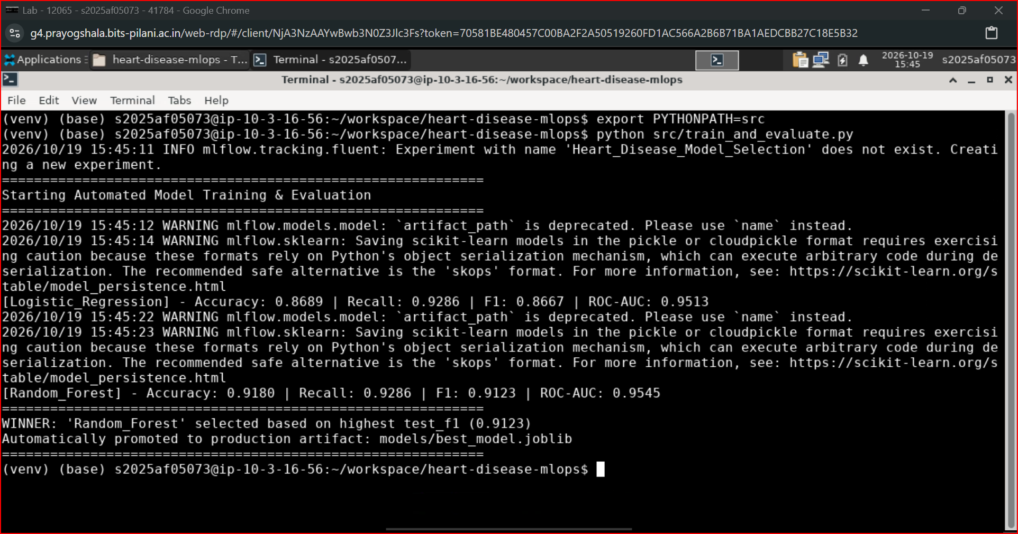

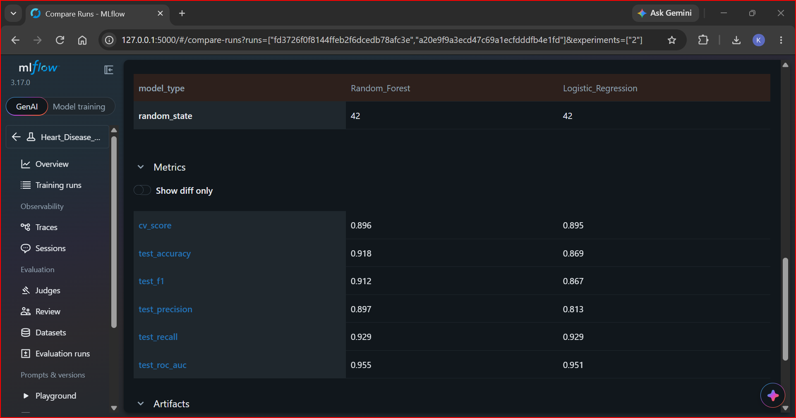

4.2 Automated Unit Testing (Pytest Suite)

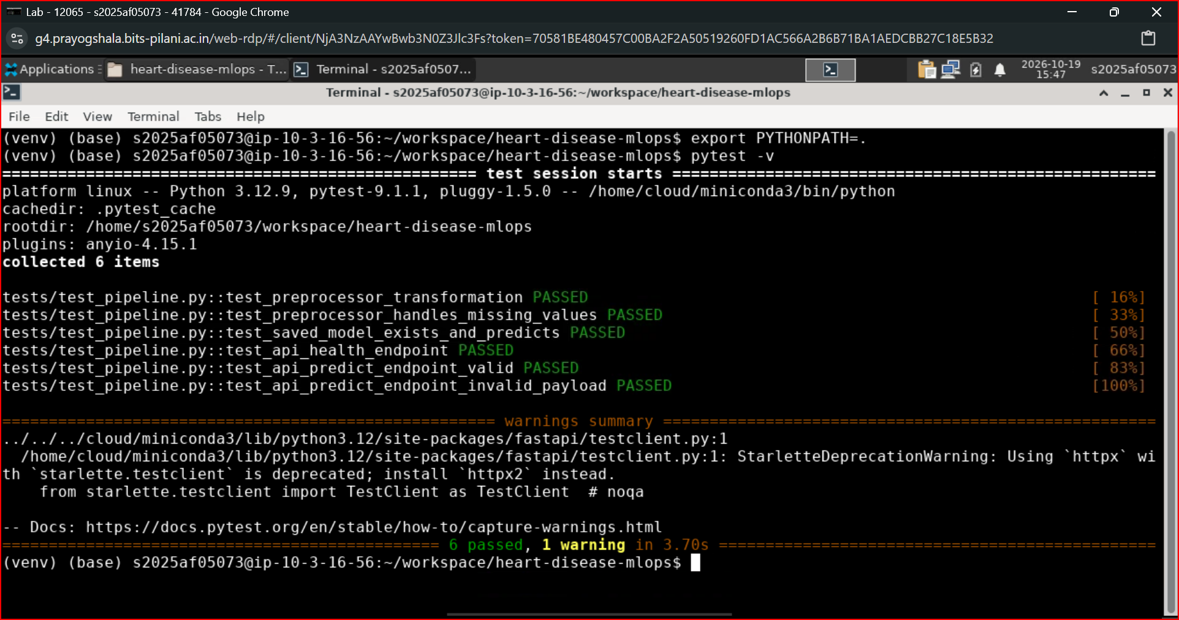

4.3 Code Quality & Linting Gate (Flake8)

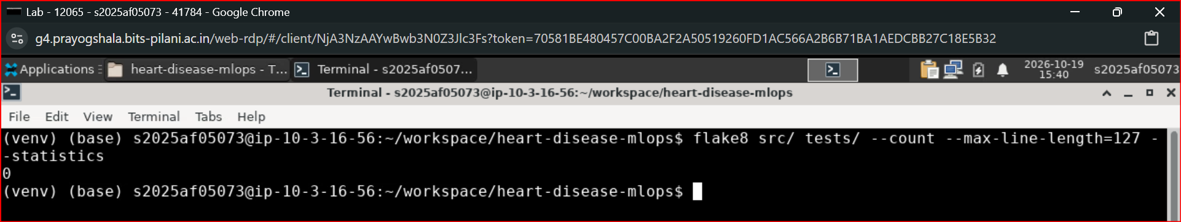

4.4 GitHub Actions CI/CD Pipeline

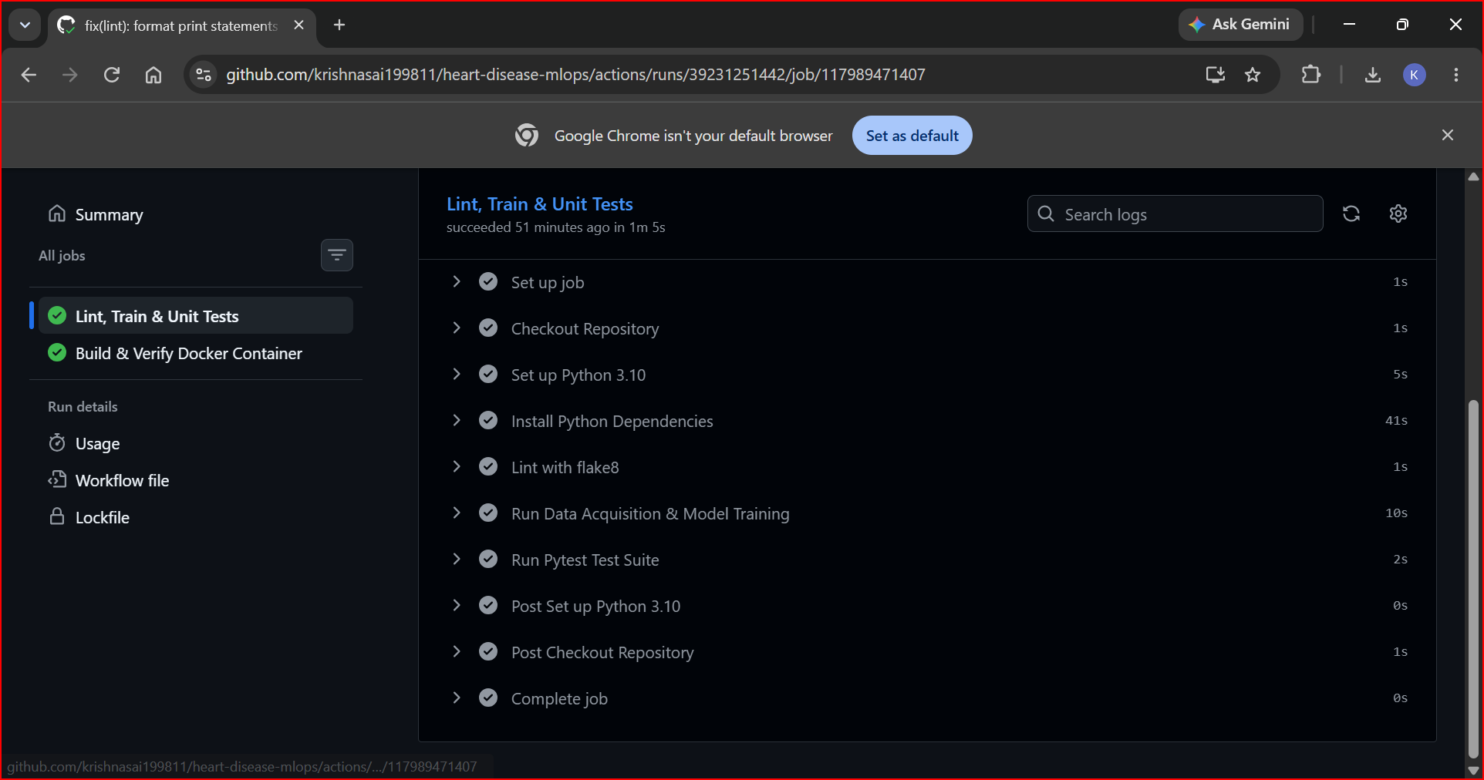

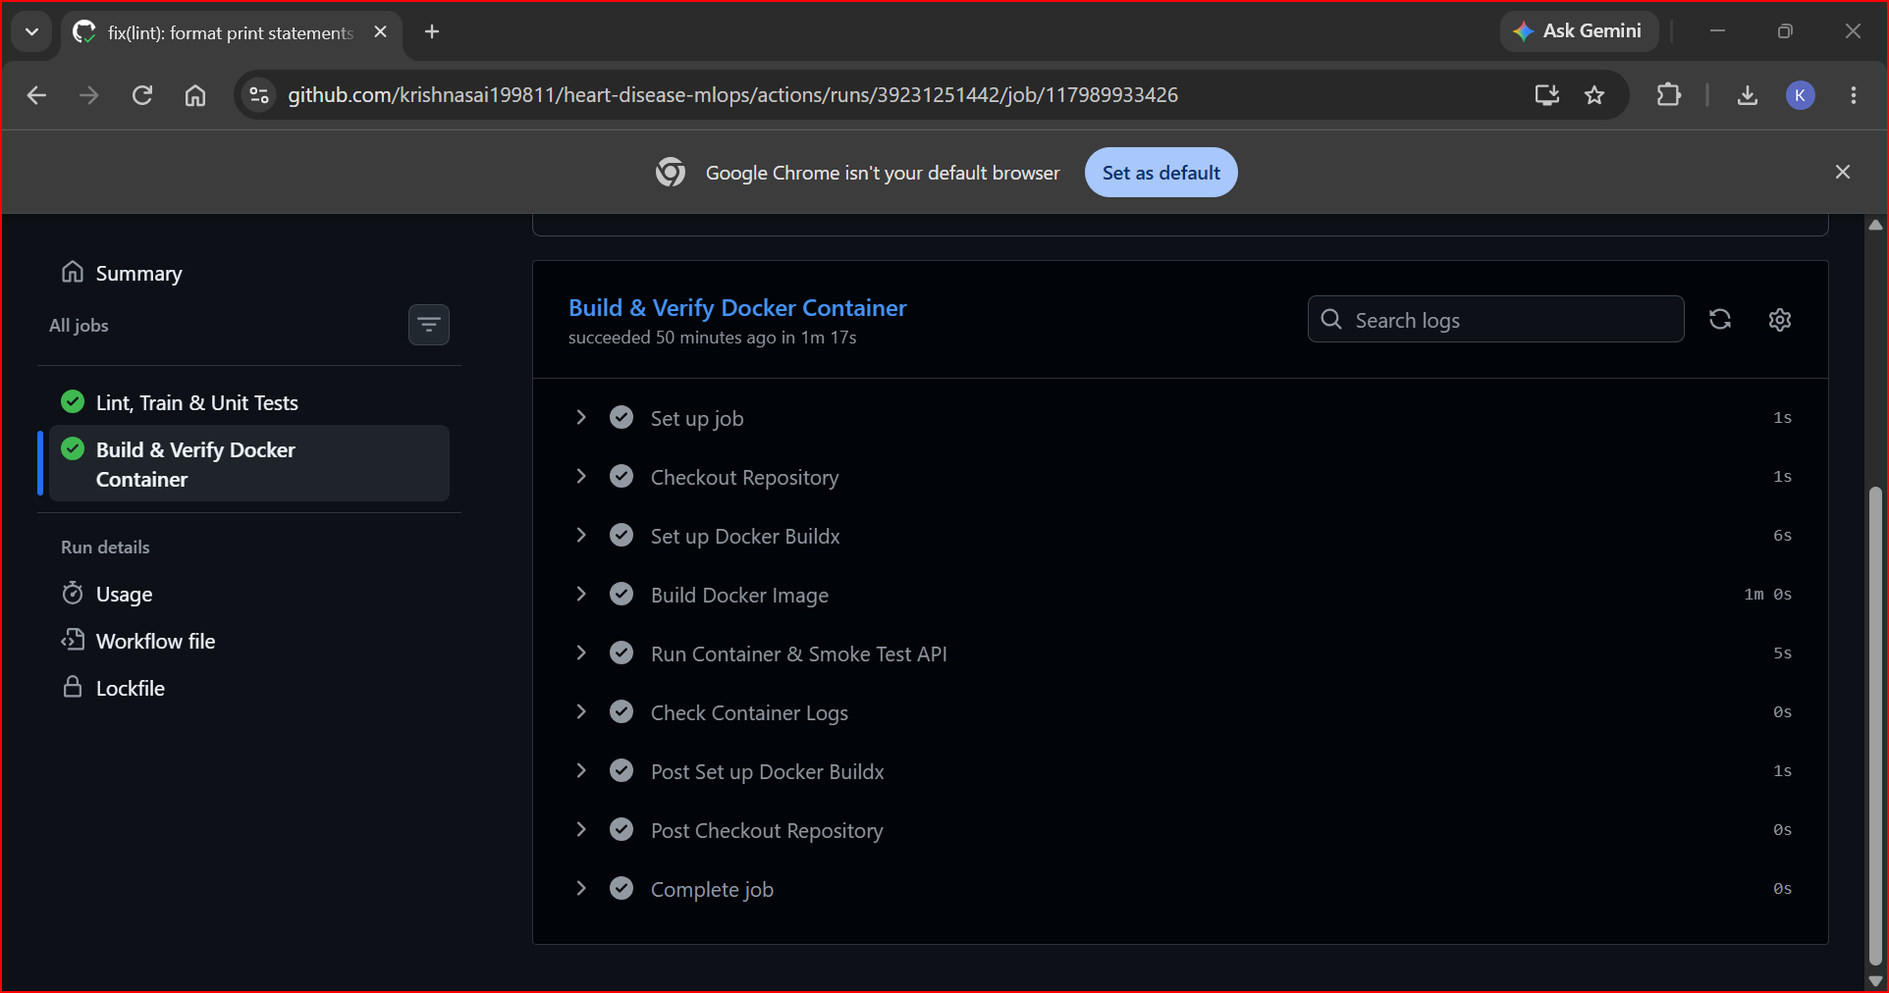

4.5 Container Runtime & Endpoint Verification (Docker & Lab VM)

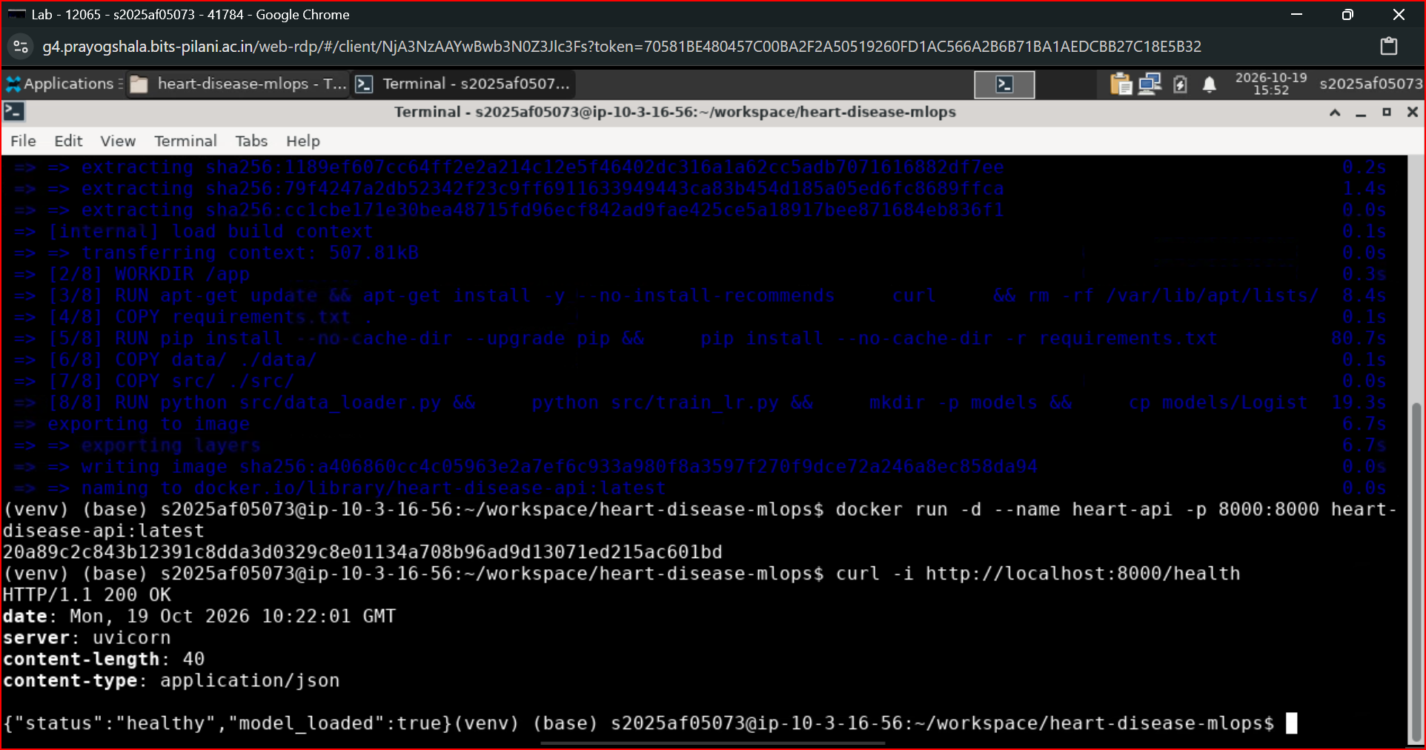

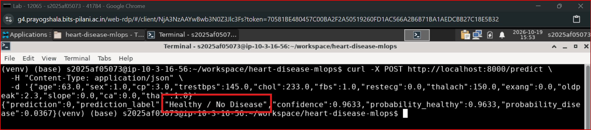

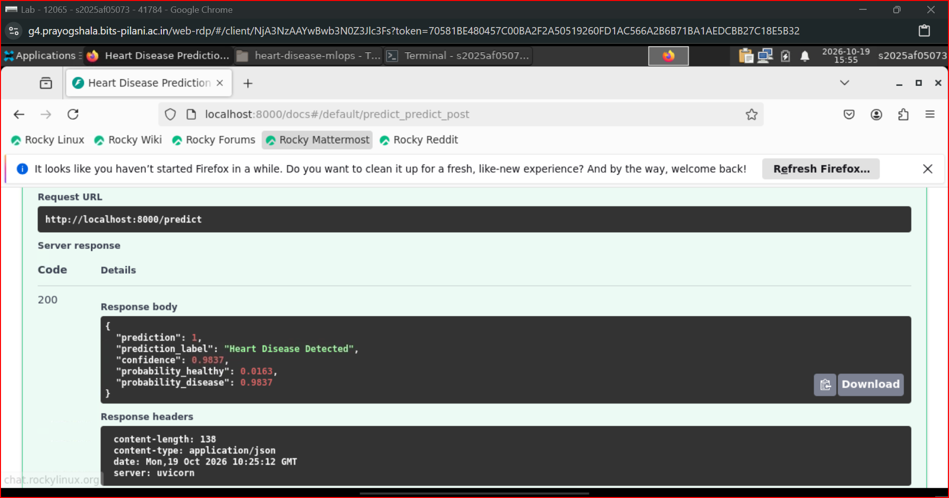

4.6 Kubernetes Cluster Orchestration

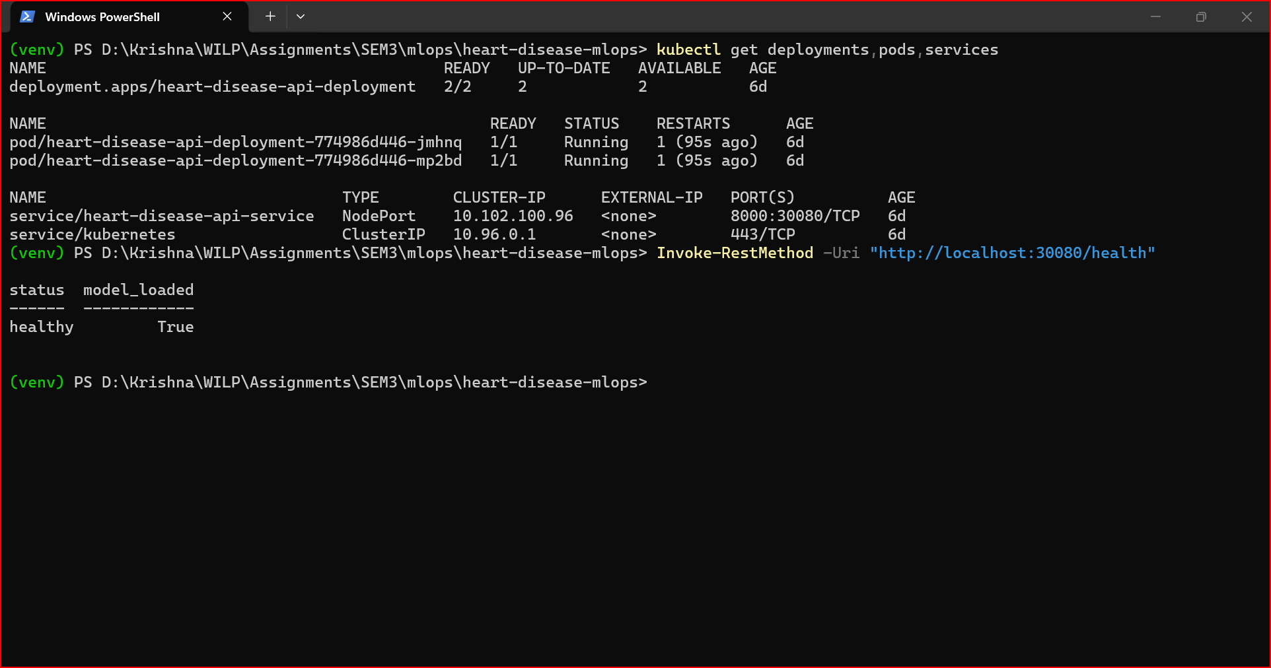

5. Conclusion & Operational Insights
The implemented architecture fulfills the objectives of modern MLOps by removing manual touchpoints across model lifecycle stages:
- Automation: Eliminates human bias in model promotion through algorithmic thresholding (src/train_and_evaluate.py).
- Quality Assurance: Integrates linting and unit testing gates in CI/CD before any artifact packaging occurs.
- Resilience & Scalability: Kubernetes health probes ensure zero downtime during traffic spikes or transient pod failures, while containerization guarantees consistent deployment across lab, local, and production cloud environments.

6. Appendix: Complete End-to-End Execution Guide

6.1 Environment Initialization & Dependency Setup:
1. Clone repository
git clone https://github.com/krishnasai199811/heart-disease-mlops.git
cd heart-disease-mlops

2. Create isolated virtual environment
python3 -m venv venv
source venv/bin/activate # On Windows: .\venv\Scripts\Activate.ps1

3. Upgrade pip and install all production & testing dependencies
pip install --upgrade pip
pip install -r requirements.txt
pip install flake8

6.2 Data Acquisition, Quality Gates & Automated Model Promotion:
1. Static code analysis & PEP 8 style validation (max line length 127)
flake8 src/ tests/ --count --max-line-length=127 --statistics

2. Download raw UCI Cleveland dataset
export PYTHONPATH=src # On Windows: $env:PYTHONPATH="src"
python src/data_loader.py

3. Automated training, MLflow tracking, and model selection
(Trains Logistic Regression & Random Forest, tracks runs in sqlite:///mlflow.db,
and automatically saves the best performing model to models/best_model.joblib)

python src/train_and_evaluate.py

4. Run Pytest test suite (6 automated unit & integration tests)

export PYTHONPATH=. # On Windows: $env:PYTHONPATH="."
pytest -v

6.3 MLflow Experiment Tracking UI:
Launch MLflow tracking dashboard (accessible at http://localhost:5000)

mlflow ui --backend-store-uri sqlite:///mlflow.db --port 5000

6.4 Containerization via Docker:

1. Build the production Docker image

docker build -t heart-disease-api:latest .

2. Run container as a detached service on port 8000

docker run -d --name heart-api -p 8000:8000 heart-disease-api:latest

3. Verify container health status

curl -i http://localhost:8000/health

4. Smoke test live inference endpoint (Healthy Case)
curl -X POST http://localhost:8000/predict \
-H "Content-Type: application/json" \
-d '{"age":63.0,"sex":1.0,"cp":3.0,"trestbps":145.0,"chol":233.0,"fbs":1.0,"restecg":0.0,"thalach":150.0,"exang":0.0,"oldpeak":2.3,"slope":0.0,"ca":0.0,"thal":1.0}'

5. Smoke test live inference endpoint (Disease Detected Case)

curl -X POST http://localhost:8000/predict \
-H "Content-Type: application/json" \
-d '{"age":67.0,"sex":1.0,"cp":4.0,"trestbps":160.0,"chol":286.0,"fbs":0.0,"restecg":2.0,"thalach":108.0,"exang":1.0,"oldpeak":1.5,"slope":2.0,"ca":3.0,"thal":2.0}'

6. Stop and remove container

docker stop heart-api && docker rm heart-api

6.5 Cluster Orchestration via Kubernetes (k8s):
1. Apply deployment (2 pod replicas with resource limits & health probes)

kubectl apply -f k8s/deployment.yaml

2. Expose deployment via NodePort service (port 30080)

kubectl apply -f k8s/service.yaml

3. Verify cluster resources and readiness

kubectl get deployments,pods,services

4. Query deployed service via cluster NodePort

curl http://localhost:30080/health
# On Windows PowerShell: Invoke-RestMethod -Uri "http://localhost:30080/health"

5. Tear down cluster resources when completed

kubectl delete -f k8s/service.yaml
kubectl delete -f k8s/deployment.yaml

