Project Code functionalities

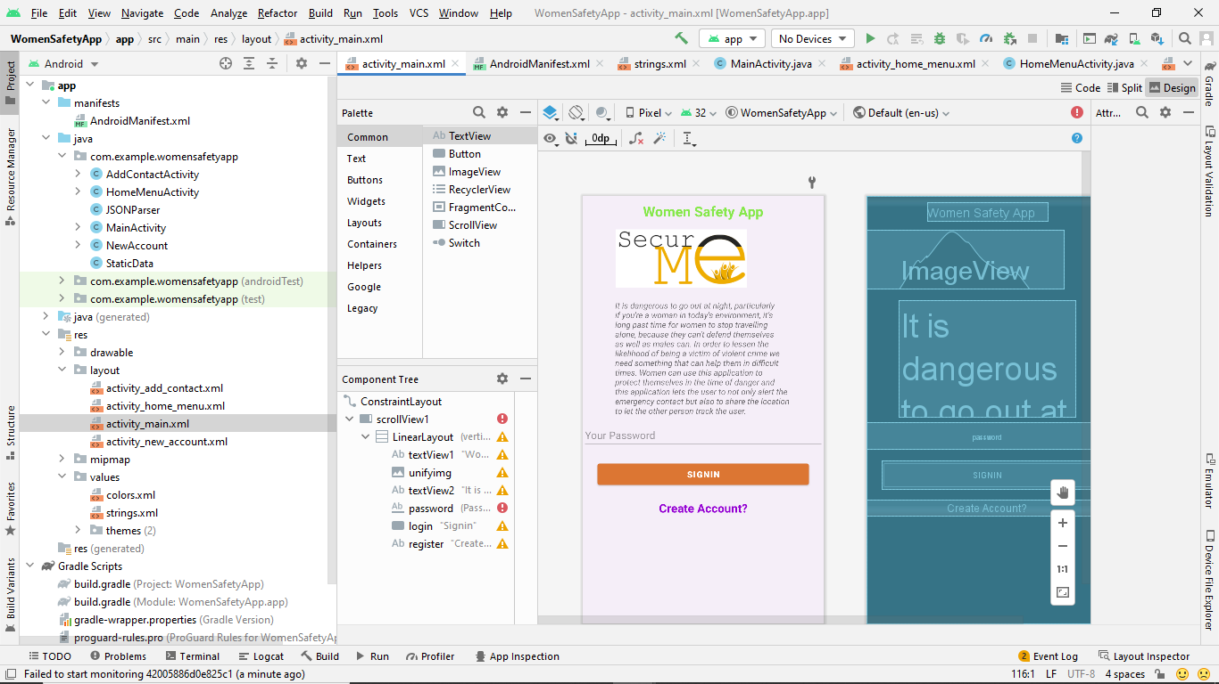

This screen is the design of Main Acitivity which is displayed when app is opened.

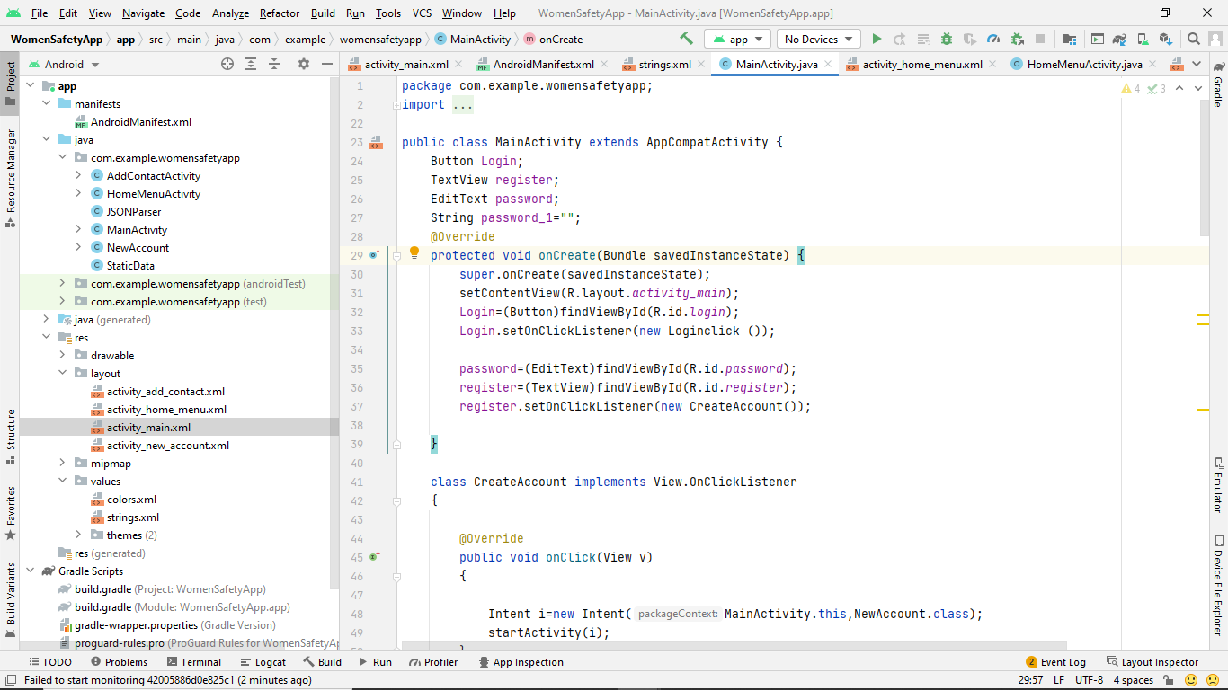

This is the main page code where the reference variables for the login button, registration text view, and password edit text are created. The onCreate for the same reference variables then uses ids to retrieve objects from the xml page file. The registration text view and login button are registered with an on-click listener to monitor click occurrences. The onclick method is triggered when the register button is pressed, and the click listener sends an event to the CreateAccount object. This function creates an intent object to display NewAccount page.

New Account Activity

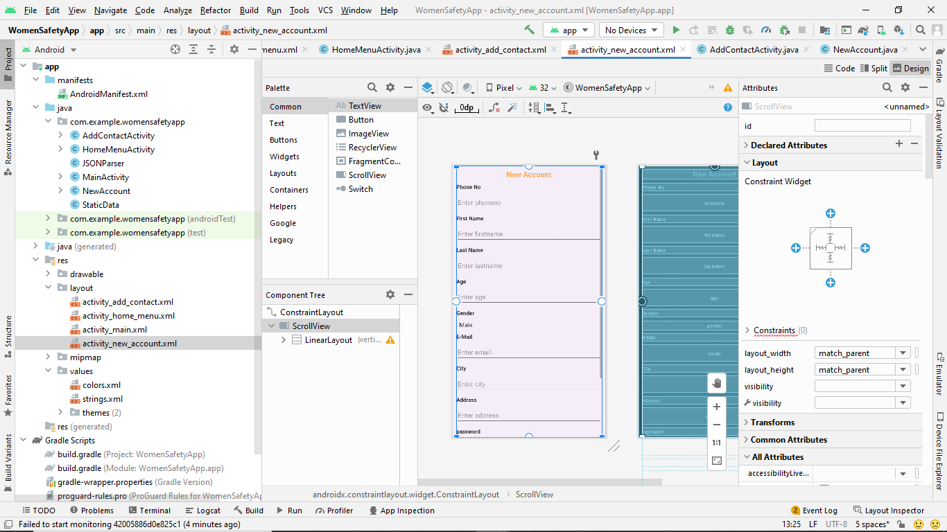

The above screen is related to design of new account page that contains all form fields such as firstname, lastname, age, gender, email, city, address, password.

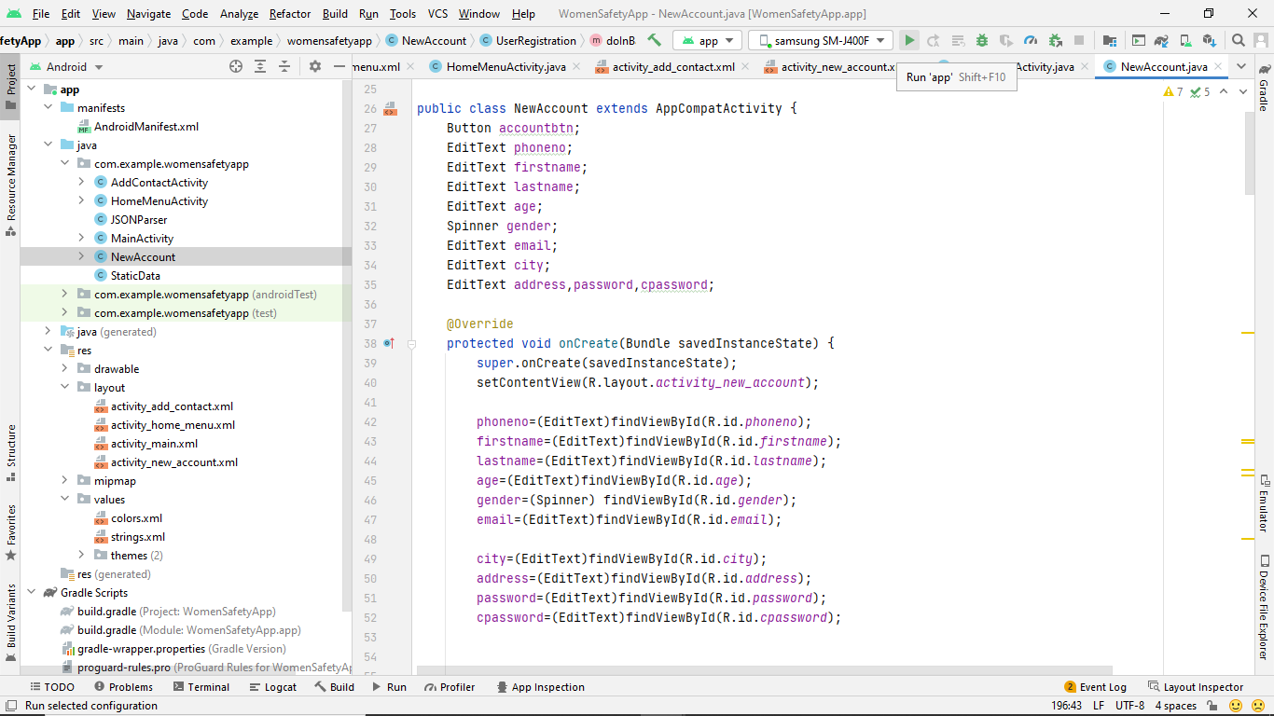

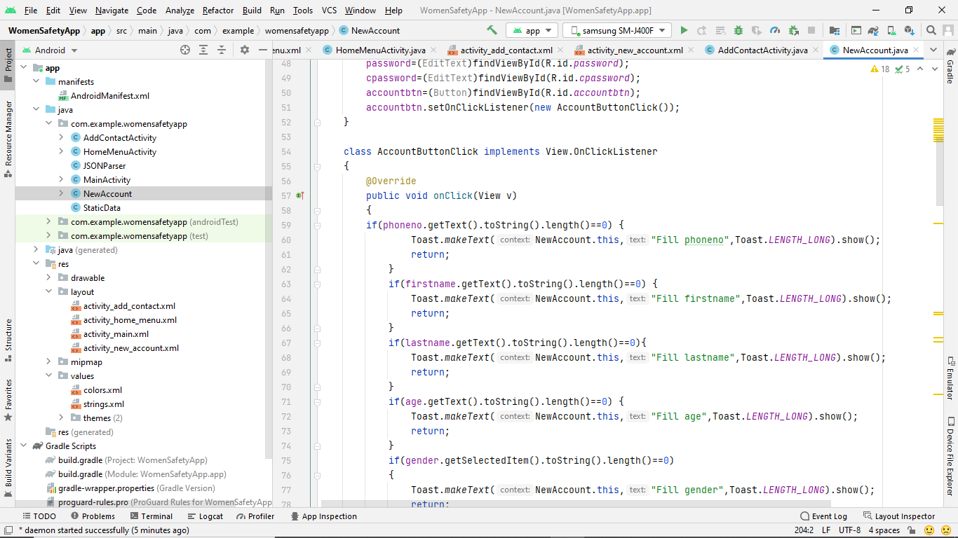

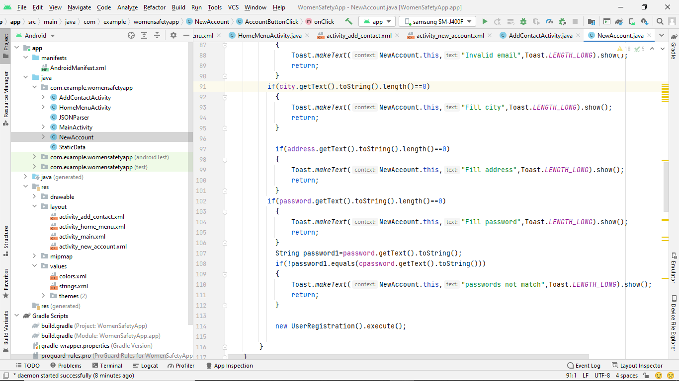

Firstname, lastname, age, address, city, password, and confirm password edit text reference variables are all included in the NewAccount class, along with a button for creating new accounts. The reference variables are assigned by the onCreate method, which receives all actual controls from new account page. In the new account form after giving the new account details the user has to click on create account button. When clicked onClick method of AccountButtonCliced is called where it validate the user input and UserRegistration object is created and executed.

User Registration

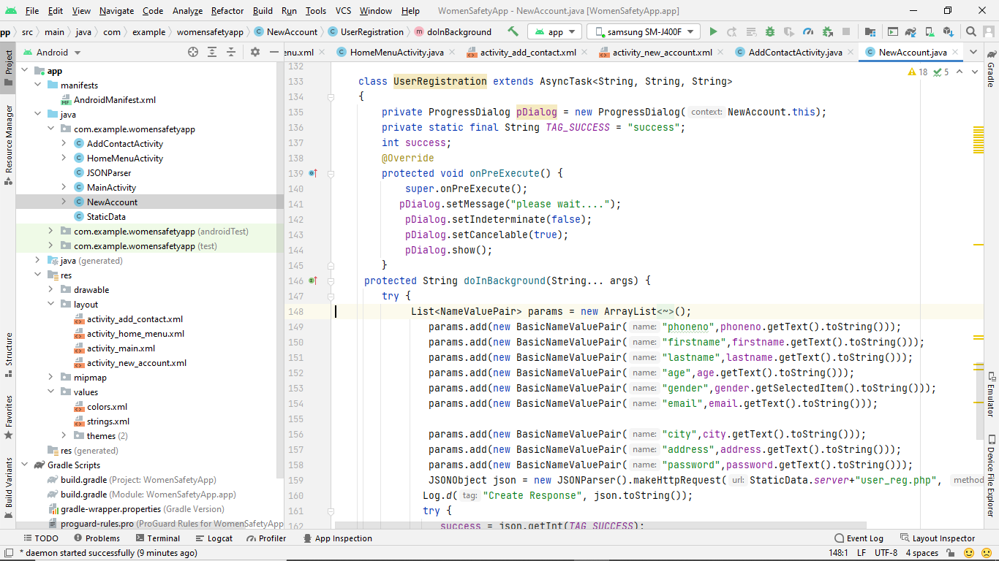

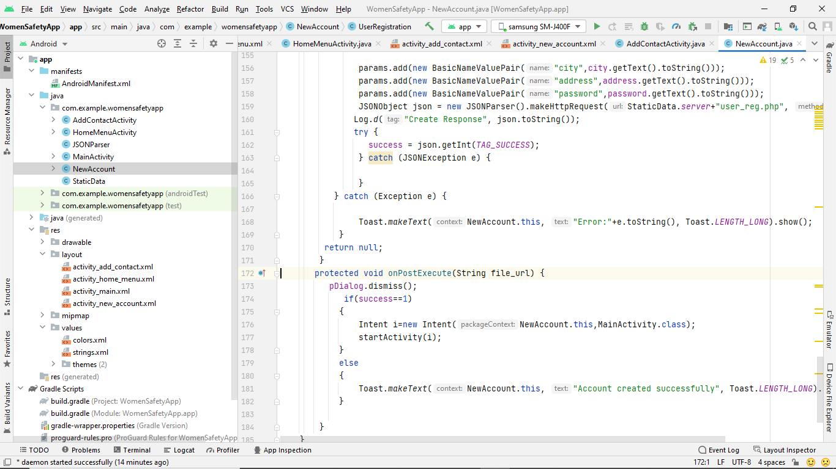

The onPreExecute method in this UserRegistration class sets the progress dialog's message and displays it on the screen. Following this, Android executes the doInBackground method, reading data from form fields to generate a list and send a request with arguments to the user reg.php file. This PHP file receives input data, stores it in a database on the server, and sends the app a response. Finally, the OnPostExcecute method is run, and it checks to see if the response was successful or not. If success is 1, registration was successful, and an intent object was created to direct users to the Main page for login.

AddAcontactActivity

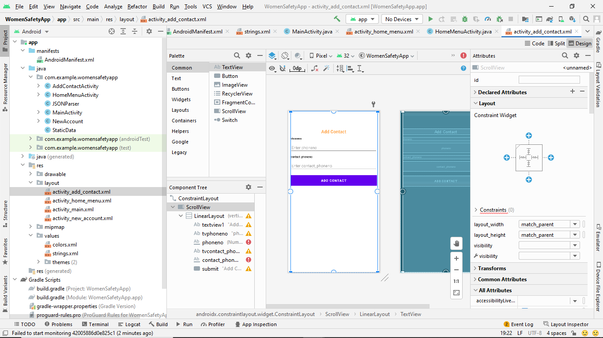

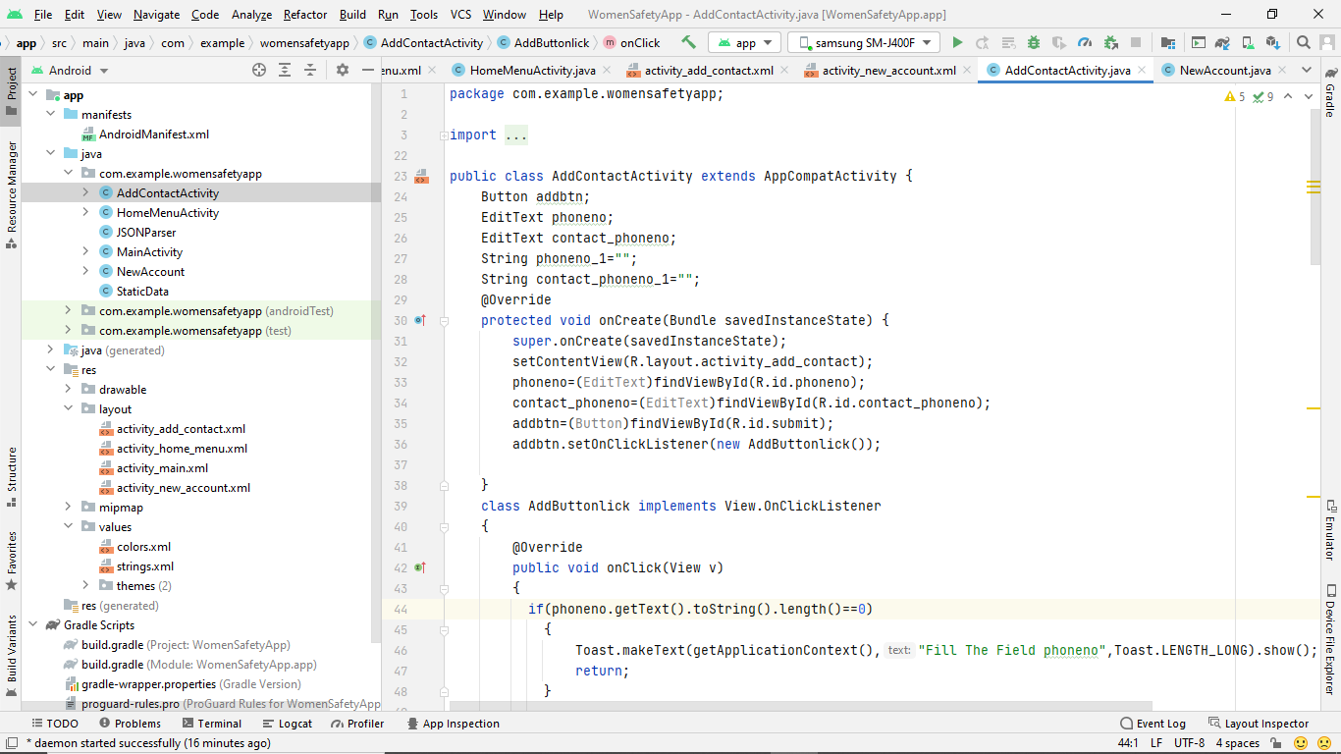

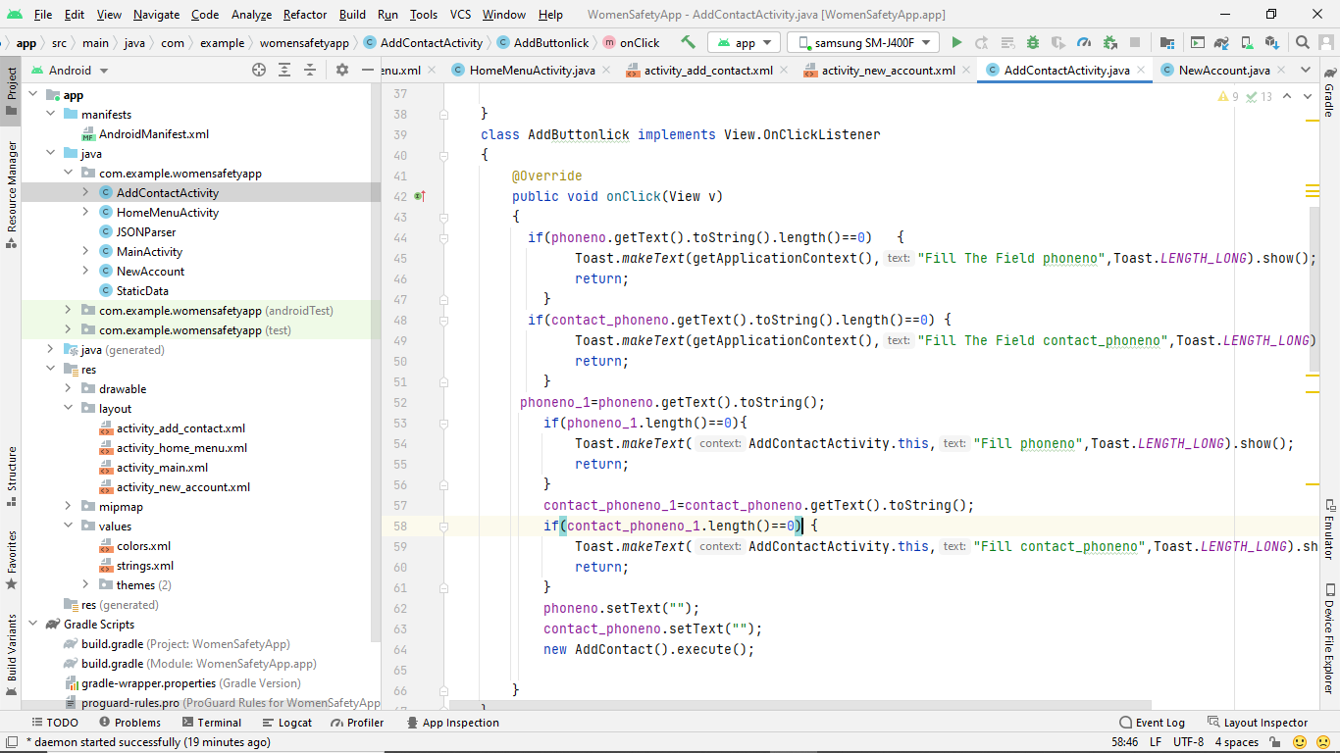

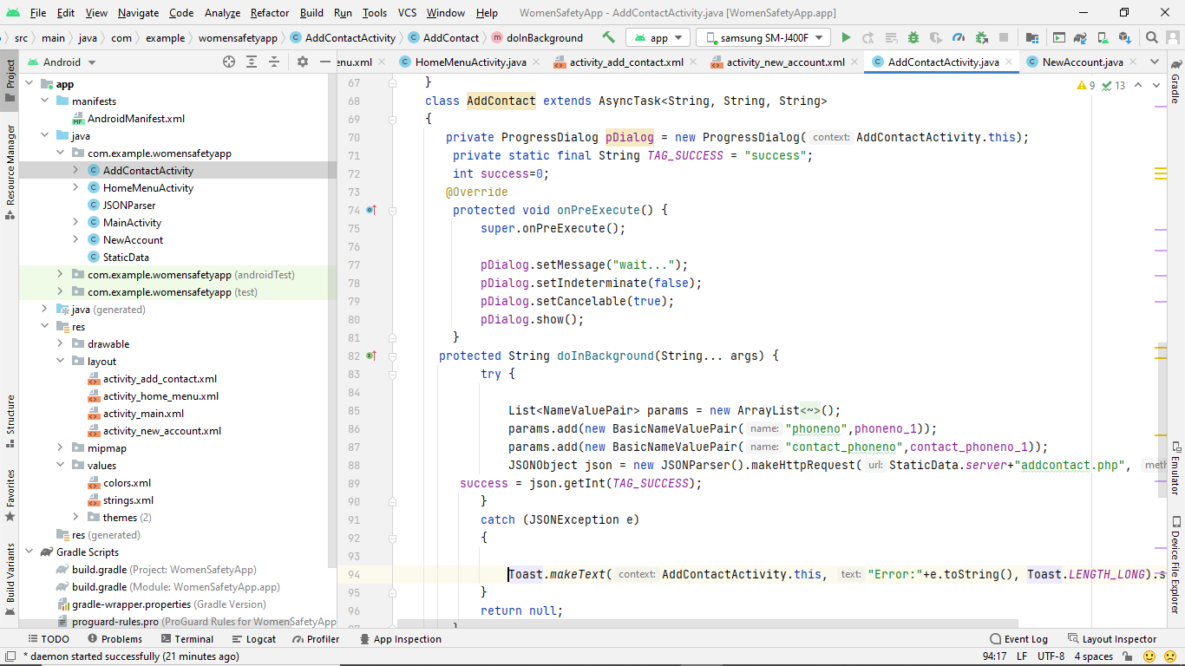

Get all the wedgets from the xml file into the phoneno, contac phoneno, and add button in the AddContactActivity's onCreate function. Register the addbtn button with a click listener. The onClick() method is called when a user clicks the add contact button on a page. Phoneno and contact phoneno are verified in the Onclick method, stored in variables, and then an object of the AddContact class is created and executed. The doInBackground method of the add contact class reads form data, including phoneno and contact phoneno, and produces a list of parameters with these values before making a request to the server's url addcontact.php and sending this information. The server's PHP file accepts input, adds to the database, and returns a response.

HomeMenu Activity:

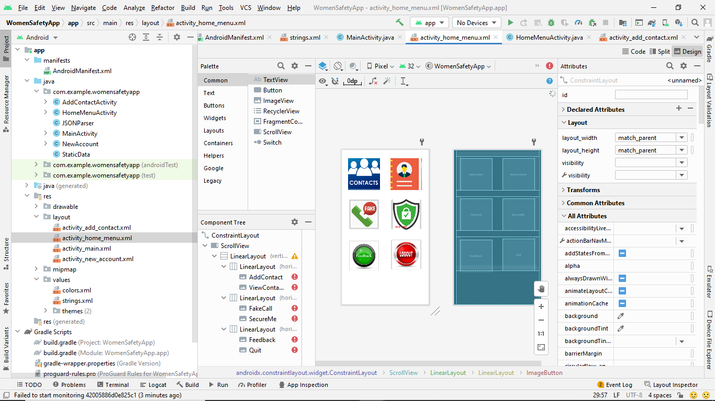

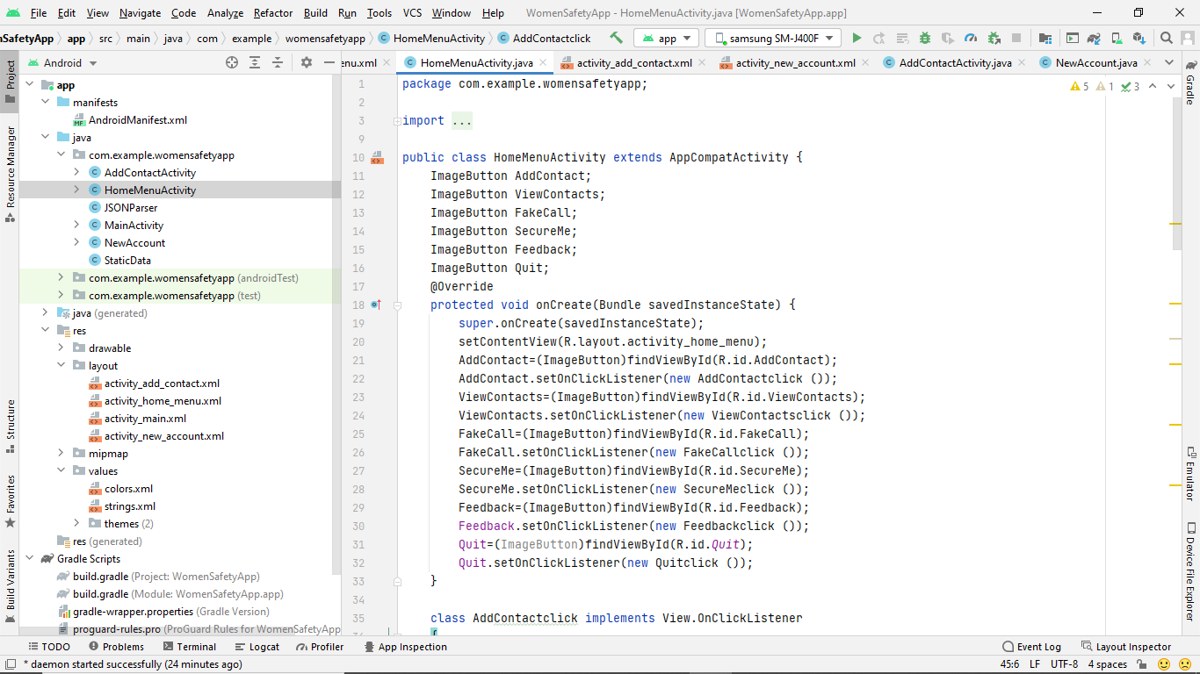

Here it gets all buttons of menu to perform operations.