Git & GitHub Practical Tasks (Step-by-Step)

1. Install Git
- Step 1: Download Git from https://git-scm.com/downloads
- Step 2: Install using default options.
- Step 3: Open Git Bash.
- Step 4: Run: git –version
- 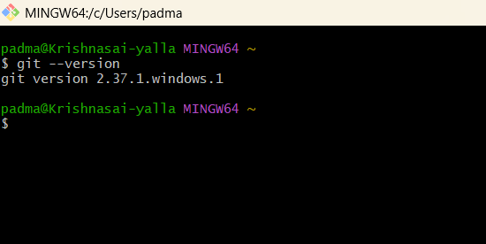

2. Create GitHub Repository
- Step 1: Login to GitHub.
- Step 2: Click New Repository.
- Step 3: Enter repository name (e.g., git-practice).
- Step 4: Select Add README.md.
- Step 5: Select Add .gitignore.
- Step 6: Click Create Repository.
- 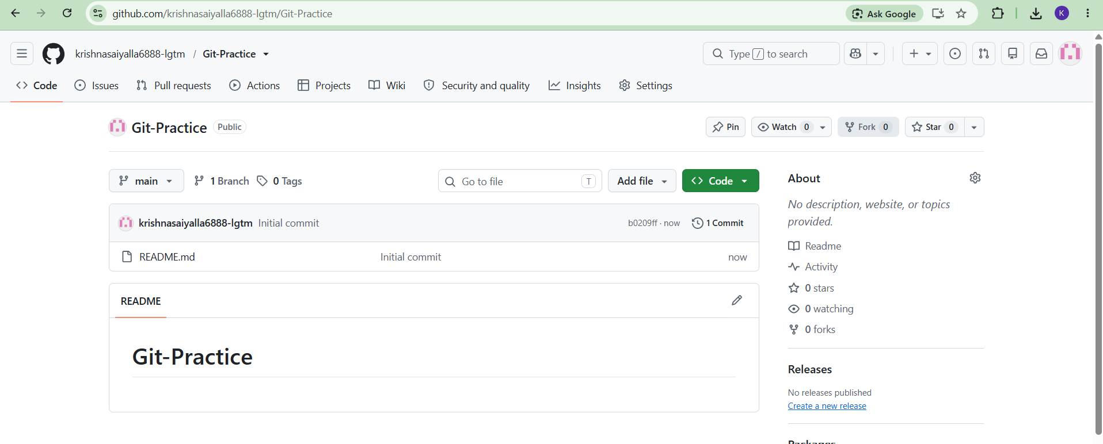

3. Clone Repository
- Step 1: Copy repository URL.
- Step 2: Run: git clone <repo-url>
- Step 3: Run: cd git-practice
- 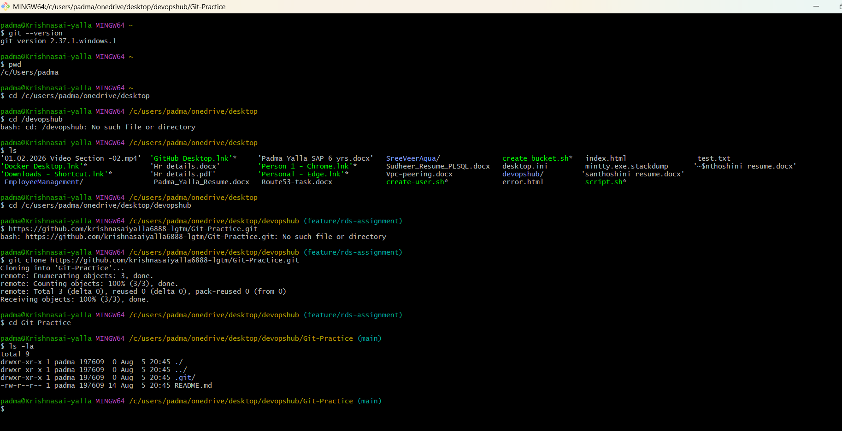

4. Create Two Files
- Step 1: Run: touch file1.txt file2.txt
- 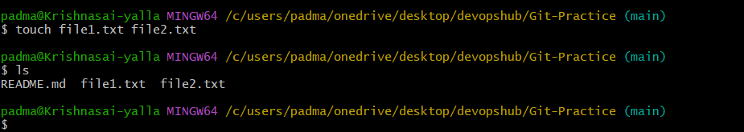

5. Commit and Push
- Step 1: Run: git add .
- Step 2: Run: git commit -m "Added two files"
- Step 3: Run: git push origin main
- 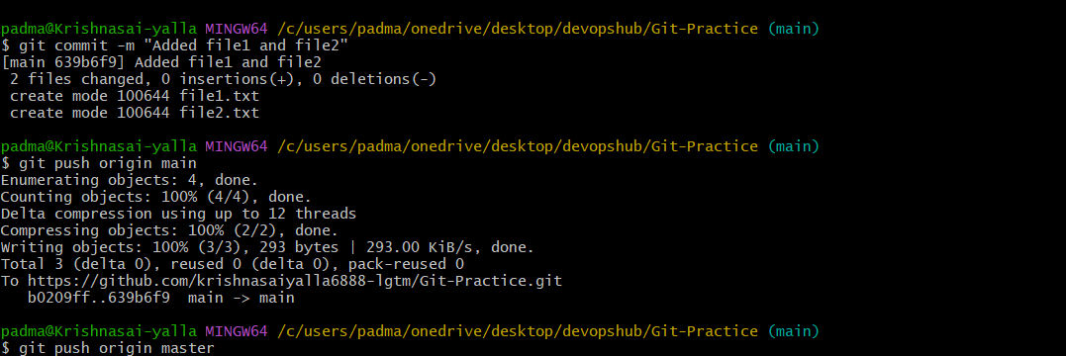

6. Create Local Branch and Push
- Step 1: Run: git checkout -b feature1
- Step 2: Create sample.txt
- Step 3: Run: git add .
- Step 4: Run: git commit -m "Added sample file"
- Step 5: Run: git push origin feature1
- 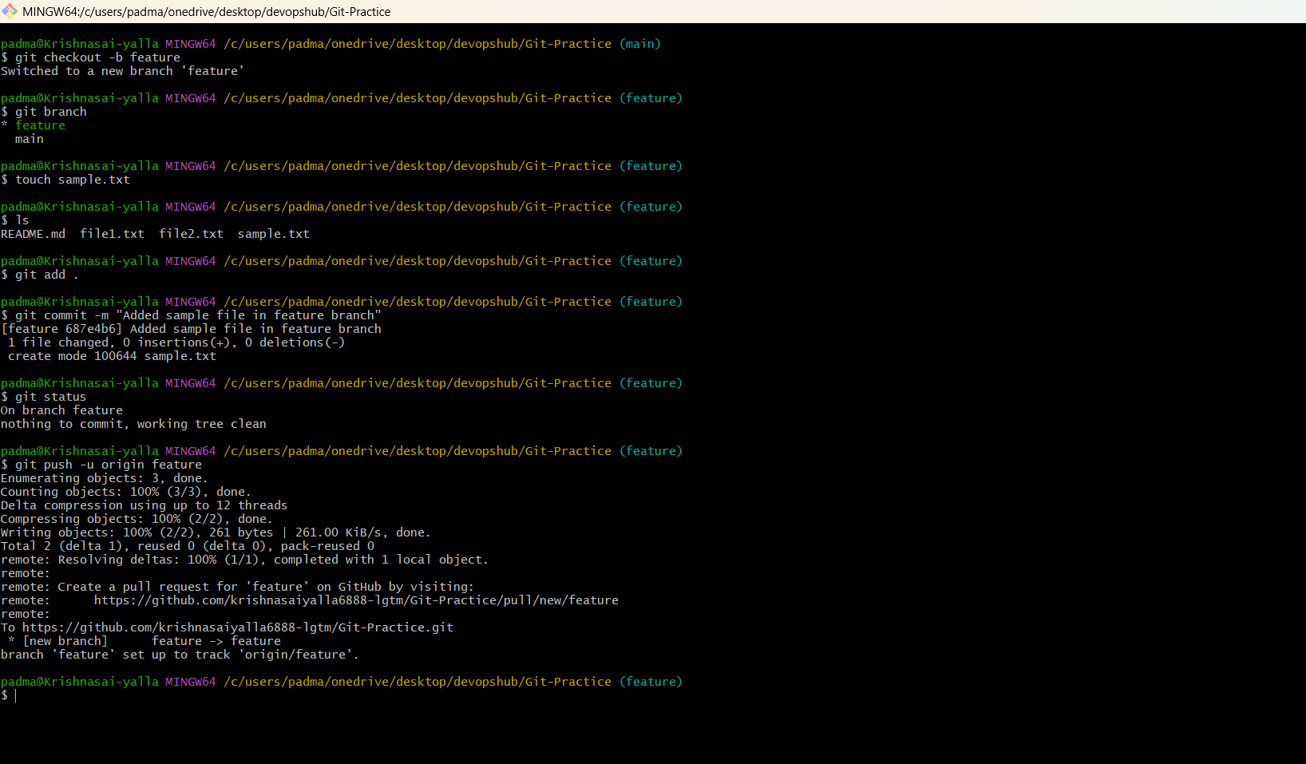
- 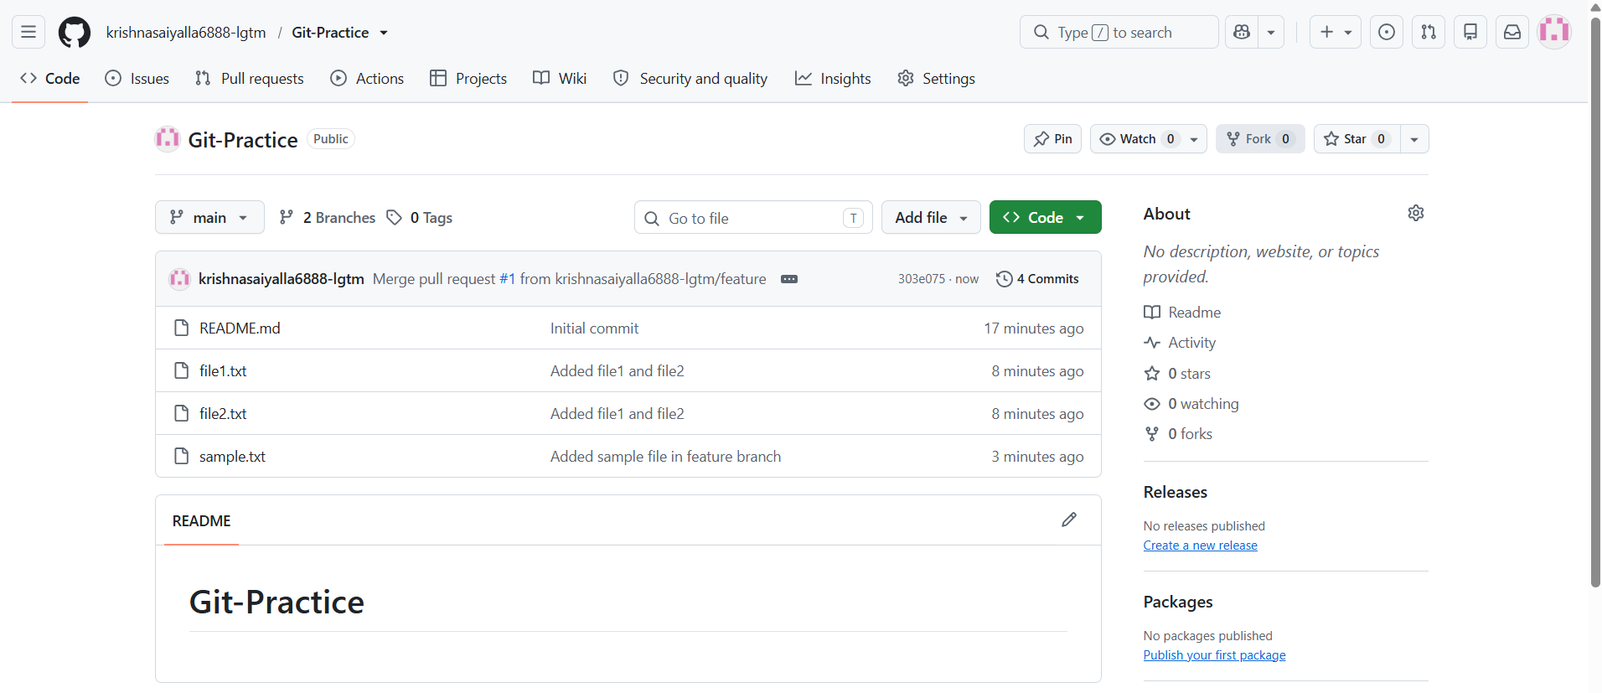

7. Create Branch in GitHub
- Step 1: Create branch in GitHub.
- Step 2: Run: git fetch
- Step 3: Run: git checkout <branch-name>
- 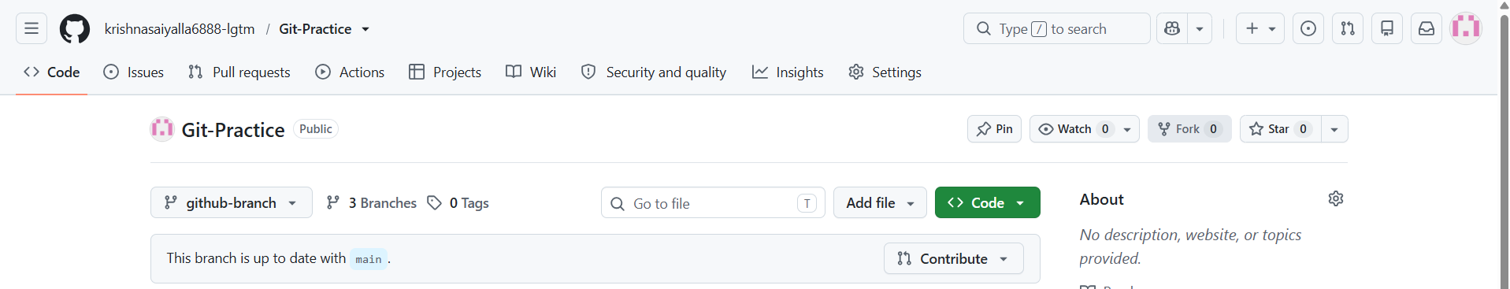
- 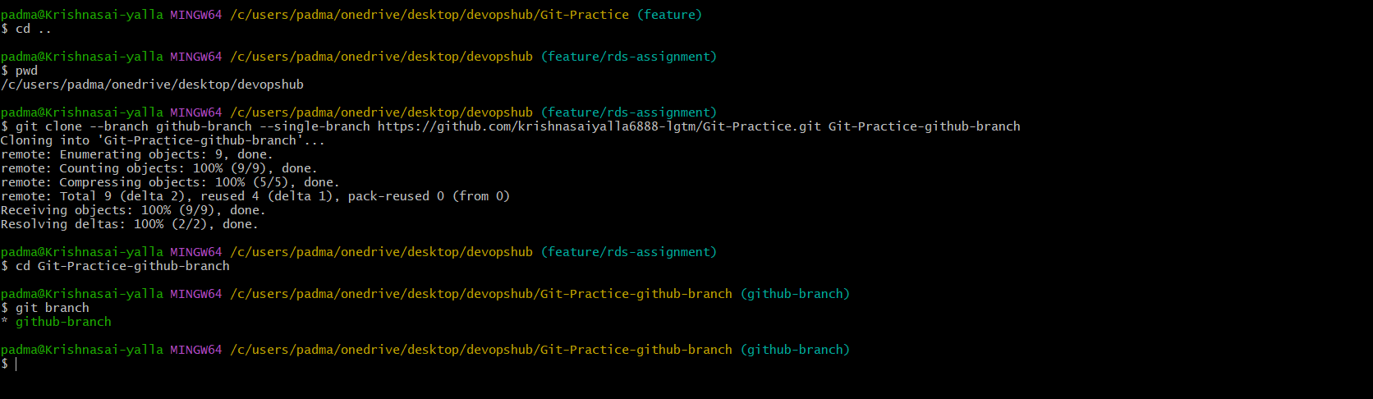

8. Merge Branch Locally
- Step 1: Run: git checkout main
- Step 2: Run: git merge feature1
- Step 3: Run: git push origin main
- 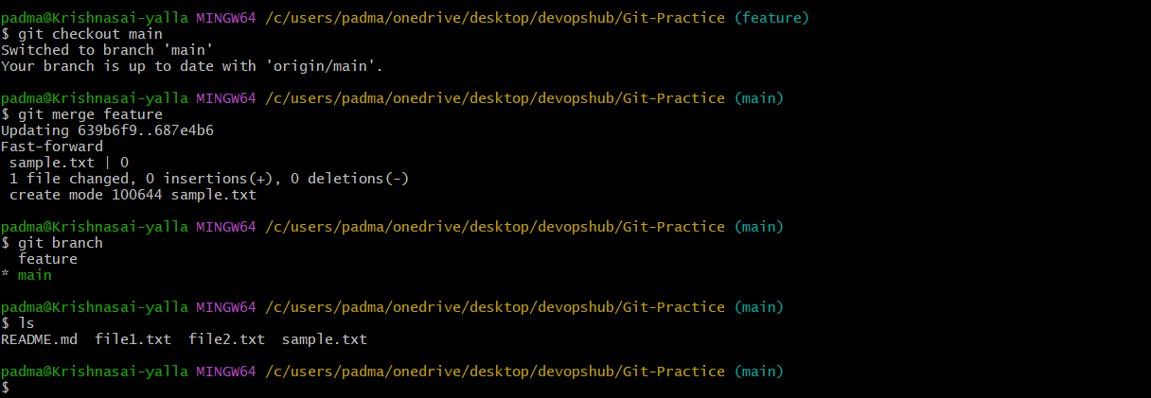

9. Merge Using Pull Request
- Step 1: Push branch.
- Step 2: Open GitHub.
- Step 3: Click Compare & pull request.
- Step 4: Create PR.
- Step 5: Merge PR.
- 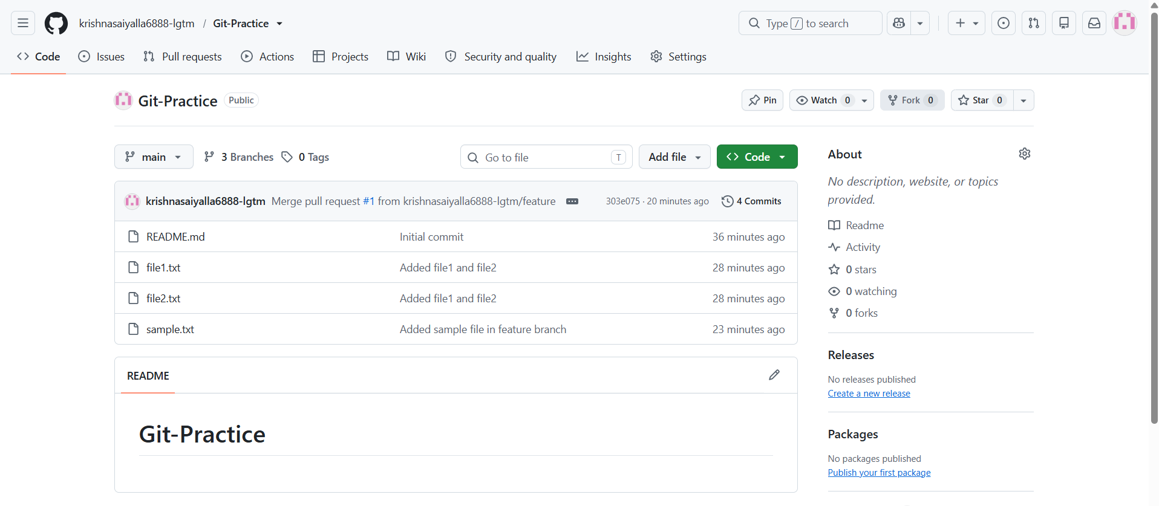

10. Push File to Branch
- Step 1: Run: git checkout feature1
- Step 2: Create newfile.txt
- Step 3: Run: git add .
- Step 4: Run: git commit -m "Added new file"
- Step 5: Run: git push origin feature1
- 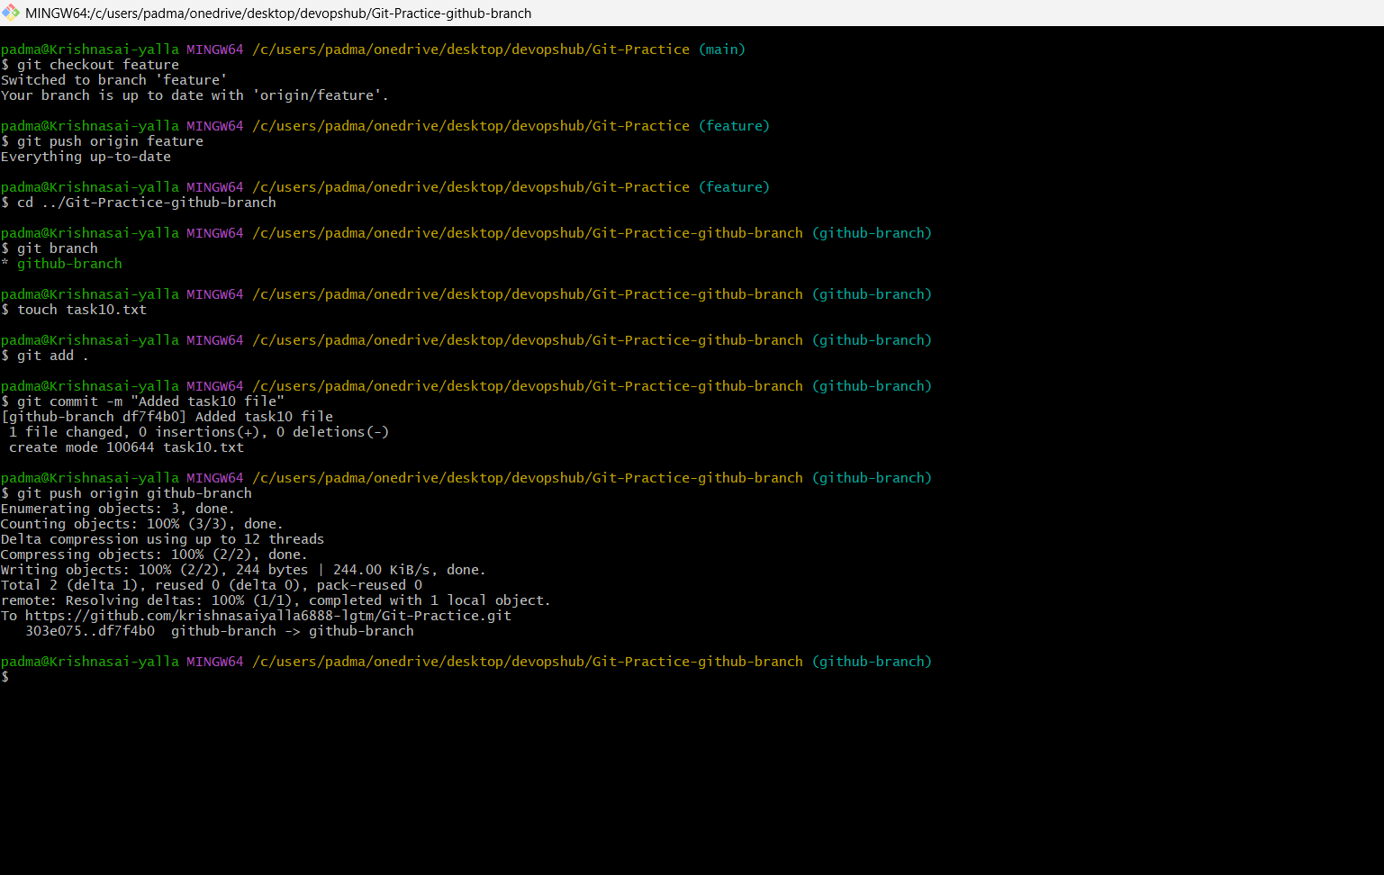
- 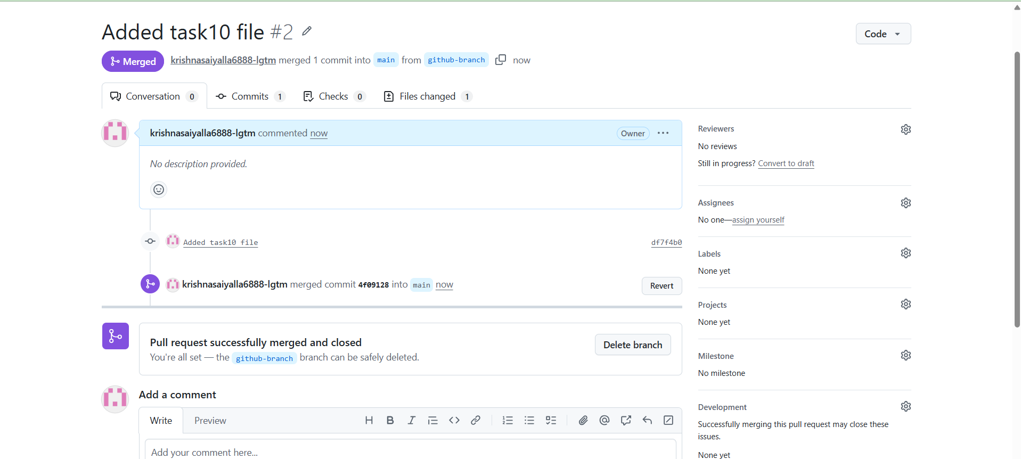

11. Clone Single Branch
- Step 1: Run: git clone --branch feature1 --single-branch <repo-url>
- 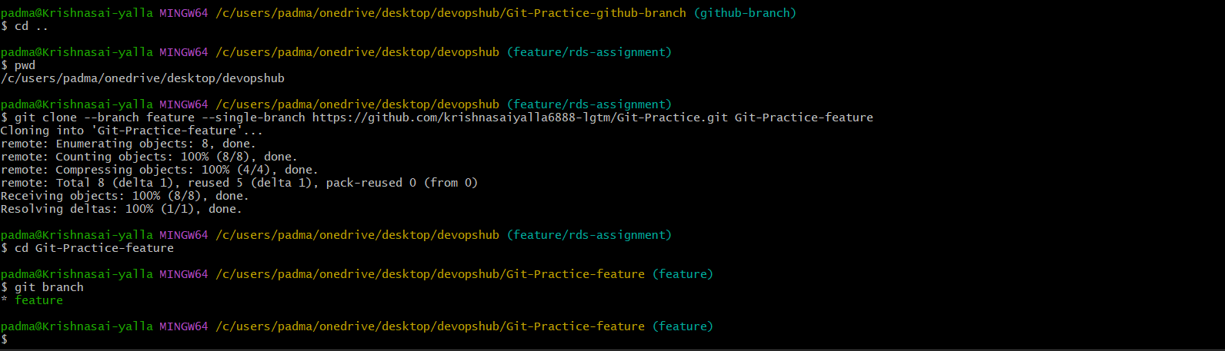

12. Ignore Password File
- Step 1: Create passwords.txt
- Step 2: Add passwords.txt to .gitignore
- Step 3: Verify using git status
- 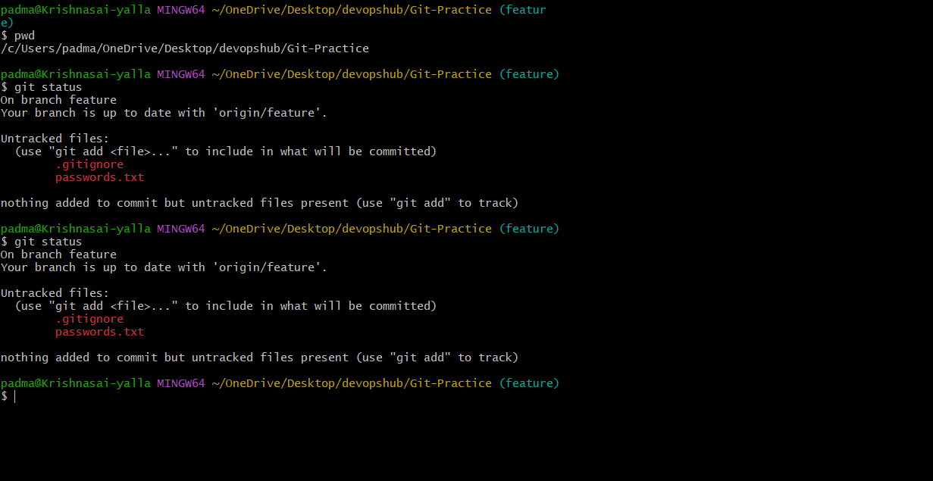

13. Reset Last Commit
- Step 1: Run: git reset --hard HEAD~1
- 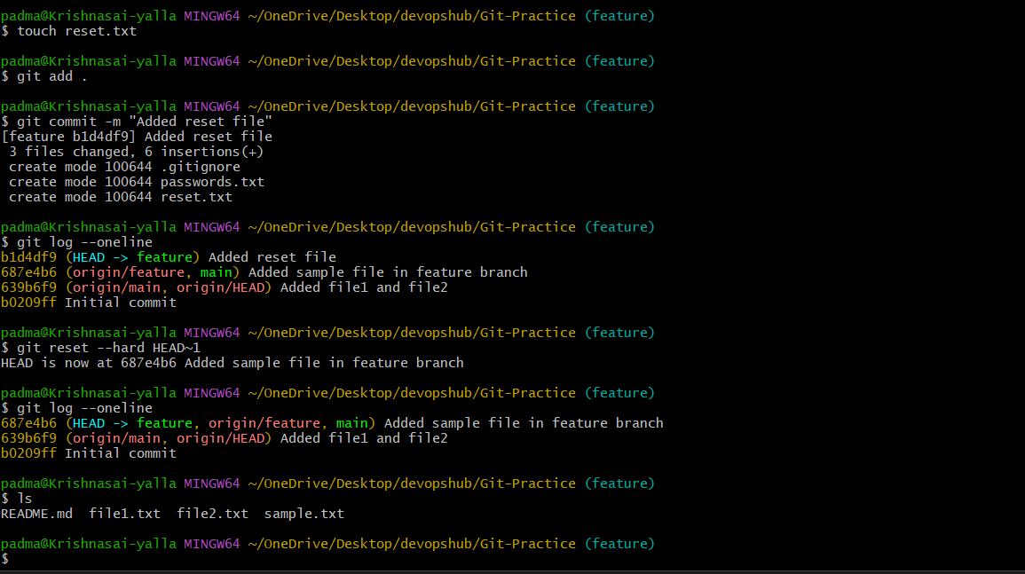

14. Revert Commit
- Step 1: Run: git log
- Step 2: Copy commit ID
- Step 3: Run: git revert <commit-id>
- Step 4: Run: git push
- 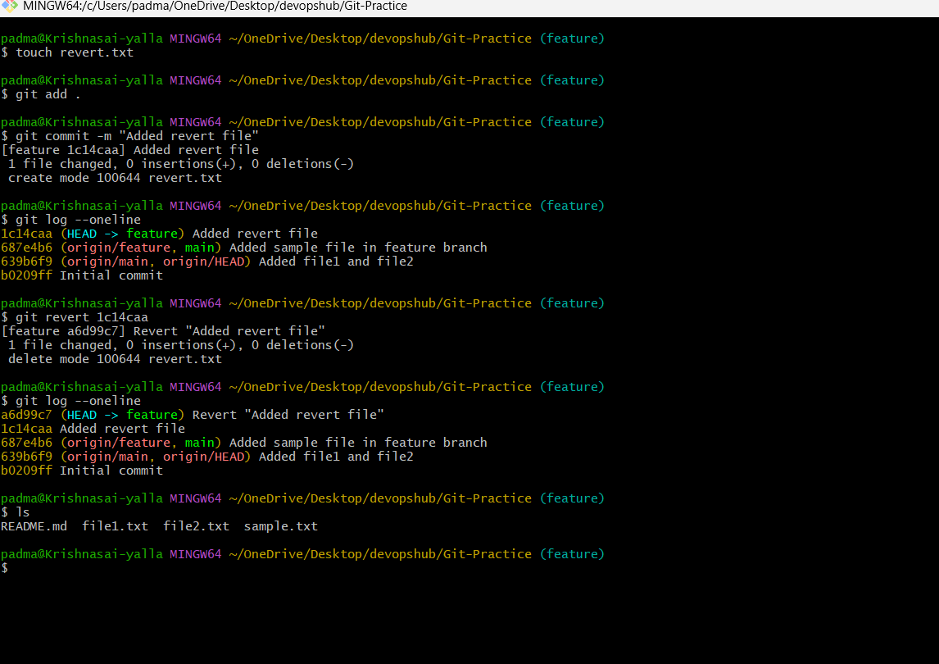

15. Stash Changes
- Step 1: Modify a file.
- Step 2: Run: git stash
- Step 3: Work on another file.
- 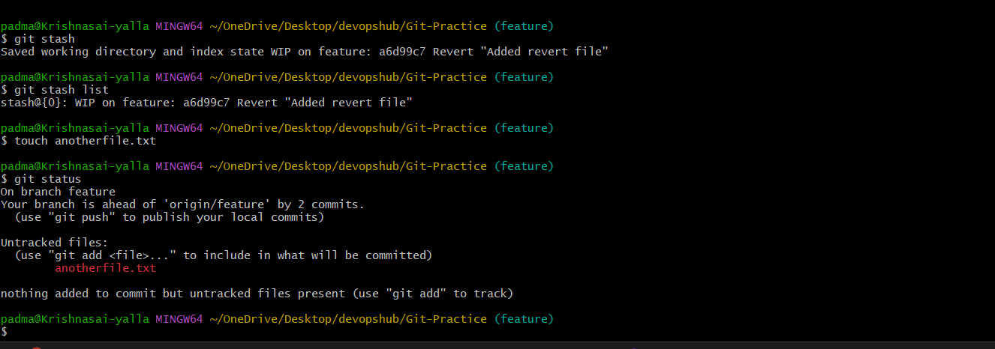

16. Restore Stash
- Step 1: Run: git stash list
- Step 2: Run: git stash pop

17. Configure SSH
- Step 1: Run: ssh-keygen -t ed25519 -C "your_email@example.com"
- Step 2: Run: eval "$(ssh-agent -s)"
- Step 3: Run: ssh-add ~/.ssh/id_ed25519
- Step 4: Run: cat ~/.ssh/id_ed25519.pub
- Step 5: Copy key to GitHub > Settings > SSH and GPG Keys > New SSH Key.
- Step 6: Run: ssh -T git@github.com
- 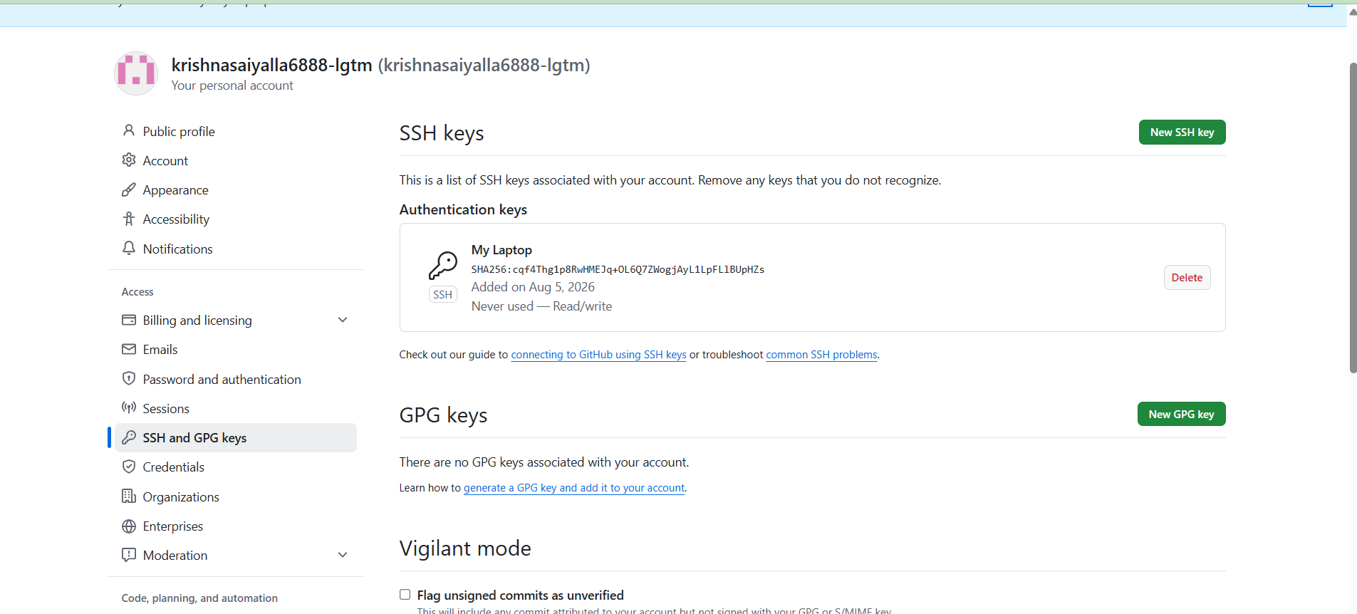

18. Configure Webhook
- Step 1: Repository > Settings > Webhooks > Add Webhook
- Step 2: Enter Payload URL
- Step 3: Select application/json
- Step 4: Choose Push events
- Step 5: Save
- 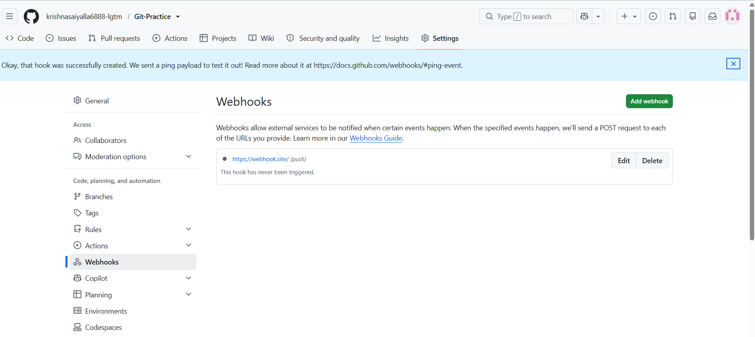
- 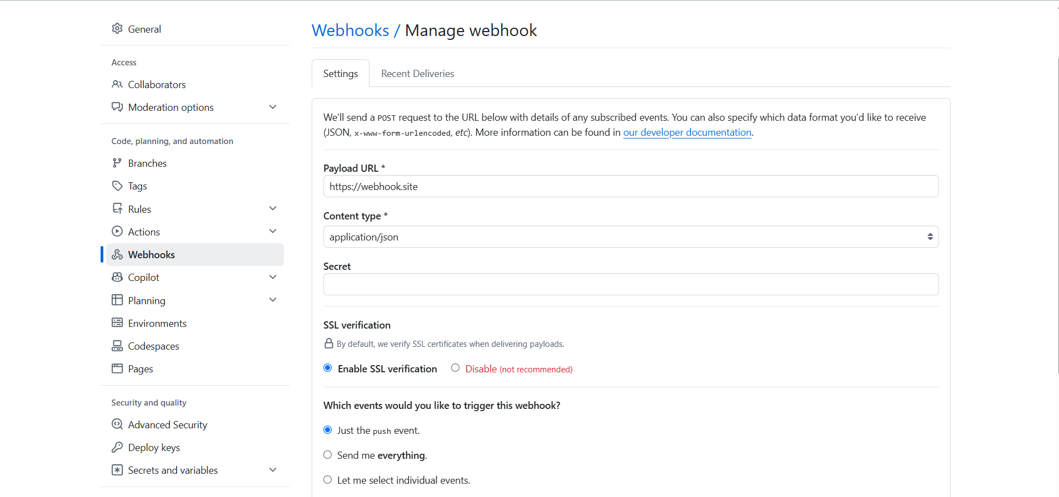

19. Understand .git Folder
- Step 1: Run: git init
- Step 2: Run: ls -la
- Step 3: Observe hidden .git folder containing repository metadata.
- 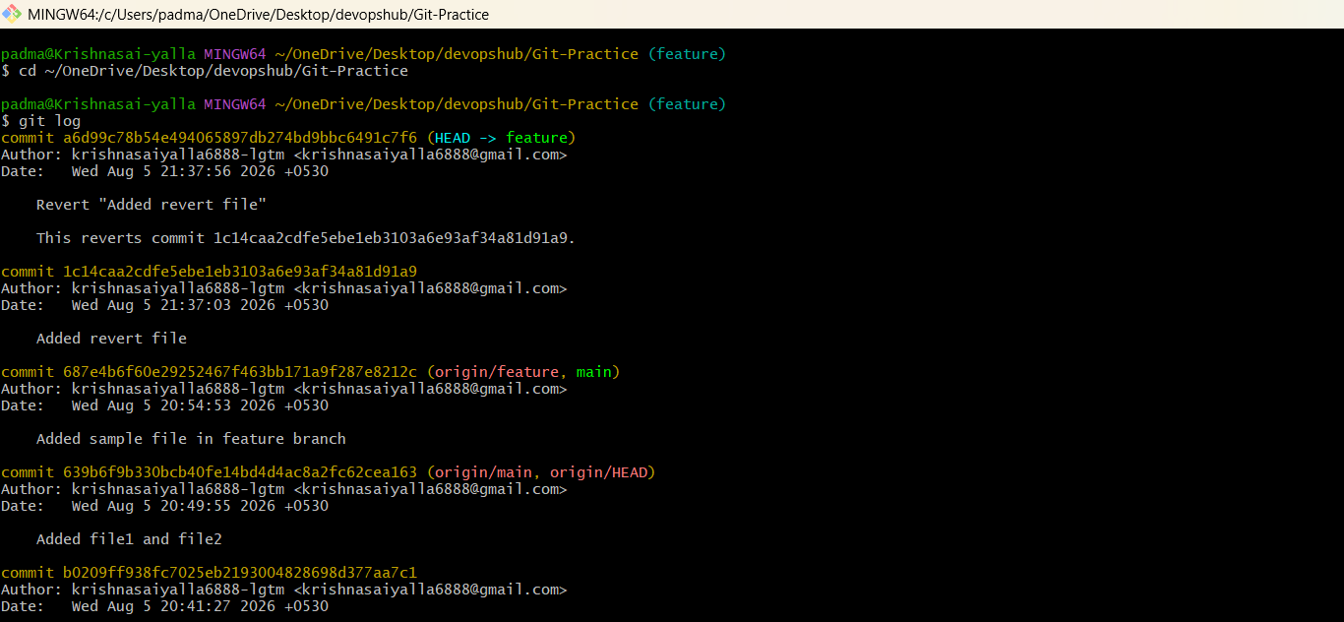

20. Check Logs
- Step 1: Run: git log
- Step 2: Run: git log --oneline
- Step 3: Run: git log –graph
- 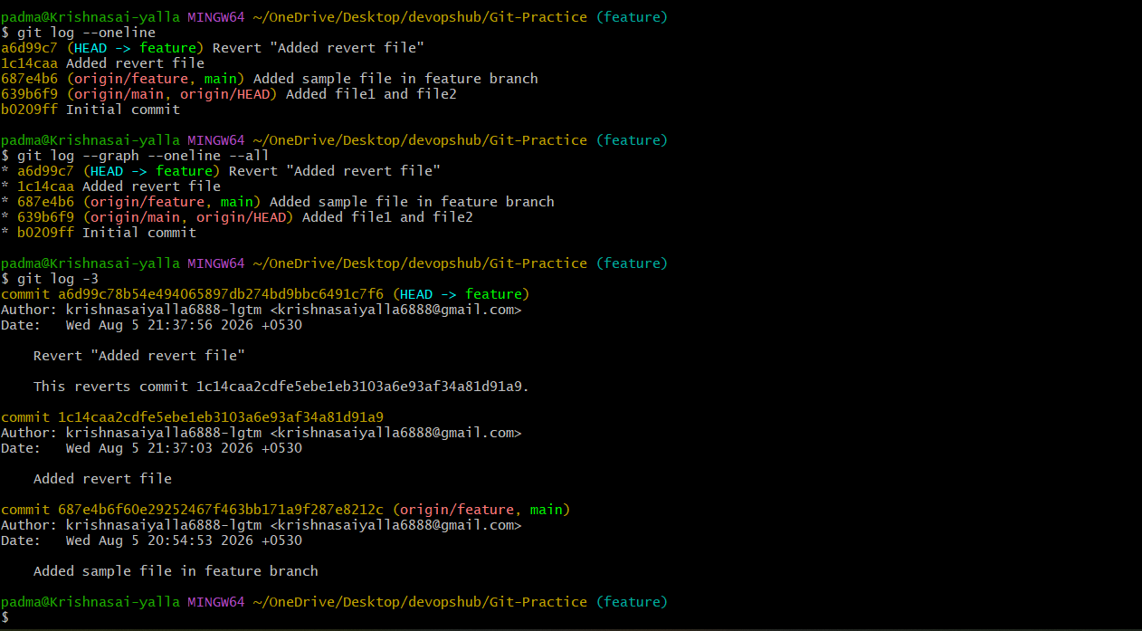

21. Rename Commit Message
- Step 1: Run: git commit --amend -m "New message"
- Step 2: If already pushed: git push –force
- 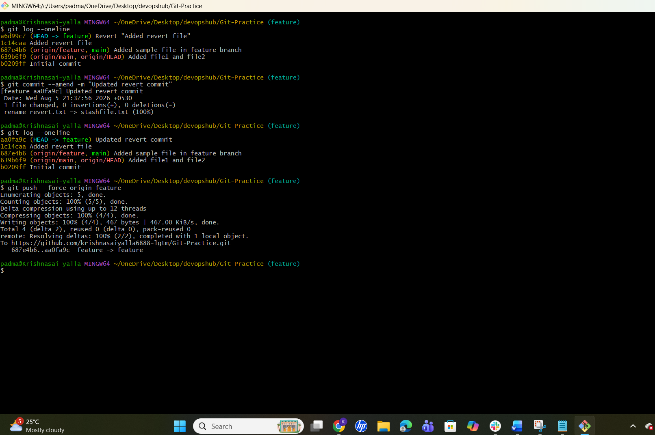

22. Squash Multiple Commits
- Step 1: Run: git rebase -i HEAD~3
- Step 2: Change pick to squash for later commits.
- Step 3: Save.
- Step 4: Edit commit message.
- Step 5: Run: git push –force
- 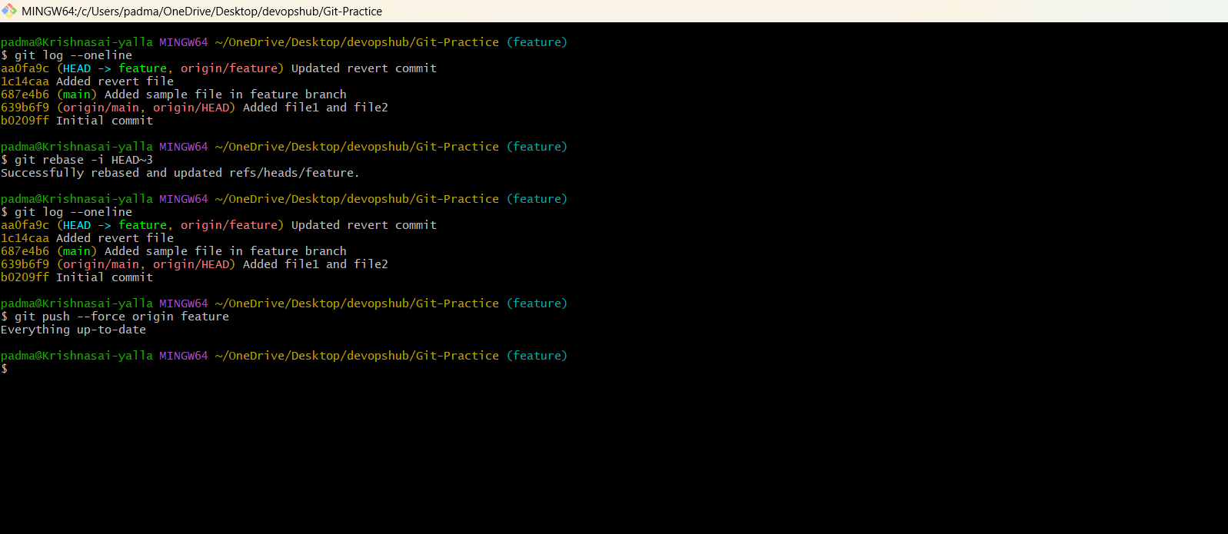

Common Git Commands
Command | Purpose
git status | Check repository status
git add . | Stage changes
git commit -m "msg" | Commit
git push | Push changes
git pull | Pull changes
git fetch | Fetch remote updates
git checkout | Switch branch
git checkout -b name | Create branch
git merge | Merge branches
git stash | Save uncommitted changes
git stash pop | Restore stash
git log --oneline | View history

