Docker-02 Task

1. Objective
Docker-02 was completed on the existing Ubuntu EC2 Docker server. The assignment covered Tomcat containers, Docker volumes, an Nginx memory limit, a custom Dockerfile, Docker Hub, and AWS ECR.

2. Environment
- OS: Ubuntu 24.04.4 LTS
- Docker Engine: 29.1.3
- AWS Region: us-east-1 (US East – N. Virginia)
- AWS Account ID used for ECR: 899867382860
- Docker Hub username: krishna6888

3. Task 1 – Tomcat Container on Port 8080
Jenkins was stopped because it was using host port 8080. Tomcat was then pulled and started with host port 8080 mapped to Tomcat port 8080.
docker stop jenkins
docker pull tomcat
docker run -d --name tomcat-8080 -p 8080:8080 tomcat
docker ps
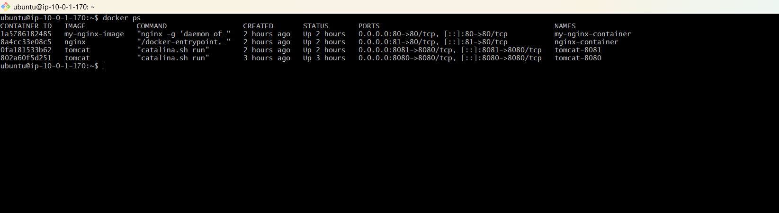
A sample index.html application was created and copied into Tomcat's ROOT web application.
nano index.html
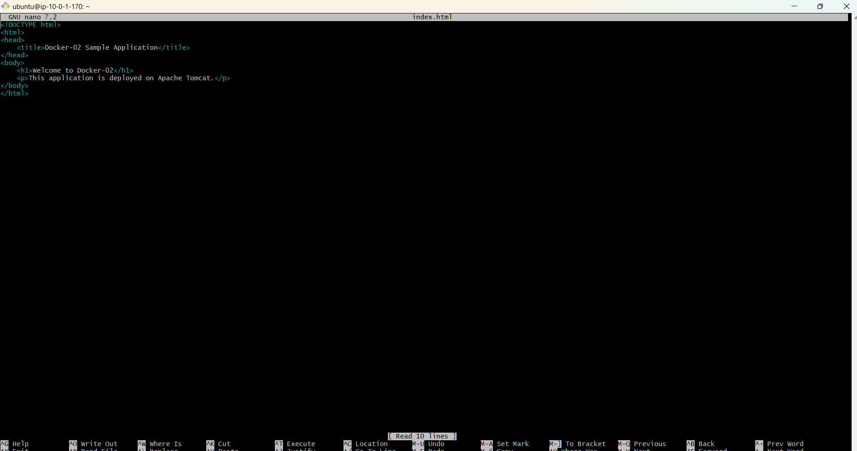
docker cp index.html tomcat-8080:/usr/local/tomcat/webapps/ROOT/index.html
The Tomcat application was tested from the EC2 server and browser. During troubleshooting an HTTP 404 was encountered, after which the application deployment was corrected.

4. Task 2 – Docker Volume and Tomcat on Port 8081
A Docker volume was created and mounted into a second Tomcat container. Host port 8081 was mapped to Tomcat's internal port 8080.
docker volume create tomcat-volume
docker run -d --name tomcat-8081 -p 8081:8080 -v tomcat-volume:/usr/local/tomcat/webapps tomcat
docker ps
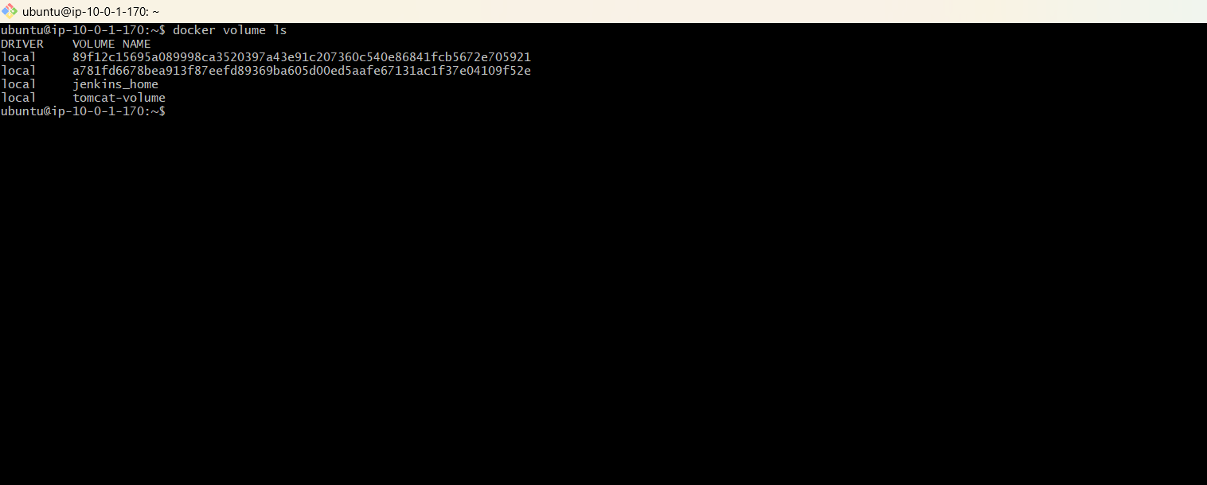
The final container list showed tomcat-8080 and tomcat-8081 running on the required host ports.

5. Task 3 – Limit Nginx Container to 500 MB
The Nginx container was configured with a Docker memory limit of 500 MB using the --memory option.
docker stop nginx-container
docker rm nginx-container
docker run -d --name nginx-container -p 81:80 --memory=500m nginx
docker stats --no-stream nginx-container
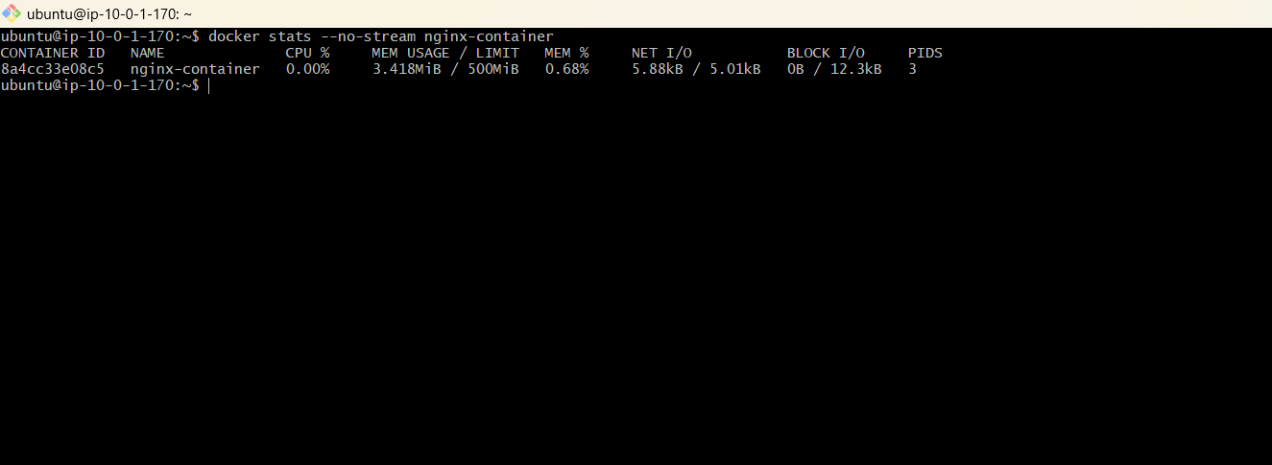

6. Task 4 – Create a Sample Dockerfile
A docker-02-image directory was created containing Dockerfile and index.html.
mkdir docker-02-image
cd docker-02-image
nano index.html
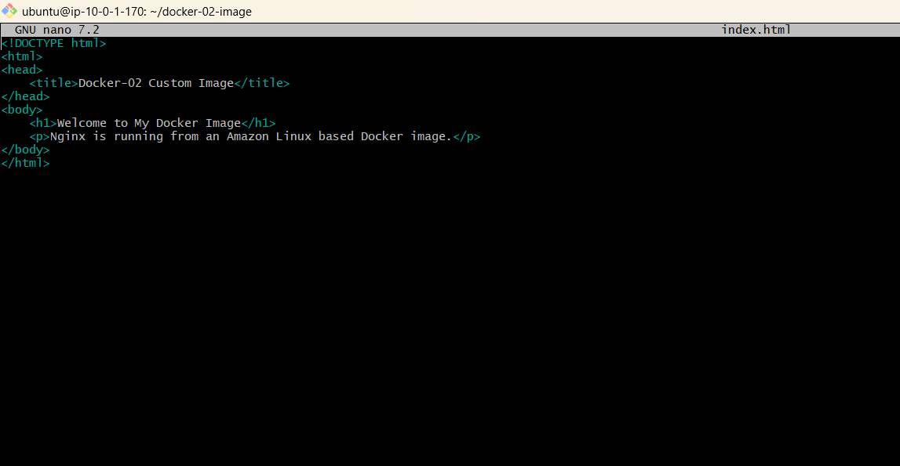
nano Dockerfile
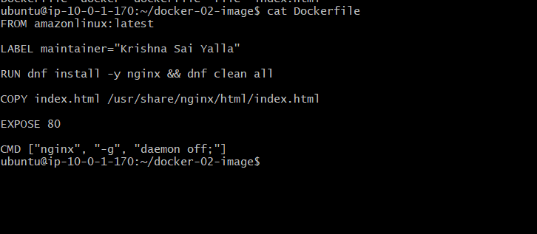
Dockerfile:
FROM amazonlinux:latest
LABEL maintainer="Krishna Sai Yalla"
RUN dnf install -y nginx && dnf clean all
COPY index.html /usr/share/nginx/html/index.html
EXPOSE 80
CMD ["nginx", "-g", "daemon off;"]
The Dockerfile satisfies the assignment: Amazon Linux base image, maintainer, Nginx installation, index.html copied to the Nginx web root, port 80 exposed, and Nginx started in the foreground.
docker build -t my-nginx-image .
docker images
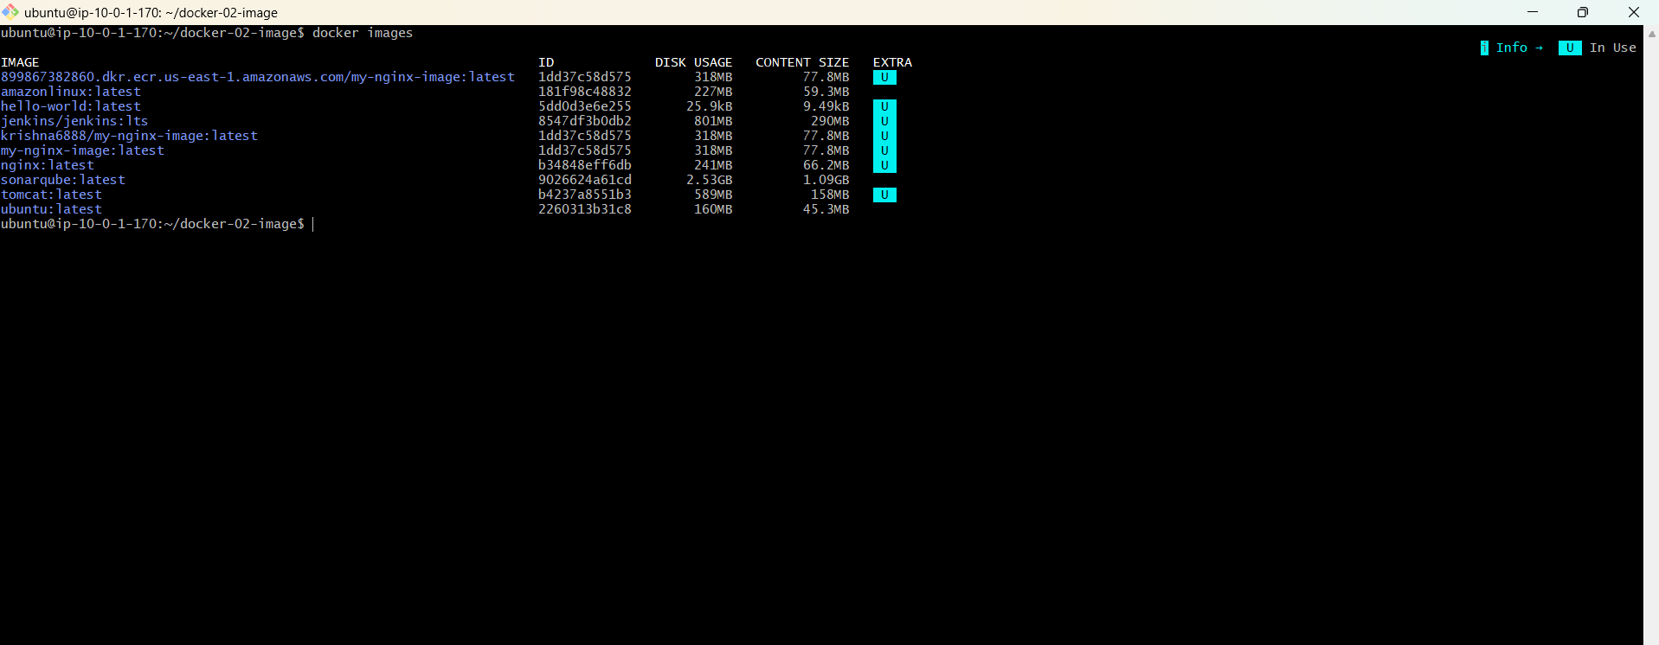
The image my-nginx-image:latest was successfully built.
Build verification:

7. Task 5 – Push Image to Docker Hub
Docker Hub was authenticated using Docker's device login flow. The repository used was krishna6888/my-nginx-image.
docker login
docker tag my-nginx-image:latest krishna6888/my-nginx-image:latest
docker push krishna6888/my-nginx-image:latest
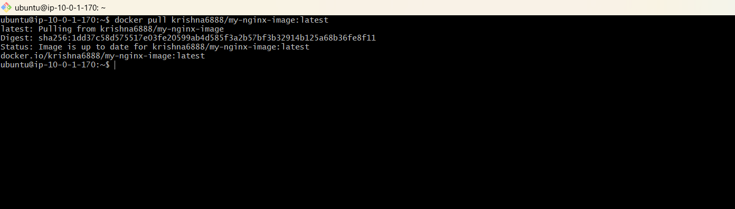
The first push attempt returned an authorization error because the repository was not yet available. The Docker Hub repository was created, authentication was completed, and the image was pushed successfully.

8. Task 6 – Push Image to AWS ECR
AWS CLI was installed on the EC2 server. The installer initially reported that unzip was missing, so unzip was installed.
sudo apt install -y unzip
The EC2 instance was assigned the IAM role Docker-ECR-Role. Identity verification succeeded:
aws sts get-caller-identity
AWS region was configured and ECR authentication succeeded:
aws configure set region us-east-1
aws ecr get-login-password --region us-east-1 | docker login --username AWS --password-stdin 899867382860.dkr.ecr.us-east-1.amazonaws.com
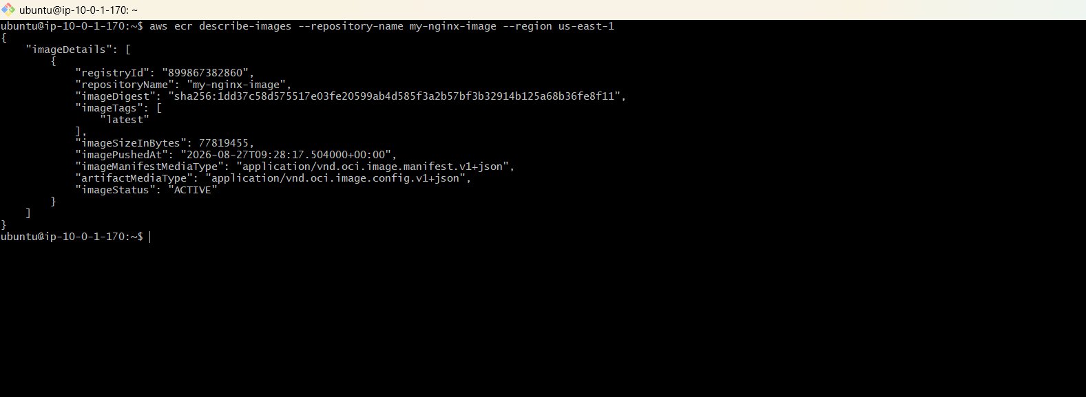
Result: Login Succeeded
The IAM role did not have permission to create ECR repositories, so the private ECR repository was created from the AWS Console.
- Repository: my-nginx-image
- Type: Private
- Region: us-east-1
- Encryption: AES-256
- Repository URI: 899867382860.dkr.ecr.us-east-1.amazonaws.com/my-nginx-image
docker tag my-nginx-image:latest 899867382860.dkr.ecr.us-east-1.amazonaws.com/my-nginx-image:latest
docker push 899867382860.dkr.ecr.us-east-1.amazonaws.com/my-nginx-image:latest
aws ecr describe-images --repository-name my-nginx-image --region us-east

