AWS Cloud Monitoring Assignment - Task 1 to Task 6
This document is designed so you can complete each task and paste screenshots immediately after each step.

Task 1: Enable CloudTrail Monitoring
- Login to AWS Console.
- Search for CloudTrail and open it.
- Click Trails → Create trail.
- Trail Name: DevOpsTrail.
- Select Multi-region trail.
- Keep Management events enabled.
- Create a new S3 bucket (example: cloudtrail-devops-12345).
- Enable CloudWatch Logs.
- Create Log Group: CloudTrailLogs.
- Create IAM Role: CloudTrail_CloudWatchLogs_Role.
- Click Create Trail.
Screenshot 1: CloudTrail Create Trail page
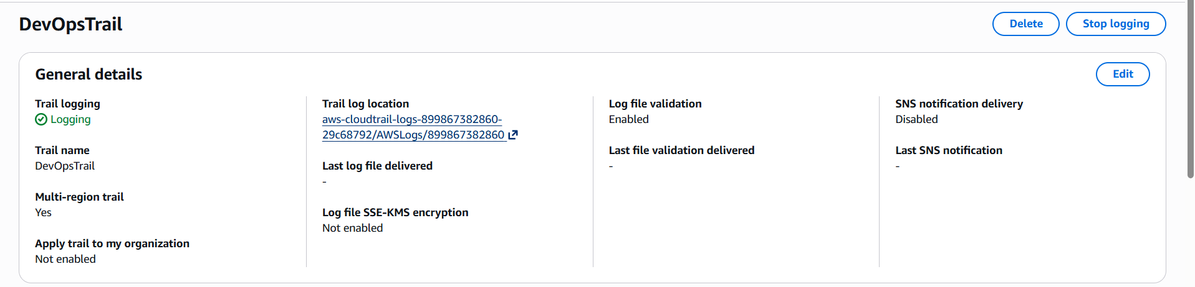
Screenshot 2: S3 Bucket created
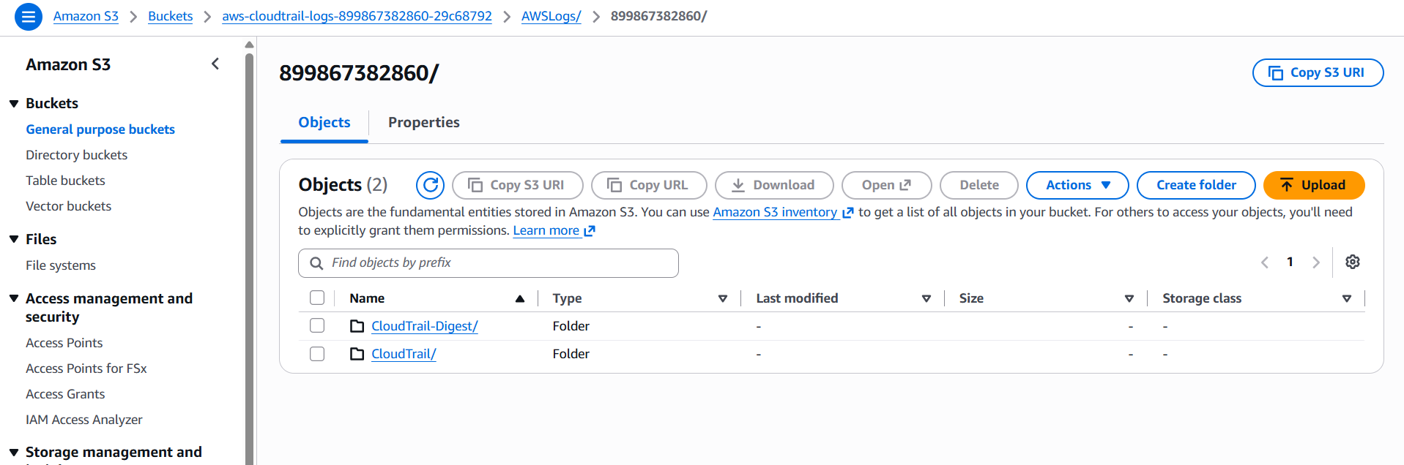
Screenshot 3: CloudWatch Log Group
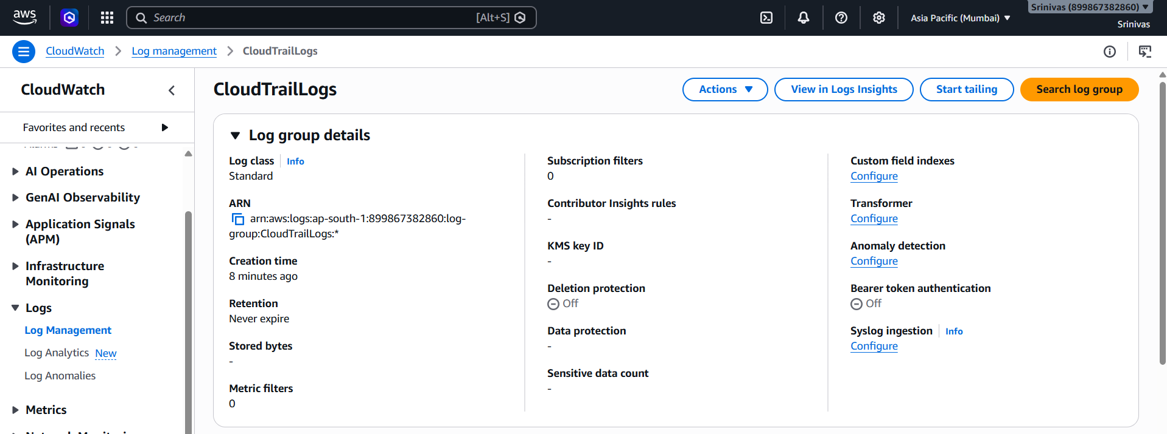
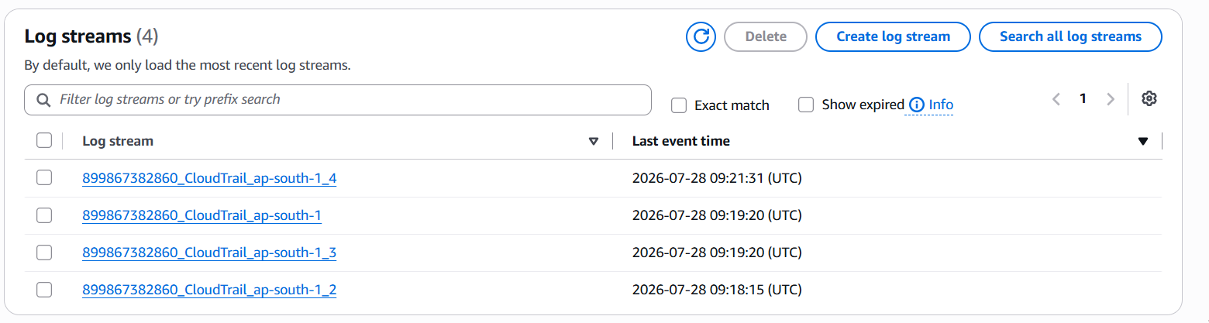

Task 2: Configure SNS Email Alerts
- Open Amazon SNS.
- Create a Standard Topic named CloudTrailAlerts.
- Create an Email subscription.
- Enter your email address.
- Confirm the subscription from your email inbox.
- 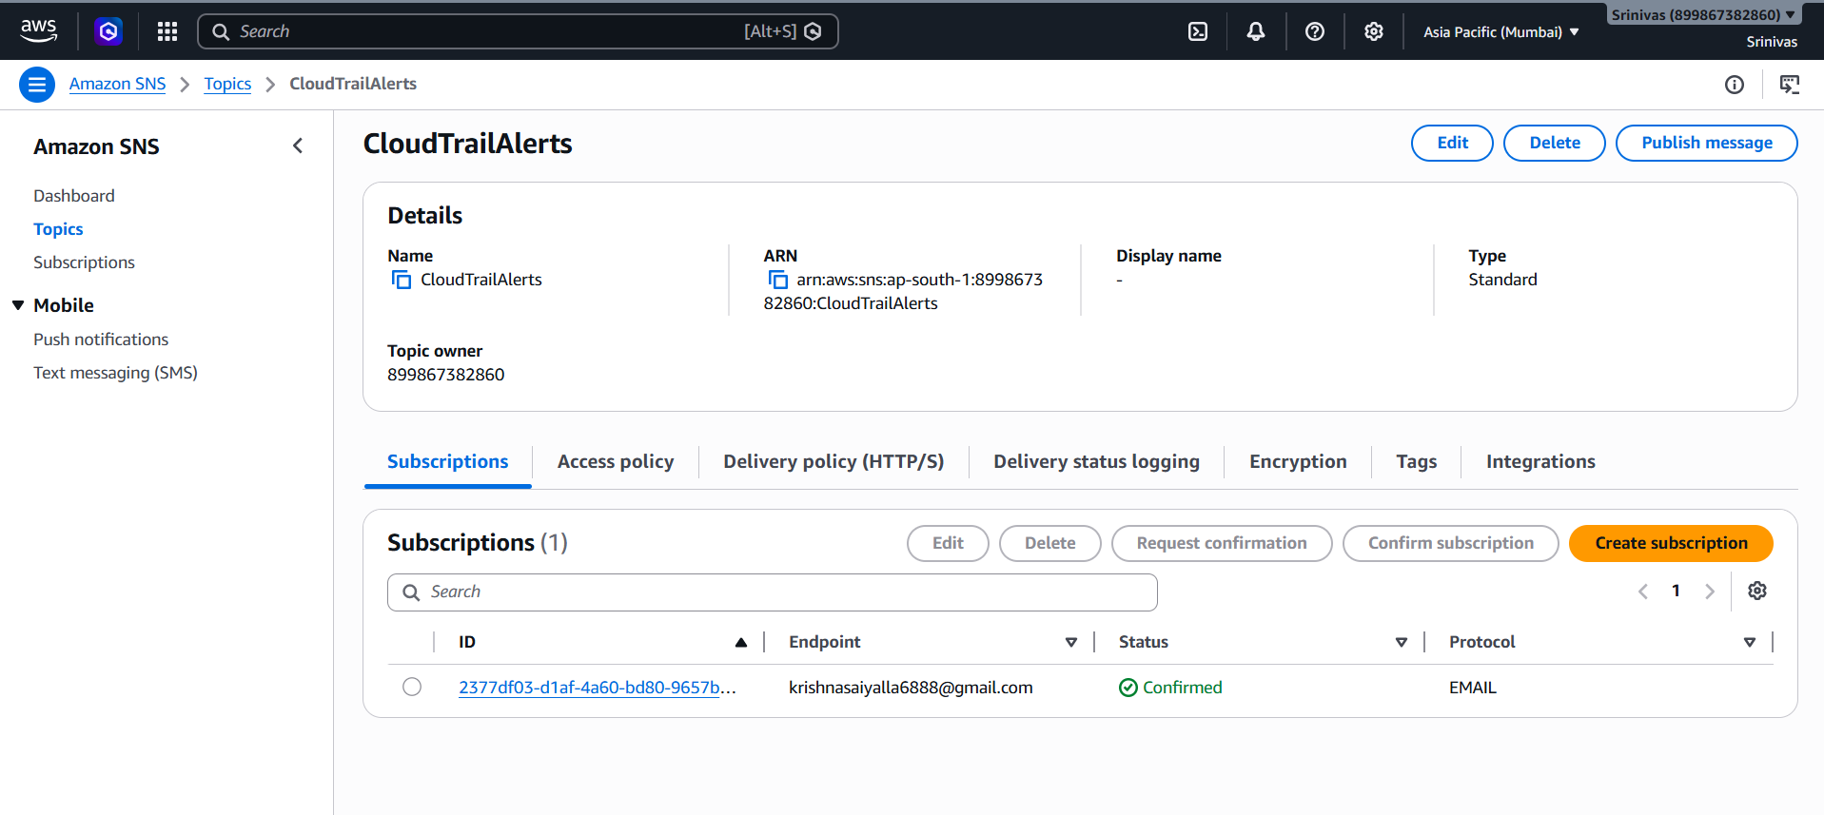
- 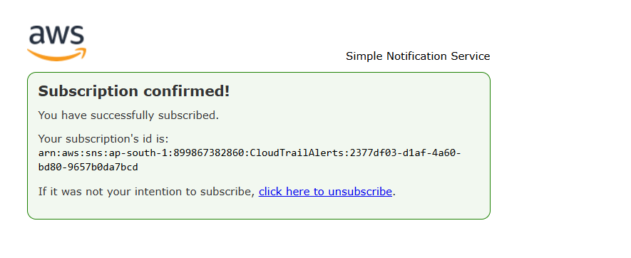

Task 3: Configure CloudWatch Monitoring
- Open EC2 Console.
- Select your EC2 instance.
- Open the Monitoring tab.
- Enable Detailed Monitoring (1-minute metrics).
- Verify CPUUtilization, NetworkIn, NetworkOut, DiskReadOps, and DiskWriteOps metrics.
- 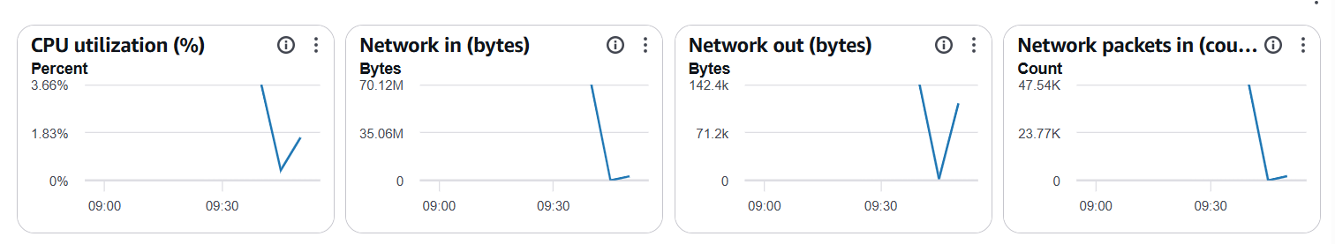
- 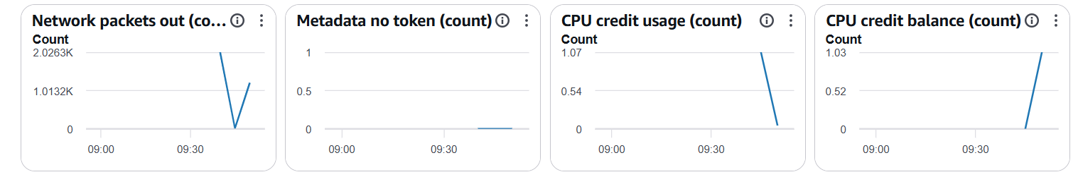
- 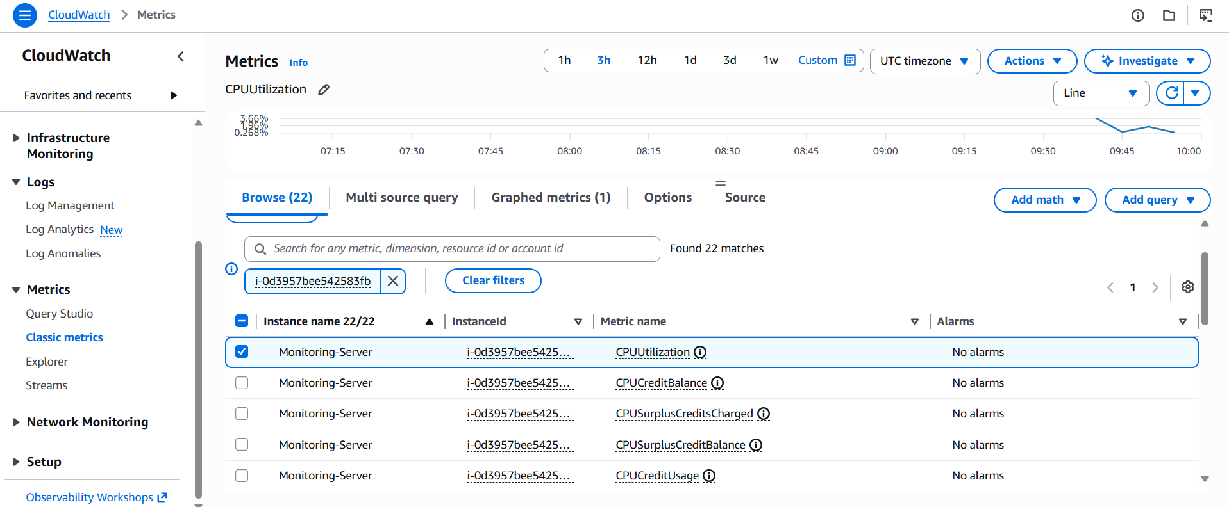

Task 4: Create CPU Alarm
- Open CloudWatch → Alarms → Create Alarm.
- Select EC2 → Per-Instance Metrics → CPUUtilization.
- Choose your EC2 instance.
- Set Threshold: Greater than 70%.
- Period: 1 Minute.
- Evaluation: 1 out of 1.
- Select SNS Topic: CloudTrailAlerts.
- Alarm Name: CPU_70_Alarm.
- Create Alarm.
- 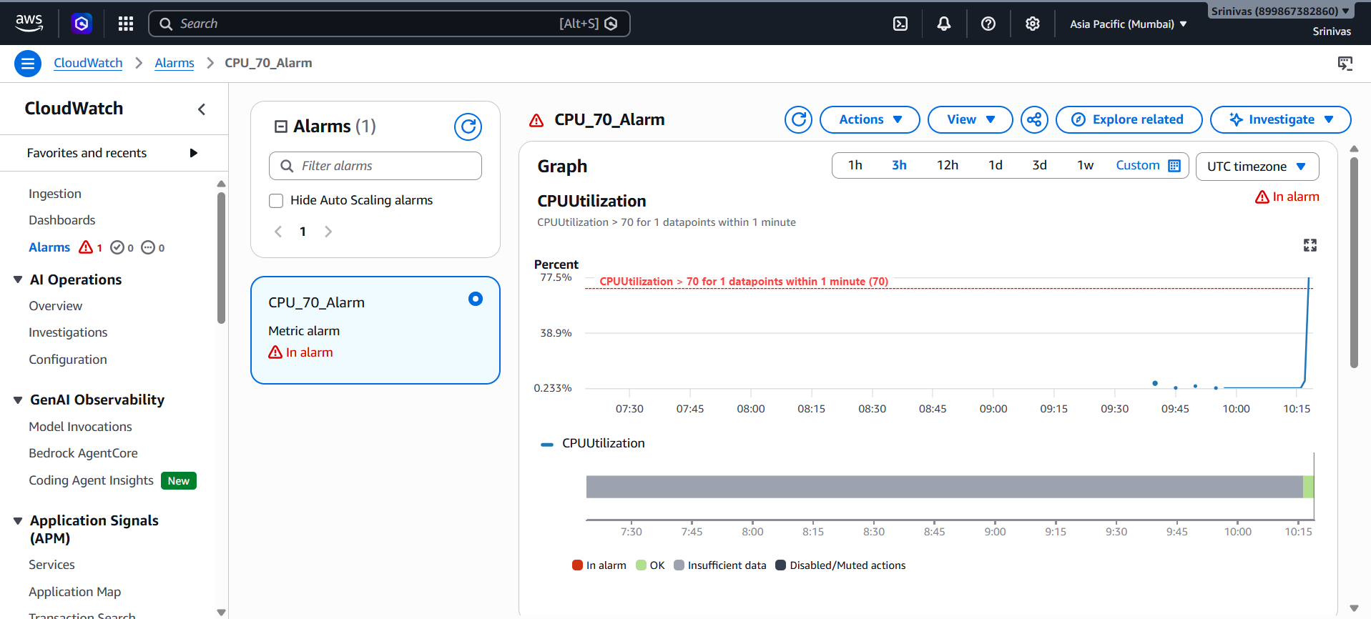
- 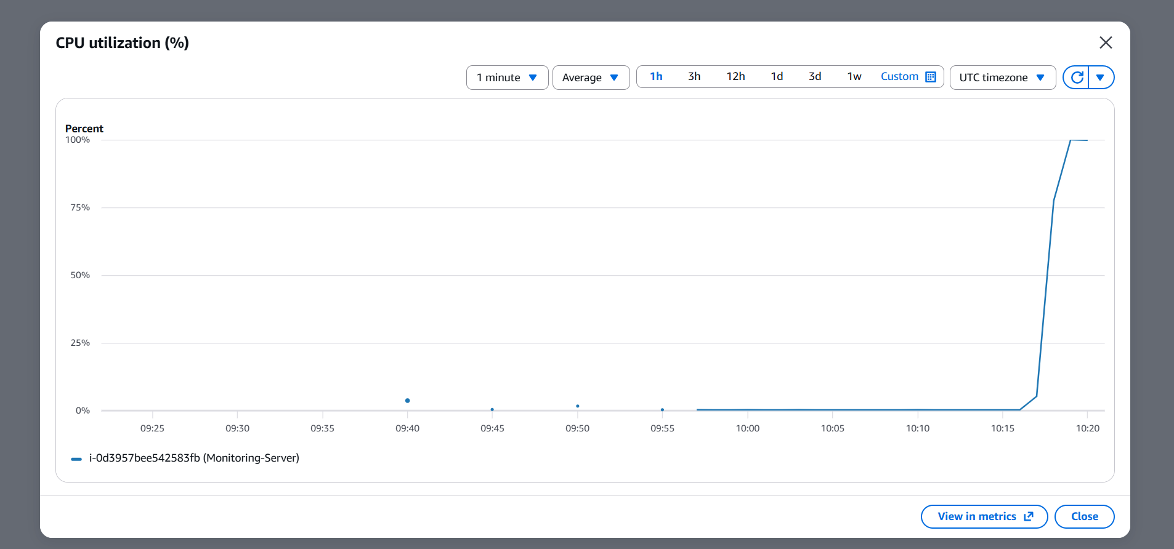
- 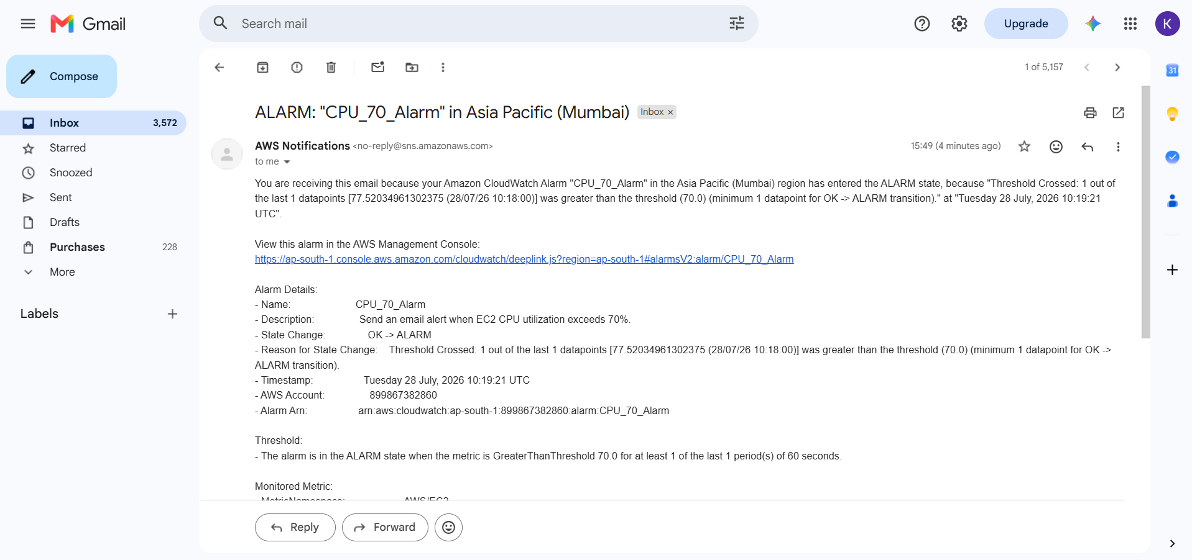

Task 5: Monitor Tomcat Service
- Install and configure CloudWatch Agent or publish a custom metric named TomcatStatus.
- Create an alarm when TomcatStatus is less than 1.
- Create a Dashboard widget showing TomcatStatus.
- Stop the Tomcat service to test the alarm.
- 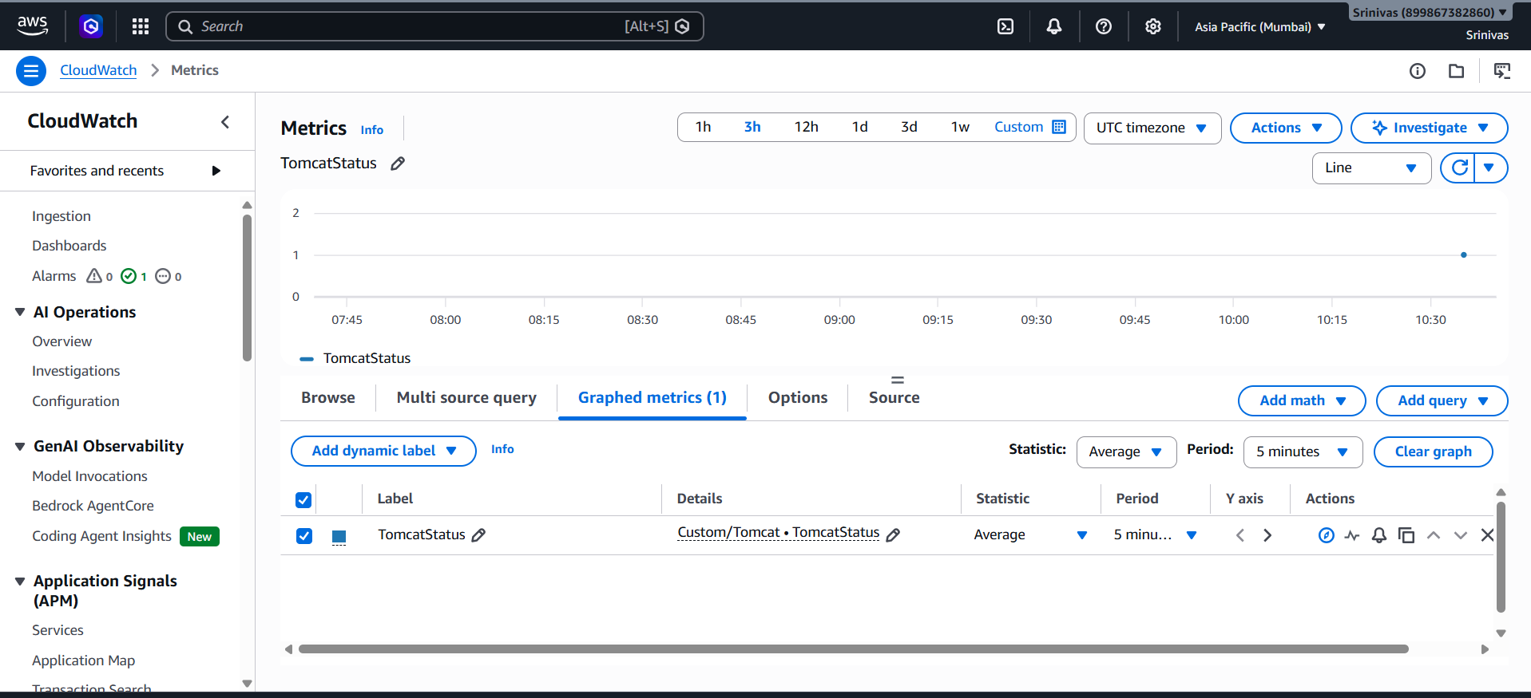
- 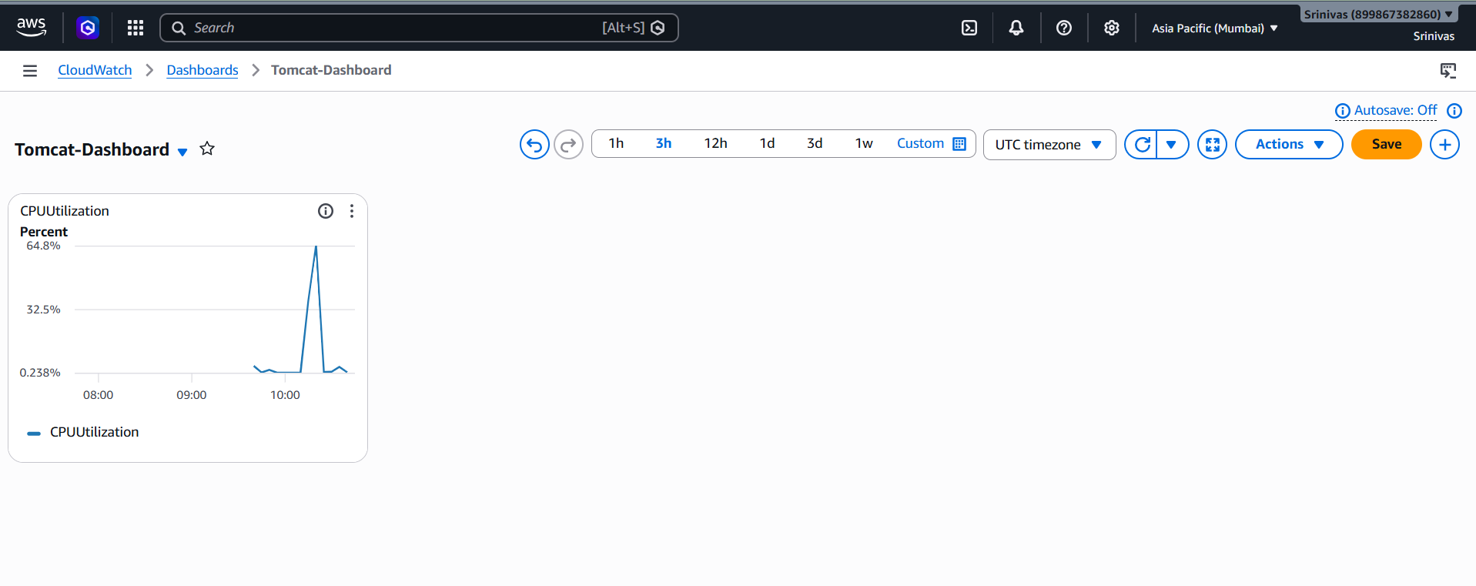
- 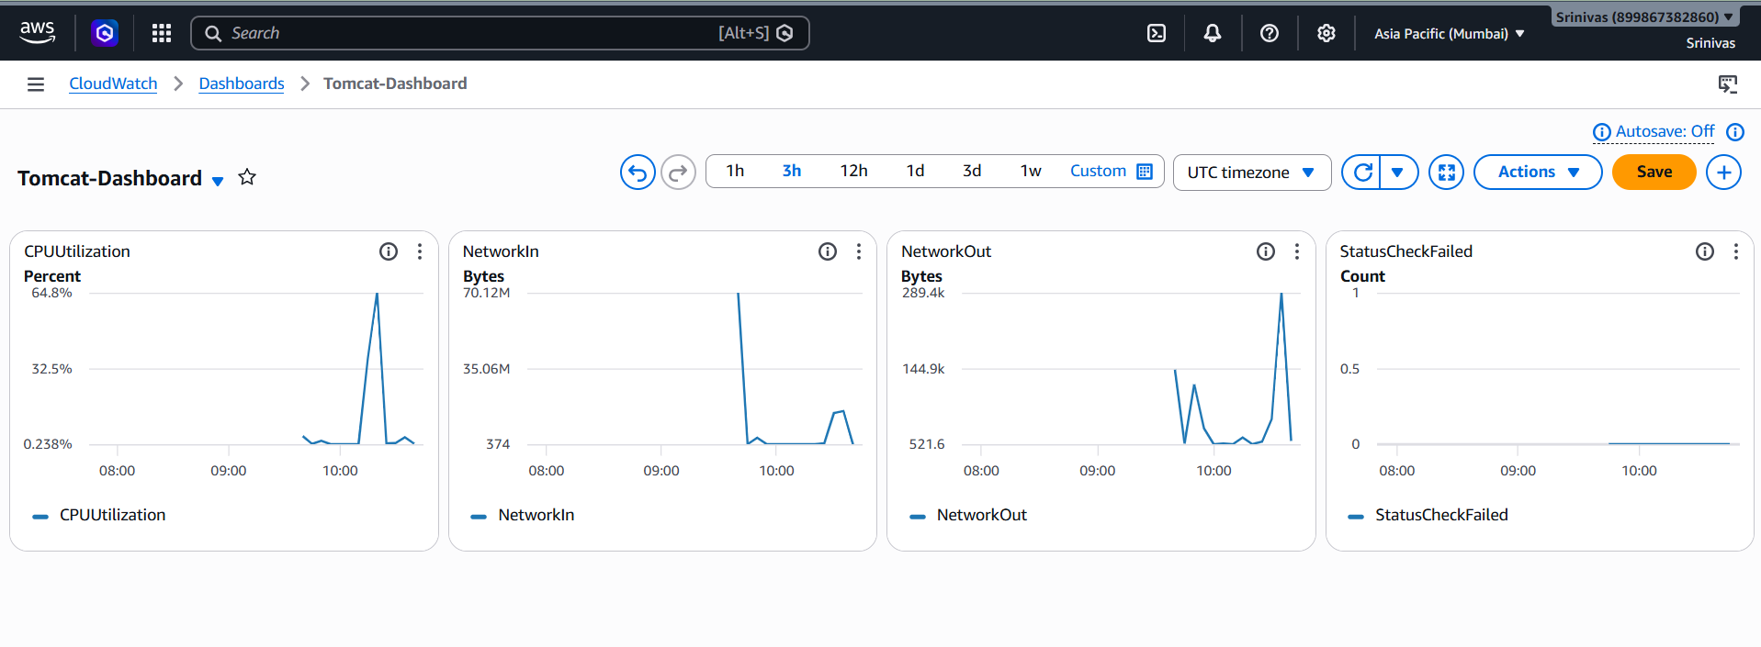
- 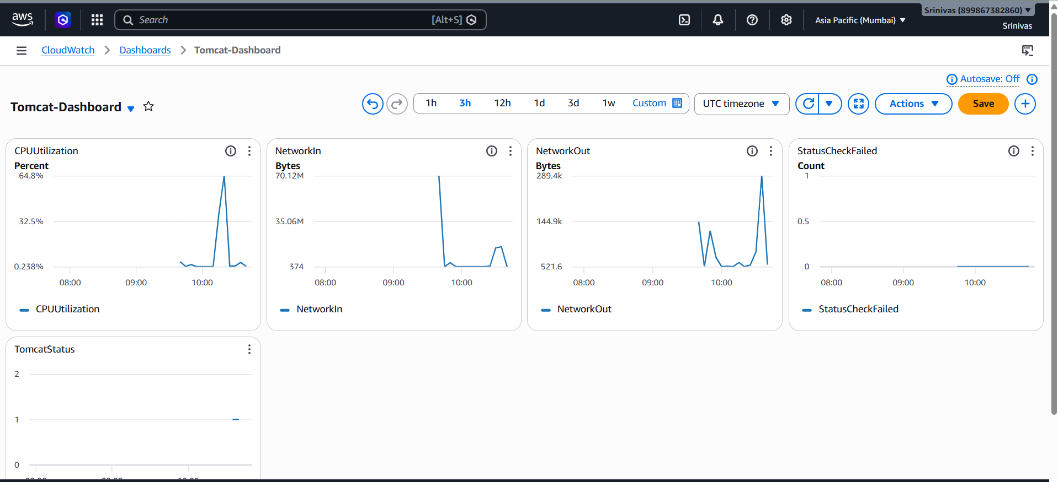

Task 6: Monitor Nginx Service
- Publish a custom metric named NginxStatus.
- Create an alarm when NginxStatus is less than 1.
- Add NginxStatus to the Dashboard.
- Stop the Nginx service to test the alert.
- 
 