AWS Load Balancer Assignment - Step-by-Step Process
Objective: Configure Classic, Application, and Network Load Balancers, enable HTTPS using ACM, map the ALB to Route 53, and store ALB access logs in Amazon S3.

Task 1: Configure Classic Load Balancer
- Launch an EC2 instance and install Apache Web Server.
- Create a Classic Load Balancer (CLB).
- Select the required VPC and Availability Zone.
- Configure a listener (HTTP:80).
- Create or select a Security Group allowing HTTP traffic.
- Register the EC2 instance with the CLB.
- Verify the website using the CLB DNS name.
- 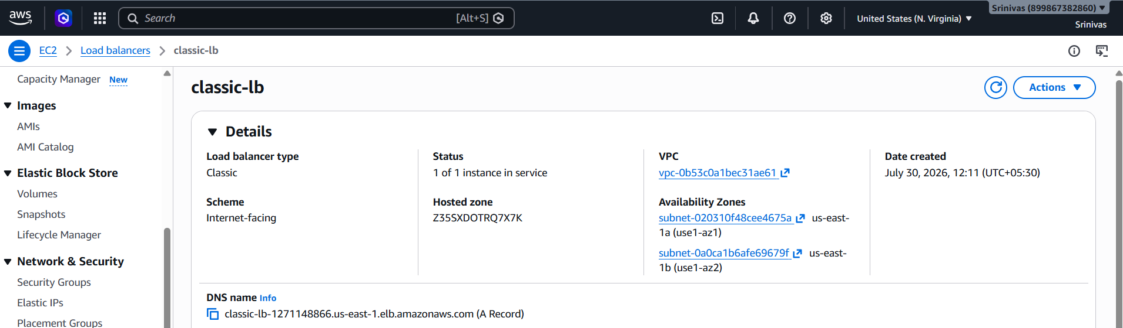
- 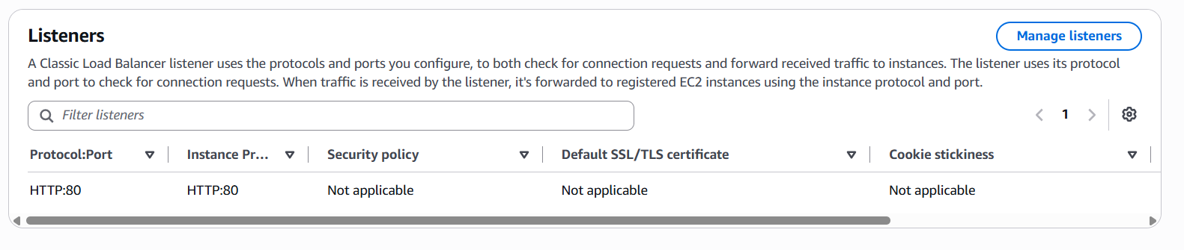
- 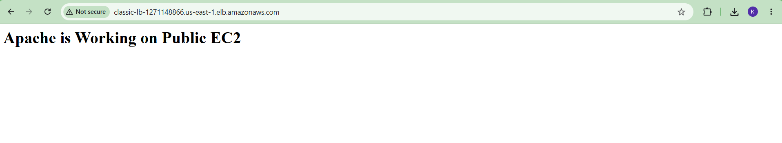

Task 2: Configure Application Load Balancer
- Create a Target Group (HTTP:80).
- Register the EC2 instance in the Target Group.
- Create an Application Load Balancer (ALB).
- Select Internet-facing, IPv4, and two public subnets.
- Assign a Security Group allowing HTTP/HTTPS.
- Create an HTTP (80) listener forwarding traffic to the Target Group.
- Verify the Target Group is healthy.
- Open the ALB DNS name and verify the Apache page.
- 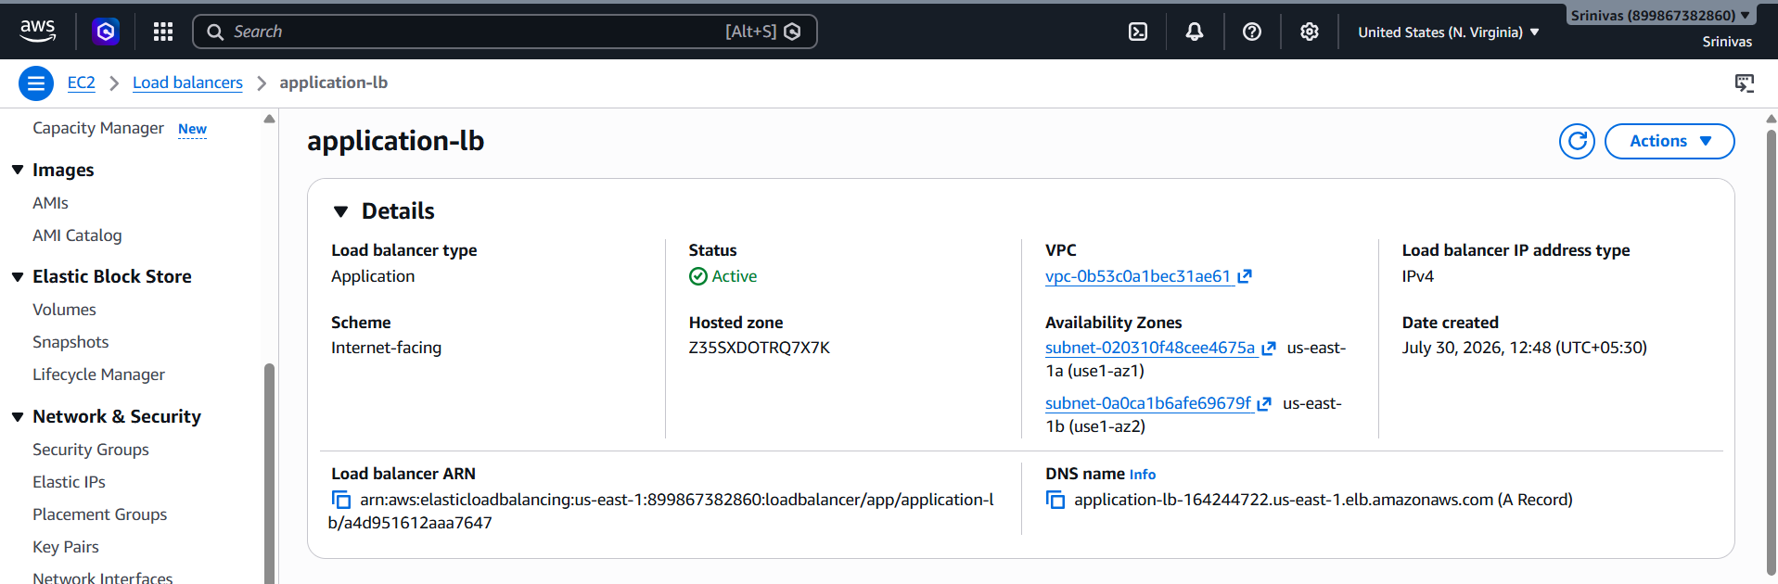
- 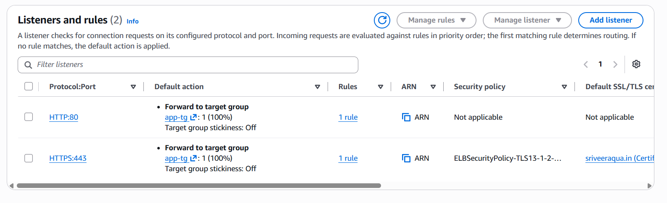
- 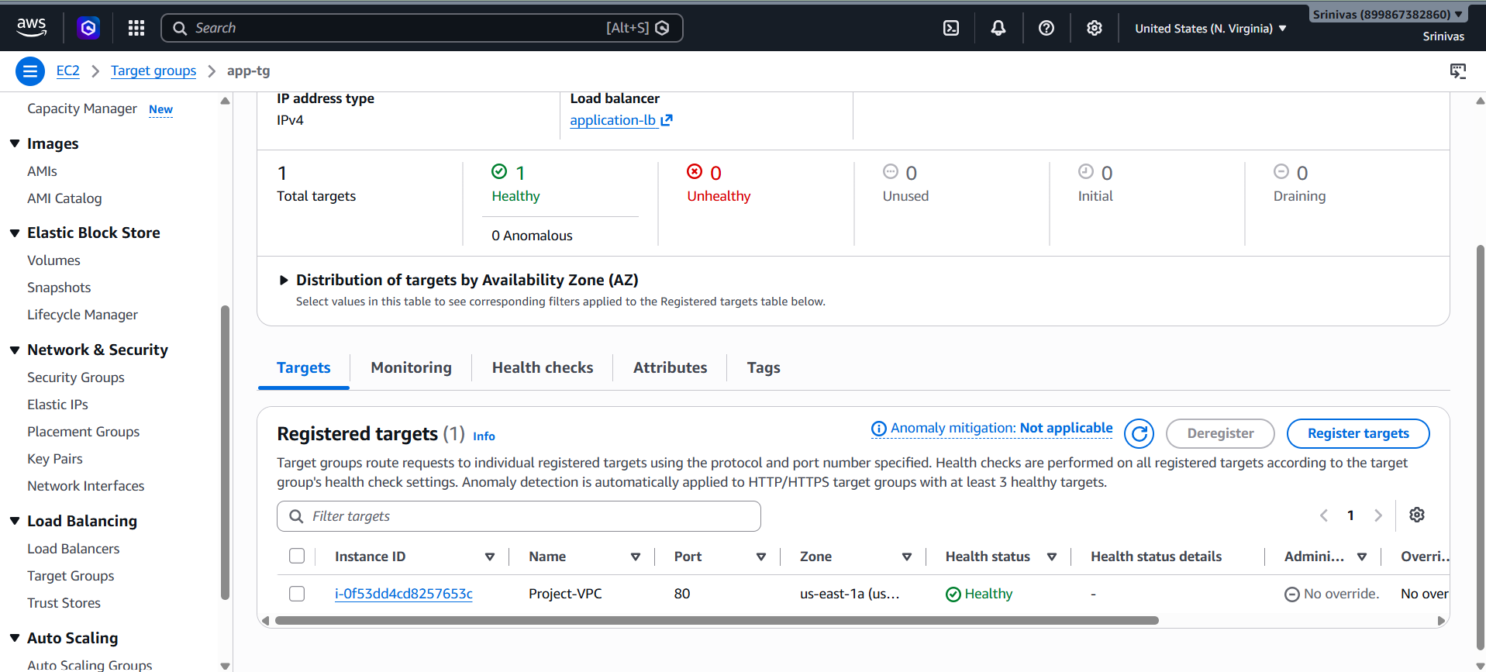
- 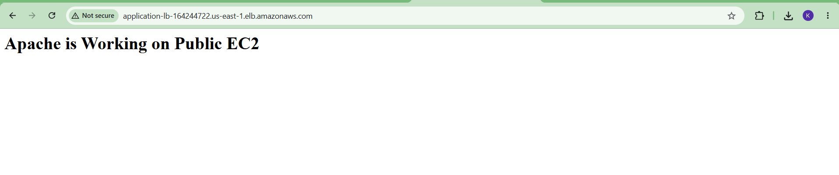

Task 3: Configure Network Load Balancer
- Create a Network Load Balancer (NLB).
- Select Internet-facing.
- Choose the required Availability Zones.
- Create a TCP listener.
- Associate a Target Group.
- Verify the NLB DNS name.
- 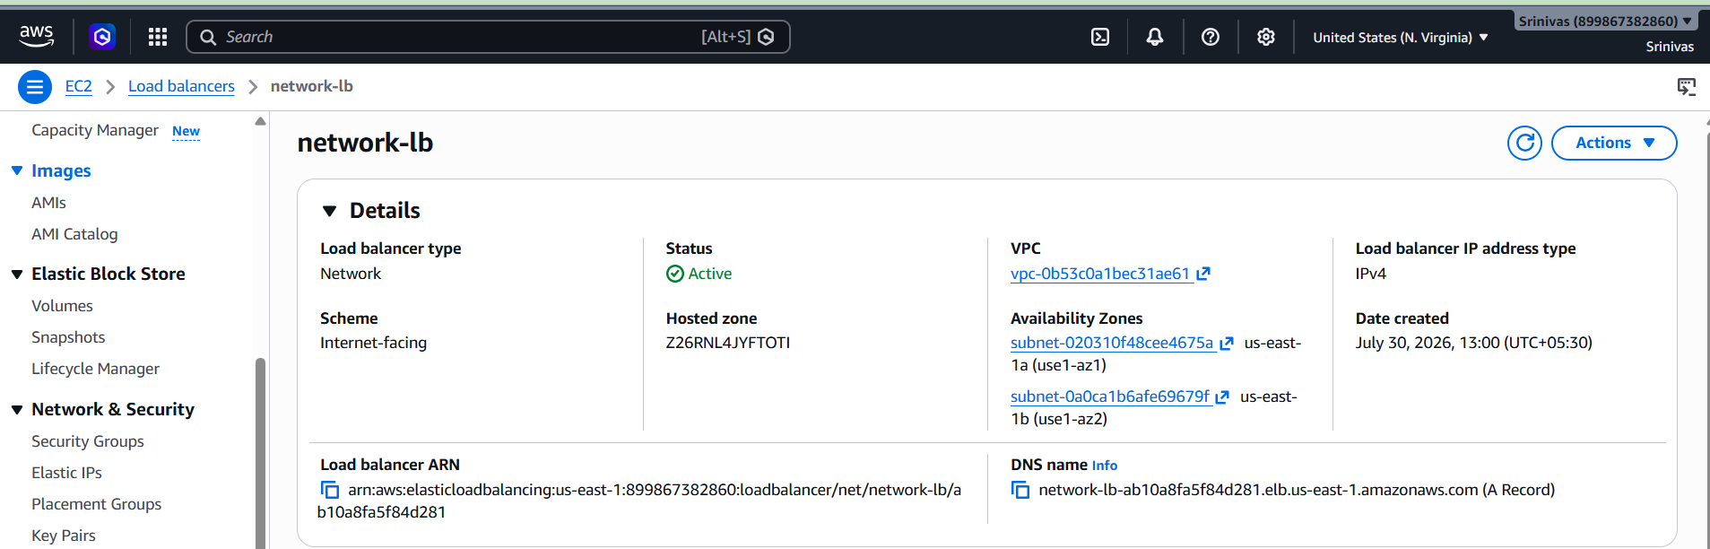
- 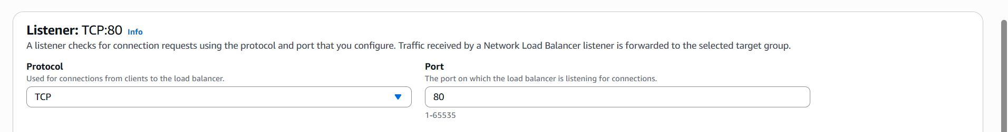
- 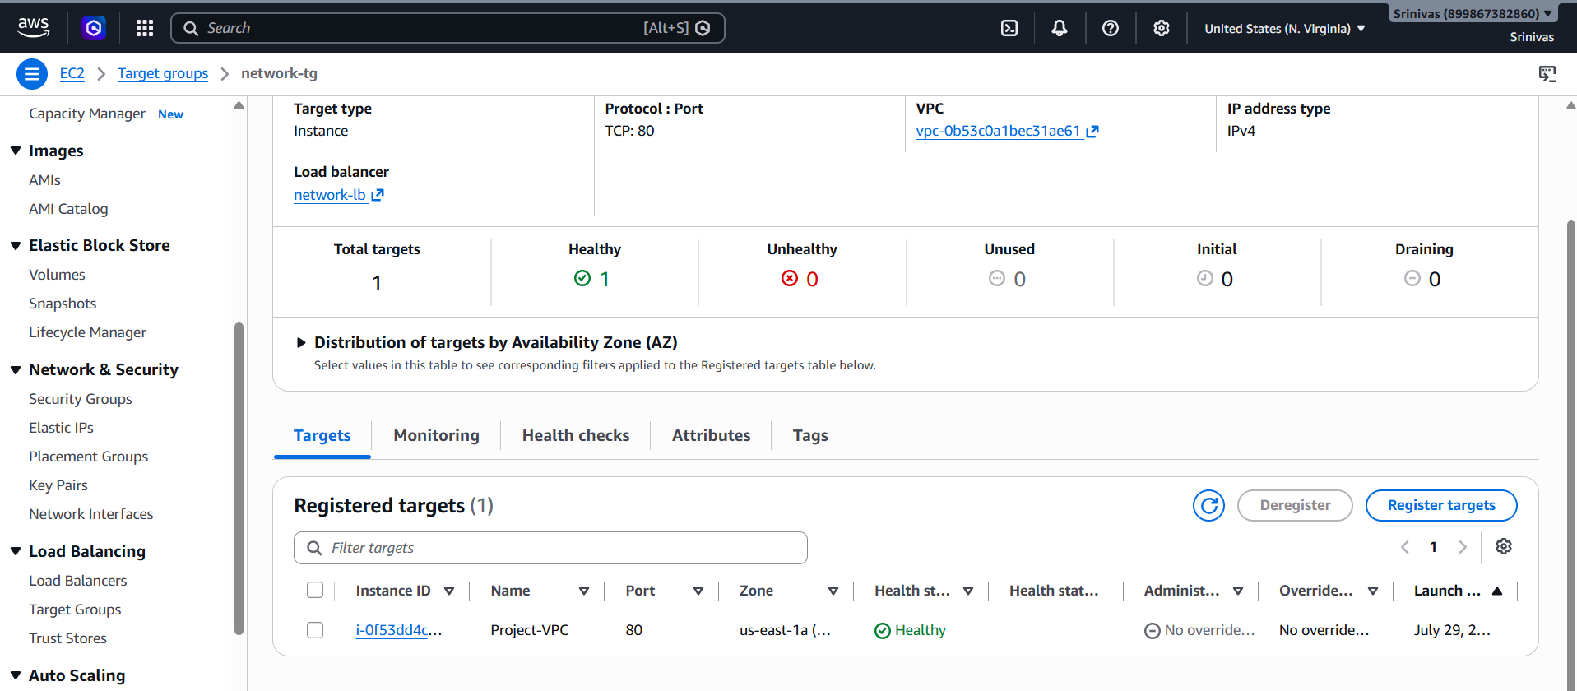

Task 4: Attach SSL to the Application Load Balancer
- Request or import an SSL certificate in AWS Certificate Manager (ACM).
- Validate the certificate using DNS validation.
- Create an HTTPS (443) listener on the ALB.
- Attach the ACM certificate to the HTTPS listener.
- Forward HTTPS traffic to the existing Target Group.
- Verify HTTPS works using https://your-domain.
- 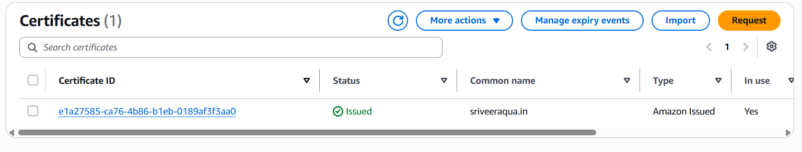
- 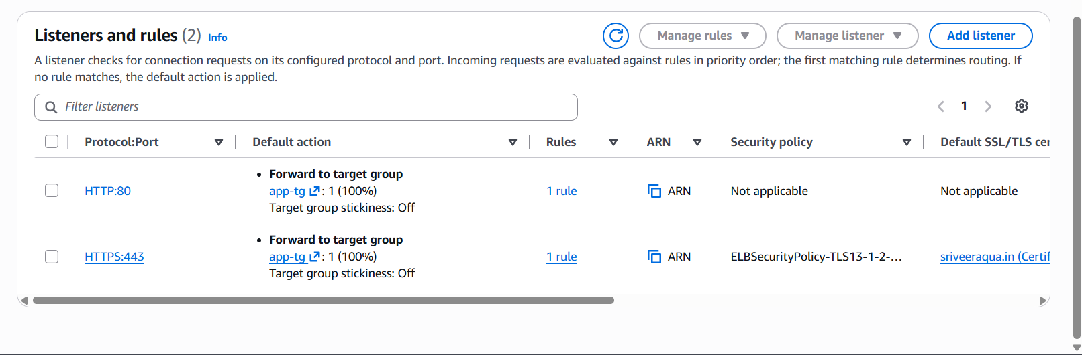
- 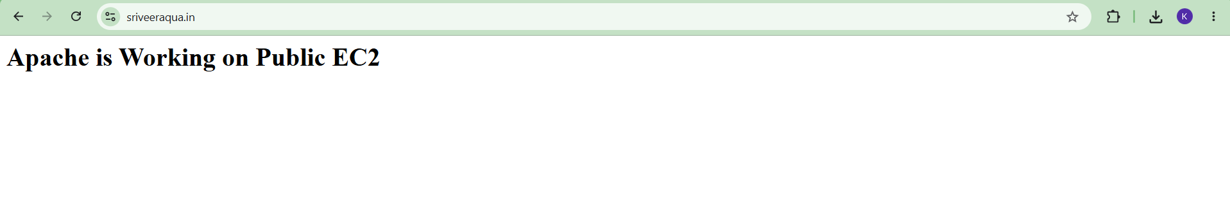

Task 5: Map Application Load Balancer to Route 53
- Create or open the hosted zone in Route 53.
- Create an Alias A Record.
- Select the Application Load Balancer as the target.
- Wait for DNS propagation.
- Verify the custom domain opens the website through the ALB.
- 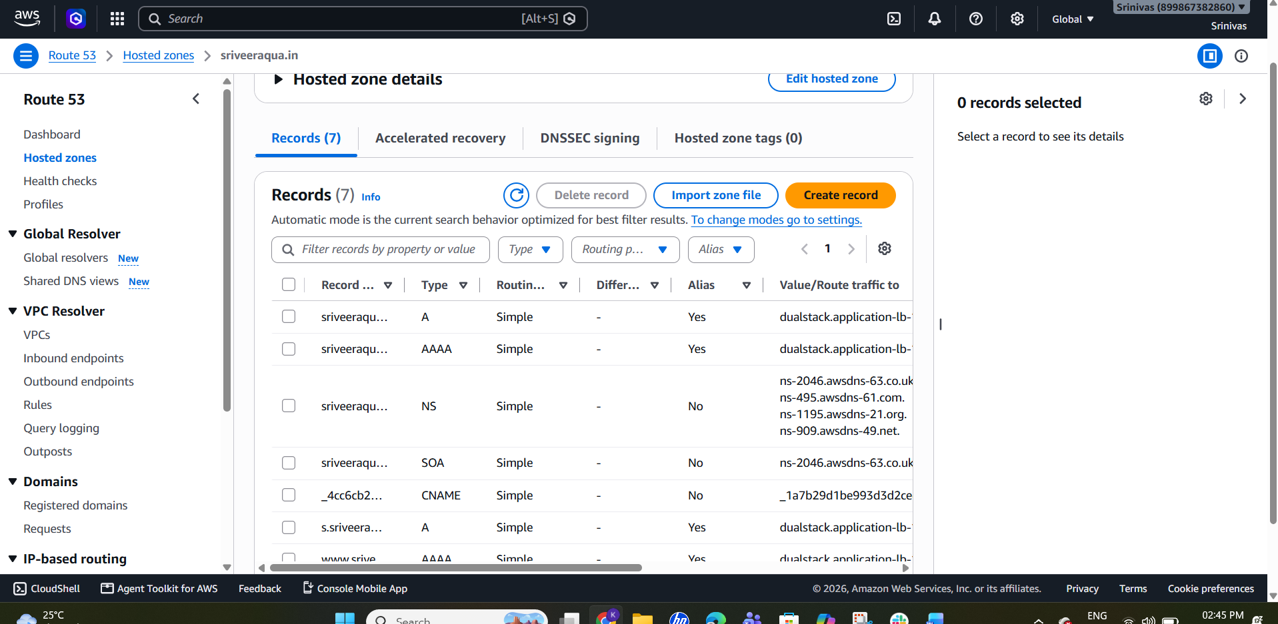
- 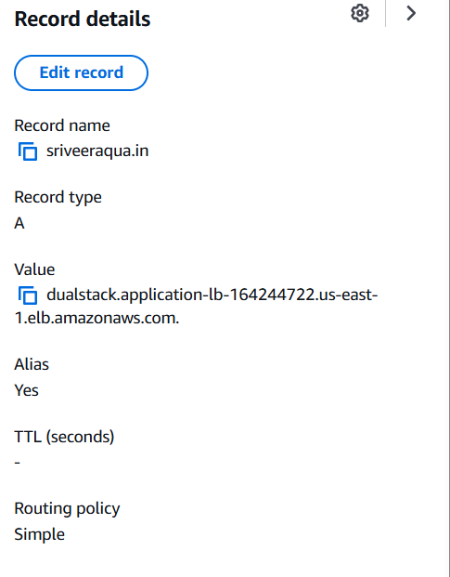
- 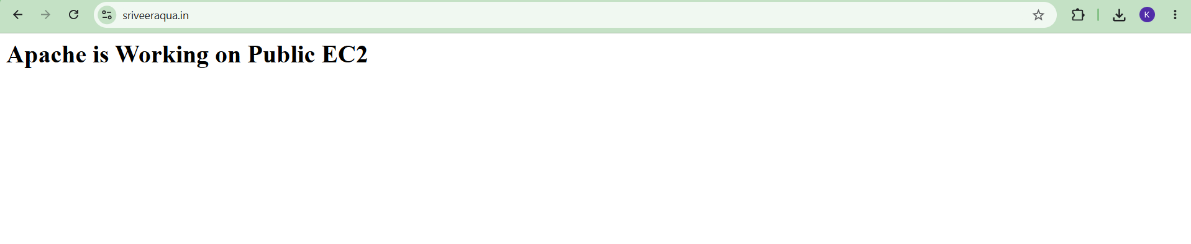

Task 6: Push Application Load Balancer Logs to S3
- Create an S3 bucket for ALB access logs.
- Open EC2 > Load Balancers > Application Load Balancer.
- Open the Attributes tab.
- Enable Access Logs.
- Select the S3 bucket.
- If Access Denied appears, add the required bucket policy allowing ALB log delivery.
- Save the changes.
- Generate traffic by refreshing the website several times.
- After a few minutes, verify logs are present in the S3 bucket under AWSLogs.
- 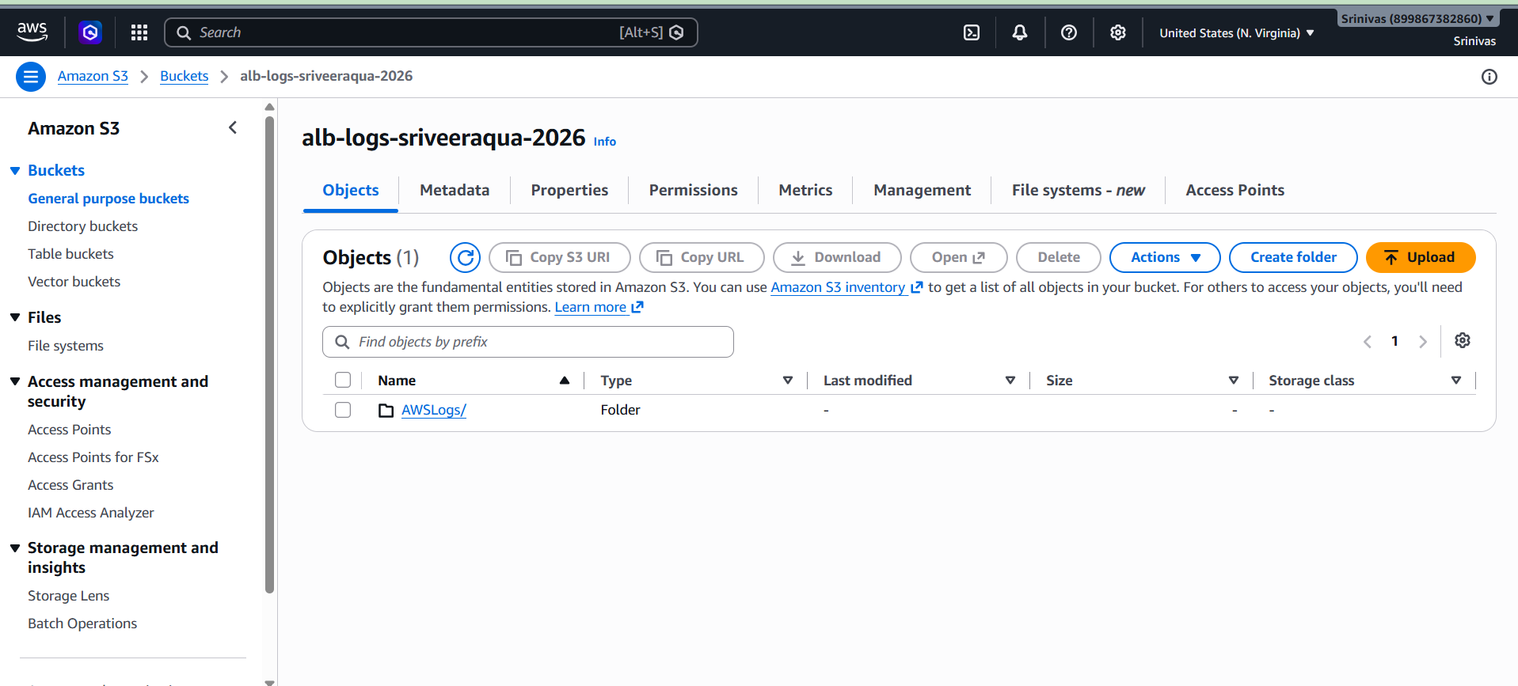
- 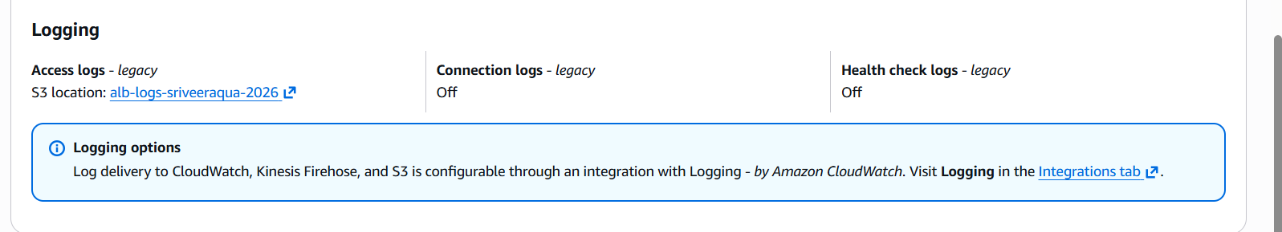
- 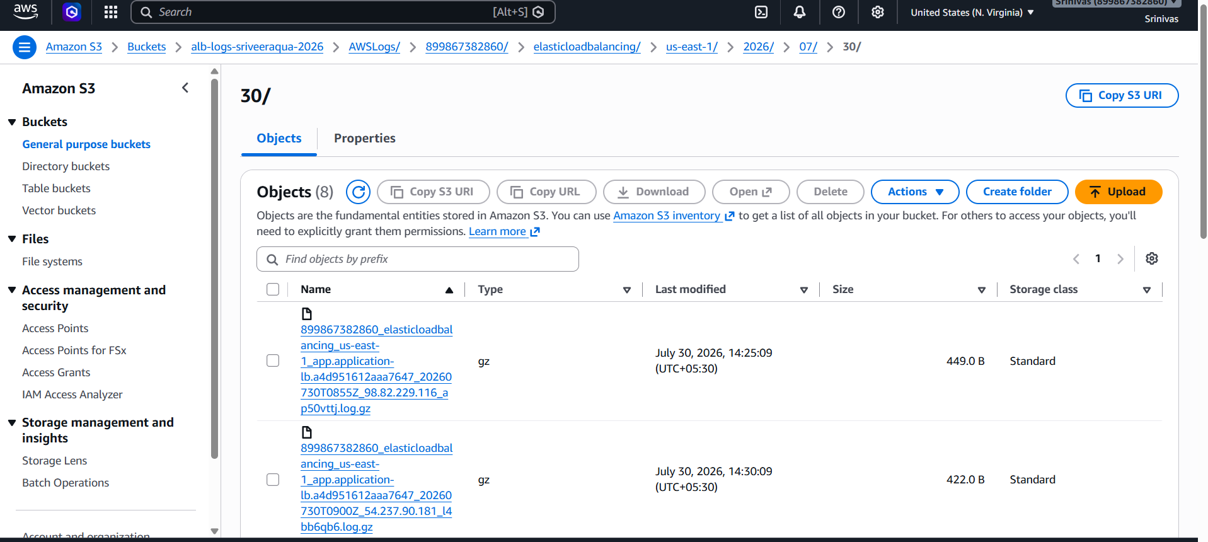
- 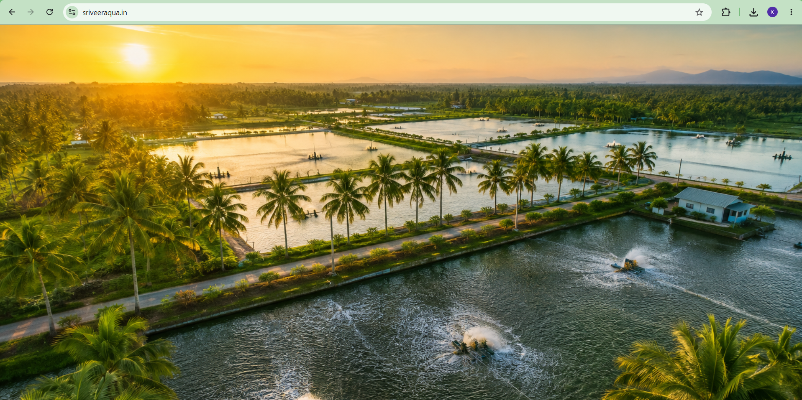

Outcome
- Classic Load Balancer configured successfully.
- Application Load Balancer configured successfully.
- Network Load Balancer configured successfully.
- SSL certificate attached to the ALB.
- Custom domain mapped using Route 53.
- ALB access logs stored in Amazon S3.

