Amazon SQS

Overview
Amazon Simple Queue Service (SQS) is a fully managed messaging service that lets applications and microservices exchange messages asynchronously. It separates application components, helping systems remain scalable, reliable, and resilient.

Hands-on procedure
- Open the AWS Management Console.
- Navigate to Amazon SQS.
- Create a Standard queue with the name my-standard-queue.
- Send a few test messages to the queue.
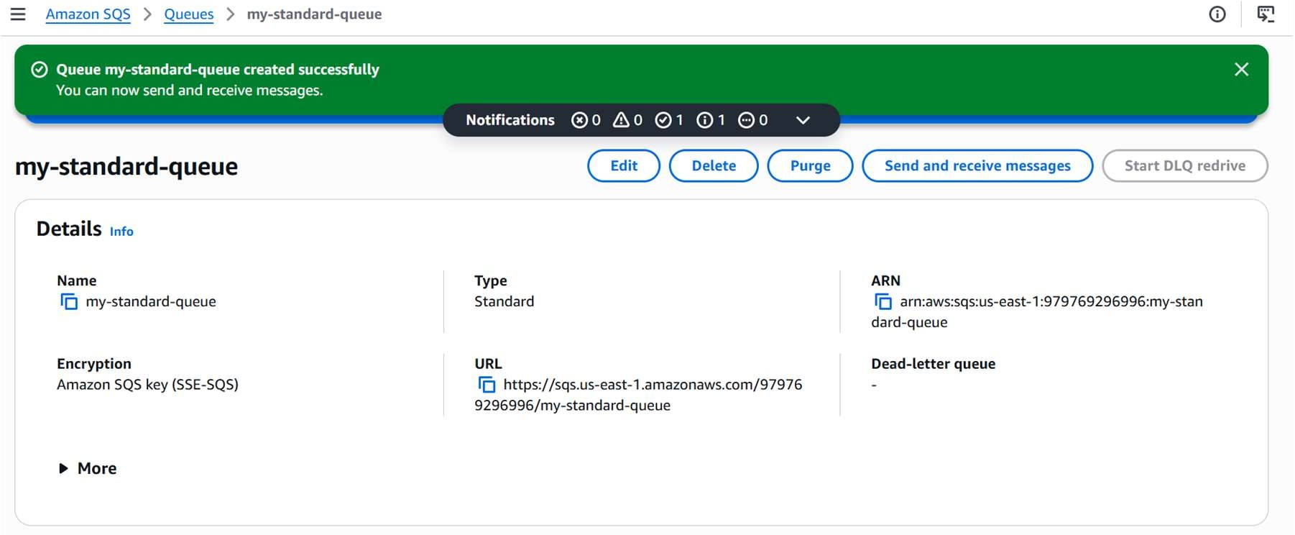
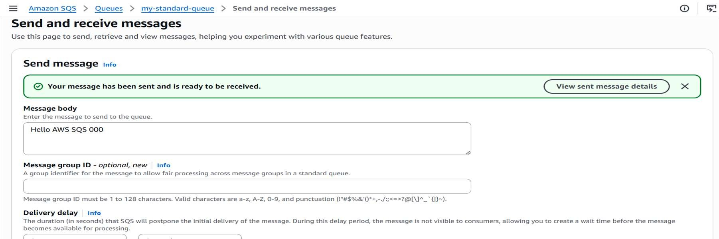

- Poll the queue and receive the available messages.
- Delete the messages after processing them.
- Create a Dead Letter Queue and set MaxReceiveCount to 10.
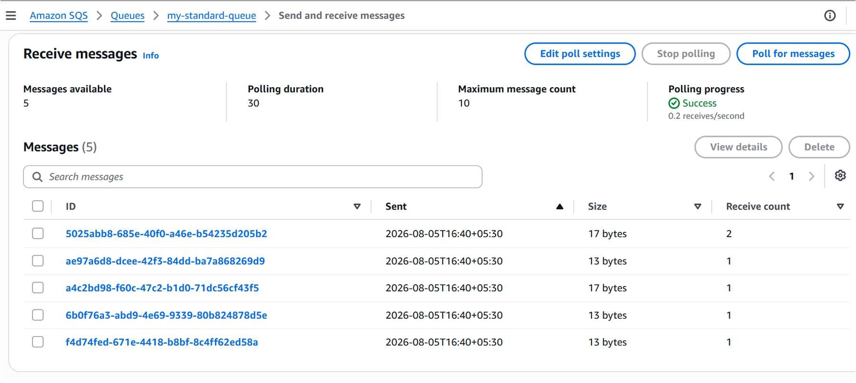
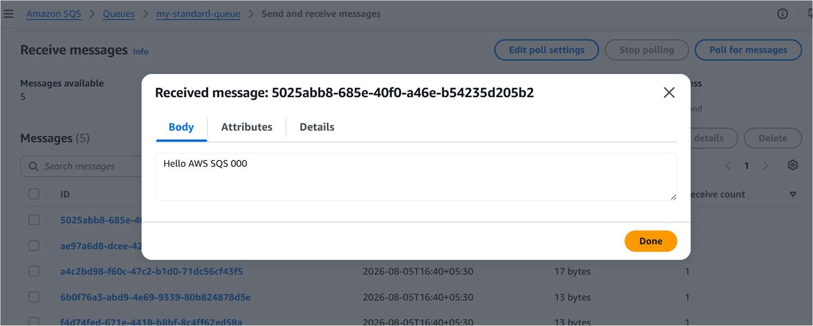

- Turn on Server-Side Encryption using SSE-SQS.
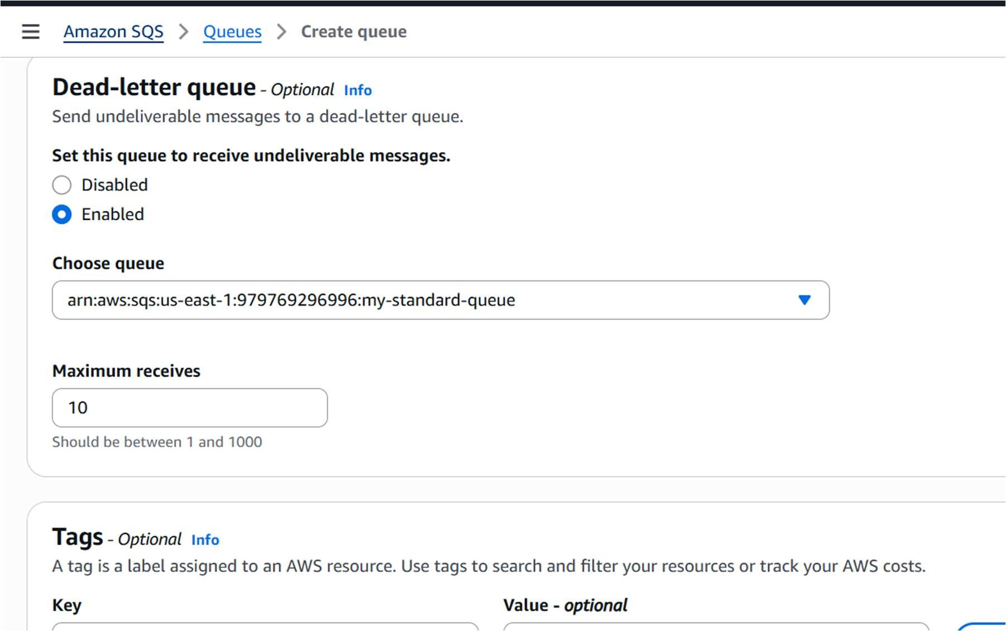
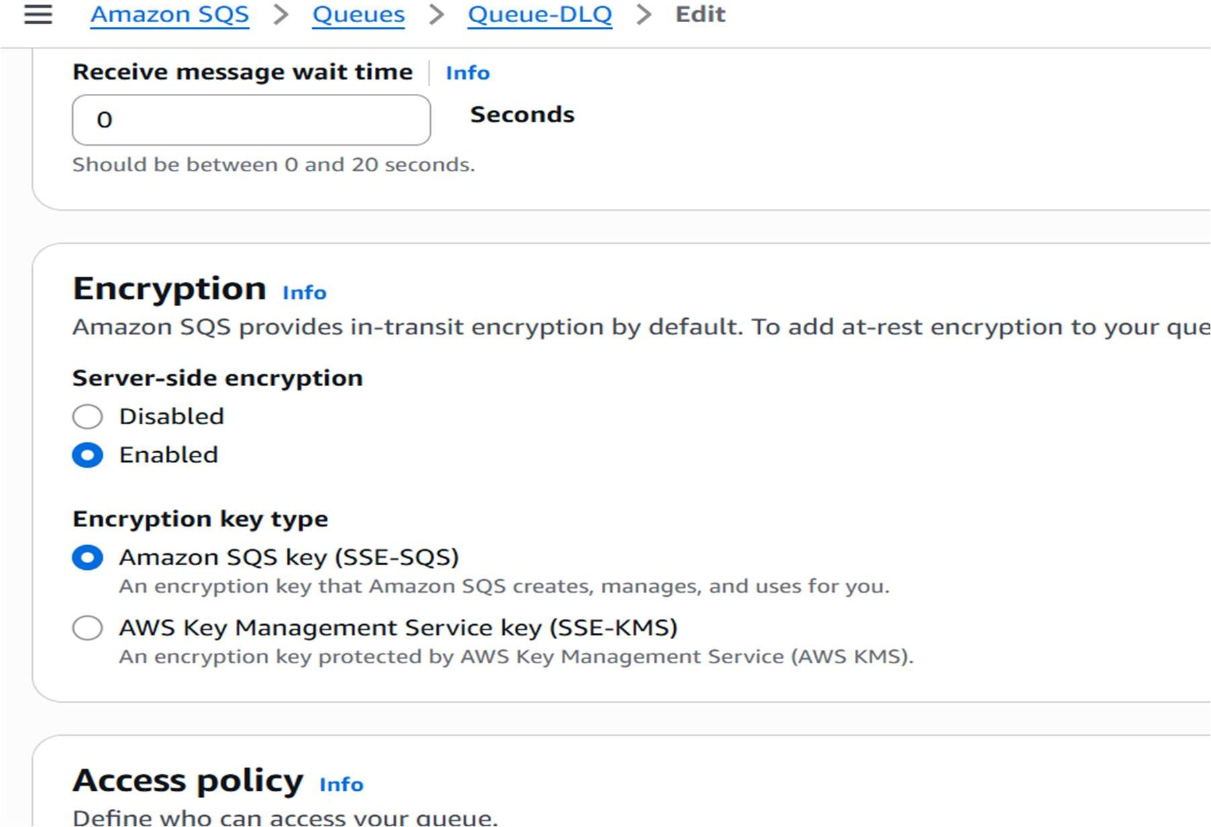

- Open CloudWatch, review the SQS queue metrics, and create a dashboard for monitoring.
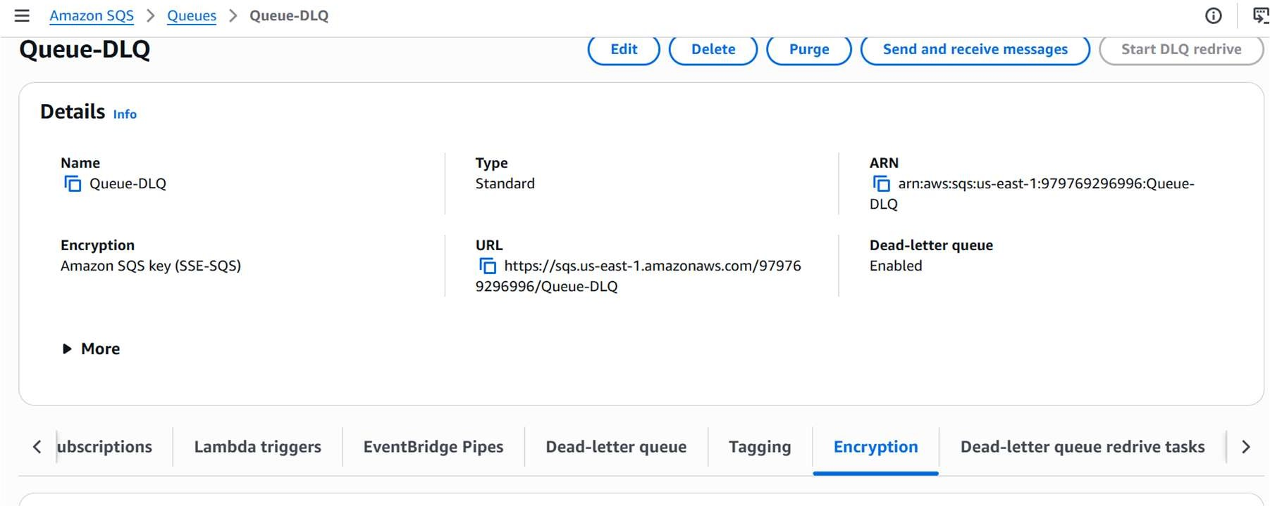
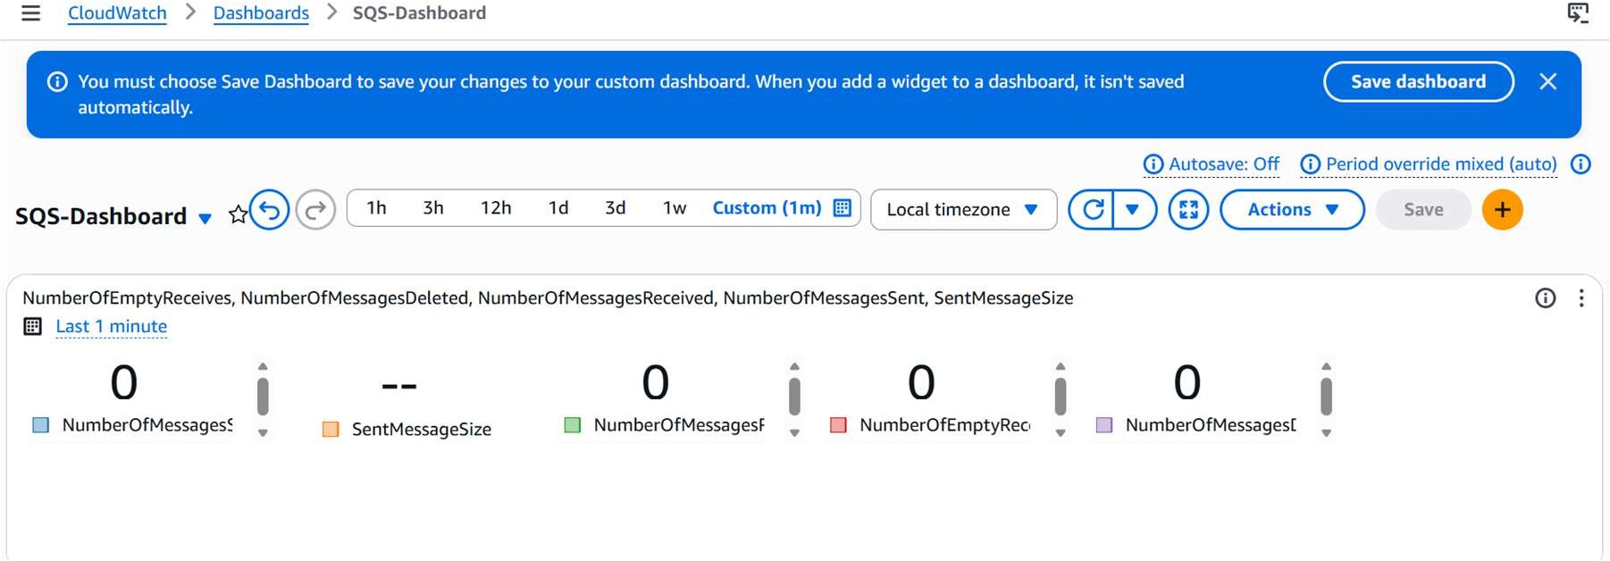
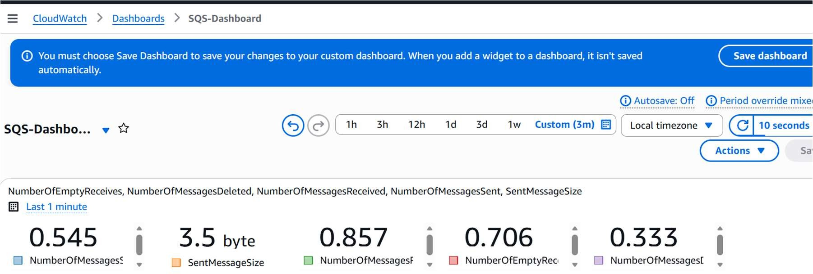

Amazon MQ

Overview
Amazon MQ is a managed message-broker service that supports technologies such as Apache ActiveMQ and RabbitMQ. It reduces the operational effort required to run brokers while helping existing applications migrate with minimal code changes.

Hands-on procedure
- Open Amazon MQ.
- Create an ActiveMQ broker using the single-instance deployment option.
- Enter the broker name and configure the required username and password.
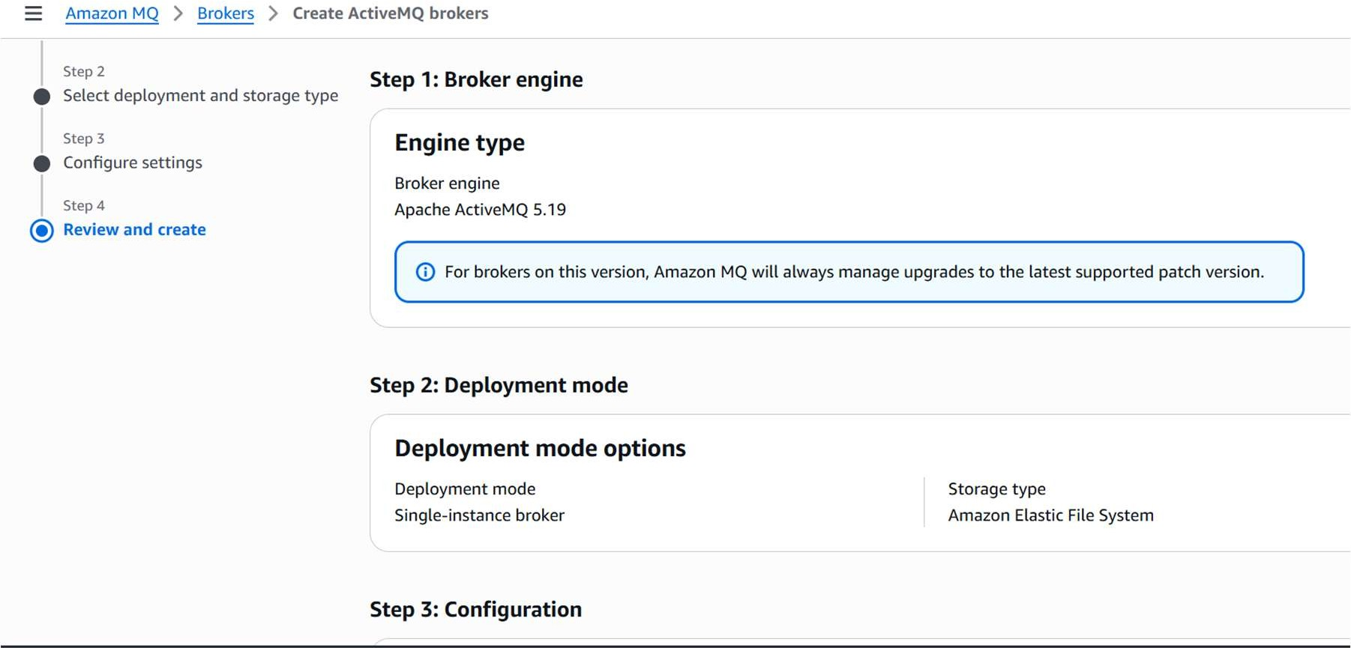
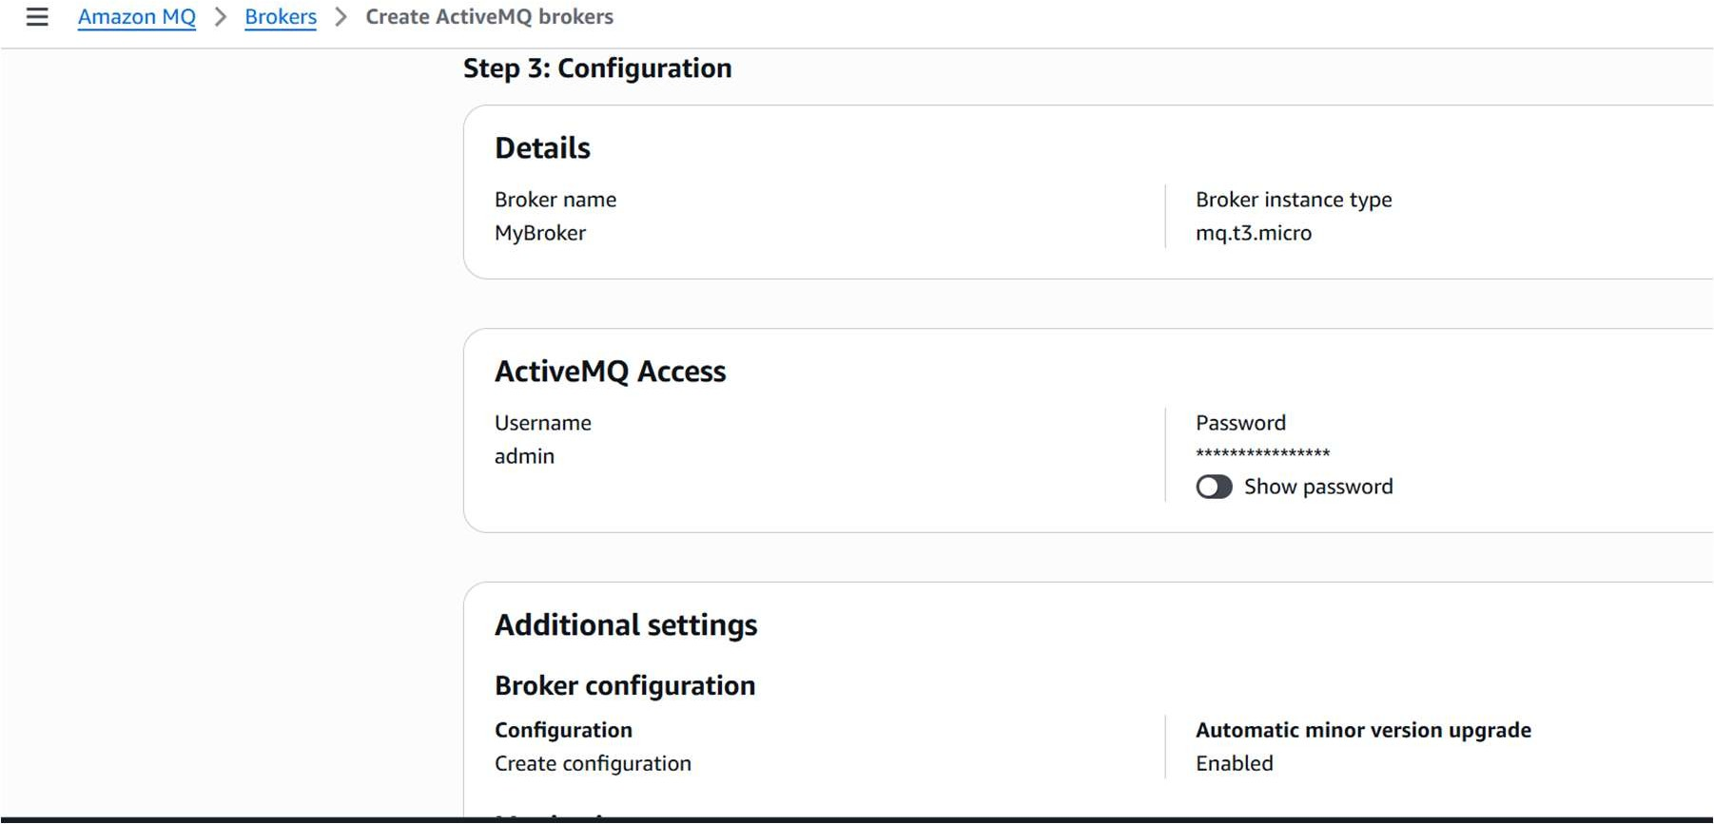

- Select the required VPC, private subnet, and security group.
- Wait until the broker status changes to Running.
- Open the ActiveMQ Web Console from the broker details.
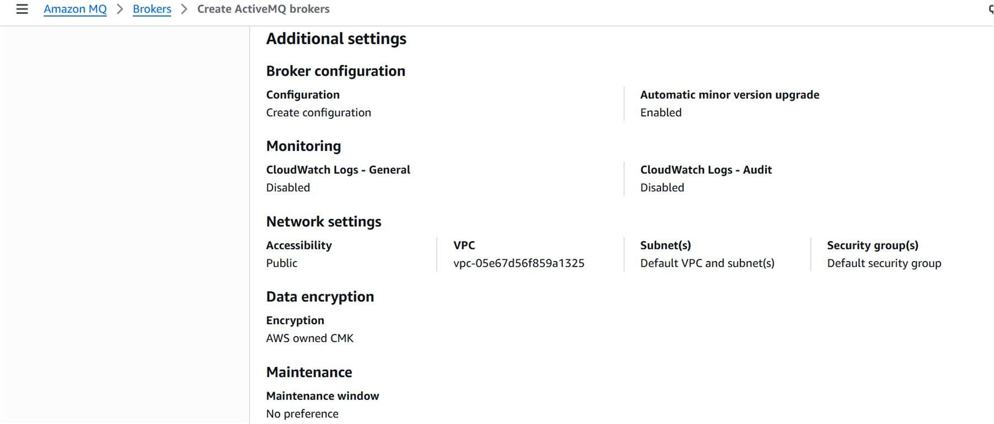
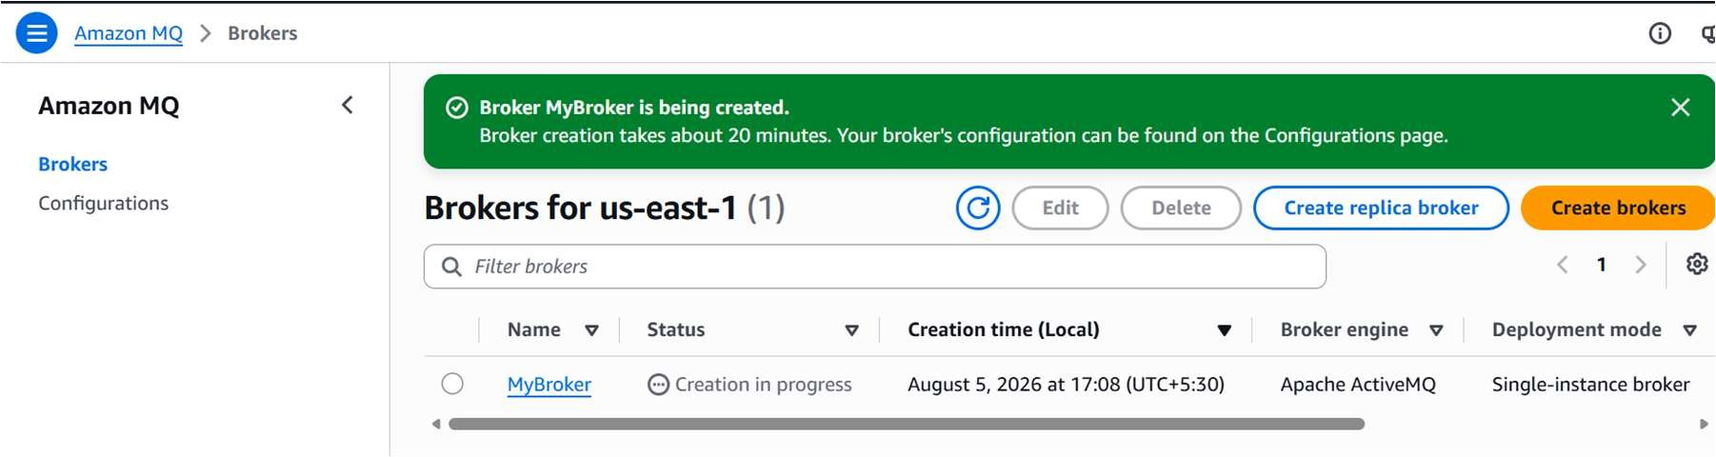
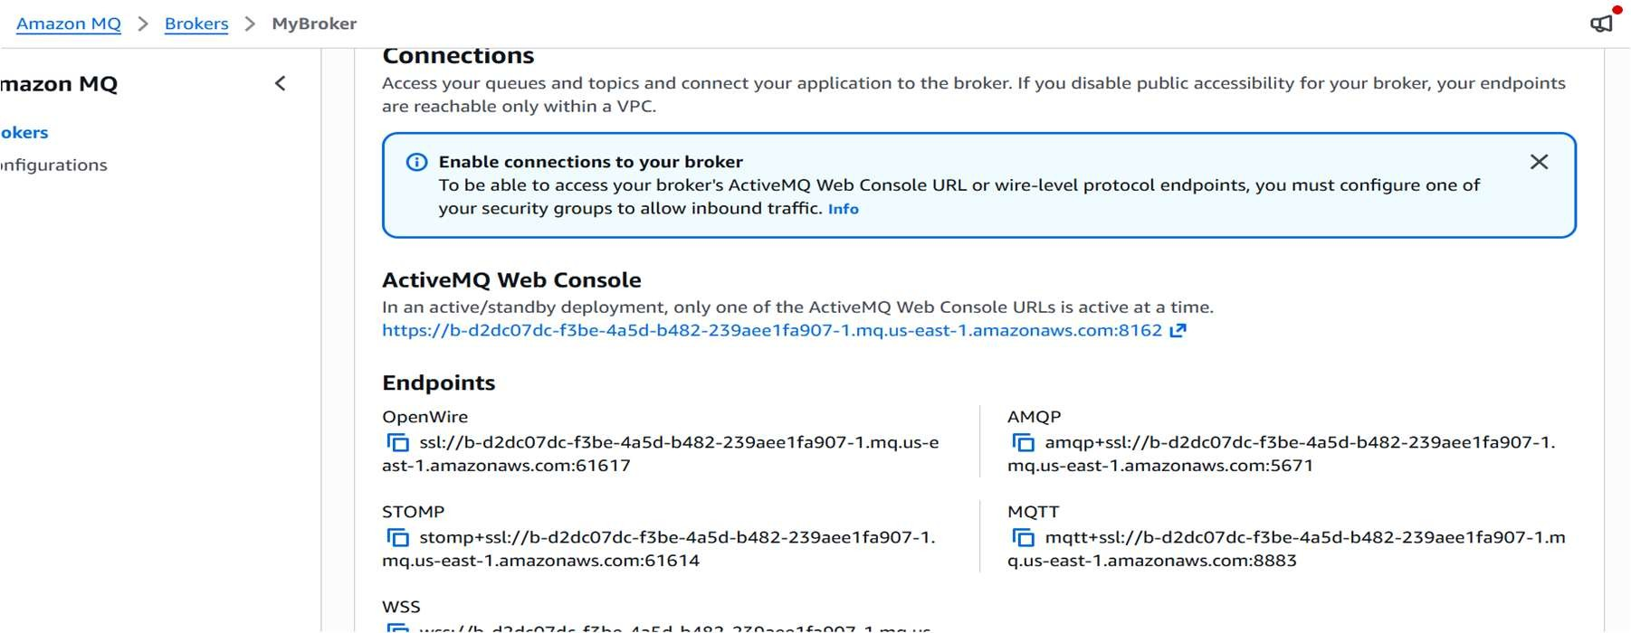

- Sign in to the ActiveMQ Web Console using the broker credentials.
- Create a queue named orders.queue from the Queues page, or allow the broker to create it automatically.
- Use a JMS client to send and receive test messages.
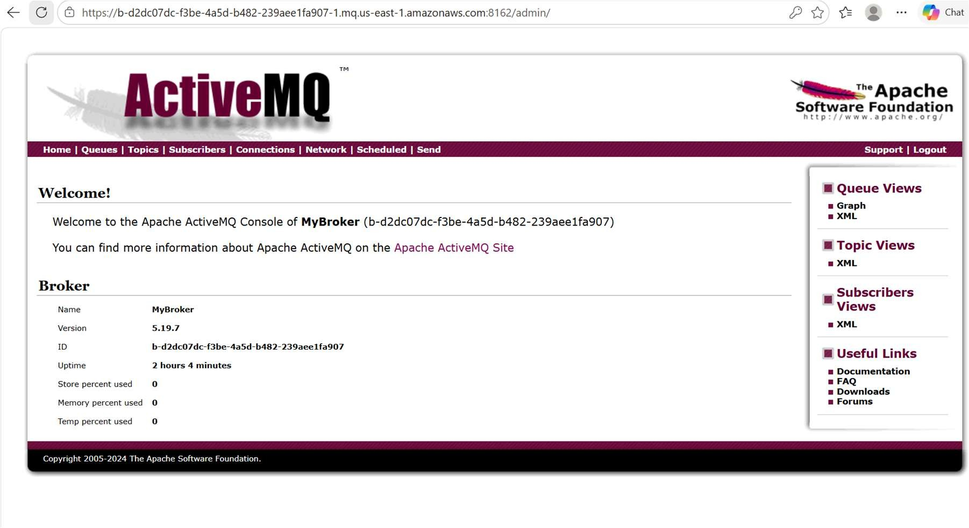
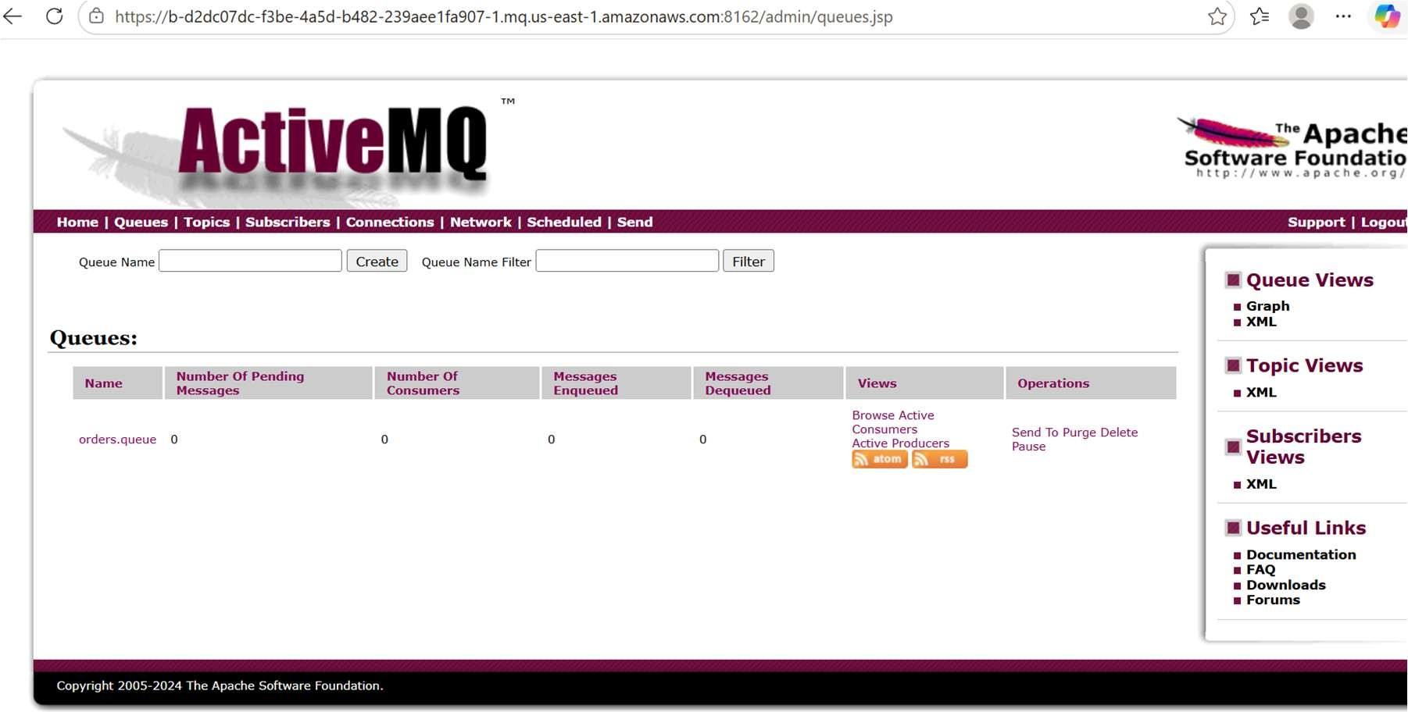

AWS Secrets Manager

Overview
AWS Secrets Manager is a managed service for securely storing, controlling, and retrieving sensitive information such as database credentials, API keys, tokens, and passwords. It works with IAM for access control and can support automated secret rotation.

Hands-on procedure
- Open AWS Secrets Manager.
- Choose the option to store a new secret and select Other type of secret.
- Add username and password as key-value pairs.
- Set the secret name to database-secret.
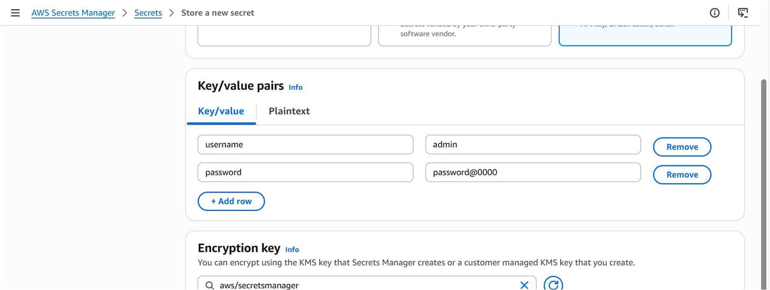
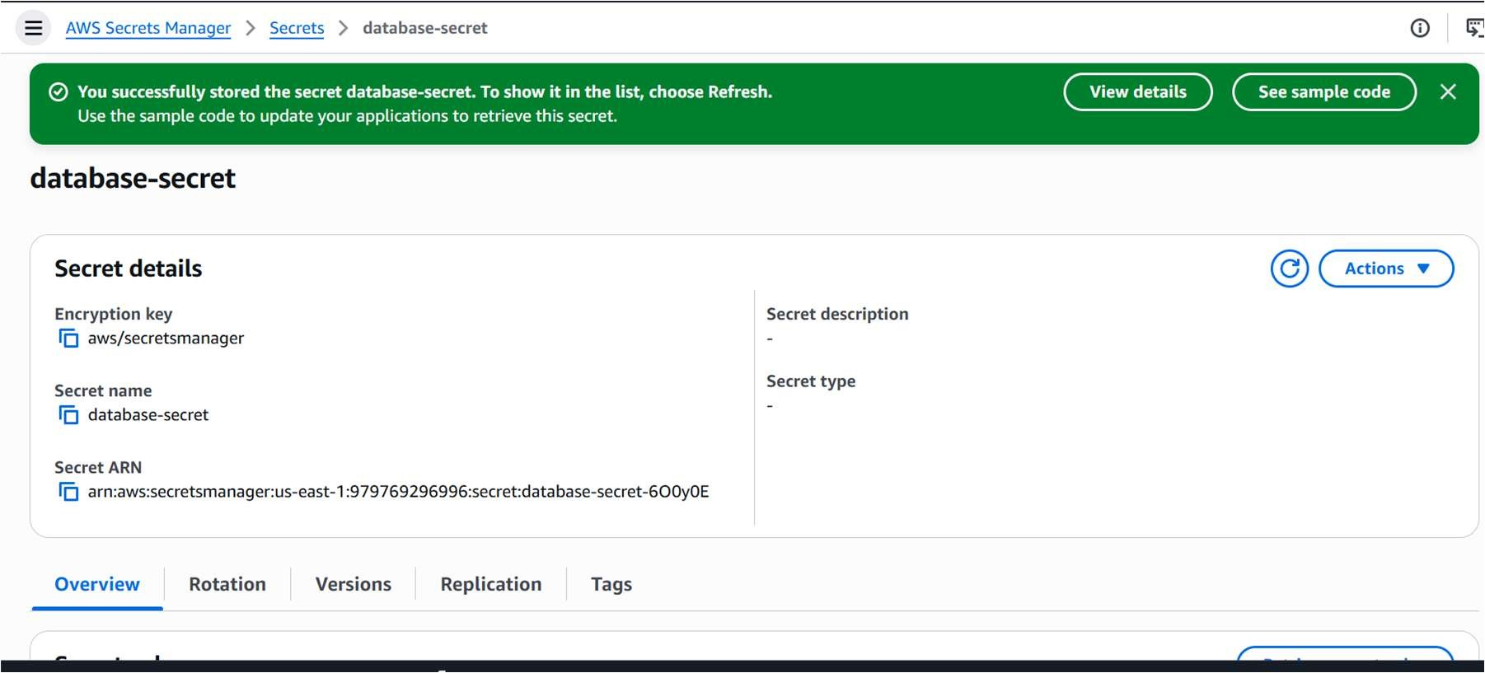

- Disable automatic rotation and save the secret.
- Retrieve and inspect the secret value from the AWS Console.
- Retrieve the same secret using the AWS CLI.
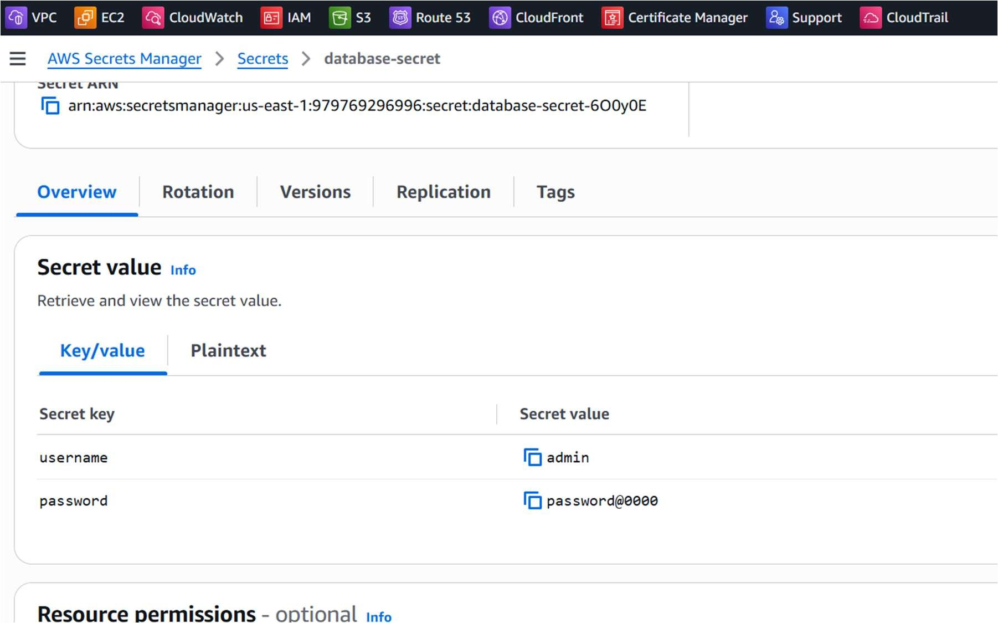
- Update the stored secret value and confirm that the new version is saved.
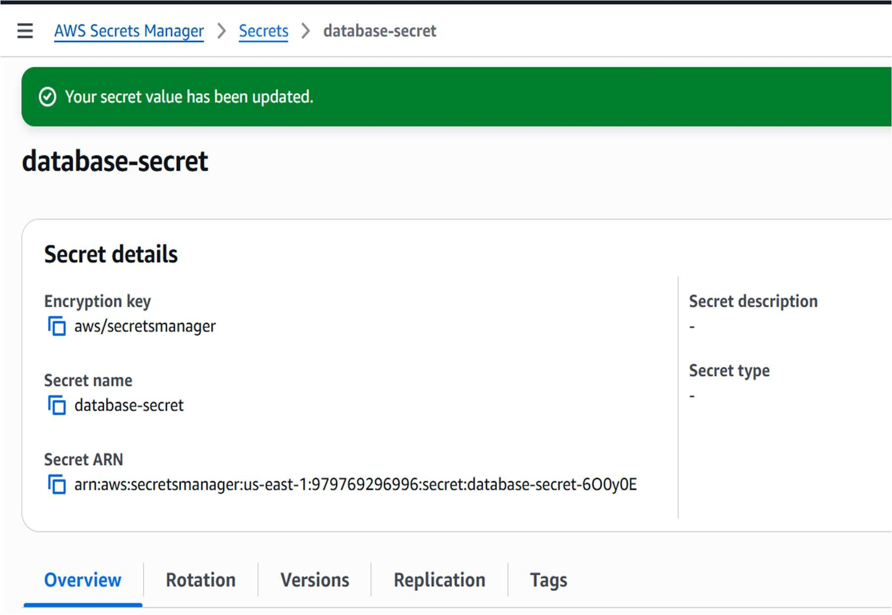

- Create an IAM policy that grants the secretsmanager:GetSecretValue permission.
- Attach the policy to the required IAM user or IAM role.
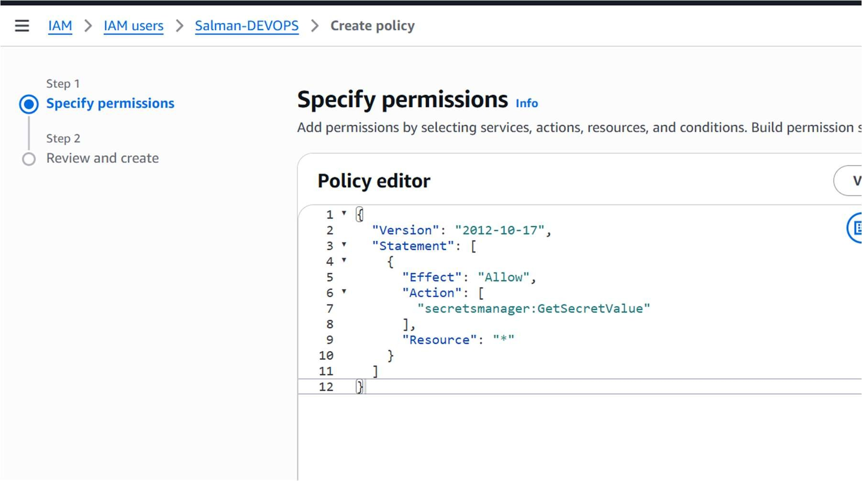
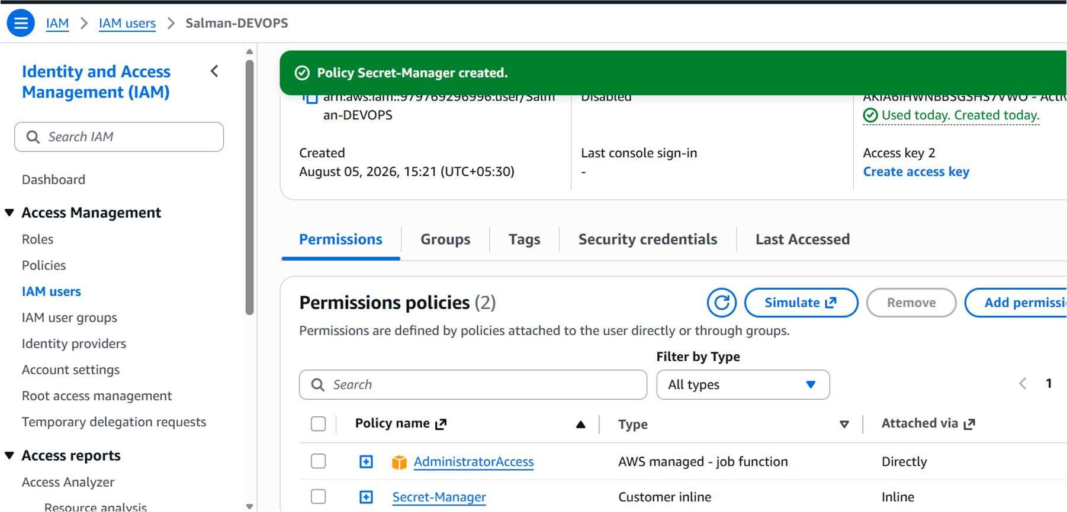

- From an EC2 instance that has the appropriate IAM role, retrieve the secret securely using the AWS CLI.
