JENKINS-03
Jenkins CI/CD Pipeline Documentation

1. Objective
The objective of Jenkins-03 was to create two Jenkins Pipeline jobs. Each job had three stages: (1) clone the source code from GitHub, (2) perform SonarQube code-quality analysis, and (3) send a Slack notification.

2. Assignment Requirements
Job | Application | Source Code
Job 1 | VProfile | https://github.com/betawins/VProfile-1.git
Job 2 | Hiring App | https://github.com/betawins/hiring-app.git

3. Environment Preparation
An Ubuntu EC2 instance was created and Jenkins was accessed through the Jenkins web interface. During troubleshooting, the EC2 instance was resized to provide more memory and disk capacity because SonarQube is resource intensive.
The final environment used:
- Ubuntu EC2 server
- Jenkins 2.568.2
- Java 21
- Maven 3.9.12
- Docker
- SonarQube running in Docker on port 9000
- Slack workspace and custom Slack app

4. Verify Server Resources
The following Linux commands were used to verify memory, disk, and block-device information:
free -h
df -h
lsblk
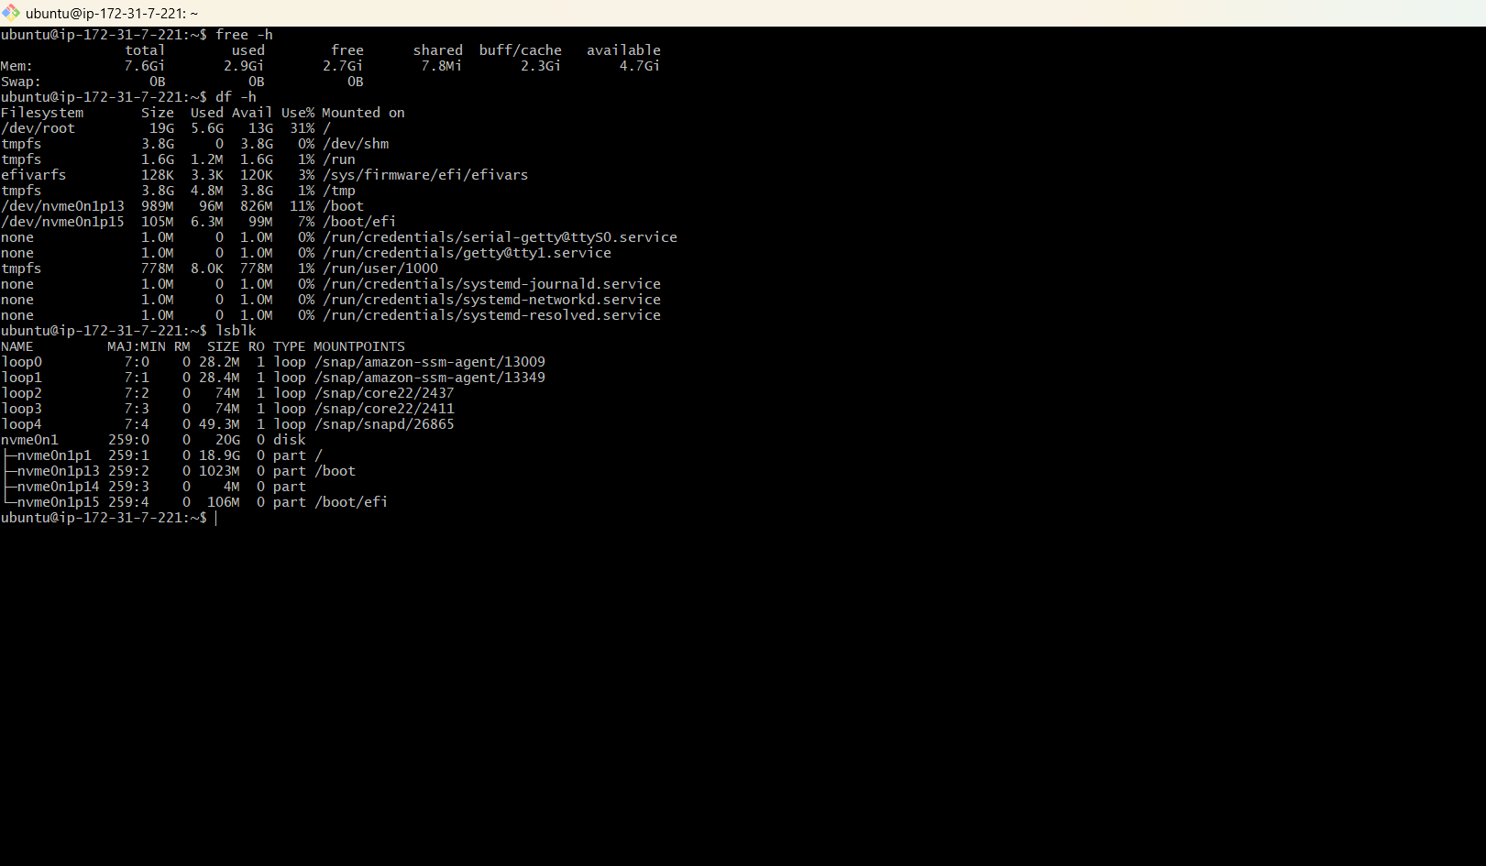
The root disk was expanded and the filesystem was resized. The final check showed approximately 19 GB available disk size for the root filesystem.

5. Install and Verify Maven
Maven was installed on the Ubuntu server:
sudo apt update
sudo apt install maven -y
Maven was verified successfully with:
mvn -version
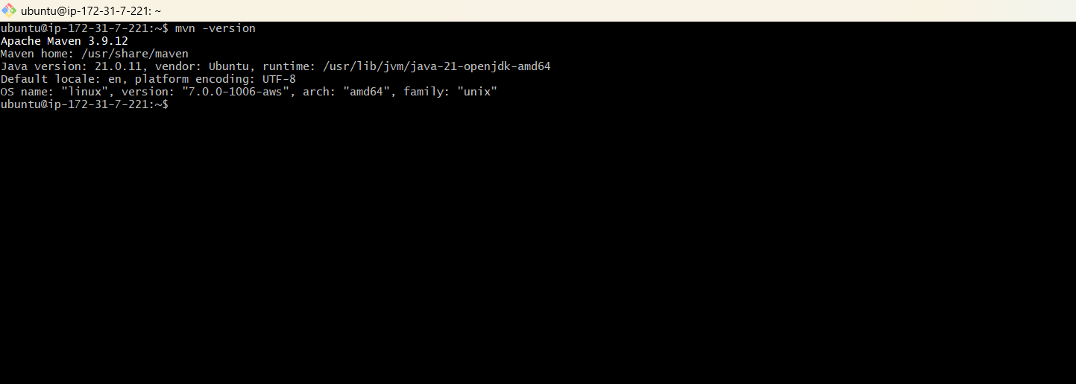
The completed setup showed Maven 3.9.12 running with Java 21.

6. Install SonarQube Using Docker
SonarQube Community Edition was run as a Docker container and exposed on port 9000.
sudo docker run -d --name sonarqube -p 9000:9000 sonarqube:lts-community
The container was checked with:
sudo docker ps
The first container attempt stopped because the server did not have enough memory. The container logs showed Elasticsearch exiting with code 137, indicating an out-of-memory condition.
sudo docker ps -a
sudo docker logs sonarqube --tail 50
After increasing the EC2 instance resources, SonarQube was started again. The logs eventually showed: 'SonarQube is operational'.
Port 9000 was verified with:
sudo ss -lntp | grep 9000
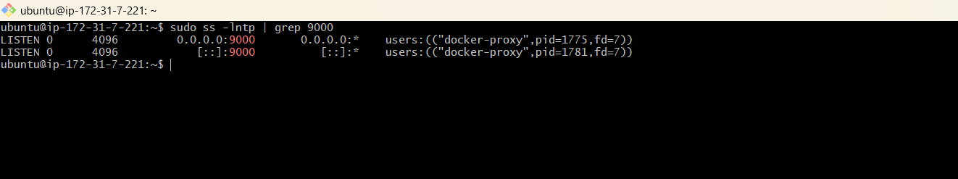
SonarQube was then opened in a browser using the server public IP and port 9000.
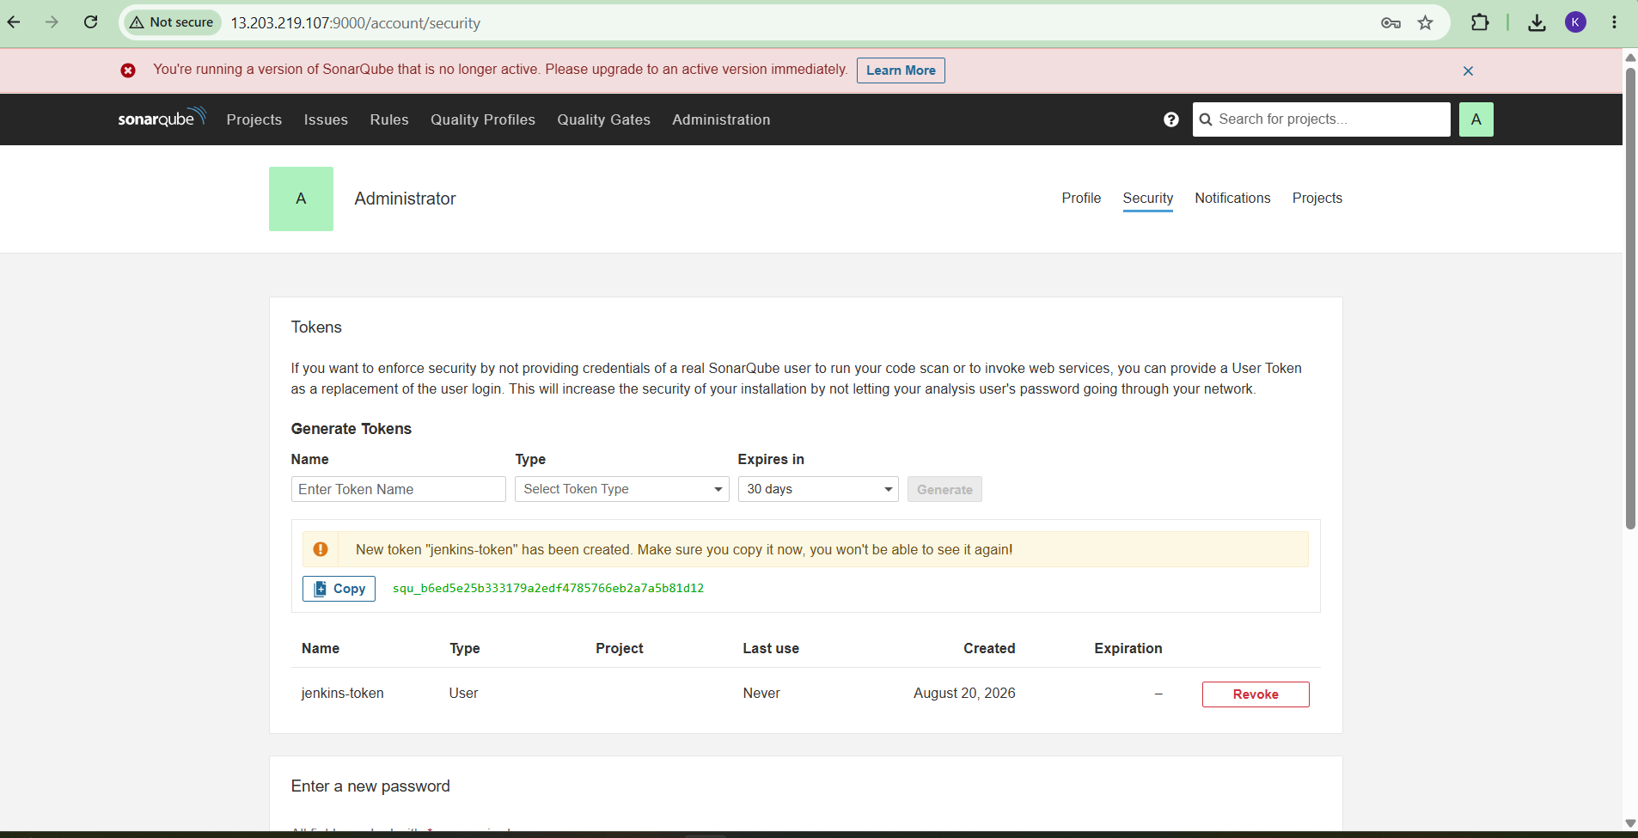

7. SonarQube Initial Configuration
The default SonarQube administrator account was used to enter the administration area. A SonarQube token was generated for Jenkins integration.
The SonarQube server was configured in Jenkins with the server name used by the pipeline:
SonarQube
This name is important because the pipeline uses withSonarQubeEnv('SonarQube').
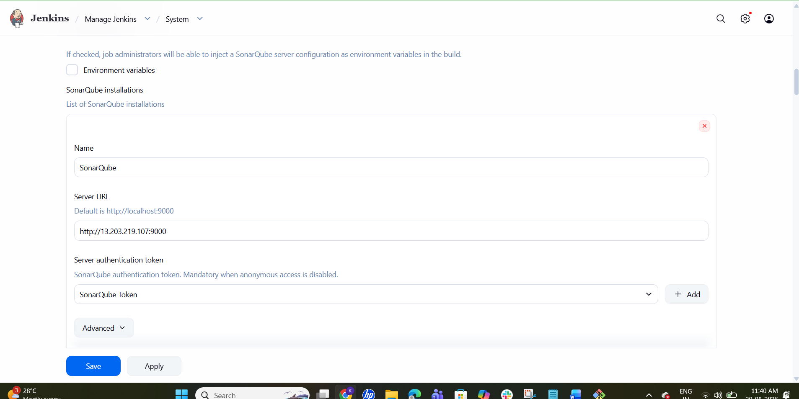

8. Configure Slack Integration
A Slack app was created for Jenkins notifications. The app was installed in the Slack workspace and a bot token was generated.
In Jenkins → Manage Jenkins → Credentials → System → Global credentials, a Secret text credential was created:
Credential Type | Secret text
Credential ID | slack-token
Purpose | Slack bot token for Jenkins notifications
Slack notification settings in Jenkins were configured as follows:
- Workspace: Krishna Sai Yalla
- Credential: Slack Bot Token
- Default channel: #new-channel
- Custom slack app bot user: enabled
- 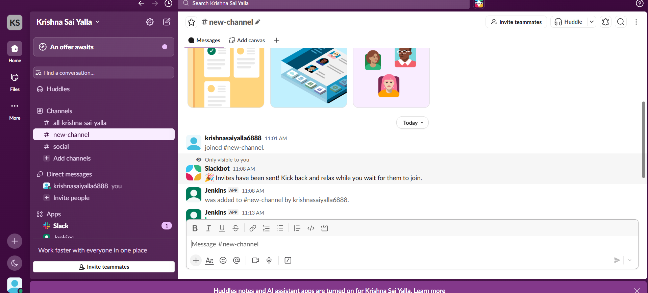
- 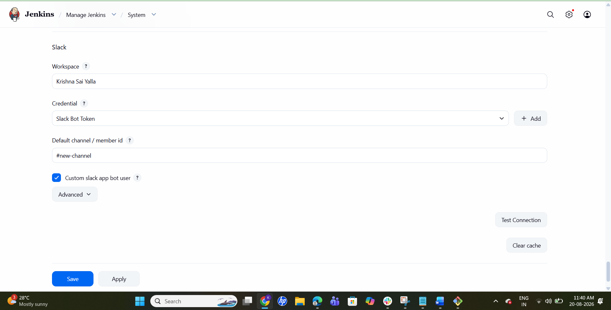
- 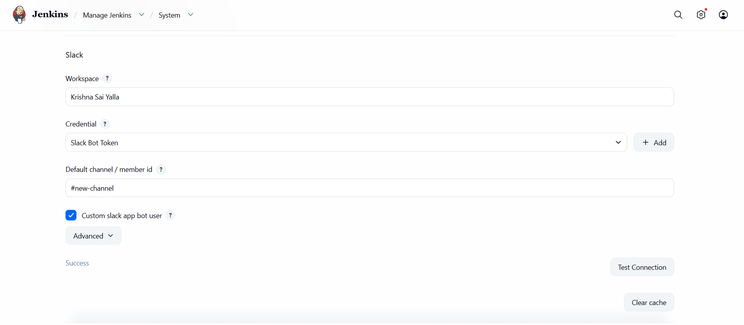
The 'Test Connection' operation returned 'Success', confirming that Jenkins could communicate with Slack.

9. Job 1 — Jenkins-03-VProfile
A Pipeline job named 'Jenkins-03-VProfile' was created.
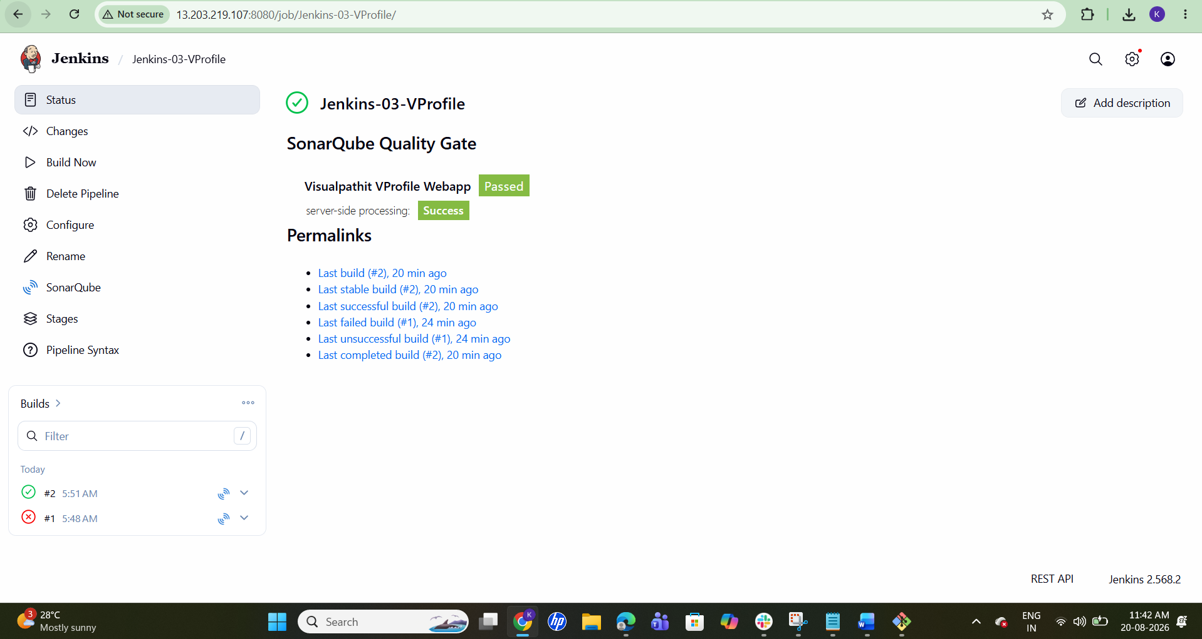

Step 1: Create the Pipeline Job
Jenkins Dashboard → New Item → enter Jenkins-03-VProfile → select Pipeline → OK.

Step 2: Configure Pipeline Script
Open Configure → Pipeline → Definition: Pipeline script.
The following Declarative Pipeline was used:
pipeline {
agent any
stages {
stage('Git Clone') {
steps {
git 'https://github.com/betawins/VProfile-1.git'
}
}
stage('SonarQube Integration') {
steps {
withSonarQubeEnv('SonarQube') {
sh '''
mvn clean verify \
org.sonarsource.scanner.maven:sonar-maven-plugin:sonar
'''
}
}
}
stage('Slack Notification') {
steps {
slackSend(
channel: '#new-channel',
message: "Jenkins-03-VProfile build #${BUILD_NUMBER} completed successfully. SonarQube analysis completed."
)
}
}
}
post {
failure {
slackSend(
channel: '#new-channel',
message: "Jenkins-03-VProfile build #${BUILD_NUMBER} FAILED. Check Jenkins console output."
)
}
}
}
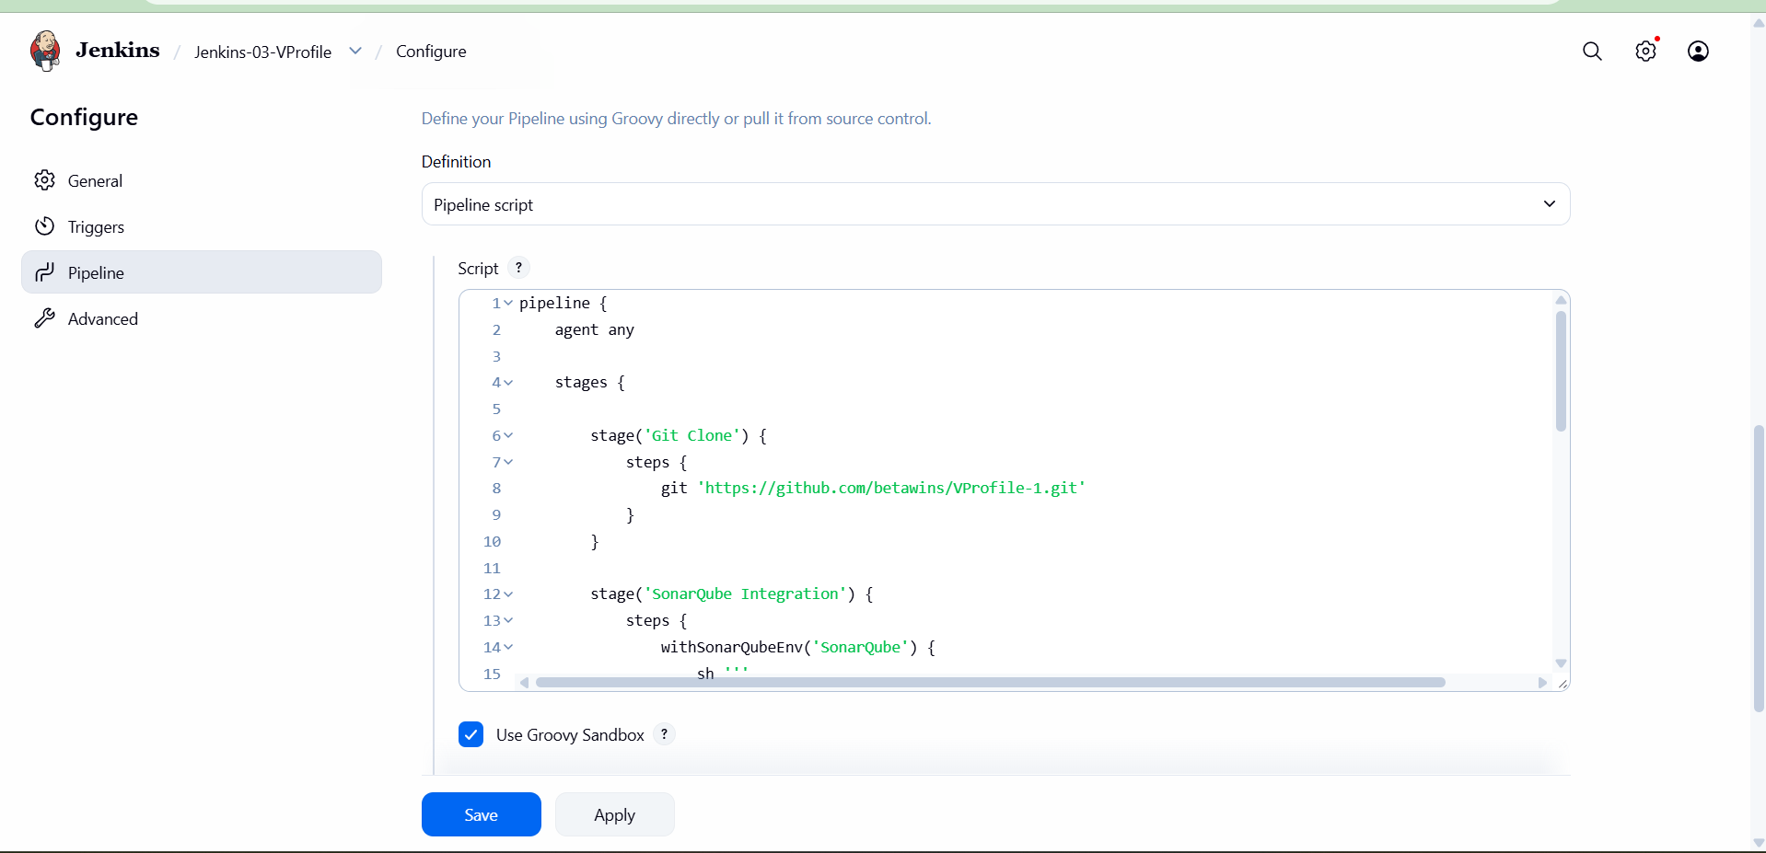

10. VProfile Build Troubleshooting
The first VProfile build successfully cloned the repository but failed during the SonarQube stage. The error was 'NoPluginFoundForPrefixException' because Maven could not resolve the short sonar plugin prefix.
The SonarQube command was changed from:
mvn clean verify sonar:sonar
to the explicit Maven plugin invocation:
mvn clean verify org.sonarsource.scanner.maven:sonar-maven-plugin:sonar
After this correction, the VProfile pipeline completed successfully through all three stages.

11. Job 2 — Jenkins-03-Hiring-App
A second Pipeline job was created for the hiring application.
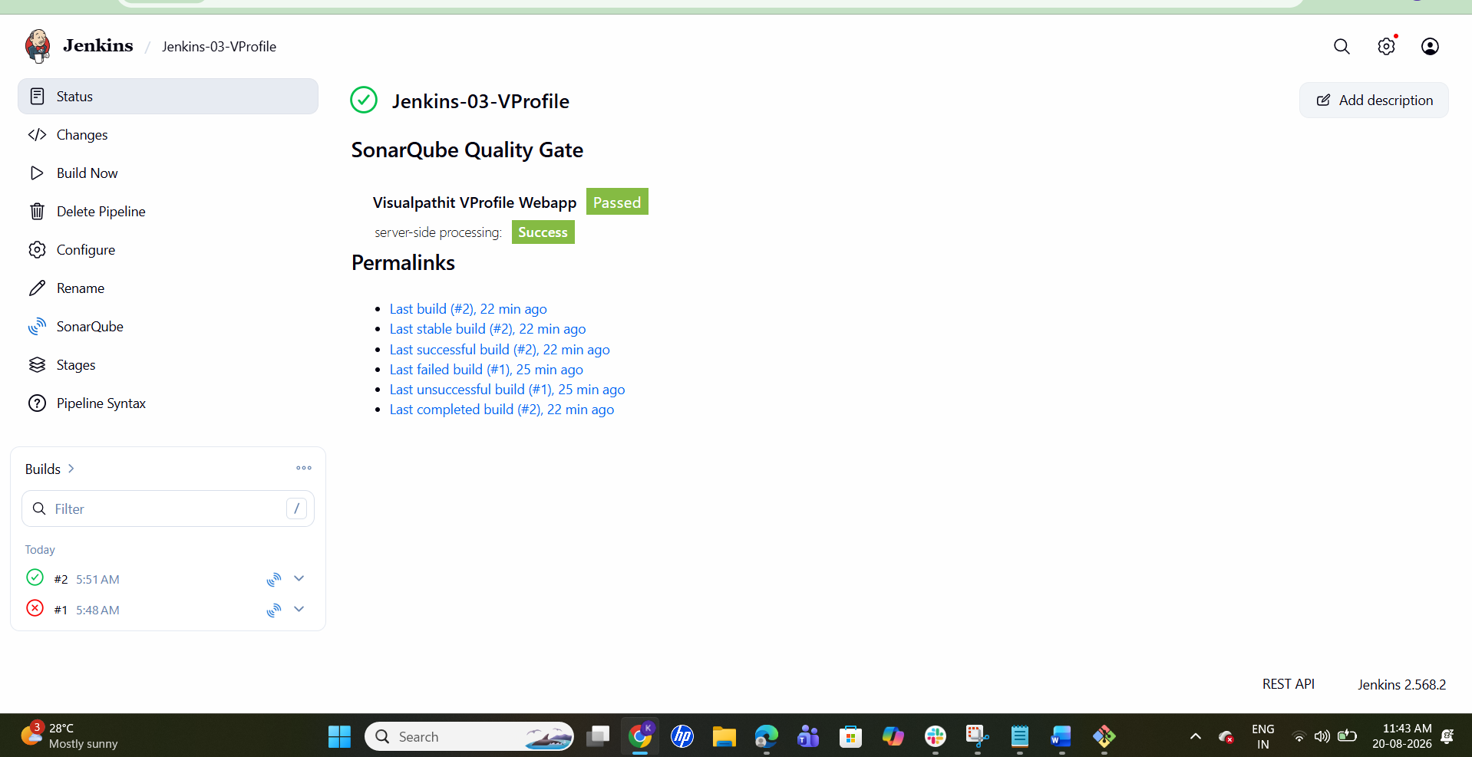

Step 1: Create the Pipeline Job
Jenkins Dashboard → New Item → enter Jenkins-03-Hiring-App → select Pipeline → OK.

Step 2: Configure the Pipeline
Configure → Pipeline → Definition: Pipeline script.
The final working pipeline was:
pipeline {
agent any
stages {
stage('Git Clone') {
steps {
git branch: 'main',
url: 'https://github.com/betawins/hiring-app.git'
}
}
stage('SonarQube Integration') {
steps {
withSonarQubeEnv('SonarQube') {
sh '''
mvn clean verify \
org.sonarsource.scanner.maven:sonar-maven-plugin:sonar
'''
}
}
}
stage('Slack Notification') {
steps {
slackSend(
channel: '#new-channel',
message: "Jenkins-03-Hiring-App build #${BUILD_NUMBER} completed successfully. SonarQube analysis completed."
)
}
}
}
post {
failure {
slackSend(
channel: '#new-channel',
message: "Jenkins-03-Hiring-App build #${BUILD_NUMBER} FAILED. Check Jenkins console output."
)
}
}
}

12. Hiring App Build Troubleshooting
The first Hiring App build failed in the Git Clone stage with 'Maximum checkout retry attempts reached' and 'Couldn't find any revision to build'. The Git stage was updated to explicitly use the main branch.
The corrected Git stage was:
stage('Git Clone') {
steps {
git branch: 'main',
url: 'https://github.com/betawins/hiring-app.git'
}
}
The pipeline was run again and completed successfully.
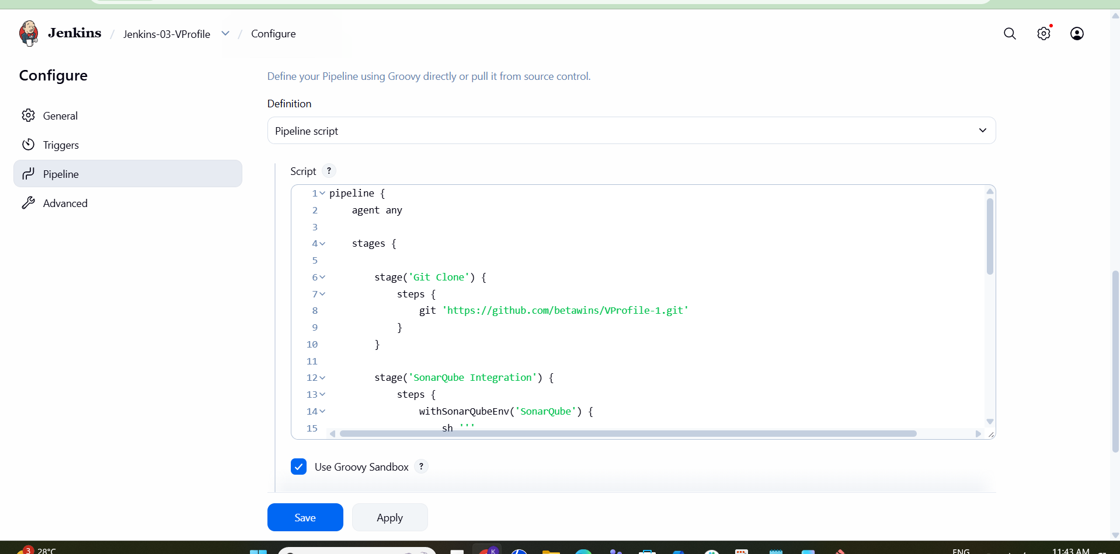
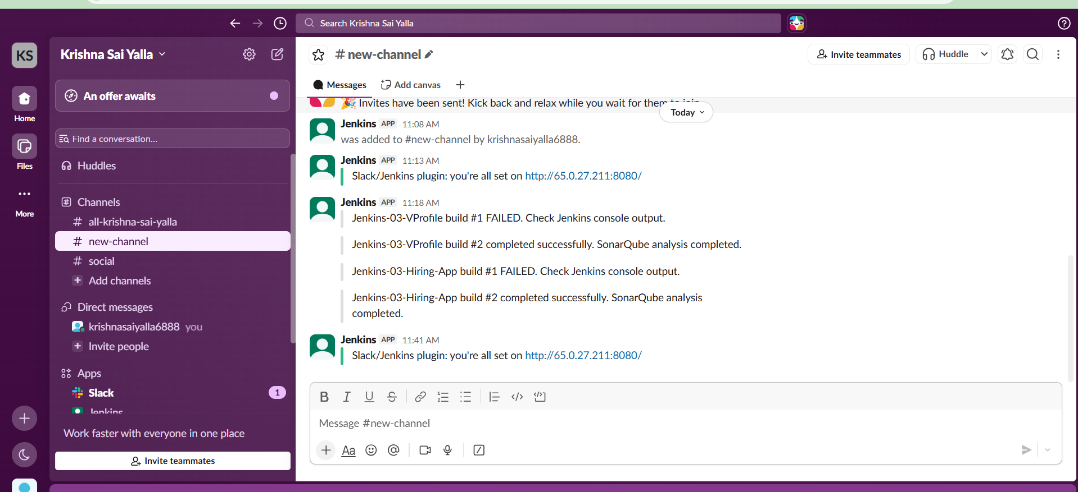

13. Final Results
Job | Git Clone | SonarQube | Slack | Result
Jenkins-03-VProfile | PASS | PASS | PASS | SUCCESS
Jenkins-03-Hiring-App | PASS | PASS | PASS | SUCCESS

14. Pipeline Flow
The completed CI flow for both applications is:
GitHub Repository → Git Clone → Maven + SonarQube → Slack Notification

16. Conclusion
Jenkins-03 was completed by implementing two Declarative Pipeline jobs. Both applications were cloned from GitHub, analyzed using SonarQube through Maven, and integrated with Slack for notifications. Initial Git/Maven issues were diagnosed using Jenkins Console Output and corrected. The final builds for both VProfile and Hiring App completed successfully.

