Jenkins Pipeline Assignment
CICD Pipeline Implementation using Jenkins

1. Objective
The objective of this assignment was to create and successfully execute four Jenkins Pipeline jobs using the hiring application repository. The four required pipeline types were Declarative Pipeline, Scripted Pipeline, Multi-Stage Pipeline, and Parallel Stage Pipeline.

2. Source Code
The application source code was taken from the following GitHub repository:
https://github.com/betawins/hiring-app.git
The repository contains a Maven-based hiring application. The generated application package is a WAR file.

3. EC2 and Jenkins Environment Setup
A new Ubuntu EC2 instance was launched with the required configuration. The previous EC2 instance had been deleted, so the Jenkins environment was rebuilt on the new instance.
The following software was installed and verified:
- Java 21
- Jenkins
- Git
- Maven
Jenkins was installed, started, enabled as a system service, and successfully accessed through the Jenkins web interface.

4. Verify Development Tools
After connecting to the Ubuntu EC2 instance through SSH, Git and Maven were installed and their versions were verified.
sudo apt update
sudo apt install git maven -y
git --version
mvn -version
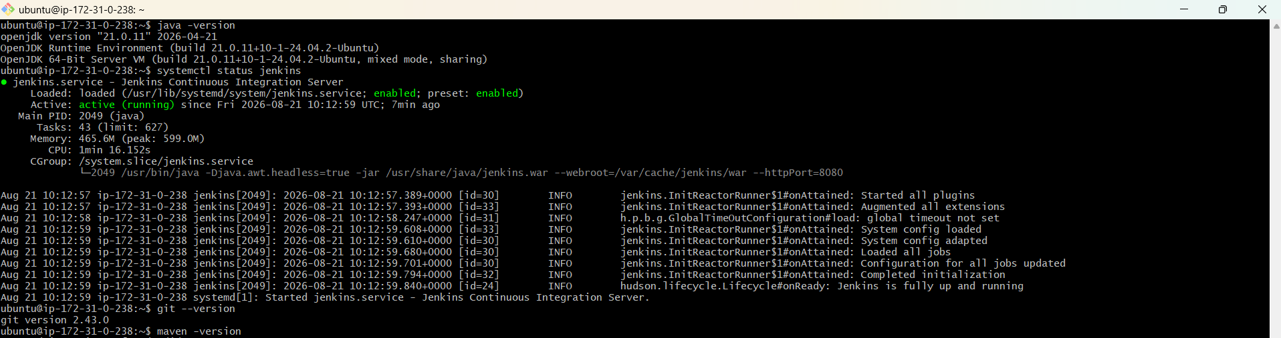
The environment was ready for building the application through Jenkins.

5. Clone and Verify the Application Repository
cd /tmp
git clone https://github.com/betawins/hiring-app.git
cd hiring-app
ls
git branch -a
The repository was cloned successfully and the application files were verified.

6. Job 1 – Declarative Pipeline
A Jenkins Pipeline job named hiring-app-declarative was created. The Pipeline definition was entered directly in the Jenkins job configuration.
Pipeline script used:
pipeline {
agent any
environment {
APP_NAME = 'hiring-app'
REPO_URL = 'https://github.com/betawins/hiring-app.git'
}
stages {
stage('Checkout') {
steps {
echo "Cloning ${APP_NAME} repository..."
git branch: 'main', url: "${REPO_URL}"
}
}
stage('Build') {
steps {
echo 'Building application...'
sh 'mvn clean package -DskipTests'
}
}
stage('Test') {
steps {
echo 'Running tests...'
sh 'mvn test'
}
}
stage('Package') {
steps {
echo 'Checking generated WAR file...'
sh 'ls -lh target/'
}
}
}
post {
success {
echo 'Jenkins Declarative Pipeline completed successfully!'
}
failure {
echo 'Jenkins Declarative Pipeline failed!'
}
}
}
The job was saved and Build Now was executed. The build completed successfully.
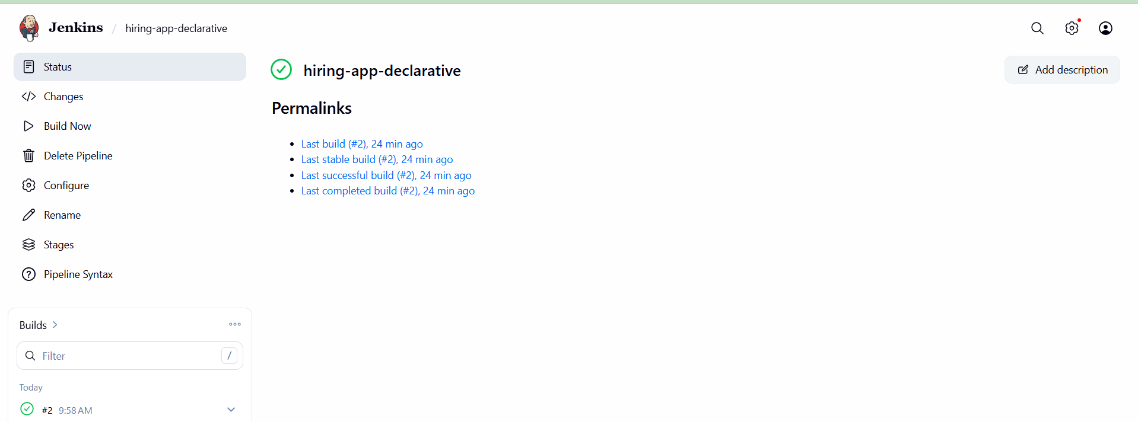

7. Job 2 – Scripted Pipeline
A second Jenkins Pipeline job named hiring-app-scripted was created. This job demonstrated Jenkins Scripted Pipeline syntax using node and stage blocks.
node {
stage('Checkout') {
echo 'Cloning hiring-app repository...'
git branch: 'main',
url: 'https://github.com/betawins/hiring-app.git'
}
stage('Build') {
echo 'Building application...'
sh 'mvn clean package -DskipTests'
}
stage('Test') {
echo 'Running tests...'
sh 'mvn test'
}
stage('Package') {
echo 'Checking generated WAR file...'
sh 'ls -lh target/'
}
stage('Complete') {
echo 'Scripted Pipeline completed successfully!'
}
}
The job was saved and executed using Build Now. The build completed successfully.
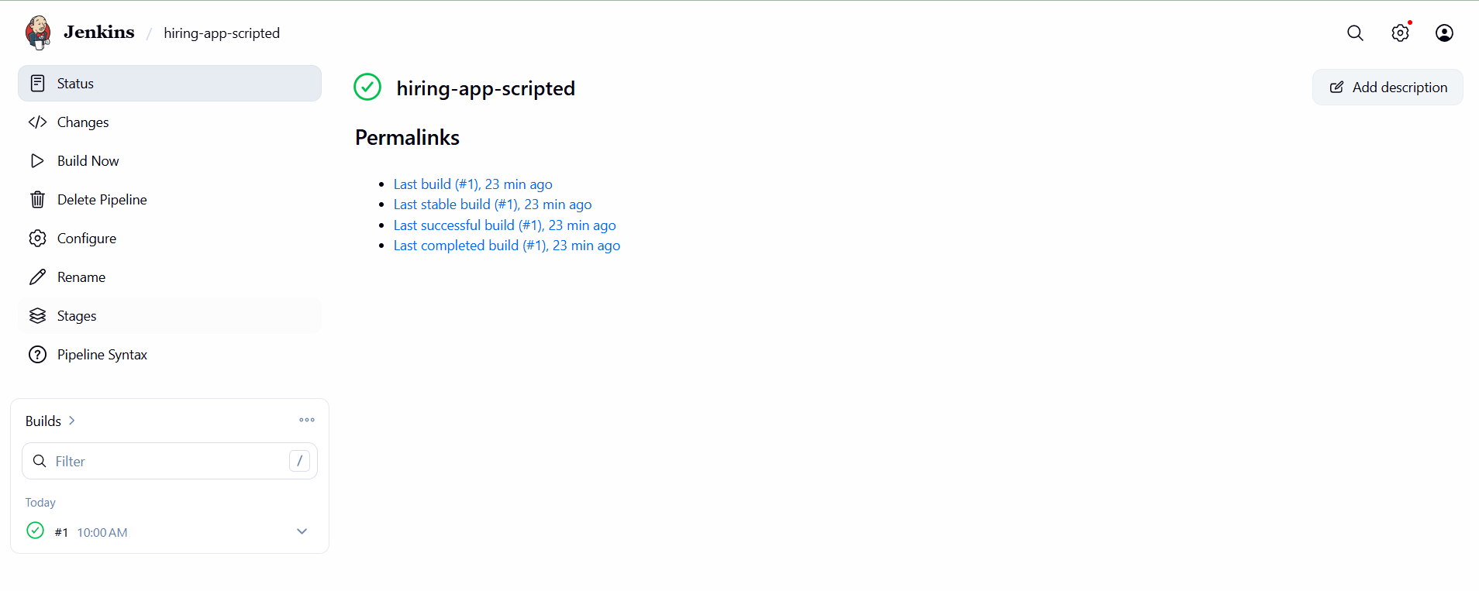

8. Job 3 – Multi-Stage Pipeline
A third Jenkins Pipeline job named hiring-app-multistage was created. The pipeline was organized into multiple sequential stages so that each stage could be viewed independently in Jenkins Stage View.
pipeline {
agent any
stages {
stage('Checkout') {
steps {
echo 'Checking out source code...'
git branch: 'main',
url: 'https://github.com/betawins/hiring-app.git'
}
}
stage('Compile') {
steps {
echo 'Compiling application...'
sh 'mvn clean compile'
}
}
stage('Test') {
steps {
echo 'Running tests...'
sh 'mvn test'
}
}
stage('Package') {
steps {
echo 'Packaging application...'
sh 'mvn package -DskipTests'
}
}
stage('Verify') {
steps {
echo 'Verifying generated artifact...'
sh 'ls -lh target/'
}
}
}
post {
success {
echo 'Multi-Stage Pipeline completed successfully!'
}
failure {
echo 'Multi-Stage Pipeline failed!'
}
}
}
The pipeline was executed successfully. The stages Checkout, Compile, Test, Package, and Verify completed successfully.
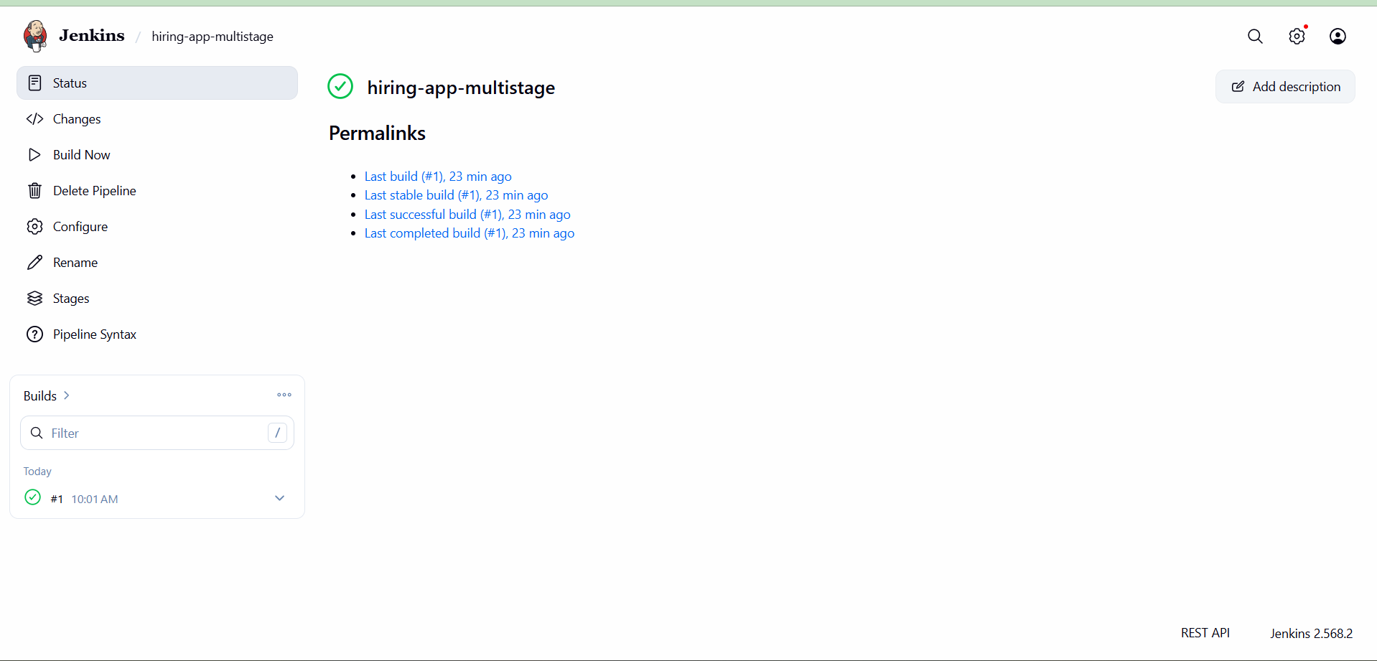

9. Job 4 – Parallel Stage Pipeline
A fourth Jenkins Pipeline job named hiring-app-parallel was created. The pipeline demonstrated parallel execution by running Build and Test as parallel branches after the Checkout stage.
pipeline {
agent any
stages {
stage('Checkout') {
steps {
echo 'Checking out source code...'
git branch: 'main',
url: 'https://github.com/betawins/hiring-app.git'
}
}
stage('Parallel Build and Test') {
parallel {
stage('Build') {
steps {
echo 'Building application...'
sh 'mvn clean package -DskipTests'
}
}
stage('Test') {
steps {
echo 'Running tests...'
sh 'mvn test'
}
}
}
}
stage('Verify') {
steps {
echo 'Verifying application...'
sh 'ls -lh target/'
}
}
}
post {
success {
echo 'Parallel Pipeline completed successfully!'
}
failure {
echo 'Parallel Pipeline failed!'
}
}
}
The pipeline executed successfully. Checkout completed first, Build and Test were configured to execute in parallel, and Verify completed after the parallel branches finished.
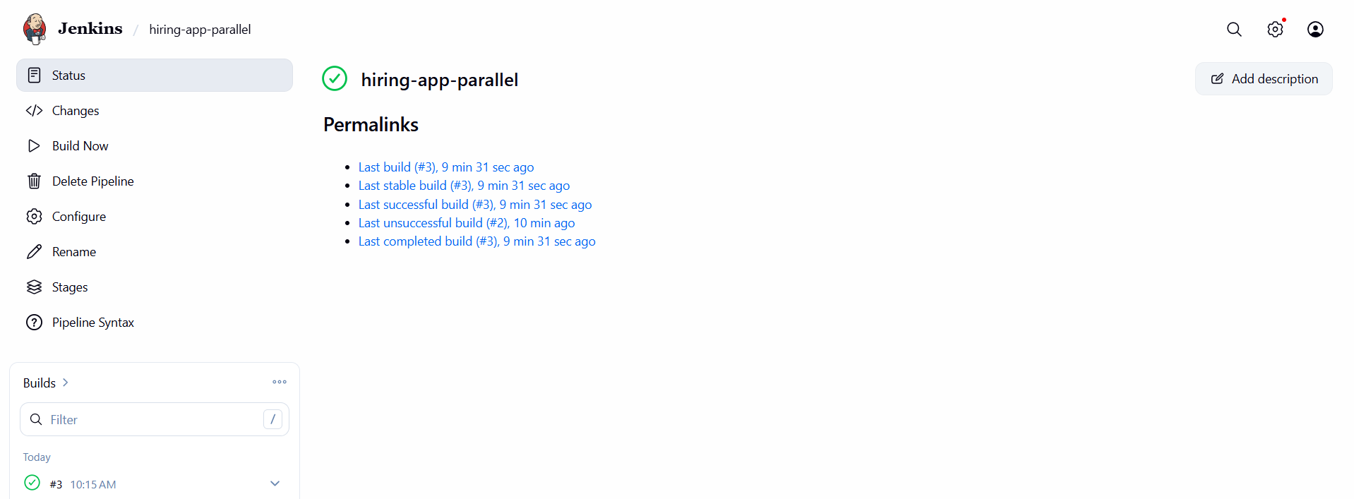

11. Pipeline Flow
GitHub Repository
|
v
Git Checkout
|
+------------------------------+
| | |
v v v
Declarative Scripted Multi-Stage
Pipeline Pipeline Pipeline
| | |
+--------------+---------------+
|
v
Parallel Pipeline
/ \
v v
Build Test
\ /
v v
Verify

12. Key Jenkins Concepts Demonstrated
- Declarative Pipeline syntax using pipeline {}.
- Scripted Pipeline syntax using node {} and stage {}.
- Sequential multi-stage pipeline execution.
- Parallel stage execution.
- Environment variables in a Declarative Pipeline.
- Git checkout from a GitHub repository.
- Maven build, compile, test, and package commands.
- Post actions for success and failure handling.
- Jenkins Stage View for monitoring pipeline execution.

13. Result
The Jenkins Pipeline assignment was completed successfully. Four separate Jenkins Pipeline jobs were created using the hiring-app GitHub repository. All four jobs executed successfully and demonstrated the required Declarative, Scripted, Multi-Stage, and Parallel Pipeline approaches.

14. Conclusion
This assignment provided practical experience in creating Jenkins CI/CD pipelines, integrating GitHub source code, building a Maven application, running tests, packaging the application, organizing pipeline stages, and executing selected stages in parallel. The successful builds confirmed that the Jenkins environment and pipeline configurations were working correctly.

